Dallen Teruel
March 25th, 2026
IT FDN 110 GP
Assignment 08

Creating Applications

Intro
In Module 08, I learned how to transition from individual scripts to architecting full-scale applications using the Separation of Concerns (SoC) design pattern. I explored how to visualize software architecture through UML diagrams and how to organize code into specialized modules for data, processing, and presentation. By implementing unit testing and leveraging tools like the PyCharm debugger and GitHub, I’ve moved past the "black box" stage of development to create scalable, professional-grade software.

Files Named:
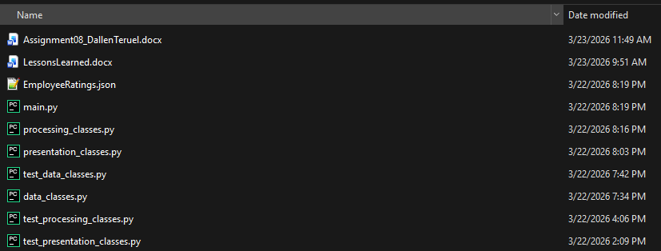

Script Header
The program starts with a script header that explains the purpose of the file and includes the author’s name, date, and revision information. This makes the code easier to understand and maintain (Figure 1.1). 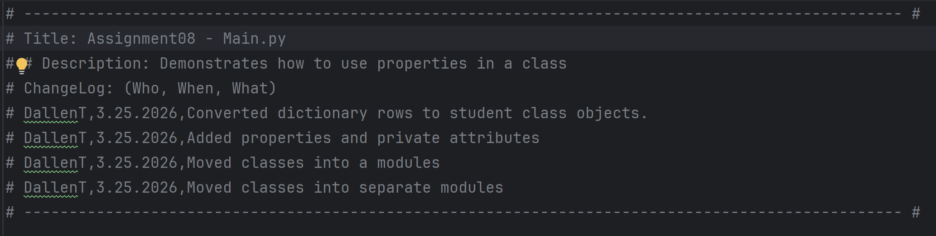
Figure 1.1: Script header comments containing the program title, description, author name, and current date.

Imports
Next, this section pulls in all the external code the program needs before anything else runs. The program is split into separate modules, each with a specific job — processing_classes handles file operations, presentation_classes manage everything the user sees and interacts with, and the Employee class serves as the blueprint for creating employee objects throughout the program. (Figure 1.2).

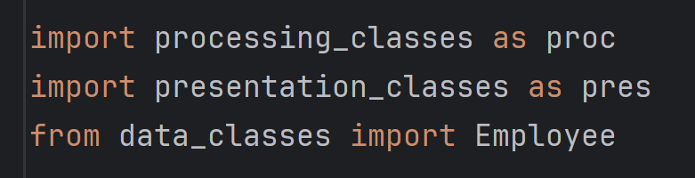
Figure 1.2: Three import statements that load proc for file operations, pres for user interaction, and the Employee class as the object blueprint used throughout the program.

Constants
Two constants are used in the program. One stores the file name (Enrollments.json) where Employee Ratings data is saved, and the other constant stores the menu text that is displayed to the use. Using constants keeps important values in one place and makes the program easier to update (Figure 1.3).
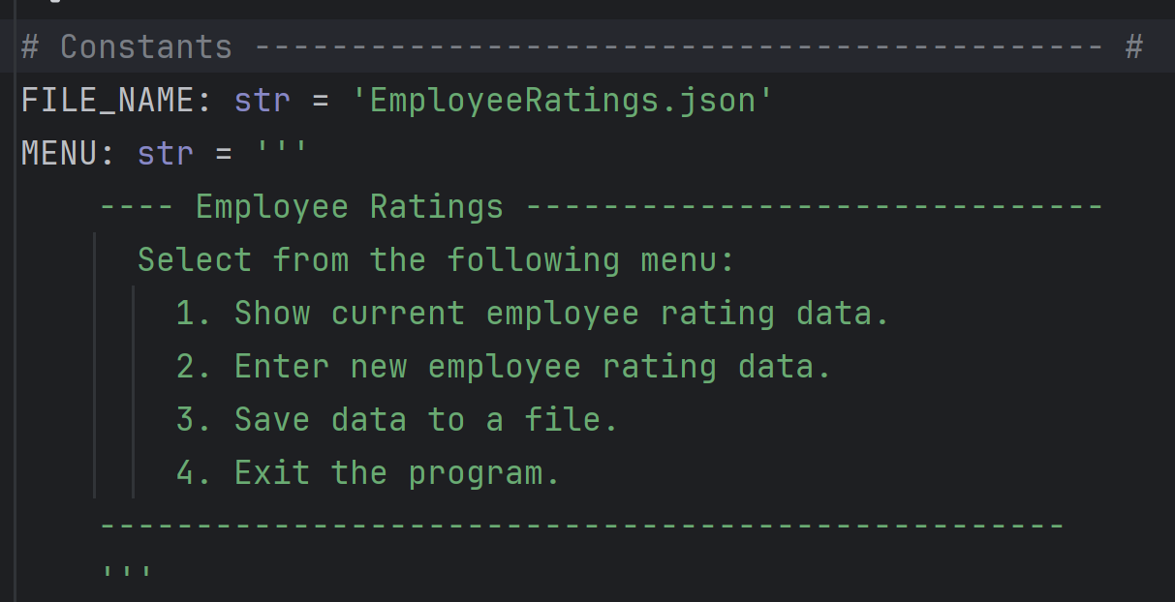
Figure 1.3: Constant string values the JSON file name used to store enrollment data and for the program menu.

Variables
The program also initializes a variables to store a list to hold all employee records and the user’s menu choice (Figure 1.4).
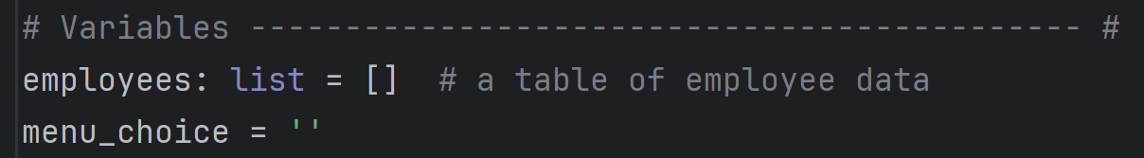
Figure 1.4: Variable initialization for the list of all employees and menu choice,

Main Body (Functions, I/O, Processing and Error Handling)
Next, before the menu appears, this section loads any previously saved employee data from the JSON file into the employees list, so the user isn't starting from scratch every time. It passes the Employee class as an argument so the file processor knows what kind of objects to create when converting the raw JSON data. The result overwrites the empty list, giving the program a fully populated starting state. (Figure 1.5).

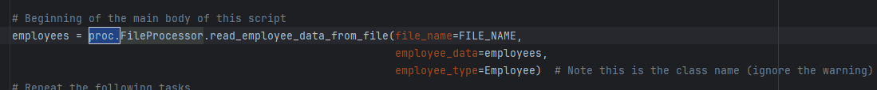

Figure 1.5 A pre-loop file read that calls read_employee_data_from_file(), passing the filename, empty list, and Employee class so existing JSON records are parsed and returned as typed Employee objects before the menu appears.

Main Loop
The while True loop runs indefinitely, keeping the program open and responsive until the user chooses to exit. Every iteration starts by re-displaying the menu and waiting for the user to make a choice, which is then handed off to the if/elif block below to determine what action to perform. Without this loop, the program would run once and immediately close (Figure 1.6).

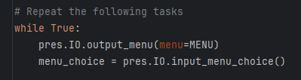
Figure 1.6: A while True loop that repeatedly displays the menu and stores the user's input in menu_choice to drive the if/elif block below.

Input/Output/Processing
For menu_choice 1, this block safely prints all current employee records using a try/except, catching and displaying any errors before looping back to the menu with continue (Figure 1.7).

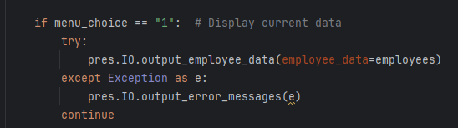
Figure 1.7: A conditional branch that calls output_employee_data() in a try/except to print all Employee records, handling errors gracefully before returning to the menu..

For menu_choice 2, this block prompts the user for a new employee entry, constructs an Employee object from their input, appends it to the list, and immediately redisplays all records to confirm the addition (Figure 1.8).

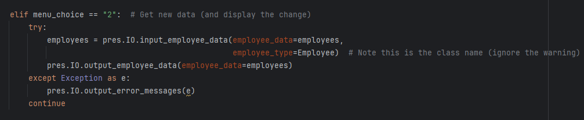
Figure 1.8: A conditional branch that calls input_employee_data() to build and append a new Employee object, then redisplays the full list to confirm the addition.

For menu_choice 3, this block writes the current in-memory employee list to the JSON file, making all data permanent. A confirmation message is printed on success, and the try/except handles any file-level errors (Figure 1.9).

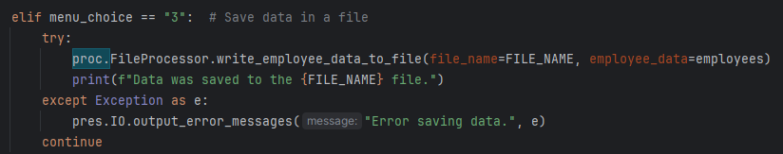
Figure 1.9: A conditional branch that calls write_employee_data_to_file() to save the employee list to JSON, confirming success with a printed message and catching any file errors.

For menu_choice 4, this block prints a goodbye message and executes break to immediately exit the while True loop, cleanly terminating the program (Figure 1.10).
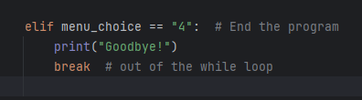
Figure 1.10: A conditional branch that prints a farewell message and uses break to exit the loop and terminate the program when the user selects option 4.

Test
The program was tested in both IDLE and the Windows Command Prompt. All menu options worked correctly, including registering students, displaying data, saving to the file, handling invalid input, and exiting the program (Figure 1.10-1.14).
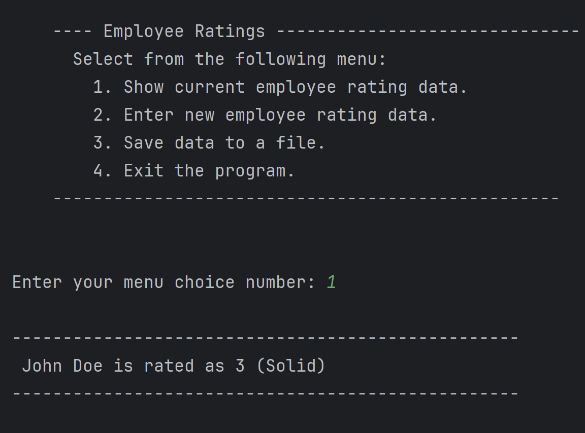

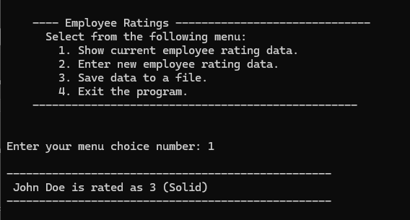

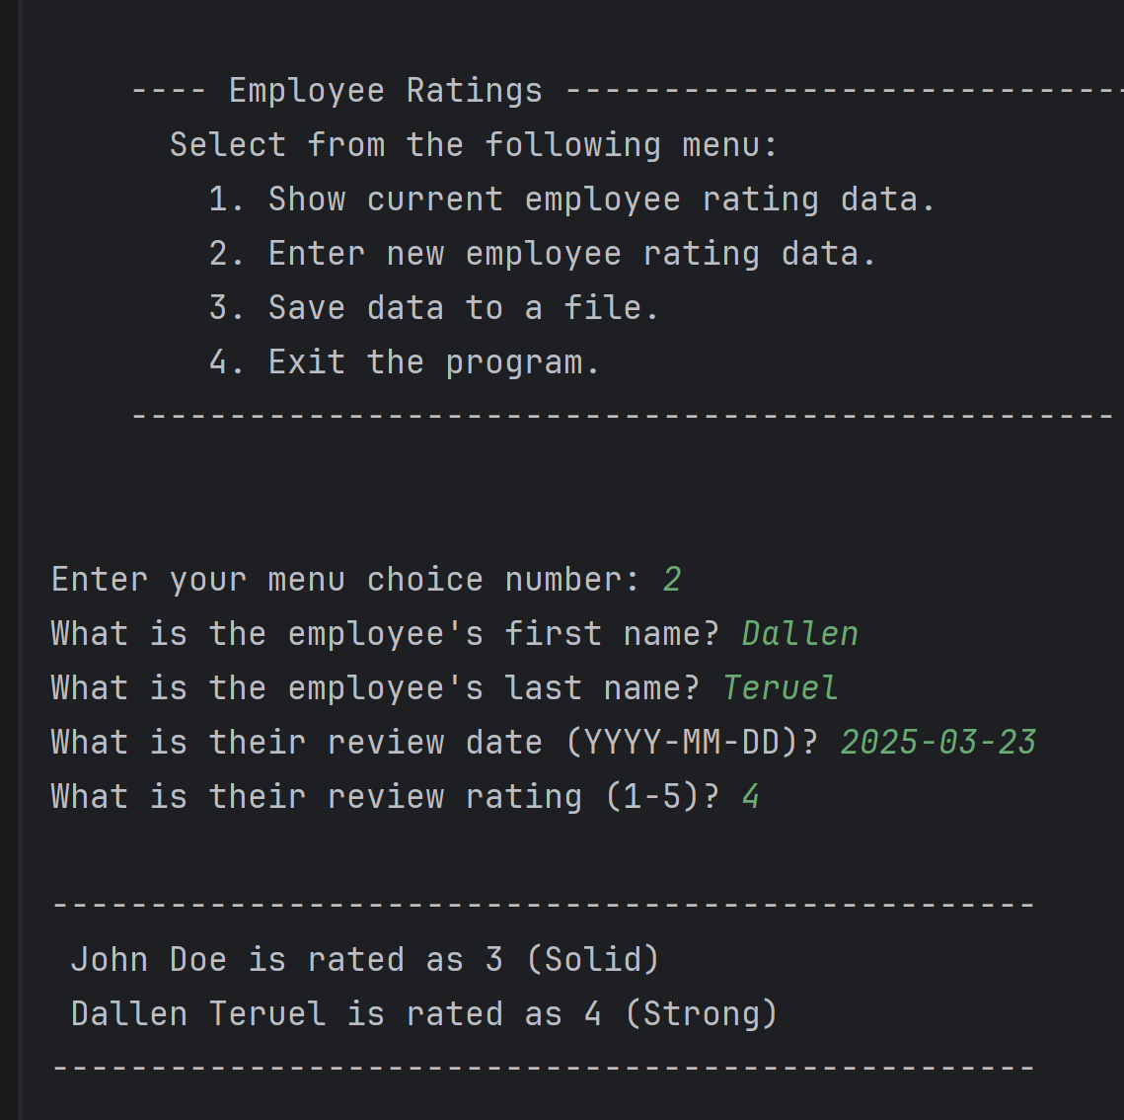

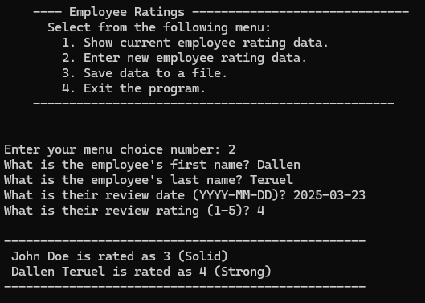

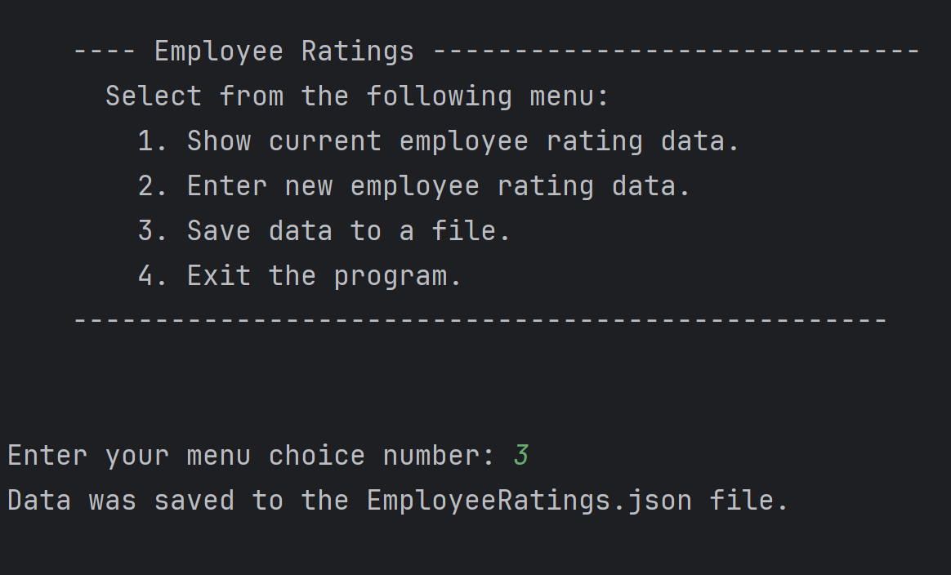

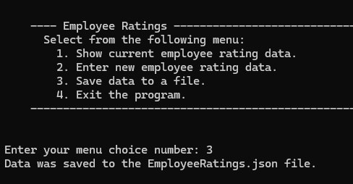

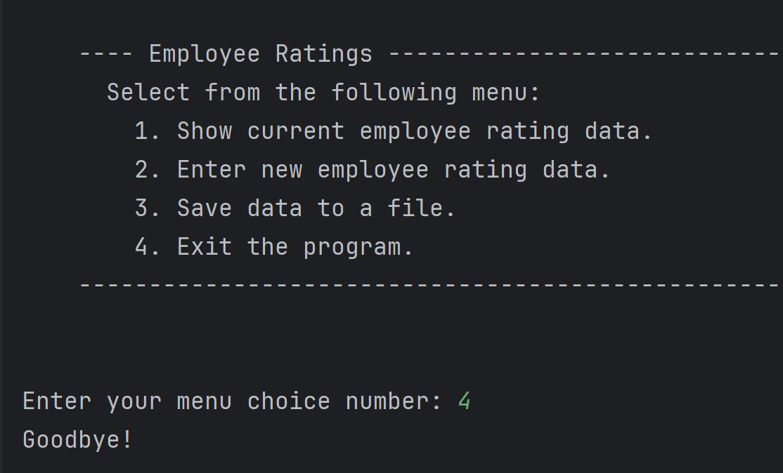

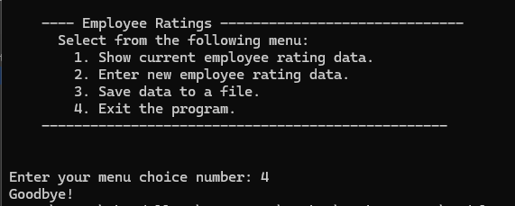

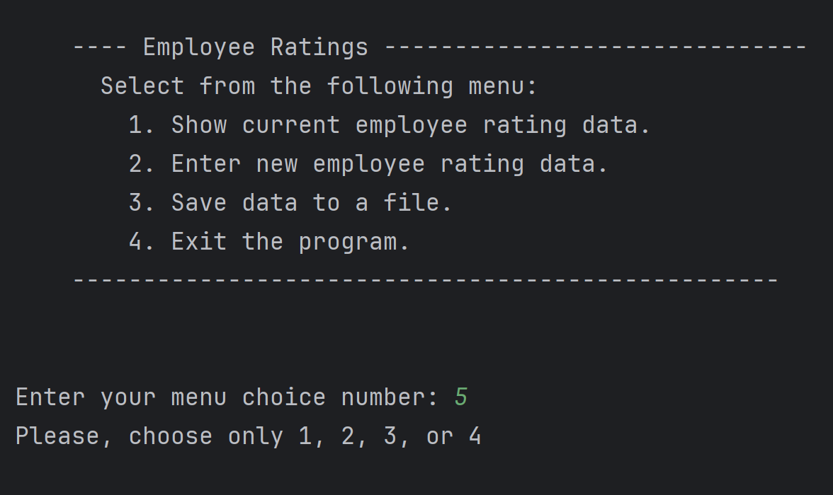

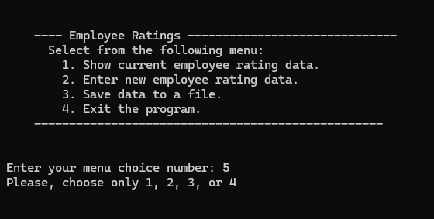

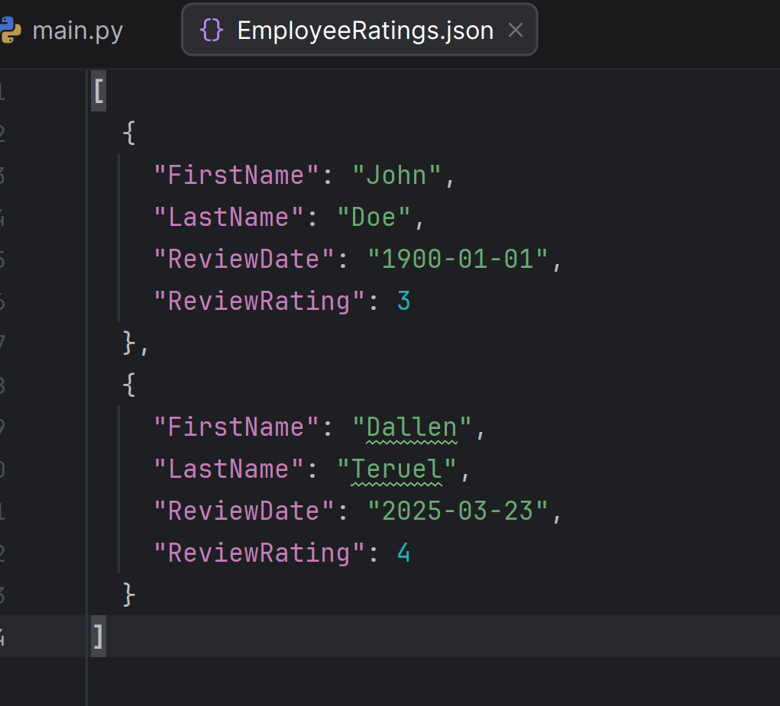

Summary
In Module 08, transitioning from scripts to full-scale applications offered a deeper look into how professional software is built and maintained. Splitting the project into specialized modules transformed the code into a scalable system that is much easier to debug and reuse. Visualizing these relationships through UML diagrams and implementing unit testing provided the technical visibility needed to ensure reliability. By integrating the PyCharm debugger and GitHub into this workflow, I’ve moved beyond basic automation toward creating robust, production-ready tools.

