Dallin Scott

29 Jan 2023

FSY Discussion – 2nd Hour

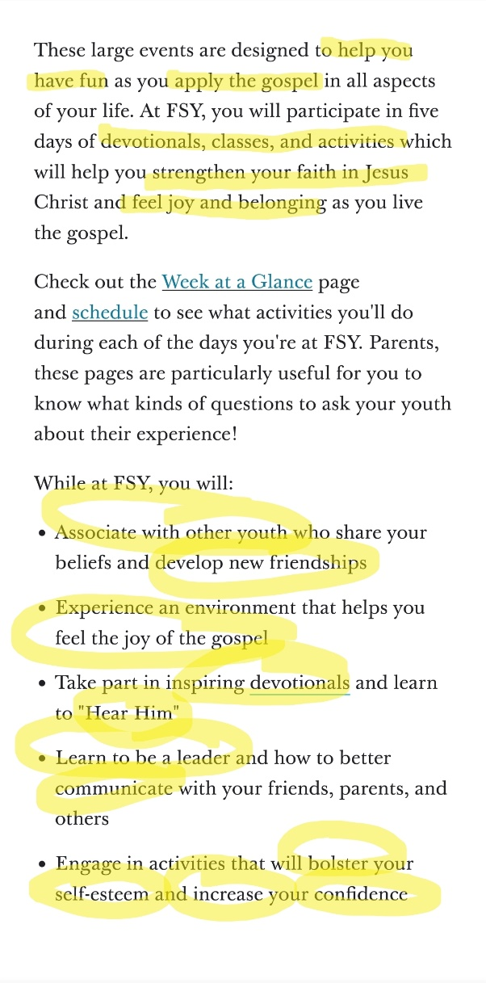

The Lord wants us to have FUN! (*2 Ne 2:25* – “Men are that they might have joy.”)

The Gospel of Jesus Christ is a way of life, not just something we learn that makes us feel good inside.

“Bolster” = Support; strengthen; fortify/reinforce

FSY stands for “For the Strength of Youth.” The Lord cares deeply about His children, and He cares most especially about those who make up the rising generation.

* *John 13:33-35* >> “33 Little children, yet a little while I am with you. Ye shall seek me: and as I said unto the Jews, Whither I go, ye cannot come; so now I say to you.   
  34 A new commandment I give unto you, That ye love one another; as I have loved you, that ye also love one another.   
  35 By this shall all men know that ye are my disciples, if ye have love one to another.”
* ***1 John 2****:1-5* >> “1 My little children, these things write I unto you, that ye sin not. And if any man sin, we have an advocate with the Father, Jesus Christ the righteous:  
  2 And he is the propitiation for our sins: and not for ours only, but also for the sins of the whole world.  
  3 And hereby we do know that we know him, if we keep his commandments.  
  4 He that saith, I know him, and keepeth not his commandments, is a liar, and the truth is not in him.  
  5 But whoso keepeth his word, in him verily is the love of God perfected: hereby know we that we are in him.”
* ***1 John 3****:7, 18* >> “7 Little children, let no man deceive you: he that doeth righteousness is righteous, even as he is righteous.  
  18 My little children, let us not love in word, neither in tongue only; but in deed and in truth.”

***\*\*bolded scripture chapters are good ones to leave behind with the Youth***

Your life can be fortified, strengthened, and improved as you actively engage in FSY and keep implementing Gospel principles in your personal life for the rest of your life!

* *Mosiah 5:7* >> “7 And now, because of the covenant which ye have made ye shall be called the children of Christ, his sons, and his daughters; for behold, this day he hath spiritually begotten you; for ye say that your hearts are changed through faith on his name; therefore, ye are born of him and have become his sons and his daughters.”

What are the activities I will be participating in?

* Meeting Your Counselor (Spiritual Mentor for the Week)
  + Your “adult” friend and guide for the week
* Meeting Your Company (Your Company Family)
  + This is where you can develop new, lasting friendships!
* Devotionals
  + Spiritual charge to start each day strong
* Games Night
  + Play a variety of insanely fun games
  + Some are challenging, some are dramatic, and most involve working together as a team
* Personal & Company Studies
  + Diving into the scriptures and gospel study resources to find answers to questions and insights into Jesus Christ and His Restored Gospel
* Classes
  + Learn how to connect with the Savior more personally
  + Learn more about what the brethren have said regarding the Gospel of Christ through all sorts of cool lessons and slideshows and presentations
* Pizza Party Night
  + After a full evening of games, finish off the night with a pizza party with your company!
* Variety Show
  + Talents, interesting skills, unique acts, jokes, musical gifts, share ANYTHING you want!
* Musical Program
  + Invite the Spirit powerfully into Thursday’s devotional – this activity is one of the most spiritual experiences of FSY, and the more people that join, the more God’s presence can be felt!