

**MAKERERE**

**UNIVERSITY**

COLLEGE OF COMPUTING AND INFORMATION SCIENCES

DEPARTMENT OF NETWORKS

BACHELOR OF SCIENCE IN SOFTWARE ENGINEERING (YEAR 2)

RECESS TERM 2 (BSE 2301)

SOFTWARE DESIGN DOCUMENT FOR

CHAT ANALYSIS APPLICATION FOR NEW VISION

**PROJECT MEMBERS [GROUP 3]**

|  |  |  |
| --- | --- | --- |
| **NAME** | **REG NO** | **STUDENT NO** |
| ASINGWIRE DALLINGTON | 16/U/127 | 216000708 |
| KALEMA ARNOLD | 16/U/5256/PS | 216003529 |
| NANJUKI SAIDAT | 16/U/9715/PS | 216017634 |
| MUTUNGI DENIS SHARP | 16/X/2340/PS | 216002239 |

**PROJECT LEADER:** ASINGWIRE DALLINGTON

**SUPERVISOR**: NOAH KANGE

SUBMITTED IN PARTIAL FULFILLMENT OF

SOFTWARE ENGINEERING RECESS PROJECT BSE 2301

4TH, JULY 2018

**Contents**

1. INTRODUCTION 3

1.1 Purpose 3

1.1.1 Intended Audience 3

1.2 Scope 3

1.2.1 Description and Scope of the system 3

1.2.2 The goal 4

1.2.3 Main Objective 4

1.3 Overview 4

1.4 Definitions and Acronyms 5

2. SYSTEM OVERVIEW 5

3. SYSTEM ARCHITECTURE 5

3.1 Architectural Design 5

3.1.1 Module design 6

3.2 Decomposition Description 7

3.2.1 Decomposition diagram 8

3.2.2 Data flow diagrams 8

Level 1 DFD 9

3.2.3 Child DFD diagrams 9

4. DATA DESIGN 11

4.1 Data Description 11

4.2 Data Dictionary 12

5. COMPONENT DESIGN 13

6. HUMAN INTERFACE DESIGN 13

6.1 Overview of User Interface 14

6.2 Screen Images 14

6.3 Screen Objects and Actions 17

7. REQUIREMENTS MATRIX 20

8. APPENDICES 20

8.1 Reference Material 20

# 1. INTRODUCTION

This document describes the design of chat analysis application developed for New Vision Uganda. It is assumed that this document’s reader has read the SRS, since this document also defines the implementation details of the desired behavior given the requirements within it. This document builds heavily on the concept paper and so knowledge of the general architecture is recommended prior to commencing this document.

## 1.1 Purpose

This SDD describes the architecture and design of chat analysis application. The design description defined in this document is significant in the following ways;

* It will be used to assess the impact of New Vision data analysis application on the company itself.
* It will aid in producing test cases for example it will be used to verify compliance with the requirements specified in the SRS.
* It describes the modular structure, data and diagrams involved with in the application.
* It identifies the required system resources.
* It will be used in case of carrying out maintenance activities on the application.

### 1.1.1 Intended Audience

In contrast to the SRS, this SDD is written for knowledgeable software professionals and designers which implies that the operational staff of New Vision Uganda will not be among the suggested audience of this document.

## 1.2 Scope

This SDD describes the detailed structure of the components of the chat analysis application and the implementation details required to satisfy the requirements as specified in the SRS.

### 1.2.1 Description and Scope of the application

This chat analysis application analyzes information exchanged between clients and operatives of New Vision via an online chat inform of visual diagrams (i.e. graphs,plots,word cloud etc) that will be used to provide a clear review and analysis of data. For example it will output:

* A bar graph indicating performance of operators
* Pie chart that shows the most queried department or the department that many clients have subscribed to,in order to interact with it.
* A word cloud indicating the most common meaningful words within the chat content

### 1.2.2 Goal

The goal of chat analysis application is to specifically derive or output understandable models that can be used to effectively analyze sentiments exchanged between New Vision operatives and its clients, draw out results that can be interpreted to make desired decisions in the company.

### 1.2.3 Main Objective

To develop a data analysis application for reviewing, analyzing and visualizing data for New Vision.

1.2.3.1 Specific Objectives

* To analyze and visualize chat content from the customers with an aim of displaying the common meaningful words within the chats that may guide the New Vision customer support department in determining the most common complaints from their customers.
* To analyze and visualize the emotional reaction of the customers towards the department’s customer service.
* To visualize the most hard working or active operator among company operators, this will guide the department in performing employee morale boosting.
* To provide better decision making tools that will be used by the New Vision corporate staff in making better and smart decisions towards their customer service delivery for example the application will produce bar graphs and pie charts of different fields against their counter parts from the uploaded file which can be downloaded and saved for future reference.

## 1.3 Overview

Up to SDD, the concept paper document and SRS have been released. In this document, detailed design of the system with user interfaces will be described. In section 3; decomposition of the system with module.Decomposition, concurrent process decomposition and data decomposition is given, in section 4; Data design with data descriptions is given, in section 5; there is description of the component design. In section 6, there are user interfaces; screen objects, images and actions. In section 8; Requirements matrix is provided and finally in section 8; there is the appendix which has the abbreviations and their in full and the reference materials.

## 1.4 Definitions and Acronyms

For a complete list of the definitions and acronyms used in the remainder of this document, refer to the Glossary.

# 2. SYSTEM OVERVIEW

The chat data analysis application follows client-server architecture design. The application consists of two major components: the functional component,and the graphical component. The functional component consists of several methods or modules of New Vision chat analysis app. It receives user input (uploaded files) and displays the content. It performs all the analysis required to guide decision making process at New Vision Uganda through offering faster decision making techniques and better data analysis tools. The graphical component, as the name implies, is simply the graphical user interface. It provides all of the buttons, table panels, and other onscreen elements which user can interact with to use the application.

# 3. SYSTEM ARCHITECTURE

## 3.1 Architectural Design

The design of this New Vision data analysis application will follow the client/server architecture where by the client is represented by user Interface which is used to send requests to the server,which then services the requests of the client.

**ADIAGRAM SHOWING CLIENT/SERVER ARCHITECTURE OF CHAT ANALYSIS APP**



Server

Client

(

UI

.

R

)

Server

Sends Requests

Request responses

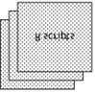

loads the server

.

R script

Out put

##### *Fig 1.0 shows the client/server architecture of the New Vision chat analysis application*

In this chat analysis application, the U1.R gets data from the user and sends it to the server. The server manipulates the data and sends the results in form of visual diagrams such as bar graphs, pie charts, sentiment analysis and word cloud which are displayed to the user on the user interface.

### 3.1.1 Module design

The SDD module design of the New Vision Chat Analysis application contains a detailed description of the classes within the whole application. The module design defines methods, properties and indicates algorithms or ways of how process occurs.

**Uploading file class**

The Uploading file class allows the user of New Vision chat analysis application to select a data file he/she wants to analyze. The data should be in csv or xls format.

#### PROCESSING NARRATIVE

When the app user selects a file, the file is then uploaded.

This file object is used to output visual diagrams which include:

* Bar graphs
* World cloud
* Pie charts.

Therefore for the app user to visualize and analyze data of New Vision, a file must be uploaded first.

#### RESTRICTIONS/LIMITATIONS

The data set to be uploaded should be a csv file or an xls file and should contain column names as they are in within the sample data set (New Vision file) that is to say fields like ID, city, department, country, chat content, operatives’ names, waiting time in minutes and URLs being used by clients because the application will be developed basing on the imported file.

**Data Analysis and visualization class**

This class analyzes and visualizes data within the uploaded file.

#### PROCESSING NARRATIVE

When a user selects an analysis tool from the tab set panel, the data within the uploaded file is analyzed according to the selected analysis tool.

This analyzed data object will be used to output visual diagrams such as:

* Bar graphs of operators’ performance
* World cloud of most common meaningful words within chat content
* Pie chart analyzing departments of New Vision.

## 3.2 Decomposition Description

This section decomposes each use-case feature into its data flow processes by examining its data flow diagram and process. These assist in determining the preliminary members and methods of the modules that need to be implemented, or the modifications to existing modules to implement the feature. This document uses the names of the use cases in the SRS document as the names of the features. This section includes the description of the intended design to meet the requirements. When appropriate, the use cases will be expanded to include system requirements. This section also incorporates a decomposition diagram providing the segments involved in each process.

**3.2.1 Decomposition diagram**

Chat

analysis

Application

File

upload

Data

analysis

Data

Visualization

Validate

data

Transmit

data

Inspect

data

Cleanse

data

Transform

&

model

data

Visual

diagrams

&

models

### 3.2.2 Data flow diagrams

These diagrams provide a description of how data flows within the New Vision chat analysis app. There is a level 1 data flow diagram obtained from the context diagram, it consists of all the processes within the New Vision chat analysis app. This diagram is further divided into child diagrams which provide steps involved in each process thus every process has its own child diagram.

***LEVEL 1 DFD OF NEW VISION CHAT ANALYSIS APP***



Operator

/

Manager

1

.

0

Upload file

File upload

Selects an analysis tool

2

.

0

Analyse data

3

.

0

Visualise data

D

1

Datasets

Uploaded file

Analysed file

Visual diagrams

Selected csv

file

Csv file

***Fig 2.0 level 1 data flow diagram of New Vision chat analysis app***

### 3.2.3 Child DFD diagrams

Process specifications and functional primitives

#### 1.File Upload

1.1 Choose a file

1.2 Upload a file

1.3 Display uploaded file

##### 2. Analyze data

2.1 Select an analysis tool

2.2 Analyze data

##### 3. Visualize data

3.1 Select an analysis tool

3.2 Analyze data

3.3 Visualize analyzed data

###### 3.2.2.1 CHILD DIAGRAM FOR UPLOAD FILE PROCESS

1.0 upload file

1

.

1

Choose a

file



Operator

/

Manager

D

1

Data Sets

1

.

2

Upload

file

Csv or xls file

File upload

selected file

Csv/xls file

###### 3.2.2.2 CHILD DIAGRAM FOR ANALYZE DATA PROCESS

2.0 analyze data

2

.

1

Select an

analysis tool



Operator

/

Manager

2

.

2

Analyze data

Analyzed data

Selected

analysis tool

analysis tool

#### *Fig 1.4* level 1 diagram for analyze data process

##### *3.2.2.3 CHILD DIAGRAM FOR VISUALIZE DATA PROCESS*

3.0 visualize data

3

.

1

Select an

analysis tool



Operator

/

Manager

3

.

2

Analyze data

Analysed data

Selected analysis

tool

Analysis tool

3

.

3

Visualize

Analyzed data

Analyzed data

Visual diagrams

##### *Fig 2.5 level 1 diagram for visualize data process*

###### 1.2 Design Rationale

Client/server architecture is preferred in designing chat analysis application because of the need to provide the user with an interactive interface. Most of the manipulations will be done in the server and this makes the user/operator’s interaction with the application easier since he /she will only have to send requests to which the server will respond to.

# 4. DATA DESIGN

## 4.1 Data Description

This New Vision chat analysis application uses chat data about customers and operatives of New Vision.This data is obtained from the interaction between New Vision operative and the customer via online chat .It will be collected within Microsoft excel spread sheet(s) which can be also saved as csv file(s). These xls or csv files will be the data sets to be uploaded into the application.

## 4.2 Data Dictionary

***TABLE FOR CHAT ENTITY OF THE NEW VISION CHAT ANALYSIS APP***

|  |  |  |
| --- | --- | --- |
| **Attributes** | **Types** | **Descriptions** |
| Chat content | Character | Contents of the chat between the New Vision operative and the customer |
| ID | Numeric | Chat Identity |
| Date | Date | Date of the chat |
| Came.from | Character | Link of the response |
| Wait.time | Integer | Waiting time during the chat(in seconds) |
| Minutes | Alphanumeric | Waiting time in minutes |

***Fig 3.0 table for chat entity of the New Vision chat Analysis app***

***TABLE FOR CUSTOMER ENTITY OF THE NEW VISION CHAT ANALYSIS APP***

|  |  |  |
| --- | --- | --- |
| **Attributes** | **Types** | **Descriptions** |
| ID | Numeric | Identity of the client |
| Visitor.name | Character | Customer name |
| Vote.status | Character | Voting status of the customer |
| Country | Character | Country of the customer |

***Fig 3.1 table for customer entity of the New Vision chat Analysis app***

***TABLE FOR OPERATOR ENTITY OF THE NEW VISION CHAT ANALYSIS APP***

|  |  |  |
| --- | --- | --- |
| **Attributes** | **Types** | **Descriptions** |
| Name | Character | Operator name |
| Department | Character | Department to which operator belongs to |

***Fig 3.1 table for operator entity of the New Vision chat Analysis app***

***TABLE SHOWING METHODS AND THEIR PARAMETERS OF THE DFD***

|  |  |  |
| --- | --- | --- |
| **Methods** |  | **Method parameters** |
| UploadFile() chooseFile() |  | Csvfile |
| AnalyseData()  selectAnalysisTool() | | uploadedFile |
| visualizeData() | | AnalysedData |

***Fig 2.4 table showing methods and their parameters of the DFD in section 3.2.1***

# 5. COMPONENT DESIGN

* **File Upload**

#### Algorithm

1. Run the app
2. Select a file
3. Upload the file

* **Analyze and visualize data**

#### Algorithm

1. Select an analysis tool from the tab set panel to view data analyis technique.

# 6. HUMAN INTERFACE DESIGN

This section provides a complete description of the actual user interfaces of the New Vision chat analysis application. It includes screen images of the interfaces with brief explanation on their importance and how user interacts with them.

## 6.1 Overview of User Interface

**INTERFACE THAT AUTHENTICATES THE USER**

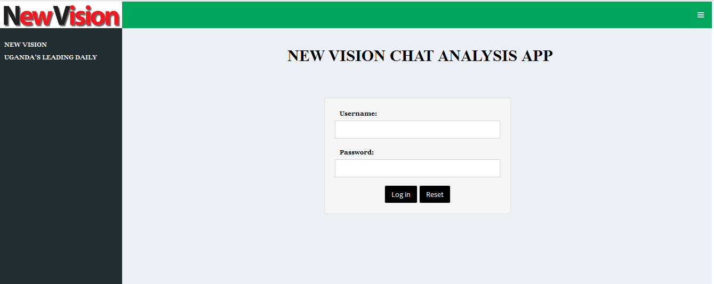

**Fig 6.0** shows a log in interface for chat analysis app.Registered user must enter correct details ie username and password to access full functionality of the app.

## 6.2 Screen Images

**USER INTERFACE THAT ACTS AS INDEX PAGE AFTER LOGGING IN**

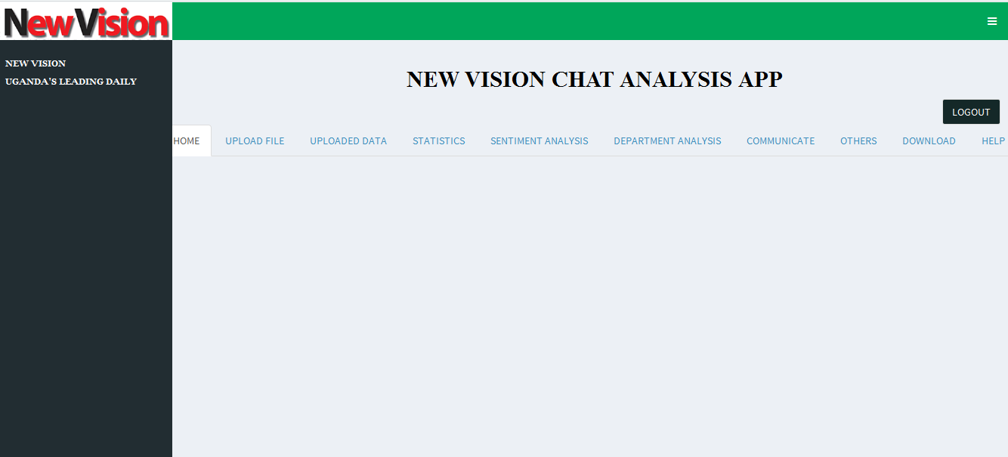

**Fig 6.1.1** On loading the application this page will be displayed indicating all the various buttons, tab panels (as mentioned in section 6.1) available for the user interact with the application.

**INTERFACE THAT IS DISPLAYED FOR THE USER TO SELECT A DATA FILE**

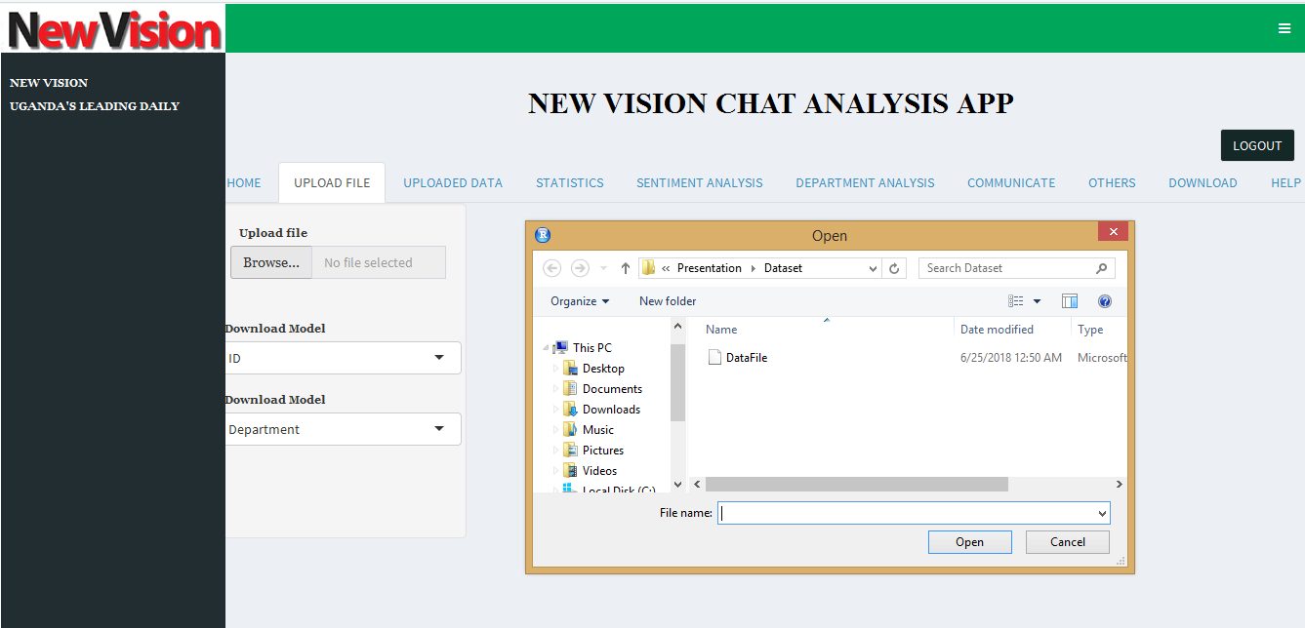

**fig 6.1.2** In order for the application to analyze data, the user will be expected to select and upload a file. This figure shows a tab that will be displayed when a user clicks the browse button, it helps the user to choose a file that he/she wants to be analyzed.

**INTERFACE SHOWING UPLOADED DATA ONCE DATA FILE IS UPLOADED**

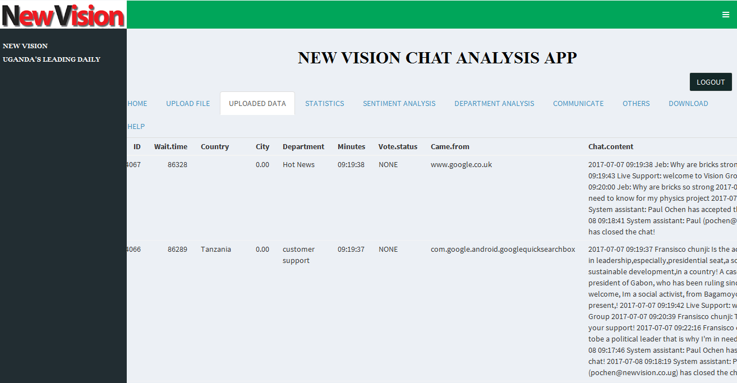

**Fig 6.1.3** shows a page containing the contents of the uploaded file. In case the user wants to see the contents of the uploaded file, he/she will have to click the uploaded contents tab panel.

**INTERFACE SHOWING ONE OF THE BAR GRAPHS THAT CAN BE OUTPUT**

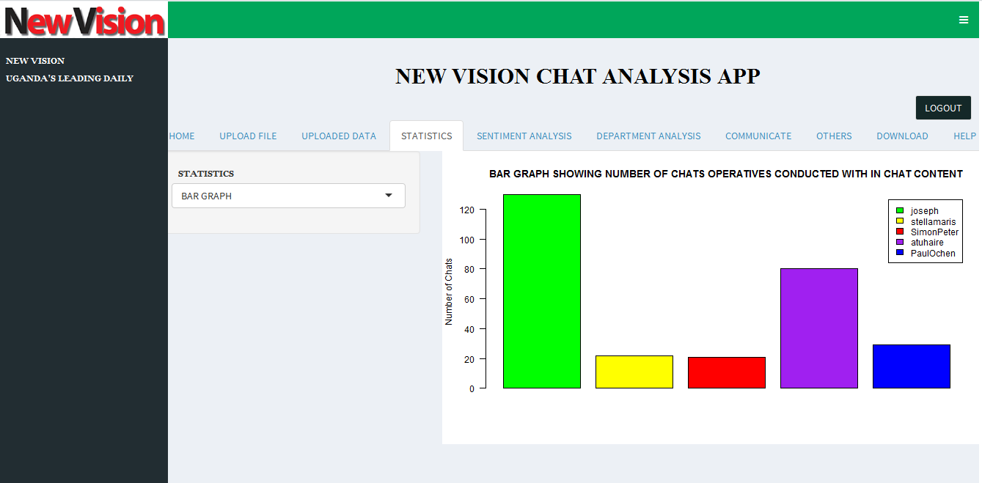

**Fig 6.1.4** shows one of the bar graphs that can be produced by application. For bar graph to be created,the user will have to first select two variables x and y of his or her own choice, and then he/she will have to click the bar graph from the table set panel for it to be displayed.

**INTERFACE SHOWING ONE OF THE PIE CHARTS THAT CAN BE OUTPUT**

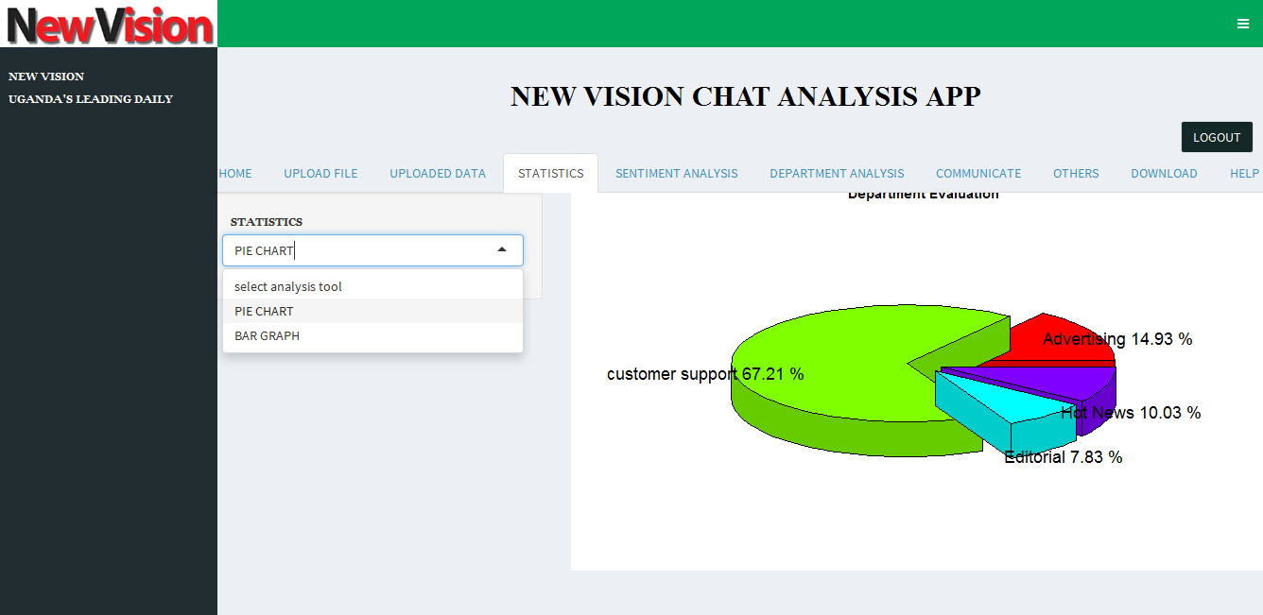

**Fig 6.1.5** shows one of the pie charts that application can output. For pie chart to be created,the user will have to first select two variables x and y of his or her own choice, then he/she will have to click the pie chart from Visualization dashboard for it to be displayed.

## INTERFACE SHOWING A WORDCLOUD AS ONE OF ANALYSIS TECHNIQUES

## 

## Fig 6.1.6 shows a word cloud that can be output by chat analysis app. For a word cloud to be displayed,the user must have uploaded data, then he/she will have to select word cloud under Sentiment Analysis from tab panel for it to be displayed.

## INTERFACE THAT CAN BE USED BY APP USER TO SEND AN EMAIL TO APPROPRIATE RECIEVER.

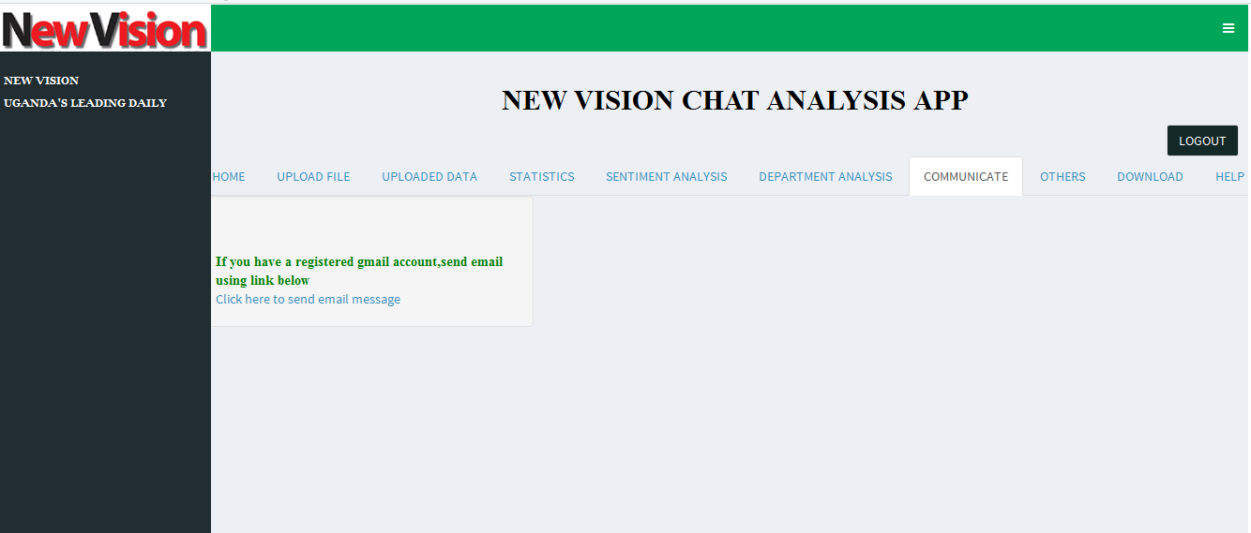

**Fig 6.1.7** shows an interface used to send an email by app user. For this interface to be displayed,the user must select Communication from tab panel for it to be displayed.

**INTERFACE THAT IS USED TO ASSESS OPERATORS’ PERFORMANCE**

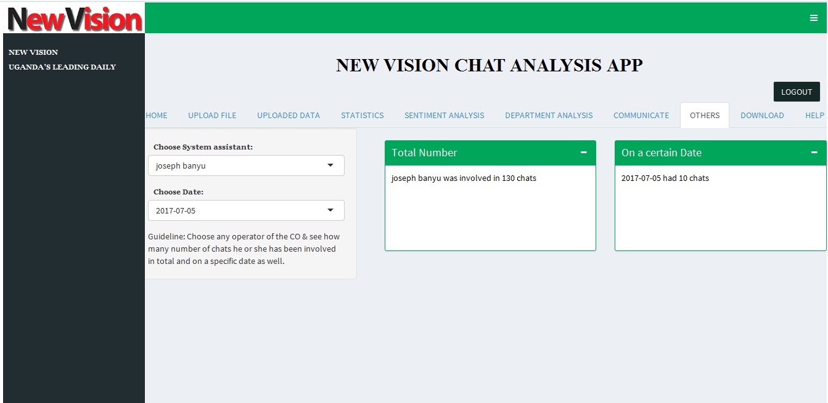

**Fig 6.1.8** shows one of the interfaces used to assess performance of operators .For an authorized app user to determine most hardworking operator,file data must be uploaded first and then he or she selects ‘OTHERS’ tab. Under this tab,the app user selects system assistant to see how many chats he or she has participated in and can also enter a specific date to determine number of chats on that real day.

**INTERFACE THAT PROVIDES APP USER GUIDELINES ON HOW TO USE THE APP**

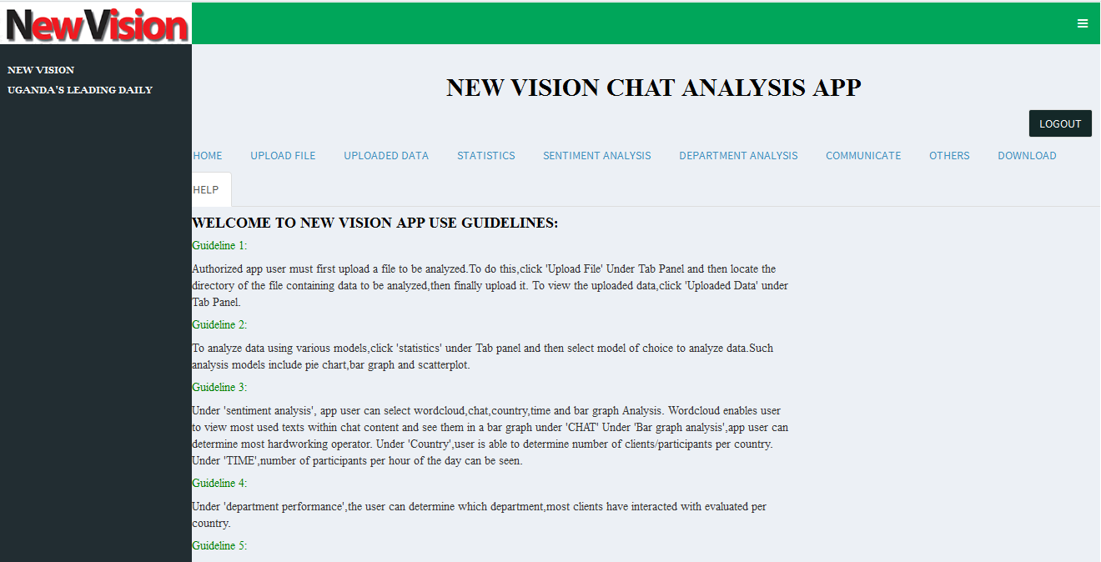

**Fig 6.1.9** shows an interface with guidelines to enable app user in case of any help .App user clicks on HELP under Tab panel and he or she will be able to view app guidelines.

## 6.3 Screen Objects and Actions

The screen objects and actions with in the New Vision chat analysis app include the following:

**1.Login Interface.**

This is used to authenticate users. It requires entry of ones username and password and it is only when one enters registered corresponding login details that he or she will be allowed access to the full functionality of the chat analysis app.

**2.Main Interface**

This basically contains the full functionality of the whole app. Majorly it contains the tab set panel.

**Tab set Panel with in Dashboard body**

This consists of a list of tab panels used in uploading file,viewing uploaded data,analysing and visualising data .For each tab panel,app user must click on it to see its functionality.

The following are the tab panels on the tab set panel:

* **Home**-This is just an index page. It is just static.
* **Upload file**-This lets the user to browse,select and upload the file that contains data to be analysed.
* **Statistics**: This lets the app user to view analysis models like pie chart and bar garaph.
* **Sentiment analysis**. This provides app user to select options of visualization models like wordcloud,look at performance of operators and others.
* **Department analysis**. This allows the user to select a department and then select how often customers select that department per country.
* **Communicate.** This allows the app user to send an email to any person regarding performance especially company operators.
* **Others.**This enables app user to select system assistant to see how many chats he or she was involved in total and how many on a certain date as well.
* **Download**.This enables app user to download visualiazation model of choice
* **Help**. In case of any authorized app user doesnot know how to use the app especially new recruited staff member, he or she can refer to help tab panel to see guidelines on the app use.

# 7. REQUIREMENTS MATRIX

UC stands for use case

|  |  |  |  |  |  |
| --- | --- | --- | --- | --- | --- |
| Use Cases  from SRS |  | Upload file  Component | Analyze data component | Visualize component | data |
| UC1 | X |  |  |  |  |
| UC2 | X |  | X |  |  |
| UC3 | X |  | X | X |  |

# 

# 8. APPENDICES

|  |  |
| --- | --- |
| **Terms** | **Definitions** |
| Concept paper document | A document that is used to convince a project sponsor that a project needs to kicked-off to solve a particular business problem or opportunity. |
| Sentiment analysis | The process of determining whether a piece of writing is positive, negative or neutral. |
| Word cloud | An image composed of words in a particular text, email or subject in which the size of each word indicates frequency or importance. |

|  |  |
| --- | --- |
| **Acronym/Abbreviation** | **Full Form** |
| i.e. | that is |
| CSV | Comma Separated Values |
| SRS | Software Requirements Specifications |
| SDD | Software Design Document |
| DFD | Data Flow Diagram |
| ID | Identification |

## 8.1 Reference Material

[1]SRS Group 3, 2018

[2]433-340 Software Engineering Project Manual, 2002