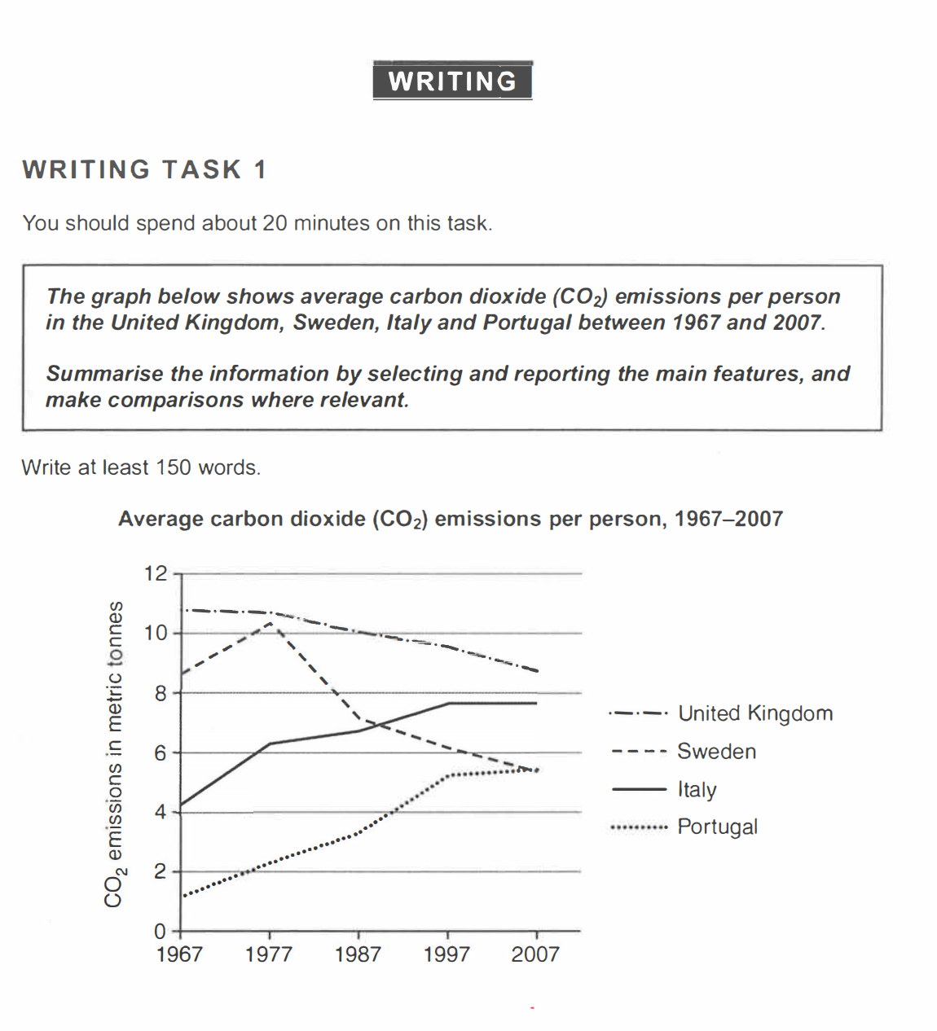
The average amount of carbon dioxide released by single person declined gradually in the UK and Sweden from 1967 to 2007. The UK produced more carbon dioxide than the other three countries throughout the whole period, which decreased moderately from 11 metric tones in1967 to 9 tones in 2007. As for Sweden, its output did not drop straight away. In the first decade, the number of emission climbed from 8.5 to its highest point of around 10.5 tones. After the short rise, the country witnessed a continuous reduction which ended at 5.5 tones in 2007.
Overall, the line chart demonstrates how the carbon emissions per person fell in the United Kingdom and Sweden while rising in Italy and Portugal.

