**Walkthrough**

* The user accesses The Weave website.
* From the **HOME** page, the user can **view threads created by other users**, as well as the **time** the thread was created. The user can also **SIGN UP** and **create a new account** or **LOG IN** if they already have valid credentials. If the user is not logged in, they can still **CLICK A THREAD** to **view comment history**, or **find a particular thread** with the **SEARCH BAR**.

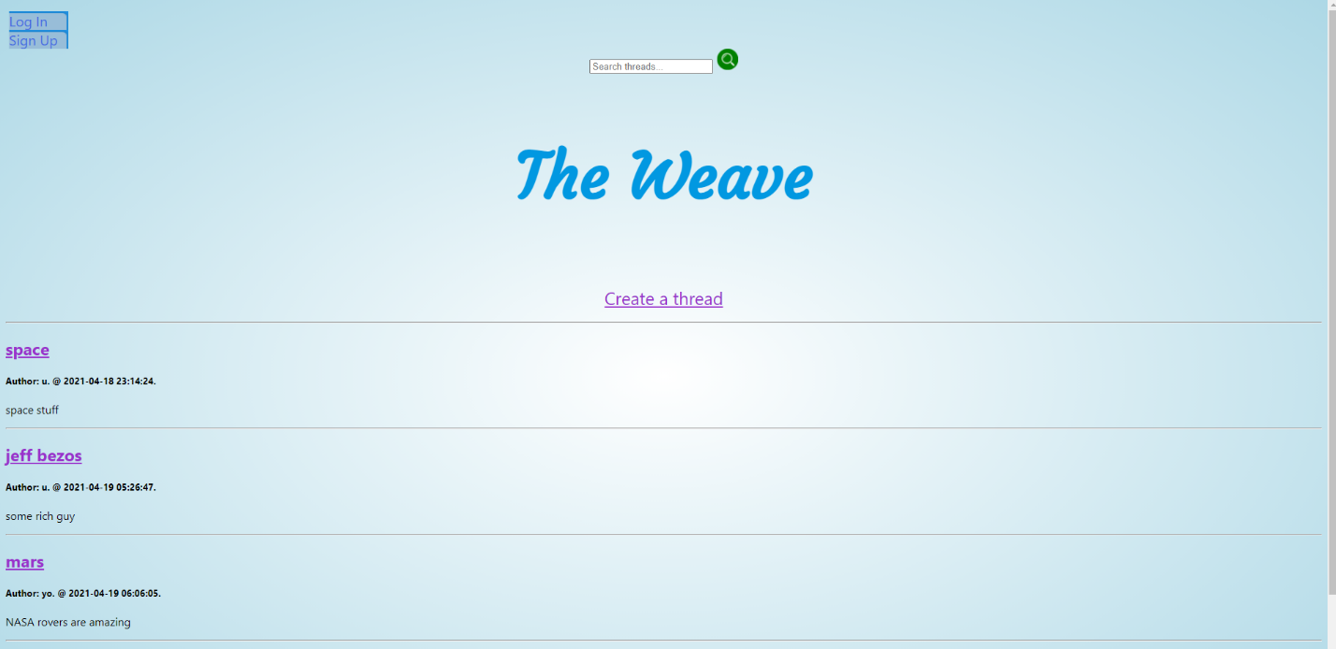

On the **SIGN UP** page, the user can register as a user by completing the form: 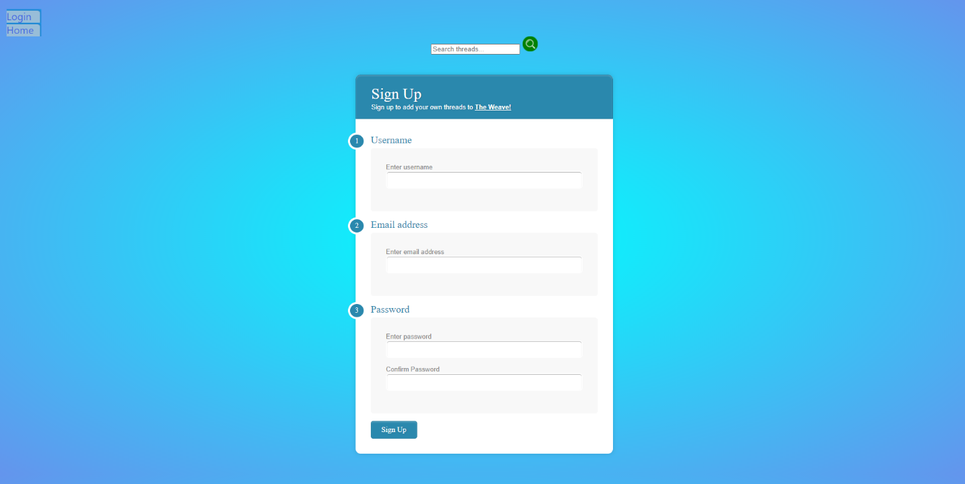

The user is then returned to the home page with the **list of created threads**.

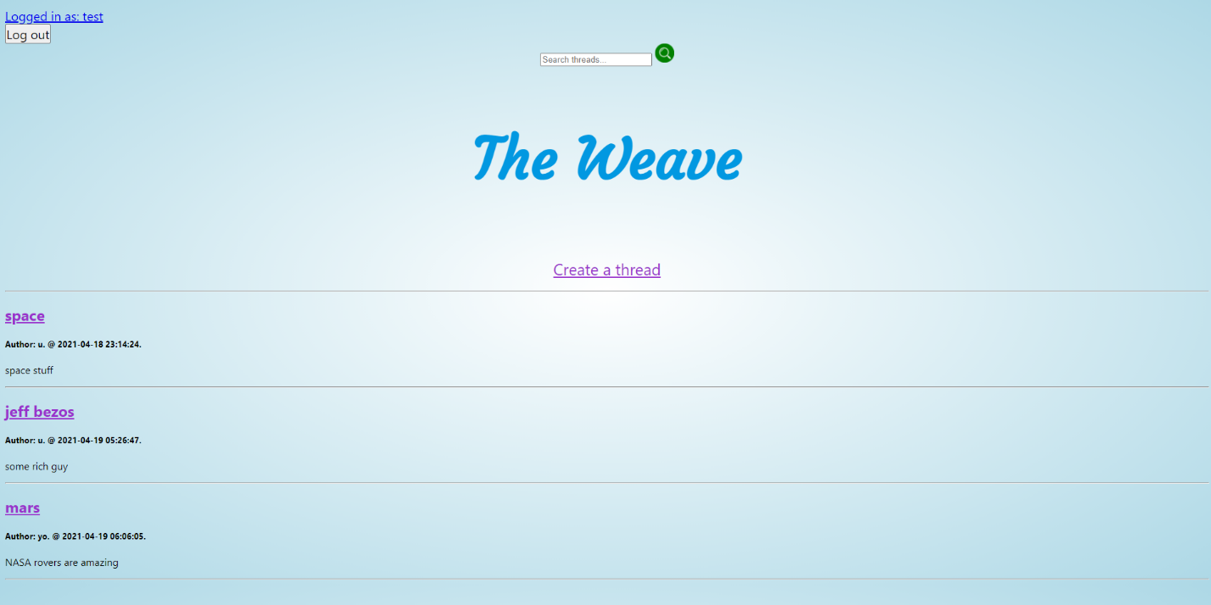

After logging in, the user can also **CREATE A NEW THREAD** by providing a title and a description:

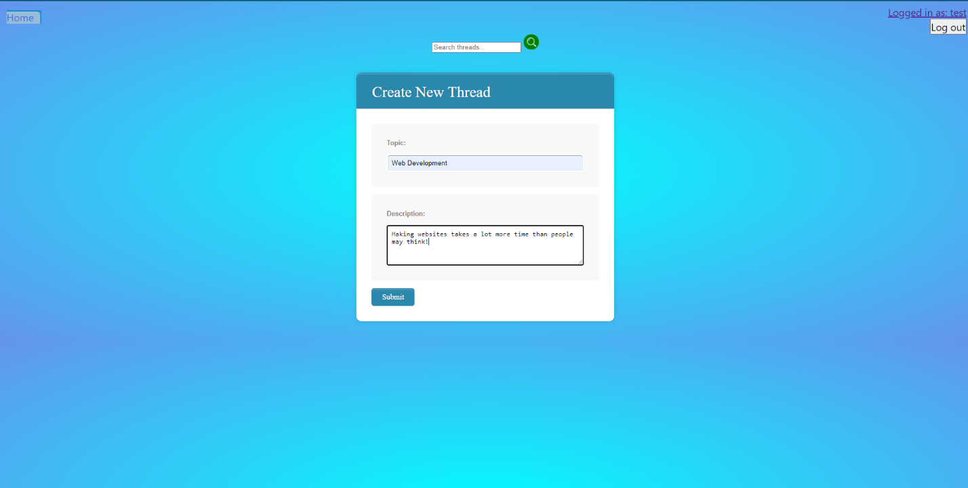

After which they are **notified that the thread has been created**, and can now return to the home page to **view their new thread**:



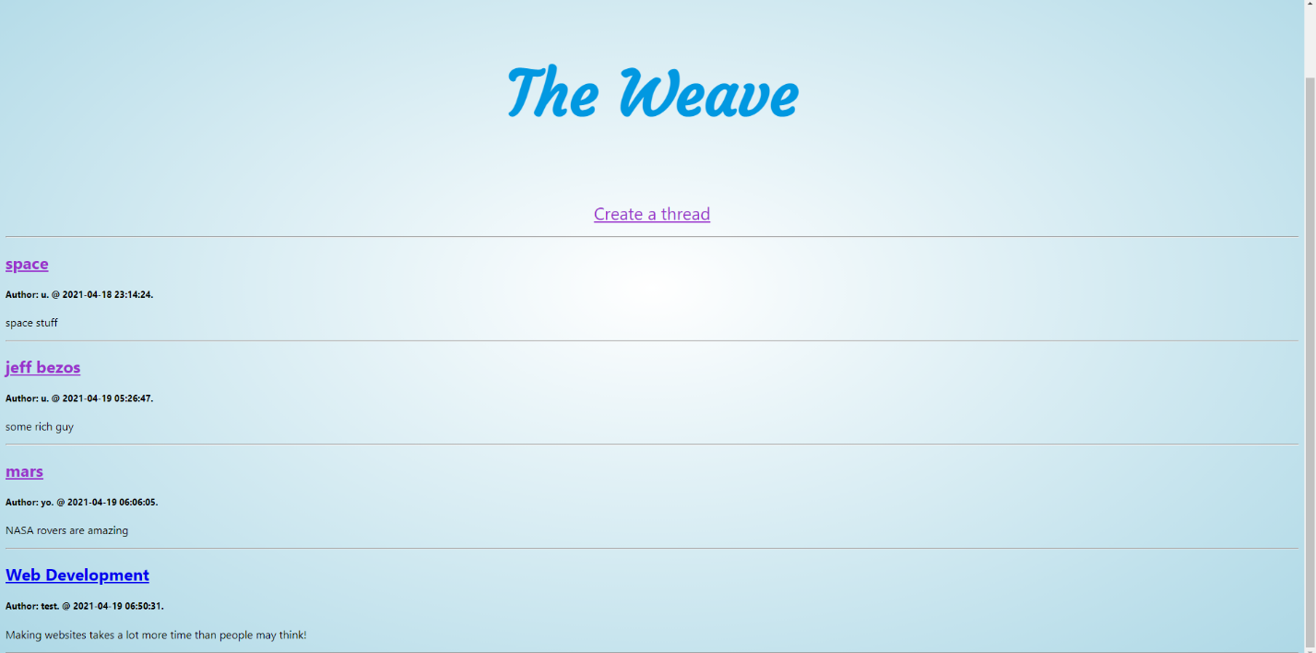

If logged in, the user can also click on a thread to **leave a comment**: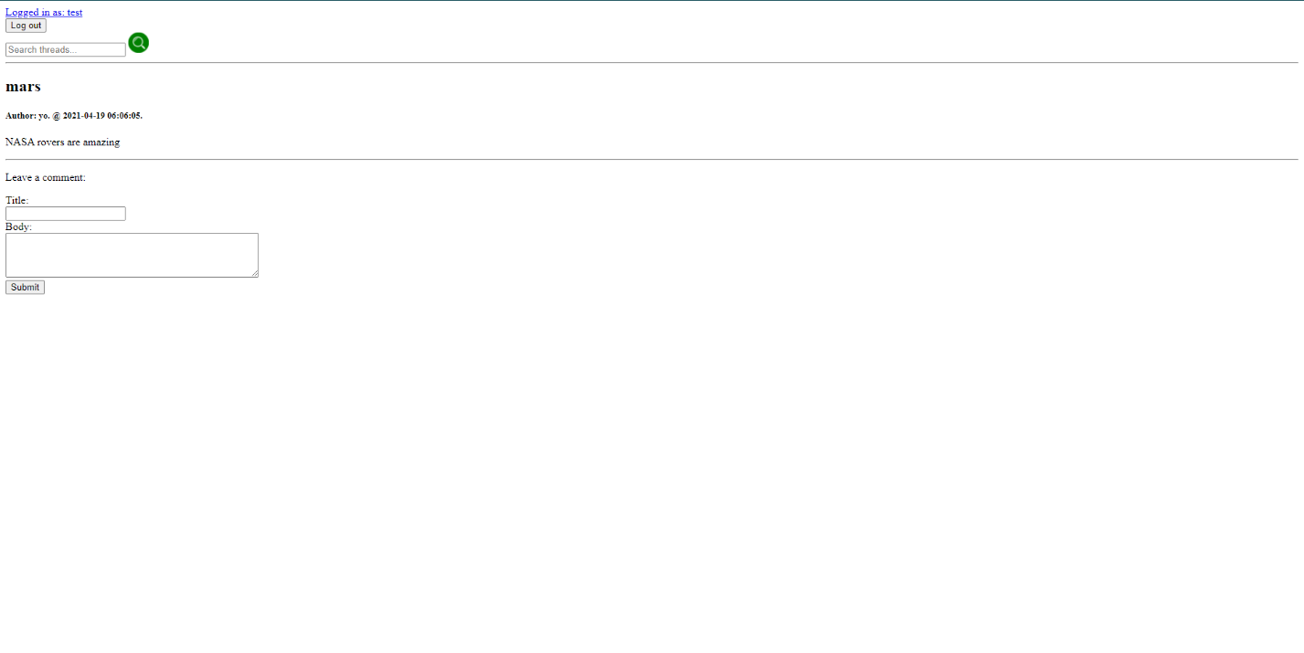

The user can also use the **SEARCH BAR** to find threads of interest:

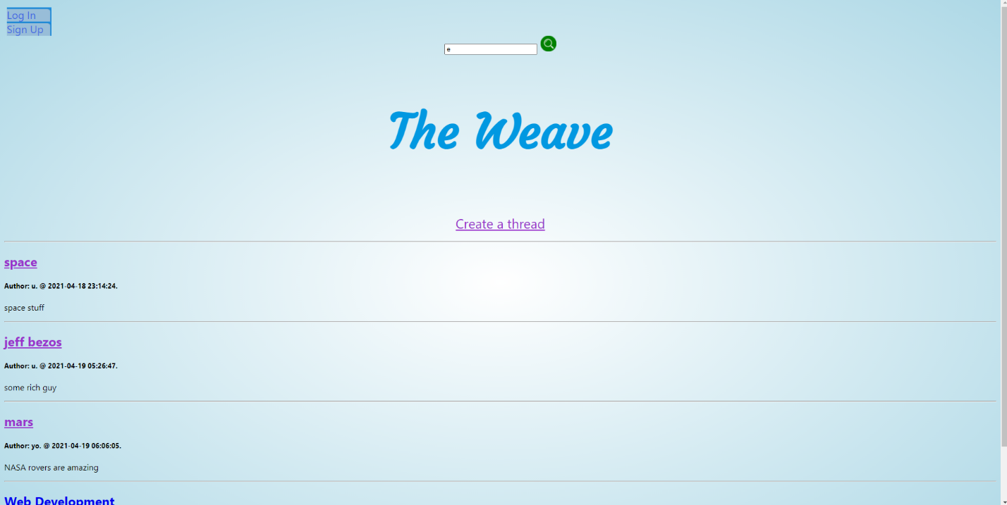

Searching for threads with the letter ‘e’

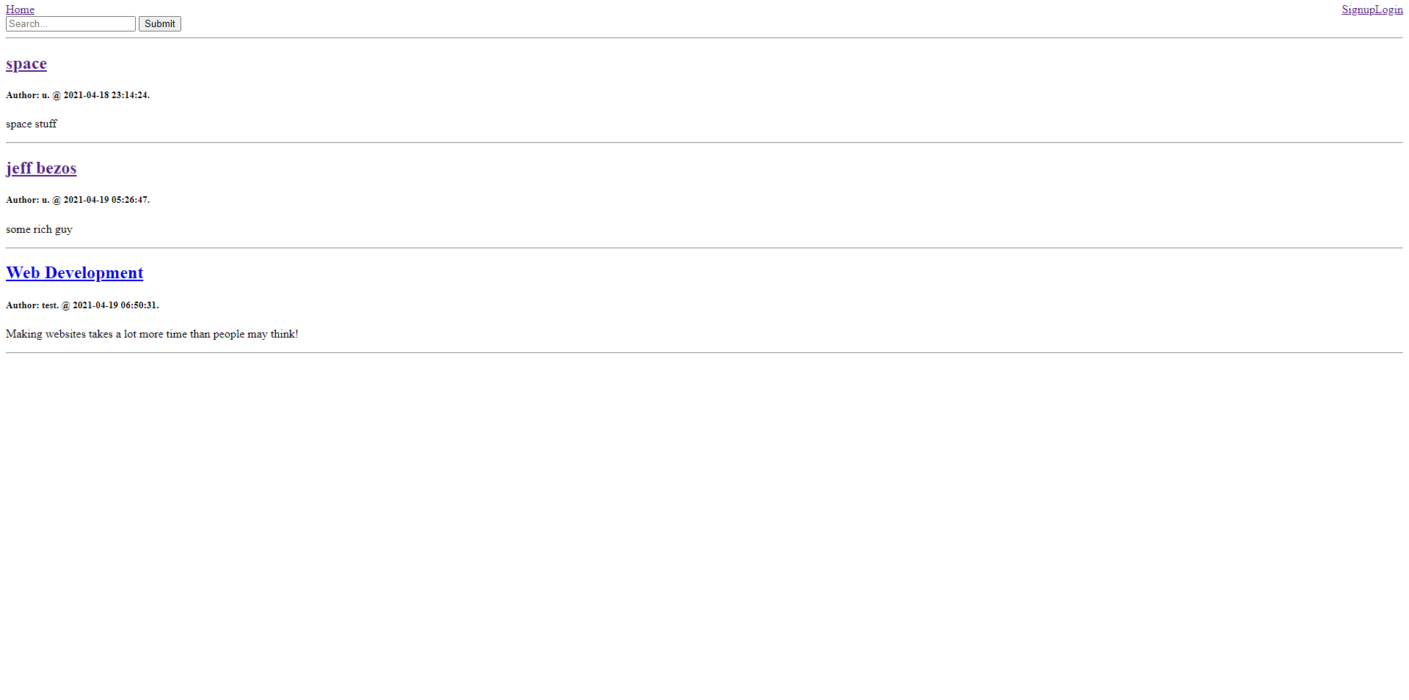

Like the **SEARCH BAR** feature, the user can decide to **LOG OUT** from any page:

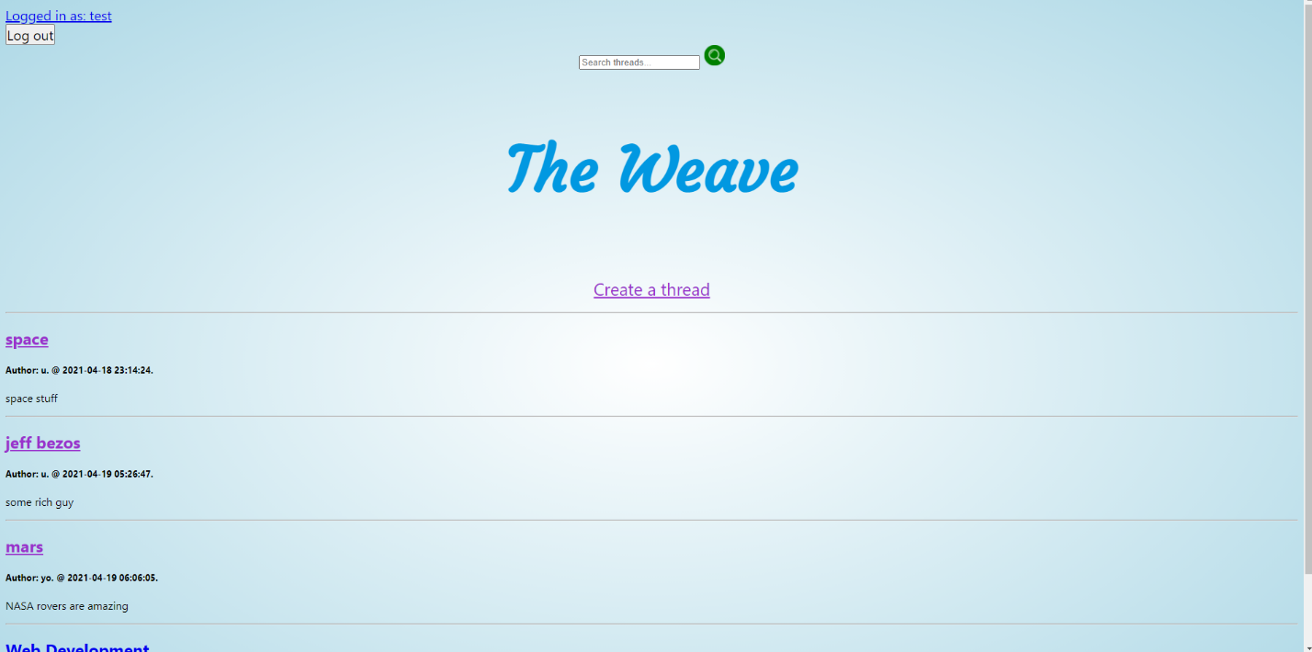

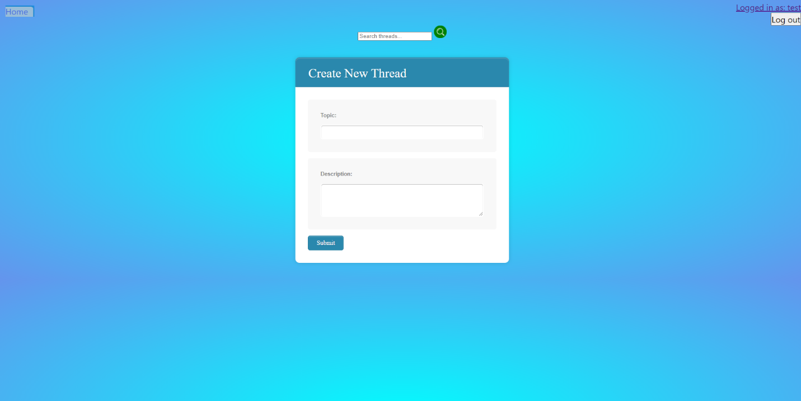

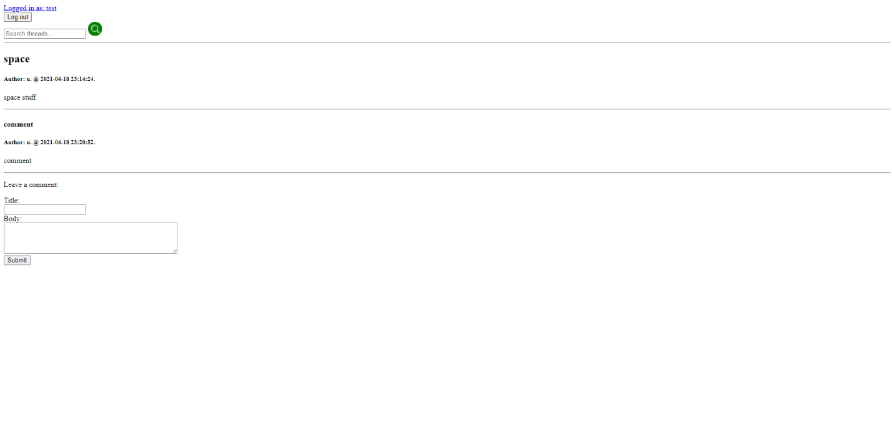

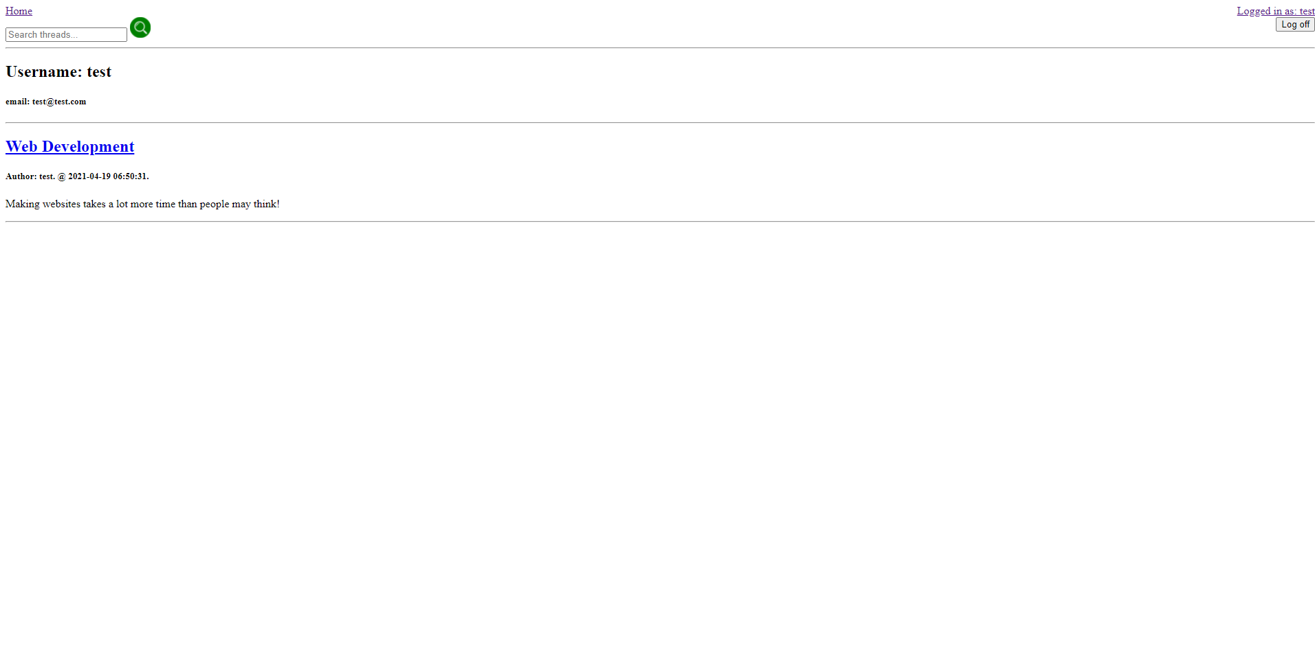

Welcome to The Weave!