AGROSENSE
Smart Irrigation Advisory Platform for Smallholder Farmers
Project Baseline Document
Prepared by: Oscar Adams Dalmau Tamayo
September 2026

1. Project Overview
AgroSense is a lightweight web platform that helps smallholder farmers in water-scarce, semi-arid regions such as Jalisco make data-driven irrigation decisions. By combining low-cost soil-moisture sensors, weather API data, and a scheduling engine, the system generates daily, plot-level irrigation recommendations delivered through a bilingual (Spanish/English) web dashboard, with SMS alerts as a fallback for farmers with limited internet access. The goal is to reduce water waste and improve crop yields for farms that cannot afford commercial precision-agriculture tools.

2. Methodology
The project follows Scrum, an agile framework well suited to a small, four-person team that must adapt as pilot farmers provide feedback. Oscar (Project Manager) acts as Product Owner, owning the backlog and priorities; the Senior Full-Stack Developer serves as Scrum Master, facilitating ceremonies and removing blockers; and the Senior plus two Junior Developers form the Development Team responsible for building and testing each increment. Work is organized into two-week sprints, each including sprint planning, daily stand-ups, a sprint review/demo, and a sprint retrospective, with the Product Backlog, Sprint Backlog, and a working increment as the core artifacts produced every sprint.

3. Requirements
The following functional and non-functional requirements define the scope of the AgroSense system, grouped by the eight functional modules identified during discovery.

3.1 Modules Summary
Module Code | Module Name | # of Functional Requirements
UM | User & Farm Management | 5
SD | Sensor & Device Management | 5
DC | Data Collection & Integration | 5
IS | Irrigation Scheduling Engine | 5
WD | Web Dashboard / UI | 5
NA | Notifications & Alerts | 4
RA | Reporting & Analytics | 4
AC | Administration & Configuration | 4
Total |  | 37

3.2 Functional Requirements
Code | Name | Description
UM — User & Farm Management
UM-01 | User Registration | Allow a farmer to create an account with basic profile information (name, email, phone, password).
UM-02 | User Login | Allow a registered user to log in to the platform using their email/username and password.
UM-03 | Password Recovery | Allow a user to reset a forgotten password through a verification link sent by email.
UM-04 | Farm Profile Creation | Allow a user to register one or more farms, including location and total area.
UM-05 | Plot Management | Allow a user to add, edit, or remove individual plots within a registered farm.
SD — Sensor & Device Management
SD-01 | Sensor Registration | Allow a user or administrator to register a new soil-moisture sensor and associate it with a plot.
SD-02 | Sensor Status Monitoring | Display the real-time online/offline status of each registered sensor.
SD-03 | Sensor Calibration | Allow adjustment of calibration parameters for an individual sensor.
SD-04 | Sensor Removal | Allow deactivation or removal of a sensor from a plot.
SD-05 | Low Battery Alert | Notify the responsible user when a sensor's battery level falls below a defined threshold.
DC — Data Collection & Integration
DC-01 | Soil Moisture Data Ingestion | Automatically collect soil-moisture readings from registered sensors at defined intervals.
DC-02 | Weather Data Integration | Retrieve current conditions and forecast data from an external weather API for each farm's location.
DC-03 | Data Storage | Store all sensor and weather readings in a time-stamped historical database.
DC-04 | Data Validation | Detect and flag anomalous or out-of-range sensor readings before they reach the scheduling engine.
DC-05 | Manual Data Entry | Allow a user to manually enter a soil-moisture reading when a sensor is temporarily unavailable.
IS — Irrigation Scheduling Engine
IS-01 | Irrigation Recommendation Generation | Generate a daily irrigation recommendation per plot based on soil-moisture and weather data.
IS-02 | Schedule Adjustment | Allow a user to manually override a system-generated irrigation recommendation.
IS-03 | Crop Profile Configuration | Allow a user to select a crop type per plot to refine irrigation calculations.
IS-04 | Historical Schedule Log | Maintain a record of past irrigation recommendations and whether each was followed.
IS-05 | Water Usage Estimation | Estimate the volume of water recommended per irrigation event.
WD — Web Dashboard / UI
WD-01 | Dashboard Overview | Display a summary view of all of a user's plots and their current irrigation status.
WD-02 | Plot Detail View | Display detailed sensor readings, weather data, and recommendations for a selected plot.
WD-03 | Multilingual Interface | Allow the user to switch the interface language between Spanish and English.
WD-04 | Mobile-Responsive Layout | Render the dashboard correctly on both mobile and desktop screen sizes.
WD-05 | Historical Chart View | Display a chart of soil-moisture trends over a user-selectable date range.
NA — Notifications & Alerts
NA-01 | SMS Irrigation Alert | Send an SMS message with the daily irrigation recommendation to farmers without internet access.
NA-02 | In-App Notification | Display in-app alerts for new irrigation recommendations and sensor issues.
NA-03 | Email Notification | Send a weekly email summary of irrigation activity to the user.
NA-04 | Alert Preferences | Allow a user to configure which alerts they receive and through which channel (SMS, email, in-app).
RA — Reporting & Analytics
RA-01 | Water Savings Report | Generate a report comparing estimated water usage against a manual-irrigation baseline.
RA-02 | Yield Correlation Report | Provide a report correlating irrigation adherence with reported crop outcomes.
RA-03 | Export Report | Allow a user to export a report as a PDF or CSV file.
RA-04 | Seasonal Summary | Generate an end-of-season summary of irrigation activity per plot.
AC — Administration & Configuration
AC-01 | Role-Based Access Control | Restrict system functions based on user role (farmer or administrator).
AC-02 | System Configuration | Allow an administrator to configure global thresholds and default settings.
AC-03 | Audit Log | Record administrative actions for accountability and traceability.
AC-04 | User Management (Admin) | Allow an administrator to view, disable, or delete user accounts.

3.3 Non-Functional Requirements
Quality attributes the system must satisfy, independent of specific features.
Code | Attribute | Description
NFR-01 | Performance | The system shall generate an irrigation recommendation within 5 seconds of a data request.
NFR-02 | Availability | The web platform shall be available at least 99% of the time, excluding scheduled maintenance.
NFR-03 | Scalability | The system shall support growth from a pilot group of 20 farms to at least 500 farms without architectural changes.
NFR-04 | Security | The system shall encrypt farmer data both in transit and at rest.
NFR-05 | Usability | A first-time user shall be able to complete farm registration in under 10 minutes without prior training.
NFR-06 | Reliability | The system shall correctly deliver SMS alerts to at least 98% of intended recipients.
NFR-07 | Portability | The web dashboard shall function correctly on the latest two versions of major browsers (Chrome, Firefox, Safari, Edge).
NFR-08 | Maintainability | The codebase shall follow a documented style guide and maintain automated test coverage of at least 70%.
NFR-09 | Accessibility | The dashboard shall meet WCAG 2.1 Level AA accessibility guidelines.
NFR-10 | Data Retention | Historical sensor and weather data shall be retained for at least 24 months for reporting purposes.
NFR-11 | Localization | The interface shall support both Spanish and English, with the ability to add further languages later.

4. System Architecture — Module Design
The diagram below shows how the eight functional modules connect. Administration & Configuration (AC) sits above User & Farm Management (UM) and Sensor & Device Management (SD), governing both. SD feeds Data Collection & Integration (DC), which validates and stores incoming sensor and weather data. DC passes clean data to the Irrigation Scheduling Engine (IS), the system's core logic, which in turn drives three downstream modules: the Web Dashboard / UI (WD, alongside UM), Notifications & Alerts (NA), and Reporting & Analytics (RA, alongside DC).
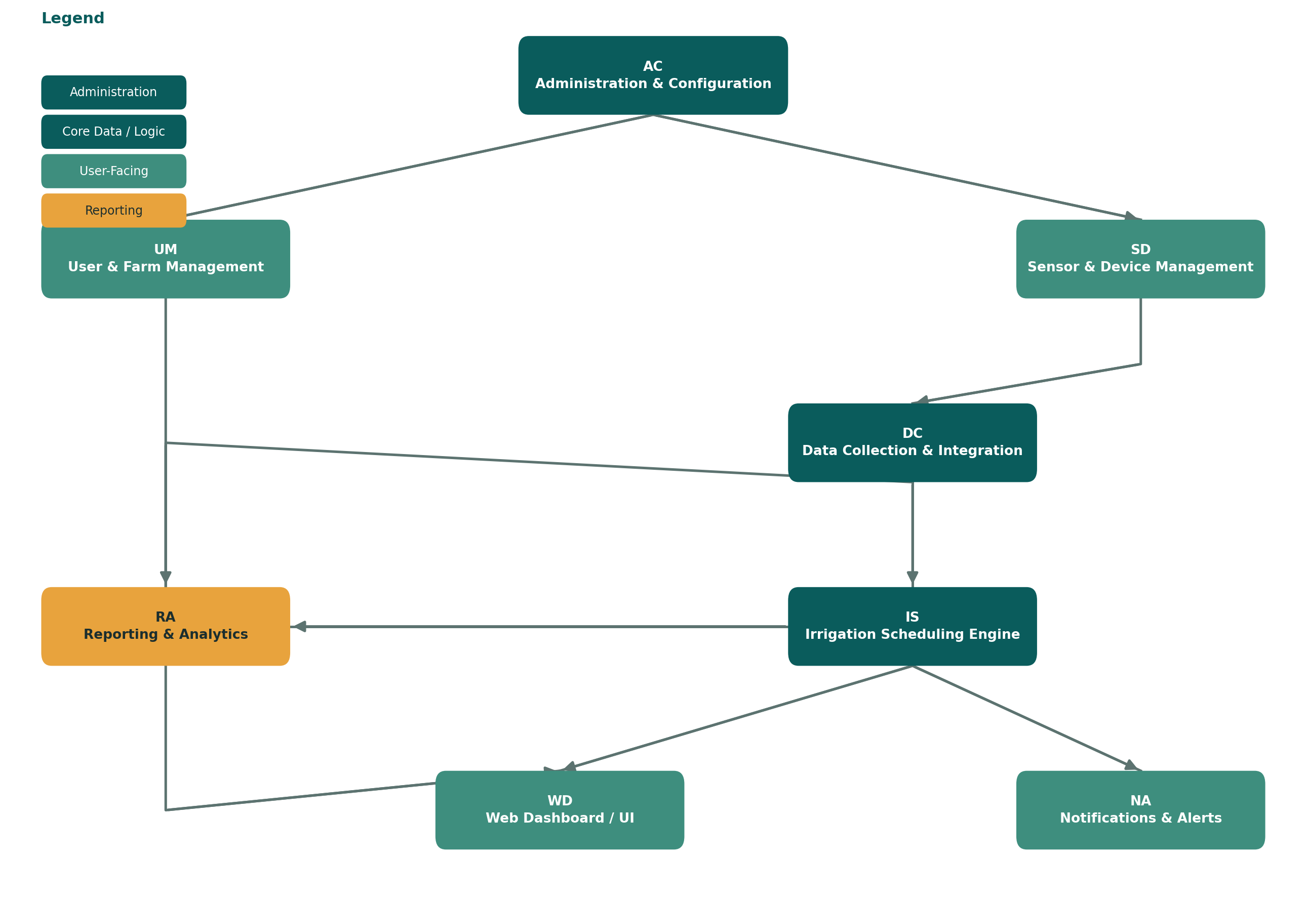

Module Connections
- AC → UM and AC → SD: administration governs user/farm management and sensor/device management (global thresholds, roles, configuration).
- SD → DC: registered sensors stream readings into the data collection and integration layer.
- DC → IS: validated soil-moisture and weather data feed the irrigation scheduling engine.
- IS → WD: generated recommendations are rendered on the farmer-facing dashboard.
- IS → NA: recommendations and sensor issues trigger SMS, email, and in-app alerts.
- UM → WD: farm and plot profile data populates the dashboard views.
- DC → RA and IS → RA: historical sensor data and scheduling history feed water-savings and yield-correlation reports.

5. Team & Roles
A lean four-person team covers management, architecture, and implementation.
Role | Level | Responsibilities
Project Manager | Oscar Adams Dalmau Tamayo | Scope, planning, budget, and stakeholder communication.
Senior Full-Stack Developer | Senior | System architecture, sensor/API integration, and code review.
Junior Backend Developer | Junior | REST API, database design, and automated testing.
Junior Frontend Developer | Junior | Dashboard UI/UX, alerts, and accessibility for low-connectivity users.

6. Project Budget
8-month development cycle, estimated in Mexican Pesos (MXN), at an approximate exchange rate of $17.00 MXN/USD (September 2026).
Role | Monthly Rate (MXN) | Months | Subtotal (MXN)
Project Manager | $42,500 | 8 | $340,000
Senior Full-Stack Developer | $54,400 | 8 | $435,200
Junior Backend Developer | $23,800 | 8 | $190,400
Junior Frontend Developer | $23,800 | 8 | $190,400
Personnel subtotal |  |  | $1,156,000
Infrastructure & tools (cloud hosting, licenses) |  |  | $28,900
Sensor prototyping hardware |  |  | $18,700
Contingency (10%) |  |  | $120,360
TOTAL BUDGET (MXN) |  |  | $1,323,960

