**Topics: Normal distribution, Functions of Random Variables**

1. The time required for servicing transmissions is normally distributed with *μ* = 45 minutes and *σ* = 8 minutes. The service manager plans to have work begin on the transmission of a customer’s car 10 minutes after the car is dropped off and the customer is told that the car will be ready within 1 hour from drop-off. What is the probability that the service manager cannot meet his commitment?
2. 0.3875
3. **0.2676**
4. 0.5
5. 0.6987

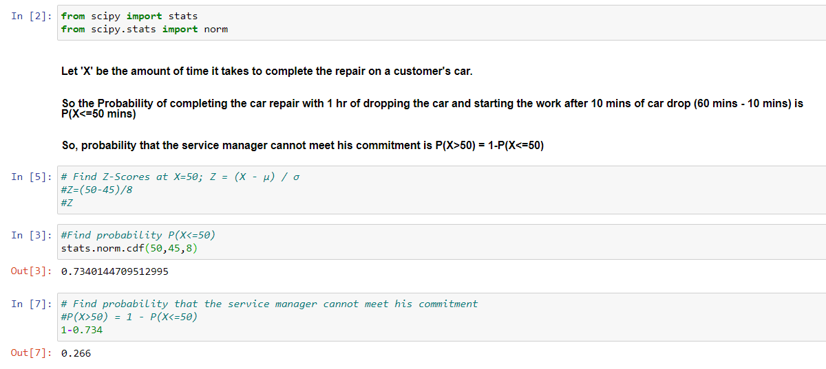

1. The current age (in years) of 400 clerical employees at an insurance claims processing center is normally distributed with mean *μ* = 38 and Standard deviation *σ* =6. For each statement below, please specify True/False. If false, briefly explain why.
2. More employees at the processing center are older than 44 than between 38 and 44.
3. A training program for employees under the age of 30 at the center would be expected to attract about 36 employees.

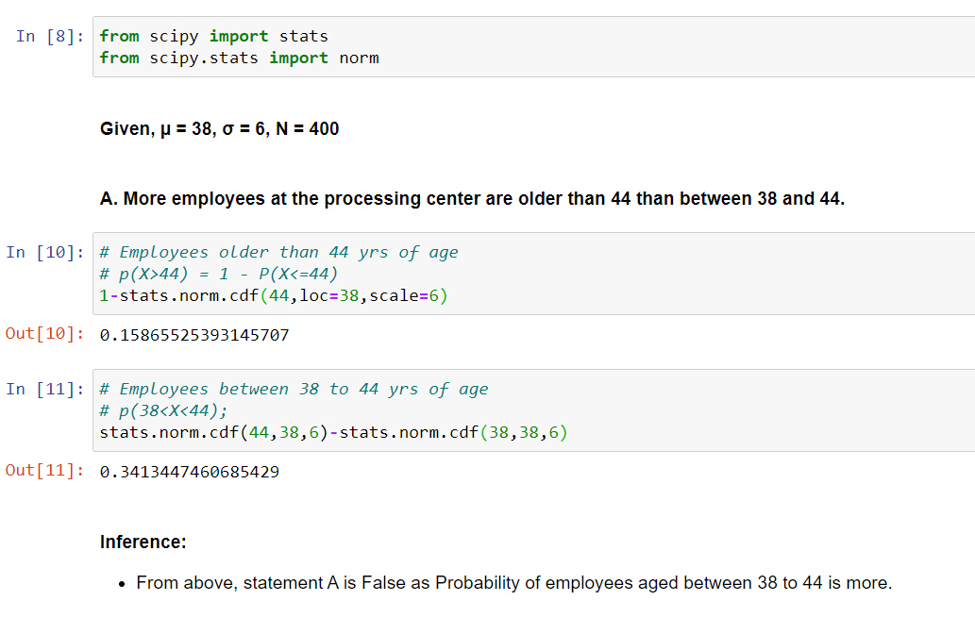

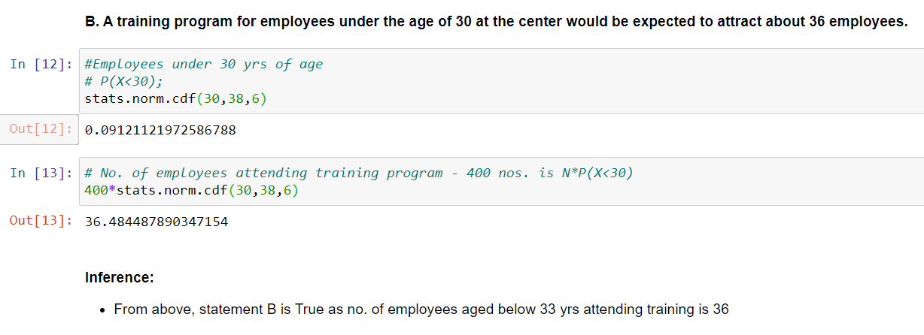

1. If *X1* ~ *N*(μ, σ2) and *X*2 ~ *N*(μ, σ2) are *iid* normal random variables, then what is the difference between 2 *X*1 and *X*1 + *X*2? Discuss both their distributions and parameters.

In both the normal distribution X1 and *X*2 , values of μ, σ2 are same.

So let assume μ =4 and σ2 =2

2 *X*1 =2( μx1, σ2x1)

= 2(4,2)

= (8,4)

*X*1 + *X*2 = ( μx1, σ2x1) + ( μx1, σ2x1)

= ( μx1 +μx1) , (σ2x1 + σ2x1)

= ( 4 + 4) , (2+2)

= (8,4)

1. Let X ~ N(100, 202). Find two values, *a* and *b*, symmetric about the mean, such that the probability of the random variable taking a value between them is 0.99.
2. 90.5, 105.9
3. 80.2, 119.8
4. 22, 78
5. **48.5, 151.5**
6. 90.1, 109.9

Method 1:

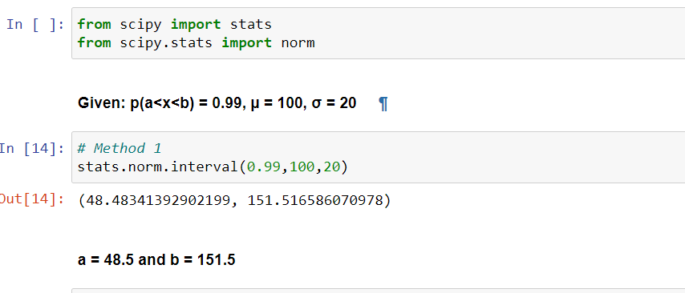

Method 2:

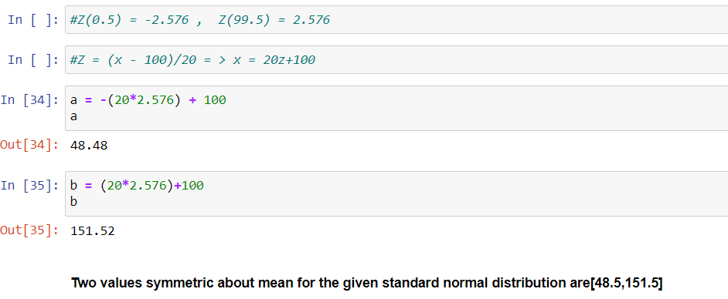

5.Consider a company that has two different divisions. The annual profits from the two divisions are independent and have distributions Profit1 ~ N(5, 32) and Profit2 ~ N(7, 42) respectively. Both the profits are in $ Million. Answer the following questions about the total profit of the company in Rupees. Assume that $1 = Rs. 45

1. Specify a Rupee range (centered on the mean) such that it contains 95% probability for the annual profit of the company.
2. Specify the 5th percentile of profit (in Rupees) for the company
3. 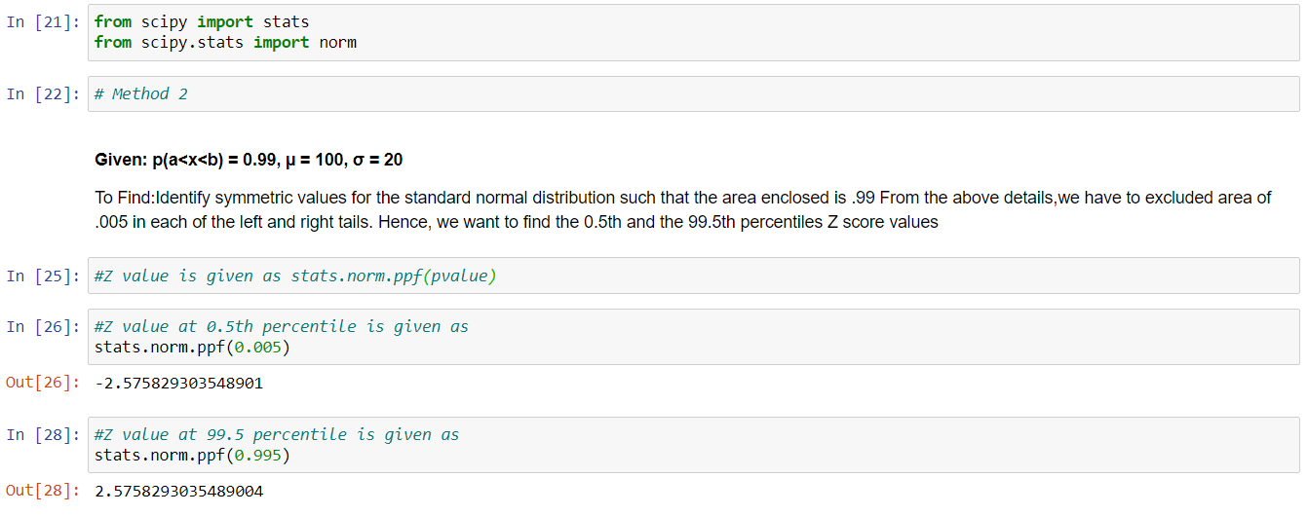Which of the two divisions has a larger probability of making a loss in a given year?

