**PRACTICAL 10**

**AIM:**

Create an application with the help of database.

**THEORY:**

SQLite : SQLite is an open-source relational database i.e. used to perform database operations on android devices such as storing, manipulating or retrieving persistent data from the database. It is embedded in android bydefault. So, there is no need to perform any database setup or administration task.SQLiteOpenHelper class provides the functionality to use the SQLite database. openOrCreateDatabase() this method is used to create a database.

execSQL() : This method not only insert data , but also used to update or modify already existing data in database using bind arguments.

rawQuery() : directly accepts an SQL select statement as input. The method returns 'Cursor' object which points to one row of the query result.

**CODE:**

|  |
| --- |
| **// MainActivity.java**  package com.example.practical10;  import androidx.appcompat.app.AppCompatActivity;  import android.content.Context;  import android.content.Intent;  import android.database.sqlite.SQLiteDatabase;  import android.os.Bundle;  import android.provider.ContactsContract;  import android.view.View;  import android.widget.Button;  import android.database.Cursor;  public class MainActivity extends AppCompatActivity {  Button in,del,viewa;  SQLiteDatabase db;  @Override  protected void onCreate(Bundle savedInstanceState) {  super.onCreate( savedInstanceState );  setContentView( R.layout.activity_main );  in=findViewById(R.id.button5);  del=findViewById(R.id.button6);  viewa=findViewById(R.id.button7);  db=openOrCreateDatabase("myDb", Context.MODE_PRIVATE,null);  db.execSQL("CREATE TABLE IF NOT EXISTS student(name VARCHAR,rollno VARCHAR);");  in.setOnClickListener(new View.OnClickListener() {  @Override  public void onClick(View v) {  startActivity(new Intent(MainActivity.this, Insert.class));  }  });  del.setOnClickListener(new View.OnClickListener() {  @Override  public void onClick(View v) {  startActivity(new Intent(MainActivity.this, Delete.class));  }  });  viewa.setOnClickListener(new View.OnClickListener() {  @Override  public void onClick(View v) {  startActivity(new Intent(MainActivity.this,Viewa.class));  }  });  }  }    **//Insert.java**  package com.example.practical10;  import androidx.appcompat.app.AppCompatActivity;  import android.content.Context;  import android.database.SQLException;  import android.database.sqlite.SQLiteDatabase;  import android.os.Bundle;  import android.view.View;  import android.widget.EditText;  import android.widget.Toast;  import android.widget.Button;  public class Insert extends AppCompatActivity {  EditText name,rollno;  Button insert;  SQLiteDatabase db;  @Override  protected void onCreate(Bundle savedInstanceState) {  super.onCreate( savedInstanceState );  setContentView( R.layout.activity_insert );  name=findViewById(R.id.editText);  rollno=findViewById(R.id.editText2);  insert=findViewById(R.id.button);  db=openOrCreateDatabase("myDb", Context.MODE_PRIVATE,null);  insert.setOnClickListener(new View.OnClickListener() {  @Override  public void onClick(View v) {  if (name.getText().toString().trim().length()==0 || rollno.getText().toString().trim().length()==0){  Toast.makeText(getApplicationContext(),"Please Enter Details", Toast.LENGTH_SHORT).show();  }  else  {  try{  db.execSQL("INSERT INTO student VALUES('"+name.getText()+"','"+rollno.getText()+"');");  Toast.makeText(getApplicationContext(),"Inserted Successfully",Toast.LENGTH_SHORT).show();  }  catch (SQLException e){  Toast.makeText(getApplicationContext(),"Operation Not Successful",Toast.LENGTH_SHORT).show();  }  }  }  });  }  }  **//Delete.java**  package com.example.practical10;  import androidx.appcompat.app.AppCompatActivity;  import android.content.Context;  import android.database.Cursor;  import android.database.sqlite.SQLiteDatabase;  import android.os.Bundle;  import android.view.View;  import android.widget.Button;  import android.widget.EditText;  import android.widget.Toast;  public class Delete extends AppCompatActivity {  EditText name,rollno;  Button delete;  SQLiteDatabase db;  @Override  protected void onCreate(Bundle savedInstanceState) {  super.onCreate( savedInstanceState );  setContentView( R.layout.activity_delete );  name=findViewById(R.id.editText);  rollno=findViewById(R.id.editText2);  delete=findViewById(R.id.button);  db=openOrCreateDatabase("myDb", Context.MODE_PRIVATE,null);  delete.setOnClickListener(new View.OnClickListener() {  @Override  public void onClick(View v) {  if (name.getText().toString().trim().length()==0 || rollno.getText().toString().trim().length()==0){  Toast.makeText(getApplicationContext(),"Please Enter Details", Toast.LENGTH_SHORT).show();  }  Cursor c=db.rawQuery("SELECT * FROM student WHERE name='"+name.getText()+"'", null);  if(c.moveToFirst())  {  db.execSQL("DELETE FROM student WHERE name='"+name.getText()+"'");  Toast.makeText(getApplicationContext(),"Deleted Successfully",Toast.LENGTH_SHORT).show();  }  else  {  Toast.makeText(getApplicationContext(),"Operation Not Successful",Toast.LENGTH_SHORT).show();  }  }  });  }  }  **//Viewa.java**  package com.example.practical10;  import androidx.appcompat.app.AppCompatActivity;  import android.content.Context;  import android.database.Cursor;  import android.database.sqlite.SQLiteDatabase;  import android.os.Bundle;  import android.widget.EditText;  import android.widget.TextView;  import android.widget.Toast;  public class Viewa extends AppCompatActivity {  TextView t1;  SQLiteDatabase db;  @Override  protected void onCreate(Bundle savedInstanceState) {  super.onCreate( savedInstanceState );  setContentView( R.layout.activity_viewa );  t1=findViewById(R.id.textView4);  db=openOrCreateDatabase("myDb", Context.MODE_PRIVATE,null);  Cursor c=db.rawQuery("SELECT * FROM student",null);  if (c.getCount()==0){  Toast.makeText(getApplicationContext(),"No Data Found",Toast.LENGTH_SHORT).show();  }  StringBuffer result=new StringBuffer();  while (c.moveToNext()){  result.append("Name:"+c.getString(0)+"\n");  result.append("Roll No:"+c.getString(1)+"\n\n");  }  t1.setText(result.toString());  }  }  **//AndroidManifest.xml**  <?xml version="1.0" encoding="utf-8"?> <manifest xmlns:android="http://schemas.android.com/apk/res/android"  package=" com.example.practical10">   <application  android:allowBackup="true"  android:icon="@mipmap/ic_launcher"  android:label="@string/app_name"  android:roundIcon="@mipmap/ic_launcher_round"  android:supportsRtl="true"  android:theme="@style/AppTheme">  <activity android:name=".Viewa"></activity>  <activity android:name=".Delete" />  <activity android:name=".Insert" />  <activity android:name=".MainActivity">  <intent-filter>  <action android:name="android.intent.action.MAIN" />   <category android:name="android.intent.category.LAUNCHER" />  </intent-filter>  </activity>  </application>  </manifest>    **//activity_main.xml**  <?xml version="1.0" encoding="utf-8"?>  <androidx.constraintlayout.widget.ConstraintLayout xmlns:android="http://schemas.android.com/apk/res/android"  xmlns:app="http://schemas.android.com/apk/res-auto"  xmlns:tools="http://schemas.android.com/tools"  android:layout_width="match_parent"  android:layout_height="match_parent"  tools:context=".MainActivity"  android:background="#fff"  >  <Button  android:id="@+id/button5"  android:layout_width="wrap_content"  android:layout_height="wrap_content"  android:layout_marginStart="161dp"  android:layout_marginLeft="161dp"  android:layout_marginTop="283dp"  android:layout_marginEnd="162dp"  android:layout_marginRight="162dp"  android:layout_marginBottom="64dp"  android:background="#FFE5E5"  android:text="Insert"  android:textColor="#000"  app:layout_constraintBottom_toTopOf="@+id/button6"  app:layout_constraintEnd_toEndOf="parent"  app:layout_constraintStart_toStartOf="parent"  app:layout_constraintTop_toTopOf="parent" />  <Button  android:id="@+id/button6"  android:layout_width="wrap_content"  android:layout_height="wrap_content"  android:layout_marginStart="161dp"  android:layout_marginLeft="161dp"  android:layout_marginTop="64dp"  android:layout_marginEnd="162dp"  android:layout_marginRight="162dp"  android:layout_marginBottom="64dp"  android:background="#FFE5E5"  android:text="Delete"  android:textColor="#000"  app:layout_constraintBottom_toTopOf="@+id/button7"  app:layout_constraintEnd_toEndOf="parent"  app:layout_constraintStart_toStartOf="parent"  app:layout_constraintTop_toBottomOf="@+id/button5" />  <Button  android:id="@+id/button7"  android:layout_width="wrap_content"  android:layout_height="wrap_content"  android:layout_marginStart="161dp"  android:layout_marginLeft="161dp"  android:layout_marginTop="64dp"  android:layout_marginEnd="162dp"  android:layout_marginRight="162dp"  android:layout_marginBottom="148dp"  android:background="#FFE5E5"  android:text="View All"  android:textColor="#000"  app:layout_constraintBottom_toBottomOf="parent"  app:layout_constraintEnd_toEndOf="parent"  app:layout_constraintStart_toStartOf="parent"  app:layout_constraintTop_toBottomOf="@+id/button6" />  <TextView  android:id="@+id/textView3"  android:layout_width="wrap_content"  android:layout_height="wrap_content"  android:layout_marginStart="159dp"  android:layout_marginLeft="159dp"  android:layout_marginTop="95dp"  android:layout_marginEnd="159dp"  android:layout_marginRight="159dp"  android:layout_marginBottom="144dp"  android:text="Database Data"  app:layout_constraintBottom_toTopOf="@+id/button5"  app:layout_constraintEnd_toEndOf="parent"  app:layout_constraintStart_toStartOf="parent"  app:layout_constraintTop_toTopOf="parent"  android:textColor="#B53160"  android:textSize="30sp"  />  </androidx.constraintlayout.widget.ConstraintLayout>  **//activity_viewa.xml**  <?xml version="1.0" encoding="utf-8"?>  <androidx.constraintlayout.widget.ConstraintLayout xmlns:android="http://schemas.android.com/apk/res/android"  xmlns:app="http://schemas.android.com/apk/res-auto"  xmlns:tools="http://schemas.android.com/tools"  android:layout_width="match_parent"  android:layout_height="match_parent"  tools:context=".Viewa"  android:background="#fff"  >  <TextView  android:id="@+id/textView4"  android:layout_width="259dp"  android:layout_height="498dp"  android:layout_marginStart="48dp"  android:layout_marginLeft="48dp"  android:layout_marginTop="35dp"  android:layout_marginEnd="56dp"  android:layout_marginRight="56dp"  android:layout_marginBottom="48dp"  app:layout_constraintBottom_toBottomOf="parent"  app:layout_constraintEnd_toEndOf="parent"  app:layout_constraintStart_toStartOf="parent"  app:layout_constraintTop_toTopOf="parent"  android:textSize="10sp"  android:textColor="#FFE5E5"  />  </androidx.constraintlayout.widget.ConstraintLayout>  **//activity_insert.xml**  <?xml version="1.0" encoding="utf-8"?>  <androidx.constraintlayout.widget.ConstraintLayout xmlns:android="http://schemas.android.com/apk/res/android"  xmlns:app="http://schemas.android.com/apk/res-auto"  xmlns:tools="http://schemas.android.com/tools"  android:layout_width="match_parent"  android:layout_height="match_parent"  tools:context=".Insert"  android:background="#fff"  >  <EditText  android:id="@+id/editText"  android:layout_width="wrap_content"  android:layout_height="wrap_content"  android:layout_marginTop="156dp"  android:layout_marginEnd="30dp"  android:layout_marginRight="30dp"  android:layout_marginBottom="60dp"  android:ems="10"  android:hint="Name"  android:inputType="textPersonName"  app:layout_constraintBottom_toTopOf="@+id/editText2"  app:layout_constraintEnd_toEndOf="parent"  app:layout_constraintTop_toTopOf="parent" />  <TextView  android:id="@+id/textView"  android:layout_width="wrap_content"  android:layout_height="wrap_content"  android:layout_marginStart="58dp"  android:layout_marginLeft="58dp"  android:layout_marginTop="96dp"  android:layout_marginEnd="56dp"  android:layout_marginRight="56dp"  android:text="Name"  android:textColor="#B53160"  android:textSize="20sp"  app:layout_constraintEnd_toStartOf="@+id/editText"  app:layout_constraintStart_toStartOf="parent"  app:layout_constraintTop_toTopOf="parent" />  <EditText  android:id="@+id/editText2"  android:layout_width="wrap_content"  android:layout_height="wrap_content"  android:layout_marginTop="60dp"  android:layout_marginEnd="30dp"  android:layout_marginRight="30dp"  android:layout_marginBottom="425dp"  android:ems="10"  android:hint="Roll No"  android:inputType="textPersonName"  app:layout_constraintBottom_toBottomOf="parent"  app:layout_constraintEnd_toEndOf="parent"  app:layout_constraintTop_toBottomOf="@+id/editText" />  <TextView  android:id="@+id/textView2"  android:layout_width="wrap_content"  android:layout_height="wrap_content"  android:layout_marginStart="58dp"  android:layout_marginLeft="58dp"  android:layout_marginTop="145dp"  android:layout_marginEnd="20dp"  android:layout_marginRight="20dp"  android:layout_marginBottom="437dp"  android:text="Roll No"  android:textColor="#B53160"  android:textSize="20sp"  app:layout_constraintBottom_toBottomOf="parent"  app:layout_constraintEnd_toStartOf="@+id/editText2"  app:layout_constraintHorizontal_bias="1.0"  app:layout_constraintStart_toStartOf="parent"  app:layout_constraintTop_toBottomOf="@+id/textView" />  <Button  android:id="@+id/button"  android:layout_width="wrap_content"  android:layout_height="wrap_content"  android:layout_marginStart="180dp"  android:layout_marginLeft="180dp"  android:layout_marginTop="58dp"  android:layout_marginEnd="92dp"  android:layout_marginRight="92dp"  android:layout_marginBottom="299dp"  android:background="#FFE5E5"  android:text="Insert"  android:textColor="#000"  app:layout_constraintBottom_toBottomOf="parent"  app:layout_constraintEnd_toEndOf="parent"  app:layout_constraintStart_toStartOf="parent"  app:layout_constraintTop_toBottomOf="@+id/editText2" />  </androidx.constraintlayout.widget.ConstraintLayout>  **//activity_delete.xml**  <?xml version="1.0" encoding="utf-8"?>  <androidx.constraintlayout.widget.ConstraintLayout xmlns:android="http://schemas.android.com/apk/res/android"  xmlns:app="http://schemas.android.com/apk/res-auto"  xmlns:tools="http://schemas.android.com/tools"  android:layout_width="match_parent"  android:layout_height="match_parent"  tools:context=".Delete"  android:background="#fff"  >  <EditText  android:id="@+id/editText"  android:layout_width="wrap_content"  android:layout_height="wrap_content"  android:layout_marginTop="156dp"  android:layout_marginEnd="30dp"  android:layout_marginRight="30dp"  android:layout_marginBottom="60dp"  android:ems="10"  android:hint="Name"  android:inputType="textPersonName"  app:layout_constraintBottom_toTopOf="@+id/editText2"  app:layout_constraintEnd_toEndOf="parent"  app:layout_constraintTop_toTopOf="parent" />  <TextView  android:id="@+id/textView"  android:layout_width="wrap_content"  android:layout_height="wrap_content"  android:layout_marginStart="58dp"  android:layout_marginLeft="58dp"  android:layout_marginTop="96dp"  android:layout_marginEnd="56dp"  android:layout_marginRight="56dp"  android:text="Name"  android:textColor="#B53160"  android:textSize="20sp"  app:layout_constraintEnd_toStartOf="@+id/editText"  app:layout_constraintStart_toStartOf="parent"  app:layout_constraintTop_toTopOf="parent" />  <EditText  android:id="@+id/editText2"  android:layout_width="wrap_content"  android:layout_height="wrap_content"  android:layout_marginTop="60dp"  android:layout_marginEnd="30dp"  android:layout_marginRight="30dp"  android:layout_marginBottom="425dp"  android:ems="10"  android:hint="Roll No"  android:inputType="textPersonName"  app:layout_constraintBottom_toBottomOf="parent"  app:layout_constraintEnd_toEndOf="parent"  app:layout_constraintTop_toBottomOf="@+id/editText" />  <TextView  android:id="@+id/textView2"  android:layout_width="wrap_content"  android:layout_height="wrap_content"  android:layout_marginStart="58dp"  android:layout_marginLeft="58dp"  android:layout_marginTop="145dp"  android:layout_marginEnd="20dp"  android:layout_marginRight="20dp"  android:layout_marginBottom="437dp"  android:text="Roll No"  android:textColor="#B53160"  android:textSize="20sp"  app:layout_constraintBottom_toBottomOf="parent"  app:layout_constraintEnd_toStartOf="@+id/editText2"  app:layout_constraintHorizontal_bias="1.0"  app:layout_constraintStart_toStartOf="parent"  app:layout_constraintTop_toBottomOf="@+id/textView" />  <Button  android:id="@+id/button"  android:layout_width="wrap_content"  android:layout_height="wrap_content"  android:layout_marginStart="180dp"  android:layout_marginLeft="180dp"  android:layout_marginTop="58dp"  android:layout_marginEnd="92dp"  android:layout_marginRight="92dp"  android:layout_marginBottom="299dp"  android:background="#FFE5E5"  android:text="Delete"  android:textColor="#000"  app:layout_constraintBottom_toBottomOf="parent"  app:layout_constraintEnd_toEndOf="parent"  app:layout_constraintStart_toStartOf="parent"  app:layout_constraintTop_toBottomOf="@+id/editText2" />  </androidx.constraintlayout.widget.ConstraintLayout> |

**Output :**

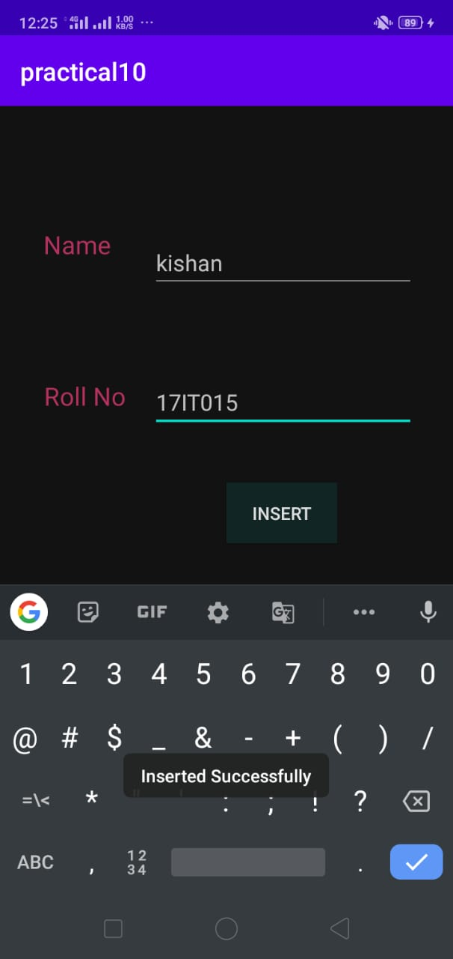 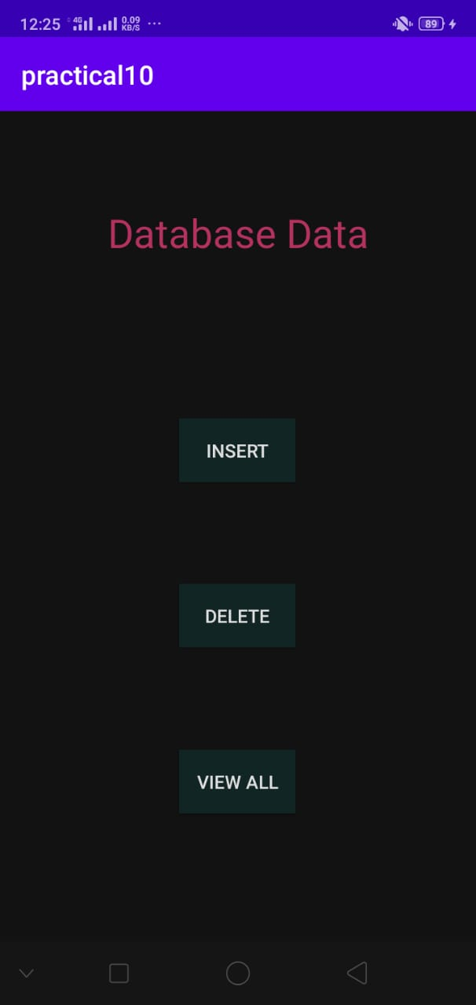

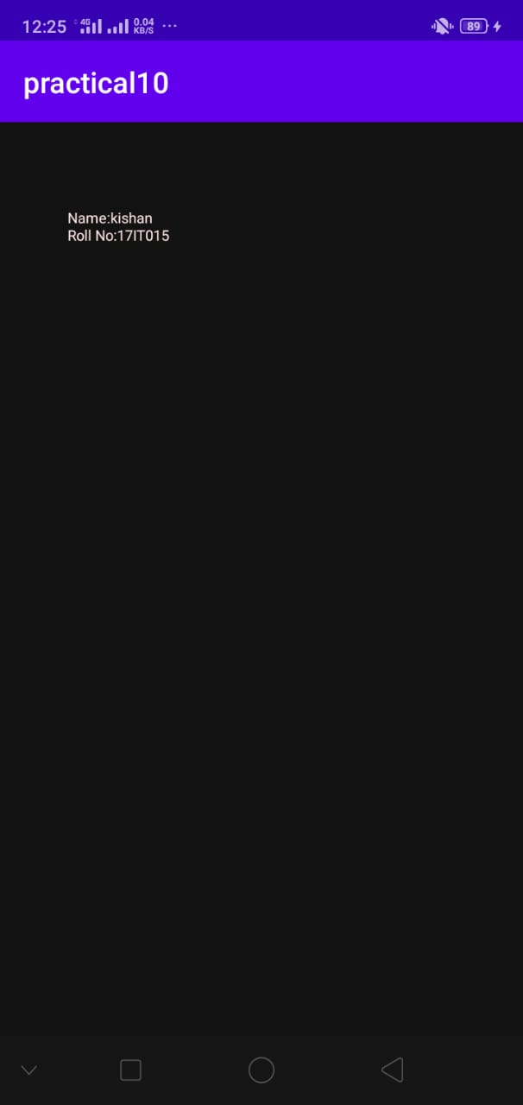 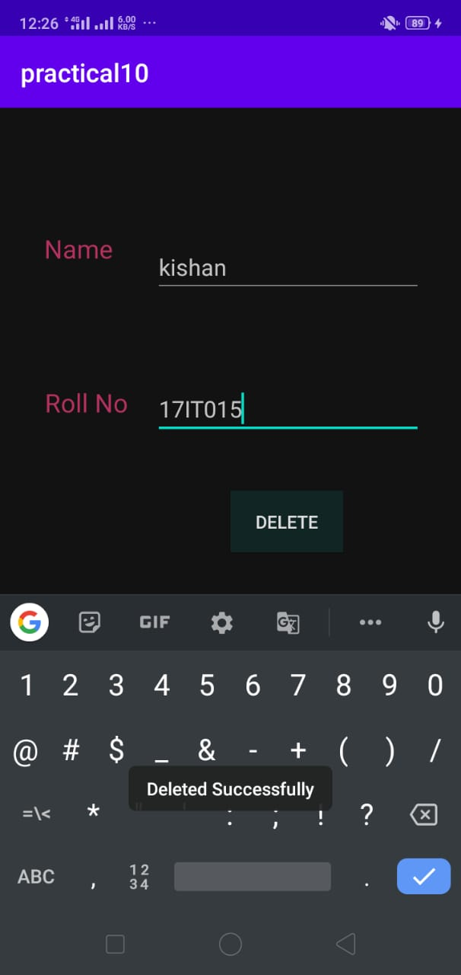

**LATEST APPLICATIONS:**

Altibase , MongoDB , Oracle RDBMS , IBM DB2 , Redis etc…

**LEARNING OUTCOME:**

In this Practical , we learnt how to use database in android application using SQLite.We also learnt how to create database and table.Then how to insert Data in the database.