**PRACTICAL: 13**

**AIM:**

Create an application to play video using YouTube API in PIP mode

**THEORY:**

PIP is a special type of multi-window mode mainly used for activities that need to be active on screen but should not take up the whole screen space like watching videos, video calls, navigation, etc. It lets the user watch a video in a small window pinned to a corner of the screen (by default bottom right) while navigating between apps or browsing content on the main screen. Android 8.0 (API level 26) and above allows activities to launch in PIP mode.

The PIP window appears in the top-most layer of the screen. You can drag the PIP window to another location using some special toggles. When you tap on the window two special controls appear:

* a full-screen toggle (in the centre of the window) and
* a close button (an “X” in the upper right corner).

**CODE:**

|  |
| --- |
| **MainActvity.java**  package com.example.prac_13_wcmc_17it015;  import androidx.appcompat.app.AppCompatActivity;  import android.app.ActionBar;  import android.app.Notification;  import android.app.PictureInPictureParams;  import android.drm.DrmStore;  import android.graphics.Point;  import android.net.Uri;  import android.os.Build;  import android.os.Bundle;  import android.util.Rational;  import android.view.Display;  import android.view.View;  import android.widget.Button;  import android.widget.MediaController;  import android.widget.VideoView;  public class MainActivity extends AppCompatActivity {  Button pipbtn;  String path = "/storage/DCIM/Camera/movie.mp4";  ActionBar actionBar;  VideoView video;  @Override  protected void onCreate(Bundle savedInstanceState) {  super.onCreate(savedInstanceState);  setContentView(R.layout.activity_main);  video = (VideoView)findViewById(R.id.video);  actionBar = getActionBar();  MediaController mediaController= new MediaController(this);  mediaController.setAnchorView(video);  video.setMediaController(mediaController);  video.setVideoURI(Uri.parse(path));  video.requestFocus();  video.start();  pipbtn = (Button)findViewById(R.id.pipbtn);  pipbtn.setOnClickListener(new View.OnClickListener() {  @Override  public void onClick(View view) {  Display display = getWindowManager().getDefaultDisplay();  Point point = new Point();  display.getSize(point);  int width = point.x;  int height = point.y;  Rational ratio = null;  if (Build.VERSION.SDK_INT >= Build.VERSION_CODES.LOLLIPOP) {  ratio = new Rational(width,height);  }  PictureInPictureParams.Builder pip_builder = null;  if (Build.VERSION.SDK_INT >= Build.VERSION_CODES.O) {  pip_builder = new PictureInPictureParams.Builder();  }  if (Build.VERSION.SDK_INT >= Build.VERSION_CODES.O) {  pip_builder.setAspectRatio(ratio).build();  }  pipbtn.setVisibility(View.INVISIBLE);  if (Build.VERSION.SDK_INT >= Build.VERSION_CODES.O) {  enterPictureInPictureMode(pip_builder.build());  }  }  });  }  }  **activity_main.xml**  <?xml version="1.0" encoding="utf-8"?>  <RelativeLayout  xmlns:android="http://schemas.android.com/apk/res/android"  xmlns:app="http://schemas.android.com/apk/res-auto"  xmlns:tools="http://schemas.android.com/tools"  android:layout_width="match_parent"  android:layout_height="match_parent"  tools:context=".MainActivity">  <VideoView  android:layout_width="match_parent"  android:layout_height="match_parent"  android:id="@+id/video"  android:layout_above="@id/pipbtn"/>  <Button  android:layout_width="match_parent"  android:layout_height="wrap_content"  android:text="Enter PIP mode"  android:layout_alignParentBottom="true"  android:id="@+id/pipbtn"/>  </RelativeLayout>  **AndroidManifest.xml**  <?xml version="1.0" encoding="utf-8"?>  <manifest xmlns:android="http://schemas.android.com/apk/res/android"  package="com.example.prac_13_wcmc_17it015">  <application  android:allowBackup="true"  android:icon="@mipmap/ic_launcher"  android:label="@string/app_name"  android:roundIcon="@mipmap/ic_launcher_round"  android:supportsRtl="true"  android:theme="@style/AppTheme">  <activity android:name=".MainActivity">  <intent-filter>  <action android:name="android.intent.action.MAIN" />  <category android:name="android.intent.category.LAUNCHER" />  </intent-filter>  </activity>  </application>  </manifest> |

**OUTPUT:**

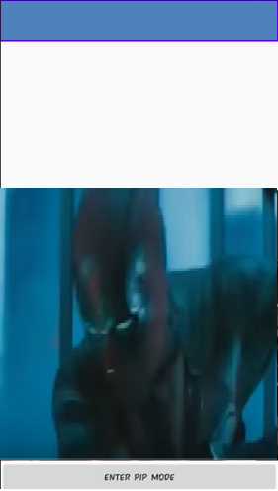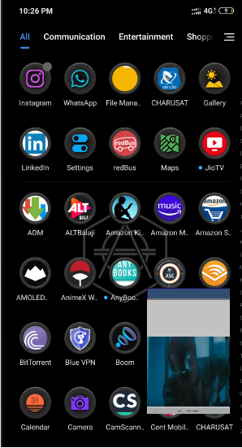

**LATEST APPLICATIONS:**

Zomato, Swiggy , Youtube Vanced.

**LEARNING OUTCOME:**

I learnt how to work with video in android studio as well as I also learnt pip mode and implement in real application.