**PRACTICAL: 1**

**AIM:**

Introduction to Android and Create “Custom Message” application. That will display “Custom Message” in the middle of the screen in the Black color with the Yellow background.

**THEORY:**

Android apps can be written using Kotlin, Java, and C++ languages. The Android SDK tools compile your code along with any data and resource files into an APK, an *Android package*, which is an archive file with an .apk suffix. One APK file contains all the contents of an Android app and is the file that Android-powered devices use to install the app.

**CODE:**

|  |
| --- |
| **MainActivity.java**  package com.example.wcmc_pr1_17it015;  import androidx.appcompat.app.AppCompatActivity;  import android.os.Bundle; import android.view.View;  public class MainActivity extends AppCompatActivity {  View v1;  @Override  protected void onCreate(Bundle savedInstanceState) {  super.onCreate(savedInstanceState);  setContentView(R.layout.*activity_main*);   v1 = this.getWindow().getDecorView();  v1.setBackgroundResource(R.color.*yellow*);  } }  **AndroidManifest.xml**  <?xml version="1.0" encoding="utf-8"?> <manifest xmlns:android="http://schemas.android.com/apk/res/android"  package="com.example.wcmc_pr1_17it015">   <application  android:allowBackup="true"  android:icon="@mipmap/ic_launcher"  android:label="@string/app_name"  android:roundIcon="@mipmap/ic_launcher_round"  android:supportsRtl="true"  android:theme="@style/AppTheme">  <activity android:name=".MainActivity">  <intent-filter>  <action android:name="android.intent.action.MAIN" />   <category android:name="android.intent.category.LAUNCHER" />  </intent-filter>  </activity>  </application>  </manifest>  **activity_main.xml**  <?xml version="1.0" encoding="utf-8"?> <androidx.constraintlayout.widget.ConstraintLayout xmlns:android="http://schemas.android.com/apk/res/android"  xmlns:app="http://schemas.android.com/apk/res-auto"  xmlns:tools="http://schemas.android.com/tools"  android:layout_width="match_parent"  android:layout_height="match_parent"  tools:context=".MainActivity">   <TextView  android:layout_width="wrap_content"  android:layout_height="wrap_content"  android:text="Kishan_17IT015"  app:layout_constraintBottom_toBottomOf="parent"  app:layout_constraintLeft_toLeftOf="parent"  app:layout_constraintRight_toRightOf="parent"  app:layout_constraintTop_toTopOf="parent"  android:textSize="30sp"  android:textColor="#000000"/>  </androidx.constraintlayout.widget.ConstraintLayout>  **Colors.xml**  <?xml version="1.0" encoding="utf-8"?> <resources>  <color name="colorPrimary">#008577</color>  <color name="colorPrimaryDark">#00574B</color>  <color name="colorAccent">#D81B60</color>  <color name="yellow">#ffff45</color> </resources> |

**OUTPUT:**

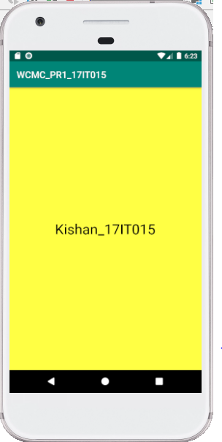

**LATEST APPLICATIONS:**

Clip layer, Clipboard Action, Native Clipboard, Clip Stack, Copy Bubble etc.

**LEARNING OUTCOME:**

We can learn how to change the background color in the application adding color in color.xml and add custom message in the app with black color.