**PRACTICAL 3**

**AIM:** Create an application that will display Toast (Message) on specific interval of time.

**THEORY:**

Android CountDownTimer class is used to schedule a countdown until a time in the future defined by the user, with regular notifications on intervals along the way. This class is an [abstract class](https://www.journaldev.com/1582/abstract-class-in-java) whose methods need to be overridden to implement it in our project.

**CODE:**

|  |
| --- |
| **// MainActivity.java**  package com.MyApplication;  import android.os.CountDownTimer;  import android.support.v7.app.AppCompatActivity;  import android.os.Bundle;  import android.widget.Toast;  public class MainActivity extends AppCompatActivity {  @Override  protected void onCreate(Bundle savedInstanceState) {  super.onCreate(savedInstanceState);  setContentView(R.layout.activity_main);  new CountDownTimer(50000,5000){  @Override  public void onTick(long l) {  Toast.makeText(getApplicationContext(),”17it015!!",Toast.LENGTH_SHORT).show();  }  @Override  public void onFinish() {}  }.start();  }  }  **// activity_main.xml**  <?xml version="1.0" encoding="utf-8"?>  <android.support.constraint.ConstraintLayout xmlns:android="http://schemas.android.com/apk/res/android"  xmlns:app="http://schemas.android.com/apk/res-auto"  xmlns:tools="http://schemas.android.com/tools"  android:layout_width="match_parent"  android:layout_height="match_parent"  android:background="#000"  tools:context=".MainActivity">  <TextView  android:layout_width="wrap_content"  android:layout_height="wrap_content"  android:text="Hello World"  android:textSize="60sp"  android:textColor="##66ff66"  app:layout_constraintBottom_toBottomOf="parent"  app:layout_constraintLeft_toLeftOf="parent"  app:layout_constraintRight_toRightOf="parent"  app:layout_constraintTop_toTopOf="parent" />  </android.support.constraint.ConstraintLayout>  **// AndroidManifest.xml**  <?xml version="1.0" encoding="utf-8"?>  <manifest xmlns:android="http://schemas.android.com/apk/res/android"  package="com.17IT022_practical3">  <application  android:allowBackup="true"  android:icon="@mipmap/ic_launcher"  android:label="@string/app_name"  android:roundIcon="@mipmap/ic_launcher_round"  android:supportsRtl="true"  android:theme="@style/AppTheme">  <activity android:name=".MainActivity">  <intent-filter>  <action android:name="android.intent.action.MAIN" />  <category android:name="android.intent.category.LAUNCHER" />  </intent-filter>  </activity>  </application>  </manifest> |

**OUTPUT:**

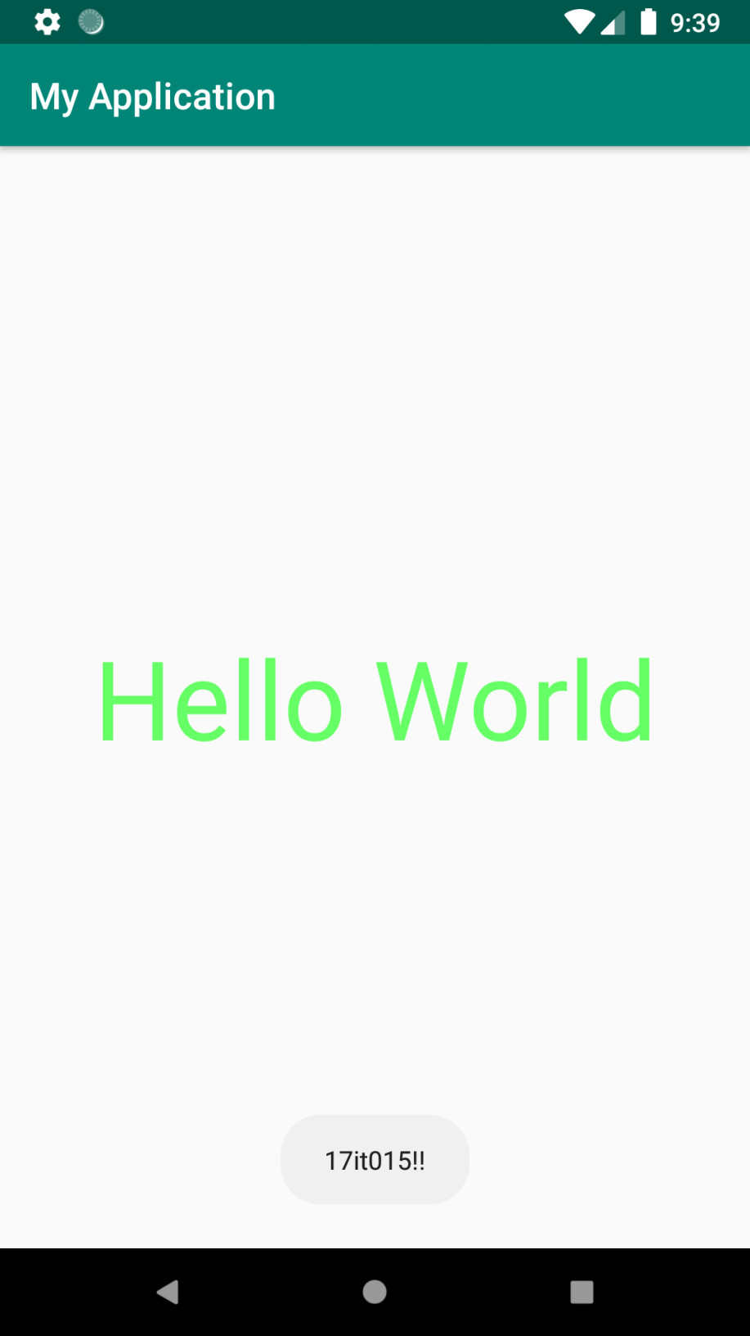

Here we have selected the timer of 50 seconds so the toast will display for 50 seconds and the interval we use is 5 seconds.

**LATEST APPLICATIONS:**

Stop watches, Instagram etc.

**LEARNING OUTCOME:**

In this practical we learn how to display toast message in specific interval of time.