PRACTICAL 4

AIM: Create a temperature converter Application. (Fahrenheit-Celsius).

THEORY:

Android CountDownTimer class is used to schedule a countdown until a time in the future defined by the user, with regular notifications on intervals along the way. This class is an [abstract class](https://www.journaldev.com/1582/abstract-class-in-java) whose methods need to be overridden to implement it in our project.

CODE:

|  |
| --- |
| // MainActivity.java  package com.example.temp;  import androidx.appcompat.app.AppCompatActivity;  import android.os.Bundle;  import android.view.View;  import android.widget.Button;  import android.widget.EditText;  import android.widget.Toast;  public class MainActivity extends AppCompatActivity {  EditText temp;  Button fc;  Button cf;  Double d;  @Override  protected void onCreate(Bundle savedInstanceState) {  super.onCreate(savedInstanceState);  setContentView(R.layout.activity_main);  temp=(EditText)findViewById(R.id.editText);  fc=(Button)findViewById(R.id.button);  cf=(Button)findViewById(R.id.button2);  fc.setOnClickListener(new View.OnClickListener() {  @Override  public void onClick(View v) {  d=Double.parseDouble(String.valueOf(temp.getText()));  Double d1=d-32.0;  Double d2= d1*(9.0/5.0);  String s=String.valueOf(d2);  Toast.makeText(MainActivity.this,s+" C",Toast.LENGTH_LONG).show();  }  });  cf.setOnClickListener(new View.OnClickListener() {  @Override  public void onClick(View v) {  d=Double.parseDouble(String.valueOf(temp.getText()));  Double d3=d*(9.0/5.0)+32.0;  String s=String.valueOf(d3);  Toast.makeText(MainActivity.this,s+" F",Toast.LENGTH_LONG).show();  }  }); } }  // activity_main.xml  *<?*xml version="1.0" encoding="utf-8"*?>* <androidx.constraintlayout.widget.ConstraintLayout xmlns:android="http://schemas.android.com/apk/res/android"  xmlns:app="http://schemas.android.com/apk/res-auto"  xmlns:tools="http://schemas.android.com/tools"  android:layout_width="match_parent"  android:layout_height="match_parent"  tools:context=".MainActivity">  <TextView  android:id="@+id/textView"  android:layout_width="wrap_content"  android:layout_height="wrap_content"  android:text="17it015"  android:textSize="30sp"  app:layout_constraintBottom_toBottomOf="parent"  app:layout_constraintLeft_toLeftOf="parent"  app:layout_constraintRight_toRightOf="parent"  app:layout_constraintTop_toTopOf="parent"  app:layout_constraintVertical_bias="0.126" />  <EditText  android:id="@+id/editText"  android:layout_width="wrap_content"  android:layout_height="wrap_content"  android:ems="10"  android:hint="temperature"  android:inputType="textPersonName"  app:layout_constraintBottom_toBottomOf="parent"  app:layout_constraintEnd_toEndOf="parent"  app:layout_constraintStart_toStartOf="parent"  app:layout_constraintTop_toBottomOf="@+id/textView"  app:layout_constraintVertical_bias="0.121" />  <Button  android:id="@+id/button"  android:layout_width="wrap_content"  android:layout_height="wrap_content"  android:layout_marginTop="72dp"  android:text="F->C"  app:layout_constraintBottom_toBottomOf="parent"  app:layout_constraintEnd_toEndOf="parent"  app:layout_constraintHorizontal_bias="0.306"  app:layout_constraintStart_toStartOf="parent"  app:layout_constraintTop_toBottomOf="@+id/editText"  app:layout_constraintVertical_bias="0.0" />  <Button  android:id="@+id/button2"  android:layout_width="wrap_content"  android:layout_height="wrap_content"  android:text="C->F"  app:layout_constraintBottom_toBottomOf="parent"  app:layout_constraintEnd_toEndOf="parent"  app:layout_constraintHorizontal_bias="0.306"  app:layout_constraintStart_toStartOf="parent"  app:layout_constraintTop_toBottomOf="@+id/button"  app:layout_constraintVertical_bias="0.158" /> </androidx.constraintlayout.widget.ConstraintLayout>  // AndroidManifest.xml  *<?*xml version="1.0" encoding="utf-8"*?>* <manifest xmlns:android="http://schemas.android.com/apk/res/android"  package="com.example.temp">  <application  android:allowBackup="true"  android:icon="@mipmap/ic_launcher"  android:label="@string/app_name"  android:roundIcon="@mipmap/ic_launcher_round"  android:supportsRtl="true"  android:theme="@style/AppTheme">  <activity android:name=".MainActivity">  <intent-filter>  <action android:name="android.intent.action.MAIN" />  <category android:name="android.intent.category.LAUNCHER" />  </intent-filter>  </activity>  </application> </manifest> |

OUTPUT:

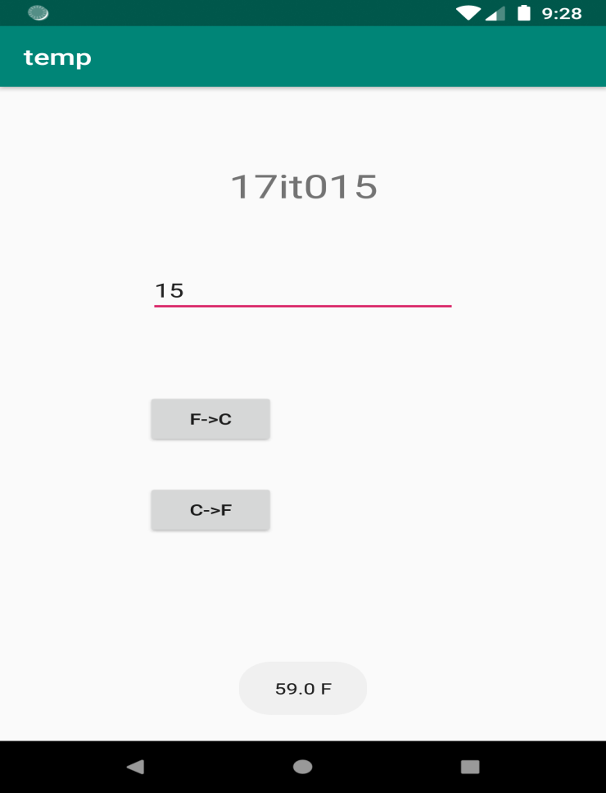

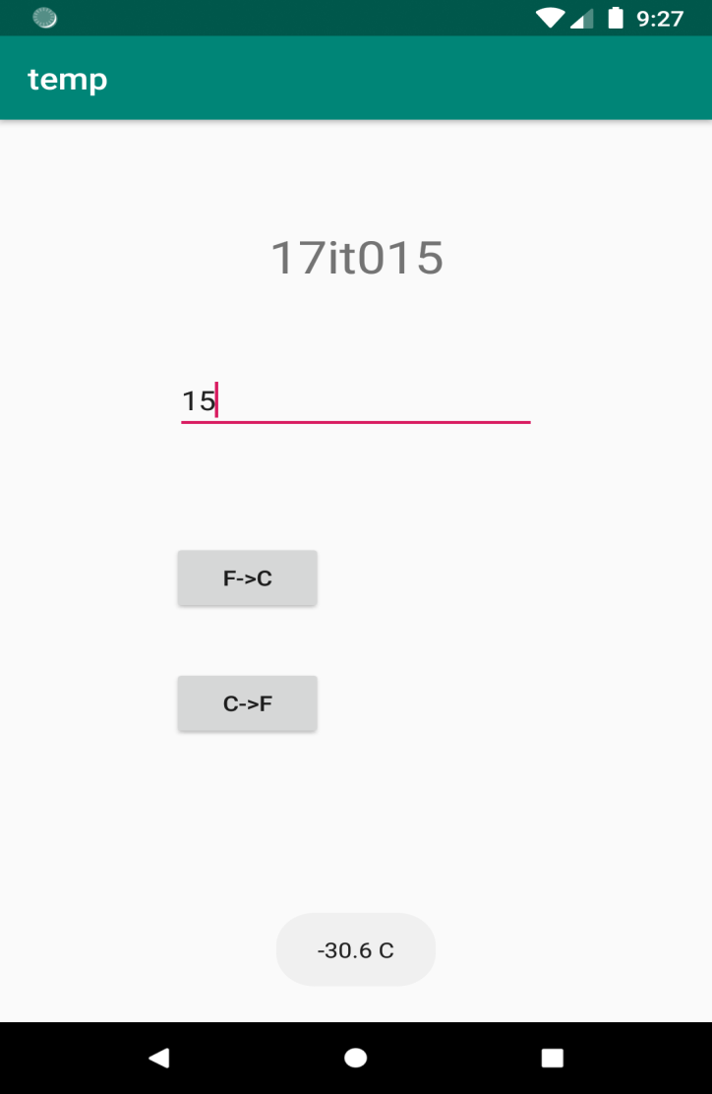

LATEST APPLICATIONS:

AccuWeather, Dark Sky-Hyperlocal Weather etc.

LEARNING OUTCOME:

In this practical we learn use of buttons and toast a message here we have created a application to convert temperature from celcius to faranheit and viceversa.