**PRACTICAL 6**

**AIM:**

Create an application which turns ON or OFF Torch/Flashlight of Camera.

**THEORY:**

**Switch:** Switch is a two-state toggle switch widget that can select between two options. It is used to display checked and unchecked state of a button providing slider control to user. Switch is a subclass of CompoundButton. It is basically an off/on button which indicates the current state of Switch. It is commonly used in selecting on/off in Sound, Bluetooth, Wi-Fi etc.

**Permission:** Specifies a system permission that the user must grant in order for the app to operate correctly. Permissions are granted by the user when the application is installed (on devices running Android 5.1 and lower) or while the app is running (on devices running Android 6.0 and higher).

**CODE:**

|  |
| --- |
| **// MainActivity.java**  package com.example.a17ito15_prac6;  import androidx.annotation.RequiresApi;  import androidx.appcompat.app.AppCompatActivity;  import android.content.Context;  import android.graphics.Camera;  import android.hardware.camera2.CameraAccessException;  import android.hardware.camera2.CameraManager;  import android.os.Build;  import android.os.Bundle;  import android.widget.CompoundButton;  import android.widget.Switch;  import android.widget.Toast;  import java.security.Policy;  public class MainActivity extends AppCompatActivity {  Switch s;  @Override  protected void onCreate(Bundle savedInstanceState) {  super.onCreate(savedInstanceState);  setContentView(R.layout.activity_main);  s=(Switch) findViewById(R.id.switch1);  s.setOnCheckedChangeListener(new CompoundButton.OnCheckedChangeListener() {  @RequiresApi(api = Build.VERSION_CODES.M)  @Override  public void onCheckedChanged(CompoundButton buttonView, boolean isChecked) {  if(s.isChecked())  {  flashLightOn();  }  else  {  flashLightOff();  }  }  });  }  @RequiresApi(api = Build.VERSION_CODES.M)  private void flashLightOn() {  CameraManager cameraManager = (CameraManager) getSystemService(Context.CAMERA_SERVICE);  try {  String cameraId = cameraManager.getCameraIdList()[0];  cameraManager.setTorchMode(cameraId, true);  Toast.makeText(MainActivity.this,"Flash On",Toast.LENGTH_LONG).show();  } catch (CameraAccessException e) {  }  }  @RequiresApi(api = Build.VERSION_CODES.M)  private void flashLightOff() {  CameraManager cameraManager = (CameraManager) getSystemService(Context.CAMERA_SERVICE);  try {  String cameraId = cameraManager.getCameraIdList()[0];  cameraManager.setTorchMode(cameraId, false);  Toast.makeText(MainActivity.this,"Flash Off",Toast.LENGTH_LONG).show();  } catch (CameraAccessException e) {  }  }  }  // **activity_main.xml**  <?xml version="1.0" encoding="utf-8"?>  <androidx.constraintlayout.widget.ConstraintLayout xmlns:android="http://schemas.android.com/apk/res/android"  xmlns:app="http://schemas.android.com/apk/res-auto"  xmlns:tools="http://schemas.android.com/tools"  android:layout_width="match_parent"  android:layout_height="match_parent"  tools:context=".MainActivity">  <Switch  android:id="@+id/switch1"  android:layout_width="145dp"  android:layout_height="55dp"  android:text="Torch"  android:textSize="36sp"  app:layout_constraintBottom_toBottomOf="parent"  app:layout_constraintEnd_toEndOf="parent"  app:layout_constraintStart_toStartOf="parent"  app:layout_constraintTop_toTopOf="parent" />  </androidx.constraintlayout.widget.ConstraintLayout>  **// AndroidManifest.xml**  <?xml version="1.0" encoding="utf-8"?>  <manifest xmlns:android="http://schemas.android.com/apk/res/android"  package="com.example.a17ito15_prac6">  <application  android:allowBackup="true"  android:icon="@mipmap/ic_launcher"  android:label="@string/app_name"  android:roundIcon="@mipmap/ic_launcher_round"  android:supportsRtl="true"  android:theme="@style/AppTheme">  <activity android:name=".MainActivity">  <intent-filter>  <action android:name="android.intent.action.MAIN" />  <category android:name="android.intent.category.LAUNCHER" />  </intent-filter>  </activity>  </application>  <uses-permission android:name="android.permission.CAMERA" />  <uses-feature android:name="android.hardware.camera" />  </manifest> |

**OUTPUT:**

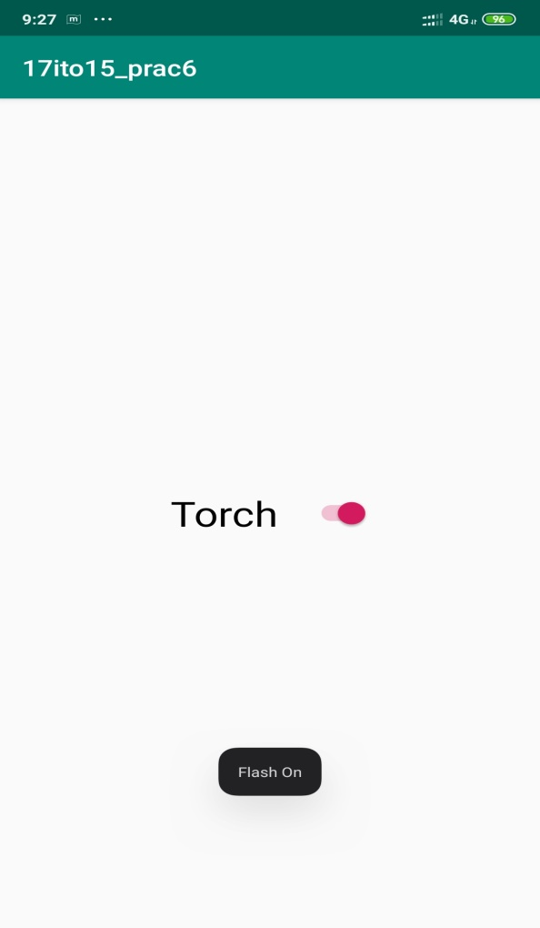 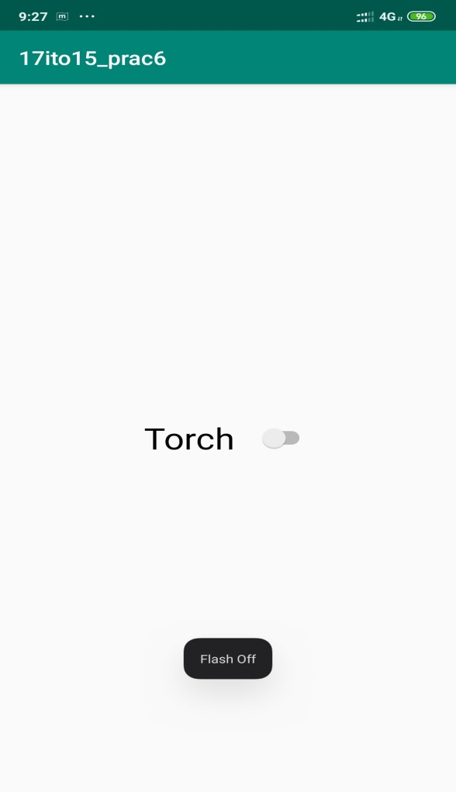

**LATEST APPLICATIONS:**

Huji,vivavideo etc…

**LEARNING OUTCOME:**

In this practical we learn how to display toast message in application and also how to use Switch and also how to take permission for using camera function.