**PRACTICAL 7**

**AIM:**

Create an application that will change color of the screen, based on selected options from the menu.

**THEORY:**

**Option menu:** Android Option Menus are the primary menus of android. They can be used for settings, search, delete item etc.Here, we are going to see two examples of option menus. First, the simple option menus and second, options menus with images.Here, we are inflating the menu by calling the inflate() method of MenuInflater class. To perform event handling on menu items, you need to override onOptionsItemSelected().

**Toast:** Andorid Toast can be used to display information for the short period of time. A toast contains message to be displayed quickly and disappears after sometime.The android.widget.Toast class is the subclass of java.lang.Object class.You can also create custom toast as well for example toast displaying image. You can visit next page to see the code for custom toast.

**CODE:**

|  |
| --- |
| **// MainActivity.java**  package com.example.a17it015_prac7;  import androidx.appcompat.app.AppCompatActivity;  import androidx.constraintlayout.widget.ConstraintLayout;  import android.graphics.Color;  import android.os.Bundle;  import android.view.ContextMenu;  import android.view.Menu;  import android.view.MenuItem;  import android.widget.Toast;  public class MainActivity extends AppCompatActivity {  ConstraintLayout current;  @Override  protected void onCreate(Bundle savedInstanceState) {  super.onCreate(savedInstanceState);  setContentView(R.layout.activity_main);  current = (ConstraintLayout)findViewById(R.id.lay);  }  public boolean onCreateOptionsMenu(Menu menu) {  // super.onCreateContextMenu(menu, v, menuInfo);  // MenuInflater inflater = getMenuInflater();  getMenuInflater().inflate(R.menu.option_menu, menu);  return true;  }  public boolean onOptionsItemSelected(MenuItem item) {  switch (item.getItemId()) {  case R.id.item1:  current.setBackgroundColor(Color.RED);  Toast.makeText(getApplicationContext(),"RED color ",Toast.LENGTH_SHORT).show();  return true;  case R.id.item2:  current.setBackgroundColor(Color.GREEN);  Toast.makeText(getApplicationContext(),"GREEN color",Toast.LENGTH_SHORT).show();  return true;  case R.id.item3:  current.setBackgroundColor(Color.BLUE);  Toast.makeText(getApplicationContext(),"BLUE color",Toast.LENGTH_SHORT).show();  return true;  default:  return super.onContextItemSelected(item);  }  }  }  // **activity_main.xml**  <?xml version="1.0" encoding="utf-8"?>  <androidx.constraintlayout.widget.ConstraintLayout xmlns:android="http://schemas.android.com/apk/res/android"  xmlns:app="http://schemas.android.com/apk/res-auto"  xmlns:tools="http://schemas.android.com/tools"  android:id="@+id/lay"  android:layout_width="match_parent"  android:layout_height="match_parent"  tools:context=".MainActivity">  <TextView  android:layout_width="wrap_content"  android:layout_height="wrap_content"  android:text="To see the menu click the dots above in actionbar"  android:textSize="18sp"  app:layout_constraintBottom_toBottomOf="parent"  app:layout_constraintLeft_toLeftOf="parent"  app:layout_constraintRight_toRightOf="parent"  app:layout_constraintTop_toTopOf="parent"  app:layout_constraintVertical_bias="0.181" />  </androidx.constraintlayout.widget.ConstraintLayout>  **// AndroidManifest.xml**  <?xml version="1.0" encoding="utf-8"?>  <manifest xmlns:android="http://schemas.android.com/apk/res/android"  package="com.example.a17it015_prac7">  <application  android:allowBackup="true"  android:icon="@mipmap/ico"  android:label="@string/app_name"  android:roundIcon="@mipmap/ic_launcher_round"  android:supportsRtl="true"  android:theme="@style/AppTheme">  <activity android:name=".MainActivity">  <intent-filter>  <action android:name="android.intent.action.MAIN" />  <category android:name="android.intent.category.LAUNCHER" />  </intent-filter>  </activity>  </application>  </manifest>  **// option_menu.xml**  <?xml version="1.0" encoding="utf-8"?>  <menu xmlns:android="http://schemas.android.com/apk/res/android"  xmlns:app="http://schemas.android.com/apk/res-auto">  <item android:id="@+id/item1"  android:title="Red"/>  <item android:id="@+id/item2"  android:title="Green"/>  <item android:id="@+id/item3"  android:title="Blue"/>  </menu> |

**OUTPUT:**

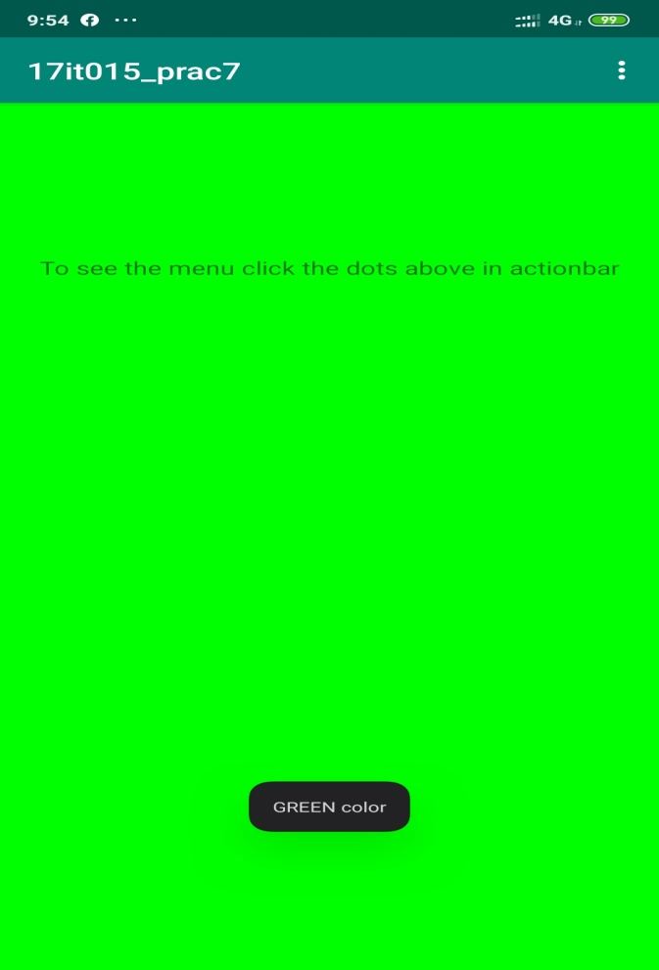 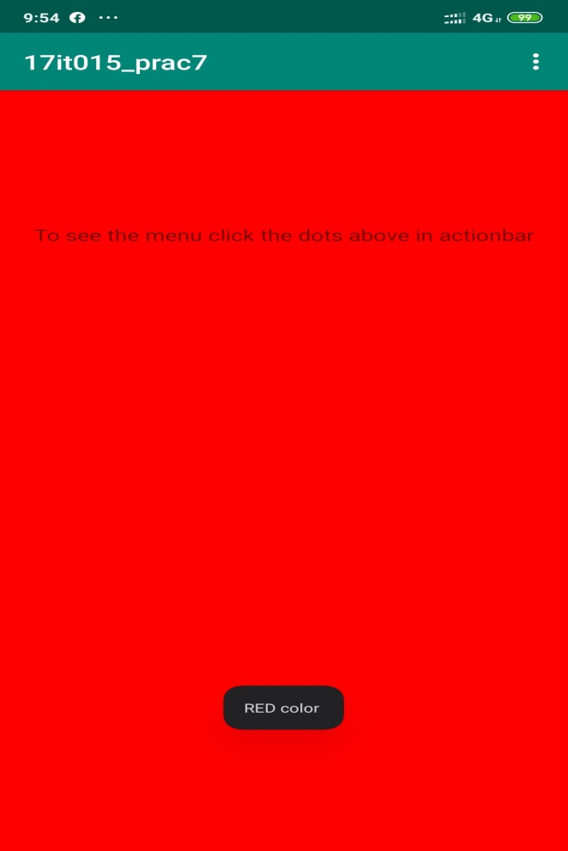

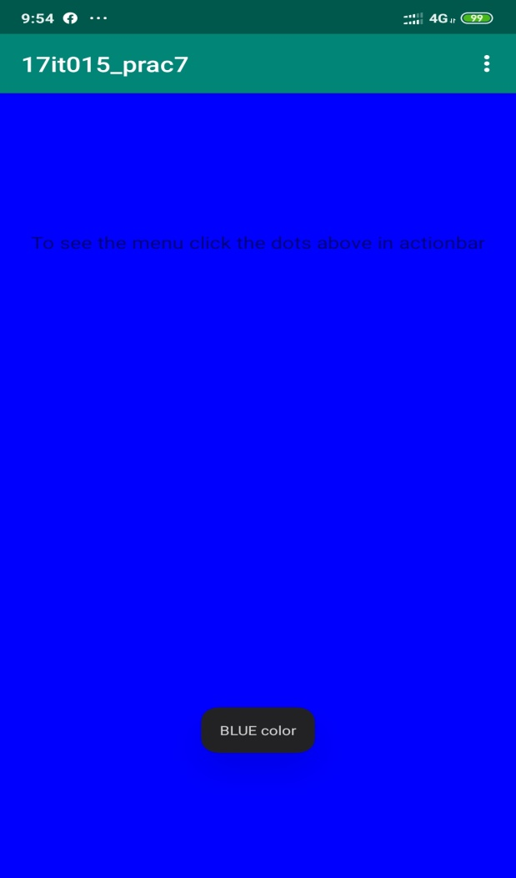

**LATEST APPLICATIONS:**

Snapseed,GFX tool,crickbuzz

**LEARNING OUTCOME:**

In this practical we learn how to display toast message in application and also how to use option menu and how to add actions on their items list.