**PRACTICAL 9**

**AIM:**

Create an application with the help of web view.

**THEORY:**

**EditText:** In android, EditText is a user interface control which is used to allow the user to enter or modify the text. While using EditText control in our android applications, we need to specify the type of data the text field can accept using input Type attribute. For example, if it accepts plain text, then we need to specify the inputType as “text”. In case if EditText field is for password, then we need to specify the inputType as “textPassword”.

**Permission:** Specifies a system permission that the user must grant in order for the app to operate correctly. Permissions are granted by the user when the application is installed (on devices running Android 5.1 and lower) or while the app is running (on devices running Android 6.0 and higher).\

**WebView:** WebView is a view that display web pages inside your application. You can also specify HTML string and can show it inside your application using WebView. WebView makes turns your application to a web application.

**CODE:**

|  |
| --- |
| **// MainActivity.java**  package com.example.wcmc_17it015_prac_9;  import androidx.appcompat.app.AppCompatActivity;  import android.os.Bundle;  import android.view.View;  import android.webkit.WebView;  import android.webkit.WebViewClient;  import android.widget.Button;  import android.widget.EditText;  public class MainActivity extends AppCompatActivity {  WebView w;  EditText t1;  Button b1;  @Override  protected void onCreate(Bundle savedInstanceState) {  super.onCreate(savedInstanceState);  setContentView(R.layout.activity_main);  b1 = findViewById(R.id.button);  t1 = findViewById(R.id.editText);  w = findViewById(R.id.webview);  w.loadUrl("http://kishandalsania.ml/");  b1.setOnClickListener(new View.OnClickListener() {  @Override  public void onClick(View v) {  w.getSettings().setLoadsImagesAutomatically(true);  w.getSettings().setJavaScriptEnabled(true);  w.setScrollBarStyle(View.SCROLLBARS_INSIDE_OVERLAY);  w.loadUrl(t1.getText().toString());  }  });  }  }  // **activity_main.xml**  <?xml version="1.0" encoding="utf-8"?>  <LinearLayout xmlns:android="http://schemas.android.com/apk/res/android"  xmlns:app="http://schemas.android.com/apk/res-auto"  xmlns:tools="http://schemas.android.com/tools"  android:layout_width="match_parent"  android:layout_height="match_parent"  android:orientation="vertical"  tools:context=".MainActivity">  <LinearLayout  android:layout_width="match_parent"  android:layout_height="wrap_content"  android:orientation="horizontal">  <EditText  android:id="@+id/editText"  android:layout_width="330dp"  android:layout_height="wrap_content"  android:hint="Enter Url"  android:inputType="textPersonName" />  <Button  android:id="@+id/button"  android:layout_width="wrap_content"  android:layout_height="wrap_content"  android:text="Go" />  </LinearLayout>  <WebView  android:id="@+id/webview"  android:layout_width="match_parent"  android:layout_height="match_parent"  android:layout_marginBottom="4dp" />  </LinearLayout>  **// AndroidManifest.xml**  <?xml version="1.0" encoding="utf-8"?>  <manifest xmlns:android="http://schemas.android.com/apk/res/android"  package="com.example.wcmc_17it015_prac_9">  <uses-permission android:name="android.permission.INTERNET"/>  <application  android:allowBackup="true"  android:icon="@mipmap/ic_launcher"  android:label="@string/app_name"  android:roundIcon="@mipmap/ic_launcher_round"  android:supportsRtl="true"  android:theme="@style/AppTheme">  <activity android:name=".MainActivity">  <intent-filter>  <action android:name="android.intent.action.MAIN" />  <category android:name="android.intent.category.LAUNCHER" />  </intent-filter>  </activity>  </application>  </manifest> |

**OUTPUT:**

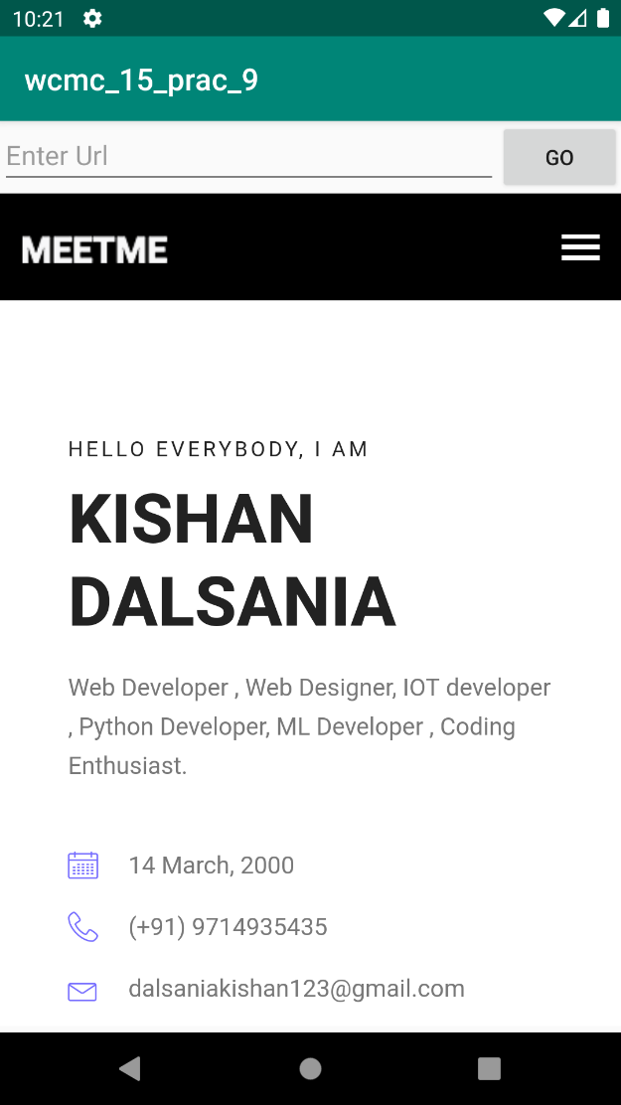



**LATEST APPLICATIONS:**

Quora , Reactnative , ArcadeHero etc…

**LEARNING OUTCOME:**

In this practical we learn how to display web pages inside our application and also we turn our application into Web application with the help of WebView and also how to take permission for using internet.