AmigaChrome · Feature focus · Tata

Tata looks after your Amiga
Before a program or a file loads, Tata checks it against a list of things known to crash or draw badly on AmigaOS 3.2.3 or with OpenUp, and asks you first. It's MIT licensed and free.
Why "Tata"
Amiga is Spanish for a girlfriend. Tata is Italian for a nanny. So Tata is the one who looks after her: quietly, in the background, and only speaking up when something she's about to do is known to go wrong.

How it works
1 It watches loading  Programs started from Workbench or a Shell, pictures and documents opened through datatypes, and files opened from Workbench all pass Tata on the way in. | 2 Name first, then size  Tata checks the name first, which costs almost nothing, then the size and a checksum only on a likely match. On AmigaChrome the checksum runs on the x86 or ARM64 cores. | 3 It asks you  "Don't run it this time", "Never run it", "Run it this time" or "Always run it". Your answer is kept in ENVARC:Tata/Decisions, plain text you can read.

What you see  The question says what the Team knows, what helps, and where the file is. The safe answer comes first, and if nobody answers it's taken for you. | In the taskspace  Tata's shield sits on the title bar beside the network, sound and settings icons: blue when it's on, grey when it's off, red for a minute after it has stopped something. Click it for Tata's window.
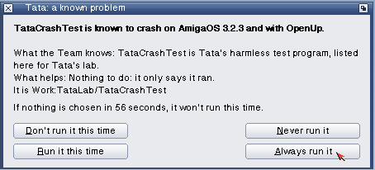 | 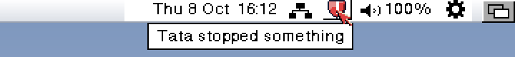

+22 µs  per program load, 377 → 399 µs | None  measurable change to start-up time

Tata's window: four pages, every action visible
- What happened: everything Tata checked, asked about or stopped, with times.
- Your decisions: every "always" and "never", each one changeable or forgettable.
- Known issues: the whole list, searchable, with what goes wrong, what helps and where the report came from. Drop a file on it to check it.
- Settings: on or off, how long the question waits, what Tata watches, and "Check the list for updates now".

Built to be safe: a nanny, not a gatekeeper
- Never in the way at start-up: nothing is asked while the Amiga boots; only your "always" and "never" answers apply.
- Libraries, devices and fonts are only noted, never made to wait.
- Every issue on the list has a source: something someone actually saw and wrote down. Nothing is guessed.
- From a Shell: Tata ON, OFF, STATUS, CHECK, LIST, FORGET and WINDOW.
Tata 0.1, today  Built and tested on AmigaOS 3.2.3, with the taskspace in OpenTitle 0.6 and ten known issues to start, from early OpenWrite and OpenPuTTY versions to old openrtg.library releases. | Coming next  The Team is checking Aminet's patches and system hacks against AmigaChrome to grow the list, then Tata joins OpenUp as an optional part.

AmigaChrome · amigachrome.com · Questions? Ask the Team on Facebook. © 2026 Dalsin Limited · github.com/DalsinAI

