AmigaChrome · Feature focus · Tata

Tata looks after your Amiga
Before a program or a file loads, Tata checks it against a list of things known to crash or draw badly on AmigaOS 3.2.3 or with OpenUp, and asks you first. It's MIT licensed and free.
Why "Tata" Amiga is Spanish for a girlfriend. Tata is Italian for a nanny. So Tata is the one who looks after her: quietly, in the background, and only speaking up when something she's about to do is known to go wrong.

How it works
1 It watches loading Programs started from Workbench or a Shell, pictures and documents opened through datatypes, and files opened from Workbench all pass Tata on the way in.

What you see The question says what the Team knows, what helps, and where the file is. The safe answer comes first, and if nobody answers it's taken for you.
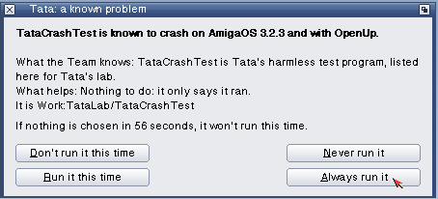

+22 µs per program load, 377 → 399 µs

Tata's window: four pages, every action visible
• What happened: everything Tata checked, asked about or stopped, with times.
• Your decisions: every "always" and "never", each one changeable or forgettable.
• Known issues: the whole list, searchable, with what goes wrong, what helps and where the report came from. Drop a file on it to check it.
• Settings: on or off, how long the question waits, what Tata watches, and "Check the list for updates now".

Built to be safe: a nanny, not a gatekeeper
• Never in the way at start-up: nothing is asked while the Amiga boots; only your "always" and "never" answers apply.
• Libraries, devices and fonts are only noted, never made to wait.
• Every issue on the list has a source: something someone actually saw and wrote down. Nothing is guessed.
• From a Shell: Tata ON, OFF, STATUS, CHECK, LIST, FORGET and WINDOW.
Tata 0.1, today Built and tested on AmigaOS 3.2.3, with the taskspace in OpenTitle 0.6 and ten known issues to start, from early OpenWrite and OpenPuTTY versions to old openrtg.library releases.

AmigaChrome · amigachrome.com · Questions? Ask the Team on Facebook. © 2026 Dalsin Limited · github.com/DalsinAI

