SE 4485: Software Engineering Projects

Fall 2024

Architecture Documentation

|  |  |
| --- | --- |
| Group Number | 3 |
| Project Title | Knowledge Management Assistant (Team B) |
| Sponsoring Company | The Fellows Consulting Group (FCG) |
| Sponsor(s) | Jeff Buchmiller |
| Students | 1. Blythe Williams 2. Nidhi Prakuzhy 3. Roj Pawig 4. Ashley Primrose 5. Humayl Sheryar 6. Dalton Brua |

# ABSTRACT

* brief summary of the entire document

# TABLE OF CONTENTS

# LIST OF FIGURES

# Figure 1.1 Architecture Model

# LIST OF TABLES

# INTRODUCTION

* introduction to the entire document
* purpose and scope of the document
* description of the structure of the document

# ARCHITECTURAL STYLE(S) USED

* Generic Layering
  + Three-Tier Client-Server Architecture
* How does the architecture support various features of your application?
  + For the first tier, the presentation tier, this will handle some example use cases such as user input/output, logging in, changing passwords, and viewing history. Second tier would be the application tier where the features supported will handle processing tasks such as web scraping, gathering and processing information from previous searches, and so on. For the last tier, which is the data tier, the features supported would include saving or retrieving previous queries as well as ensuring that our application can hold data/queries.

# ARCHITECTURAL MODEL

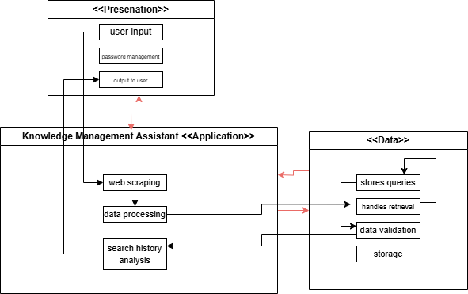

Figure 1.1 Architecture Model

* Three tiers:
* What they represent:
  + Presentation subsystem: (input/outputs) -> user login, user interaction, password management, output to user. Tech used -> ReactJS.
  + Application subsystem: web scraping, data processing, search history analysis. Tech used -> Python with API integration.
  + Data subsystem: stores previous search queries, handles retrieval, data validation, storage. Tech used -> MongoDB, Github.
* How the architecture interacts with each other:
  + Presentation subsystem interacts with Application subsystem.
  + Application subsystem interacts with both data and presentation subsystems.
  + Data subsystem interacts with Application subsystem.
* What the interactions are for:
  + The presentation subsystem interacts with the Application subsystem because the presentation will send requests to the application.
  + With the interactions between the application subsystem, it takes the requests from the presentation subsystem. After the application processes the data, it sends over the query to the data subsystem and waits for the data subsystem to send back data validation. Once data validation has been completed, the application processes the recent history and sends back the query to the presentation subsystem for the user to see the output.
  + The data subsystem interactions between the application is just a transfer of data. The application requests data validation and the data layers requests data to store and validate.

# TECHNOLOGY, SOFTWARE, AND HARDWARE USED

* Python 3.8
* ReactJS
* MongoDB
* GitHub

RATIONALE FOR YOUR ARCHITECTURAL STYLE AND MODEL

TRACEABILITY FROM REQUIREMENTS TO ARCHITECTURE ~ Roj

* provide a mapping between requirements and architecture
* clearly describe how each requirement in the *Requirements Documentation* is captured in the architecture
* TABLE/GRAPHIC

|  |  |  |
| --- | --- | --- |
| REQUIREMENT 1 | ARCHITECTURE 1 | DESCRIPTION |

EVIDENCE THE DOCUMENT HAS BEEN PLACED UNDER CONFIGURATION MANAGEMENT

ENGINEERING STANDARDS AND MULTIPLE CONSTRAINTS

* IEEE Std 1471-2000: Software Architecture
* ISO/IEC/IEEE Std 42030:2019: Software, Systems and Enterprise   
  – Architecture Evaluation Framework

ADDITIONAL REFERENCES

* Lattanze, A.J., 2008. *Architecting Software Intensive Systems: A Practitioner’s Guide*. CRC Press
* Bass, L., Clements, P. and Kazman, R., 2003. *Software Architecture in Practice.* Addison-Wesley