**Chapter 1 questions**

**2: How do data communications networks support the four core capabilities of MIS?**

Page 3

1. Storing and Retrieving Data –
   1. (From the book) “Just like humans live in houses, data created by businesses and societies must live somewhere. The ‘house’ for data is a database. There are many different kinds of databases, just like many different kinds of houses. The most frequently used database in organizations is an SQL database.”
   2. This simply explains where data is stored and that it’s commonly in a SQL database.
2. Analyzing and Visualizing Data –
   1. (From the book) “Managers need to be able to make decisions regarding their business such as: What is our bestselling product? Which regions bring in the most revenue? Data is retrieved from a database and imported to a software like Excel, Tableu, or PowerBI so that these business questions can be answered using a variety of techniques (e.g., aggregation, conditional aggregation, and charting).”
   2. This explains that you need to be able to see and analyze the data to make decisions such as what is selling, what isn’t, and where
3. Automating Data Operations –
   1. (From the book) “Many business operations are repeated over and over again, such as calculating the total amount of a items bought at a local store or an e-commerce web site, applying any discounts, and determining appropriate taxes. To automate these kinds of every day transactions on data we have a wide variety of IT we can buy or build using a variety of programming languages.”
   2. This means that why do the same thing over and over when you can automate it and it can be more efficient and accurate
4. Protecting Data –
   1. (From the book) “The first three core capabilities are designed to make it easy to store and access data. However, this means that an intruder or malicious employee could also access the data. Therefore, organizations must spend resources to protect their data. We will discuss security capability in Chapter 11.”
   2. This shows that we have to protect data so if someone has bad intentions we are able to protect ourselves and our customers/clients

**3: Discuss three important applications of data communications networks in business and personal use.**

Is not directly said, however, can be implied, page 5 of the book, “They also provide message transfer services to allow computer users to talk to one another via email, chat, and video streaming.” So this would make my answer email, chat and video streaming or more in general email, the Internet, and video streaming/conferencing/calls.

**9: There are three computers that make the Internet work. Name them and describe their similarities and differences.**

Question is a little confusing and isn’t directly stated, however, I am assuming in this case we’ll make Internet the same as network, and will be a client, server, and router, and not a circuit, or a web server, mail server, or file server.

Page 7 of the book, “There are three computers that make networks what they are. These are the client, the server and the router”

Client – Initiates a communication with the server by sending a request to the server

“Only the client has a screen, keyboard and mouse.”

Server – Receives the request from the client and processes it, responds with a response

“Purpose not to receive an input from the user…”

Router – Makes the connection possible

**10: Why are network layers important?**

Network layers are important for a variety of reasons.

On page 8 of the book, it states that network layers are important so that vendors can develop software and hardware in order to provide for each layer individually. As well, the software or hardware can work in any manner and can be updated and improved easily as long as the interface between the layers and ones around them are unchanged.

Page 14 says the pros of layers are that there are many different software packages and many different PDUs that operate at different layers to ensure a successful transfer of message. Secondly, each layer in one computer must be able to communicate with its matching layer, and third, the con is that using a layered network model can be somewhat inefficient.

**11: Describe the seven layers in the OSI network model and what they do.**

Page 9, 10

Physical layer – Transmitting data bits over a communication circuit. Defines rules by which ones and zeros are transmitted, and physical format of the cables and connectors used.

Data link layer – Manages the physical transmission circuit in layer 1 and transforms it into a circuit that is free of transmission errors, solve problems caused by damaged, lost, or duplicate messages.

Network layer – Performs the routing

Transport layer – Deals with end-to-end issues, procedures for entering and departing the network. Establishes, maintains and terminates logical connections for the transfer of data between the original sender and the final destination of the message

Session layer – Responsible for managing and structuring all sessions. Arrange for all the desired and required services between session participants.

Presentation layer – Formats the data for presentation

Application layer – End user’s access to the network, provide a set of utilities for application programs.

**12: Describe the five layers in the Internet network model and what they do.**

Page 11

Physical layer – Physical connection between the sender and the receiver, transfer a series of electrical, radio, or light signals through the circuit. Includes all the hardware devices and physical media

Data link layer – Responsible for moving a message from one computer to the next computer

Network layer – Same function as network layer in OSI model. Performs routing

Transport layer – Responsible for linking the application layer software to the network and establishing end-to-end connections between sender and receiver, and is responsible for breaking long messages into several smaller messages

Application layer – Application software used by he network user, includes much of the application, presentation, and session layers of OSI model

**13: Explain how a message is transmitted from one computer to another using layers.**

Page 12 and 13 of the book

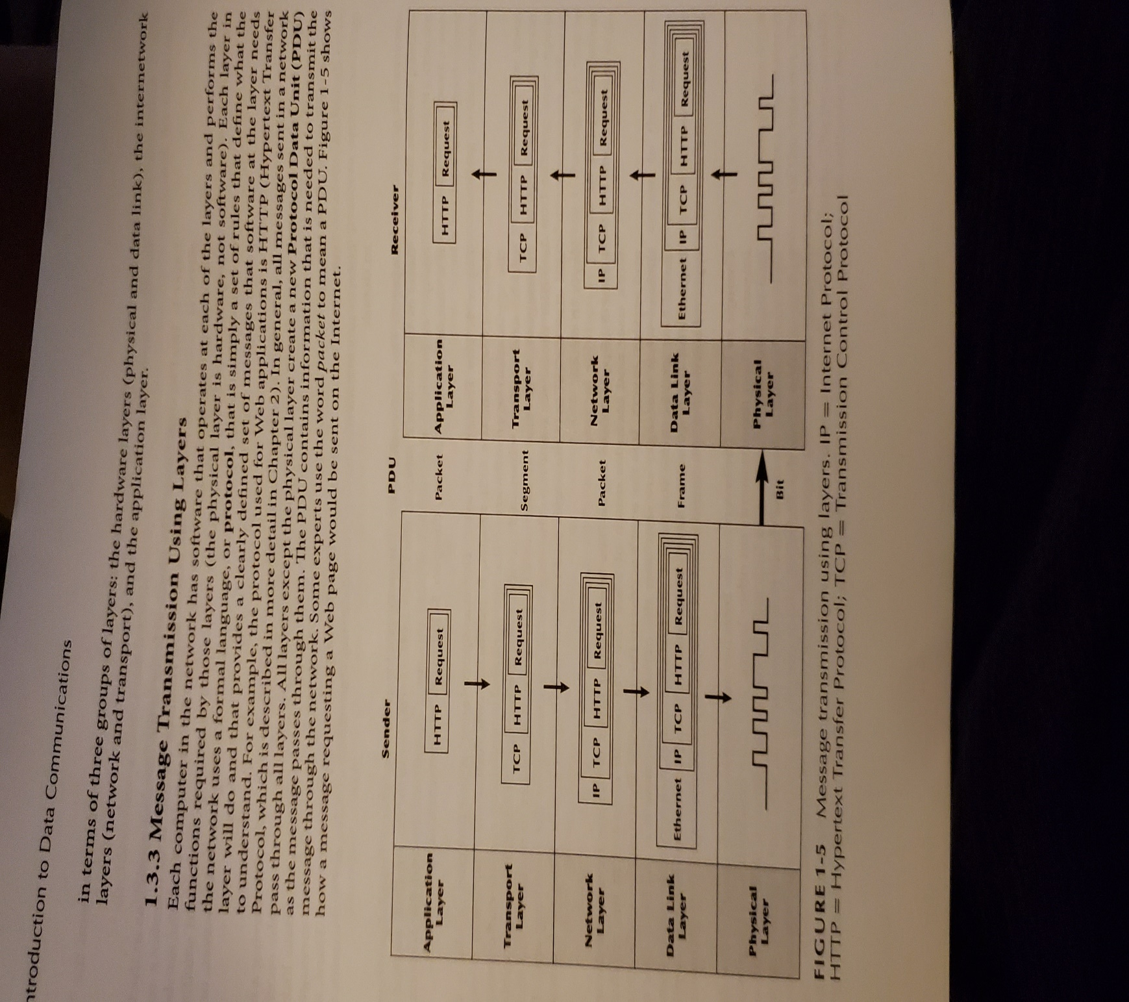

Message requesting a web page

Application layer – First the user creates a message, browser translates the user’s message into HTTP, web browser fills in necessary information in the HTTP packet, puts user’s request in packet, passed HTTP packet to transport layer

Transport layer – TCP protocol, breaking large files into smaller packets, places HTTP packet into TCP PDU, fills in the information for TCP segment, passes it to network layer

Network layer – Protocol called IP, selects next stop on the message’s route through the network, places TCP Segment inside IP PDU, sends IP packet to data link layer

Data link layer – Formats message with start and stop markers, adds error checks, places IP packet inside Ethernet PDU, instructs physical layer

Physical layer – Takes ethernet frame and sends it as a series of electrical pulses, process is then done in reverse when server gets message

**16: Describe two important data communications standards-making bodies. How do they differ?**

Page 15

International Organization for Standardization – Stands for ISO, makes technical recommendations about data communication interfaces, ISO is based in Geneva, membership is composed of national standards organization of each ISO member country

International Telecommunications Union-Telecommunications Group – Known as ITU-T, technical standards-setting organization of the United Nations International Telecommunications Union, composed of representatives from about 200 member countries, has members of public and private organizations who operate computer or communications networks or build software and equipment for them

**18: Discuss three trends in communications and networking.**

Page 18

Bring Your Own Device – (BYOD) , great way to get work quickly, saves money, and makes employees happier however can bring in a lot of problems

Internet of Things – (IoT) Unified communications, phones plugged into computers or directly into LAN using VoIP, computers and networks build into everyday things such as kitchen appliances, smart devices becoming more common

Multiplayer games – Thousands of players together in real time, as well as not just games but educational platforms

**19: Why has the Internet model replaced the OSI model?**

Page 10

Dominates current hardware and software, is a more simple five-layer model

Unlike OSI model, which was developed by formal committees, the Internet model evolved from thousands of people who developed pieces of the Internet, and has never been formally defined, has to be interpreted from a number of standards

I pledge that on all academic work that I submit, I will neither give nor receive unauthorized aid, nor will I present another person's work as my own.

*Dalton Murray*