**8A**

**1.**

**Network map:**

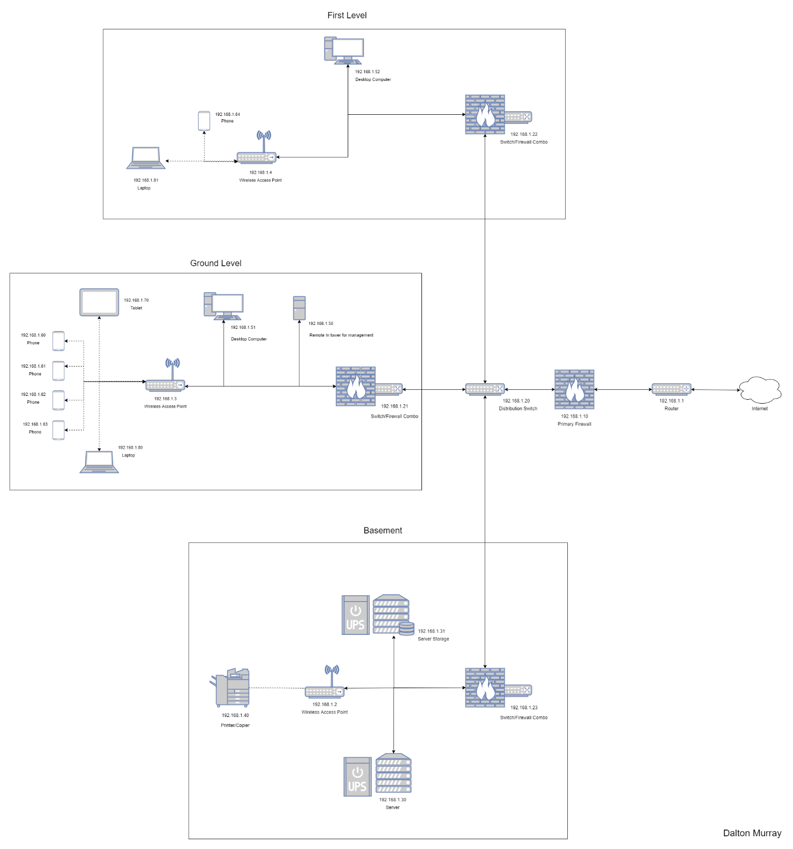

**Describe two to five components on your map just like the example in the textbook shows.**

Within this network map we go directly from the Internet to our router. Our router handles all incoming/outgoing traffic eventually unless the traffic is from one device in the network to another device within it and not going to the outside Internet. We then go from the router to the firewall so we can stop traffic before it even hits our distribution switch. From the firewall it goes into our distribution switch which is connected to 3 other firewall/switch 2-in-1. We liked the idea of having firewall/switched so that if something were to start from within it won’t be able to get out and cause security problems. It is also important to note that each floor for looks has been separated with a surrounding box, however, this is mostly just for looks and serves no real function.

On the basement we go from the firewall/switch to our server, server storage rack, as well as an access point for our wireless printer/copier.

On the ground level we go directly into a tower which servers as kind have a security check point which helps control of other devices and is meant to only be remoted into as it doesn’t have a monitor, keyboard, or mouse. We also are directly connected into a desktop computer and directly connected to an access point which has 4 phones, 1 tablet, and 1 laptop connected to it.

On the first level we go directly into a desktop computer as well as a wireless access point which is then connected to a desktop computer and phone.

All of my switches are 24 port switches, the distribution switch is 10 Gbps, the ground level switch and basement switches are also 10 Gbps and the first-floor switch is 1 Gbps. All these switches are also Cisco switches.

The server which I have is in the basement for cooling purposes as well as a few other purposes, sound being one of those other reasons. This server is doing a wide variety of things for me such as handling game servers, websites, self-hosted tools, and many other things.

**2. Use the system information and provide additional information (e.g., MAC address and card manufacturer) about at least two devices on your network.**

Device 1:

Desktop Computer

MAC address: 24-4B-FE-BA-EB-86

Manufacturer: Realtek PCIe GbE Family Controller

Device 2:

Router

MAC address: 00-10-7b-3a-92-3c

Manufacturer: CISCO Systems, Inc.

Unfortunately, I am unable to provide a screenshot for this device as I have the MAC address written down and know the manufacturer off the top of my head and I am currently living on-campus and wouldn’t really be able to provide a screenshot.

**8B**

1. I have attached a copy of my entire network diagram as a PNG file so it can be more easily accessible than embedding it into word

Please note this has 3 sections for floors 3-8, the first being the west wing, the second being the regular floor, then the third being the east wing. However, this same exact design is repeated for floors 3-8 so I didn’t copy and paste the design 5 more times to make all the floors because it was being very laggy, though, I will still include every floor in my price calculations. I also included floors 4-8 in the backbone/overall network design with the equipment to make sure they work, however, the floors themselves just aren’t there.

1. Price breakdown

**First Floor/Lobby with offices**

Switches:

Ethernet 10/100/1,000 Base-T 48 port switch: $300

Upgrades:

Include PoE: $75

300 + 75 = $375

375 * 1 = $375

Wireless Access Points:

802.11 managed wireless access point with PoE: $200

200 * 4 = $800

Wi-Fi Controller With PoE 8-ports: $300

300 * 1 = $300

800 + 300 = $1,100

Cable:

UTP Cat 6 (1,000 Base-T or slower): $60

60 * 48 = $2,880

First Floor Total:

375 + 1,100 + 2,880 = $4,355

**Second Floor/Meeting areas**

Switches:

Ethernet 10/100/1,000 Base-T 48 port switch: $300

Upgrades:

Include PoE: $75

300 + 75 = $375

375 * 1 = $375

Wireless Access Points:

802.11 managed wireless access point with PoE: $200

200 * 2 = $400

Wi-Fi Controller With PoE 8-ports: $300

300 * 1 = $300

400 + 300 = $700

Cable:

UTP Cat 6 (1,000 Base-T or slower): $60

60 * 54 = $3,240

Second Floor Total:

375 + 700 + 3,240 = $4,315

**Third-Eighth floors**

Switches:

Ethernet 10/100/1,000 Base-T 48 port switch: $300

Upgrades:

Include PoE: $75

300 + 75 = $375

375 * 17 = $6,375

6,375 * 6 = $38,250

Wireless Access Points:

802.11 managed wireless access point with PoE: $200

200 * 108 = $21,600

Wi-Fi Controller With PoE 48-ports: $500

500 * 3 = $1,500

21,600 + 1,500 = $23,100

23,100 * 6 = $138,600

Cable:

UTP Cat 6 (1,000 Base-T or slower): $60

60 * 748 = $44,880

44,880 * 6 = $269,280

Floor 3-8 total:

38,250 + 138,600 + 269,280 = $446,130

**Building Backbone:**

Routers:

Ethernet 1000 Base F 8-port: $1,000

1,000 * 3 = $3,000

Cable:

UTP Cat 6 (1,000 Base-T or slower): $60

60 * 12 = $720

Fiber 1GbE: $100

100 * 6 = $600

720 + 600 = $1,320

Building Backbone Total

3,000 + 720 + 1,320 = $5,040

**Grand Total**

4,355 + 4,315 + 446,130 + 5,040 = $459,840

The final price for all equipment for the entirety of the building plus building backbone needs is $459, 840. However, I believe this price definitely can be smaller or larger depending on if there are discounts, products, as well as real costs.

I pledge that on all academic work that I submit, I will neither give nor receive unauthorized aid, nor will I present another person's work as my own.

Dalton Murray