**10A**

**1.**

Trace route to cnn.com

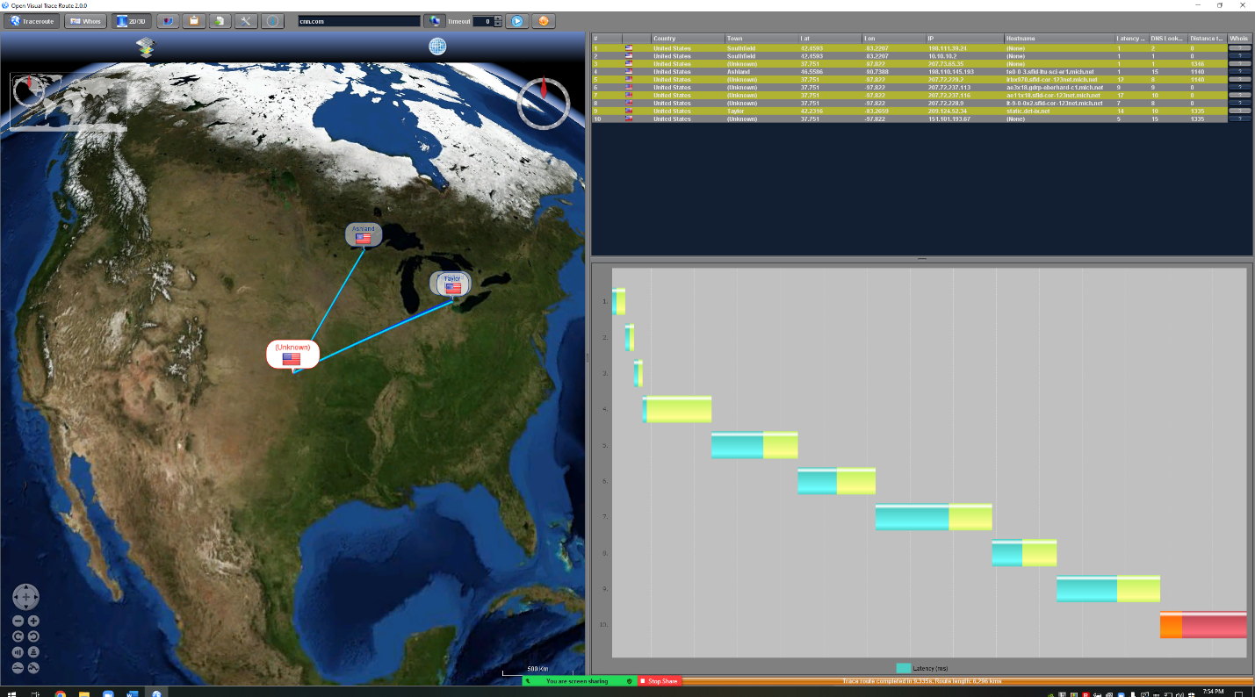

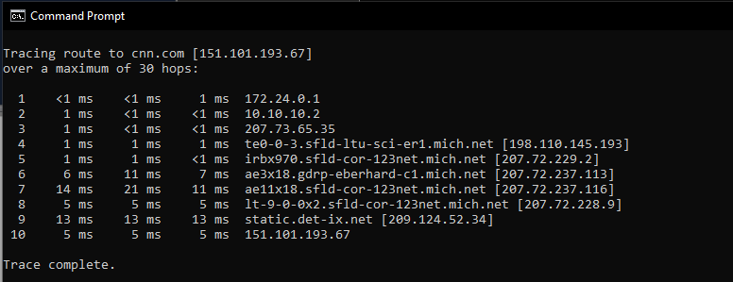

Trace route to [www.ox.ac.uk](http://www.ox.ac.uk)

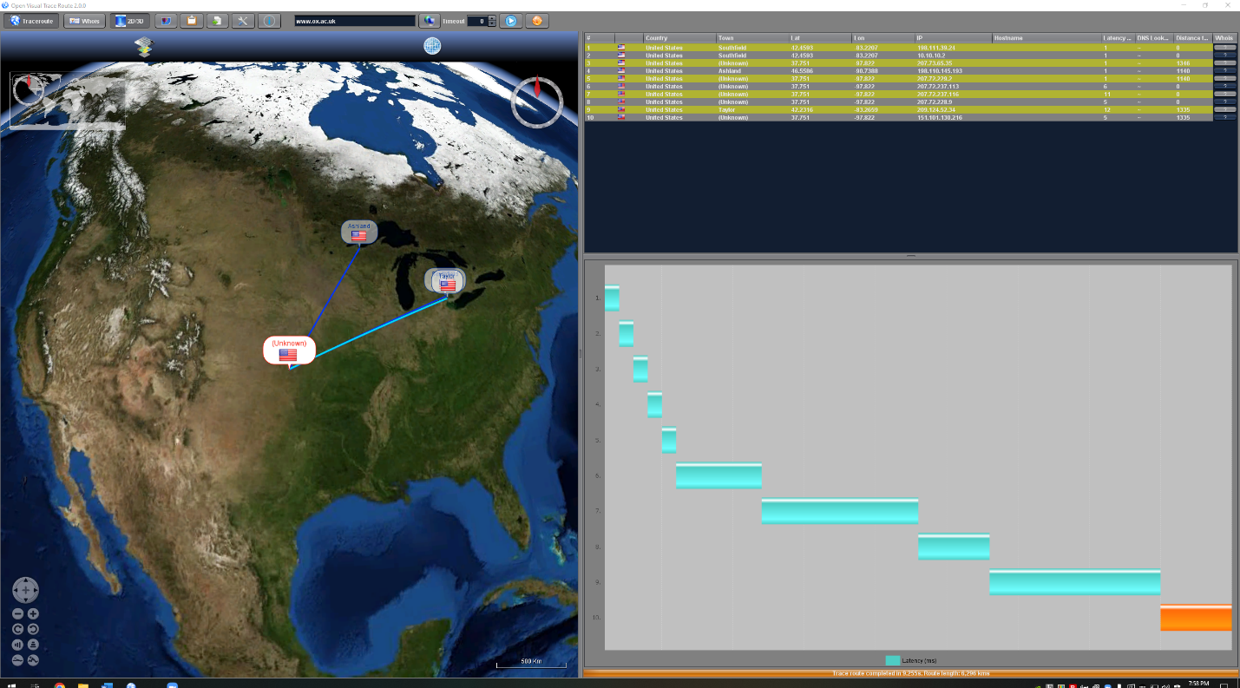

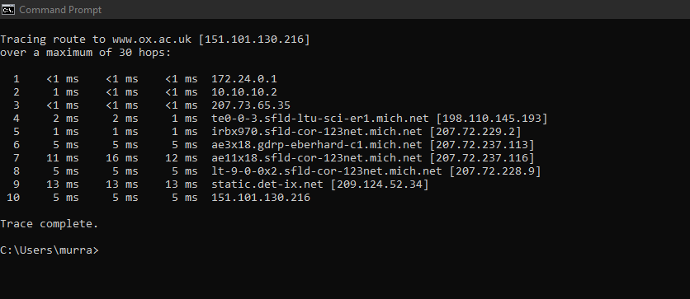

**2.**

**Overall:**

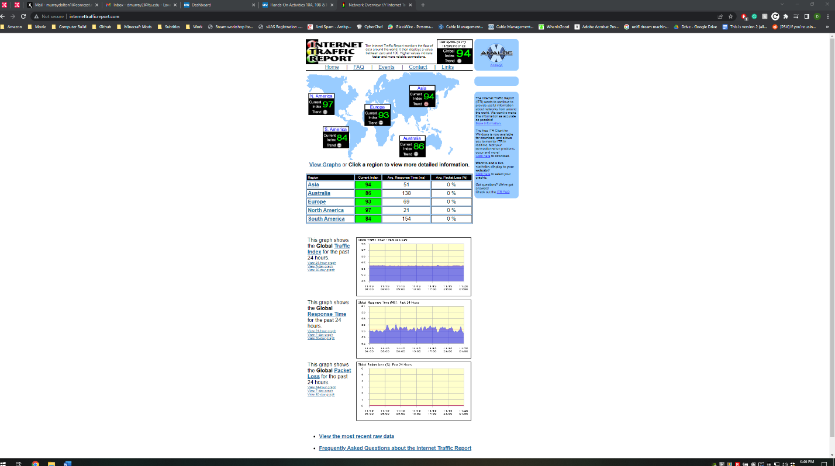

**Asia:**

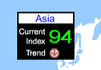



**Average Response Time:**

51 ms

**Average Packet Loss:**

0%

**Australia:**

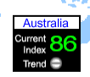



**Average Response Time:**

138 ms

**Average Packet Loss:**

0%

**North America:**

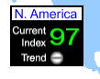



**Average Response Time:**

21 ms

**Average Packet Loss:**

0%

**Router in North America:**

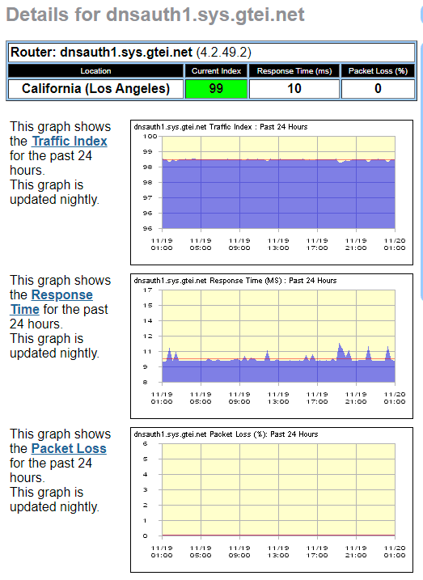

**Router:**

dnsauth1.sys.gtei.net (4.2.49.2)

**Typical Response Time past 24 hours:**

10 ms

**Typical Packet Loss past 24 hours:**

0%

**3.**

The closest connection between Chicago and Atlanta by Internet 2 with the shortest amount of jumps currently has a traffic usage of 7.4% between Chicago and Cincinnati and between Cincinnati and Nashville is also approximately 3% and between Nashville and Atlanta approximately 2%. These same connections/jumps are also having almost identical/approximate percentages in their peak 24 hours.

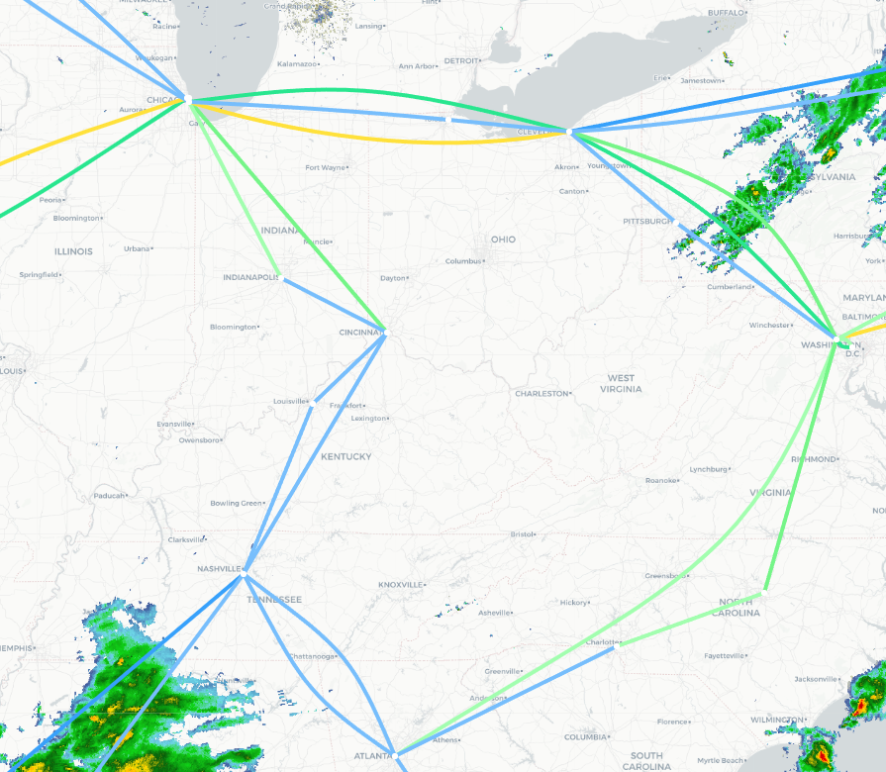

**10B**

**Server close to me:**

Wayne State University, Detroit, Michigan

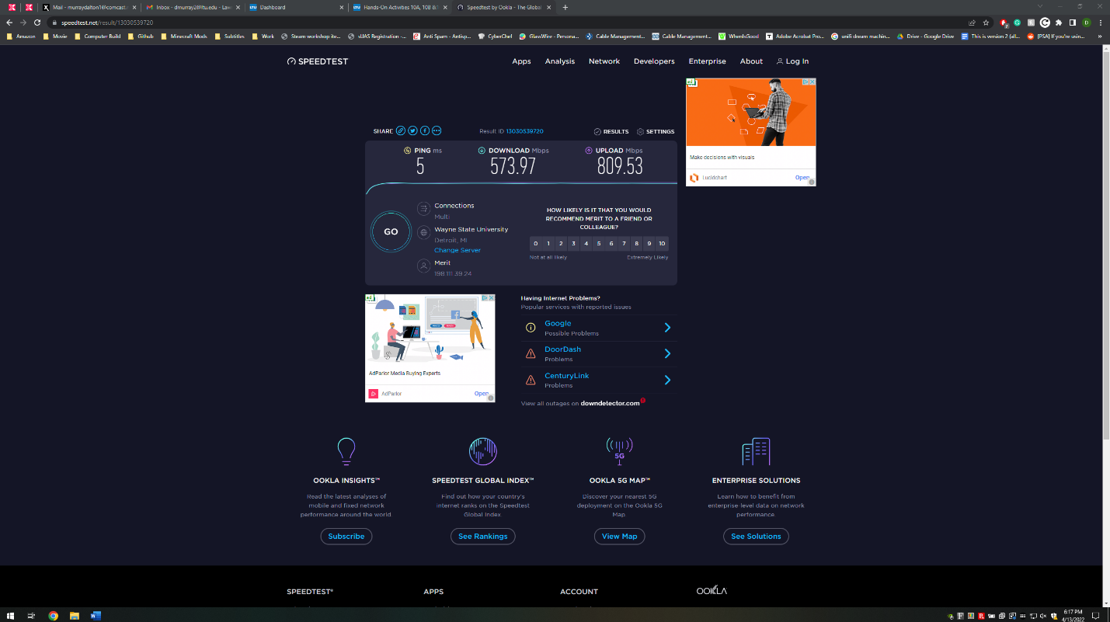

**Server far from me:**

Telstra, Sunshine Coast, Australia

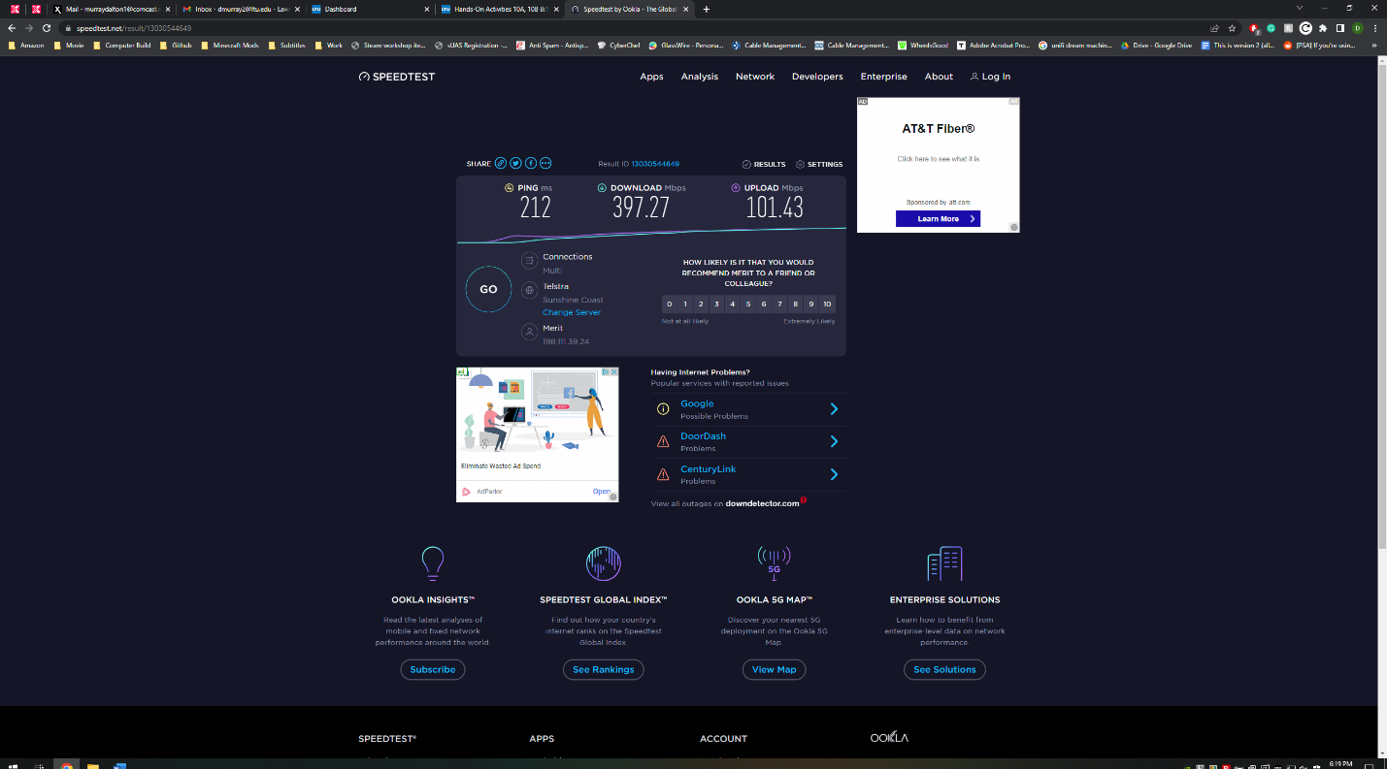

**10C**

Out of the available Internet Services we are allowed to pick on Figure 10-8, I chose to use FTTH which has a 1 Gbps up and down speed and costs $150/month. I chose to use this because firstly it is not very expensive, and secondly it will be good to use it and to keep it for a while as it will prove to be useful in the future instead of needing to upgrade immediately. This is also good because the highest tier in Cable Modem is 200 Mbps up/down and costs $175/month which shows that FTTH is less expensive and is faster than the highest available option in Cable Modem. 200 Mbps up/down also might limit their speeds where 1 Gbps will be very beneficial to have especially as it is a circuit for an entire residence hall and be used as a backup for their Internet 2 connections (FitzGerald, J. p. 288).

References:

FitzGerald, J., Dennis, A., & Durcikova, A. (2021). Business data communications and networking (Fourteenth). Wiley.

I pledge that on all academic work that I submit, I will neither give nor receive unauthorized aid, nor will I present another person's work as my own.

Dalton Murray