A neural network in which at least one layer is **a convolutional layer**. A typical convolutional neural network consists of some combination of the following layers:

1. *Convolutional Layer*: A layer of a deep neural network in which a convolutional filter passes along an input matrix. For example, consider the following 3x3 convolutional filter:

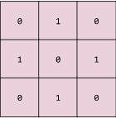



1. *Pooling:* Reducing a matrix (or matrices) created by an earlier convolutional layer to a smaller matrix. Pooling usually involves taking either the maximum or average value across the pooled area. For example, suppose we have the following 3x3 matrix.

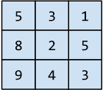

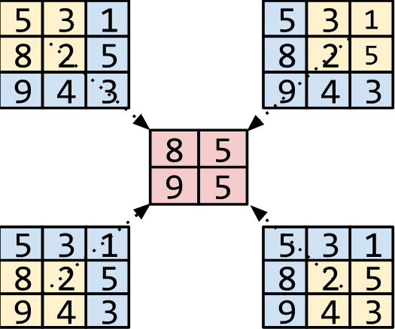

1. *Dense layer*: A generate layer in a neural network between the input layer ( features) and the output layer (predictions). Hidden classes usually contain a functional activity (such as ReLU: If is a number or not, is 0 and back up by first into) for training.

Convolutional neural networks have had great success in certain kinds of problems, such as image recognition.