CURVES
Robert E. Clay
Since a curve is given as the range of a function, there are many different functions that yield the same curve. Intuitively, this means that there are many different ways to draw the same curve: we can draw it quickly or draw it slowly; we can draw it going in one direction or the other. We don't care how it is drawn; we are interested in the geometric properties of the curve. For simplicity, we don’t consider the case in which a segment or all of the curve is retraced.

We begin with plane curves.

Consider the example
r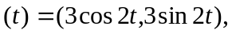 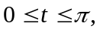 i.e. 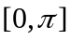,
with the domain (the line segment) and the range (the circle) pictured below.
0 t
r(0) = (3,0)
If we consider r as taking the interval [0,], placing the point 0 onto (3,0) and then stretching and bending the interval around counter-clockwise to form the circle, we have an intuitive idea of what the function does.

We wish to decompose r into two functions: s, which is pure stretching, and R, which is pure bending.

The circle has circumference 2r = 2(3) = 6. [0,] has length . Thus, [0,] must be stretched by 6/6 =6, in order to draw the circle. Now consider r(0) and r(/4). The length of the arc between them is (6/4)/(/4) = 6. So [0,/4] must be stretched by a factor of 6 as well.

r(/4)

r(0)

Thus, the stretching factor seems to be 6. (Not all functions stretch so uniformly as this function.)

s = the range length = the arc length = 6 = the stretching factor,
t domain length domain length

so s = 6t (or s(t) = 6t) is the stretching function.

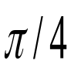
s-axis
6
/4
0
6
t-axis
0

s(t)
Note that both the t-axis and the s axis are straight lines. Thus the function s stretches the t-axis but does not bend it.

Now consider the picture below.

t-axis
s-axis
0
0
6
/4
R
s(t)
r(
/4) = R(6
/4)
r
6
r(/4) = (0,3) and s(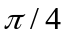) = (6/4).
r takes /4 directly to (0,3) and s takes /4 to 6/4.
We now define the function R from the s-axis to the circle which takes 6/4 to (0,3).

Since s = 6t, then t = s/6. Replacing t by s/6 in r(t), we get
R(s) = (3cos s/3, 3sin s/3), where s [0,6]
We see that
R(0) = (3,0) = r(0) and R(6/4) = (0,3) = r(/4).
So, R takes the interval [0,6/4] to the arc between (3,0) and (0,3). The length of this arc is 6/4, which is exactly the length of the interval on the s-axis. Thus, R has not stretched the s-interval [0,6/4]; it has only bent it to form the quarter circle. Thus,
R(s) = (3cos s/3, 3sin s/3),
is the bending function.

Now, r(/4) = R(6/4) = R(s(/4)). In general, we may consider any t on the t-axis. If we first apply s to this t to get to the s-axis and then apply R to get to the circle, we get to the same place as if we applied r directly to t, i.e.

r(t) = R(s(t)) or r = Rs.

Thus, we have decomposed r into two functions,
s, which is pure stretching and
R, which is pure bending.

Now let us consider the general case. Refer to the picture below.
r(t) = (x(t),y(t)).
t
t
r(t
)
r(t)
Choose any point t on the t-axis and fix it. Now choose a general t. We will suppose that as t increases, r(t) is formed as the arrows indicate. The interval [t,t] must be stretched and bent in order to form the part of the curve between r(t) and r(t). In our picture it looks like it is stretched by a factor of about 3. In general, the length of [t,t] must be stretched to the length of the arc between r(t) and r(t).
Recall that the formula for arc length is
s(t) = s = 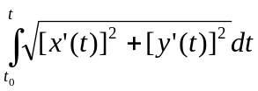
This is the stretching function.
(The notation in the integral is bad since t is used both as the variable of integration and the upper limit of the integral. But we all know what we mean.)

We now introduce the s-axis.
From the formula for s, s(t) = 0.
t
t
R(0) =r(t
)
r(t) = R(s)
0
s
s(t)
R
r

We now introduce the function R, which takes s directly to r(t). (See the picture above). The length of [0,s] is exactly the length of the arc between R(0) and R(s), so that R only bends the interval – it does not stretch it. Again,

r(t) = R(s(t)) or r = Rs.

So we have decomposed r into
s, a pure stretching function and
R, a pure bending function.

In our example of the circle, let us show that s = 6t is indeed the correct stretching function.
r(t) = (3cos2t,3sin2t)
r'(t) = (x'(t),y'(t)) = (-6sin2t,6cos2t)
s(t) = 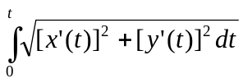 =
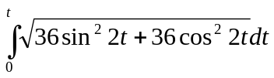 = 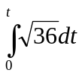 = 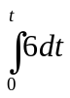 = 6t] = 6t.
Thus, s = 6t is indeed the stretching function.

In general, r’(t), i.e. dr/dt, gives the tangent vector at r(t). On the circle,
r'(t) = (-6sin2t,6cos2t).
At t = 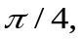
r'() = (-6sin/2,6cos/2) = (-6,0) is a tangent vector.
IIr'(/4)II = 6, which is the stretching factor. Later, we shall show that IIr'(t)II always gives the stretching factor.

r'(
/4) = (-6,0)
R'(6
/4) = (-1,0)
r(
/4) = R(6
/4)
(3,0)
Now consider R(s) = (3cos s/3,3sin s/3), the pure bending function for the circle.
R'(s) = dR/ds = (-sin s/3,cos s/3).
Since r(/4) = R(6/4), we evaluate R' for s = 6/4.
R'(6/4) = (-sin/2,cos/2) = (-1,0), which is also a tangent vector at the same point.
IIR'(6/4)II = II(-1,0)II = 1.
This fits our intuition. Since R does no stretching, its stretching factor should be 1.

We now return to the general case.
r(t) = (x(t),y(t))
IIr'(t)II = 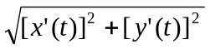
Now the stretching factor should be given by the change of arc length with respect to the domain length, i.e. ds/dt. Since
s =
by the Second Fundamental Theorem of the Calculus,
ds/dt = .
Comparing this with IIr'(t)II above, we see that ds/dt = IIr'(t)II, so
IIr'(t)II is the stretching factor.
So the length of the tangent vector gives the stretching factor.

For R, its derivative is R'(s) or dR/ds, so the stretching factor for R should be given by IIdR/dsII. Since R does no stretching, its stretching factor should be 1. Let us show that is the case, i.e. that dR/ds is a unit vector.
Now r(t) = R(s(t)),
so by the Chain Rule,
dr/dt = r'(t) = (dR/ds)(ds/dt), so
dR/ds = (dr/dt)/(ds/dt) = r'(t)/(ds/dt) = r'(t)/IIr'(t)II, since ds/dt = IIr'(t)II.
For any vector v, v/IIvII is a unit vector. Therefore,
dR/ds = r'(t)/IIr'(t)II, is a unit vector, i.e. II dR/dsII = 1.
So dR/ds gives the unit tangent vector.

Definition. T = dR/ds = R'(s) is the unit tangent vector.

Returning to the example of the circle, let us consider a few unit tangent vectors. for instance,
at s = 6/4, R'(6/4) = (-1,0) and at s = 18/4, R'(18/4) = (1,0).
T = R'(6
/4) = (-1,0)
r(
/4) = R(6
/4)
(3,0)
r(3
/4) = R(18
/4)
T = R'(18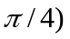= (1,0)
Note that r'(t)/IIr'(t)II also gives the unit tangent vectors.
at t = /4, r'(/4)/II r'(/4)II = (-6,0)/6 = (-1,0) and
at t = 3/4, r'(3/4)/IIr'(3/4)II = (6,0)/6 = (1,0),
So we may use either the t's or the s's to calculate the unit tangent vectors.

**Note that the unit tangent vectors change as the curve bends. So we can use the change in the unit tangent vectors to measure the bending. In the Calculus we use the derivative to measure change. But to take a derivative, we need a function. So we need to consider the unit tangent vectors as the values of some function. So we need a domain. We have two obvious choices, the t-axis and the s-axis. If we use the t-axis, we will introduce the stretching (we will show this later) which we worked so hard to eliminate. Thus, we shall use the s-axis as the domain. To reiterate: if one is only interested in the Unit Tangent Vector, it makes no difference if we use the t's or the s's to calculate it; but it makes a big difference in the derivative whether we take dT/dt or dT/ds.**

Please read this note again.

Let us return to the example of the circle.
T = T(s) = R'(s) = (-sin s/3,cos s/3).

dT/ds = R''(s) = ((-1/3)cos s/3, (-1/3)sin s/3))

at s = 6/4, dT/ds = (0,-1/3) and at s = 18/4, dT/ds = (0,1/3)

In the picture below the vectors T and dT/ds are not drawn to scale, since they would be too short to illustrate the point well.

T = R'(6
/4) = (-1,0)
dT/ds = (0,-1/3)
dT/ds = (0,1/3)
r(
/4) = R(6
/4)
T = R'(18/4) = (1,0)
r(3/4) = R(18/4)
(3,0)
Note that dT/ds is perpendicular to T. Later, we shall show that this always happens.
Now, dT/ds is a vector – it has both magnitude (length) and direction. dT/ds measures the rate of change of the unit tangent vector T. Since T is a unit vector, its length never changes, so the only change that dT/ds measures is the change in direction of the unit tangent vector, i.e. the bending of the curve. IIdT/dsII measures the magnitude (amount) of the bending. In the two cases above, IIdT/dsII = 1/3. This indicates, as intuitively clear, that the amount of bending at the top of the circle is the same as the amount of bending at the bottom of the circle. In general, the larger the IIdT/dsII, the tighter or greater the bending.

Also note that IIdT/dsII =1/3, which is just the reciprocal of the radius of the circle. In addition, the direction of dT/ds indicates the direction of the bending, i.e. the direction of the concavity. At the top of the circle, dT/ds is pointing straight down because the concavity of the curve is facing straight down. At the bottom of the circle, dT/ds is pointing straight up because that is the way that the curve is facing.

Now let us return to the general case.

We indicate a few unit tangent vectors on the picture below. Note that the unit tangent vectors (as do all tangent vectors) point in the direction in which the curve is "drawn".
T
T
T
As we saw before,
T = dR/ds = r'(t)/IIr'(t)II,
so we may use either the t's or the s's to calculate T.

Again, the unit tangent vector changes as the curve bends, so we can use the unit tangent vector to measure that bending,
Now re-read the note between ** and **. If we use the t-axis, by the Chain Rule,
dT/dt = (dT/ds)/(ds/dt),
we have reintroduced the stretching factor (underlined) that we worked so hard to eliminate. So we use the s-axis and consider T = T(s).

Since T is a unit vector,
T T = IITII = 1 = 1.
Thus, taking derivatives of both sides, we have
(T T)' = (T T ') + (T ' T) = 2((T T ' ) = 0
So T and T ' are perpendicular.

dT/ds is a vector, so it has both magnitude and direction. dT/ds measures how the unit tangent vector changes. Since the length (magnitude) does not change, the change that dT/ds measures is the change in direction, i.e. the bending of the curve.

IIdT/dsII gives the magnitude (amount) of the bending. The tighter (greater) the the bending, the greater will be IIdT/dsII.

Definition. IIdT/dsII = = (s) is called the curvature, i.e. the amount of bending.
(The symbol is the Greek letter kappa.)

The direction of dT/ds shows how the curve is positioned. It is pointing in the direction that the concavity is "facing".

As we recently saw, T and T ' (i.e. dT/ds) are perpendicular.

Definition. N = N(s) = (dT/ds)/IIdT/dsII. N is called the normal vector. (The word "normal" is often used to indicate perpendicularity.)
So N is a unit vector perpendicular to T.

Since IIdT/dsII = , N = (dT/ds)/. So
dT/ds = N.
Thus, we have written dT/ds in terms of its magnitude,, and its direction, N.

Again, if we are just interested in calculating the normal vector, we may use either the t's or the s's to do it. If we should wish to take its derivative for any reason, we should use the s's so as not to reintroduce the stretching factor.

Definition. (s) = 1/(s), is called the radius of curvature.

In our example of the circle, = 1/ = 1/(1/3) = 3, which is just the radius of the circle. In this example and consequently are constants. In general, they vary with s.

Definition. The osculating (kissing) circle at R(s) is the circle of radius (s), which touches the curve at R(s) and whose center is in the direction N(s) from R(s), i.e. the center of the osculating circle is
R(s) + (s)N(s), or, for short, R(s) + N.

Thus an equation of the osculating circle is:
osc(s,u) = (R(s) + N) + (cos u,sin u), 0u2.

In our example of the circle, the osculating circle which touches the curve at R(6/4) = (0,3) with =3 and N(6/4) = (0,-1), has it center at
(0,3) + 3(0,-1) = (0,0),
which is just the center of the original circle. Thus, the osculating circle is the circle of radius 3 and center at the origin, which coincides with the original circle. This is not surprising, since, in general, the osculating circle is the circle which best approximates the curve at the point R(s). Of course if the curve is a circle, the circle which best approximates it is the circle itself.

Note the similarity between the osculating circle and the tangent line. The tangent line is the line which best approximates a curve at a given point and the osculating circle it the best circle that approximates a curve at a given point.

While the function R is useful in defining the concepts that we have introduced above, it is usually very difficult to give R explicitly. We were able to do it in the example of the circle because it was easy to solve for t in the stretching function, i.e. since
s = 6t, t = s/6.
What we have done here is to construct the inverse of the stretching function. In general, the stretching function is given by
s = .
While solving for t in terms of s in this equation is theoretically possible, it is usually practically impossible. Therefore, to compute T, N,, etc., we have to circumvent R.
Recall that
r(t) = R(s(t)).
Thus,
dR/ds = (dr/dt)/(ds/dt).
So, dr/dt and dR/ds are vectors pointing in the same direction (since ds/dt is positive.)
So, T = dR/ds = (dr/dt)/(ds/dt).
This equation looks like a strange mixture of s's and t's (which it is). What it says, first of all, is that the unit tangent vector T at some point is just a vector. It is not a function of any variable. But to calculate T involves derivatives, so we need to consider it as a function of some variable in order to calculate it. We can either consider it as a function of s, in which case T = dR/ds, or we can consider it as a function of t, in which case T = (dr/dt)/(ds/dt) = r'(t)/IIr'(t)II.

Similarly, N is just a vector. It is not a function of any variable. But to calculate it we need to take derivatives, so we need to consider N as a function of some variable in order to calculate it. Analogous to what we had before, we have
dT/dt = (dT/ds)(ds/dt)
Thus, dT/dt and dT/ds point in the same direction.
We defined N = (dT/ds)/II(dT/ds)II.
Therefore, N is a unit vector pointing in the same direction that dT/dt and dT/ds are pointing. So if we divide either of these two vectors by its length we will get the unit vector N. So,
N = (dT/ds)/II(dT/ds)II = (dT/dt)/IIdT/dtII.

Now is just a number. It depends on the point on the curve in question, not on whether we got to that point via the s's or the t's. We defined in terms of s so that it would make intuitive sense, i.e. = II(dT/ds)II.
Since dT/dt = (dT/ds)(ds/dt),
dT/ds = (dT/dt)/(ds/dt).
So, II(dT/ds)II = IIdT/dtII(ds/dt) (since ds/dt is positive). Thus,
= II(dT/ds)II = IIdT/dtII(ds/dt) = IIdT/dtII/IIr'(t)II.

Lastly, consider the osculating circle. It also depends on the point on the curve in question, not on whether we got there via the t's or s's. So whether we choose R(s) or r(t) to get to the point makes no difference. Using the s's, the osculating circle is
osc(s,u) = (R(s) + N) + (cos u,sin u), 0u2,
where and N are functions of s.
Using the t's, it is
osc(t,u) = (r(t) + N) + (cos u,sin u), 0u2,
where and N are functions of t.
This ends our discussion of curves in the plane.

Next let us consider a space curve.
r(t) = (3cos2t,3sin2t,8t), 0t.
The curve is a helix wrapped around a cylinder of radius 3. This function not only stretches the domain and bends the domain, it also twists it as the curve is constructed. Since a line segment is a 1-dimensional object, we can use it to describe the stretching and bending. However, while we can describe the twisting of a wire (which is 3-dimensional, e.g. we can think of painting very thin parallel stripes on the wire, we cannot directly describe the twisting of a 1-dimensional object. So we can decompose r into a stretching function and a twisting/bending function, but we must measure the twisting indirectly.

Again, we use the arc length formula to stretch the interval [0,] to the length of the curve.
s = 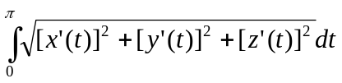
s=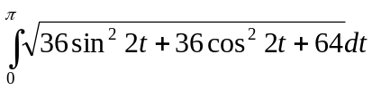 = 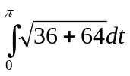 = 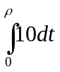 =10

For any t in the interval [0,] we have
s(t) = 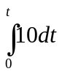 = 10t,
so the stretching function is
s(t) = 10t
and the stretching factor is
ds/dt = 10.
The inverse of the stretching function is
t = s/10.
We use this inverse to construct the function that has no stretching, that is, the bending/twisting function
R(s) = (3cos2(s/10), 3sin2(s/10), 8(s/10)) = (3cos(s/5),3sin(s/5).4s/5)

Note that dR/ds = (-3/5 sin(s/5), 3/5 cos(s/5), 4/5)
is again a unit vector as before
IIdR/dsII = 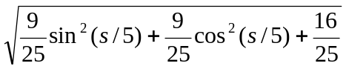 = 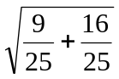 = 1.
This verifies that R does no stretching. So the unit tangent vector is
T(s) = dR/ds = (-3/5 sin(s/5), 3/5 cos(s/5), 4/5).

Now the twisting will not affect the amount of bending, so we should be able to determine the curvature as we did before. Thus, we proceed as we did in the case of the plane curve.
dT/ds = dR/ds = 3/25(-cos(s/5),-sin(s/5),0)
Then the curvature is given by
= (s) = IIdT/dsII = 3/25,
the radius of curvature by
= (s) = 1/(s) = 25/3, and the normal vector by
N = N(s) = (dT/ds)/IIdT/dsII = (-cos(s/5),-sin(s/5),0).

Note that in this special case, N is always parallel to the xy-plane and is pointed "inward" toward the z-axis.

As before, T and N are perpendicular.
TN = (-3/5 sin(s/5))(-cos(s/5)) + (3/5 cos(s/5))(-sin(s/5)) = 0.
Since they are not parallel, they can be used to form a plane passing through the point R(s). As we move along the curve, this plane twists in space. As it twists through space, it changes its tilt (I know, strictly speaking, there is no unique TN-plane, it’s a different plane at every point, but this helps to make the intuitive geometric argument easier.). Thus, the tilt of this plane can be used to measure the twist of the plane and indirectly the twist of the curve. The tilt of the plane is given by a perpendicular (normal) to the plane. We can find a perpendicular vector by taking the cross product of T and N. Let
B = T X N
B is called the bi-normal.
Since the magnitude of the cross product gives the area of the parallelogram formed by the two vectors and the two vectors are unit vectors and they are perpendicular, the magnitude of B is the area of a unit square, i.e. 1. So
B is a unit vector
If you prefer a non-geometrical argument,
IIBII = IITIIxIINIIxsin(/2) = 1x1x1 = 1
To measure the change in B, we take its derivative (with respect to s, since we don't want to reintroduce the stretching factor), dB/ds. Since B is a unit vector, its length never changes, so the only change that dB/ds measures is the change in direction in B, i.e. the tilt of the plane formed by T and N.
dB/ds = d(T X N)/ds = T X N' + T' X N.
Since N = T'/IITII, N and T' are parallel, so T' X N = 0. Therefore,
dB/ds = T X N' or B' = T X N' .
Since B is a unit vector, dB/ds is perpendicular to B.
BB = IIBII = 1. So
(BB) = BB' + B'B = 2(BB') = 0. Therefore,
B' is perpendicular to B. (if you prefer, dB/ds is perpendicular to B.)

Since B' is perpendicular to B = T X N, it lies in the TN-plane Since B' is perpendicular to T in this plane, it must be parallel to N. Thus, B' is a scalar multiple of N, or, equivalently of -N, i.e.
B' = (-N)
(We will explain the minus sign later. It has to to with the handedness of the coordinate system in space formed by T, N, and B.)
is called the torsion. II, which is the magnitude of B', measures the amount of twisting. The sign of will be explained later.

Let us return to our example of the helix and compute B and .
B = T X N
B = 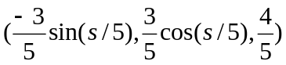 X 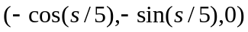
B = 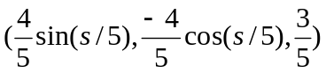
Note that IIBII = 1.
dB/ds = 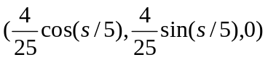
= 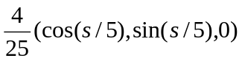 = 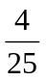(-N).
Thus, the torsion = 4/25.

I leave it to the reader to show that if we consider our original example of the circle in the plane as a circle in the xy-plane in 3-space, i.e.
r(t) = 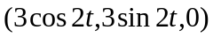,
which means that the torsion is 0. This means there is no twisting, just stretching and bending.

Now look back at the definition of the osculating circle in the case of a plane curve.
There we just needed a center and a radius. In space a center and a radius define a sphere and not a circle. They only define a circle provided that we restrict them to some plane. The plane that we shall use is the plane formed by the point R(s) and the vectors T and N. This plane is called the osculating plane. The center of the osculating circle is defined as before. It is
R(s) + N.
Since T and N are perpendicular unit vectors they can act like i and j for this plane. Thus, for example the unit circle in the ij-plane is
f() = (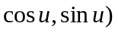 = 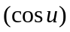i + 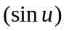j, 0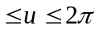.
Analogously, in the TN-plane, the unit circle can be given by
g() = T + N, 0.
To shift this circle out to a point P, we have
h() = P + T + N, 0.
If we change the radius from 1 to , we have
k(u) = P + 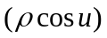T + 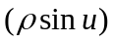N, 0.
Thus, we define the osculating circle to be
osc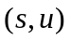 = (R(s) + N) + T + N, 0.
As it is given here, T, N and are all functions of .

In our example of the helix, let's let 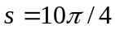.The center of the osculating circle is
R(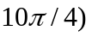 + 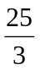N(10/4) =
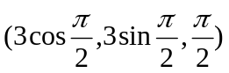 + 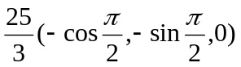=
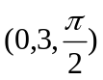 + 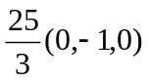 = 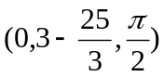 =
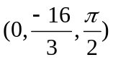
T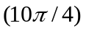 = 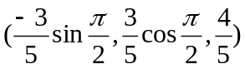 = 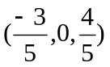
N = 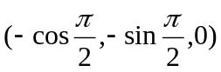 = 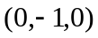
Thus, the osculating circle is
osc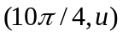 = + 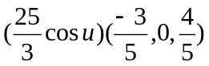 + 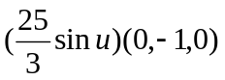
= +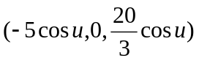 + 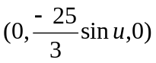
= 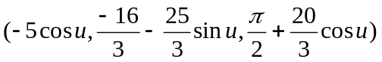

If T, N and are given as functions of , we have
osc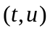 = (r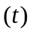 + N) + T + N, 0.

Finally, let us consider the sign of the torsion. Rather than saying that the torsion measures the "twisting" of the curve, it is more accurate to say that is measures the tendency of the curve to lift out of the TN-plane. If the curve lifts out of the TN-plane on the T X N (or B) side (i.e. if it follows the right-hand rule), then the torsion is positive. If it lifts out of the TN-plane on the other side, the torsion is negative.

In the case of our helix above, the curve is lifting out of the TN-plane on the
T X N side so the torsion is positive.

This ends our discussion of curves in 3-space.

