PayJustNow

SCREEN 1
Welcome
By the end of this course, you will be able to:
- Identify what PayJustNow is and when it is the right option for a customer.
- Work out the correct instalment amounts and dates, and recommend the right plan, either the three month plan or PayStretch, for a given purchase.
- Apply the correct sequence of steps to complete a PayJustNow purchase.
- Respond correctly to customer questions and concerns.

SCREEN 2
What is PayJustNow?
PayJustNow is a South African Buy Now, Pay Later payment solution. It allows a customer to take their purchase home on the same day and split the cost into three equal, interest free instalments, as long as each instalment is paid on time.
TIP: Always mention that the plan is interest free only if instalments are paid on time.

Now that you know what PayJustNow is, the next question a customer will ask is almost always about the money. Let's break that down.
SCREEN 2
A customer wants to buy a jacket worth R1200 today using PayJustNow. How much would they need to pay today to take the jacket home?
A) R400 (a third of the purchase price).
That's correct. PayJustNow splits the purchase into three equal payments, so the customer pays a third today and takes the jacket home immediately.
B) R1200 (the full amount).
Not quite. With PayJustNow, the customer doesn't need to pay the full amount upfront, just the first of three instalments.
C) Nothing today, only once the item is delivered.
Not quite. PayJustNow requires the first instalment to be paid at the time of purchase, not at a later date

Now let's look at how those payments actually get split.
SCREEN 3
Payment Structure and PayStretch
The three month plan splits any purchase into three equal instalments. For simplicity, and to match how the PayJustNow app itself displays due dates to a customer. This way treats each instalment as due on the same date, one month and two months after the date of purchase.
Watch the video to learn more:

For bigger purchases, PayStretch spreads the cost over twelve months instead, with a small, transparent interest rate shown clearly before the customer confirms. There are no hidden fees on either plan.
TIP: Mention PayStretch whenever a customer is buying a big basket item, such as furniture or electronics, and always point out the interest rate before the customer confirms. This will help build the trust of the customer

SCREEN
Let's take a look at an example:
A Customer buys an item on the first of March. Using the calculation above, the three instalments fall on the first of March, the first of April, and the first of May.
Notice that the day of the month stays the same each time. Only the month changes. This is the pattern to apply whenever a customer asks when their payments are due.

Now try it yourself.
SCREEN 3
A customer buys a jacket on the 15th of January using the three month plan. When is the final instalment due?

A) The 15th of February.
Not quite. This is the date of the second instalment, not the final one.
B) The 13th of January.
Not quite. This changes the day of the month rather than the month itself, which does not match the pattern.
C) The 15th of March.
The 15th of March is correct. The day of the month stays the same, and the month moves forward by two.

You can now explain what PayJustNow is. Next: how does a customer actually complete the purchase, step by step?
SCREEN 4
How It Works
Firstly, the customer is required to sign up using their South African ID, mobile number, and a valid Visa or MasterCard debit/credit card.
Watch the video to learn more.

Online: the customer finds a store online, adds items to their cart and chooses PayJustNow at checkout, then confirms the transaction in the app and pays the first instalment.
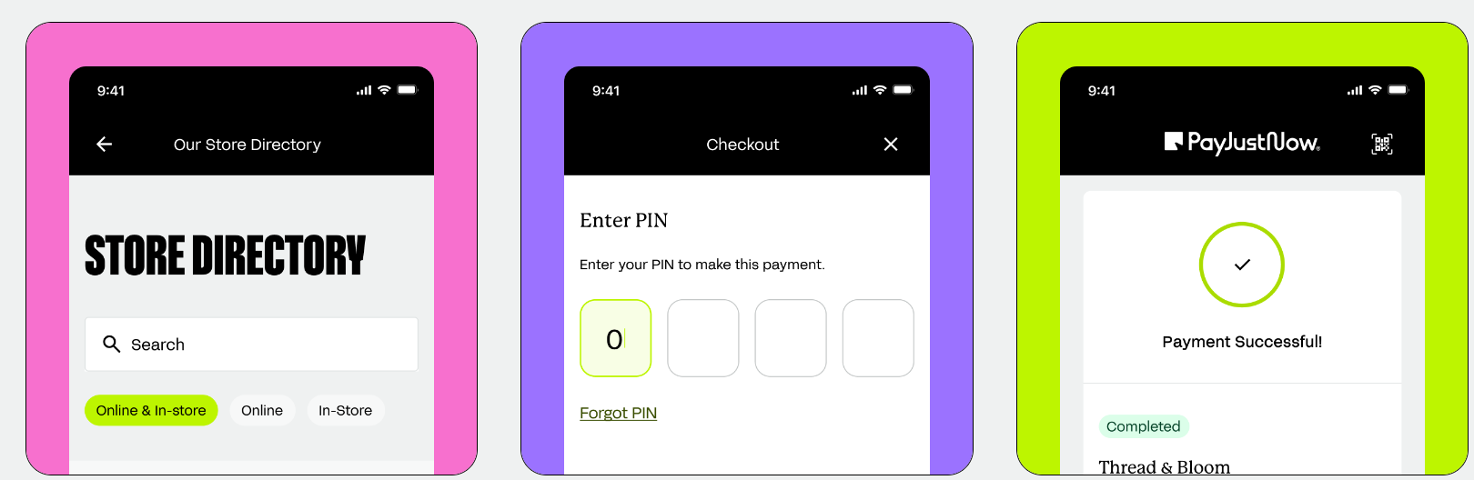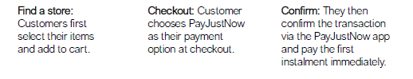
In store: the customer confirms PayJustNow is available and shops as usual, lets you know they will be using PayJustNow, scans the transaction QR code in the app, then confirms and pays the first instalment.

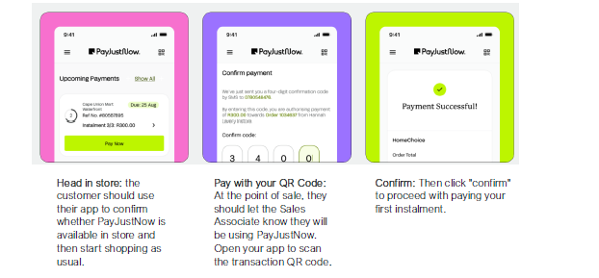
TIP: If a customer seems unsure which option applies to them, ask whether they are shopping online or in store first. The steps are similar, but the starting point is different.

SCREEN 4
Basket Ready, PayJustNow Selected
A customer has already added items to their basket and selected PayJustNow at checkout. What should happen next?
A) The customer waits for an SMS confirmation before the transaction can proceed.
Not quite. There is no waiting step here. The next action happens in the app, immediately.
B) The customer confirms the transaction in the PayJustNow app and pays the first instalment.
The customer confirms the transaction is Correct. This is the very next step once PayJustNow has been chosen at checkout.
C) The customer pays the full amount, then requests a refund for two of the three instalments.
Not quite. This defeats the purpose of PayJustNow. The customer never pays the full amount upfront in the first place.

One more thing to cover before you're ready for a real conversation: the questions customers ask when they're still unsure.
SCREEN 5
Key Considerations
- A customer needs enough funds on their card to cover the first instalment at the time of purchase.
- Late payment fees may apply if a scheduled instalment is missed.
- A quick soft credit check is performed to approve the purchase. This does not affect the customer's credit score, and approval is often almost instant.
TIP: If a customer worries about their credit score, reassure them clearly that the check is a soft check only. Being specific here, rather than vague, will give the customer reassurance.

SCREEN 5
A customer is worried this will affect my credit score.
Which response is both accurate and reassuring?
A) “It might affect it a little, but it is usually fine.”
Not quite. This is vague and would likely make a worried customer more uncertain, not less.
B) “Do not worry, there is no check done at all.”
Not quite. This overclaims. A soft check is performed, it just does not affect the credit score.
C) “There is a quick soft check, which will not affect your credit score.”
Correct. This is accurate and specific, which is what makes it genuinely reassuring.

You now know everything you need. Here's the thing: on the floor, customers don't ask their questions one at a time, neatly, in order. They ask them all at once, while you're mid-conversation.
So let's see how that actually feels.
Knowledge Check
You are behind the till. The POS screen shows the date: Tuesday, the 3rd of February. A customer is holding an item, checking the price tag.
The Customer Says: "It is a great piece. I just was not planning to spend this much today."

Knowledge Check 1
The Customer Says: "I'd like to use PayJustNow for this purchase. What do I need to do?"
A) "You'll need to sign up in the PayJustNow app or website, get approved, and then I can process your payment using PayJustNow at the till."
B) "Just give me your ID number and I'll set it up for you right now at the till."
C) "I'll add it to your existing store account, no need to sign up separately."

Knowledge Check 2

The Customer Says: "So when would my last payment actually be due?"
A) The 17th of February.
B) The 3rd of April.
C) The 3rd of March.

The sneakers cost R900. The customer pays the first instalment today, the third of February.

Knowledge Check 3

The Customer Says: "Will this affect my credit score, and what happens if I ever miss a payment?"
A) “I am honestly not sure, let us just try it and see.”
B) “It will probably affect your score a bit, and the fees can be steep.”
C) “There is just a quick soft check, so no effect on your score, but try to stick to the schedule, since late fees can apply if a payment is missed.”

Knowledge Check 4

The Customer Says: "And there is really no interest on this at all?"
A) “I would have to check with my manager.”
B) “No interest at all, ever, on anything.”
C) “No interest on this three month plan, as long as it is paid on time.”

Knowledge Check 5
The Customer Says: "This is great for the sneakers, but I have also been eyeing a bedroom set. Would this work for something that big too?"
A) “No, anything that size would need to be paid in full.”
B) “Sure, the same three payment plan would work fine.”
C) “For something bigger like that, PayStretch would spread it over twelve months instead, with a small upfront interest rate shown before you confirm.”

SCREEN 8

Well Done
Well done on completing this course!
Every question in this course reflects something a customer might ask on the shop floor on any given day. Knowing the answers well enough to respond without hesitating is exactly what builds a customer's confidence in the purchase!

