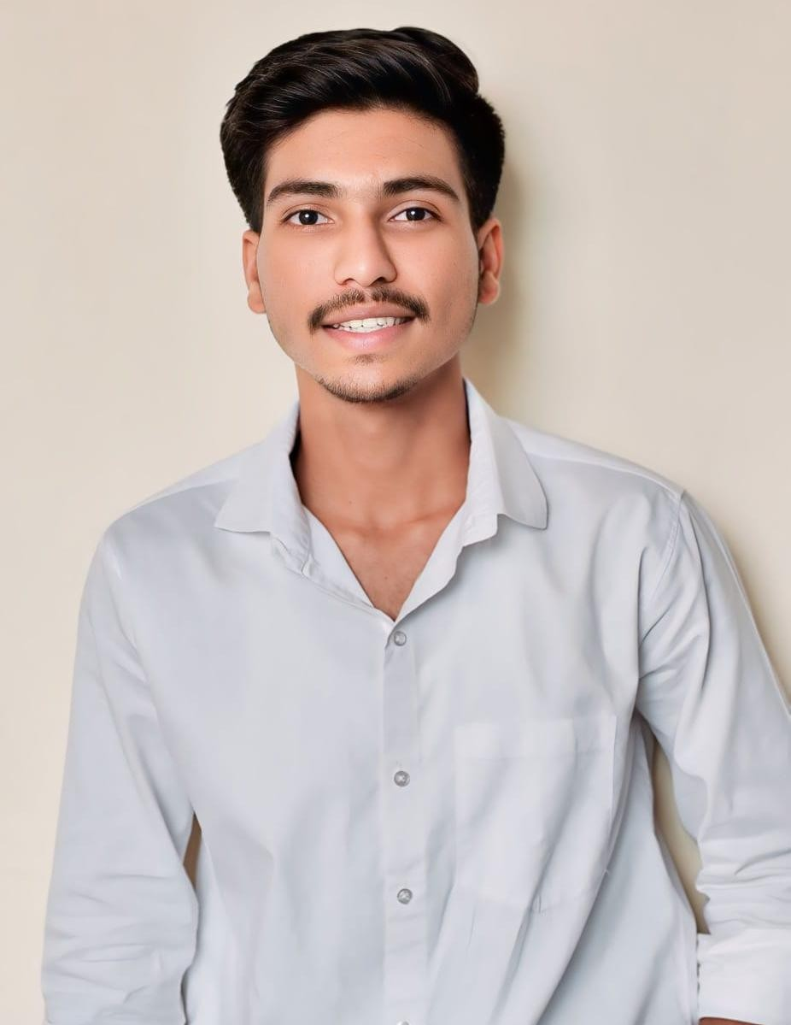Roshan Dalvi

**Pune** | **+91 7588329106** *|* [**roshandalvi16@gmail.com**](mailto:roshandalvi16@gmail.com)*|* Linkedin *|* Github

## OBJECTIVE

I am a Java Developer with expertise in software development.Experienced in working on projects in Java and aiming to deliver high-quality solutions in a dynamic work.

## EDUCATION

* Dnyanshree Institute of Engineering And Technology CGPA: 7.90 BTech (Computer Science and Engineering), 2025
* Venna vidhyamandir and junior college medha Percentage: 79.33

Senior Secondary (XII), 2021

* K.A.P.M.V.Mhate BK. Percentage: 82.40

Secondary (X), 2019

**WORK EXPERIENCE**

### Jr.Software Engineer Intern |Cravita Technologies India Private Limeted, Pune July 2025 – Present

* + Contributed to real-time live projects using HTML, CSS, JavaScript, Java, Advanced Java, C, and SQL, ensuring high-quality deliverables.
  + Collaborated with the team on back-end and front-end development, integrating API s and optimizing system performance.
  + Gained hands-on experience in full-stack development, deployment, and client-oriented application enhancements.

# PROJECTS

**Khelo-Quiz |** GitHub Jan 2025 – Jul2025

* Built a dynamic AI-integrated quiz system with **Django**, **HTML**, and **Tailwind CSS** enabling instant personalized quiz creation using Google **Gemini API**.
* Designed a scalable backend with **PostgreSQL**, applied **SDLC** principles, and implemented secure authentication, real-time scoring, and detailed performance reports.
* This platform is designed for any individuals who wants to check or improve the knowledge on any specific topic.

**Account Management System |** GitHub Mar 2024 – August 2024

* Developed a desktop-based fees management system using **Java (Swing, AWT)** for frontend and **MySQL** for backend, enabling secure and efficient college account management.
* Designed and implemented report generation using **Apache POI**, allowing export of fee reports in Excel format.
* Integrated **JDBC** Driver for database connectivity, ensuring reliable and fast transactions.
* Improved operational efficiency by streamlining fee collection, receipt generation, and record management.
* Built a user-friendly **GUI** to simplify navigation for administrative staff.

# TECHNICAL SKILLS

#### Programming Languages:

Java, JavaScript, C programming.

#### Frontend Development:

HTML, CSS, Tailwind CSS, Bootstrap.

#### Back-end Development:

Restful API’ s, Core Java, Spring Framework.

#### Database Management:

pgAdmin, MySQL(SQL).

#### Version Control & Tools:

Git, GitHub, VS Code, NetBeans, Postman, Figma (for UI/UX).

# CERTIFICATIONS

#### CSRBOX in Artificial Intelligence

IBM SkillsBuild (Online) — Jun 2024 – Augr 2024

#### Core Java Training

Internshala Training (Online) — Nov 2022 – Dec 2022

# ACHIEVEMENTS

#### Indias First Jodi Run

Under Runner Sports Association Jawali

#### Runner up ( 2023 )

**Second Runner up ( 2022 )**

18 to 25 year age category Male - Male 10 km

* **Dr. Babasaheb Ambedkar Techonological University, Lonere**

Selected for Kolhapur Zonal Kho-Kho team. participate in interzonal event.

# EXTRA CURRICULAR ACTIVITIES

### Dnyanshree Institute of Engineering and Technology

Former Captain of Dnyanshree Institute of Engineering and Technology Kho-khoKho-Kho Team.

# LANGUAGES

Engilish Hindi

Marathi (Fluent)