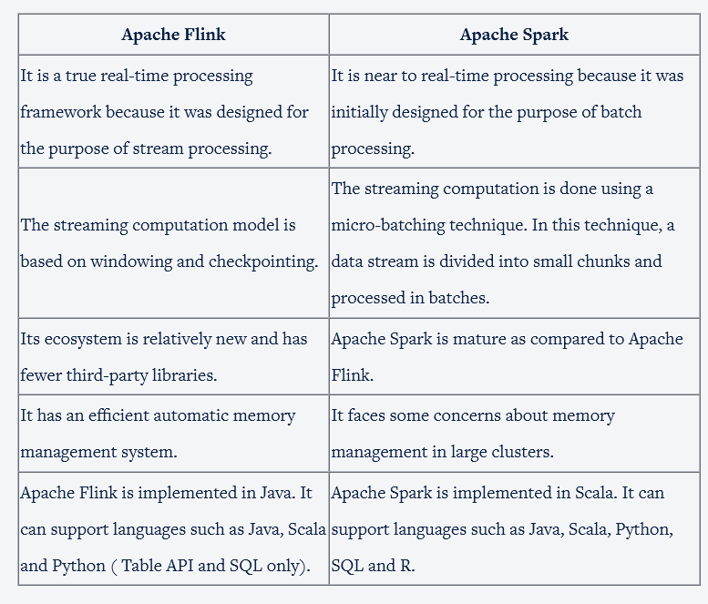

<https://nightlies.apache.org/flink/flink-docs-release-1.11/dev/connectors/>

<https://nightlies.apache.org/flink/flink-docs-release-1.11/dev/stream/operators/windows.html#global-windows>

<https://nightlies.apache.org/flink/flink-docs-release-1.11/dev/event_timestamps_watermarks.html>

<https://nightlies.apache.org/flink/flink-docs-release-1.11/dev/stream/operators/index.html>

<https://nightlies.apache.org/flink/flink-docs-release-1.11/dev/stream/state/state.html>

<https://nightlies.apache.org/flink/flink-docs-release-2.1/docs/dev/datastream/overview/>

<https://nightlies.apache.org/flink/flink-docs-release-1.11/dev/batch/connectors.html>

<https://nightlies.apache.org/flink/flink-docs-release-1.11/dev/batch/dataset_transformations.html>

<https://cwiki.apache.org/confluence/display/FLINK/Powered+by+Flink>

<https://nightlies.apache.org/flink/flink-docs-release-1.10/concepts/programming-model.html>

<https://nightlies.apache.org/flink/flink-docs-release-1.11/concepts/flink-architecture.html>

<https://nightlies.apache.org/flink/flink-docs-release-2.1/docs/internals/job_scheduling/>

<https://www.alibabacloud.com/blog/why-did-alibaba-choose-apache-flink-anyway_595190>

<https://www.dezyre.com/article/apache-flink-vs-spark-will-one-overtake-the-other/282>

<https://dzone.com/articles/apache-flink-vs-apache-spark-brewing-codes>

<https://en.wikipedia.org/wiki/Apache_Flink>

<https://newrelic.com/platform/kubernetes-pixie>

<https://flink.apache.org/what-is-flink/flink-architecture/>

<https://www.datanami.com/2018/04/30/how-netflix-optimized-flink-for-massive-scale-on-aws/>

<https://dzone.com/articles/apache-flink-vs-apache-spark-brewing-codes>

<https://www.dezyre.com/article/apache-flink-vs-spark-will-one-overtake-the-other/282>