Howard University
College of Engineering and Architecture
Department of Electrical Engineering & Computer Science

Large Scale Programming
Fall 2024

Midterm Exam – Part I
October 17, 2024

Part I: 50 pts. (essay questions)

Instructions:
- Submit completed exam to your github repository under package org.howard.edu.lsp.midterm

Verify that the commit(s) completed successfully

- OPEN BOOK, OPEN NOTES. THERE IS NO COLLABORATION ON THIS EXAM
- Site any and ALL references for anything obtained off the internet.

Question 1. (10 pts.)

You are reviewing the following class in a Fitness Tracking System. The class is intended to manage various aspects of a user’s fitness activities.

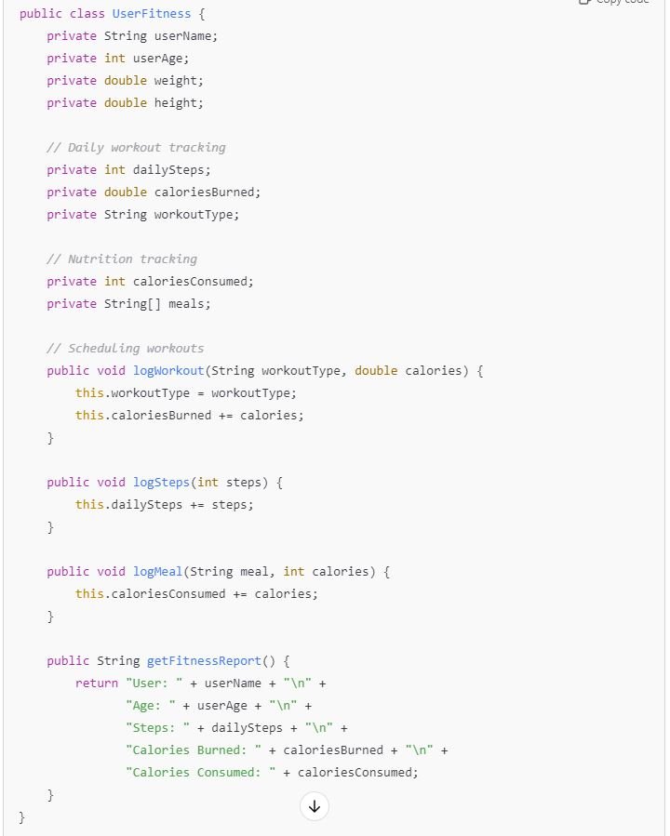

Tasks:
- Analyze the UserFitness class. Explain why this class has low cohesion. (5 pts.)
The UserFitness class has low cohesion if it tries to manage too many unrelated activities within the same class. For example, if it tracks activities, handles nutrition, and manages user personal data all within a single class, it lacks focus and is doing more than one thing. A class should ideally have a single responsibility (the Single Responsibility Principle), and when it doesn’t, it suffers from low cohesion.
- Describe, in general, how you would split the UserFitness class into more cohesive classes. Your answer should not be a complete design. (5 pts.)
To increase cohesion, you could split the UserFitness class into smaller, more focused classes:
- ActivityTracking: Responsible for tracking workouts and fitness activities.
- NutritionTracking: Responsible for managing the user's diet and calorie intake.
- UserProfile: Handles the user's personal information, such as name, age, and weight. This would make each class have a more specific purpose, improving maintainability and clarity.

Question 2. (5 pts.)
Given the following, answer the below questions.

A university manages its students using a program that has a class Student with subclasses FirstYear, SecondYear, and ThirdYear for year-specific state and behaviors. The program has a List that contains all Students.

Should Student be a class, an abstract class or an interface? Explain your answer
Student should be an abstract class because all students share common attributes (like name, ID, etc.), but each year of students has specific behaviors that can be defined in their respective subclasses. An abstract class allows shared attributes and methods while enforcing that subclasses provide their own implementation for year-specific behaviors.
- At the end of each year, the third-year students graduate and must be removed. This is done by passing the list to the following method:

void removeThirdYears(List<Students> students) {
for (Student student : students) {
try {
ThirdYear = (ThirdYear) student;
students.remove(thirdyear);
}
}
}

Why is the above method flawed? Hint: Another Arthur Riel heuristic (5 pts.)
The removeThirdYears method is flawed because modifying a list while iterating through it can cause a ConcurrentModificationException. The correct approach is to use an iterator and remove the elements through it

Question 3. (5 pts.)
Given the following, answer the below questions.

public class BankAccount {
public String accountHolderName;
public String accountNumber;
public double balance;
public double interestRate;

public BankAccount(
String accountHolderName,
String accountNumber,
double initialDeposit,
double interestRate) {
this.accountHolderName = accountHolderName;
this.accountNumber = accountNumber;
this.balance = initialDeposit;
this.interestRate = interestRate;
}

// Exposed implementation for adding interest
public void addInterest() {
double interest = balance * (interestRate / 100);
balance += interest;
}

// Exposed implementation for deposits
public void deposit(double amount) {
balance += amount;
}

// Exposed implementation for withdrawals
public void withdraw(double amount) {
balance -= amount;
}
}

- Is BankAccount well-encapsulated? Why or why not? If so, describe what changes you would make to the class. Otherwise, state nothing. (5 pts.)

No, the BankAccount class is not well-encapsulated because its fields (accountHolderName, accountNumber, balance, and interestRate) are public, which allows direct access to the data, violating the principle of encapsulation. To fix this, you should make the fields private and provide getter and setter methods.

Question 4. (10 pts.)
Given the following, answer the below questions.

Given:
A car manufacturer uses Java software to track current vehicles being built. The UML diagram below shows an excerpt of the current software structure. You should assume the presence of other appropriate fields and methods

Car
getTrimLevel()
Engine
accelerate()
getFuelLevel()
Base
Sports
Luxury
Electric
Petrol

Each car can be built to one of three trim levels: Base, Luxury or Sport. They can also be configured with an electric or petrol engine. At various points in the manufacturing process the customer can choose to change the trim level.

Task:
- Explain in detail why the current structure does not support this. (5 pts.)
If the Car class hardcodes the trim levels or engine type, it cannot dynamically change them. The current setup seems to lack flexibility for changing trim levels or engines.

- Describe how to refactor the structure to allow trim-level change for a car to dynamically change. Hint: How would you modify Car to use composition to solve the problem? (5 pts.)
To allow dynamic trim-level and engine changes, you should refactor Car to use composition

Question 5. (5 pts.)
Suppose you are about to code a particular class and find that you have written another class with nearly the functionality that you now are developing. This means that the two classes in large parts contain the same code, but in smaller parts have different code. Explain in detail why this may be a problem and how to solve it. Give your answer in terms of Arthur Riel’s design heuristics.
If you write two classes with similar functionality but some differences, you violate the Avoid Redundancy Heuristic. Duplicate code is harder to maintain. The solution is to refactor the common code into a superclass or a shared method and let the subclasses or classes inherit or reuse that code. This reduces redundancy and increases maintainability.

Question 6. (5 pts.)
Suppose we need to store instances of the classes Car and BankAccount in a database. To obtain low coupling it may seem as if the functionality to save an instance should be in precisely those classes, since they have the information that shall be saved. Why is it unwise to place the database calls there?
Placing database logic inside domain classes like Car or BankAccount creates high coupling between the business logic and the database. This is unwise because it makes the system harder to maintain and change. The solution is to use a Data Access Object (DAO) or a separate service class to handle database operations, reducing coupling and improving modularity.

Question 7. (5 pts.)
Given a set of requirements, what conditions must be met to make it appropriate to create a new class hierarchy using inheritance? Neither superclass nor subclass exist before, the question is about designing a new class hierarchy.
Conditions to create a new class hierarchy using inheritance:
- There must be common behavior or attributes that the superclass can encapsulate.
- The subclasses must extend and specialize this behavior in a meaningful way.
- There should be an "is-a" relationship (i.e., a subclass is a specific type of the superclass). Inheritance should be used when the hierarchy makes sense logically, and when it can improve code reuse without causing unnecessary complexity.

Question 8. (2.5 pts.)
Describe the difference between inheritance and composition why would you choose one over the other.
Difference between inheritance and composition:
- Inheritance: A class inherits properties and behaviors from a parent class. This creates a strong relationship (is-a relationship).
- Composition: A class is composed of other objects, meaning it uses other classes’ functionality (has-a relationship). You choose composition over inheritance when you want more flexibility and avoid tight coupling between classes, as it allows you to change parts of the system more easily.

Question 9. (2.5 pts.)
Explain the meaning of cohesion and describe whether low or high cohesion is better.
Cohesion refers to how closely related and focused the responsibilities of a class or module are. High cohesion is better because it means a class or module has a clear purpose and is easier to maintain. Low cohesion indicates that a class is trying to do too many unrelated things, making the code harder to manage and understand.

