Step 1- First Login to your AWS console

Step 2-Search for S3 in search bar

Click on S3 and open it.

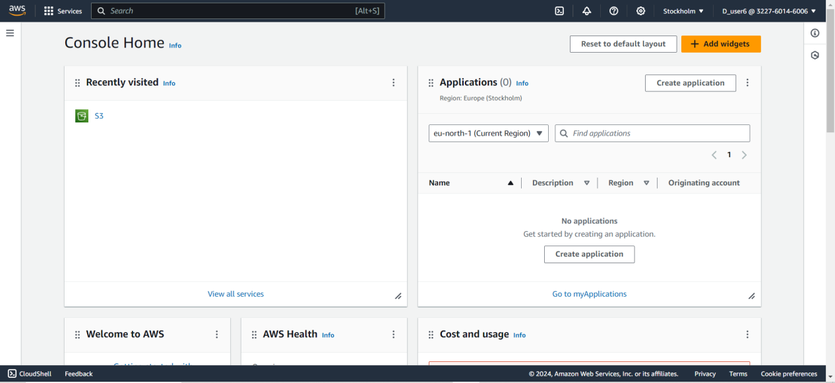

Step3- Here we can see the dashboard of S3 .Click on create bucket to create new one.

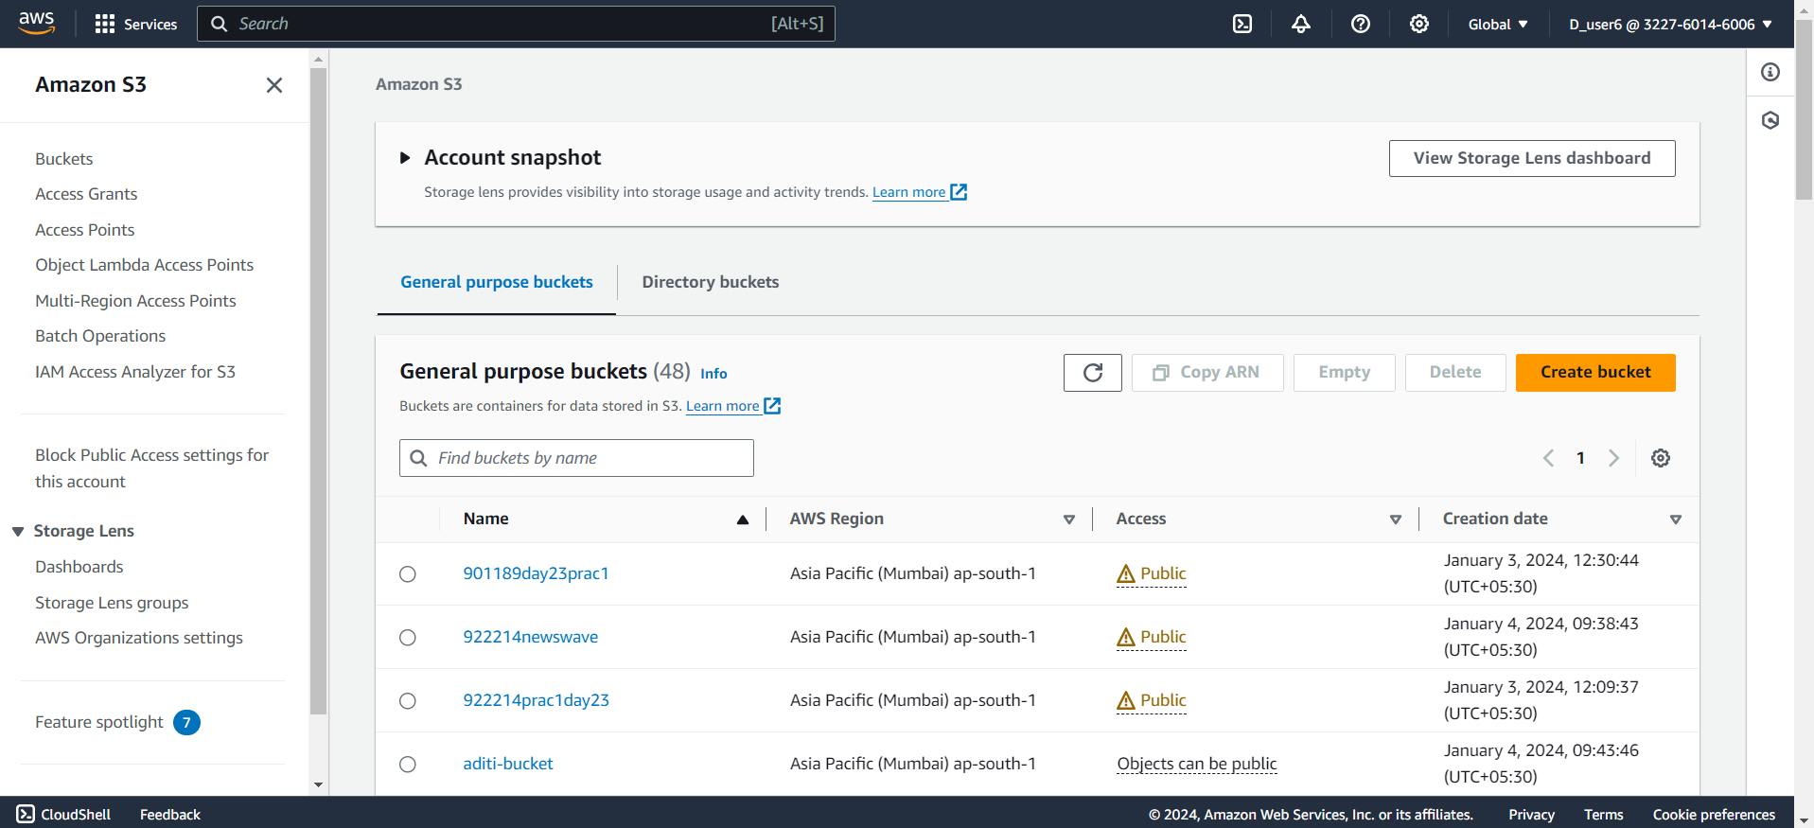

Step 4- After creating a bucket open that bucket

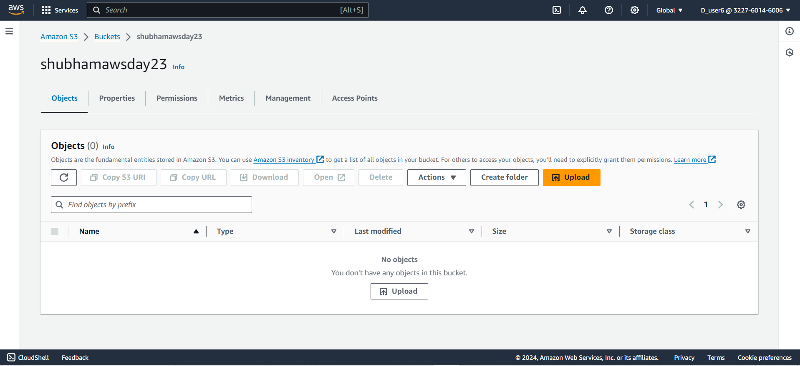

Step5- Upload the Files and Project folder here

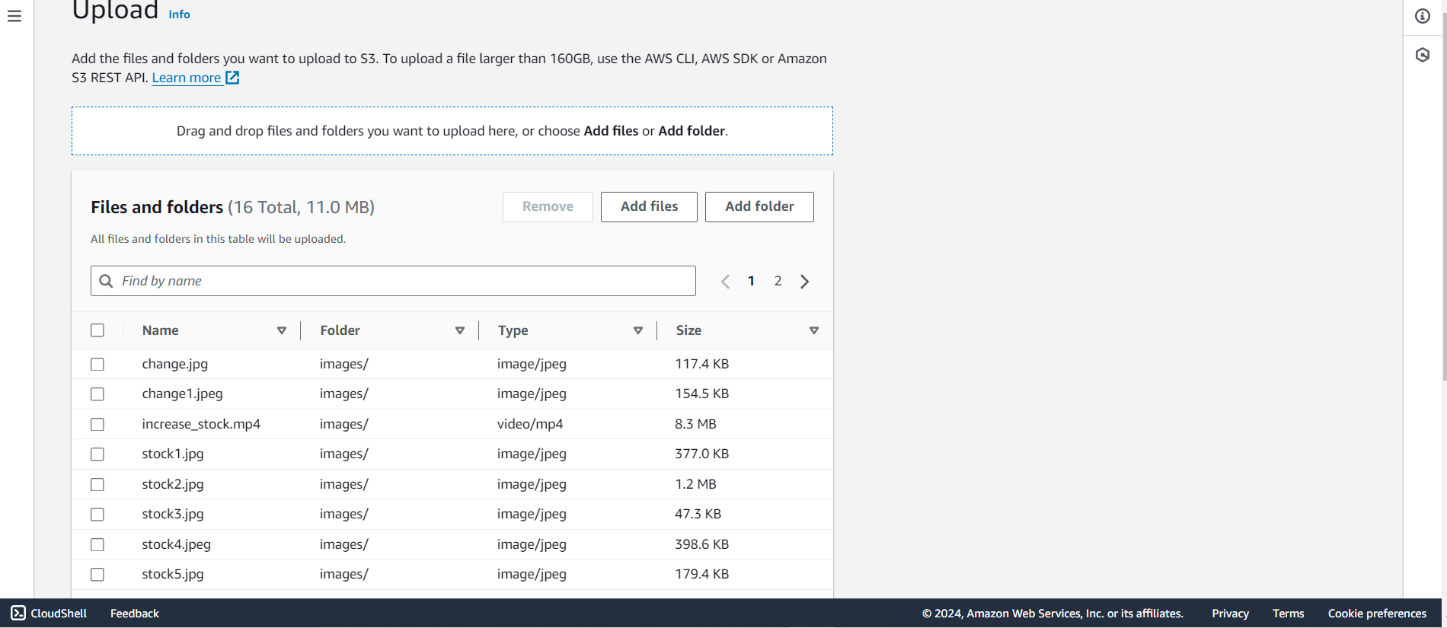

Step 6- click on properties

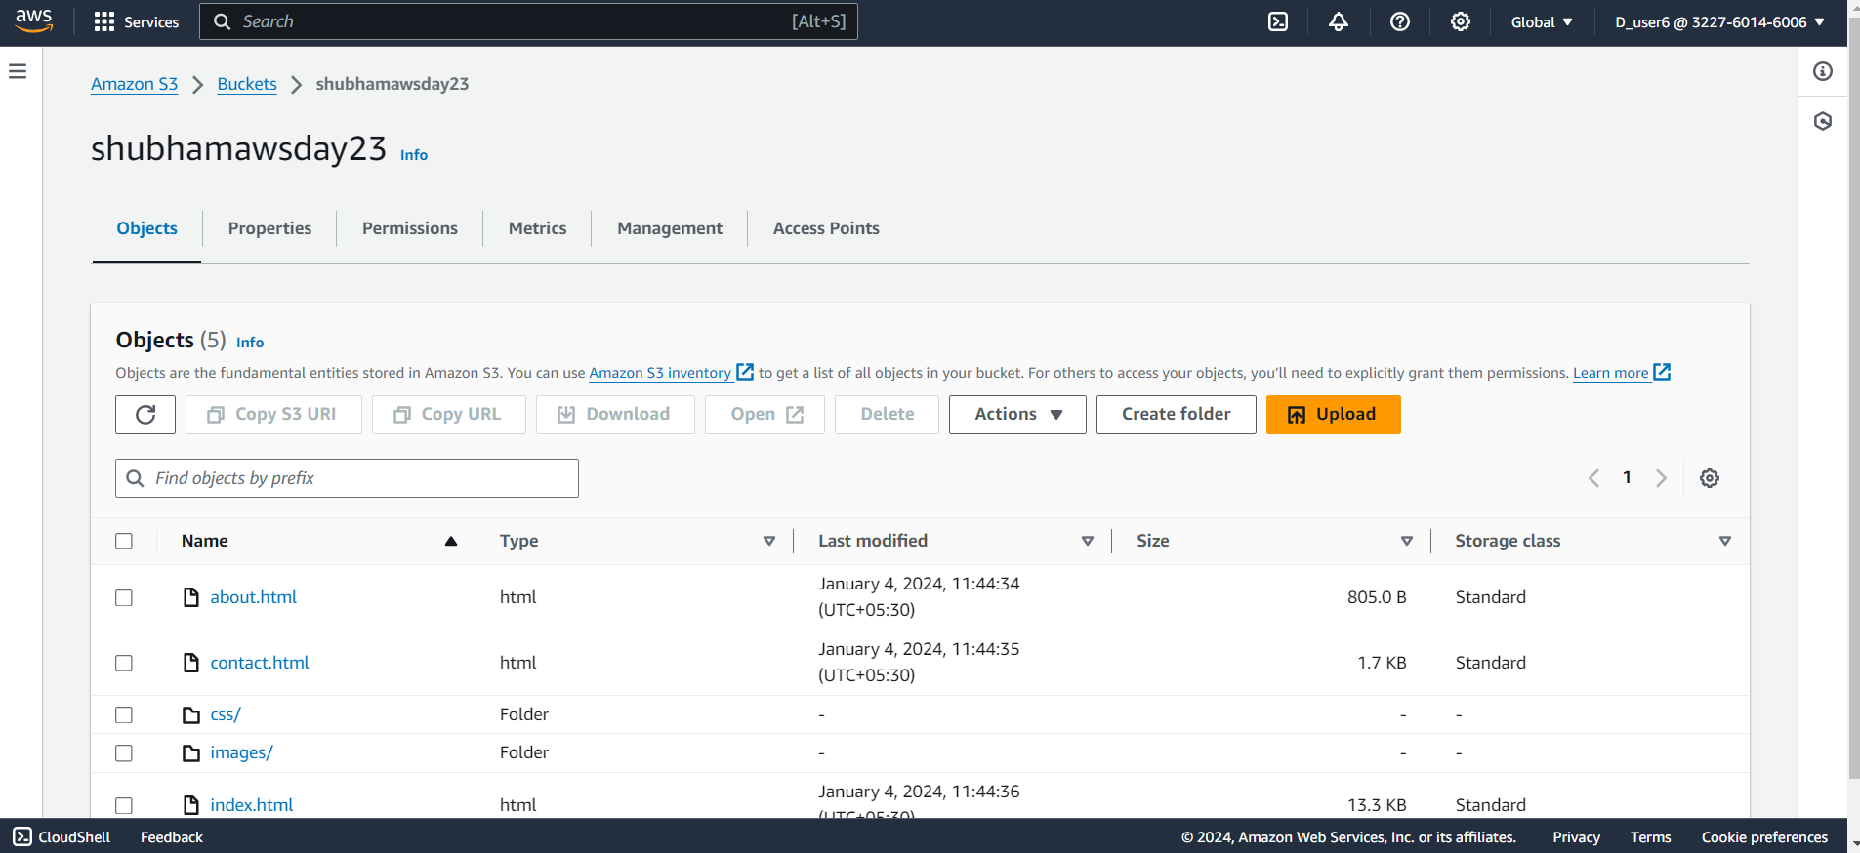

Step 7- open the Static website hosting

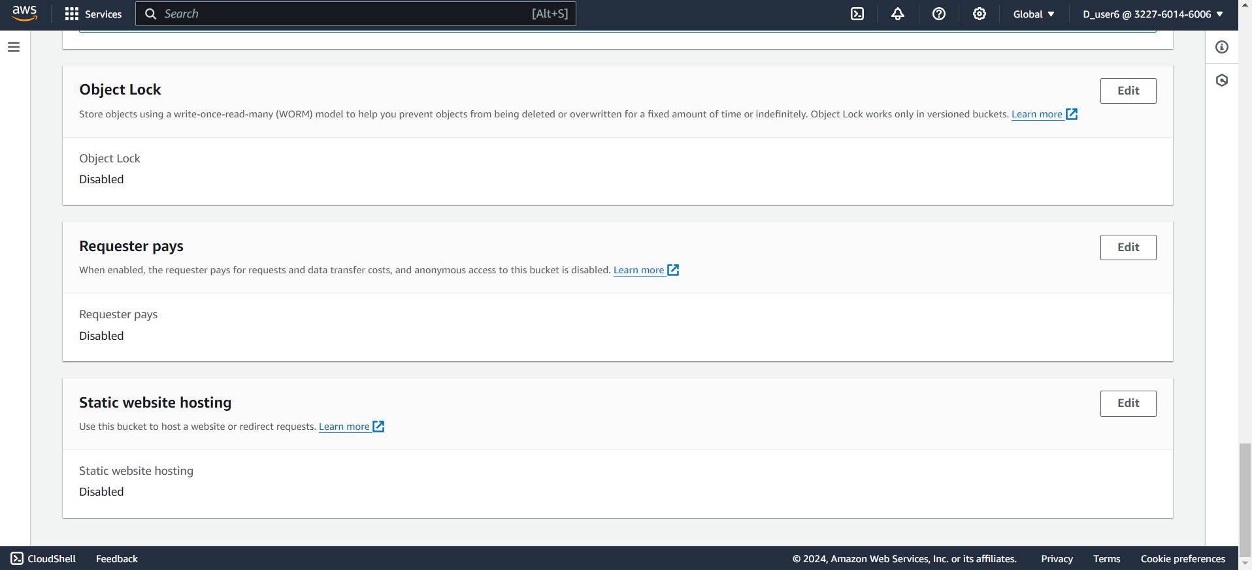

Step 8- Do enable to static website hosting and change index document name by project main file and click on submit

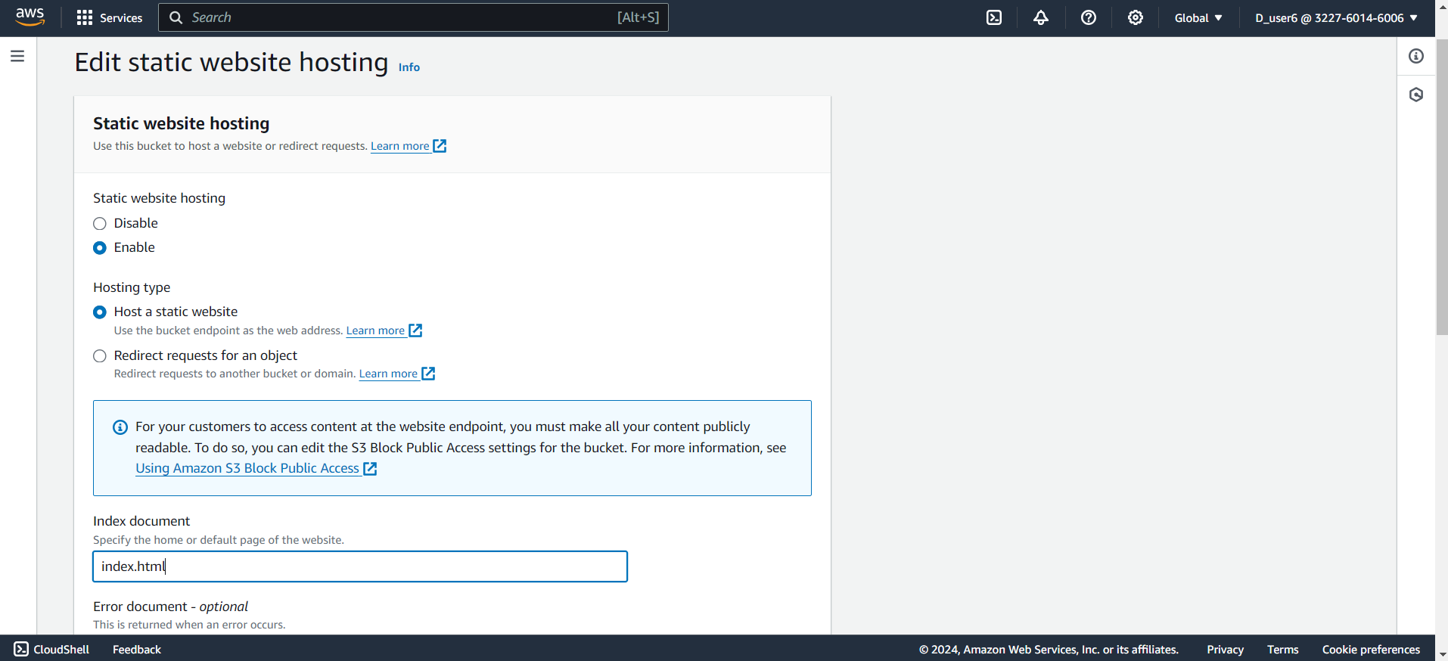

Step 9- click on Properties and open it

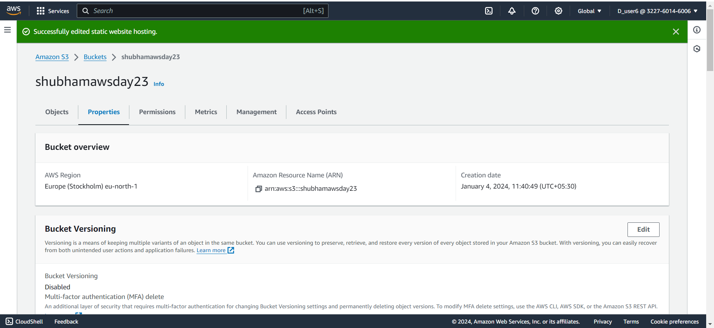

Step10- click on edit option of bucket policy and enter policy here then click on submit

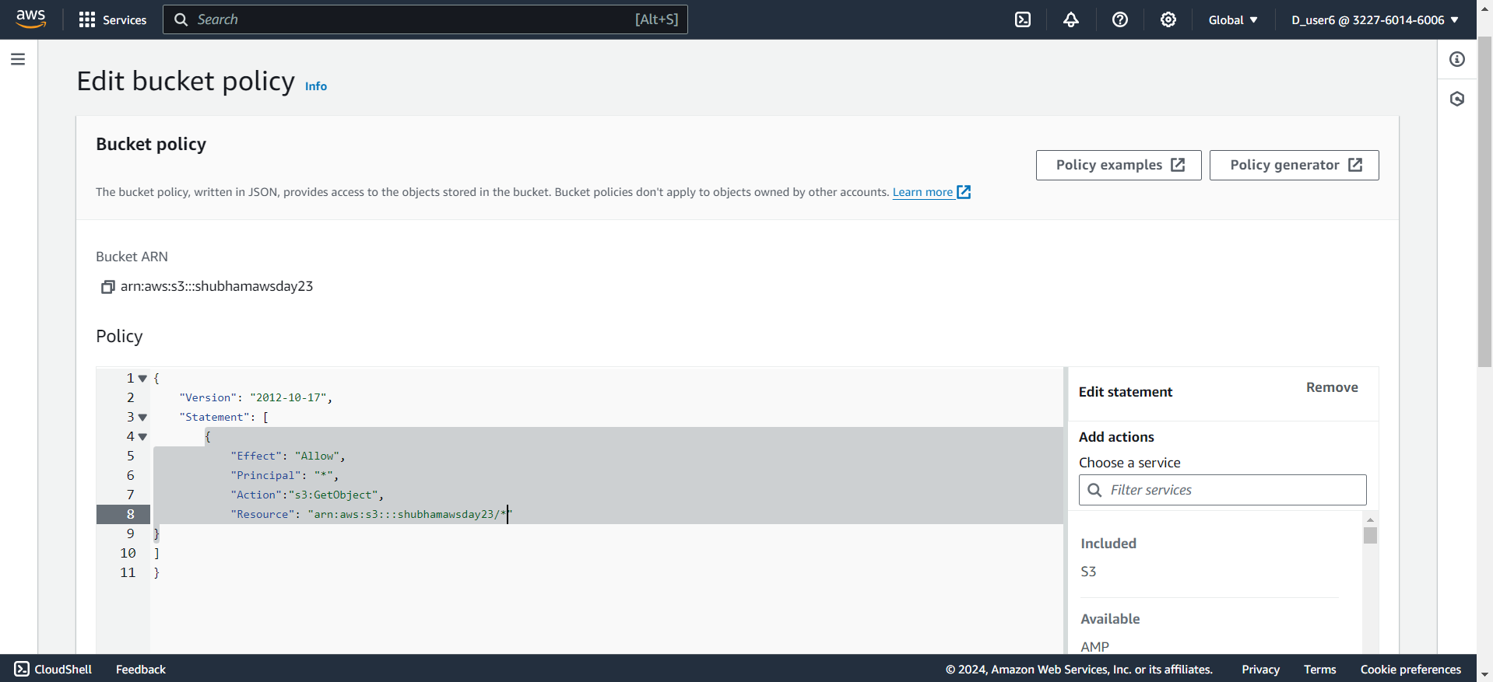

Step 11-click on index.html and open it

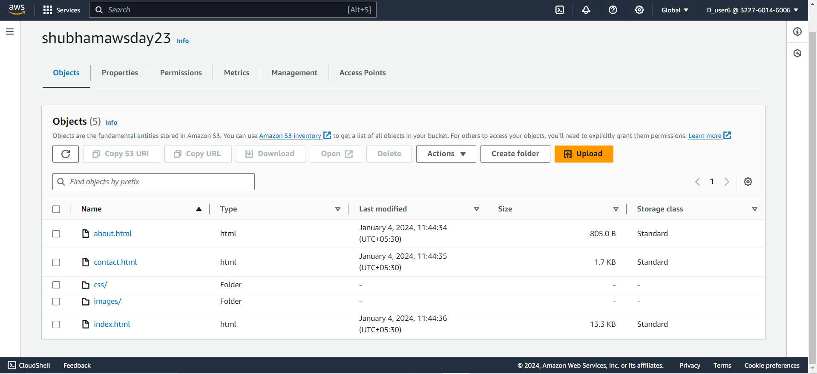

Step12- here we will get the object URL

