Supplementary
Figures:
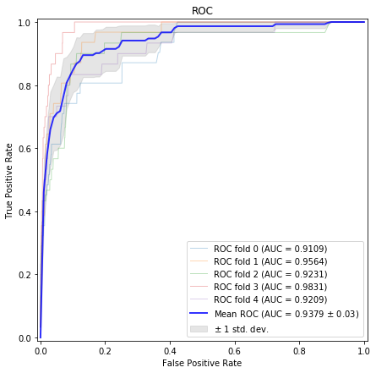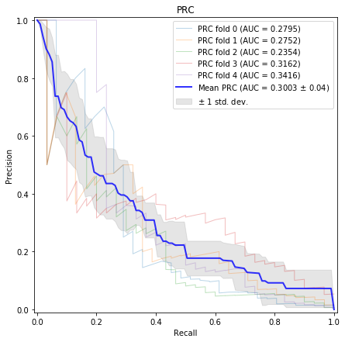
Figure S1-1. Performance comparison of Ensemble 1 under 5-fold stratified cross-validation.

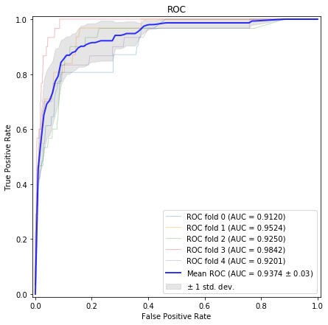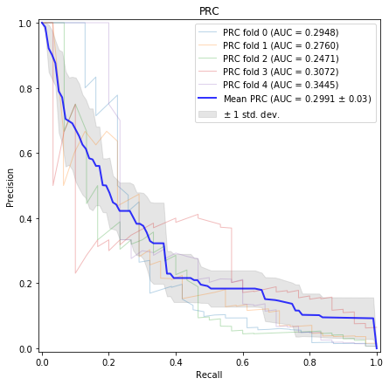
Figure S1-2. Performance comparison of Ensemble 2 under 5-fold stratified cross-validation.
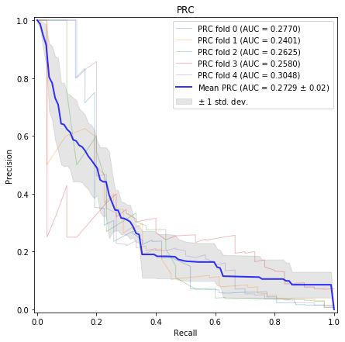
Figure S1-3. Performance comparison of Ensemble 3 under 5-fold stratified cross-validation.
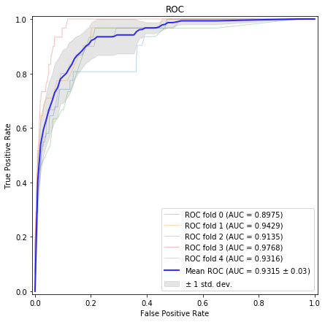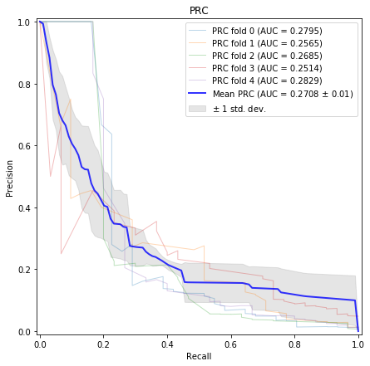
Figure S1-4. Performance comparison of Ensemble 4 under 5-fold stratified cross-validation.
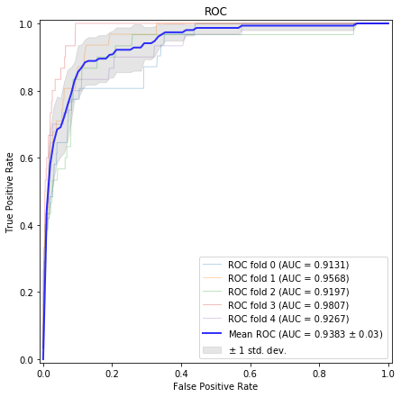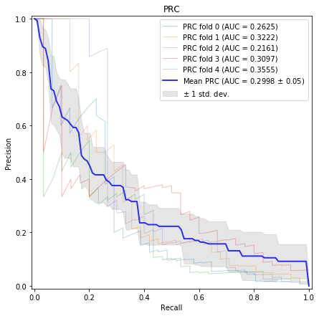
Figure S2-1. Performance comparison of Ensemble 1 using Phylop under 5-fold stratified cross-validation.
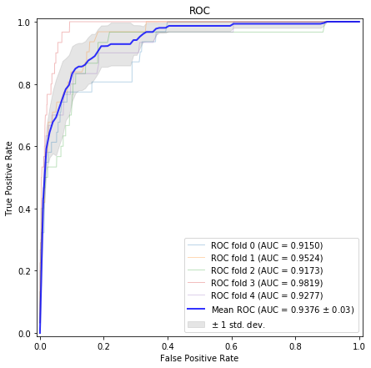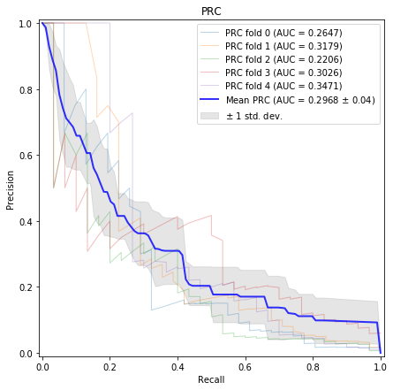
Figure S2-2. Performance comparison of Ensemble 2 using Phylop under 5-fold stratified cross-validation.

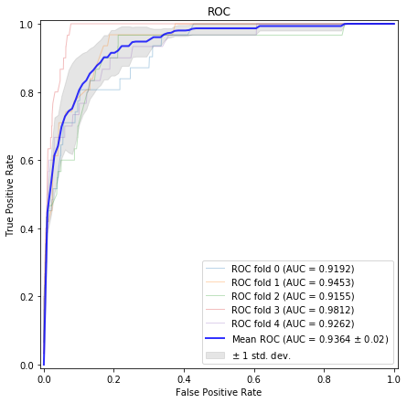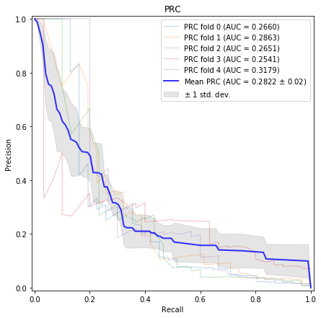
Figure S2-3. Performance comparison of Ensemble 3 using Phylop under 5-fold stratified cross-validation.

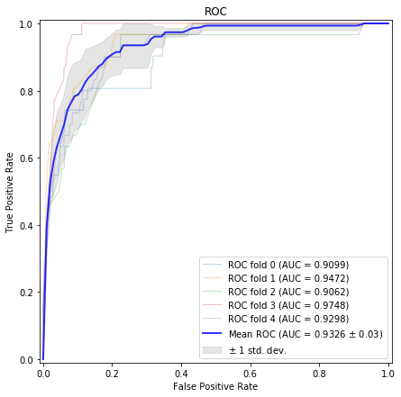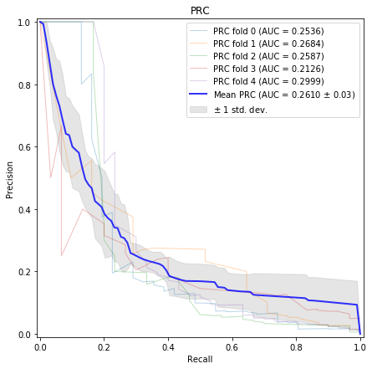
Figure S2-4. Performance comparison of Ensemble 4 using Phylop under 5-fold stratified cross-validation.

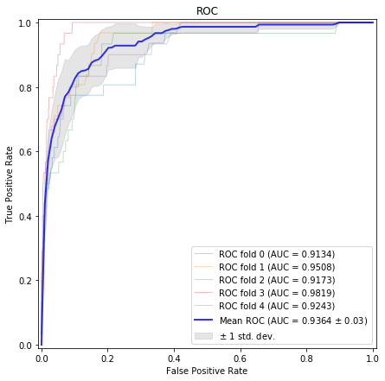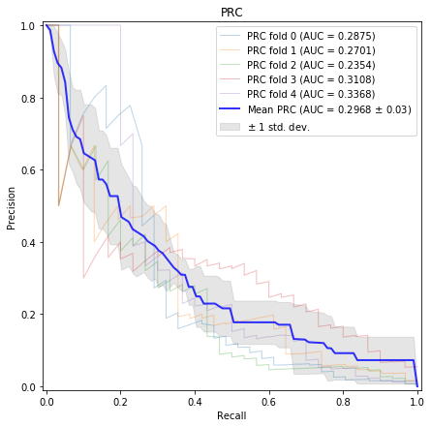
Figure S3-1. Performance comparison of Ensemble 1 using Phastcons under 5-fold stratified cross-validation.

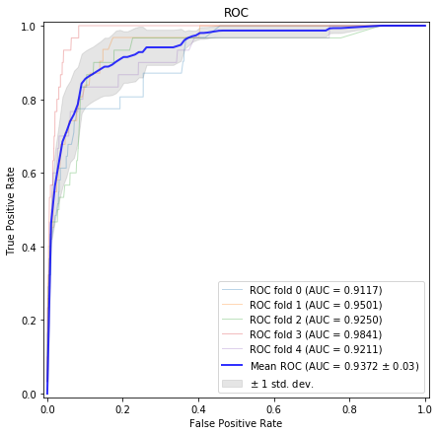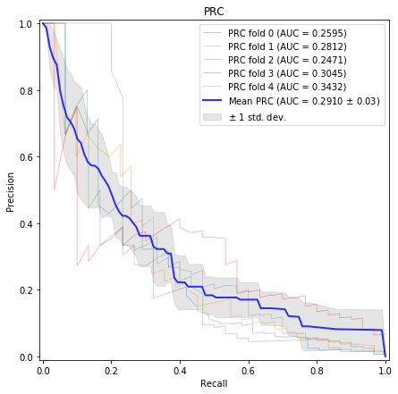
Figure S3-2. Performance comparison of Ensemble 2 using Phastcons under 5-fold stratified cross-validation.

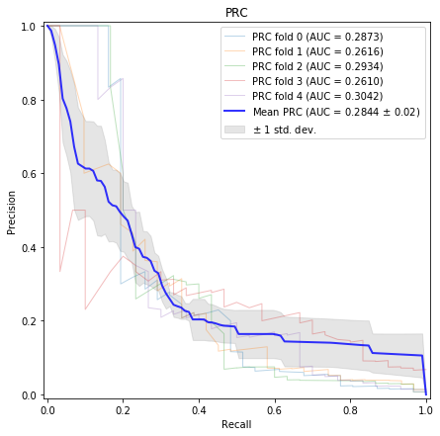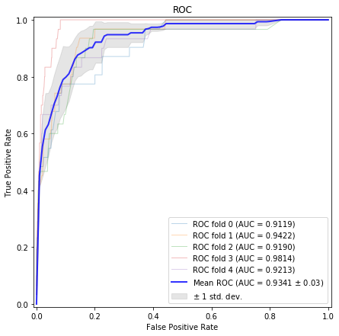
Figure S3-3. Performance comparison of Ensemble 3 using Phastcons under 5-fold stratified cross-validation.
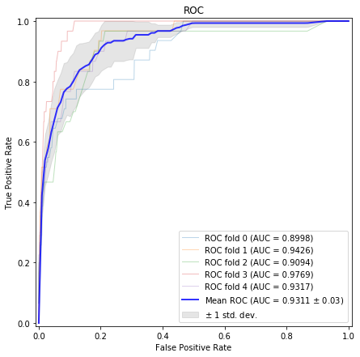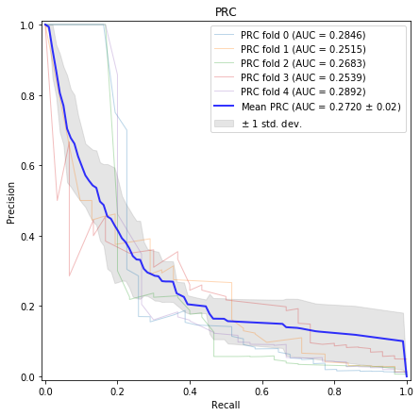
Figure S3-4. Performance comparison of Ensemble 4 using Phastcons under 5-fold stratified cross-validation.

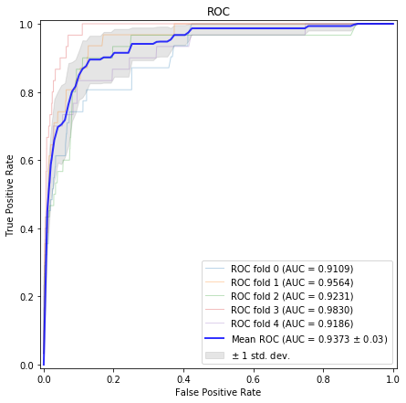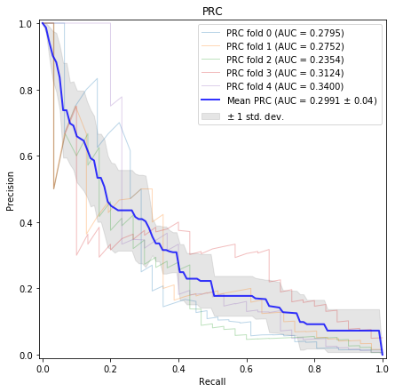
Figure S4-1. Performance comparison of Ensemble 1 using ChromHMM under 5-fold stratified cross-validation.

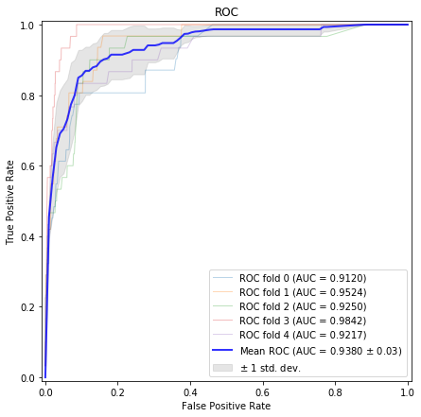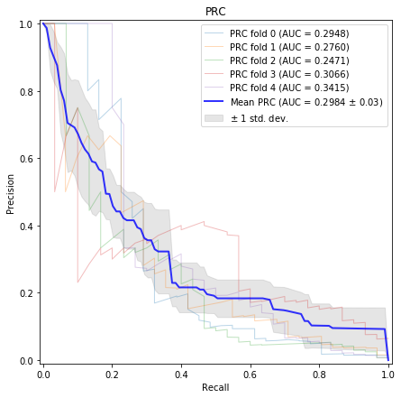
Figure S4-2. Performance comparison of Ensemble 2 using ChromHMM under 5-fold stratified cross-validation.
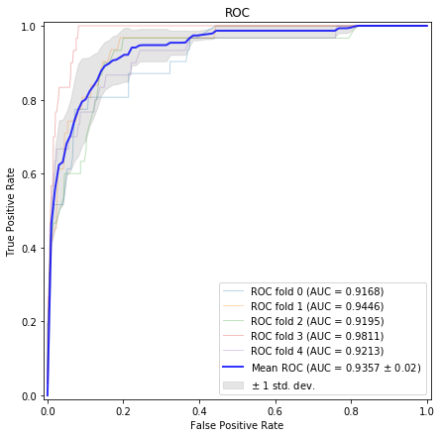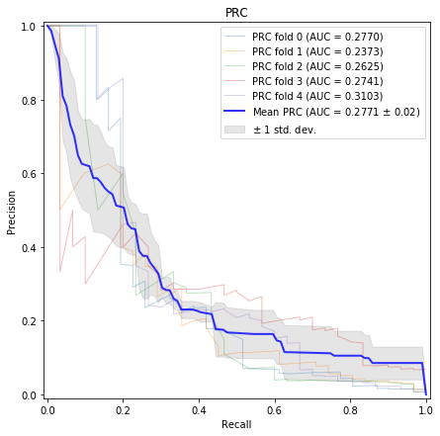
Figure S4-3. Performance comparison of Ensemble 3 using ChromHMM under 5-fold stratified cross-validation.

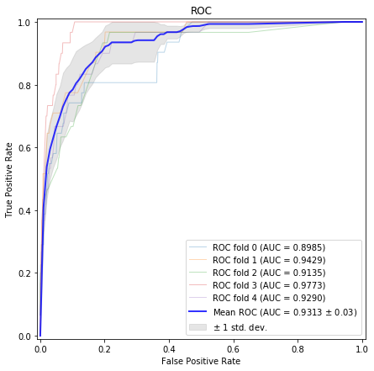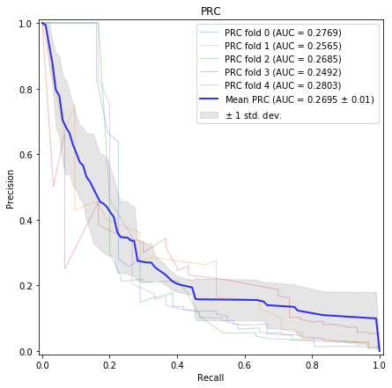
Figure S4-4. Performance comparison of Ensemble 4 using ChromHMM under 5-fold stratified cross-validation.

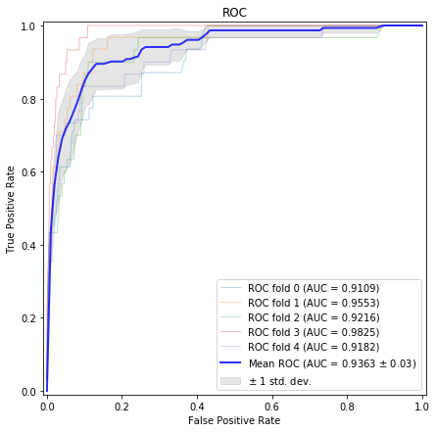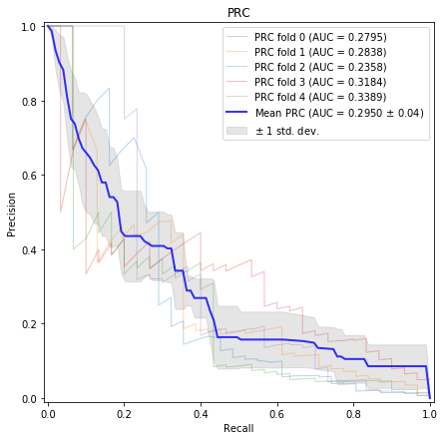
Figure S5-1. Performance comparison of Ensemble 1 using Segway under 5-fold stratified cross-validation.

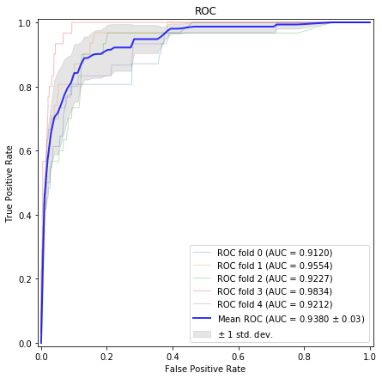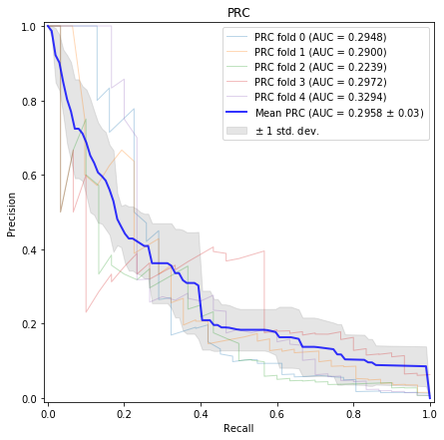
Figure S5-2. Performance comparison of Ensemble 2 using Segway under 5-fold stratified cross-validation.

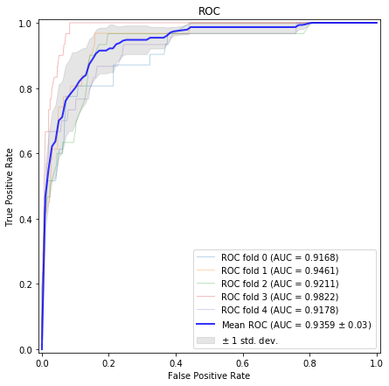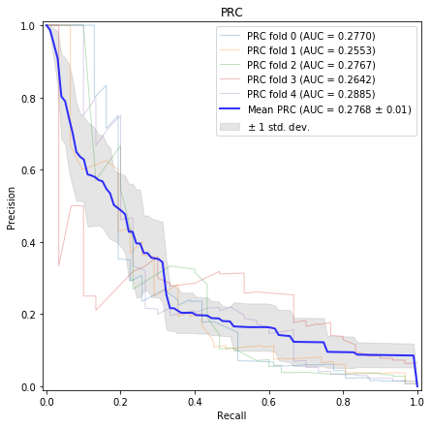
Figure S5-3. Performance comparison of Ensemble 3 using Segway under 5-fold stratified cross-validation.

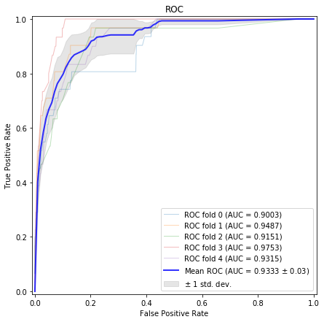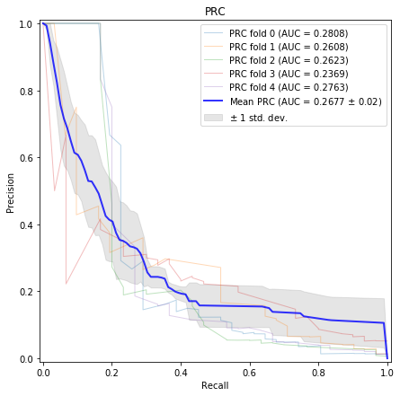
Figure S5-4. Performance comparison of Ensemble 4 using Segway under 5-fold stratified cross-validation.

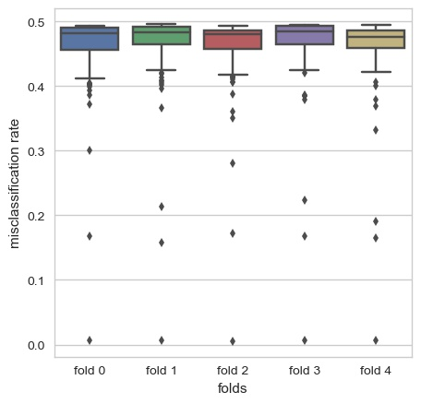
Figure S6. Misclassification rate of each base classifier for 5-fold cross-validation.

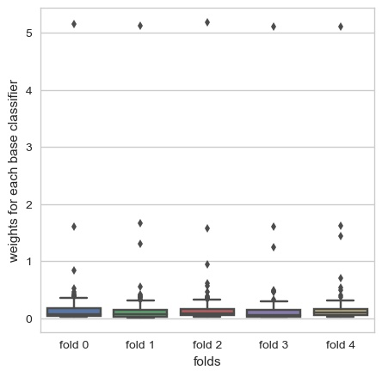
Figure S7. Weight of each base classifier (200) for 5-fold cross-validation.
Tables:
Table S1. Performance comparison of evolutionary conservation.
AUC | Ensemble |  | PhyloP |  | PhastCons
AUC | ROC | PRC | ROC | PRC | ROC | PRC
Ensemble 1 | 0.9379 | 0.3003 | 0.9383 | 0.2998 | 0.9364 | 0.2968
Ensemble 2 | 0.9374 | 0.2991 | 0.9376 | 0.2968 | 0.9372 | 0.2910
Ensemble 3 | 0.9358 | 0.2729 | 0.9364 | 0.2822 | 0.9341 | 0.2844
Ensemble 4 | 0.9315 | 0.2708 | 0.9326 | 0.2610 | 0.9311 | 0.2720
Note: Ensemble 1 states the combination of all five scoring tools. Ensemble 2 states the combination of CFD, MIT Website, MIT, and Cropit scoring tools. Ensemble 3 states the combination of CFD, MIT, and Cropit scoring tools. Ensemble 4 states the combination of CFD and MIT scoring tools.
Table S2. Performance comparison of chromatin annotations.
AUC | Ensemble |  | ChromHMM |  | Segway
AUC | ROC | PRC | ROC | PRC | ROC | PRC
Ensemble 1 | 0.9379 | 0.3003 | 0.9373 | 0.2991 | 0.9359 | 0.2950
Ensemble 2 | 0.9374 | 0.2991 | 0.9380 | 0.2984 | 0.9380 | 0.2958
Ensemble 3 | 0.9358 | 0.2729 | 0.9357 | 0.2771 | 0.9358 | 0.2768
Ensemble 4 | 0.9315 | 0.2708 | 0.9313 | 0.2695 | 0.9328 | 0.2677

Table S3. Feature importance for 5-fold cross-validation.
Folds | CFD | MIT Website | MIT | Cropit | CCTop | PhyloP
Fold1 | 0.3774 | 0.1391 | 0.0639 | 0.0758 | 0.2308 | 0.1130
Fold2 | 0.0183 | 0.3577 | 0.0819 | 0.1262 | 0.2170 | 0.1989
Fold3 | 0.3846 | 0.1025 | 0.0631 | 0.0867 | 0.2934 | 0.0696
Fold4 | 0.0175 | 0.3611 | 0.0729 | 0.0892 | 0.2114 | 0.2479
Fold5 | 0.0315 | 0.3298 | 0.0935 | 0.1275 | 0.1803 | 0.2375

Table S4. Examples of six features used in the base classifier.
No. | CFD | MIT Website | MIT | Cropit | CCTop | PhyloP
1 | 0.0625 | 1.0549 | 1.0191 | 560 | 180.8792 | 0
2 | 0.4261 | 0.6000 | 0.6000 | 462.5 | 172.0406 | 0.26095
3 | 0.1974 | 0 | 0.8156 | 470 | 181.3526 | 0.06521
4 | 0.0277 | 0 | 1.2755 | 530 | 207.4522 | 0.5434
5 | 0.0103 | 0 | 0.3725 | 552.5 | 193.3805 | 3
Table S5. Decision results of the first ten base classifiers for the five data examples tabulated in Table S4.
Data | G₁ | G₂ | G₃ | G₄ | G₅ | G₆ | G₇ | G₈ | G₉ | G₁₀ | G
1 | 0 | 0 | 0 | 0 | 1 | 0 | 0 | 0 | 1 | 0 | 0
2 | 0 | 1 | 1 | 1 | 1 | 1 | 0 | 1 | 1 | 0 | 1
3 | 0 | 1 | 0 | 0 | 1 | 0 | 0 | 0 | 1 | 0 | 0
4 | 0 | 0 | 0 | 0 | 1 | 0 | 0 | 0 | 1 | 0 | 0
5 | 0 | 0 | 0 | 0 | 1 | 0 | 0 | 0 | 1 | 0 | 0
α_{m} | 0.1778 | 0.0564 | 0.0502 | 0.0244 | 0.0141 | 0.0172 | 0.0059 | 0.0132 | 0.0103 | 0.0078

