# 



**Rainwater Harvesting**

**Documentation**

|  |  |
| --- | --- |
| **Authors** | **Group 7** |
| **Nguyen The Long**  **Dam Khoi Nguyen** |
| **Date** | **24/06/2021** |
| **Instructor** | **Trần Văn Điệp** |

**ACKNOWLEDGEMENT**

First of all, we would like to thank all those who helped us and have given us moral support. Without them, we could not have completed this project.

We would like to thank **the eProject Team at Head Office**, who guided and helped us.

We would like to thank all the staff member of **Aprotrain Aptech** center, for not only providing us with the opportunity to work with them on this eProject, but also for their support and encouragement throughout the project process.

We would like to express our immense gratitude to **Mr. Tran Van Diep**, for their constant support and motivation that has encouraged us to come up with this project.

Finally, we would like to thank to **our colleagues** for their suggestions and constructive feedback.

Table of Contents

1. Problem Definition 4

1.1. Problem Abstraction 4

1.2. The Current System 4

1.3. The Proposed System 4

1.3.1. Boundaries of the System 5

1.3.2. Hardware and Software Requirements 5

2. Customer Requirements Specification 6

2.1. Users of the System 6

2.2. System functions 6

3. System Designs 10

Entity Relationship Diagram 10

3.1. Database Design 11

3.2. Sitemap 12

3.3. System fucntions design 14

3.4. Database Structure 22

3.5. Screen Design 23

3.6. User Guide 25

3.6.1 Login 25

3.6.2 Admin 26

3.6.3 Client 29

4. Task sheet 32

5. Validation Checklists 32

6. Submission Checklists 32

# Problem Definition

## Problem Abstraction

* Rainwater harvesting is a technique used for collecting, storing and using rainwater for landscape irrigation and other uses. The rainwater is collected from various hard surfaces such as rooftops and/or other manmade aboveground hard surfaces. For a dry climate , rainwater harvesting can make a huge beneficial impact on the environment.
* Most rural households have to source all their water on their property, and rainwater often provides a better quality household supply than river, bore or dam water. Rainwater harvesting is not just for rural areas though. Although urban households may be connected to a reticulated, treated (mains) water supply, rainwater harvesting can significantly lower mains water usage.
* What are the benefits of rainwater harvesting? It will reduce water bills, provide an alternative supply during water restrictions and help maintain a green, healthy garden. In fact, depending upon tank size and climate, rainwater harvesting can reduce mains water use by 100%. Rainwater harvesting also decreases storm water runoff, thereby helping to reduce local flooding and scouring of creeks.
* We are here looking at a website which will provide brief details about few facts and details about rainwater harvesting
* The website is supposed to provide user friendly environment and navigation. The important menu must be stated in the top section of the webpage. Also a decent look out and color combination is expected.
* The website is to be developed for the Windows Platform using HTML5, JavaScript and Geolocation. The site should work well in all leading browsers including Chrome, IE, Firefox etc.

## The Current System

* Our website also provides accurate weather forecasts for each region, helping users to measure the exact amount of rain in the place where they live, thereby calculating the amount of rainwater that can be harvested. Besides, The website provides the most advanced rainwater harvesting methods for users to apply.

## The Proposed System

* The website is supposed to provide user friendly environment and navigation. The important menu must be stated in the top section of the webpage. Also a decent look out and color combination is expected.
* **Admin**: Change Password

Change information

Manage Web

## Boundaries of the System

* The system has 2 types of User: Admin & User

## Hardware and Software Requirements

**Hardware**

* A minimum computer system that will help you access all the tools in the courses is a Pentium 166 or better
* 64 Megabytes of RAM or better

**Software**

* Notepad/HTML editor
* Dreamweaver
* IE 5.0/ Netscape 6.0

# Customer Requirements Specification

## Users of the System

* **Administrator**

## System functions

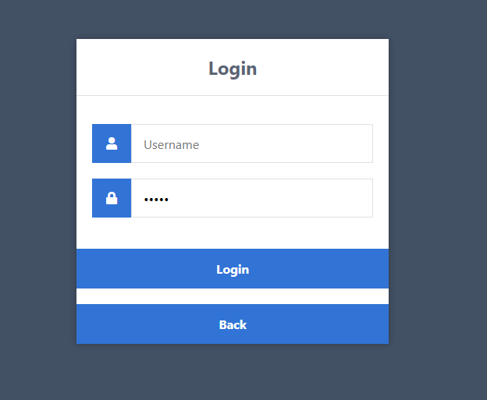

**Admin Login Interface**

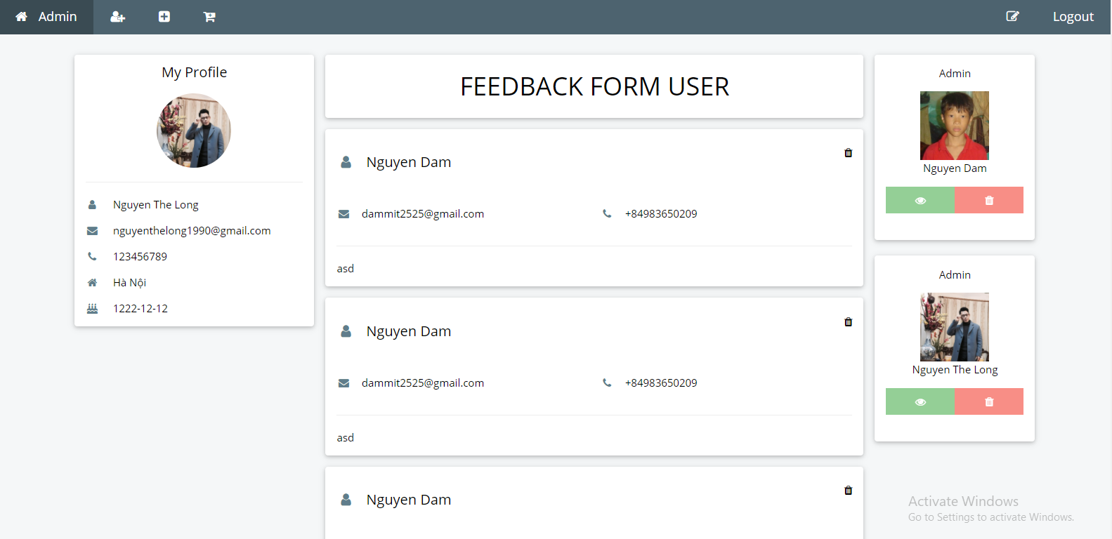

**Admin Interface**

**Login**

|  |  |
| --- | --- |
| **Description** | Administrator logs in the system |
| **Input** | Enter account and password |
| **Process** | Connect to the database and compare the account and password in the database with the account and password just entered. |
| **Output** | Log in successfully if the account and password are correct, otherwise log in wrong displayed on the notice. |

**Add new user**

|  |  |
| --- | --- |
| **Description** | Signing up an account. |
| **Input** | Enter information about the account. |
| **Process** | Connect to the database and add a record. |
| **Output** | If adding an account is successful, display on the notice successfully. If the account is already existed, display the error notice. |

**Update user**

|  |  |
| --- | --- |
| **Description** | Editing the data of an account. |
| **Input** | Enter the details which need editing. |
| **Process** | Connect to the database and edit information of the record. |
| **Output** | Inform editing is successful when it has already completed, otherwise display an error message. |

**Delete user**

|  |  |
| --- | --- |
| **Description** | Deleting an account. |
| **Input** | Enter the account need deleting. |
| **Process** | Connect to the database and delete this record. |
| **Output** | If deleting is successful, display the notice. Otherwise display an error message. |

**Add Product**

|  |  |
| --- | --- |
| **Description** | Add a new Product. |
| **Input** | Enter the details about the Product. |
| **Process** | Connect to the database and add a record. |
| **Output** | If adding a Product is successful, display the succeed notice. If the Product has already existed, display the error notice. |

**Update Product**

|  |  |
| --- | --- |
| **Description** | Edit the information of a Product. |
| **Input** | Enter the details which need editing about the Product. |
| **Process** | Connect to the database and edit the information of the record. |
| **Output** | Inform editing is successful when completing, otherwise inform error. |

**Delete Product**

|  |  |
| --- | --- |
| **Description** | Delete a Product. |
| **Input** | Enter the name of the Product which needs deleting. |
| **Process** | Connect to the database and delete this record. |
| **Output** | Inform deleting is successful. |

**View Product**

|  |  |
| --- | --- |
| **Decription** | View a Product. |
| **Input** | Enter the name of the Product which needs view. |
| **Process** | Connect to the database and view this record. |
| **Output** | Provide information Product. |

**Add Equipment**

|  |  |
| --- | --- |
| **Description** | Add a new Equipment. |
| **Input** | Enter the details about the Equipment. |
| **Process** | Connect to the database and add a record. |
| **Output** | If adding a Equipment is successful, display the succeed notice. If the Product has already existed, display the error notice. |

**Update Equipment**

|  |  |
| --- | --- |
| **Description** | Edit the information of a Equipment. |
| **Input** | Enter the details which need editing about the Equipment. |
| **Process** | Connect to the database and edit the information of the record. |
| **Output** | Inform editing is successful when completing, otherwise inform error. |

**Delete Equipment**

|  |  |
| --- | --- |
| **Description** | Delete a Equipment. |
| **Input** | Enter the name of the Product which needs deleting. |
| **Process** | Connect to the database and delete this record. |
| **Output** | Inform deleting is successful. |

**View Equipment**

|  |  |
| --- | --- |
| **Decription** | View a Equipment. |
| **Input** | Enter the name of the Equipment which needs view. |
| **Process** | Connect to the database and view this record. |
| **Output** | Provide information Equipment. |

**Delete Feedback**

|  |  |
| --- | --- |
| **Description** | Delete a Feedback. |
| **Input** | Enter the name of the Feedback which needs deleting. |
| **Process** | Connect to the database and delete this record. |
| **Output** | Inform deleting is successful. |

**View Feedback**

|  |  |
| --- | --- |
| **Decription** | View a Feedback. |
| **Input** | Enter the name of the Feedback which needs view. |
| **Process** | Connect to the database and view this record. |
| **Output** | Provide information Feedback. |

# System Designs

# Entity Relationship Diagram

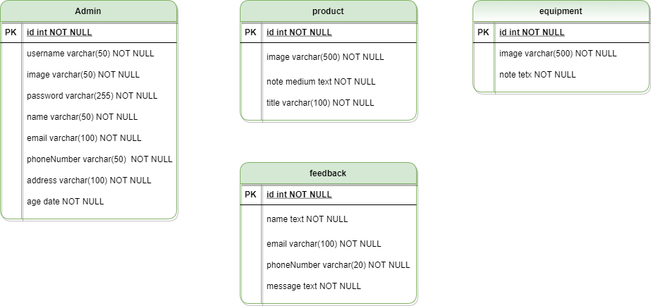

## Database Design



## Sitemap

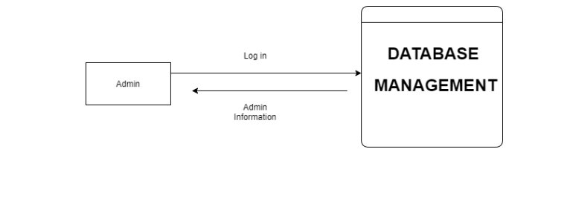

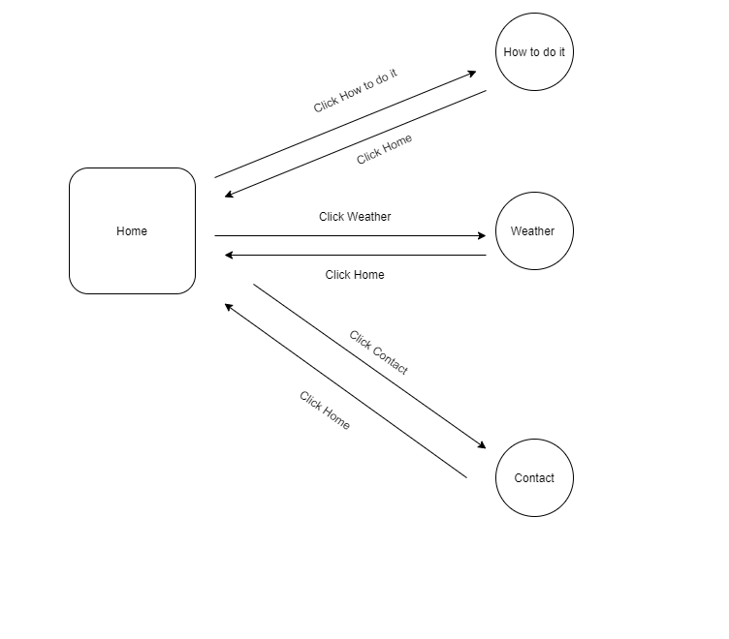

**Level 1**

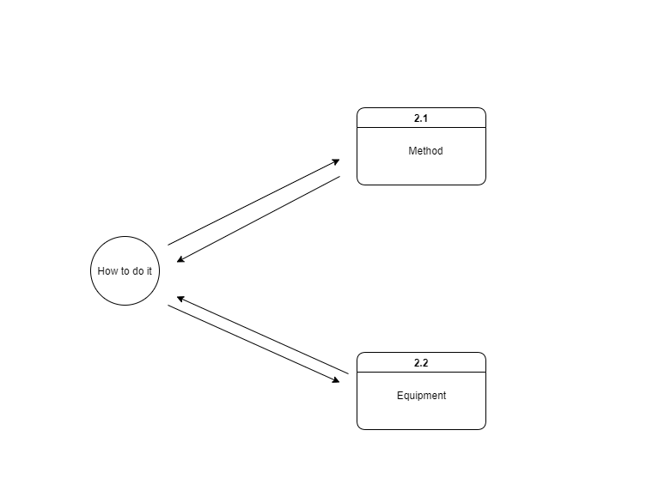

**Level 2: How to do it**

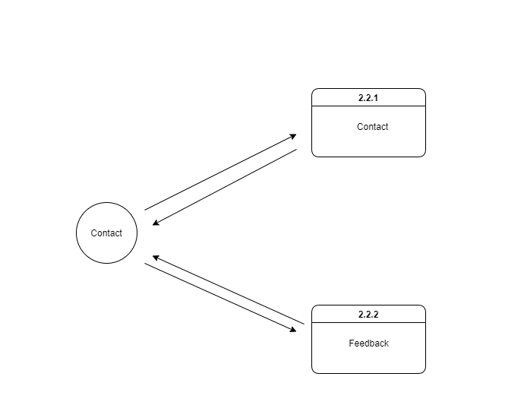

**Level 2: Contact**

## System fucntions design

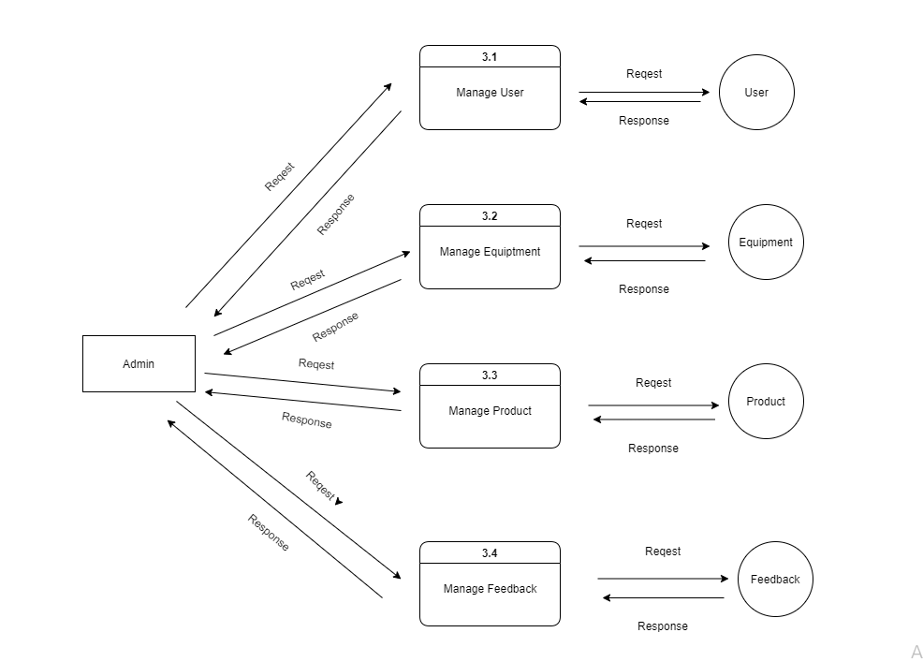

**Management Page**

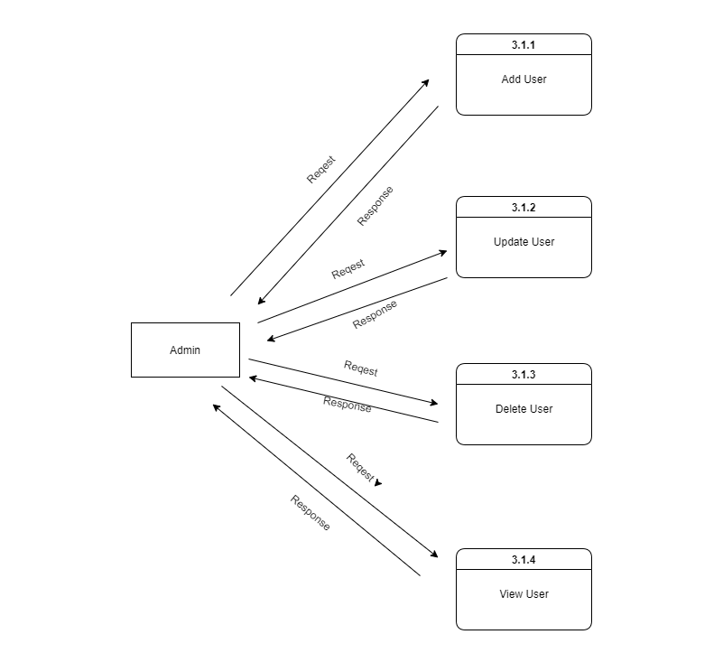

**Management User**

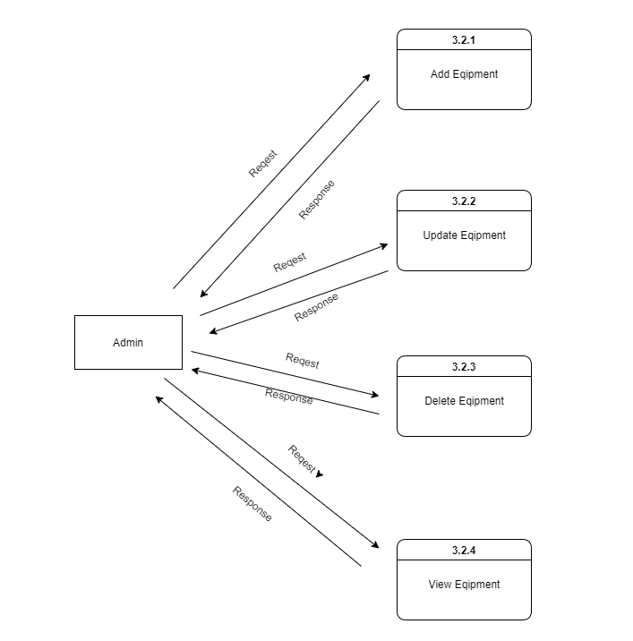

**Management Equipment**

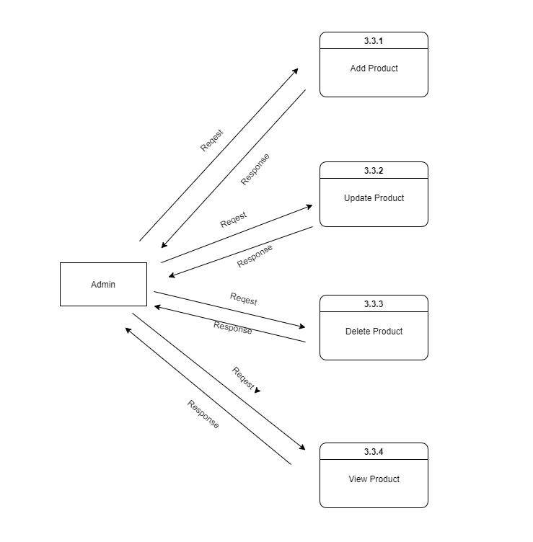

**Management Product**

**Flow Chart**



**Flowchart Login**



**FlowChart Add**



**FlowChart Update**

## Database Structure

**Information**

|  |  |  |  |  |
| --- | --- | --- | --- | --- |
| **Field Name** | **Data Type** | **Alow Null** | **Key** | **Description** |
| ID | Int | No | PK | ID of user |
| username | Varchar(50) | No |  | Username of user |
| image | Varchar(255) | No |  | Image of user |
| password | varchar(50) | No |  | Password user |
| Email | varchar(50) | No |  | E-mail of user |
| Birthday | date | No |  | Birthday of the user |
| Address | varchar(100) | No |  | Address user |
| Name | Varchar(50) | No |  | Name user |
| Phone NumBer | varrchar(50) | No |  | Primary phone number of user |

**Product**

|  |  |  |  |  |
| --- | --- | --- | --- | --- |
| **Field Name** | **Data Type** | **Alow Null** | **Key** | **Description** |
| ID | Int | No | PK | ID of product |
| note | Medium Tex | No |  | Note of product |
| image | Varchar(500) | No |  | Image of user |
| title | Varchar(100) | No |  | Password user |

**Equipment**

|  |  |  |  |  |
| --- | --- | --- | --- | --- |
| **Field Name** | **Data Type** | **Alow Null** | **Key** | **Description** |
| ID | Int | No | PK | ID of equipment |
| Note | Tex | No |  | Note of equipment |
| image | varchar(500) | No |  | Image of equipment |

**Feedback**

|  |  |  |  |  |
| --- | --- | --- | --- | --- |
| **Field Name** | **Data Type** | **Alow Null** | **Key** | **Description** |
| ID | Int | No | PK | ID of client ’s feedback |
| name | Tex | No |  | Name of client ’s feedback |
| email | Varchar(100) | No |  | Email of client ’s feedback |
| Phone Number | Varchar(20) | No |  | Phone number of client ’s feedback |
| Message | Text | No |  | Content of feedback |

## Screen Design





## User Guide

## Login



|  |  |  |  |
| --- | --- | --- | --- |
| **User** | **PassWord** | **Author** | **Locked** |
| Long | Thelong | Admin | No |
| Nguyen | Damnguyen | Admin | No |

After login, the Screen will display:



## Admin

You can choose Function

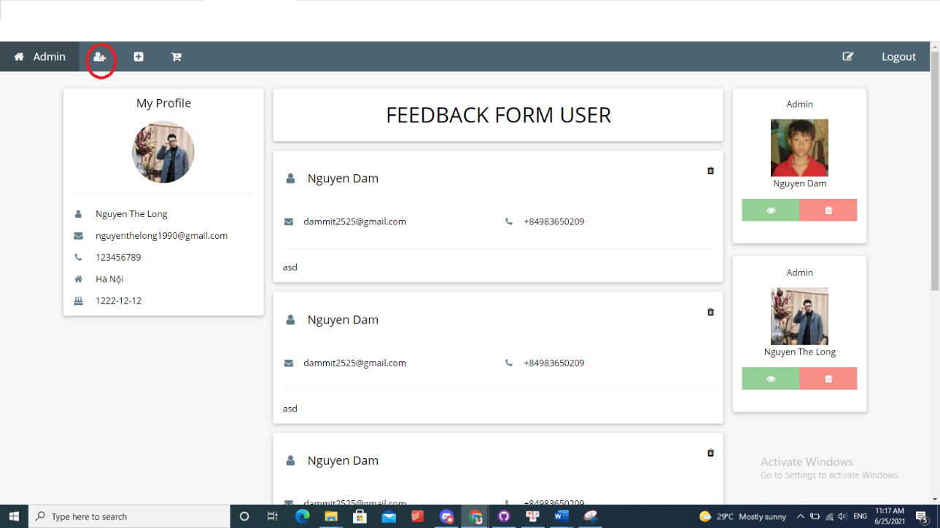

Add User

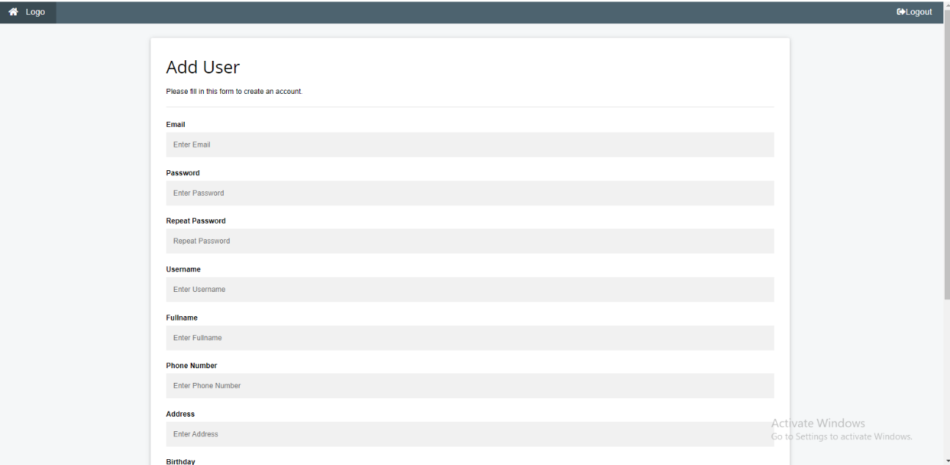

You can add Information of user

* Email
* Password
* Username
* FullName
* Phone Number
* Address

…

Beside, you can Edit Informantion of User and Delete User

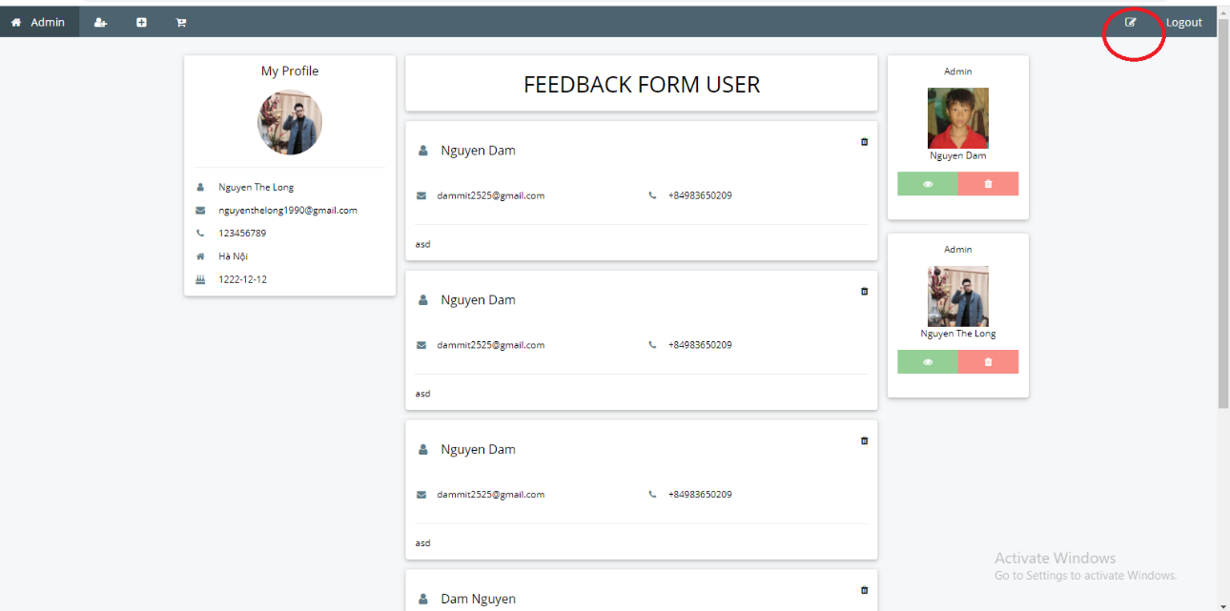

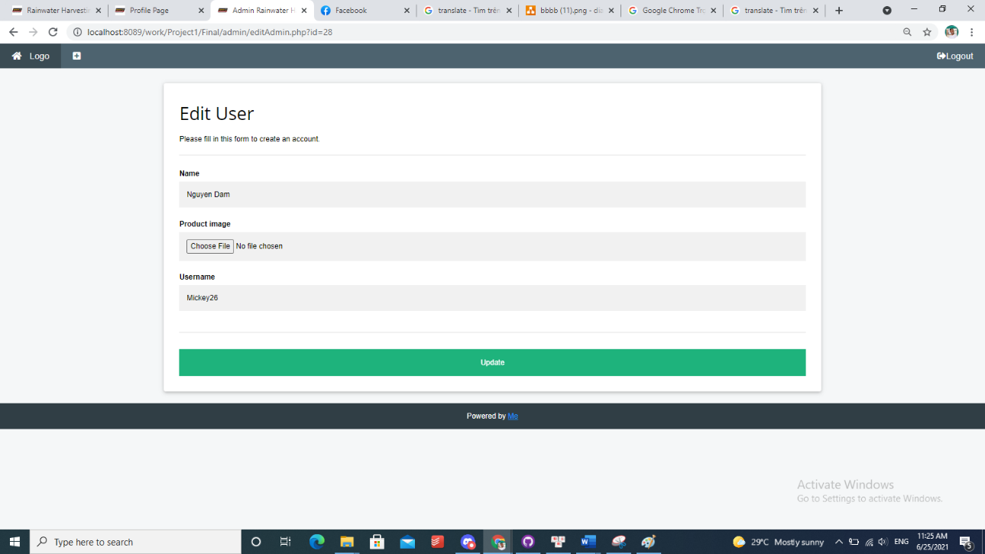

Add,Update and Delete Product

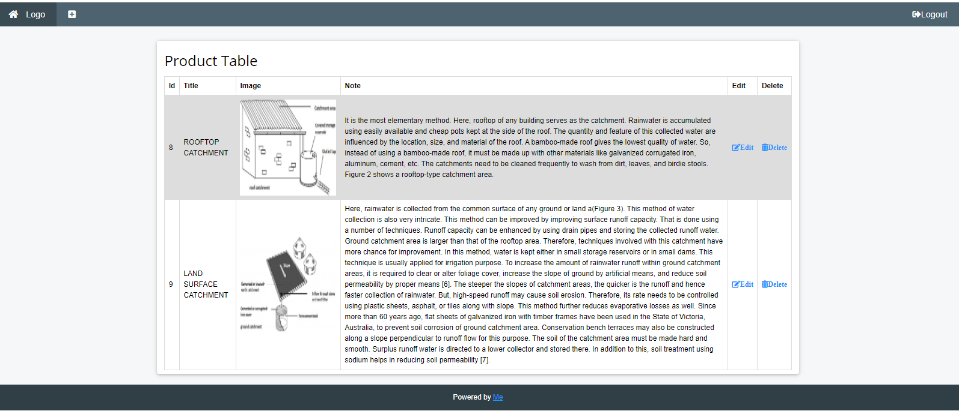

## Client



**Home Page**

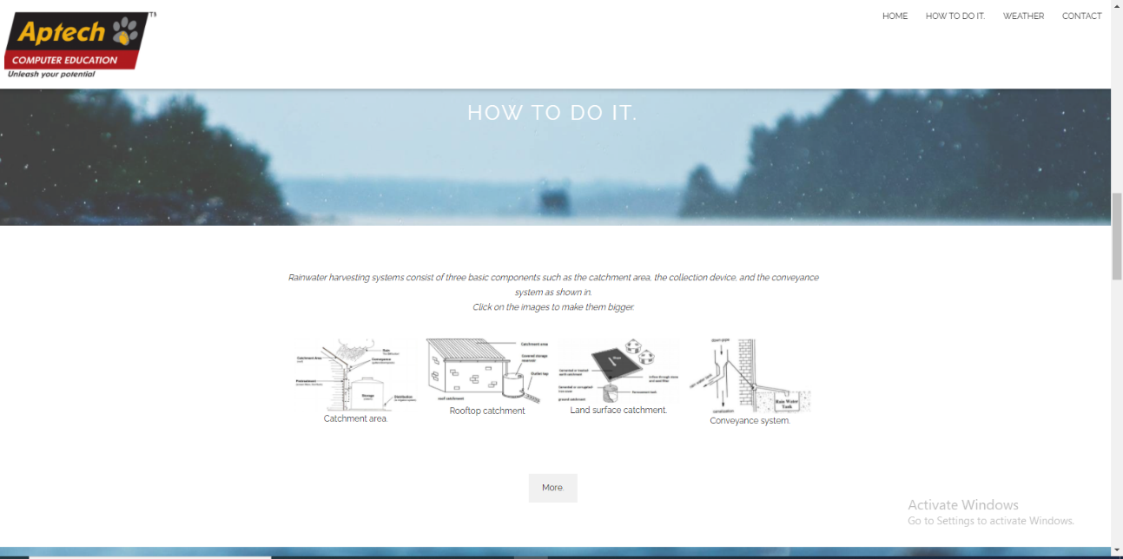

**How to do it page**

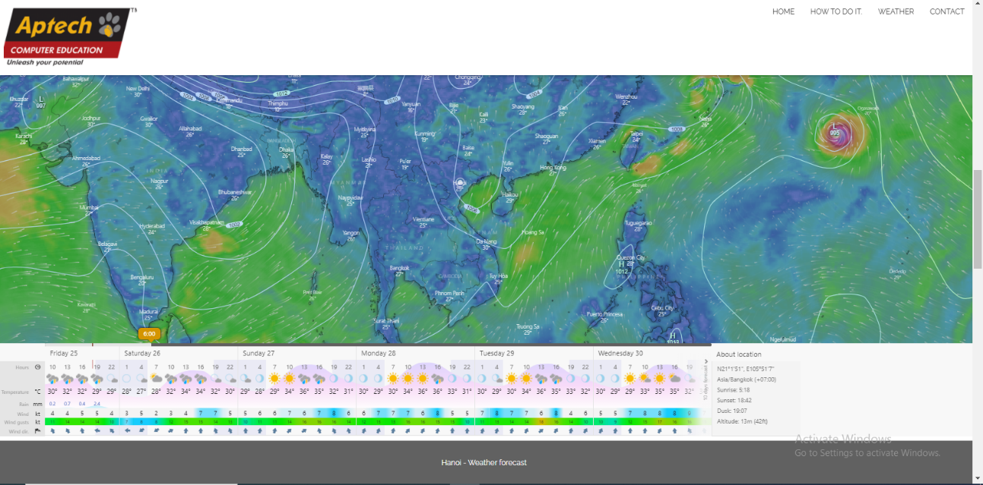

**Weather Page**

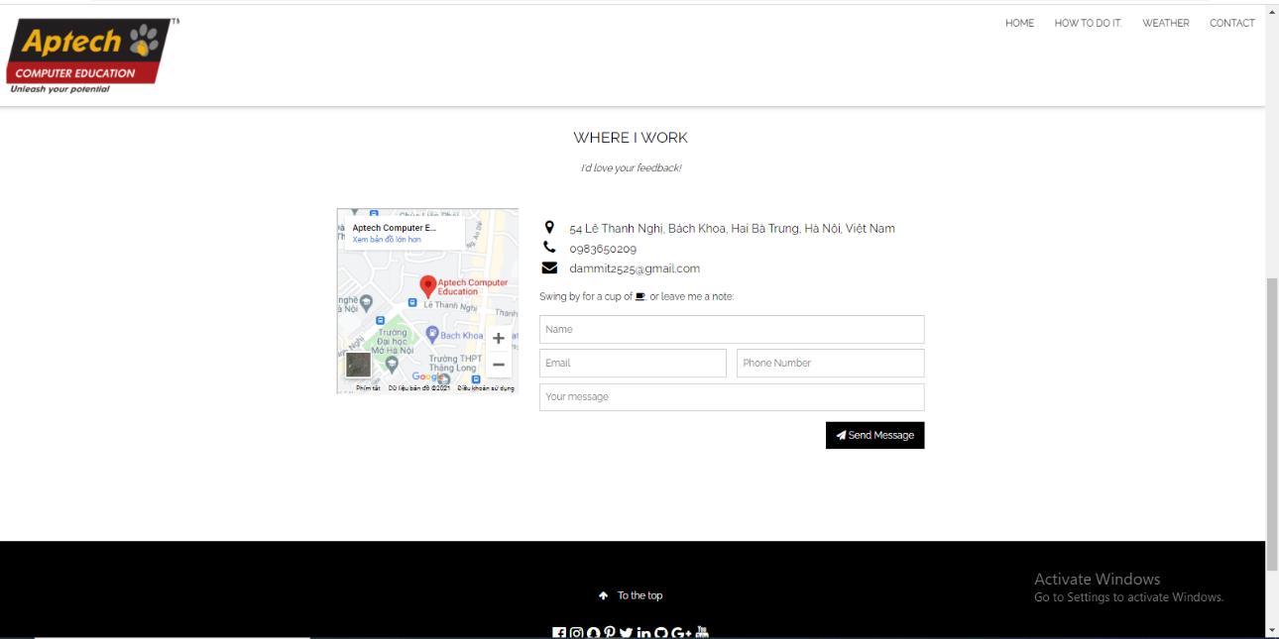

**Contact Page**

Your can feedback for us with email.You should fill all text box

# Task sheet

|  |  |  |  |  |
| --- | --- | --- | --- | --- |
| **Task** | **Start time** | **Finish time** | **Implemented by** | **Evaluation(%)** |
| Feasibility study phase |  |  |  |  |
| Viết tài liệu | 21/05/2021 | 28/05/2021 | Nguyễn Thế Long | 70 |
| Viết tài liệu | 21/05/2021 | 28/05/2021 | Đàm Khôi Nguyên | 30 |
| Đóng góp ý kiến | 21/05/2021 | 28/05/2021 | Nguyễn Thế Long | 50 |
| Đóng góp ý kiến | 21/05/2021 | 28/05/2021 | Đàm Khôi Nguyên | 50 |
| Duyệt và sửa nội dung | 21/05/2021 | 28/05/2021 | Nguyễn Thế Long | 70 |
| Duyệt và sửa nội dung | 21/05/2021 | 28/05/2021 | Đàm Khôi Nguyên | 30 |
| Requirement Analysis phase |  |  |  |  |
| Phân tích yêu cầu | 28/05/2021 | 04/06/2021 | Nguyễn Thế Long | 50 |
| Phân tích yêu cầu | 28/05/2021 | 04/06/2021 | Đàm Khôi Nguyên | 50 |
| Design phase |  |  |  |  |
| Thiết kế | 04/06/2021 | 11/06/2021 | Nguyễn Thế Long | 65 |
| Thiết kế | 04/06/2021 | 11/06/2021 | Đàm Khôi Nguyên | 35 |
| Development phase |  |  |  |  |
| Phát triển | 11/06/2021 | 18/06/2021 | Nguyễn Thế Long | 35 |
| Phát triển | 11/06/2021 | 18/06/2021 | Đàm Khôi Nguyên | 65 |
| Testing phase |  |  |  |  |
| Thử nghiệm | 18/06/2021 | 25/06/2021 | Nguyễn Thế Long | 50 |
| Thử nghiệm | 18/06/2021 | 25/06/2021 | Đàm Khôi Nguyên | 50 |
| Deployment phase |  |  |  |  |
| Triển khai | 18/06/2021 | 25/06/2021 | Nguyễn Thế Long | 50 |
| Triển khai | 18/06/2021 | 25/06/2021 | Đàm Khôi Nguyên | 50 |

# Validation Checklists

|  |  |
| --- | --- |
| **Option** | **Validated** |
| The fields in any form allow null or not? | Some null |
| Constraint type data and Foreigner Key | Yes |
| Can a new user who gets registered, enter the application after logging in? | Yes |
| Do all the options present in the application display the correct result? | Yes |
| Does the application’s functionality resolve the user problem, and satisfy their needs? | Yes |
| Has the hardware and software been correctly chosen? | Yes |
|  |  |

# Submission Checklists

|  |  |  |  |  |  |
| --- | --- | --- | --- | --- | --- |
| **Sr. No.** | **Particulars** | **Yes** | **No** | **NA** | **Comments** |
| 1. | All forms activate well | x |  |  |  |
| 2. | Are the users able to login to the application after validation is performed on the username and password? | x |  |  |  |
| 3. | Are the users able to modify their detail after getting registered? | x |  |  |  |
| 4. | All pages have not mistake | x |  |  |  |
| 5. | Is the application user-friendly? | x |  |  |  |