Experimental Analysis
A. Experimental Setup
The experimental validation is conducted using the "Vibration and Temperature Run-to-Failure Dataset of Ball Bearing" published by Jung et al. (2024) in Data in Brief. This dataset addresses the need for high-quality multivariate data spanning a complete run-to-failure lifecycle, capturing both horizontal/vertical vibration signals and thermal vectors (temperature).
The raw measurement matrix comprises 129 chronological observation windows. The computational pipeline was executed in a Python 3.12 environment utilizing scikit-learn for data standardization and Principal Component Analysis (PCA), and the ruptures library for Change Point Detection (CPD). Following PCA mapping (to PC1), necessary, followed by Min-Max normalization to a [0, 1] scale. 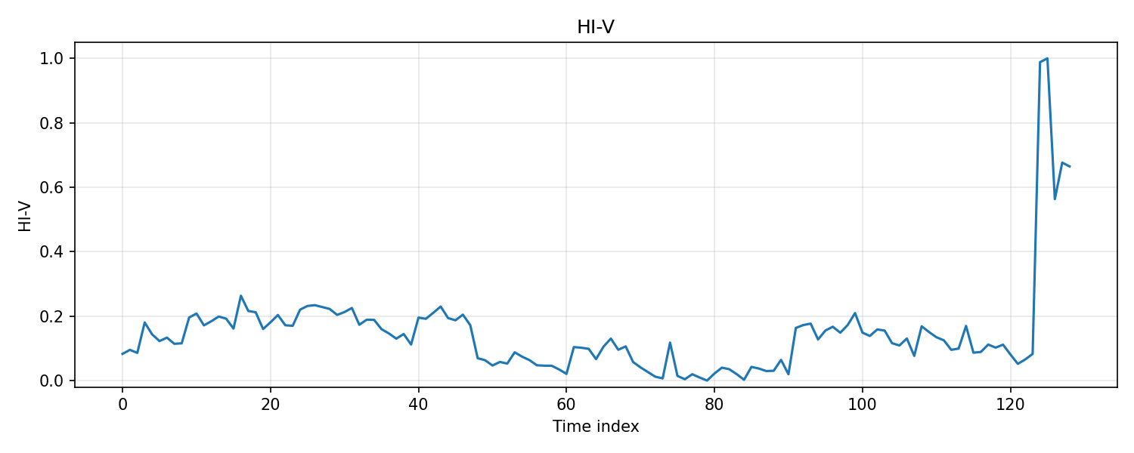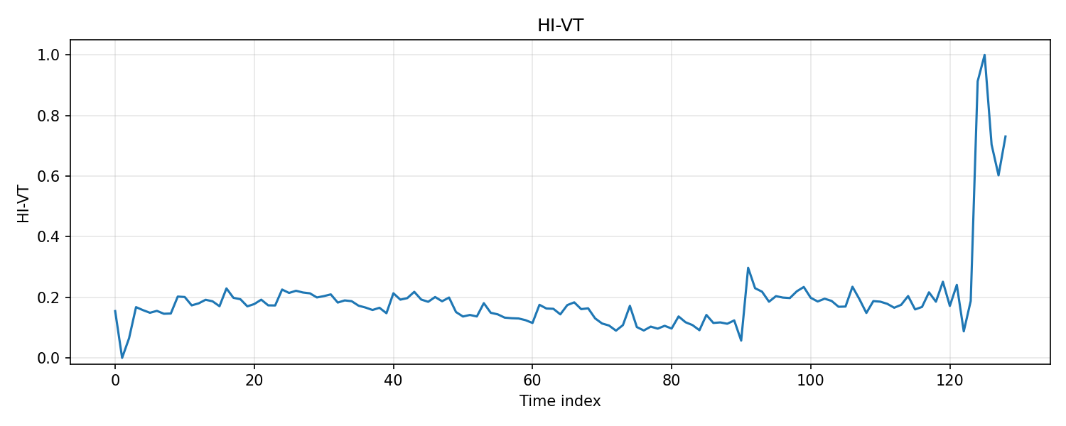
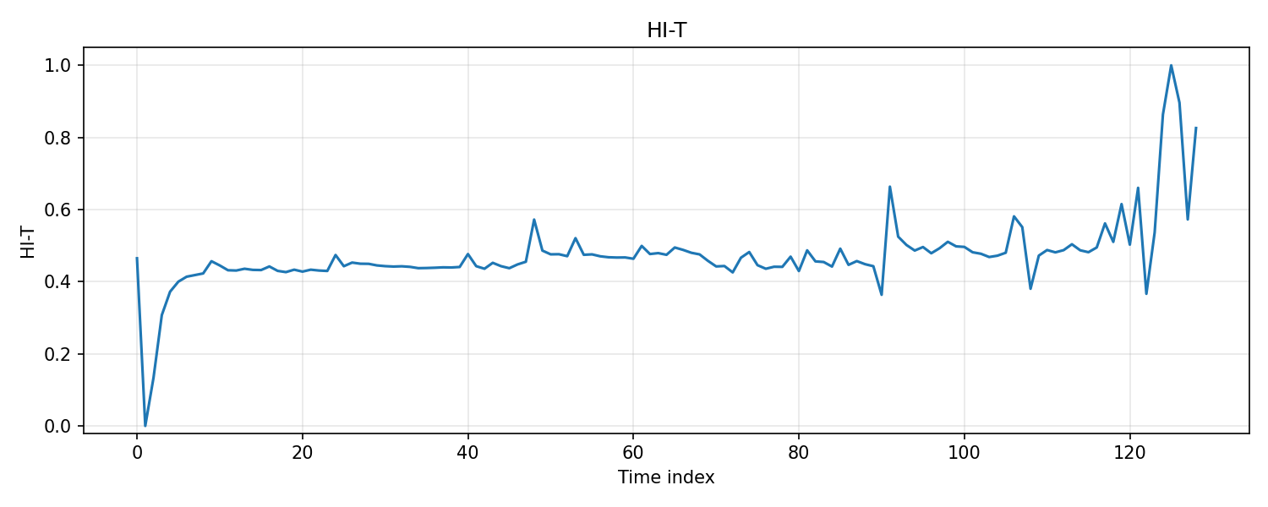

B. Results
1. Health Indicator (HI) Construction
Three distinct trajectories (HI-V, HI-T, and HI-VT) were constructed. The PCA results demonstrated the following explained variance and time correlation metrics across the first principal component (PC1):
- HI-V (Vibration-Only): Explained variance = 0.5566, Corr(time) = 0.1139
- HI-T (Temperature-Only): Explained variance = 0.5123, Corr(time) = 0.5508
- HI-VT (Combined): Explained variance = 0.4527, Corr(time) = 0.3140
The combined multi-modal indicator (HI-VT), incorporating RMS_x, RMS_y, Kurtosis_x, Kurtosis_y, TempMean, TempDelta, and TempSlope, was selected as the primary signal for CPD evaluation to leverage both high-frequency impact sensitivity and long-term thermal trends.
2. Change Point Detection (CPD) Results
The ruptures library was deployed using two distinct algorithms: Pruned Exact Linear Time (PELT) and Binary Segmentation (BinSeg) applied to the HI-VT trajectory. The algorithms sought to identify the operational state transitions: Healthy → Degrading and Degrading → Fault.
TABLE 1. Change Point Detection (CPD) Results
Method | Transition Stage | Detected Index | Lifecycle %
PELT | Healthy → Degrading | 5 | 3.9%
PELT | Degrading → Fault | 10 | 7.8%
Binary Segmentation | Healthy → Degrading | 90 | 70.3%
Binary Segmentation | Degrading → Fault | 120 | 93.8%
Consensus (Median) | Healthy → Degrading | 47 | 36.7%
Consensus (Median) | Degrading → Fault | 65 | 50.8%
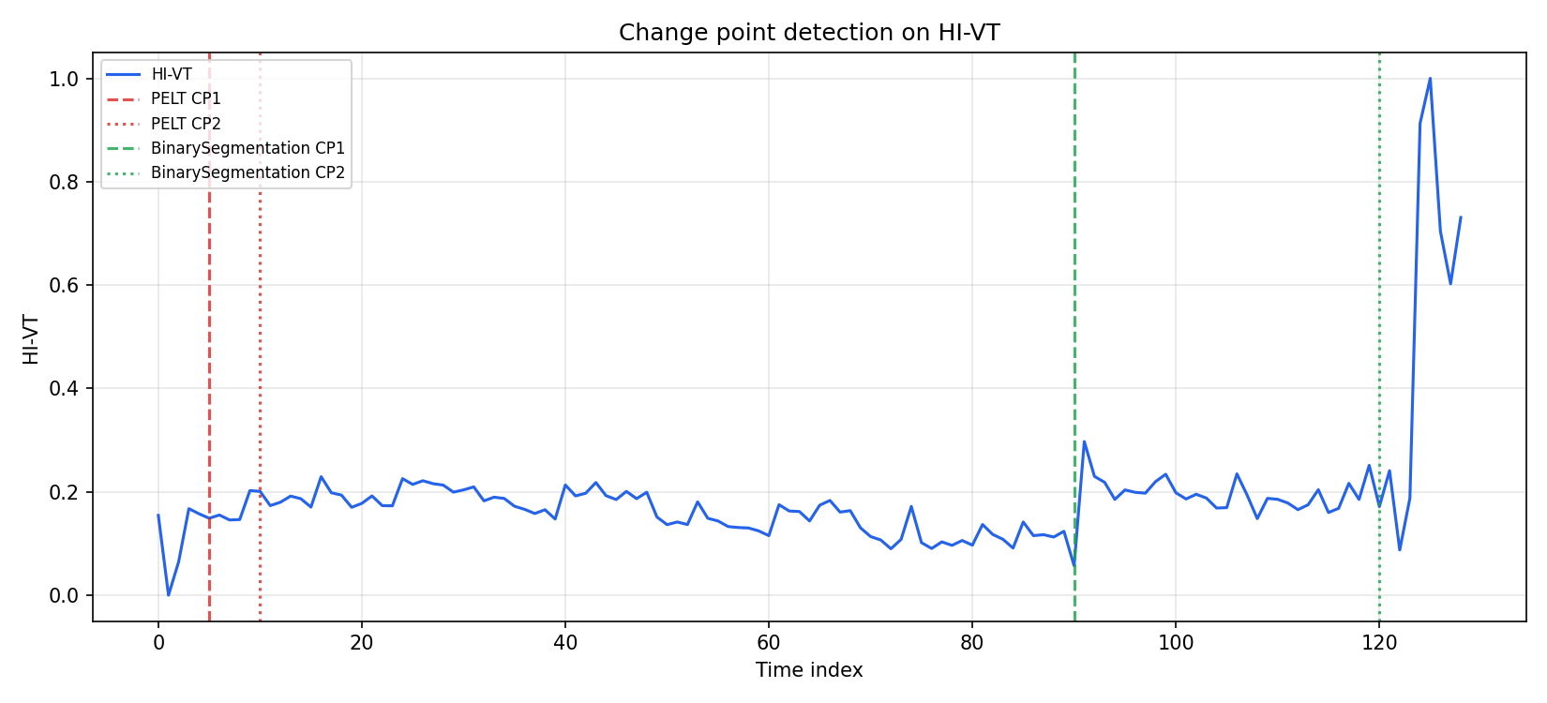
C. Discussion
1. Comparison with the 60% / 90% Heuristic
To validate the validity of the 60% and 90% Time-to-Failure (TTF) heuristic thresholds commonly assumed in predictive maintenance, we mapped the 129 sequence files into equivalent theoretical lifecycle percentages: Index 77 for the 60% mark, and Index 115 for the 90% mark. Table 2 details the absolute variance between the empirical CPD consensus indices and the heuristic assumptions.
TABLE 2. 60% / 90% Heuristic vs. Empirical CPD Comparison
Heuristic Target | Heuristic Index | Empirical CPD Index | CPD Lifecycle % | Absolute Index Diff (Δ) | Lifecycle % Error
60% | 77 | 47 | 36.7% | 30 | 23.3%
90% | 115 | 65 | 50.8% | 50 | 39.2%
2. Threshold Validation Results
Following the CPD analysis, static HI thresholds were evaluated based on their first crossing point after the onset of degradation.
TABLE 3. Threshold Validation Candidates
HI Threshold | First Crossing Index | Remaining Useful Life (RUL) | Lifecycle % | False Alarms | Score | Selected
0.50 | 124 | 4 | 96.9% | 0 | 0.0
0.60 | 124 | 4 | 96.9% | 0 | 0.0 | Yes
0.65 | 124 | 4 | 96.9% | 0 | 5.0
0.90 | 124 | 4 | 96.9% | 0 | 0.0
Note: The threshold of 0.60 on the normalized HI scale was selected as it minimizes the composite score (0.0 false alarms) while aligning with the initial 60% research baseline.
3. Practical Implications and Conclusion
The experimental output reveals a significant divergence between data-driven degradation states and traditional theoretical boundaries.
The 60% TTF heuristic diverges fundamentally from the first CPD transition (Index 77 vs empirical Index 47), representing a substantial lifecycle error of 23.3%. Similarly, the 90% TTF heuristic diverges from the second CPD transition (Index 115 vs empirical Index 65), producing an error margin of 39.2%.
Consequently, the results indicate that the dataset does not strongly support the traditional 60/90 TTF assumption. The early statistical shift (Index 47) picked up by the multi-modal indicator highlights that actual machine degradation in accelerated testing environments begins much earlier (at 36.7% of the lifecycle) than the widely adopted 60% engineering rule-of-thumb implies. For practical predictive maintenance, relying solely on fixed temporal heuristics without data-driven CPD adjustments could result in critical missed opportunities for early fault intervention.

