

CAPSTONE PROJECT REPORT
Report 3 – Software Requirement Specification

– Ho Chi Minh, January 2026 –
Table of Contents
I. Record of Changes 2
II. Software Requirement Specification 3
1. Product Overview 3
2. User Requirements 4
2.1 Actors 4
2.2 Use Cases 4
3. Functional Requirements 12
3.1 System Functional Overview 12
3.2 Authentication 40
3.3 Ride Booking 50
3.4 Booking Management 55
3.5 User Profile Management 64
3.6 Wallet & Payment 69
3.7 Voucher Management 75
3.8 Driver Ride Management 81
3.9 System & User Management 100
3.10 Complaint & Incident Management 110
3.11 Withdrawal Processing 114
4. Non-Functional Requirements 116
4.1 External Interfaces 116
4.2 Quality Attributes 116
5. Requirement Appendix 120
5.1 Business Rules 120
5.2 Common Requirements 125
5.3 Application Messages List 126

I. Record of Changes
Date | A*  M, D | In charge | Change Description
20/02/2026 | A | LongTH | Add Product Overview, User Requirements
22/02/2026 | A | DatDPT | Add Functional Requirement
25/02/2026 | A | DatDPT | Add Non-Functional Requirement
25/02/2026 | A | DatDPT | Add Requirement Appendix
25/02/2026 | M | LongTH | Modified UseCase
25/02/2026 | M | LongTH | Modified UseCase
27/02/2026 | M | DungUD | Modified Scree Flow
27/02/2026 | M | DungUD | Modified Scree Flow
27/02/2026 | D | LongTH | Delete Usecase
27/02/2026 | A | LongTH | Add Usecase
27/02/2026 | M | DatDPT | Modified UseCase
28/02/2026 | M | DatDPT | Modified UseCase
28/02/2026 | M | DatDPT | Modified UseCase
*A - Added M - Modified D - Deleted

II. Software Requirement Specification

1. Product Overview
SMC-Ride (Student Mobility Corridor Ride-Matching System) is a campus-oriented ride-matching platform designed to support university students who frequently travel between dormitories and academic buildings. Unlike traditional ride-hailing systems, SMC-Ride focuses on identifying and leveraging repetitive student mobility corridors based on their class schedules to optimize ride matching within a verified campus community. The aim is to significantly optimize transportation costs for students. The system provides mobile applications for students and drivers, along with a web-based administration portal. It integrates with external services such as Google Maps for route calculation and university email systems for identity verification.
The context diagram below illustrates the system boundary and its interactions with external actors and external systems.
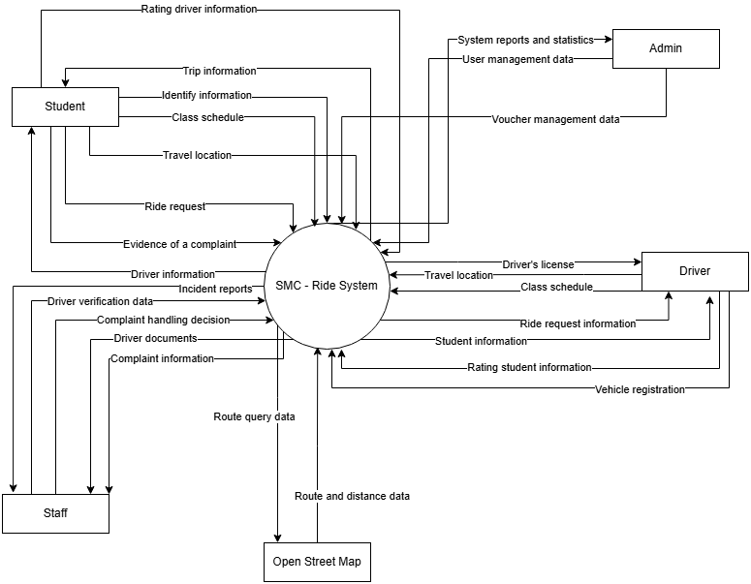

Figure 1: Context diagram

2. User Requirements

2.1 Actors
# | Actor | Description
1 | Student | A university student who uses the mobile application to search, request, and participate in corridor-based ride sharing.
2 | Driver | A verified student who publishes rides, approves ride requests, and provides transportation services within defined mobility corridors.
3 | Staff | University staff member responsible for verifying driver documents, handling complaints, and managing incidents.
4 | Admin | System administrator who manages users, mobility corridors, analytics, and overall system configuration.
5 | Open Street map | External mapping service that provides route calculation and distance measurement for ride matching, OCR information from upload document, Payment gateway for topup
6 | Google cloud OCR | OCR information from upload document
7 | Payment gateway | Payment gateway for topup
8 | AI matching engine | Matching between student and driver ride request base on many criteria

Table 1: List of actors

2.2 Use Cases

2.2.1 Diagram(s)
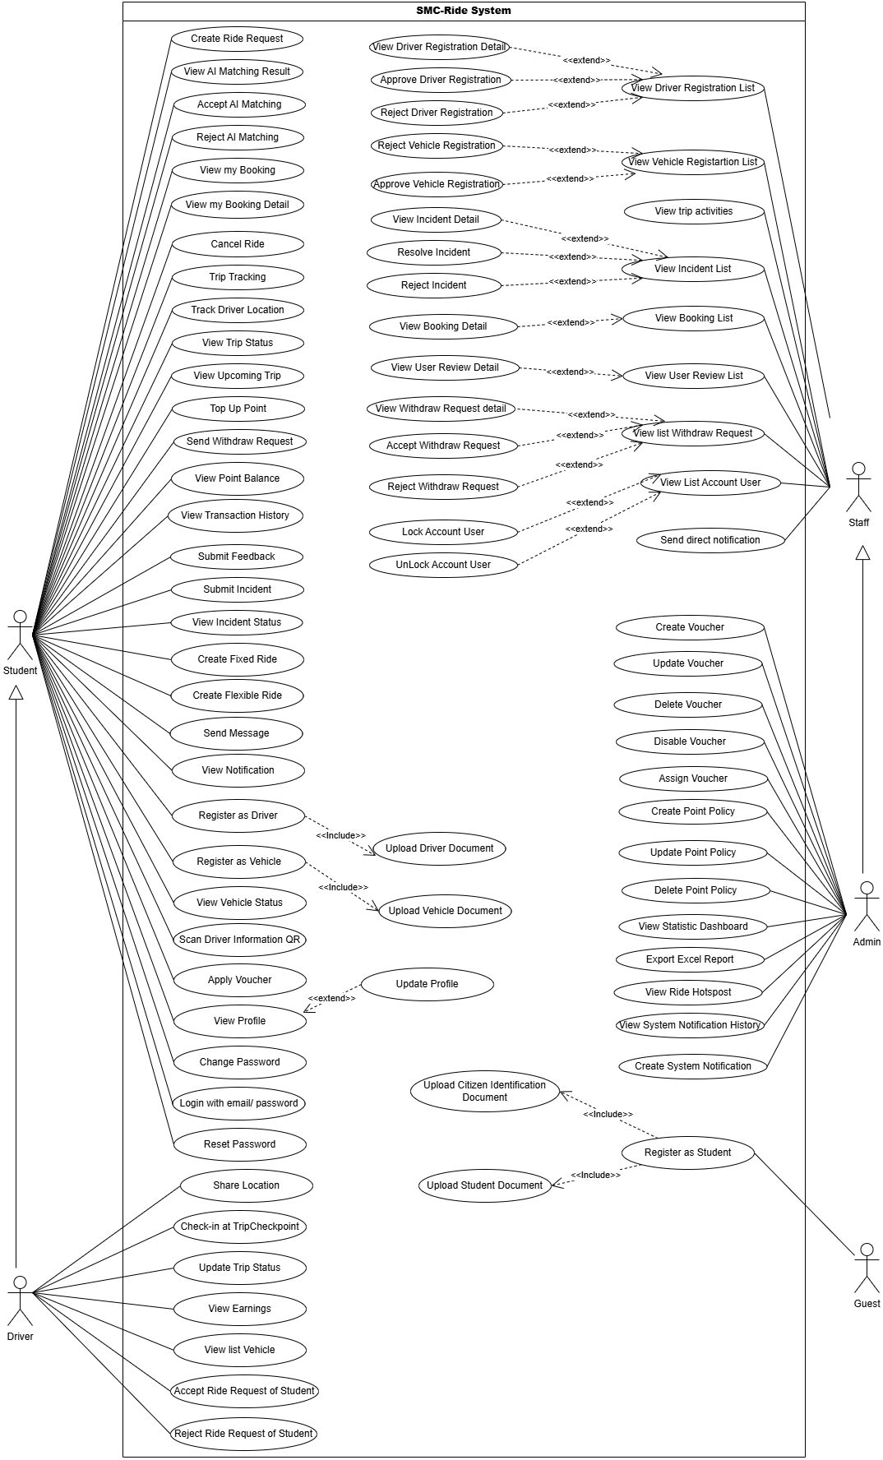

Figure 2: Use case diagram

2.2.2 Descriptions
ID | Use Case | Actors | Use Case Description
01 | Register as Student | Guest | Allows a guest (unregistered user) to register a student account on the system (includes uploading citizen identification and student documents).
02 | Login with email/password | Student, Driver | Allows students and drivers to log into the SMC-Ride system using their email address and password.
03 | Reset Password | Student, Driver | Allows students or drivers to recover their password via email when they forget it.
04 | Change Password | Student, Driver | Allows logged-in users to change their current account password.
05 | View Profile | Student, Driver | Allows users to view their account profile details.
06 | Update Profile | Student, Driver | Allows users to modify and update their personal profile information.
07 | View Notification | Student, Driver | Allows users to view a list and details of notifications sent from the system.
08 | Send Message | Student, Driver | Allows students and drivers to send text messages to each other while a trip is active.
09 | Create Ride Request | Student | Allows students to request a new ride by entering departure and destination points.
10 | Create Fixed Ride | Student | Allows students to request a ride with a fixed route or schedule.
11 | Create Flexible Ride | Student | Allows students to request a highly customizable and flexible ride.
12 | View AI Matching Result | Student | Allows students to view driver recommendations optimized and matched by the AI system.
13 | Accept AI Matching | Student | Allows students to accept the driver match suggested by the AI system.
14 | Reject AI Matching | Student | Allows students to decline the driver match suggested by the AI system to search for another driver.
15 | View my Booking | Student | Allows students to view their booking list (current active and past trip history).
16 | View my Booking Detail | Student | Allows students to view detailed information of a specific booking.
17 | Cancel Ride | Student | Allows students to cancel a booked ride before the journey begins.
18 | Trip Tracking | Student | Allows students to track the real-time route and movement status of the trip on the map.
19 | Track Driver Location | Student | Allows students to view the driver's real-time location on the map before pick-up.
20 | View Trip Status | Student | Allows students to view the current status of the trip (e.g., driver arriving, in progress, completed).
21 | View Upcoming Trip | Student | Allows students to view a list of their upcoming scheduled trips.
22 | Scan Driver Information QR | Student | Allows students to scan the driver's QR code to verify and validate driver credentials before boarding.
23 | Top Up Point | Student | Allows students to add/top up points to their account wallet through payment gateways.
24 | Send Withdraw Request | Student | Allows students to send a request to withdraw points/funds from their wallet to a bank account.
25 | View Point Balance | Student | Allows students to check their current remaining point balance in their wallet.
26 | View Transaction History | Student | Allows students to view their financial transactions and point balance history.
27 | Apply Voucher | Student | Allows students to apply discount vouchers to the ride booking to reduce costs.
28 | Submit Feedback | Student | Allows students to submit reviews and feedback about the driver after a trip is completed.
29 | Submit Incident | Student | Allows students to report incidents, disputes, or accidents that occurred during the trip.
30 | View Incident Status | Student | Allows students to track the resolution progress and final outcome of their reported incident.
31 | Register as Driver | Student | Allows registered students to apply to become a driver by uploading required driver credentials (license, ID card, etc.).
32 | Register as Vehicle | Student | Allows students to register vehicle information for operating rides (uploads vehicle registration, insurance documents).
33 | View Vehicle Status | Student | Allows students/drivers to check the verification and approval status of their registered vehicles.
34 | Share Location | Driver | Allows drivers to share their real-time GPS location with the system and the passenger.
35 | Check-in at TripCheckpoint | Driver | Allows drivers to check-in at designated checkpoints along the trip route.
36 | Update Trip Status | Driver | Allows drivers to update trip status milestones (e.g., passenger picked up, trip completed).
37 | View Earnings | Driver | Allows drivers to view their total accumulated and detailed earnings from completed trips.
38 | View list Vehicle | Driver | Allows drivers to view a list of vehicles they have registered and linked.
39 | Accept Ride Request of Student | Driver | Allows drivers to accept a ride request submitted by a student.
40 | Reject Ride Request of Student | Driver | Allows drivers to decline a ride request from a student.
41 | View Driver Registration List | Staff, Admin | Allows staff/admin to view a list of driver registration applications submitted by students.
42 | View Driver Registration Detail | Staff, Admin | Allows staff/admin to view detailed information and uploaded documents of a specific driver application.
43 | Approve Driver Registration | Staff, Admin | Allows staff/admin to approve valid driver registration applications.
44 | Reject Driver Registration | Staff, Admin | Allows staff/admin to reject driver registration applications with reason comments.
45 | View Vehicle Registration List | Staff, Admin | Allows staff/admin to view a list of vehicle registration applications.
46 | Approve Vehicle Registration | Staff, Admin | Allows staff/admin to approve valid vehicle registration applications so the vehicle can be used.
47 | Reject Vehicle Registration | Staff, Admin | Allows staff/admin to reject vehicle registration applications.
48 | View Incident List | Staff, Admin | Allows staff/admin to view a list of all incidents reported by students or drivers.
49 | View Incident Detail | Staff, Admin | Allows staff/admin to view detailed information and chat logs regarding a specific incident.
50 | Resolve Incident | Staff, Admin | Allows staff/admin to resolve an incident, issue a final decision, and close the case.
51 | Reject Incident | Staff, Admin | Allows staff/admin to reject or close invalid incident reports.
52 | View Booking List | Staff, Admin | Allows staff/admin to view a list of all bookings in the system.
53 | View Booking Detail | Staff, Admin | Allows staff/admin to view detailed information of a booking, including route, timing, fares, and user profiles.
54 | View User Review List | Staff, Admin | Allows staff/admin to monitor reviews and feedback submitted by users.
55 | View User Review Detail | Staff, Admin | Allows staff/admin to view the detailed content of a specific user review.
56 | View List Withdraw Request | Staff, Admin | Allows staff/admin to view a list of point/fund withdrawal requests submitted by users.
57 | View Withdraw Request detail | Staff, Admin | Allows staff/admin to view transactional details and target account info for a withdraw request.
58 | Accept Withdraw Request | Staff, Admin | Allows staff/admin to approve the withdraw request and process the payout to the user.
59 | Reject Withdraw Request | Staff, Admin | Allows staff/admin to decline invalid withdraw requests.
60 | View List Account User | Staff, Admin | Allows staff/admin to view a list of all registered user accounts.
61 | Lock Account User | Staff, Admin | Allows staff/admin to temporarily or permanently lock user accounts violating service terms.
62 | Unlock Account User | Staff, Admin | Allows staff/admin to reactivate/unlock user accounts once the issue is resolved.
63 | Send direct notification | Staff, Admin | Allows staff/admin to compose and send manual notifications directly to a specific user.
64 | View trip activities | Staff, Admin | Allows staff/admin to track and monitor the status/history of ongoing trips for operational supervision.
65 | Create Voucher | Admin | Allows the administrator to create new promotional discount vouchers with values and conditions.
66 | Update Voucher | Admin | Allows the administrator to update or edit details and criteria of existing active vouchers.
67 | Delete Voucher | Admin | Allows the administrator to permanently delete vouchers from the system.
68 | Disable Voucher | Admin | Allows the administrator to temporarily deactivate/disable a voucher.
69 | Assign Voucher | Admin | Allows the administrator to assign/gift vouchers to specific users or target user groups.
70 | Create Point Policy | Admin | Allows the administrator to define rules for point accumulation, topup/withdraw points, and point values.
71 | Update Point Policy | Admin | Allows the administrator to modify and update current point policies.
72 | Delete Point Policy | Admin | Allows the administrator to delete point policies that are no longer applicable.
73 | View Statistic Dashboard | Admin | Allows the administrator to view visual analytics and statistics (revenue, bookings, user growth) via dashboards.
74 | Export Excel Report | Admin | Allows the administrator to export system operational data and records into Excel files.
75 | View Ride Hotspot | Admin | Allows the administrator to view map hotspots indicating high trip demands.
76 | View System Notification History | Admin | Allows the administrator to view the historical record of sent system-wide notifications.
77 | Create System Notification | Admin | Allows the administrator to compose and publish notifications to all users (Students, Drivers, Staff) across the system.

Table 2: Description use case diagram

3. Functional Requirements

3.1 System Functional Overview

3.1.1 Screens Flow

3.1.1.1 Admin screen flow
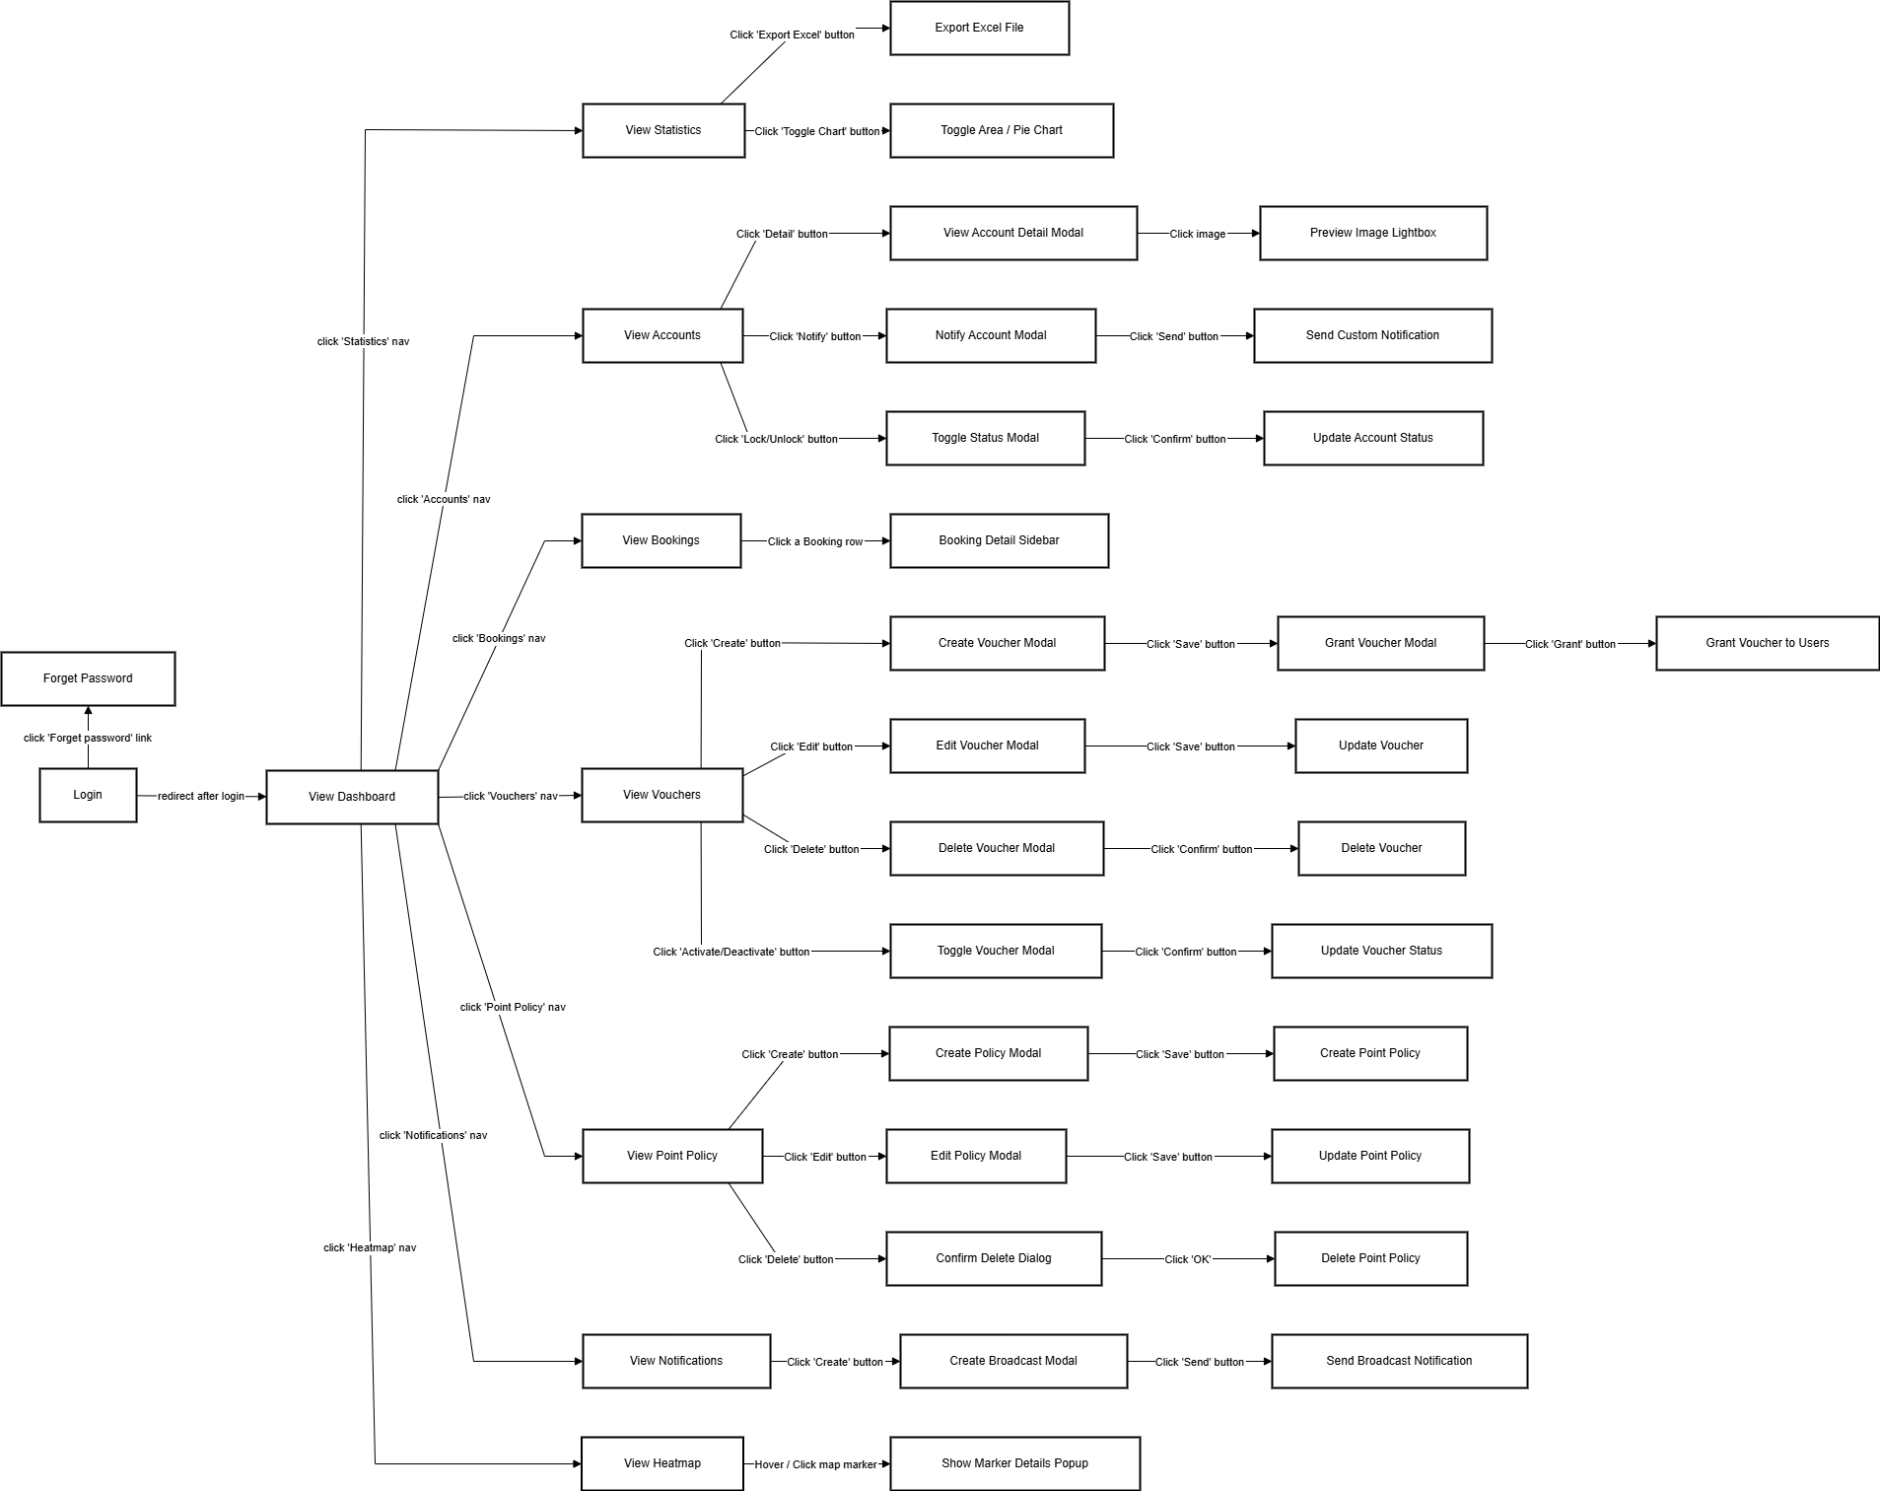

Figure 3: Admin screen flow

3.1.1.2 Staff screen flow
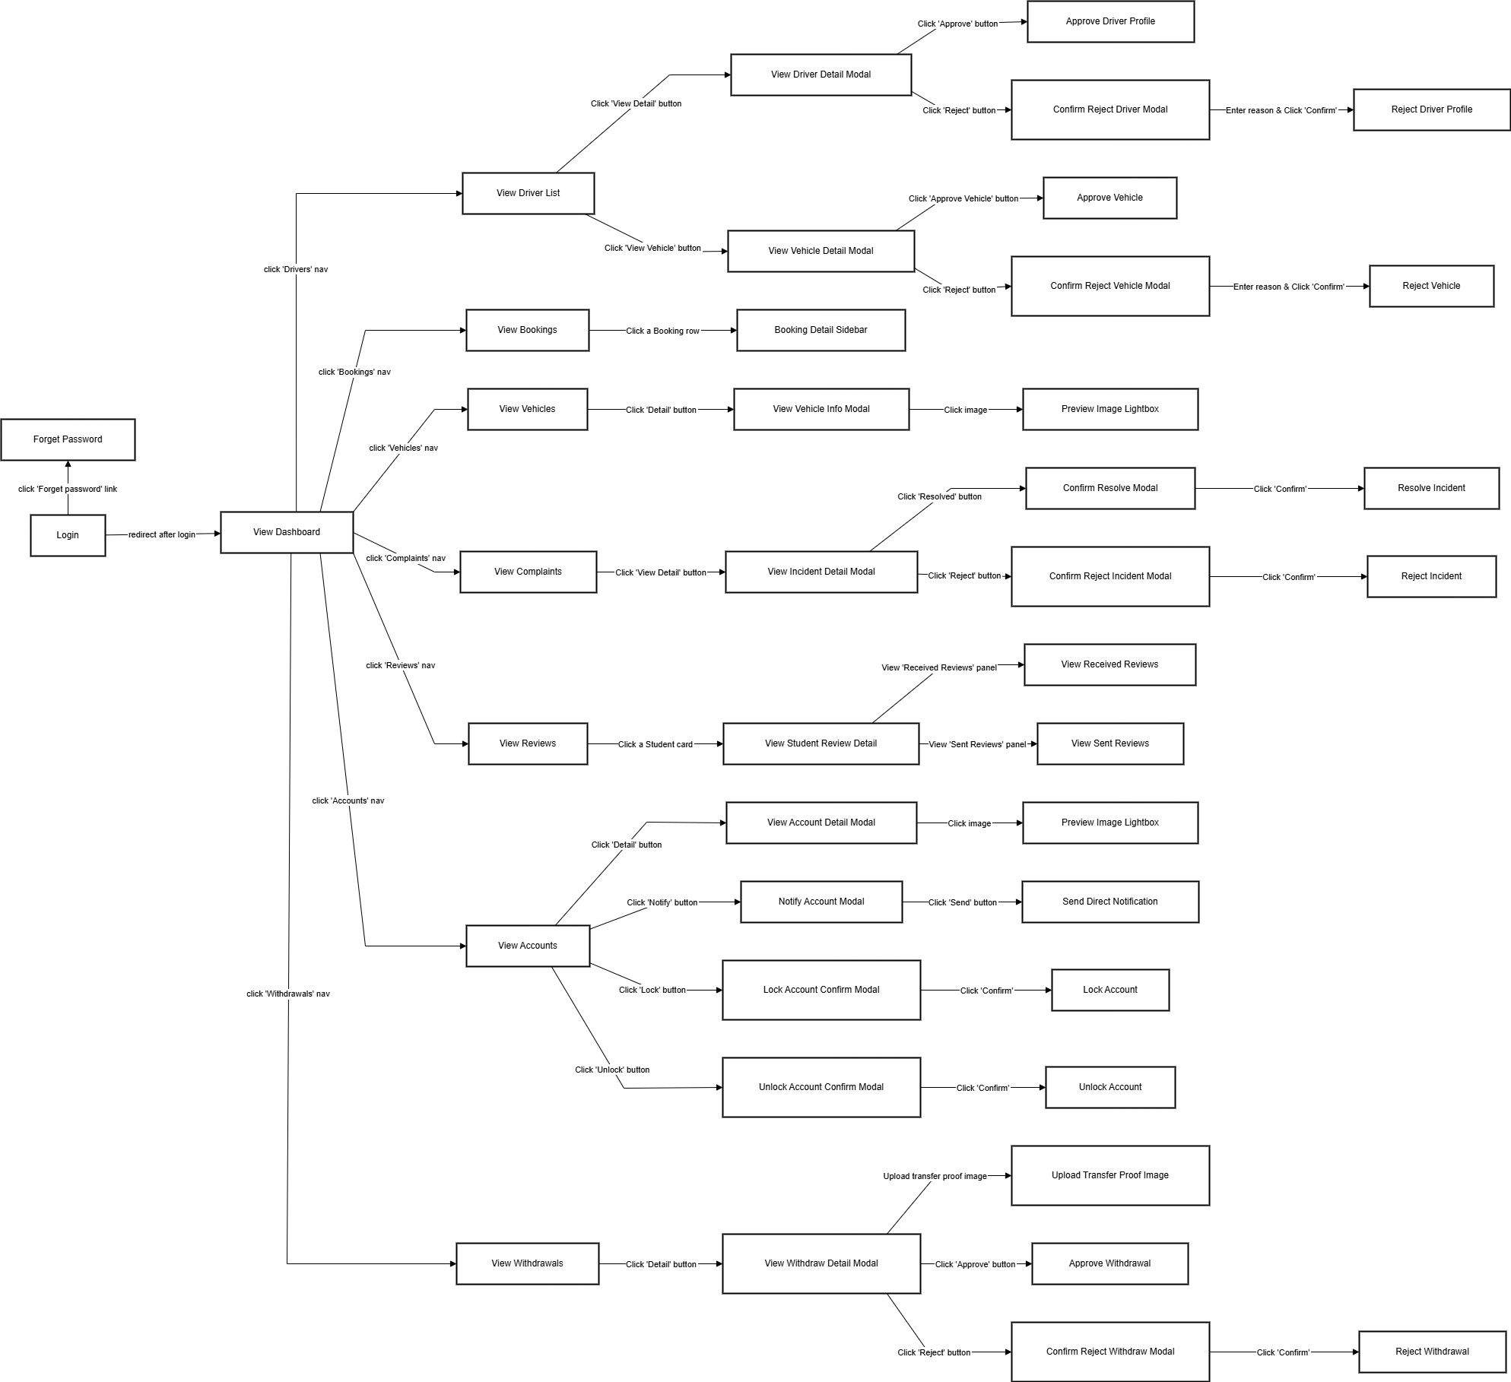

Figure 4: Staff screen flow

3.1.1.3 Student screen flow
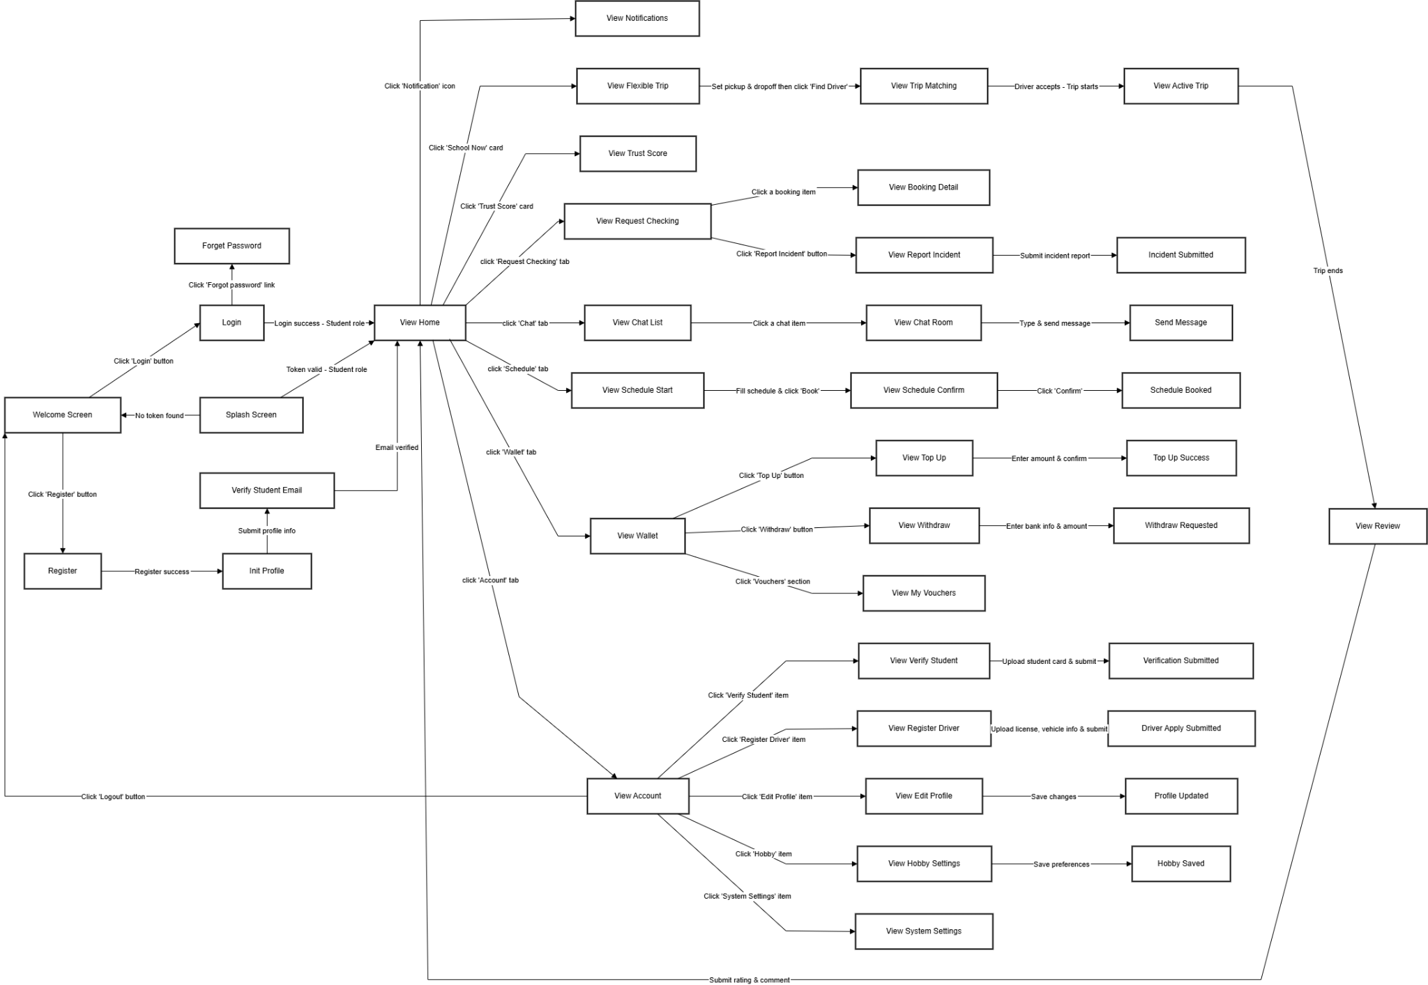

Figure 5: Student screen flow

3.1.1.4 Driver screen flow
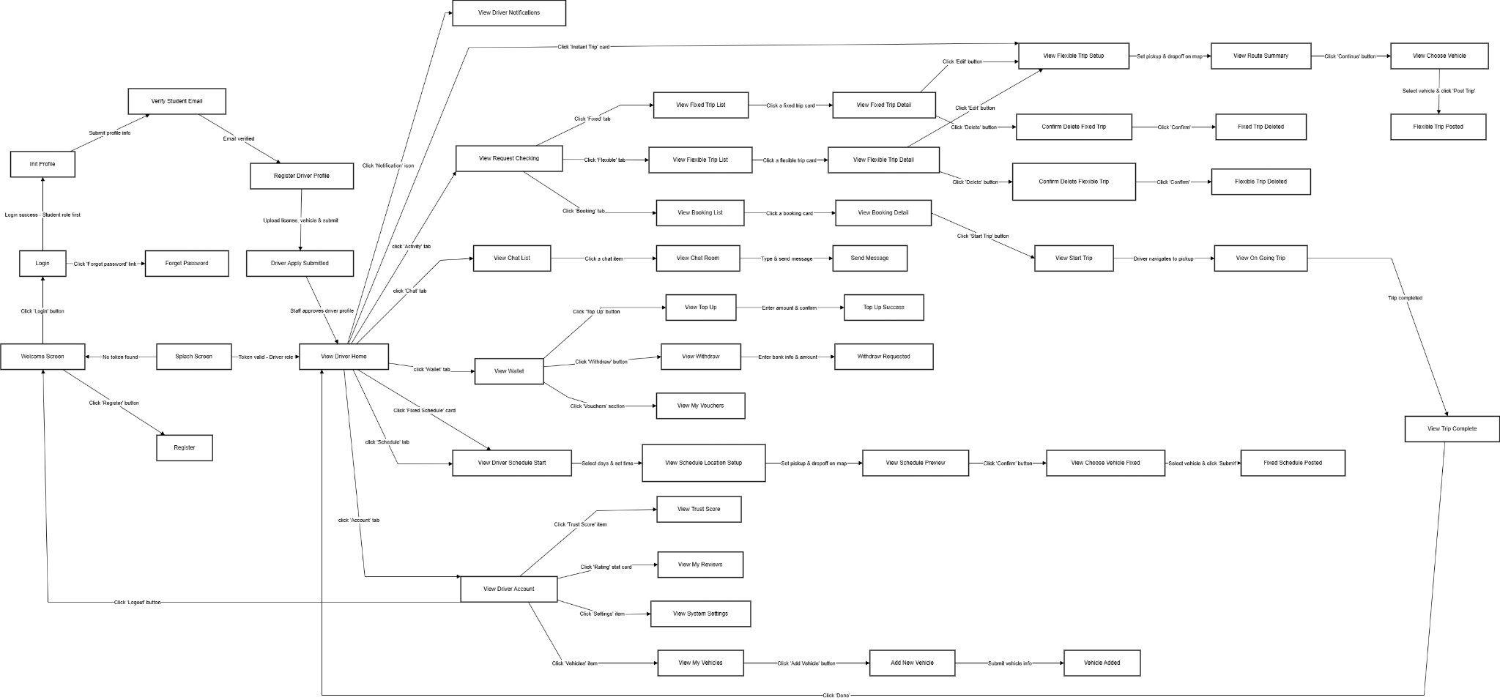

Figure 6: Driver screen flow

3.1.2 Screen Descriptions

3.1.2.1 Admin
# | Feature | Screen | Description
1 | Authentication | Login | Allows admin/staff to log in using email and password to access the dashboard
2 | Statistics | View Statistics | Displays operational KPIs, revenue charts, and booking statistics by month
3 | Statistics | Export Excel File | Downloads statistical reports in Excel format (.xlsx)
4 | Statistics | Toggle Area / Pie Chart | Switches the chart display between Area chart and Pie chart
5 | Accounts | View Accounts | Displays list of all user accounts (students & drivers) with roles and status
6 | Accounts | View Account Detail | Shows detailed user profile, vehicle details, and uploaded verification documents
7 | Accounts | Preview Image Lightbox | Displays a magnified view of verification documents (ID card, license, etc.)
8 | Accounts | Notify Account | Sends a direct custom warning or penalty notification to a specific user
9 | Accounts | Send Custom Notification | Calls API to dispatch the notification to the selected user account
10 | Accounts | Toggle Status | Confirms locking or unlocking/activating a user account
11 | Accounts | Update Account Status | Calls API to apply the new active/banned status to the account
12 | Bookings | View Bookings | Lists all passenger bookings with status, pricing, distance, and fare details
13 | Bookings | Booking Detail Sidebar | Slides in a sidebar showing vehicle info, route, trip history, and financial breakdown
14 | Vouchers | View Vouchers | Lists all promotional and compensation vouchers with status and usage info
15 | Vouchers | Create Voucher | Creates a new voucher with value limits, discount type, and expiration date
16 | Vouchers | Grant Voucher | Broadcasts a created voucher to all eligible users with a specified reason
17 | Vouchers | Grant Voucher to Users | Calls API to grant the voucher to all users in the system
18 | Vouchers | Edit Voucher | Updates the values (discount, limit, expiry) of an existing voucher
19 | Vouchers | Update Voucher | Calls API to save updated voucher information
20 | Vouchers | Delete Voucher | Requests confirmation before permanently removing a voucher
21 | Vouchers | Delete Voucher | Calls API to permanently delete the selected voucher
22 | Vouchers | Toggle Voucher | Confirms toggling whether a voucher is active or hidden from users
23 | Vouchers | Update Voucher Status | Calls API to activate or deactivate the voucher visibility
24 | Point Policy | View Point Policy | Displays all point-to-cash conversion rate configurations
25 | Point Policy | Create Policy | Adds a new conversion policy with points, value, and validity date range
26 | Point Policy | Create Point Policy | Calls API to save the new point conversion policy
27 | Point Policy | Edit Policy | Modifies the rates and dates of an existing point conversion policy
28 | Point Policy | Update Point Policy | Calls API to save the updated point policy
29 | Point Policy | Confirm Delete Dialog | Browser confirmation dialog before deleting a point conversion policy
30 | Point Policy | Delete Point Policy | Calls API to permanently remove the selected point policy
31 | Notifications | View Notifications | Lists all broadcast notifications sent to the system with history
32 | Notifications | Create Broadcast | Drafts and sends a portal-wide notification to all users
33 | Notifications | Send Broadcast Notification | Calls API to dispatch the broadcast notification to all users
34 | Heatmap | View Heatmap | Visualizes operation hotspots and popular pickup/dropoff routes on an interactive Leaflet map
35 | Heatmap | Show Marker Details Popup | Shows location name, type (Pickup/Dropoff), coordinates, and booking frequency on marker click

Table 3: Admin Screen description table

3.1.2.2 Staff
# | Feature | Screen | Description
1 | Authentication | Login | Allows staff to log in using email and password to access the Staff Dashboard
2 | Driver Approval | View Driver List | Displays all driver registration profiles with approval status (Pending / Approved / Rejected)
3 | Driver Approval | View Driver Detail | Shows full driver profile including personal info, citizen ID image, student card, license image, and vehicle registration image
4 | Driver Approval | Approve Driver Profile | Calls API to mark the driver profile as Approved
5 | Driver Approval | Confirm Reject Driver | Prompts staff to enter a rejection reason before rejecting the driver profile
6 | Driver Approval | Reject Driver Profile | Calls API to mark the driver profile as Rejected with a specified reason
7 | Driver Approval | View Vehicle Detail | Shows all vehicles registered under a specific driver with type, brand, model, color, and plate
8 | Driver Approval | Approve Vehicle | Calls API to mark the selected vehicle as Approved
9 | Driver Approval | Confirm Reject Vehicle | Prompts staff to enter a rejection reason before rejecting the vehicle
10 | Driver Approval | Reject Vehicle | Calls API to mark the selected vehicle as Rejected with a reason
11 | Bookings | View Bookings | Lists all passenger bookings with status, pricing, distance, and route details
12 | Bookings | Booking Detail Sidebar | Slides in a detailed sidebar with passenger info, driver info, vehicle, trip history, and financial breakdown
13 | Vehicles | View Vehicles | Displays all registered vehicles in the system with their type, status, and driver info
14 | Vehicles | View Vehicle Info | Shows full vehicle details including brand, model, color, license plate, and registration image
15 | Vehicles | Preview Image Lightbox | Displays a magnified view of the vehicle registration image
16 | Complaints | View Complaints | Lists all incident/complaint reports with type, status (Pending / Resolved / Rejected), reporter name, and date
17 | Complaints | View Incident Detail | Shows full incident details including type, description, trip info, driver & passenger profiles, photo/video evidence, and resolution notes
18 | Complaints | Confirm Resolve | Prompts staff to confirm before marking an incident as Resolved
19 | Complaints | Resolve Incident | Calls API to update the incident status to Resolved with a resolution note
20 | Complaints | Confirm Reject Incident | Prompts staff to confirm before marking an incident as Rejected
21 | Complaints | Reject Incident | Calls API to update the incident status to Rejected
22 | Reviews | View Reviews | Displays a list of all students with their rating averages, total received and sent review counts
23 | Reviews | View Student Review Detail | Shows the summary card of the selected student with their rating breakdown
24 | Reviews | View Received Reviews | Displays the list of reviews that the selected student has received from others
25 | Reviews | View Sent Reviews | Displays the list of reviews that the selected student has sent to others
26 | Accounts | View Accounts | Displays a paginated list of all student and driver accounts with role, status, and last login info
27 | Accounts | View Account Detail | Shows full account information including student info, driver profile, vehicles, and document gallery
28 | Accounts | Preview Image Lightbox | Displays a magnified view of uploaded documents (ID card, license, student card, vehicle registration)
29 | Accounts | Notify Account | Opens a form to compose and send a direct penalty notification to the selected user
30 | Accounts | Send Direct Notification | Calls API to dispatch a direct notification to the selected student account
31 | Accounts | Lock Account Confirm | Confirms locking the selected user account
32 | Accounts | Lock Account | Calls API to set the account status to inactive (locked)
33 | Accounts | Unlock Account Confirm | Confirms unlocking the selected user account
34 | Accounts | Unlock Account | Calls API to set the account status back to active
35 | Withdrawals | View Withdrawals | Lists all withdrawal requests from drivers with amount, status, and date
36 | Withdrawals | View Withdraw Detail | Shows withdrawal details including wallet ID, amount, bank name, and account number
37 | Withdrawals | Upload Transfer Proof Image | Allows staff to attach a bank transfer screenshot as proof of payment
38 | Withdrawals | Approve Withdrawal | Calls API to approve the withdrawal and upload the transfer proof image
39 | Withdrawals | Confirm Reject Withdraw | Confirms before rejecting a withdrawal request
40 | Withdrawals | Reject Withdrawal | Calls API to mark the withdrawal request as Rejected

Table 4: Staff Screen description table

3.1.2.3 Student
# | Feature | Screen | Description
1 | Authentication | Splash Screen | Auto-detects saved token on launch and redirects to Home or Welcome accordingly
2 | Authentication | Welcome Screen | Initial landing screen with entry buttons for Login and Register
3 | Authentication | Login | Allows students to authenticate using email and password
4 | Authentication | Forget Password | Sends a password reset email to the student's registered email
5 | Authentication | Register | Creates a new student account with full name, phone, email, and password
6 | Authentication | Init Profile | Collects initial profile info (university, student code, avatar) after registration
7 | Authentication | Verify Student Email | Prompts student to verify their university email to activate the account
8 | Home | View Home | Core dashboard showing trust score, quick action cards, live map, and recent trip history
9 | Home | View Notifications | Lists all received FCM push notifications including trip updates and system alerts
10 | Home | View Trust Score | Displays the student's reliability score breakdown, rating count, and verification status
11 | Flexible Trip | View Flexible Trip | Interactive map interface for setting pickup and dropoff points to request an instant ride
12 | Flexible Trip | View Trip Matching | Shows real-time matching status while the system finds an available driver
13 | Flexible Trip | View Active Trip | Live trip tracking screen showing driver location, route, and ETA
14 | Flexible Trip | View Review | Post-trip screen to rate the driver and leave a comment
15 | Flexible Trip | Review Submitted | Submits the rating and comment to the system and returns to Home
16 | Request Checking | View Request Checking | Monitors all active and past booking requests with their statuses
17 | Request Checking | View Booking Detail | Shows full booking info including driver, pickup/dropoff, price, and trip status
18 | Request Checking | View Report Incident | Form to report an incident (accident, misconduct) related to a trip
19 | Request Checking | Incident Submitted | Confirms the incident report has been sent to staff for review
20 | Chat | View Chat List | Lists all active conversations with drivers or co-passengers
21 | Chat | View Chat Room | Real-time chat interface for coordinating trip details with matched users
22 | Chat | Send Message | Sends a text message within the active chat room
23 | Schedule | View Schedule Start | Form to set recurring pickup/dropoff schedule based on class timetable
24 | Schedule | View Schedule Confirm | Preview of the configured schedule before final confirmation
25 | Schedule | Schedule Booked | Confirms the schedule has been saved and matching will be automated
26 | Wallet | View Wallet | Shows current point balance, transaction history, and available vouchers
27 | Wallet | View Top Up | Form to add points to the student wallet via supported payment methods
28 | Wallet | Top Up Success | Confirmation screen after a successful top-up transaction
29 | Wallet | View Withdraw | Form to submit a withdrawal request to convert points to cash
30 | Wallet | Withdraw Requested | Confirms the withdrawal request has been submitted for staff approval
31 | Wallet | View My Vouchers | Displays all available vouchers the student can redeem for discounts
32 | Account | View Account | Personal hub with links to profile, verification, preferences, and logout
33 | Account | View Verify Student | Uploads student card image and info to request student status verification
34 | Account | Verification Submitted | Confirms verification documents have been sent to staff for review
35 | Account | View Register Driver | Form to upload license, vehicle info, and photos to apply for driver mode
36 | Account | Driver Apply Submitted | Confirms the driver application has been submitted for staff approval
37 | Account | View Edit Profile | Updates personal info including full name, avatar, phone, and date of birth
38 | Account | Profile Updated | Saves updated profile information to the system
39 | Account | View Hobby Settings | Customizes ride preferences such as music, conversation level, and AC preference
40 | Account | Hobby Saved | Saves the student's ride preference settings
41 | Account | View System Settings | Manages app-level settings such as dark mode and language
42 | Account | Logout | Clears saved tokens from local storage and redirects to Welcome Screen

Table 5: Student Screen description table

3.1.2.4 Driver
# | Feature | Screen | Description
1 | Authentication | Splash Screen | Auto-detects saved token on launch and redirects to Driver Home or Welcome accordingly
2 | Authentication | Welcome Screen | Initial landing screen with entry buttons for Login and Register
3 | Authentication | Login | Allows users to authenticate using email and password
4 | Authentication | Forget Password | Sends a password reset email to the registered email address
5 | Authentication | Register | Creates a new student account as the first step before becoming a driver
6 | Authentication | Init Profile | Collects initial profile info (university, student code, avatar) after registration
7 | Authentication | Verify Student Email | Prompts user to verify their university email address to activate the student account
8 | Authentication | Register Driver Profile | Form to upload driver license, vehicle registration images and vehicle info to apply for driver status
9 | Authentication | Driver Apply Submitted | Confirms driver application has been submitted to staff for review and approval
10 | Home | View Driver Home | Core driver dashboard showing trust score, wallet balance, weather widget, quick action cards and tips
11 | Home | View Driver Notifications | Lists all received FCM push notifications including trip matches, system alerts and payment updates
12 | Flexible Trip | View Flexible Trip Setup | Interactive map for setting pickup and dropoff points to post an on-demand instant trip
13 | Flexible Trip | View Route Summary | Displays the calculated route with estimated distance, duration and suggested price per seat
14 | Flexible Trip | View Choose Vehicle | Lists driver's registered vehicles to select which one to use for the flexible trip
15 | Flexible Trip | Flexible Trip Posted | Confirms the flexible trip has been published and is visible to matching students
16 | Request Checking | View Request Checking | Main hub with three tabs: Fixed trips, Flexible trips, and Bookings
17 | Request Checking | View Fixed Trip List | Lists all fixed schedule routes posted by the driver with their match statuses
18 | Request Checking | View Fixed Trip Detail | Shows full details of a specific fixed trip including schedule list, route, price and checkpoints
19 | Request Checking | View Flexible Trip List | Lists all on-demand flexible trip posts with their match statuses
20 | Request Checking | View Flexible Trip Detail | Shows full details of a specific flexible trip including route, price, distance and passenger status
21 | Request Checking | Confirm Delete Fixed Trip | Alert dialog to confirm before permanently deleting a fixed schedule trip
22 | Request Checking | Fixed Trip Deleted | Confirms the fixed trip has been deleted and updates the trip list
23 | Request Checking | Confirm Delete Flexible Trip | Alert dialog to confirm before permanently deleting a flexible trip post
24 | Request Checking | Flexible Trip Deleted | Confirms the flexible trip has been deleted and updates the trip list
25 | Request Checking | View Booking List | Lists all confirmed bookings from matched students under the driver's trips
26 | Request Checking | View Booking Detail | Shows detailed booking info including student info, pickup/dropoff, price and booking status
27 | Active Trip | View Start Trip | Pre-departure screen showing passenger list, route, and 'Start Trip' button
28 | Active Trip | View On Going Trip | Live navigation screen with real-time map, passenger pickup status and trip controls
29 | Active Trip | View Trip Complete | Post-trip summary showing total earnings, trip distance, duration and completion status
30 | Chat | View Chat List | Lists all active conversations with matched passengers
31 | Chat | View Chat Room | Real-time chat interface for trip coordination with a specific passenger
32 | Chat | Send Message | Sends a text message within the active chat room
33 | Schedule | View Driver Schedule Start | Form to configure recurring fixed schedule with days of week and departure time
34 | Schedule | View Schedule Location Setup | Interactive map for setting pickup and dropoff points for the fixed schedule route
35 | Schedule | View Schedule Preview | Preview page showing the full weekly schedule configuration before submission
36 | Schedule | View Choose Vehicle Fixed | Lists driver's registered vehicles to select which one to use for the fixed schedule
37 | Schedule | Fixed Schedule Posted | Confirms the fixed schedule has been published and will repeat on selected days
38 | Wallet | View Wallet | Shows current point balance, transaction history, and available vouchers
39 | Wallet | View Top Up | Form to add points to the driver wallet via supported payment methods
40 | Wallet | Top Up Success | Confirmation screen after a successful top-up transaction
41 | Wallet | View Withdraw | Form to submit a withdrawal request to convert earned points to cash
42 | Wallet | Withdraw Requested | Confirms the withdrawal request has been submitted for staff approval
43 | Wallet | View My Vouchers | Displays all available discount vouchers the driver can apply
44 | Account | View Driver Account | Personal hub with stats (total trips, rating, trust score) and navigation to sub-sections
45 | Account | View Trust Score | Detailed breakdown of the driver's trust score components and rating history
46 | Account | View My Vehicles | Lists all registered vehicles with approval status (Pending / Approved / Rejected)
47 | Account | Add New Vehicle | Form to upload vehicle images, registration, and details to add another vehicle
48 | Account | Vehicle Added | Confirms the new vehicle has been submitted for staff approval
49 | Account | View My Reviews | Lists all ratings and comments received from passengers for previous trips
50 | Account | View System Settings | Manages app-level settings such as dark mode and language
51 | Account | Logout | Clears saved tokens from local storage and redirects to Welcome Screen

Table 6: Driver Screen description table

3.1.3 Screen Authorization
Screen | Student | Driver | Admin | Staff
Splash Screen | X | X
Welcome Screen | X | X
Login | X | X | X | X
Register | X | X
Forget Password | X | X | X | X
Init Profile | X | X
Verify Student Email | X | X
Register Driver Profile |  | X
Driver Apply Submitted |  | X
View Home (Student) | X
View Driver Home |  | X
View Admin Dashboard |  |  | X
View Notifications (Student) | X
View Driver Notifications |  | X
View Trust Score | X | X
View Flexible Trip Setup | X | X
View Trip Matching / Route Summary | X | X
View Active Trip (Passenger) | X
View Start Trip (Driver) |  | X
View On Going Trip |  | X
View Trip Complete |  | X
View Choose Vehicle |  | X
Flexible Trip Posted |  | X
Review After Trip | X
View Schedule Start (Student) | X
View Schedule Confirm (Student) | X
Schedule Booked | X
View Driver Schedule Start |  | X
View Schedule Location Setup |  | X
View Schedule Preview |  | X
View Choose Vehicle (Fixed) |  | X
Fixed Schedule Posted |  | X
View Request Checking (Student) | X
View Booking Detail (Student) | X
View Report Incident | X
Incident Submitted | X
View Request Checking (Driver) |  | X
View Fixed Trip List |  | X
View Fixed Trip Detail |  | X
Confirm Delete Fixed Trip |  | X
View Flexible Trip List |  | X
View Flexible Trip Detail |  | X
Confirm Delete Flexible Trip |  | X
View Booking List (Driver) |  | X
View Booking Detail (Driver) |  | X
View Chat List | X | X
View Chat Room | X | X
Send Message | X | X
View Wallet | X | X
View Top Up | X | X
Top Up Success | X | X
View Withdraw (Student) | X
View Withdraw (Driver) |  | X
Withdraw Requested | X | X
View My Vouchers | X | X
View Account (Student) | X
View Driver Account |  | X
View Verify Student | X
Verification Submitted | X
View Register Driver | X
View Edit Profile | X
Profile Updated | X
View Hobby Settings | X
View My Vehicles |  | X
Add New Vehicle |  | X
Vehicle Added |  | X
View My Reviews (Driver) |  | X
View Checking Review |  | X
View System Settings | X | X
Logout | X | X
View Statistics |  |  | X
Export Excel File |  |  | X
Toggle Area / Pie Chart |  |  | X
View Accounts (Admin) |  |  | X | X
View Account Detail Modal |  |  | X | X
Preview Image Lightbox |  |  | X | X
Notify Account Modal |  |  | X | X
Send Custom Notification |  |  | X | X
Toggle Status Modal (Lock/Unlock) |  |  | X | X
Update Account Status |  |  | X | X
View Vouchers (Admin) |  |  | X
Create Voucher Modal |  |  | X
Grant Voucher Modal |  |  | X
Grant Voucher to Users |  |  | X
Edit Voucher Modal |  |  | X
Delete Voucher Modal |  |  | X
Toggle Voucher Status Modal |  |  | X
View Point Policy |  |  | X
Create Policy Modal |  |  | X
Edit Policy Modal |  |  | X
Confirm Delete Dialog |  |  | X
View Notifications (Admin) |  |  | X
Create Broadcast Modal |  |  | X
Send Broadcast Notification |  |  | X
View Heatmap |  |  | X
Show Marker Details Popup |  |  | X
View Driver List |  |  |  | X
View Driver Detail Modal |  |  |  | X
Approve Driver Profile |  |  |  | X
Confirm Reject Driver Modal |  |  |  | X
Reject Driver Profile |  |  |  | X
View Vehicle Detail Modal |  |  |  | X
Approve Vehicle |  |  |  | X
Confirm Reject Vehicle Modal |  |  |  | X
Reject Vehicle |  |  |  | X
View Bookings (Staff) |  |  |  | X
Booking Detail Sidebar (Staff) |  |  |  | X
View Vehicles (Staff) |  |  |  | X
View Vehicle Info Modal |  |  |  | X
View Complaints |  |  |  | X
View Incident Detail Modal |  |  |  | X
Confirm Resolve Modal |  |  |  | X
Resolve Incident |  |  |  | X
Confirm Reject Incident Modal |  |  |  | X
Reject Incident |  |  |  | X
View Reviews (Staff) |  |  |  | X
View Student Review Detail |  |  |  | X
View Received Reviews |  |  |  | X
View Sent Reviews |  |  |  | X
View Withdrawals |  |  |  | X
View Withdraw Detail Modal |  |  |  | X
Upload Transfer Proof Image |  |  |  | X
Approve Withdrawal |  |  |  | X
Confirm Reject Withdraw Modal |  |  |  | X
Reject Withdrawal |  |  |  | X

Table 7: Screen authorization table

3.1.4 Non-Screen Functions
# | Feature | System Function | Description
1 | Ride Management | Ride Matching Service | Automatically matches students with available drivers based on location, time, preferences, and route optimization.
2 | Ride Management | Trip Status Processor | Handles ride lifecycle (requested → accepted → in-progress → completed → cancelled) and updates system state accordingly.
3 | Ride Management | Real-time Location Tracking API | Continuously receives and updates GPS location of drivers and students for live tracking.
4 | Driver Management | Driver Availability Service | Tracks driver online/offline status and availability for ride matching.
5 | Communication | Real-time Chat Service | Handles message exchange between student and driver using socket/websocket communication.
6 | Feedback & Rating | Rating Processor | Collects, calculates, and stores driver ratings after each completed trip
7 | Feedback & Rating | Complaint Processing Service | Handles complaints submitted with images/videos, stores evidence, and forwards them for admin review.
8 | Notification | Notification Dispatcher | Sends push notifications for ride updates, driver acceptance, trip reminders, and system alerts.
9 | Payment | Payment Integration Service | Integrates with external payment gateways to process ride payments securely.
10 | Security | Authentication & Authorization Service | Handles login, token validation, and role-based access control.
11 | Monitoring | Analytics & Reporting Job | Aggregates data for reporting (ride count, driver performance, user activity, revenue, etc.).
12 | Maintenance | Data Cleanup Batch Job | Periodically cleans outdated logs, temporary data, and inactive session records.

Table 8: Nonscreen function table

3.1.5 Entity Relationship Diagram
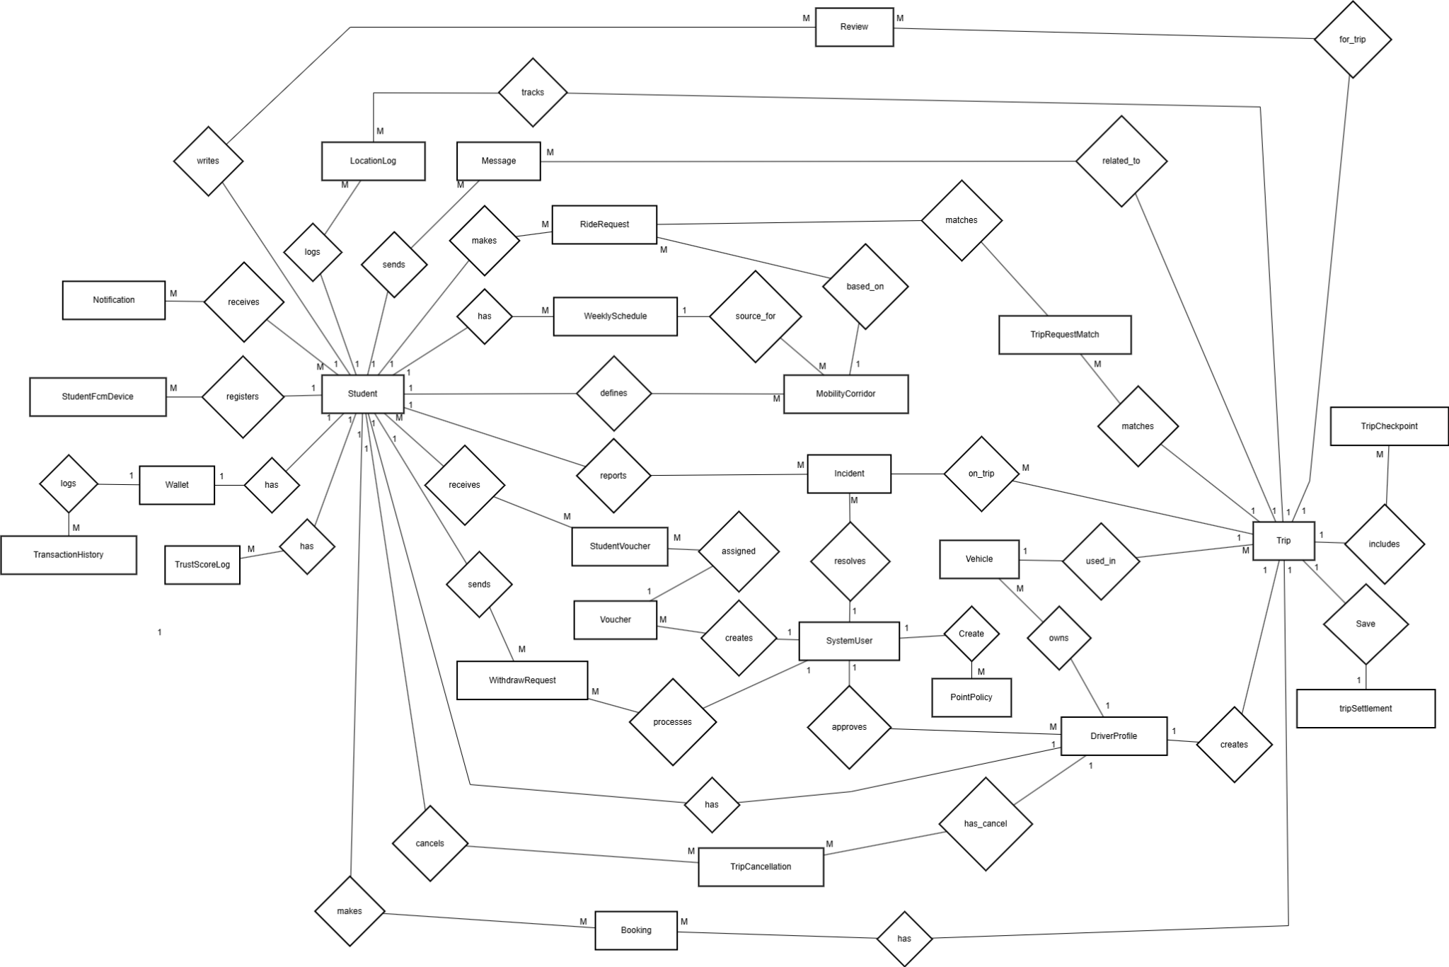

Figure 7: Entity relationship diagram
Entities Description
# | Entity | Description
1 | Student | The main user of the system who can book trips, send messages, manage balance, and interact with services.
2 | System user | System user include admin and staff, admin creates and manages vouchers and system-level operations,staff who process withdrawal requests and resolve incidents.
3 | DriverProfile | The student's driver profile, storing driver's license information and approval status to accept passengers.
4 | Vehicle | Information about the vehicle (e.g., motorcycle) registered and used by the driver for trips.
5 | WeeklySchedule | The student's fixed weekly commuting schedule (outbound and return trips).
6 | MobilityCorridor | A defined routing corridor used as a base template to create driver Trips or passenger RideRequests.
7 | Trip | A ride created by a driver, including pickup/drop-off locations, planned time, and point price per seat.
8 | TripCheckpoint | Specific stops, pickup/drop-off points, or waypoints along a trip's route.
9 | RideRequest | A request created by a student (passenger) seeking a ride, specifying the desired time and route.
10 | TripRequestMatch | Stores the data and status of matches between a driver's trip and a passenger's ride request.
11 | Booking | A successfully confirmed reservation made by a passenger for a specific trip.
12 | Wallet | The student's digital wallet, storing the point balance used to pay for platform services.
13 | TransactionHistory | A log recording all balance changes (top-ups, trip charges, refunds, withdrawals) in the wallet.
14 | WithdrawRequest | A request to withdraw points from the wallet to a student's bank account, pending Staff approval.
15 | Voucher | Discount, promotional, or compensation codes created and managed by the Admin.
16 | StudentVoucher | An intermediary table tracking the ownership status and usage history of vouchers for each student.
17 | Review | Star ratings and comments left by drivers and passengers for each other after a trip is completed.
18 | Incident | Incident reports or complaints raised by users during or after a trip, handled by Staff.
19 | LocationLog | Real-time GPS location data of students or trips logged for safety tracking purposes.
20 | Message | Direct chat messages exchanged between passengers and drivers within a trip.
21 | Notification | System notifications sent to the student's device.
22 | StudentFcmDevice | Stores the user's device token (FCM) so the system can send push notifications.
23 | TripCancellation | Records detailed history of trip cancellations, including the reason, the user who cancelled, and any applied penalty fees.
24 | TripSettlement | Save all complete ride
25 | Trustscorelog | Store all add or minus trust score after action
26 | PointPolicy | Store conversion from money to point

Table 9: Entity description table

3.2 Authentication

3.2.1 User Login
- Function trigger: The user opens the app and is not yet authenticated; system navigates to the Login screen from the Welcome/Splash screen.
- Function description: This function allows users (Student/Driver) to log into the system using their email/phone and password to access the Home Page.
- Screen layout:
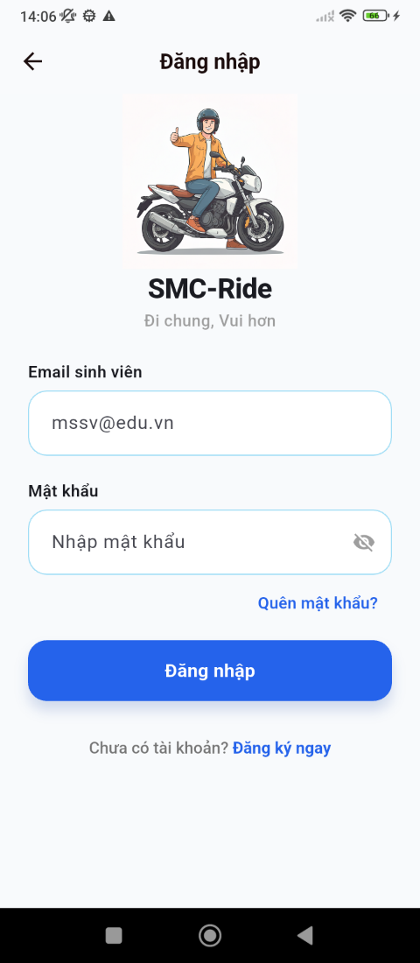

Figure 8: login screen

- Function Details:
  - Data: Email/Phone number, Password.
  - Validation: Email must follow standard email format. Phone number must contain 10-11 digits. Password must be at least 8 characters. Ensures fields are not empty. Checks that credentials match an existing account.
  - Business Rules: BR-01, BR-30
  - Normal & Abnormal Cases:
    - Normal: User enters email/phone and password -> clicks Login -> system validates inputs -> authenticates credentials -> redirects user to Home Dashboard.
    - Abnormal: Invalid credentials -> show error toast. Account not verified -> prompt verification. Account locked -> notify user and block login. Account banned -> deny access.

3.2.2 User Register
- Function trigger: The user clicks the 'Register' button from the Login/Welcome page.
- Function description: This function allows new users to create an account with personal information and student verification.
- Screen layout:
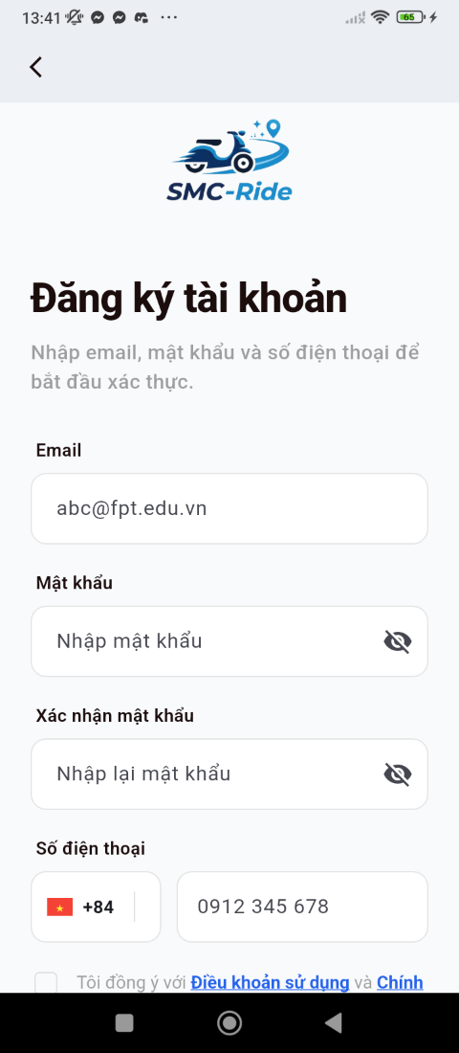

Figure 9: Register screen
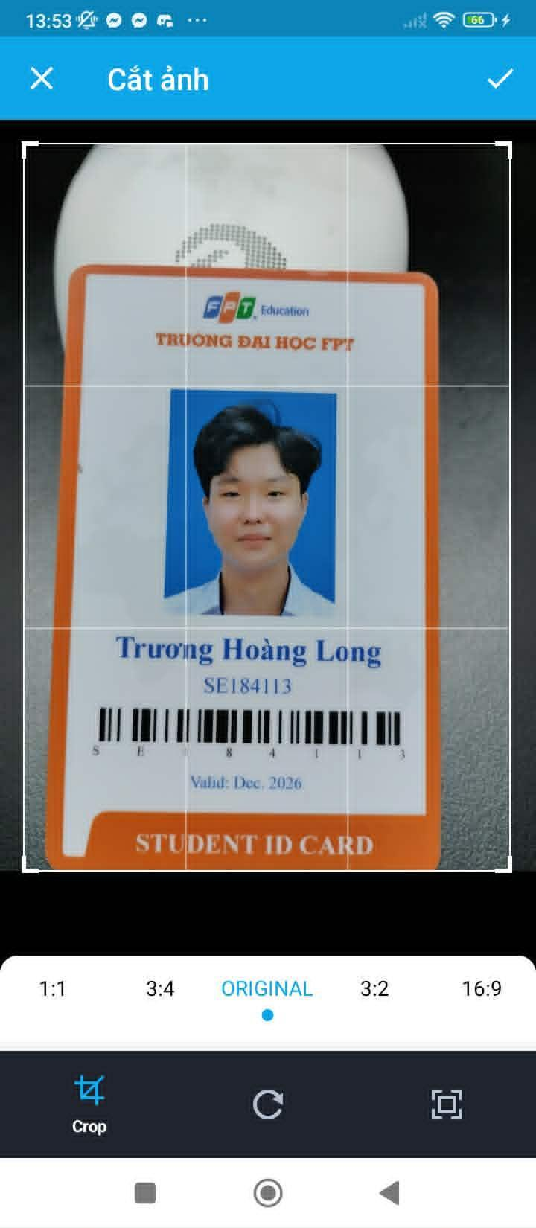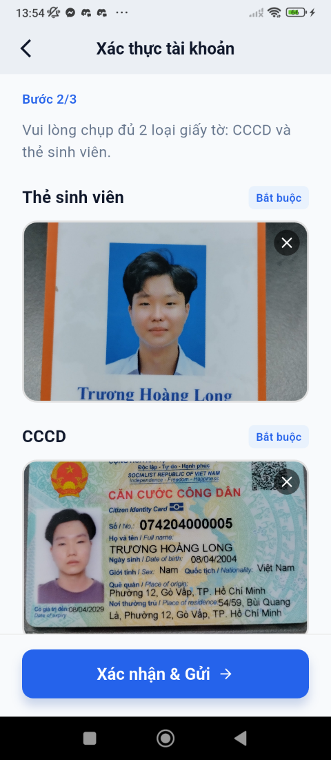

Figure 10: Card upload screen
- Function Details:
  - Data: Full Name, Email or Phone, Password, Confirm Password, Student ID card upload.
  - Validation: Email/Phone must be unique in the system. Password must be at least 8 characters. Confirm password must match password. Student ID must be unique.
  - Business Rules: BR-01, BR-02
  - Normal & Abnormal Cases:
    - Normal: User enters required information -> submits registration -> system validates data -> creates account -> sends verification email -> user proceeds to verification step.
    - Abnormal: Email/Phone already exists -> show error. Student ID already registered -> show error. Password and confirm password mismatch -> show error. Verification email sending fails -> retry.

3.2.3 Reset Password
- Function trigger: The user clicks 'Forgot Password' link on the Login page.
- Function description: This function allows users to reset their password via email verification link.
- Screen layout:


Figure 11: Login screen
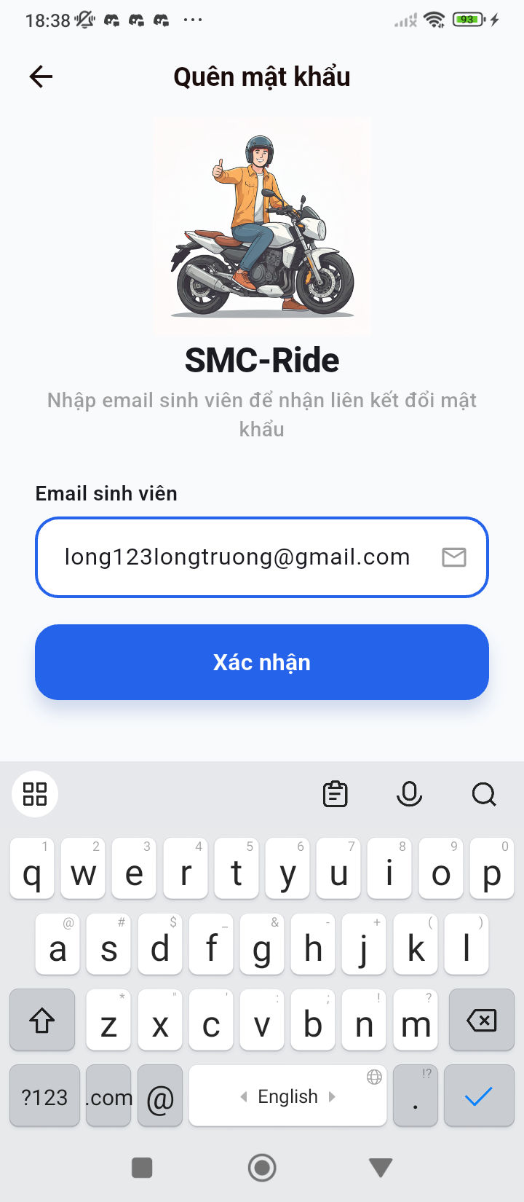

Figure 12: Forgot password screen
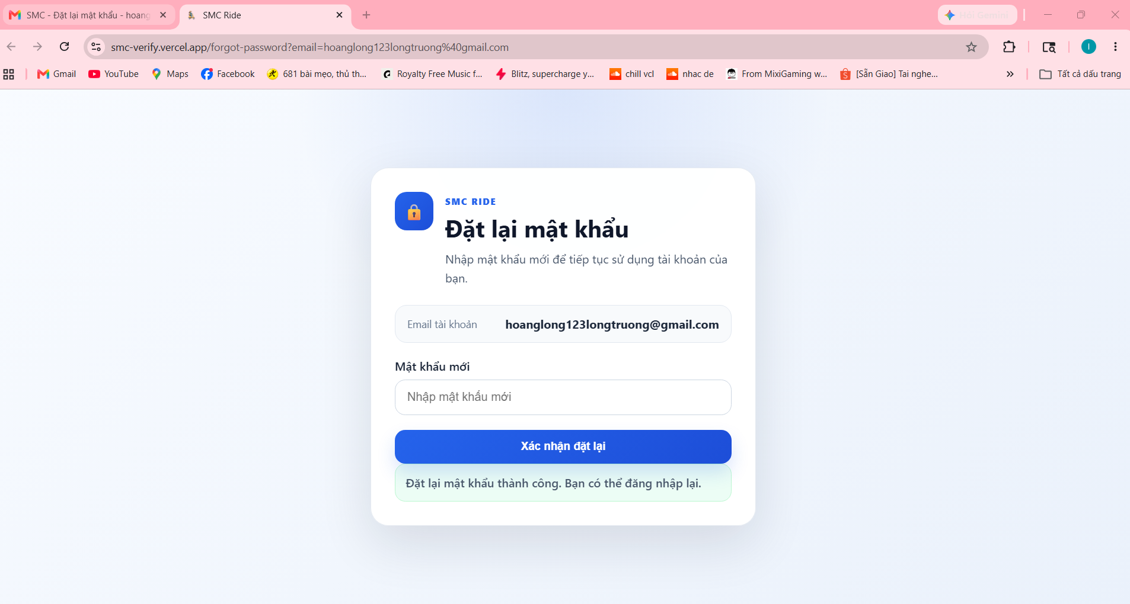

Figure 13: Input new password
- Function Details:
  - Data: Email/Phone number, New Password, Confirm New Password.
  - Validation: Email/Phone must exist in the system. New password must be at least 8 characters. Confirm password must match new password.
  - Business Rules: BR-44, BR-45
  - Normal & Abnormal Cases:
    - Normal: User enters email/phone -> system sends verification email -> user clicks link -> user enters new password -> password updated successfully -> redirected to Login.
    - Abnormal: Email/Phone not found -> show error. Reset link expired -> ask user to request again. Password validation fails -> show error.

3.2.4 Change Password
- Function trigger: Logged-in user navigates to Profile Settings -> Setting -> Account Security.
- Function description: This function allows authenticated users to change their password securely from within the app.
- Screen layout:
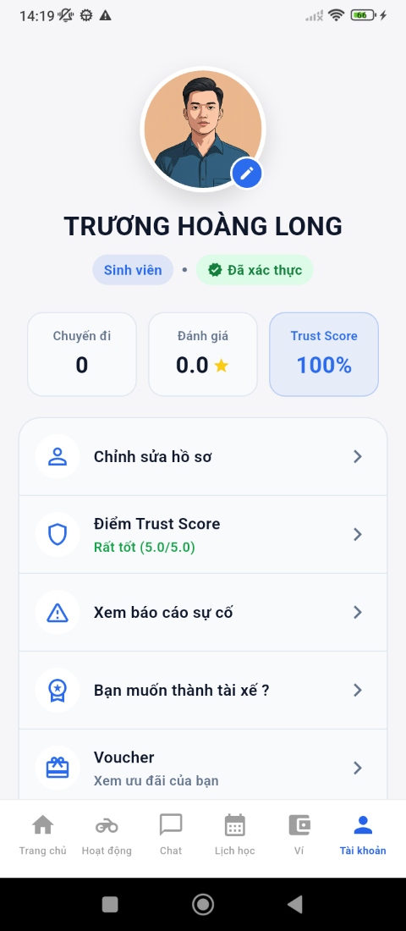

Figure 14: Account screen
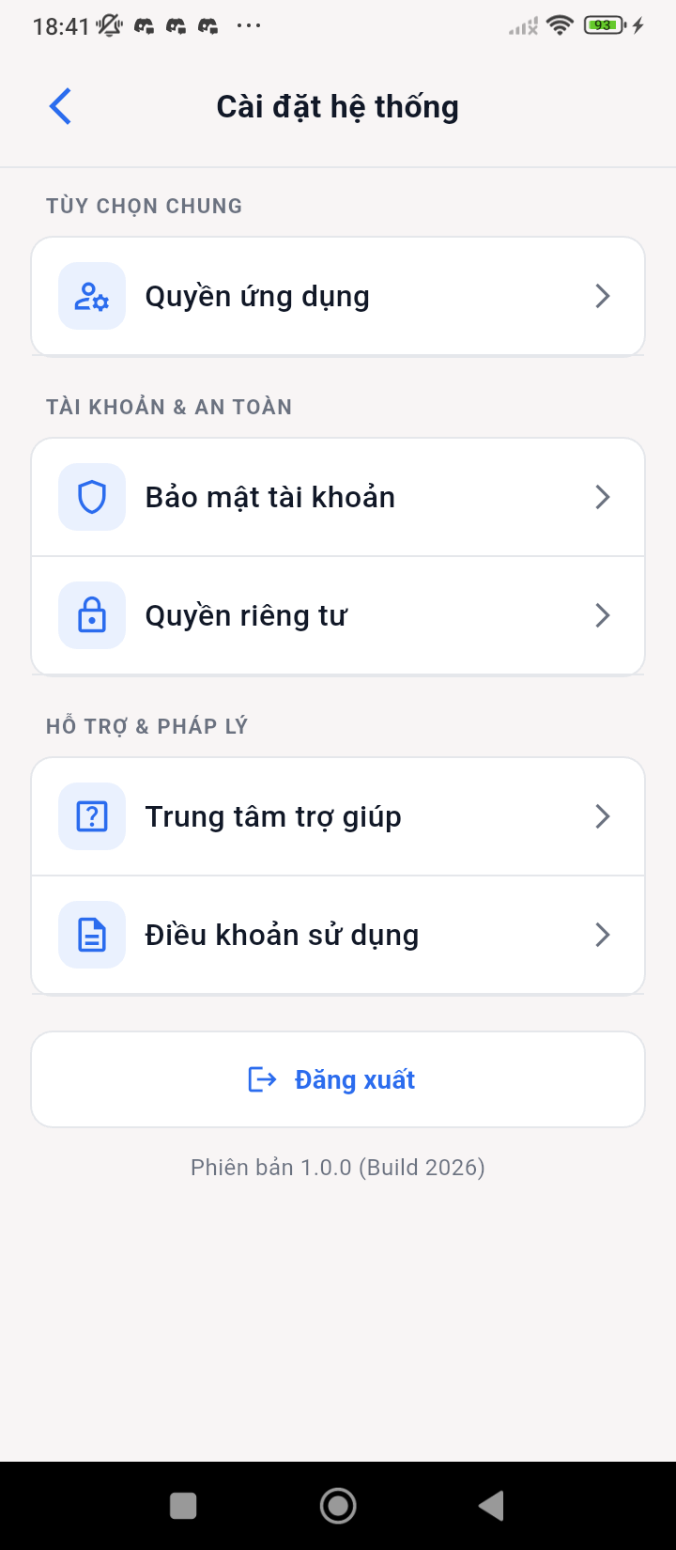

Figure 15: Setting screen
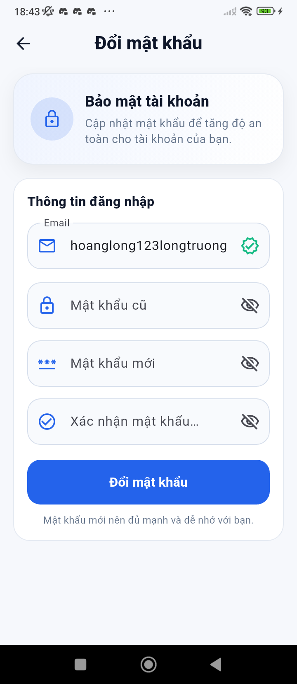

Figure 16: Change password screen
- Function Details:
  - Data: Current Password, New Password, Confirm New Password.
  - Validation: Current password must match existing password. New password must be different from current password. Confirm password must match new password.
  - Business Rules: BR-44, BR-45
  - Normal & Abnormal Cases:
    - Normal: User enters required fields -> submits change request -> system validates inputs -> updates password -> logs out user -> redirects to Login.
    - Abnormal: Incorrect current password -> show error. New password does not meet policy -> show error. Confirm password mismatch -> show error.

3.3 Ride Booking

3.3.1 Create Ride Request
- Function trigger: Student selects 'Book Ride' from the Home Page. System automatically suggests rides based on student schedule.
- Function description: This function displays available or recommended rides based on student location, preferences, and schedule, with filter and sort options.
- Screen layout:
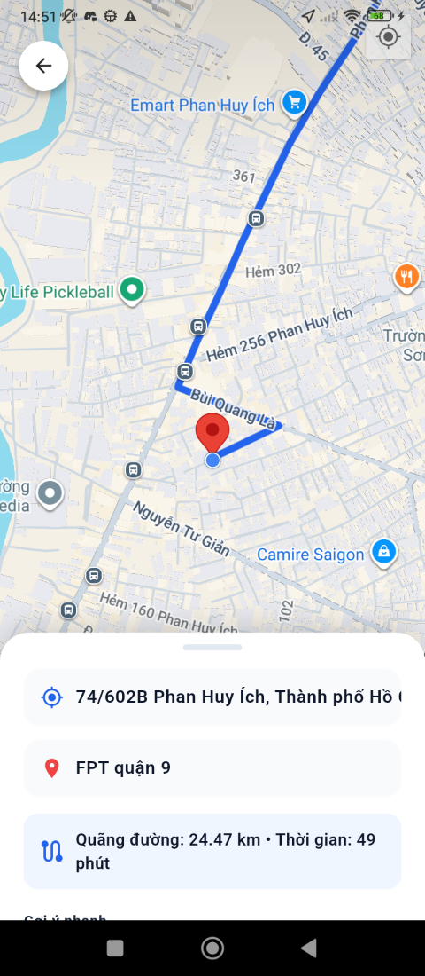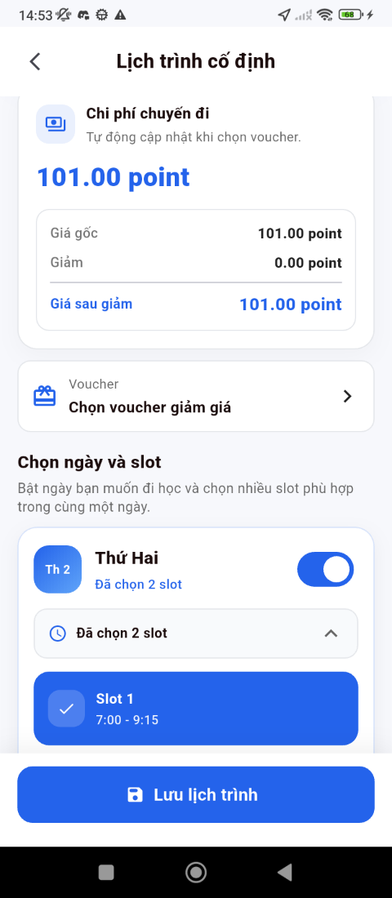

Figure 17: Input information of trip screen

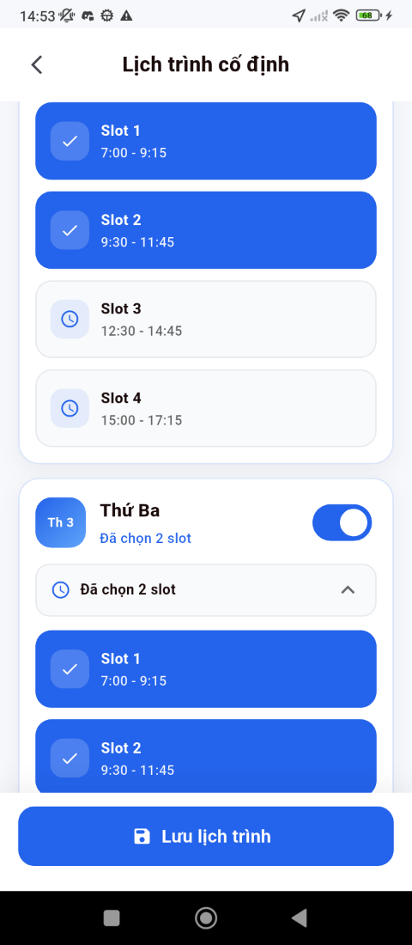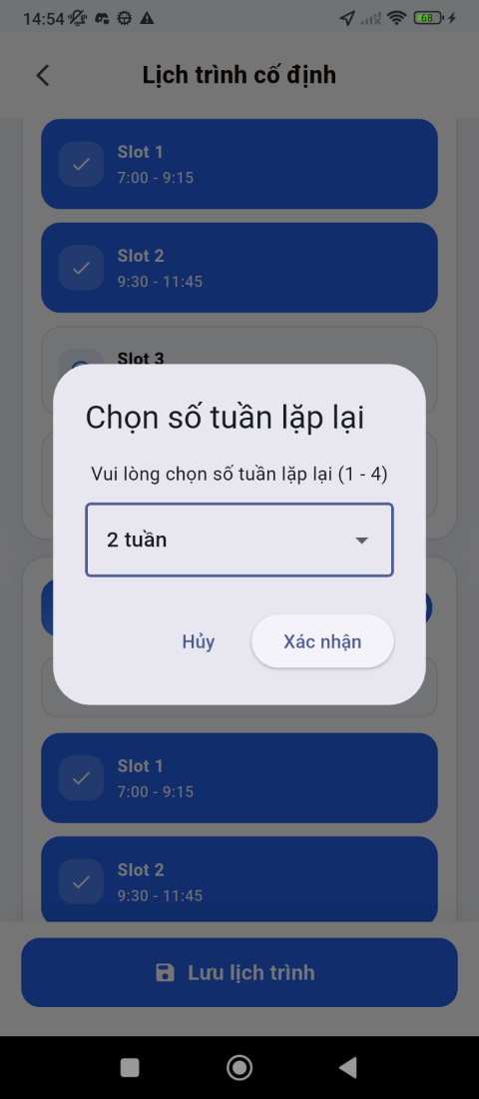

Figure 18: Slot information of trip screen
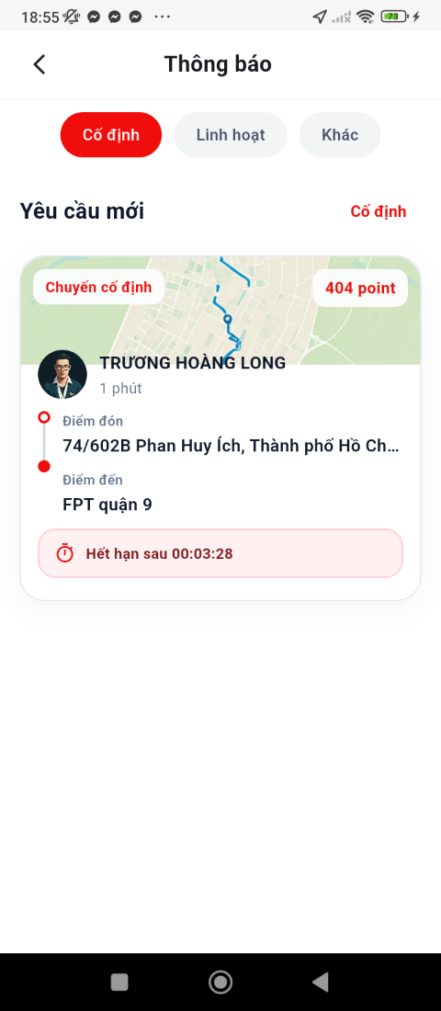

FIgure 19: List ride matching screen
- Function Details:
  - Data: Pickup location, Destination, Time preference, Filter options (price, driver rating, vehicle type).
  - Validation: Pickup location must be defined. Destination must be provided or selected.
  - Business Rules: BR-17, BR-18, BR-46, BR-47
  - Normal & Abnormal Cases:
    - Normal: Student inputs pickup & destination -> system create ride base on request -> system auto match with driver.
    - Abnormal: System cannot match request -> student cancel ride request

3.3.2 Ride Details
- Function trigger: Student selects a ride from the Ride List.
- Function description: This function shows full details of the selected ride including driver info, vehicle info, ETA, and price breakdown for the student to review before booking.
- Screen layout:
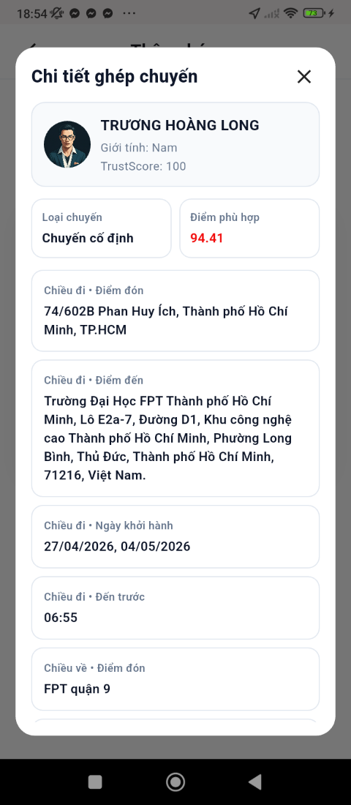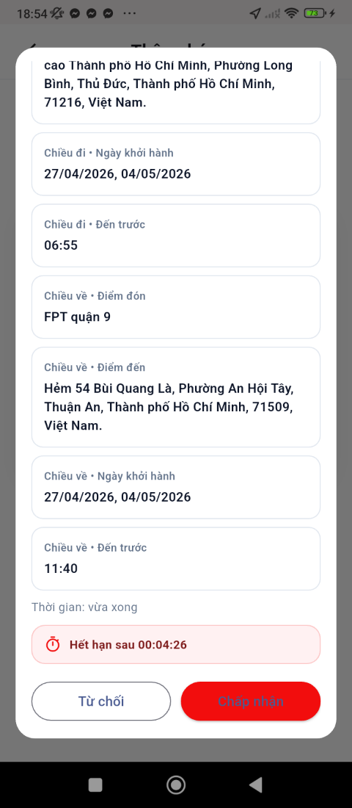

FIgure 20: Detail of trip screen
- Function Details:
  - Data: Pickup & destination, Driver information (name, rating), Vehicle information, Estimated time of arrival, Price breakdown.
  - Validation: Selected ride must still be available.
  - Business Rules: BR-10, BR-46, BR-47
  - Normal & Abnormal Cases:
    - Normal: Student selects ride -> system loads ride details -> student reviews information -> student proceeds to booking.
    - Abnormal: Ride becomes unavailable -> notify student and redirect to Ride List. Driver cancels -> remove ride from list.

3.3.3 Confirm Ride
- Function trigger: Student clicks 'confirm' from the ride request.
- Function description: This function allows the student to confirm a ride booking then system deduct money in the wallet.
- Screen layout:
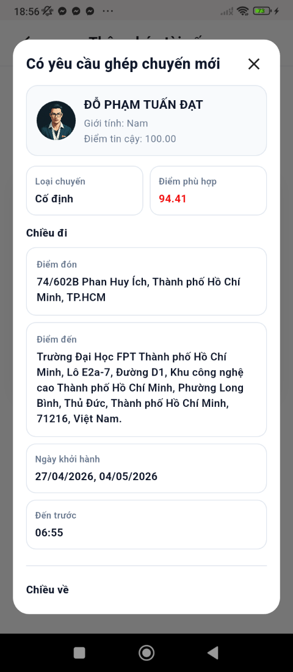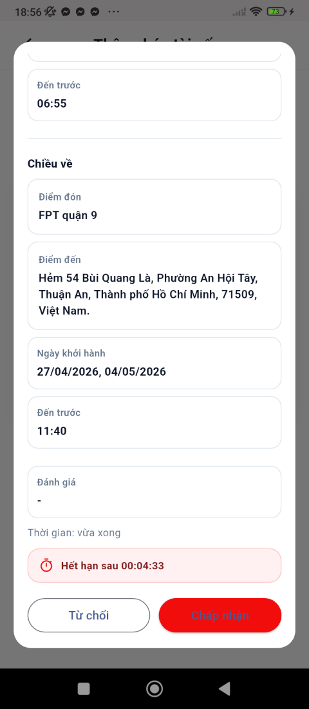

Figure 21: Accept result AI matching screen
- Function Details:
  - Data: Pickup location, Destination, Time (Now or Scheduled), Voucher code (optional)
  - Validation: Pickup and destination are required. Scheduled time must be in the future. Selected voucher must be valid and active.
  - Business Rules: BR-09, BR-10, BR-14, BR-15, BR-38, BR-39
  - Normal & Abnormal Cases:
    - Normal: System notify ‘driver matched’ -> confirms booking -> system booking created successfully -> student receives confirmation.
    - Abnormal: No driver available -> booking fails. Payment refund-> prompt student to retry. Voucher invalid or expired -> show error. Network error -> retry or cancel booking.

3.4 Booking Management

3.4.1 My booking
- Function trigger: Student/Driver navigates to App Menu -> Activity.
- Function description: This function displays all bookings categorized by status (Booked / Ongoing / Completed / Cancelled) for both Student and Driver roles.
- Screen layout:
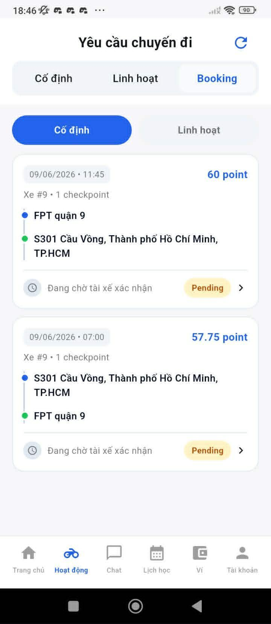

Figure 22: List of booking screen
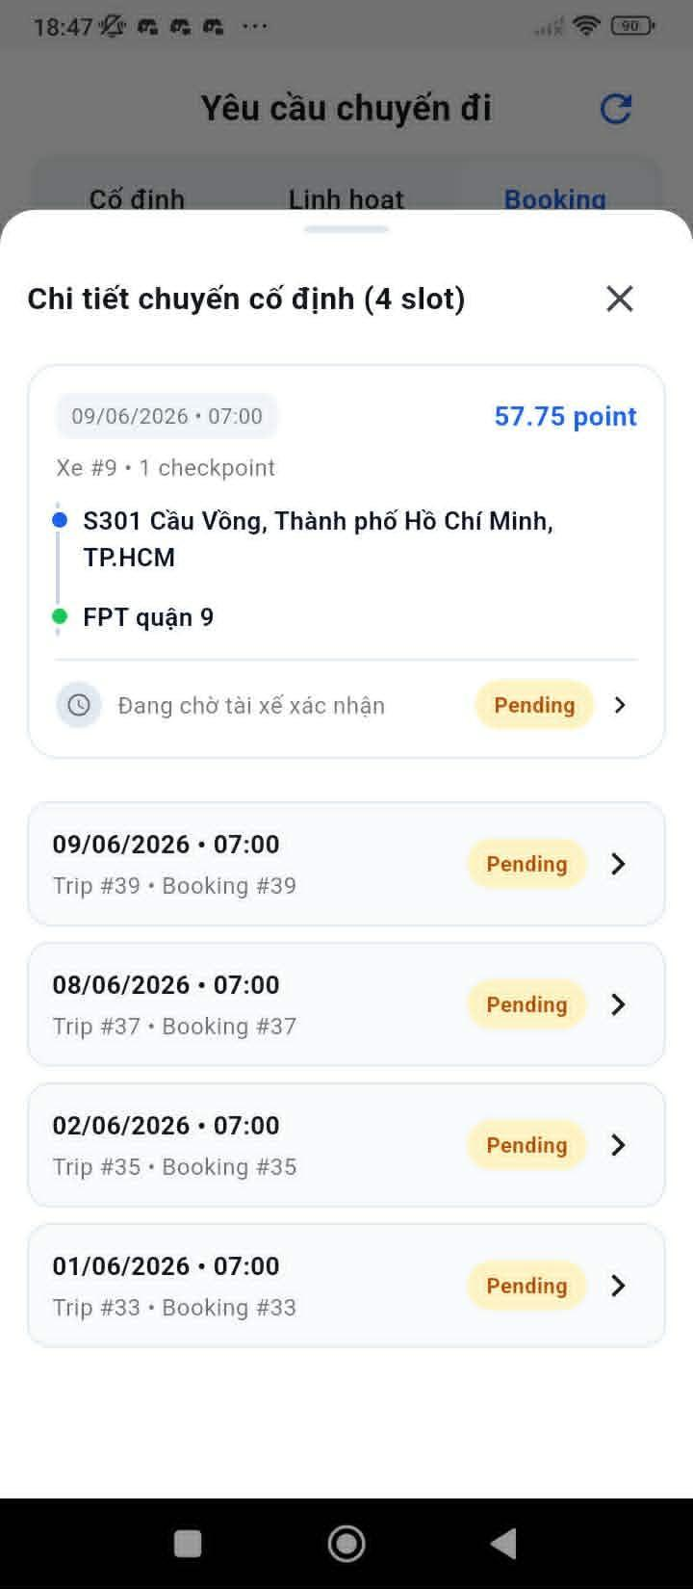

Figure 23: List of booking screen
- Function Details:
  - Data: Booking list filtered by userId, categorized by status (Upcoming, Ongoing, Completed, Cancelled).
  - Validation: User must be logged in.
  - Business Rules: BR-09, BR-44
  - Normal & Abnormal Cases:
    - Normal: User opens My Trips -> system displays categorized list with pickup, destination, time, and driver/passenger name.
    - Abnormal: No trips -> show empty state. Server error -> show retry message.

3.4.2 Booking Details
- Function trigger: User taps on a trip item in the Activity list.
- Function description: This function shows detailed information of a specific trip including trip info, driver info, and live route tracking map.
- Screen layout:
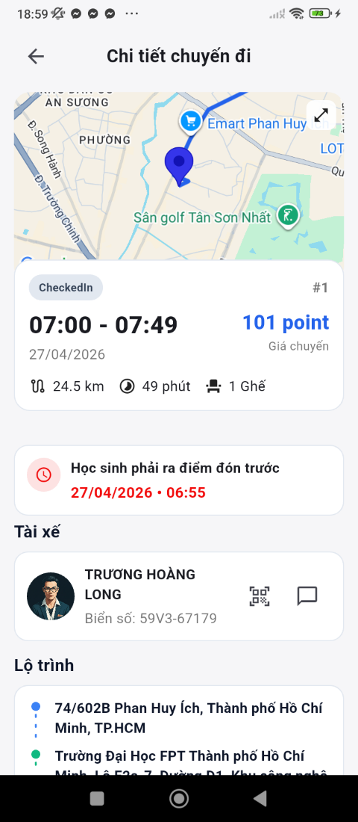

Figure 24: Information of trip booking
- Function Details:
  - Data: Trip info (pickup, destination, time, fare), Driver info (name, rating, vehicle), Route with real-time location.
  - Validation: Only the related user (driver or passenger) can view the trip details.
  - Business Rules: BR-26, BR-27, BR-44
  - Normal & Abnormal Cases:
    - Normal: User clicks trip -> system loads full trip details with map.
    - Abnormal: Trip not found -> show error. GPS unavailable -> show static route.

3.4.3 Chat Driver
- Function trigger: User taps the 'Chat' button in Trip Details or Ongoing Trip screen.
- Function description: This function enables real-time communication between Student and Driver before or during a trip via a chat popup.
- Screen layout:
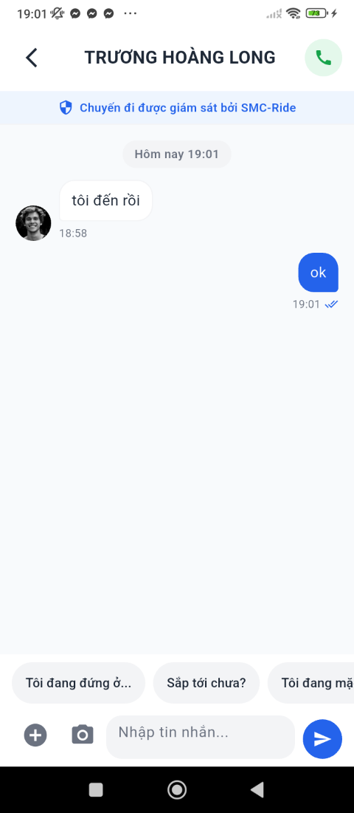

FIgure 25: Chat screen
- Function Details:
  - Data: Chat messages (text), sent/received via WebSocket/SignalR.
  - Validation: Only available during active/ongoing trip.
  - Business Rules: BR-44, BR-45
    - BR-44: All critical system actions must be logged for auditing and traceability.
    - BR-45: Personal data and financial data must be encrypted and secured according to safety standards.
  - Normal & Abnormal Cases:
    - Normal: User opens chat -> types message -> sends -> message delivered to other party in real time.
    - Abnormal: No internet connection -> show offline warning. Message send failure -> retry or show error.

3.4.4 Track Driver Location
- Function trigger: User opens the Tracking tab in Trip Details.
- Function description: This function shows real-time driver location and route on a map with ETA for the Student.
- Screen layout:
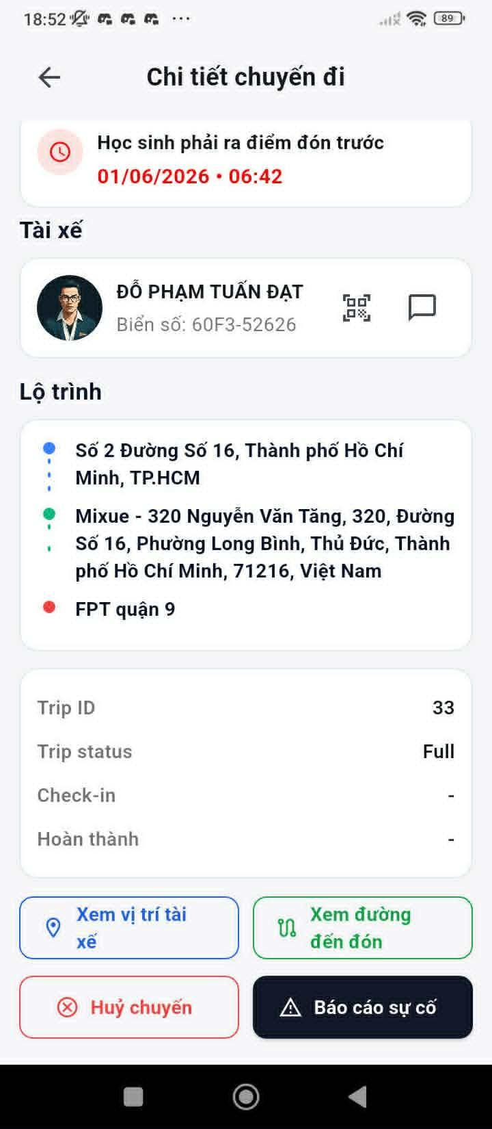

Figure 26: Detail of booking screen
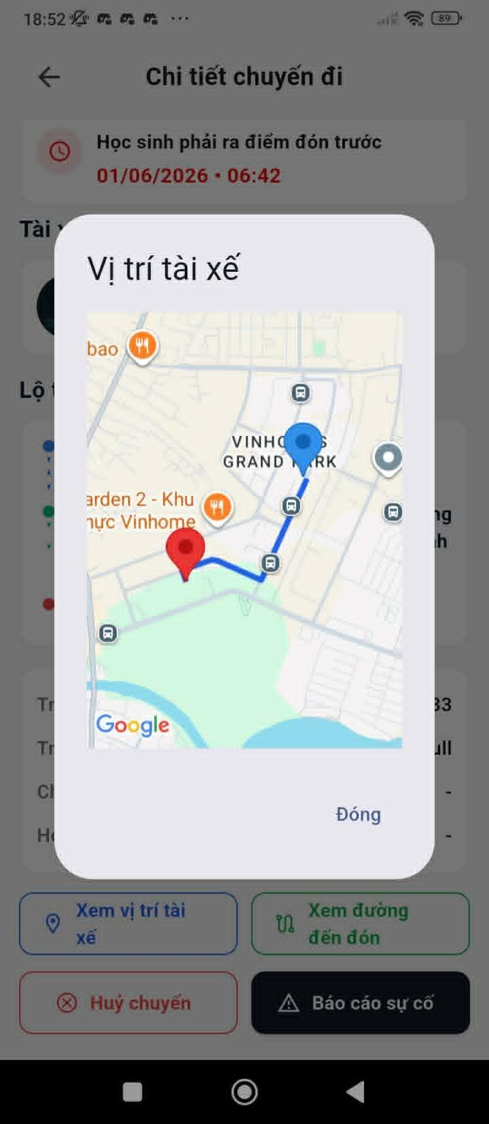

Figure 27: Tracking location screen
- Function Details:
  - Data: Driver GPS coordinates updated every 3-5 seconds, route line, ETA.
  - Validation: Driver must enable location sharing.
  - Business Rules: BR-26, BR-27, BR-28, BR-29
  - Normal & Abnormal Cases:
    - Normal: Student opens tracking -> map displays driver marker and route line -> ETA updates dynamically.
    - Abnormal: GPS lost -> show last known location. Driver offline -> show 'Location unavailable'.

3.4.5 Complaint Upload
- Function trigger: User clicks 'Report/Complaint' button after or during a trip.
- Function description: This function allows Student or Driver to submit a complaint with media evidence (images/videos) linked to a specific trip.
- Screen layout:
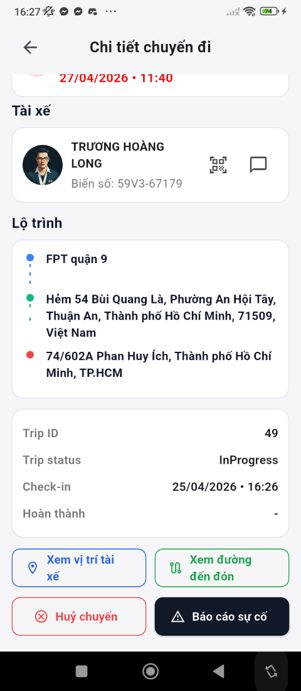

Figure 28: Trip booking detail screen
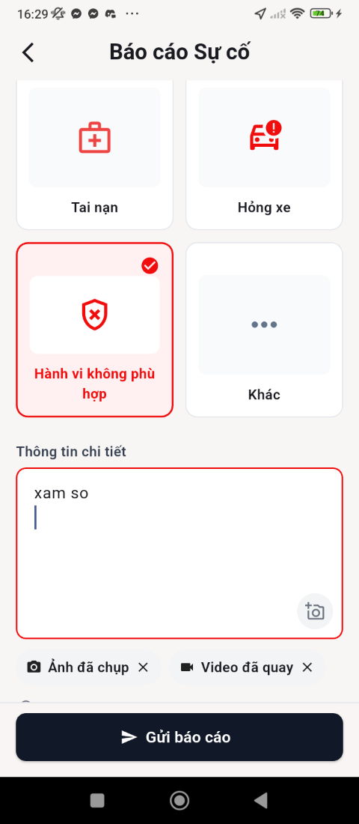

Figure 29: Incident report screen
- Function Details:
  - Data: Complaint type (dropdown), Description text, Uploaded images/videos, Trip ID.
  - Validation: Description is required. Max file size: 20MB per file.
  - Business Rules: BR-25, BR-40, BR-44
  - Normal & Abnormal Cases:
    - Normal: User selects complaint type -> enters description -> uploads media -> submits -> complaint record created.
    - Abnormal: Upload failed -> show error and retry. Invalid file format -> show supported formats. Server error -> retry.

3.4.6 Rating Driver
- Function trigger: Automatically shown after trip completion.
- Function description: This function allows the Student to rate and review the Driver after a trip is completed.
- Screen layout:
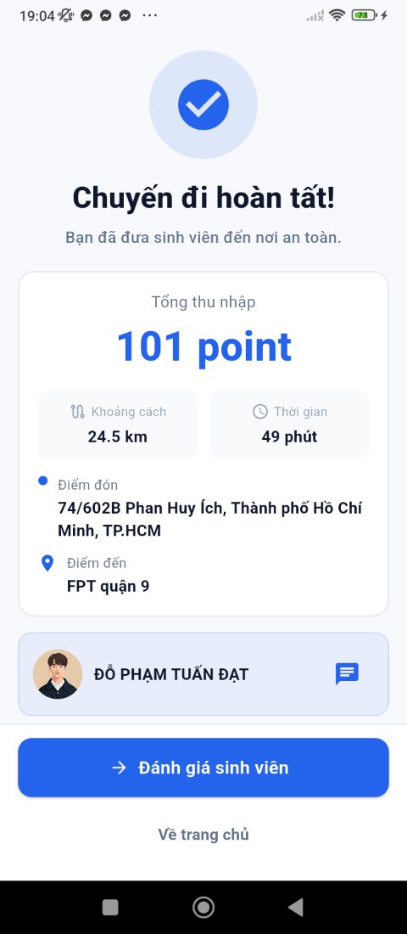

Figure 30: Complete screen
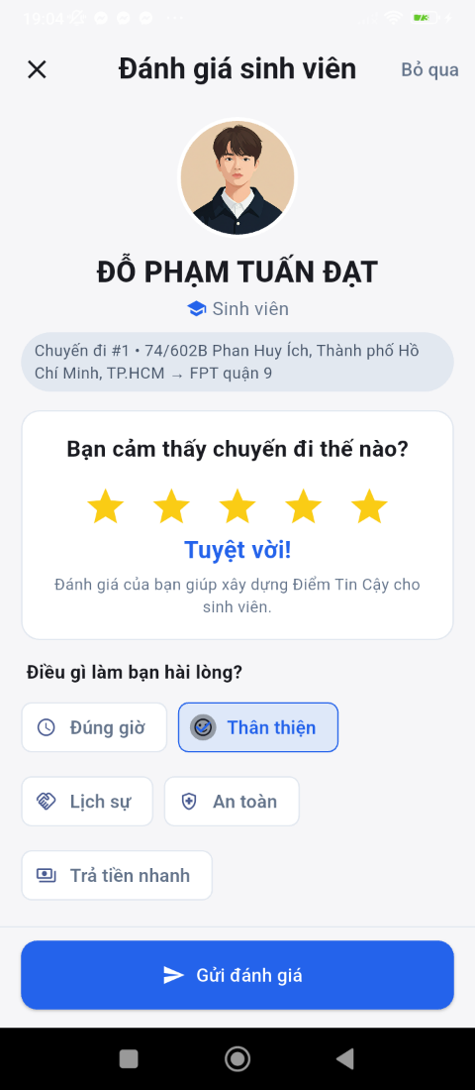

Figure 31: Review and rating screen
- Function Details:
  - Data: Star rating (1-5), Comment (optional).
  - Validation: Rating is required (1-5 stars).
  - Business Rules: BR-30, BR-31, BR-44
  - Normal & Abnormal Cases:
    - Normal: Trip ends -> rating popup appears -> student selects stars -> adds optional comment -> submits.
    - Abnormal: User skips rating -> reminder shown later. Submit fails -> retry.

3.5 User Profile Management

3.5.1 Home Page
- Function trigger: User successfully logs in -> system redirects to Home Page. Or user clicks Home from navigation menu.
- Function description: This function provides the main Home page for Students to access core ride booking features, wallet balance, vouchers, and upcoming scheduled rides.
- Screen layout:
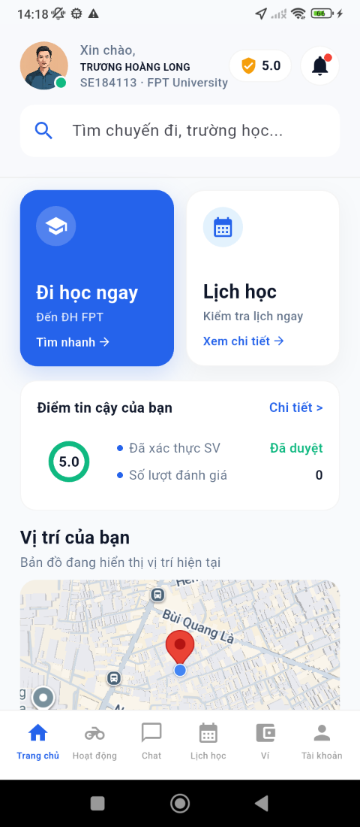

Figure 32: Home page screen
- Function Details:
  - Data: User profile, wallet balance, active vouchers, upcoming scheduled rides, current GPS location.
  - Validation: User must be authenticated. Location permission must be granted to enable ride suggestions.
  - Business Rules: BR-26, BR-27, BR-33, BR-37
  - Normal & Abnormal Cases:
    - Normal: User logs in -> system loads Home Page -> displays available features and personalized data.
    - Abnormal: Location not available -> show manual location input. Wallet service error -> display cached value with warning. No scheduled rides -> show empty state.

3.5.2 User Profile
- Function trigger: User navigates to Menu -> Profile, or taps avatar icon on the top-right corner.
- Function description: This function displays and allows editing of personal user information including name, phone, email, gender, and date of birth.
- Screen layout:
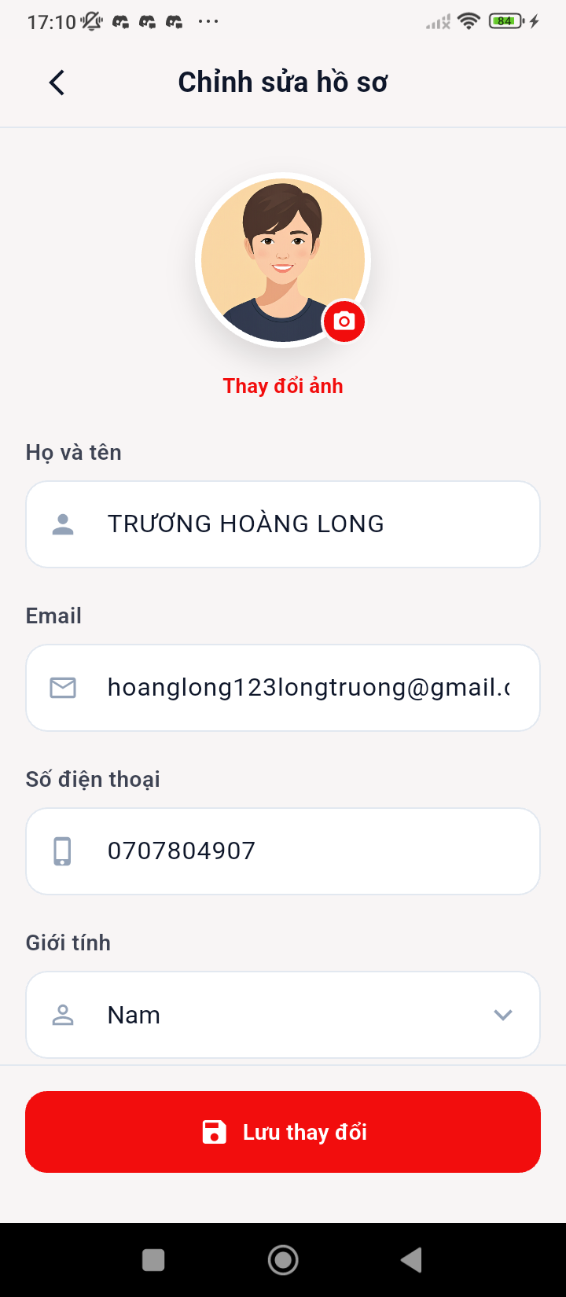

Figure 33: Edit profile screen

- Function Details:
  - Data: Profile avatar, Full name, Phone number, Email, Gender, Date of birth, Role (Student/Driver).
  - Validation: Name cannot be empty. Phone number must be valid format. Email must be valid format.
  - Business Rules: BR-44, BR-45
  - Normal & Abnormal Cases:
    - Normal: User opens Profile -> system displays current information -> user edits fields -> clicks Save -> system validates and updates database.
    - Abnormal: Invalid email/phone -> show error message. Server error -> show retry option.

3.5.3 Preferences
- Function trigger: User navigates to Edit Profile
- Function description: This function allows users to define personal ride preferences (e.g., preferred gender, music) used for trip matching algorithm.
- Screen layout:
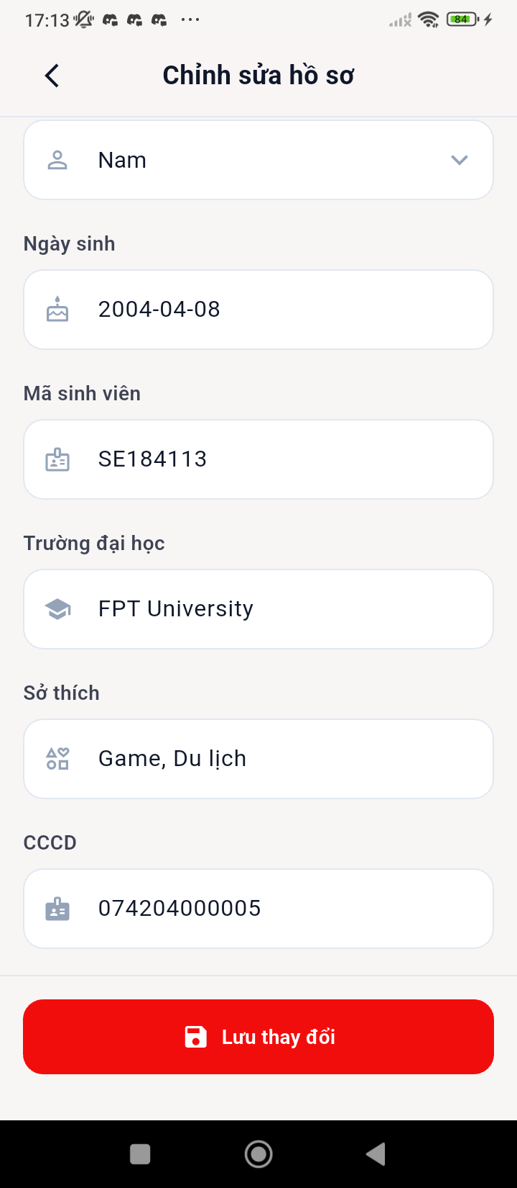

Figure 34: Edit profile screen
- Function Details:
  - Data: For Student: preferred driver gender, vehicle type, music preference, chat preference. For Driver: preferred passenger type.
  - Validation: At least one preference must be selected.
  - Business Rules: BR-17, BR-18
  - Normal & Abnormal Cases:
    - Normal: User selects preferences -> clicks Save -> system stores settings.
    - Abnormal: Save failed -> show retry option.

3.5.4 Weekly Schedule
- Function trigger: User navigates to Profile -> Weekly Schedule.
- Function description: This function allows users to input their study/availability schedule for 1 to 4 weeks, used for trip matching and availability.
- Screen layout:


Figure 35: Schedule screen
- Function Details:
  - Data: Week selector (Week 1-4), Days of week (Mon-Sun), Time slots per day.
  - Validation: Time slots cannot overlap. Must select at least 1 schedule slot.
  - Business Rules: BR-06, BR-07, BR-08
  - Normal & Abnormal Cases:
    - Normal: User selects week -> inputs time slots -> clicks Confirm-> system stores schedule.
    - Abnormal: Overlapping time slots -> show error. No schedule -> show warning.

3.6 Wallet & Payment

3.6.1 Wallet
- Function trigger: User navigates to Menu -> Wallet. Or automatically displayed after completing a trip payment.
- Function description: This function displays the user's account balance, transaction summary, and provides access to financial actions (Top up, Withdraw).
- Screen layout:
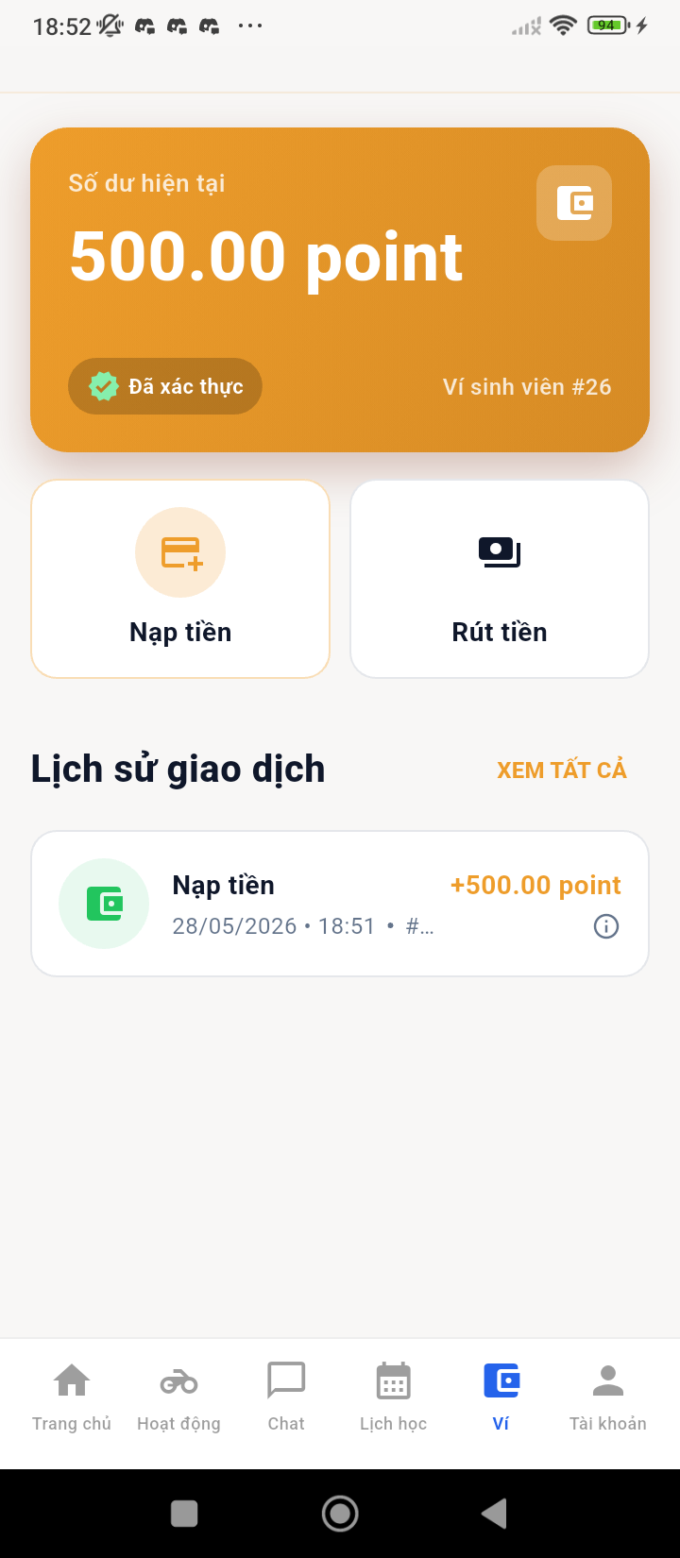

Figure 36: Wallet screen
- Function Details:
  - Data: Current Balance, Available Balance, Pending Balance (if any), Recent Transactions list.
  - Validation: User must be authenticated.
  - Business Rules: BR-32, BR-33, BR-39
  - Normal & Abnormal Cases:
    - Normal: User opens Wallet -> system displays balance and recent transactions.
    - Abnormal: Data load failed -> show retry. Wallet not initialized -> auto-create wallet.

3.6.2 Withdraw
- Function trigger: User clicks 'Withdraw' button in the Wallet screen.
- Function description: This function allows users to request a withdrawal from their wallet to an external bank account, processed manually by Staff.
- Screen layout:


Figure 37: Wallet screen
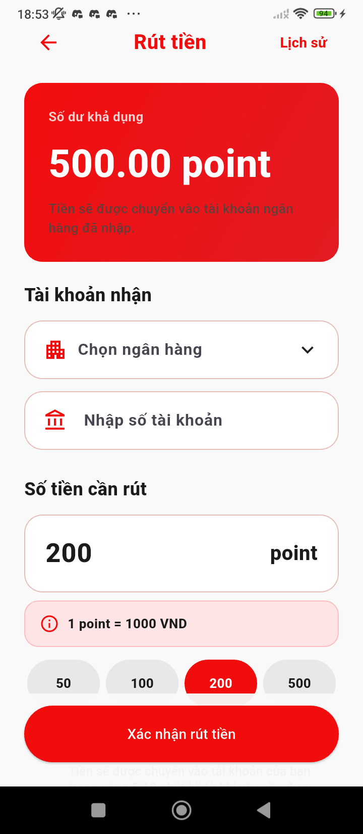

Figure 38: Withdraw screen
- Function Details:
  - Data: Withdrawal amount, Bank account information, Note (optional).
  - Validation: Withdrawal amount > 0. Withdrawal amount must not exceed available balance. Bank information must be valid.
  - Business Rules: BR-34, BR-35, BR-36, BR-39
  - Normal & Abnormal Cases:
    - Normal: User enters amount and bank info -> submits request -> system marks transaction as Pending.
    - Abnormal: Insufficient balance -> show error message. Invalid bank info -> show error.

3.6.3 Transaction History
- Function trigger: User navigates to Wallet -> Transaction History.
- Function description: This function displays the full list of wallet transactions (Deposit, Withdraw, Trip Payment, Refund) for the authenticated user.
- Screen layout:
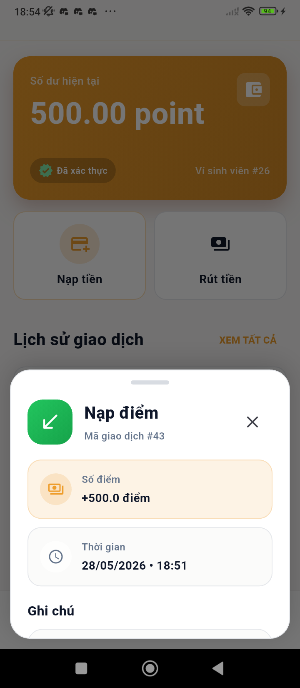

Figure 39: Transaction history screen
- Function Details:
  - Data: Transaction ID, Type, Amount, Status (Completed/Pending/Failed), Date & Time.
  - Validation: User must be authenticated.
  - Business Rules: BR-33, BR-44
  - Normal & Abnormal Cases:
    - Normal: User opens history -> system displays full list sorted by date.
    - Abnormal: No transactions -> show empty state. Server error -> show retry.

3.6.4 Top up
- Function trigger: User clicks 'Top up' button in the Wallet screen.
- Function description: This function allows users to top up money into their wallet via an integrated payment gateway.
- Screen layout:
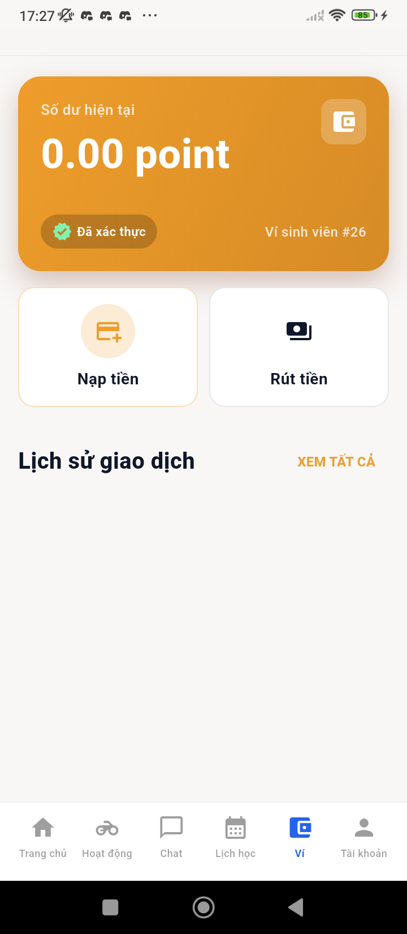

Figure 40: Wallet screen
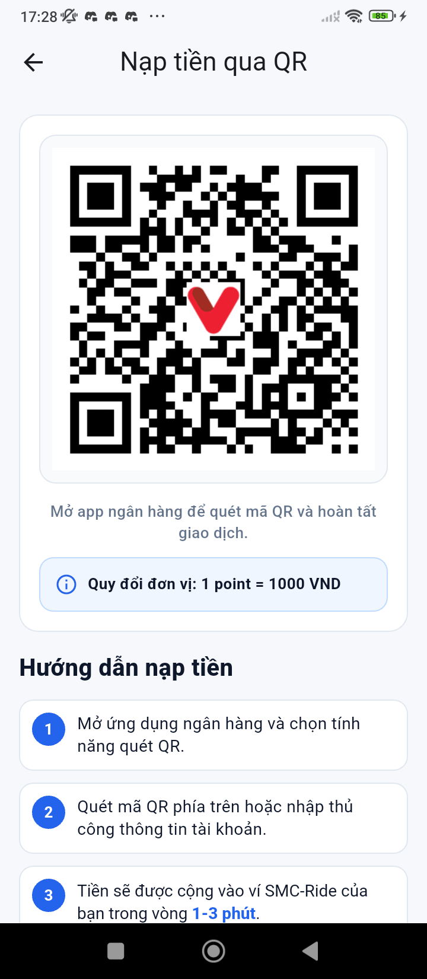

Figure 41: Top up screen
- Function Details:
  - Data: Deposit amount, Payment method selection.
  - Validation: Amount must be >= minimum deposit (e.g., 10 points equivalent).
  - Business Rules: BR-33, BR-39, BR-44
  - Normal & Abnormal Cases:
    - Normal: User enters amount -> selects payment method -> redirected to payment gateway -> payment success -> wallet balance updated.
    - Abnormal: Payment failed -> show error. Payment cancelled -> no balance change.

3.7 Voucher Management

3.7.1 My Voucher
- Function trigger: User navigates to Menu -> Account -> Voucher, or opens from Trip Booking -> Apply Voucher.
- Function description: This function displays all available vouchers the user can use, organized by status (Available, Used, Expired).
- Screen layout:
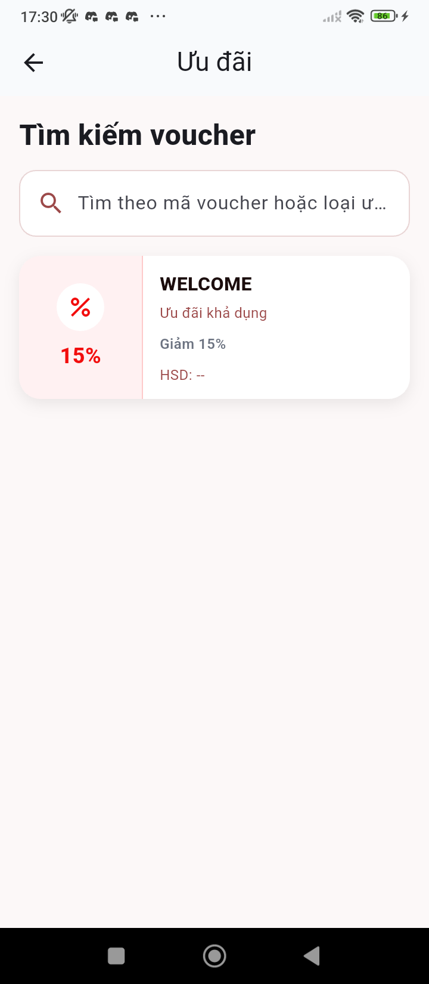

Figure 42: Voucher screen
- Function Details:
  - Data: Voucher title, Discount value (% or fixed), Expiry date, Minimum trip value, Usage conditions, Status.
  - Validation: Only logged-in users can access.
  - Business Rules: BR-37, BR-38
  - Normal & Abnormal Cases:
    - Normal: User opens Voucher screen -> system displays voucher list with tabs (Available / Used / Expired).
    - Abnormal: No voucher available -> show empty state. Data load failed -> retry.

3.7.2 Apply Voucher
- Function trigger: User selects 'Apply Voucher' during trip booking.
- Function description: This function allows the Student to select and apply a voucher to a trip to receive a discount on the fare.
- Screen layout:
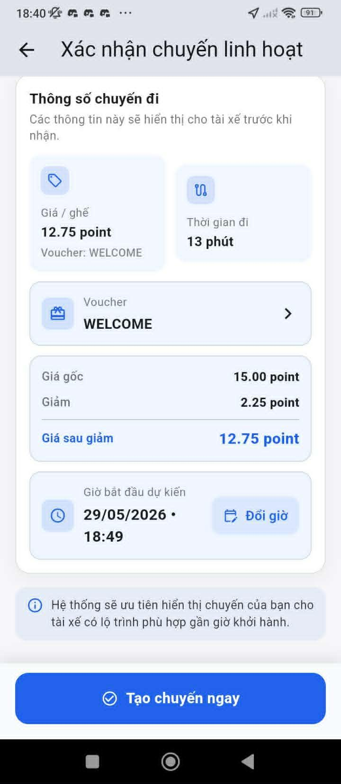

Figure 43: Input information for the trip screen
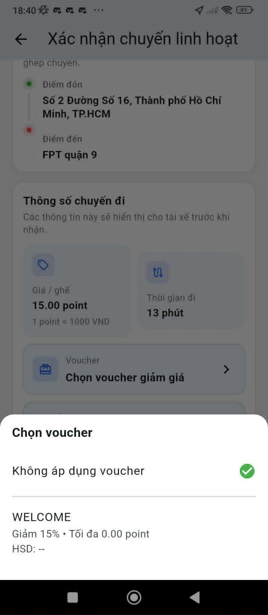

Figure 44: Apply voucher for the trip screen
- Function Details:
  - Data: List of available vouchers, Selected voucher, Updated trip fare.
  - Validation: Voucher must be valid and active. Trip must meet minimum value condition.
  - Business Rules: BR-37, BR-38, BR-39
  - Normal & Abnormal Cases:
    - Normal: User opens Apply Voucher popup -> selects voucher -> system calculates new fare -> user confirms booking.
    - Abnormal: Voucher expired during selection -> show error. Voucher not eligible for this trip -> disable selection.

3.7.3 Voucher List
- Function trigger: Admin/Staff navigates to Admin Dashboard -> Voucher Management -> Voucher List.
- Function description: This function allows Admin/Staff to view and manage all system vouchers with filter, search, create, edit, and disable capabilities.
- Screen layout:
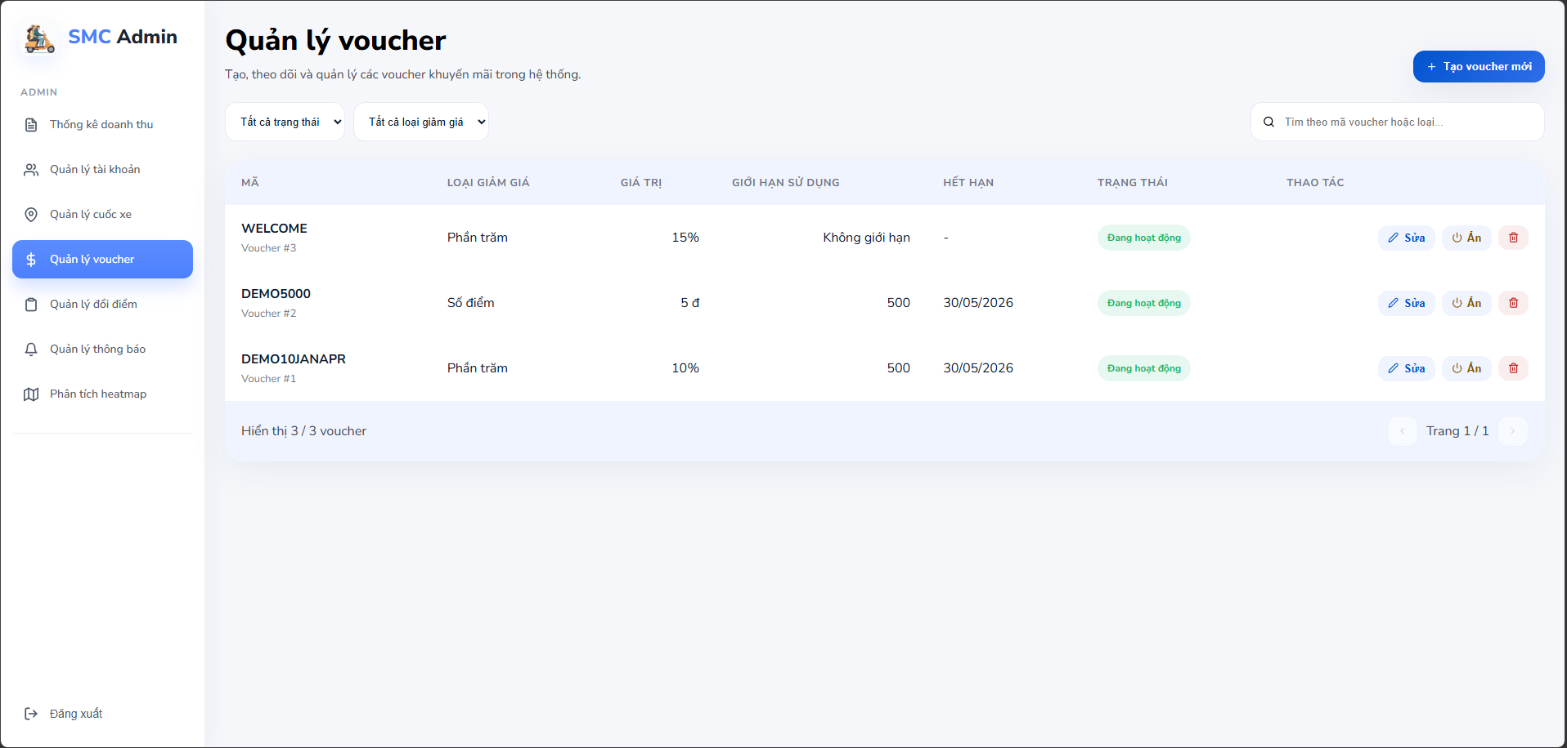

Figure 45:Voucher list screen
- Function Details:
  - Data: Voucher Code, Name, Discount Type (Percentage/Fixed), Discount Value, Quantity, Used Count, Expiration Date, Status.
  - Validation: Only Admin/Staff can access this screen.
  - Business Rules: BR-37, BR-38, BR-41
  - Normal & Abnormal Cases:
    - Normal: Admin opens Voucher List -> system displays all vouchers -> admin filters/searches -> manages vouchers.
    - Abnormal: No voucher -> show empty state. System error -> show retry.

3.7.4 Create Voucher Details
- Function trigger: Admin/Staff clicks 'Create Voucher'
- Function description: This function allows Admin/Staff to input detailed information of a voucher including discount info, usage conditions, and validity.
- Screen layout:
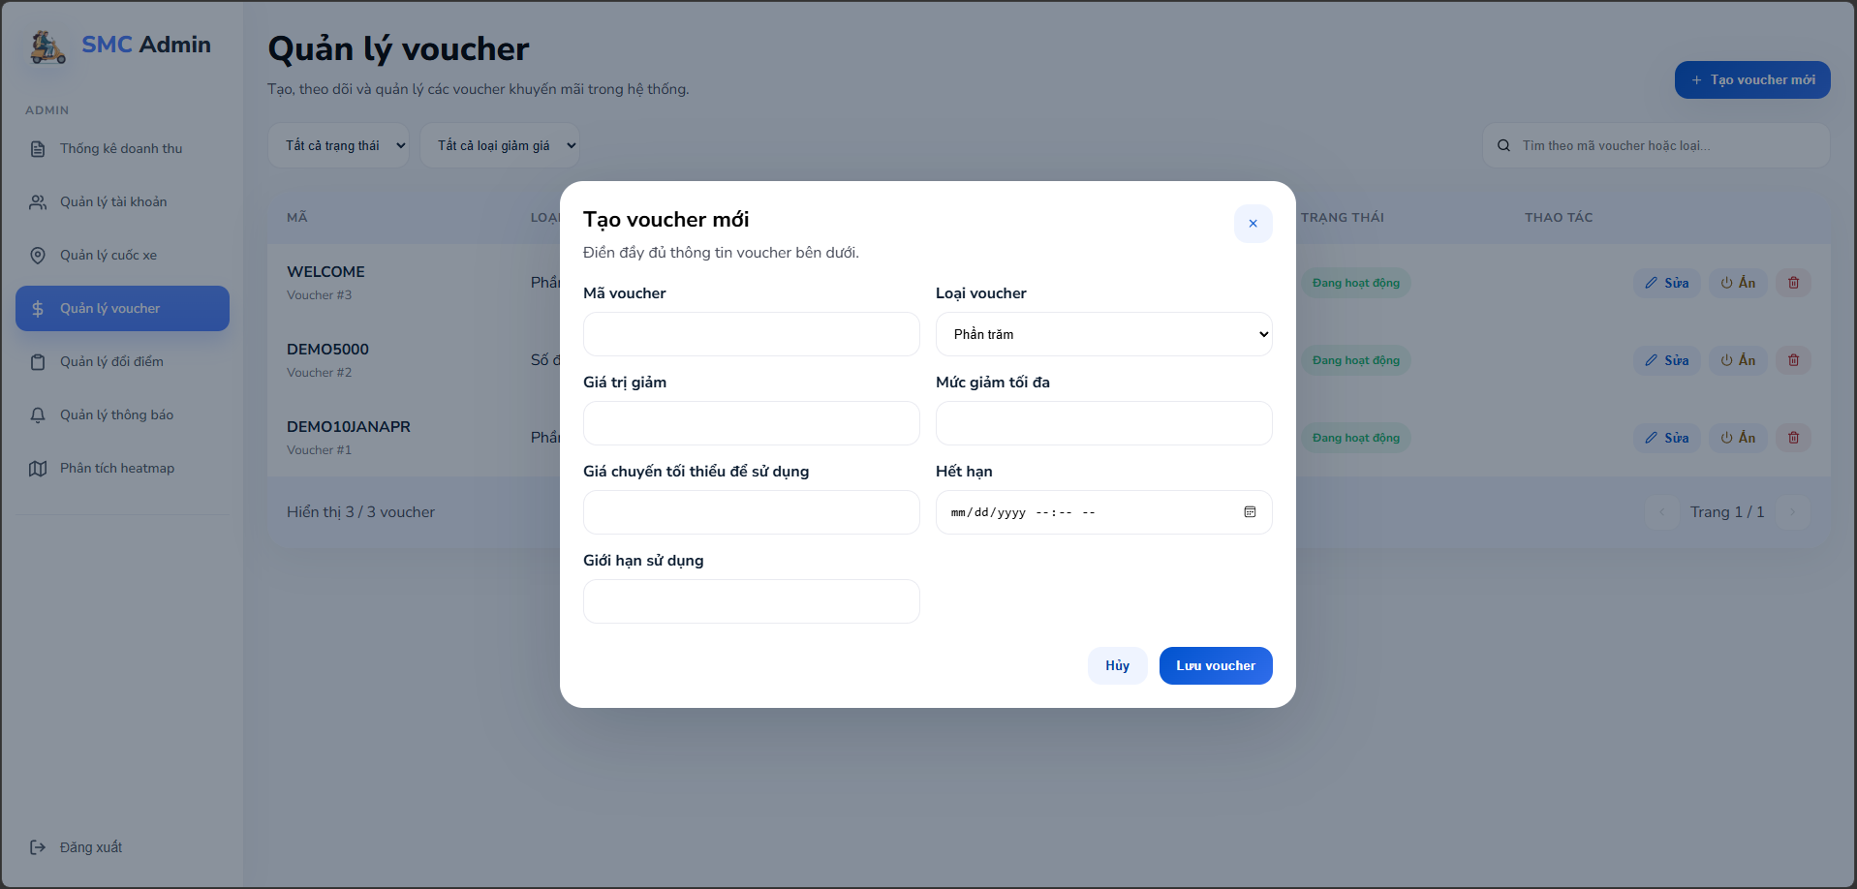

Figure 46: Create Voucher screen
- Function Details:
  - Data: Voucher code, Name, Description, Discount type & value, Max discount amount, Minimum trip value, User group, Usage limit, Start date, Expiry date, Status.
  - Validation: Discount value must be positive. Expiry date must be after start date. Quantity must be >= used count.
  - Business Rules: BR-37, BR-38, BR-41, BR-44
  - Normal & Abnormal Cases:
    - Normal: Admin opens voucher details -> edits information -> clicks Save -> system updates database.
    - Abnormal: Invalid data input -> show validation error. Permission denied -> block editing.

3.7.5 Update Voucher Details
- Function trigger: Admin/Staff clicks 'Update' on a voucher in the Voucher List.
- Function description: This function allows Admin/Staff to configure detailed information of a voucher including discount info, usage conditions, and validity.
- Screen layout:
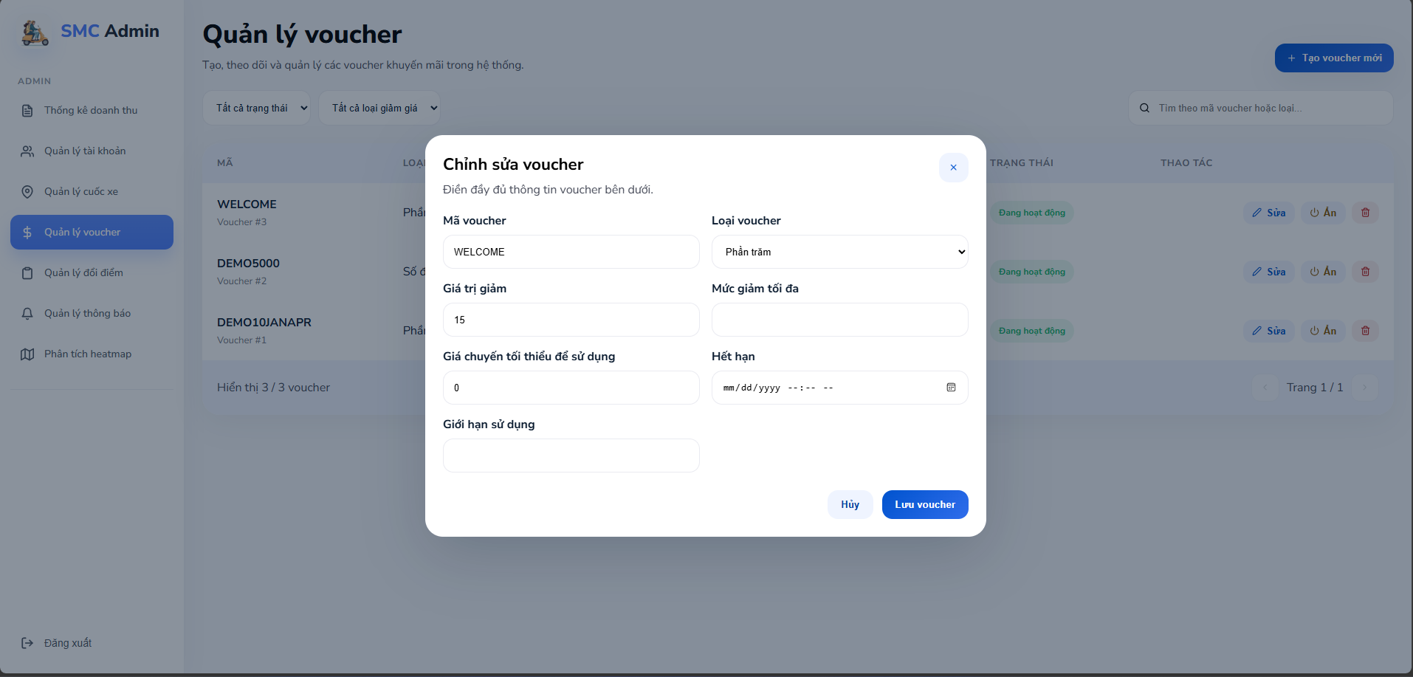

Figure 47: Update Voucher screen
- Function Details:
  - Data: Voucher code, Name, Description, Discount type & value, Max discount amount, Minimum trip value, User group, Usage limit, Start date, Expiry date, Status.
  - Validation: Discount value must be positive. Expiry date must be after start date. Quantity must be >= used count.
  - Business Rules: BR-37, BR-38, BR-41, BR-44
  - Normal & Abnormal Cases:
    - Normal: Admin opens voucher details -> edits information -> clicks Save -> system updates database.
    - Abnormal: Invalid data input -> show validation error. Permission denied -> block editing.

3.8 Driver Ride Management

3.8.1 Register as Driver
- Function trigger: Student selects Menu -> Account -> Become a Driver.
- Function description: This function allows a Student to apply to become a Driver by submitting a registration form with required documents for Staff approval.
- Screen layout:


Figure 48: Account screen
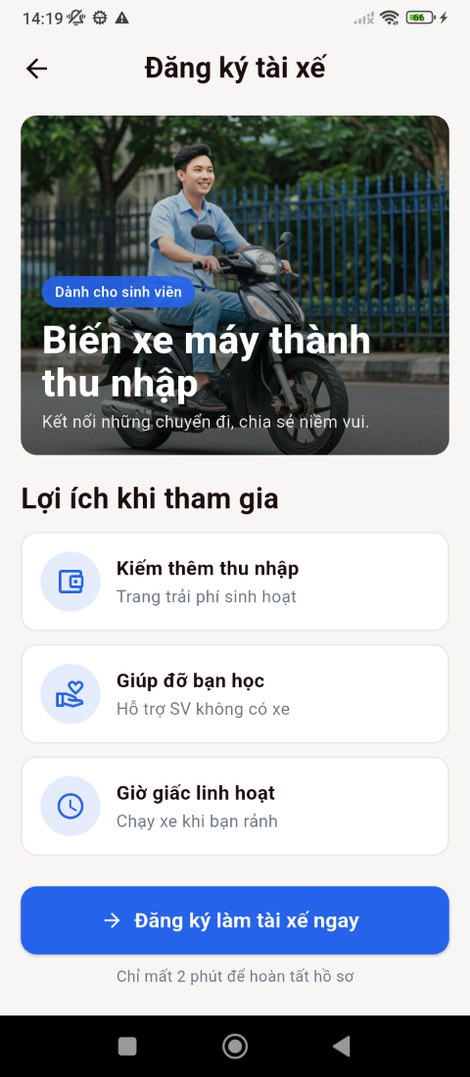

Figure 49: Become as a driver screen
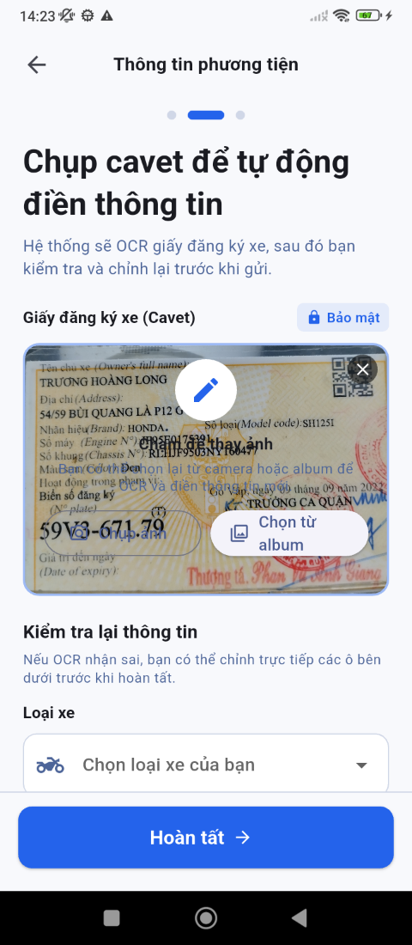

Figure 50: Input information screen
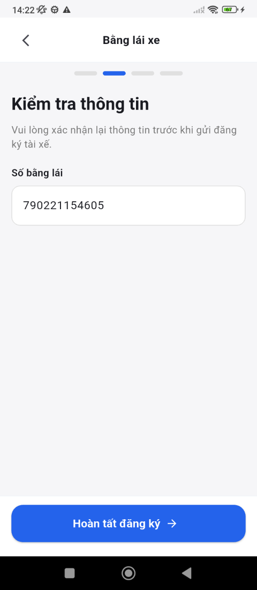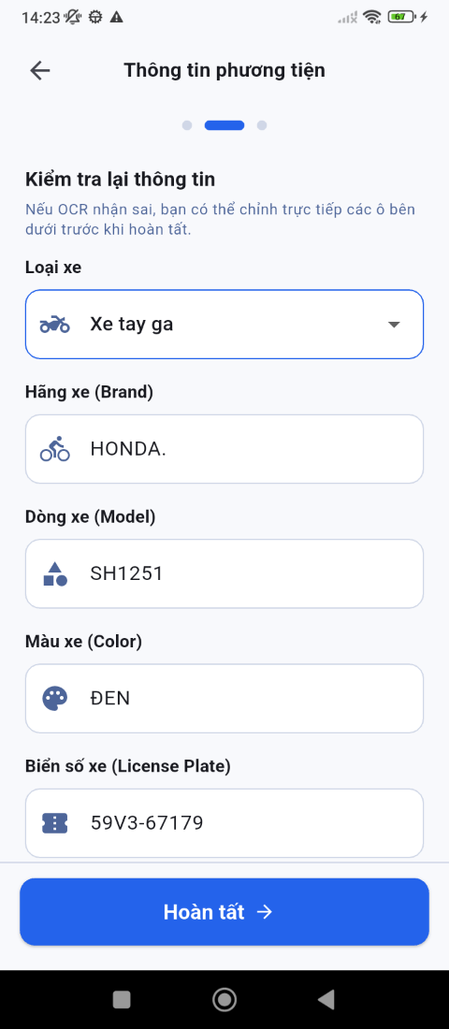

Figure 51: Validate information screen
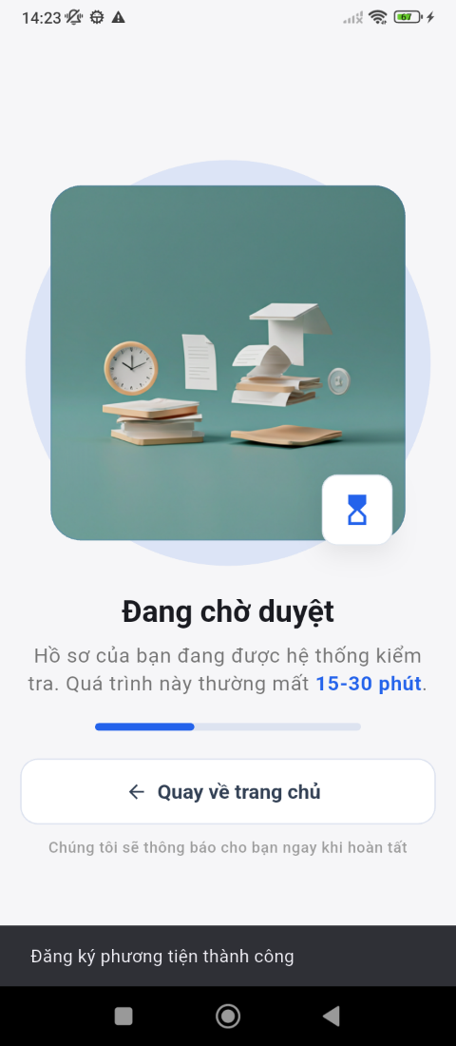

Figure 52: Complete screen
- Function Details:
  - Data: Full name, Student ID, Driver license number, Vehicle information, Uploaded documents (ID card, license, vehicle registration).
  - Validation: All required fields must be filled. Documents must be in valid format.
  - Business Rules: BR-02, BR-03, BR-04, BR-05
  - Normal & Abnormal Cases:
    - Normal: User fills application -> submits form -> status set to Pending -> Staff reviews.
    - Abnormal: Invalid documents -> reject. Duplicate application -> block resubmission.

3.8.2 Driver Profile
- Function trigger: Driver navigates to Menu -> Driver Profile.
- Function description: This function displays the driver's personal and vehicle information, rating, and total trips completed.
- Screen layout:
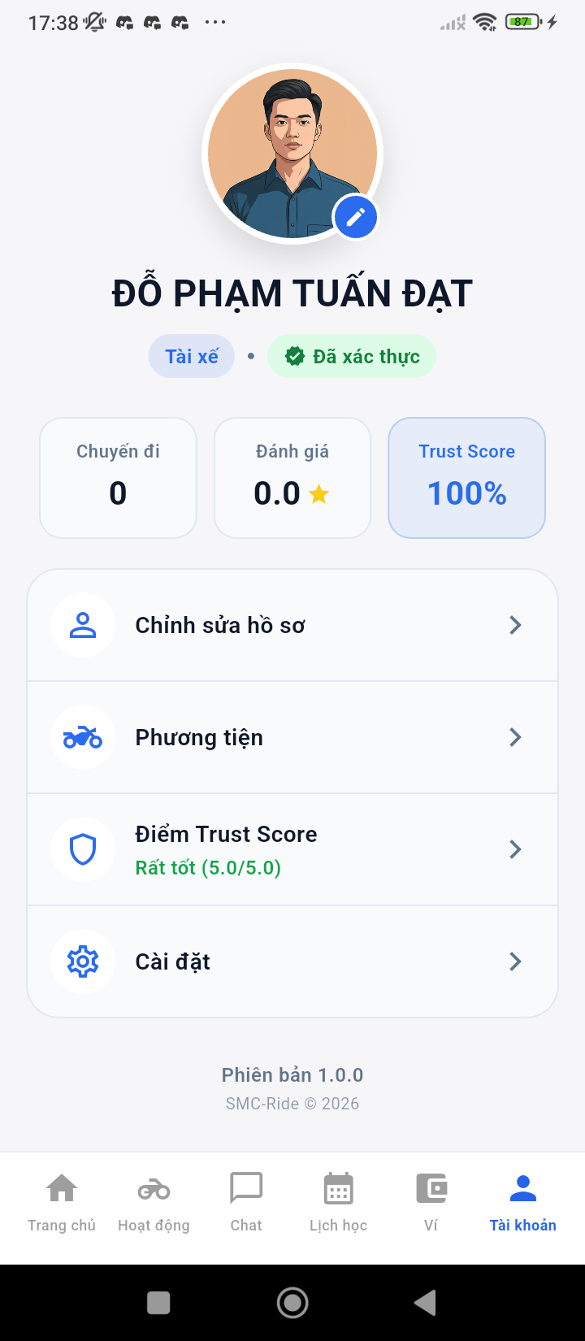

Figure 53: Account driver screen
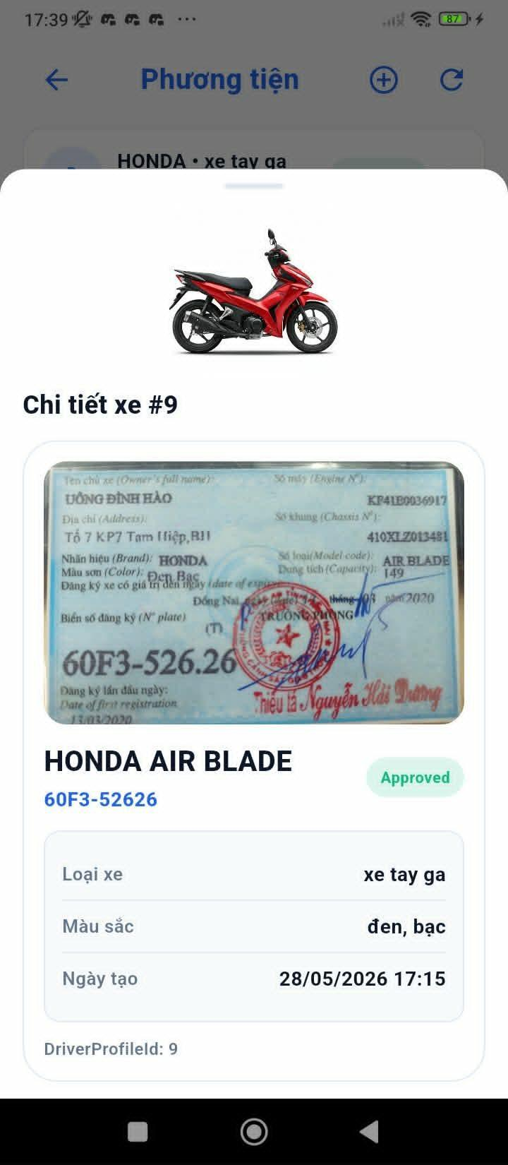

Figure 54: Vehicle information

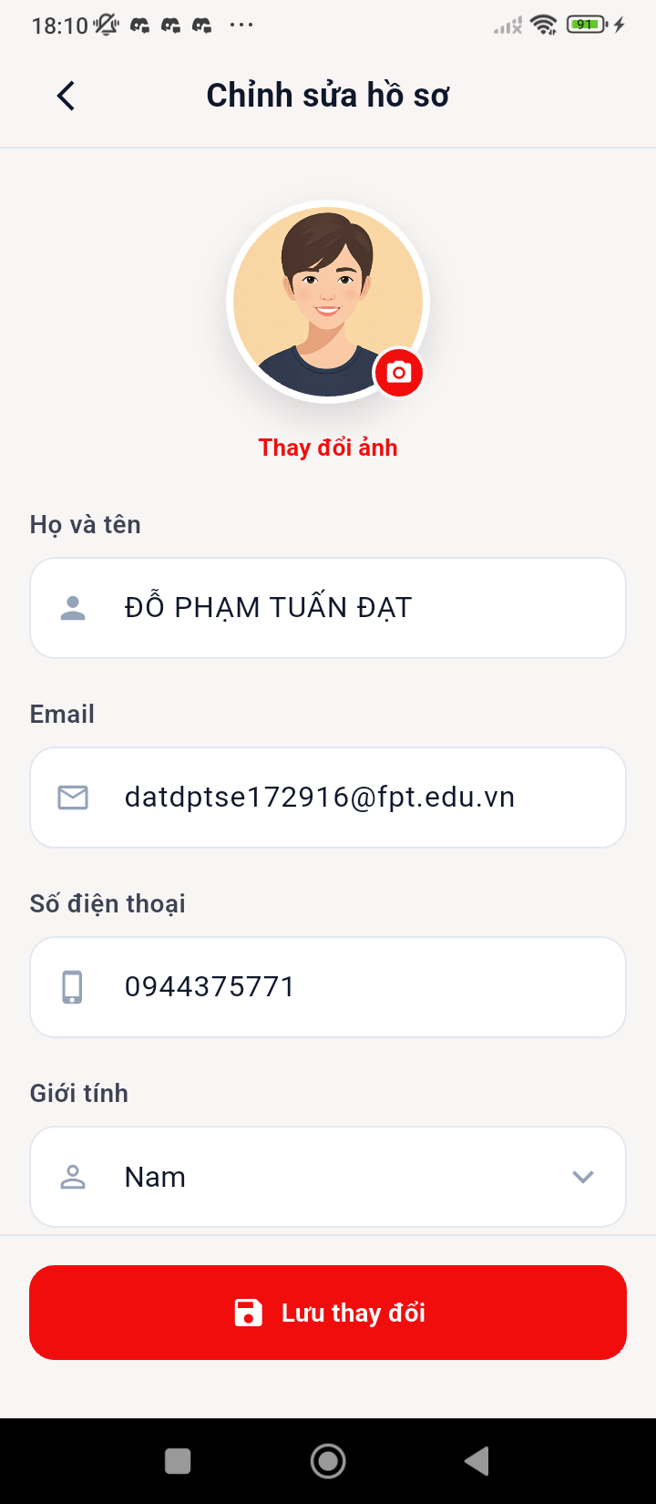

Figure 55: Driver information
- Function Details:
  - Data: Personal information, Vehicle information, Driver rating, Total trips completed.
  - Validation: Driver must be authenticated and approved.
  - Business Rules: BR-04, BR-44, BR-45
  - Normal & Abnormal Cases:
    - Normal: Driver opens profile -> system displays full profile -> driver updates editable fields -> saves.
    - Abnormal: Save failed -> show retry. Locked field edit attempt -> block action.

3.8.3 Fixed Ride
- Function trigger: Driver selects Ride Type = Fixed when posting a ride.
- Function description: This function allows the Driver to create a recurring fixed-schedule ride based on selected days and time slots.
- Screen layout:
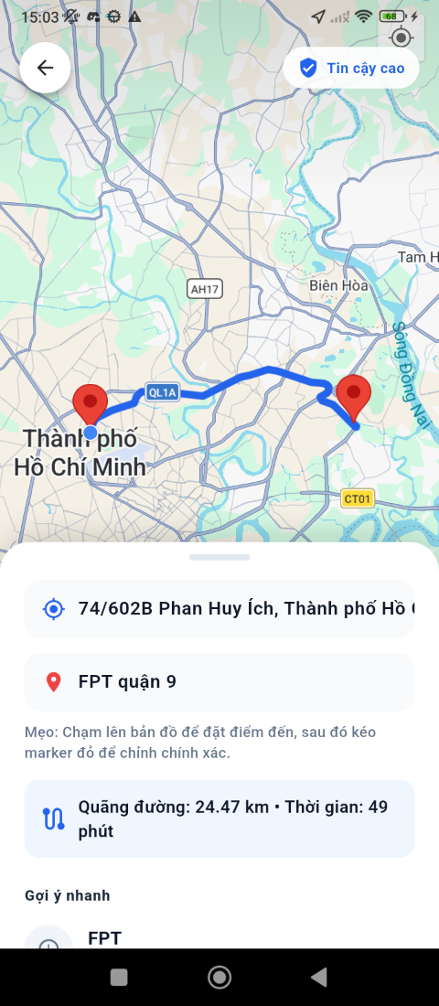

Figure 56: Input information for the trip screen


Figure 57: Input information for the trip screen
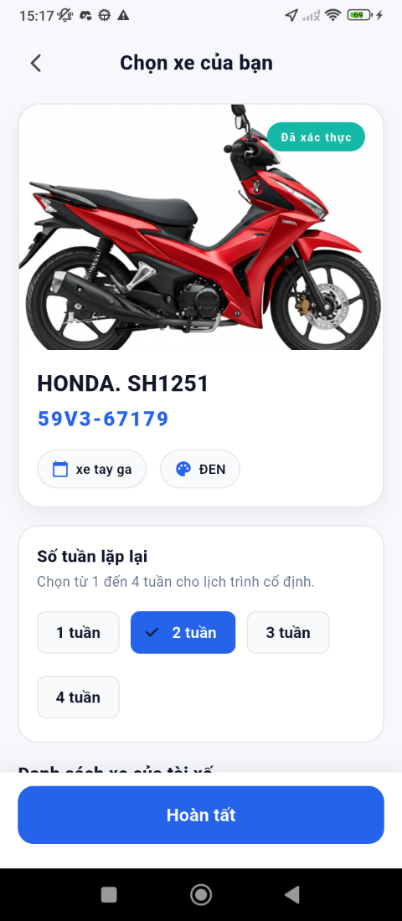

Figure 58: Select vehicle and repeat week for the trip screen
- Function Details:
  - Data: Days of week, Time slot, Pickup & destination, Vehicle selection.
  - Validation: At least one day must be selected. Time slot must not conflict with existing rides.
  - Business Rules: BR-06, BR-07, BR-09
  - Normal & Abnormal Cases:
    - Normal: Driver selects days of week -> sets time slot -> confirms -> system generates recurring rides.
    - Abnormal: Conflicting schedule -> show warning. No vehicle selected -> prompt selection.

3.8.4 Flexible Ride
- Function trigger: Driver selects Go now on Home Page screen.
- Function description: This function allows the Driver to create a one-time on-demand flexible ride with a custom date and time.
- Screen layout:


Figure 59: Input information for flexible the trip screen
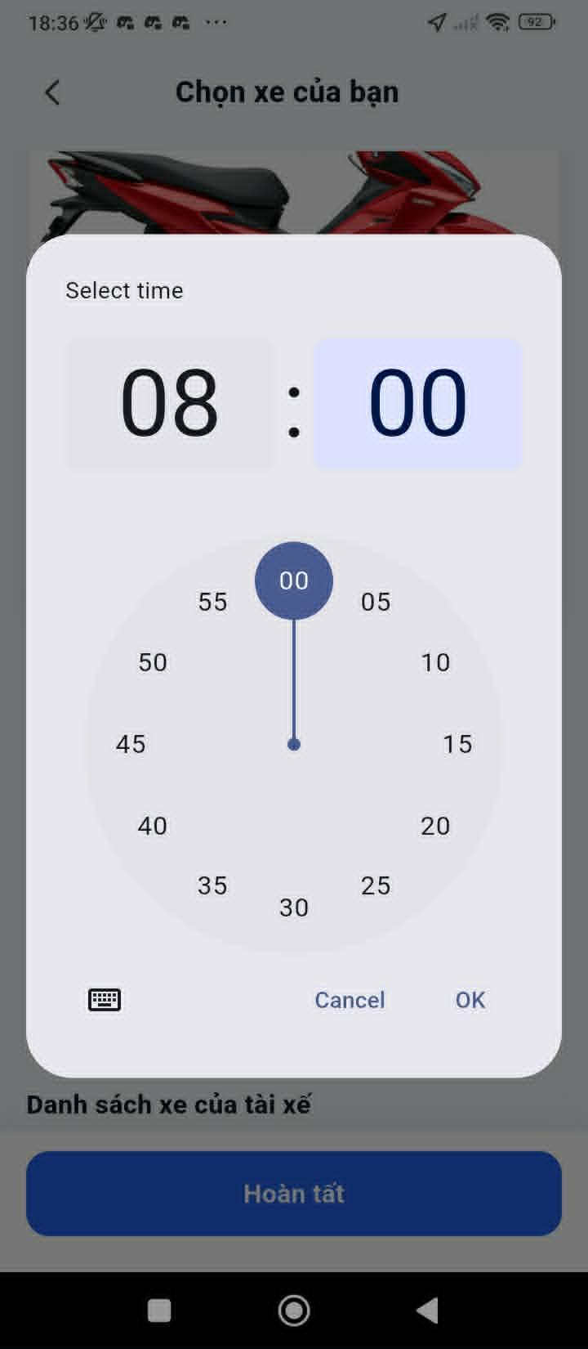

Figure 60: Input information for flexible the trip screen
- Function Details:
  - Data: Custom date/time, Pickup & destination, Price per seat, Vehicle selection.
  - Validation: Date/time must be in the future.
  - Business Rules: BR-08, BR-09, BR-46, BR-47
  - Normal & Abnormal Cases:
    - Normal: Driver inputs custom time/date -> sets route and price -> posts ride -> students can see and book.
    - Abnormal: Invalid date/time -> show error. No vehicle -> prompt to add vehicle.

3.8.5 Driver Trips
- Function trigger: Driver navigates to Menu -> Activity tab.
- Function description: This function displays a list of all rides created or accepted by the driver, organized by tabs (Posted, Accepted, Completed, Cancelled).
- Screen layout:


Figure 61: Detail of booking screen


Figure 62: Detail of booking screen
- Function Details:
  - Data: Trip list with route, time, passenger count, and status per tab.
  - Validation: Driver must be authenticated.
  - Business Rules: BR-44
  - Normal & Abnormal Cases:
    - Normal: Driver opens Driver Trips -> system displays categorized trip list.
    - Abnormal: No trips -> show empty state. Load failure -> show retry.

3.8.6 Driver Trip Details
- Function trigger: Driver selects a trip from the Driver Trips list.
- Function description: This function shows detailed trip information for the driver including trip info, passenger information, route map, and chat access.
- Screen layout:
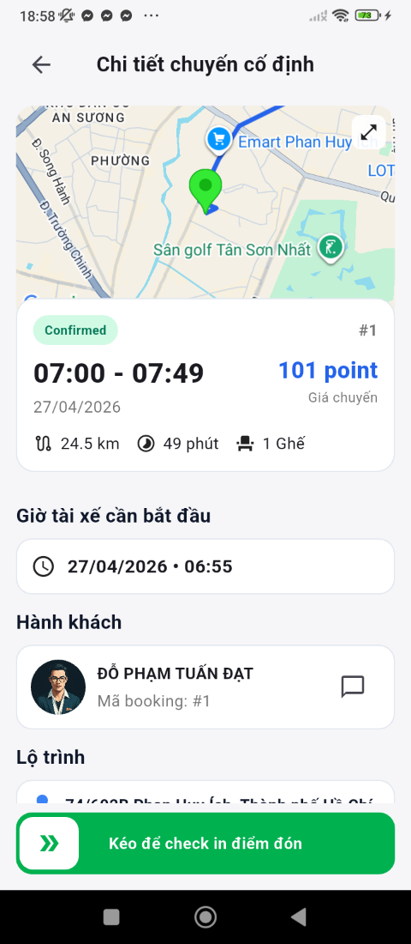

Figure 63: Detail of booking for driver screen
- Function Details:
  - Data: Trip info, Passenger information, Route map, Chat history.
  - Validation: Only the trip's driver can view these details.
  - Business Rules: BR-26, BR-27, BR-44
  - Normal & Abnormal Cases:
    - Normal: Driver taps trip -> system loads detail tabs (Info, Passengers, Route, Chat).
    - Abnormal: Trip not found -> show error. GPS unavailable -> show static route.

3.8.7 Confirm Trip
- Function trigger: Driver clicks 'Confirm' on a pending trip booking request.
- Function description: This function allows the Driver to confirm a passenger's booking request, updating the trip status to Confirmed.
- Screen layout:


Figure 64: Pending trip booking detail screen
- Function Details:
  - Data: Booking ID, Confirmation action.
  - Validation: Vehicle capacity must not be exceeded.
  - Business Rules: BR-10, BR-13, BR-15, BR-16
  - Normal & Abnormal Cases:
    - Normal: Driver clicks Confirm -> popup confirmation dialog -> confirms -> system updates status to Confirmed -> passenger notified.
    - Abnormal: Over capacity -> show error. Confirmation timeout -> auto-reject.

3.8.8 Chat Student
- Function trigger: Driver opens chat from trip detail screen.
- Function description: This function enables the Driver to communicate with a Student via real-time chat before or during a trip.
- Screen layout:


Figure 65: Chat screen
- Function Details:
  - Data: Chat messages (text) via real-time messaging (WebSocket/SignalR).
  - Validation: Chat is available only for active/ongoing trips.
  - Business Rules: BR-44, BR-45
  - Normal & Abnormal Cases:
    - Normal: Driver opens chat popup -> sends message -> student receives in real time.
    - Abnormal: No internet -> show offline warning. Message failure -> retry.

3.8.9 Share Location
- Function trigger: Driver enables location sharing when starting a trip.
- Function description: This function allows the Driver to share their real-time GPS location with the matched Student during an active trip.
- Screen layout:
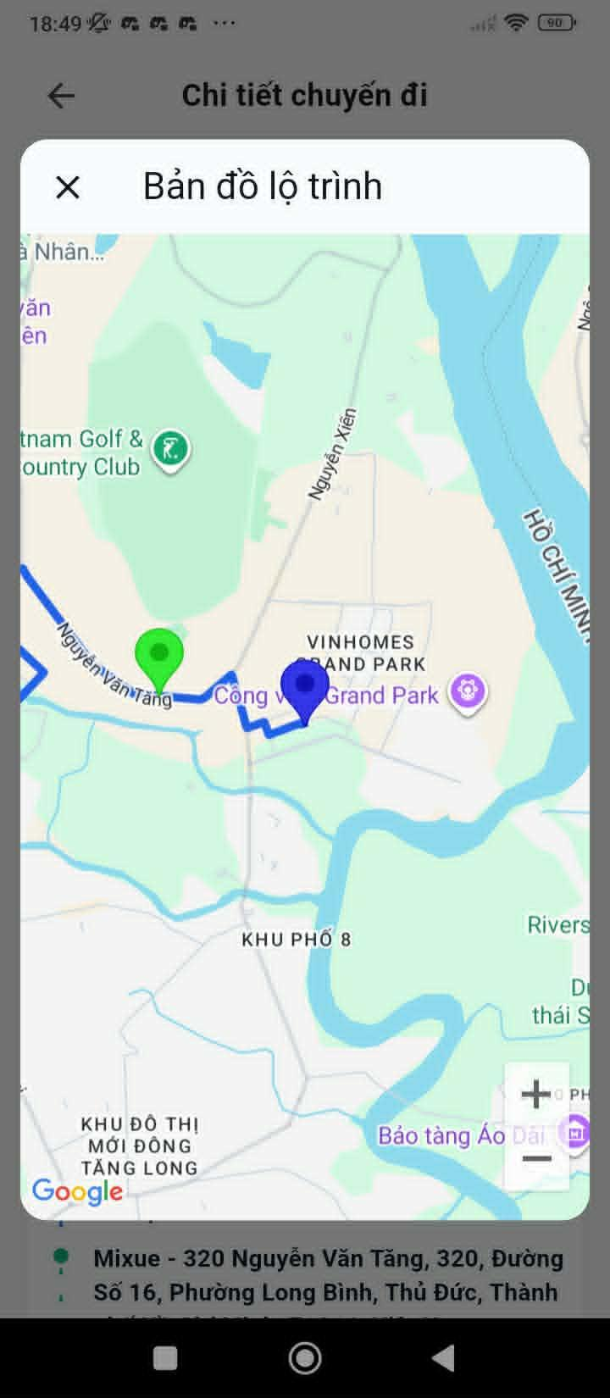

Figure 66: Share location screen
- Function Details:
  - Data: Driver GPS coordinates, updated in real time.
  - Validation: Driver must grant location permission.
  - Business Rules: BR-26, BR-27, BR-28, BR-29
  - Normal & Abnormal Cases:
    - Normal: Driver starts trip -> enables location sharing -> student's app receives live location updates.
    - Abnormal: GPS signal lost -> show last known location. Location sharing disabled -> notify student.

3.9 System & User Management

3.9.1 View Statistics Dashboard
- Function trigger: Admin/Staff clicks 'Statistics' in the navigation menu from the Admin Dashboard.
- Function description: This function displays operational KPIs, revenue charts, and booking statistics by month, allowing Admin to monitor system performance.
- Screen layout:
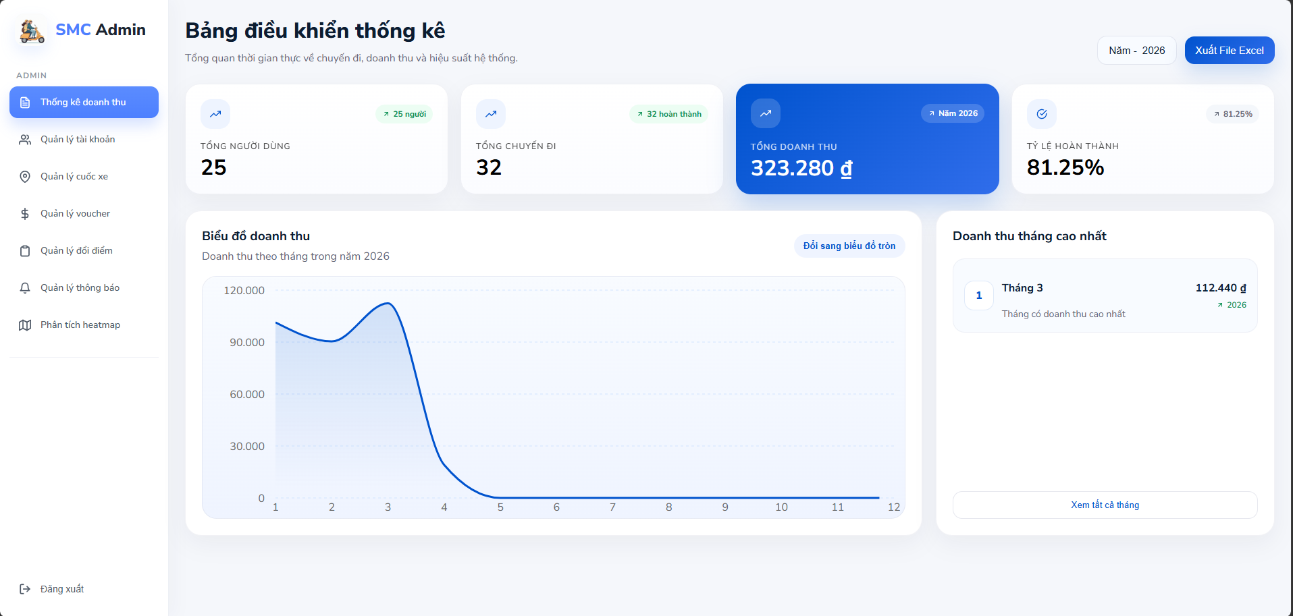

Figure 67: Statistics dashboard screen
- Function Details:
  - Data: Booking counts by status, Revenue by period, Chart toggle (Area / Pie), Export to Excel.
  - Validation: Only Admin/Staff can access this screen.
  - Business Rules: BR-41, BR-42, BR-44
  - Normal & Abnormal Cases:
    - Normal: Admin opens Statistics -> system displays KPIs and charts -> admin can toggle chart type or export.
    - Abnormal: Data load failed -> show retry. Export service error -> notify admin.

3.9.2 Account Management
- Function trigger: Admin/Staff clicks 'Accounts' in the navigation menu.
- Function description: This function displays a paginated list of all user accounts (Students and Drivers) with account details, status, and management actions.
- Screen layout:
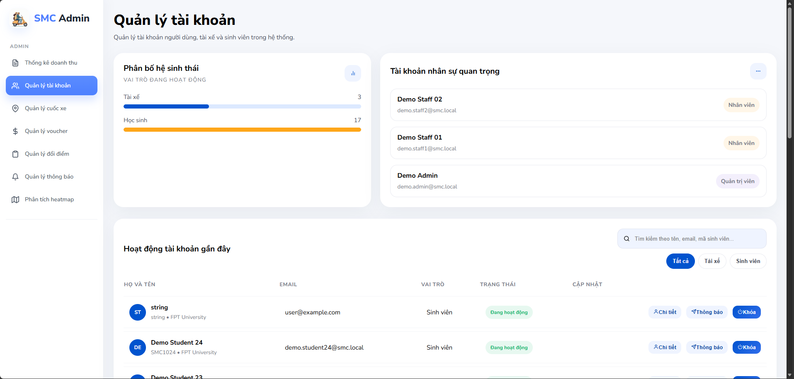

Figure 68: Account List screen
- Function Details:
  - Data: User ID, Full name, Email, Role (Student/Driver), Status (Active/Banned/Locked), Last login.
  - Validation: Only Admin/Staff can access. An account must exist to perform actions.
  - Business Rules: BR-30, BR-40, BR-41, BR-44
  - Normal & Abnormal Cases:
    - Normal: Admin opens Accounts -> views list -> selects account -> views detail -> performs action (Lock/Unlock/Notify).
    - Abnormal: Account not found -> show error. Action fails -> show retry.

3.9.3 Lock / Unlock Account
- Function trigger: Admin/Staff clicks 'Lock' or 'Unlock' button on a user account in the Account Management screen.
- Function description: This function allows Admin/Staff to lock or unlock a user account, preventing or re-enabling access to the system.
- Screen layout:
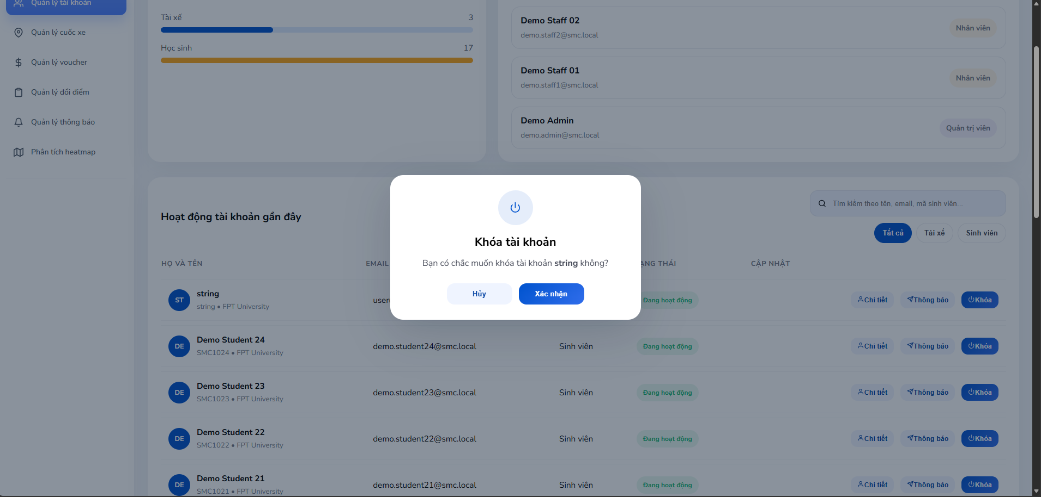

Figure 69: Ban student screen
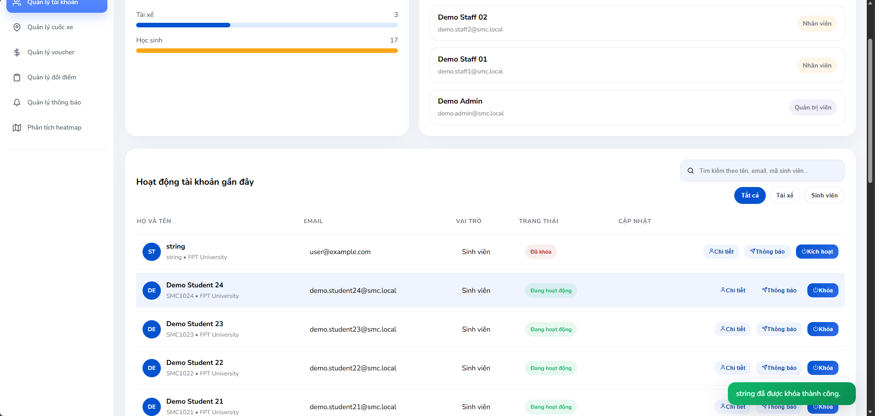

Figure 70: Account management screen after ban
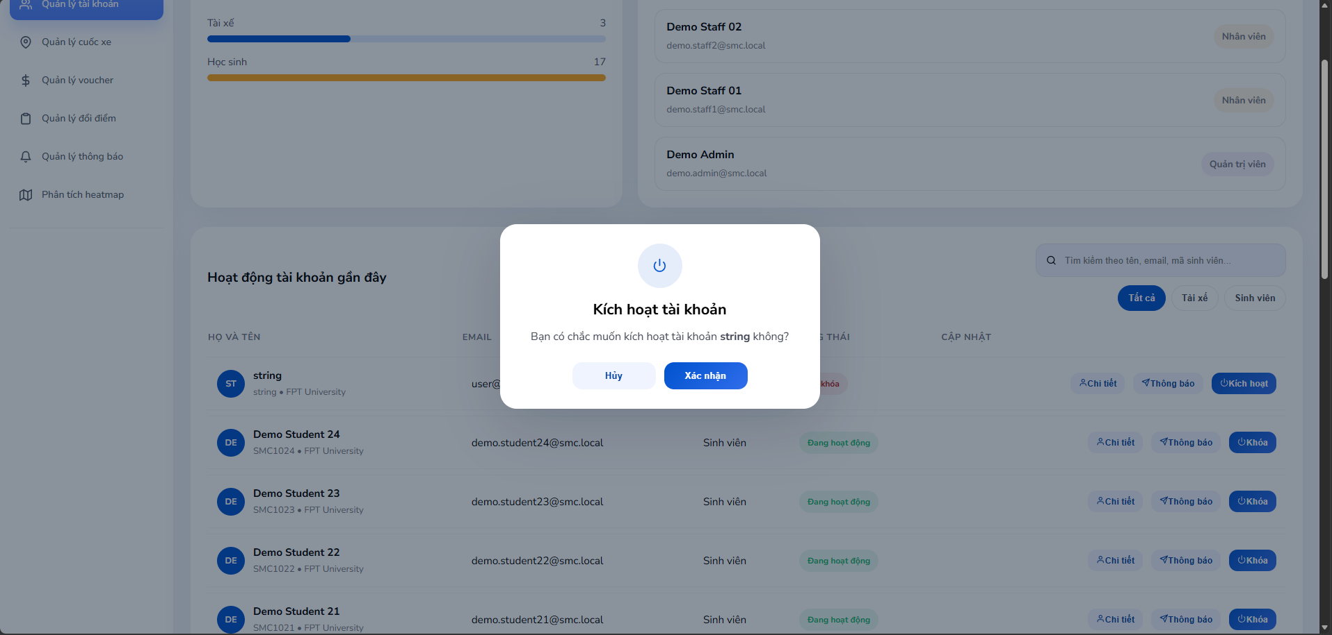

Figure 71: Unban student screen
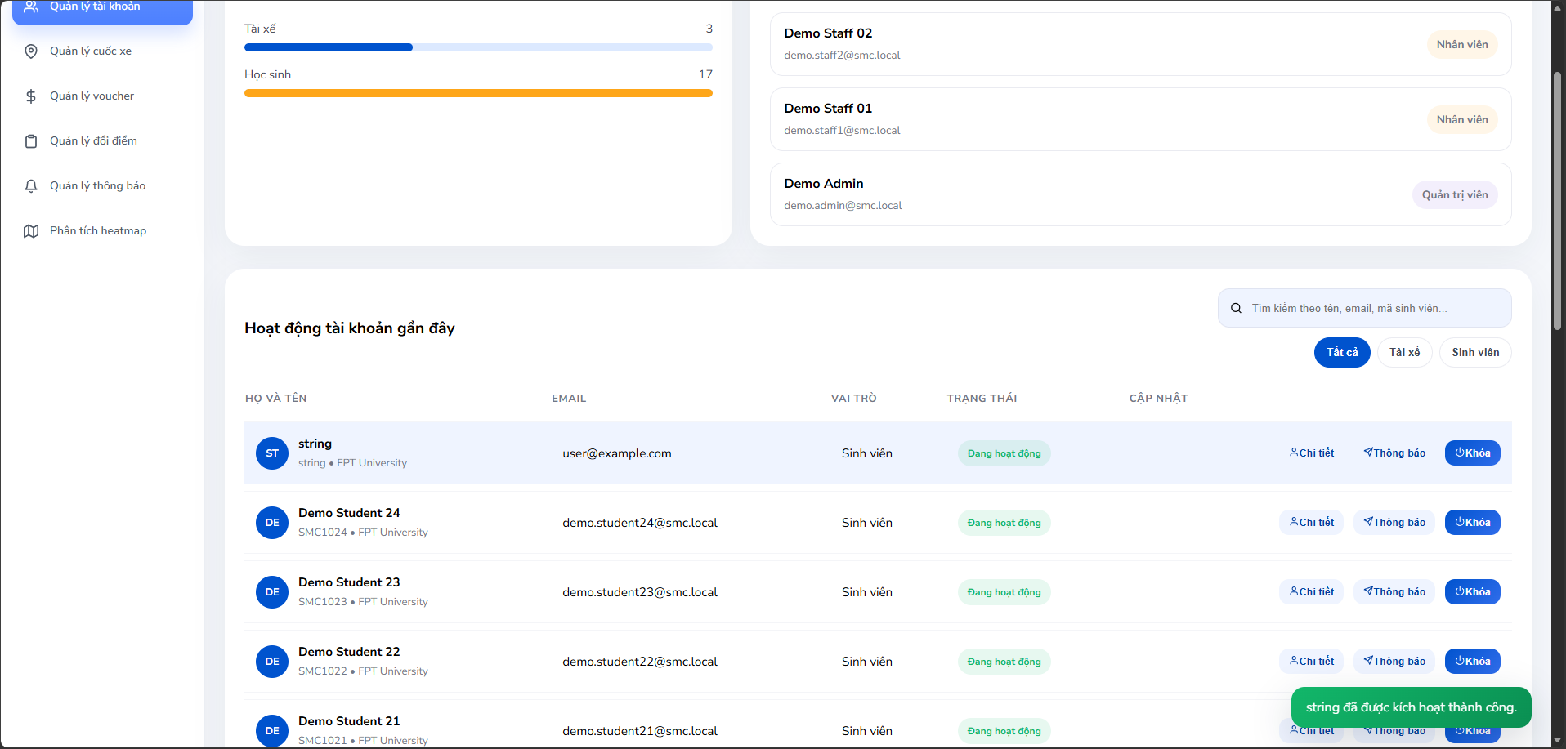

Figure 72: Account management screen after unban
- Function Details:
  - Data: User ID, New status (Locked/Active), Optional reason.
  - Validation: Must confirm action in a confirmation dialog.
  - Business Rules: BR-30, BR-40, BR-41, BR-44
  - Normal & Abnormal Cases:
    - Normal: Admin clicks Lock/Unlock -> confirmation modal -> confirms -> system updates account status -> user notified.
    - Abnormal: Action fails -> show error and retry.

3.9.4 Student Notification
- Function trigger: Admin/Staff clicks 'Notify' button on a specific user account.
- Function description: This function allows Admin/Staff to send a custom direct notification (warning/penalty) to a specific user.
- Screen layout:
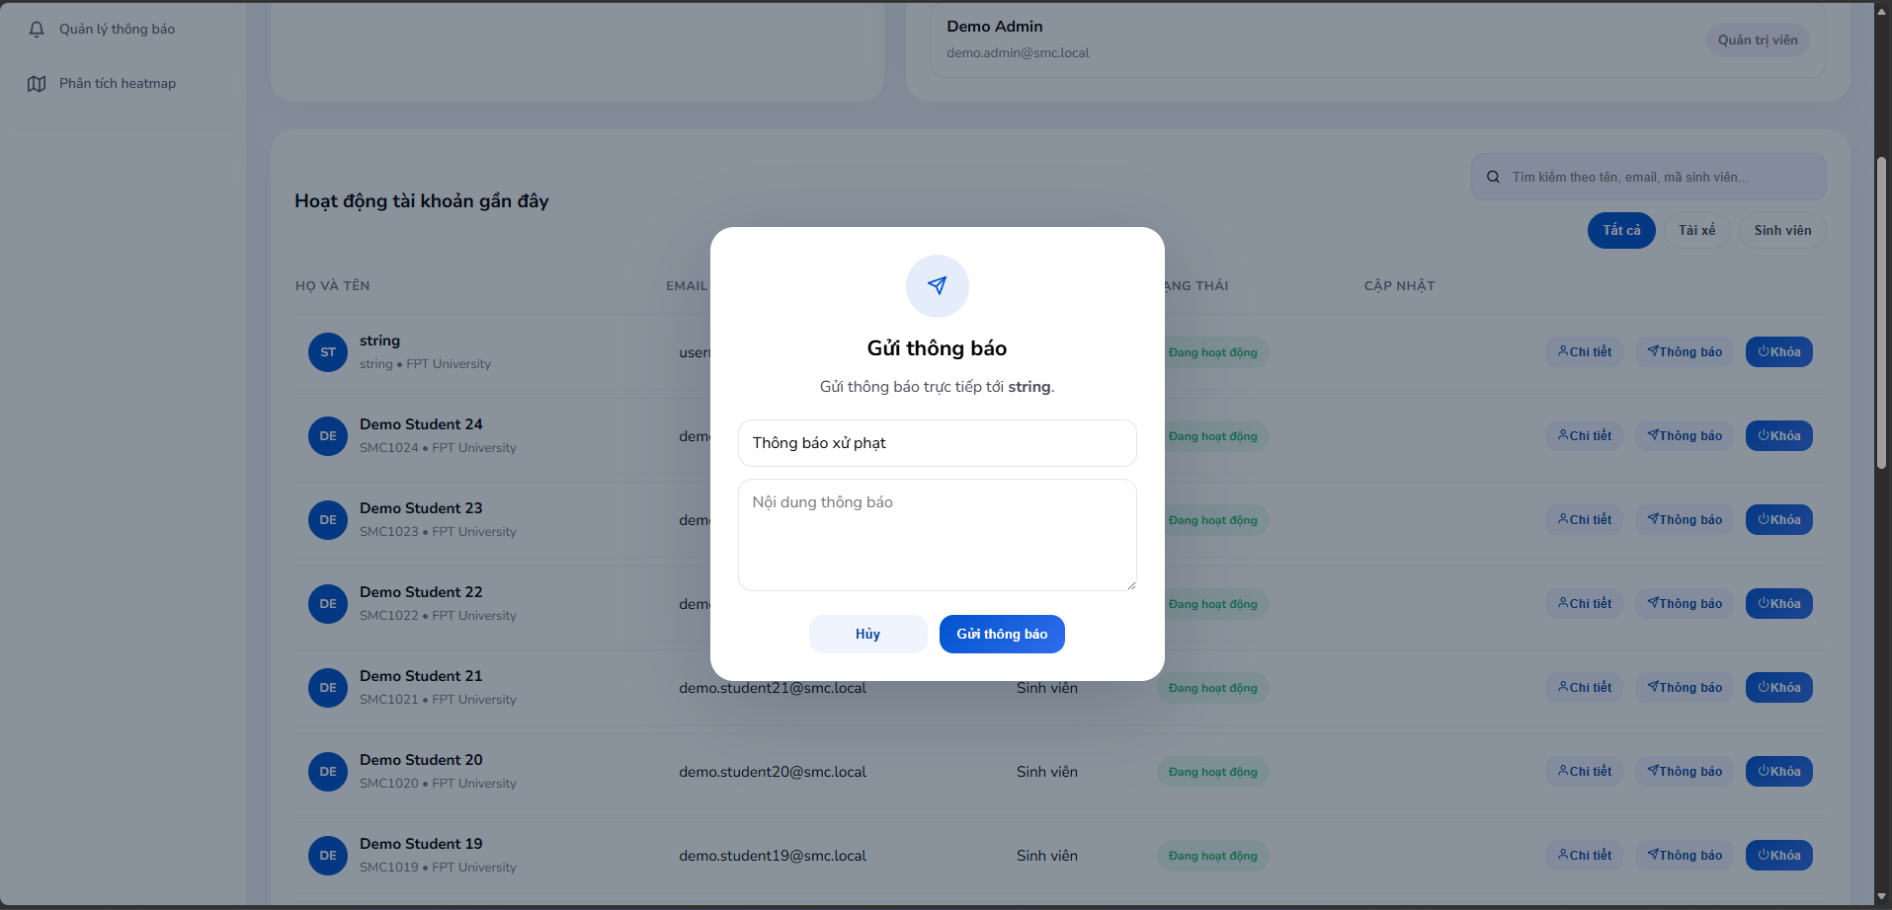

Figure 73: Student notification screen
- Function Details:
  - Data: User ID, Notification title, Message content.
  - Validation: Message content must not be empty.
  - Business Rules: BR-40, BR-41, BR-44
  - Normal & Abnormal Cases:
    - Normal: Admin clicks Notify -> fills message form -> clicks Send -> notification dispatched to user.
    - Abnormal: Send failed -> show error. User push token unavailable -> log as undelivered.

3.9.5 Broadcast Notification
- Function trigger: Admin/Staff navigates to Notifications -> clicks 'Create Broadcast'.
- Function description: This function allows Admin to create and send a broadcast notification to all users in the system simultaneously.
- Screen layout:
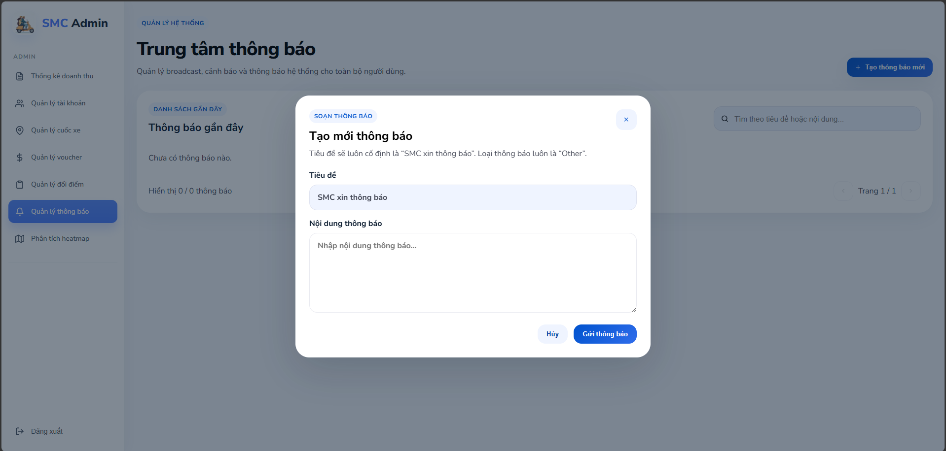

Figure 74: Broadcast notification screen
- Function Details:
  - Data: Notification title, Message content, Target group (All/Students/Drivers).
  - Validation: Title and message content must not be empty.
  - Business Rules: BR-41, BR-44
  - Normal & Abnormal Cases:
    - Normal: Admin drafts broadcast -> clicks Send -> system dispatches notification to all users.
    - Abnormal: Dispatch failure -> partial send log. Service unavailable -> queue for retry.

3.9.6 Point Policy Management
- Function trigger: Admin navigates to Admin Dashboard -> Point Policy.
- Function description: This function allows Admin to view, create, edit, and delete point-to-cash conversion rate configurations.
- Screen layout:
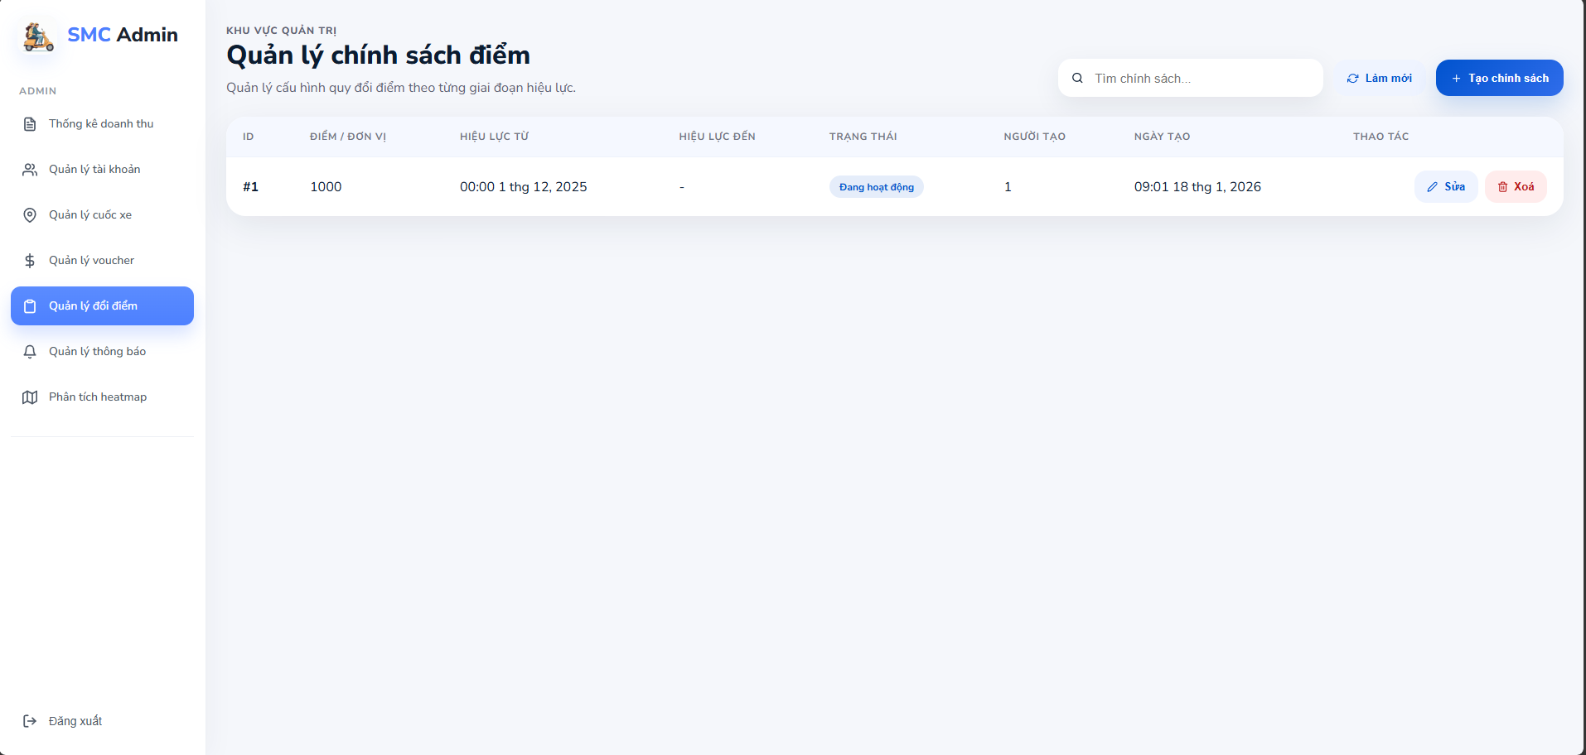

Figure 75: Point policy management screen
- Function Details:
  - Data: Policy ID, Points amount, Cash value, Validity date range, Status.
  - Validation: Points and cash values must be positive. Expiry date must be after start date.
  - Business Rules: BR-39, BR-41, BR-44
  - Normal & Abnormal Cases:
    - Normal: Admin opens Point Policy -> views list -> creates/edits policy -> saves -> system applies new rates.
    - Abnormal: Duplicate active policy -> block creation. Delete active policy -> require confirmation.

3.9.7 Heatmap View
- Function trigger: Admin navigates to Admin Dashboard -> Heatmap.
- Function description: This function visualizes operation hotspots and popular pickup/dropoff routes on an interactive Leaflet map with marker details.
- Screen layout:
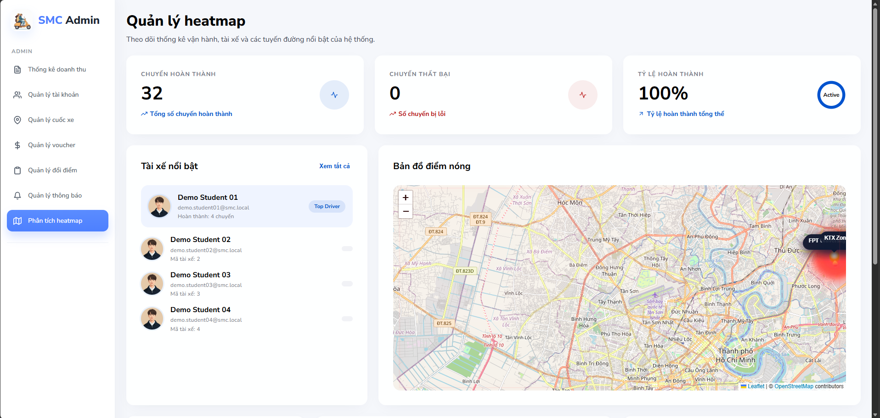

Figure 76: Heatmap screen
- Function Details:
  - Data: Location name, Type (Pickup/Dropoff), Coordinates, Booking frequency.
  - Validation: Map data must be loaded from the analytics service.
  - Business Rules: BR-43, BR-44
  - Normal & Abnormal Cases:
    - Normal: Admin opens Heatmap -> map loads with hotspot markers -> admin hovers/clicks marker -> popup shows details.
    - Abnormal: Map service unavailable -> show error. No data -> show empty map.

3.9.8 Approve / Reject Driver
- Function trigger: Staff navigates to Driver Verification -> Driver Accounts -> Approve/Reject.
- Function description: This function allows Staff to approve or reject driver applications by reviewing submitted documents (license, ID, vehicle registration).
- Screen layout:
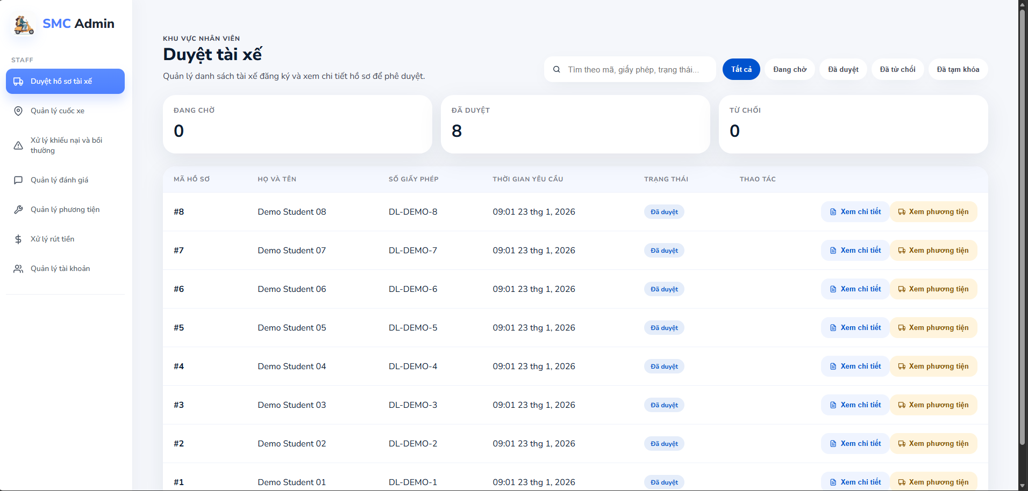

Figure 77: Driver registration List screen
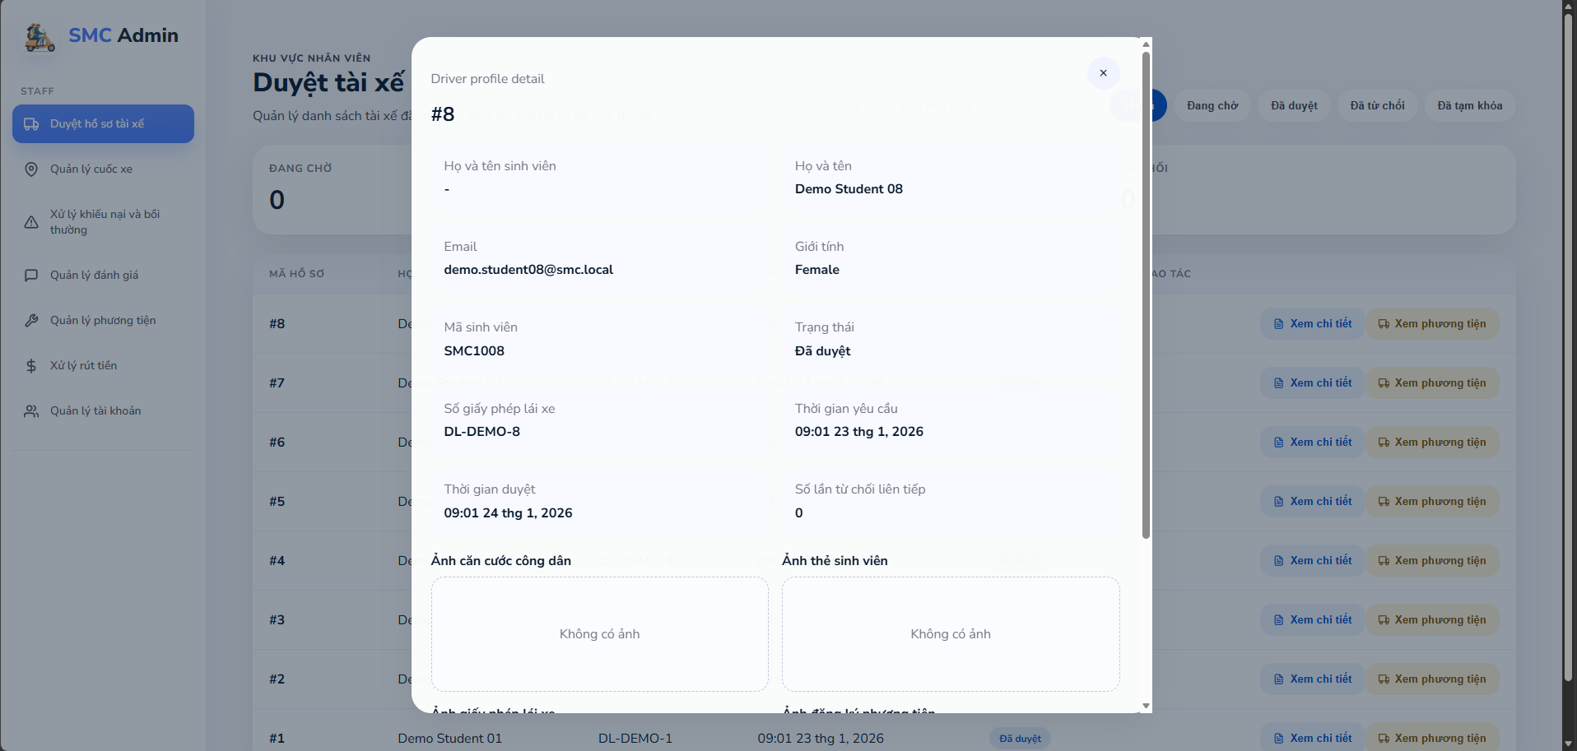

Figure 78: Driver registration detail screen 1
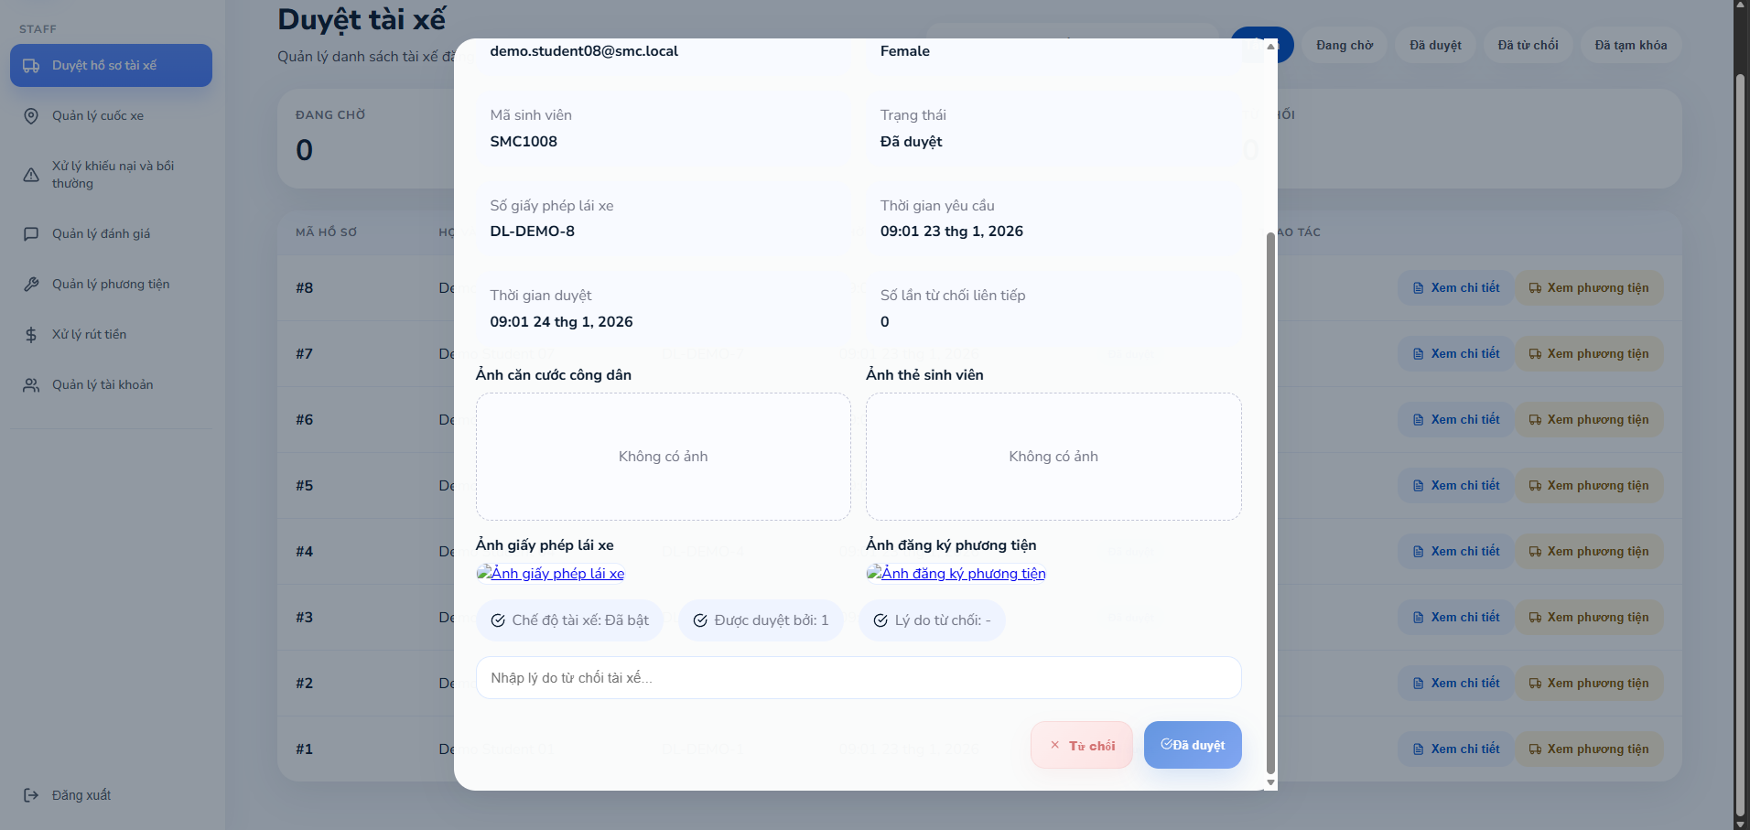

Figure 79: Driver registration detail screen 2
- Function Details:
  - Data: Driver information summary, Documents (license, ID, vehicle registration), Approval/rejection action, Rejection reason.
  - Validation: Must review all documents before approval. Rejection must include a reason.
  - Business Rules: BR-03, BR-04, BR-05, BR-40, BR-44
  - Normal & Abnormal Cases:
    - Normal: Staff reviews application -> clicks Approve or Reject -> system updates status -> notification sent to applicant.
    - Abnormal: Missing document -> cannot approve. Duplicate driver license -> auto-reject.

3.10 Complaint & Incident Management

3.10.1 Complaints List
- Function trigger: Staff navigates to Complaint Management -> Complaints List.
- Function description: This function displays all user complaints in the system with filter by status, type, and date, allowing Staff to manage and process them.
- Screen layout:
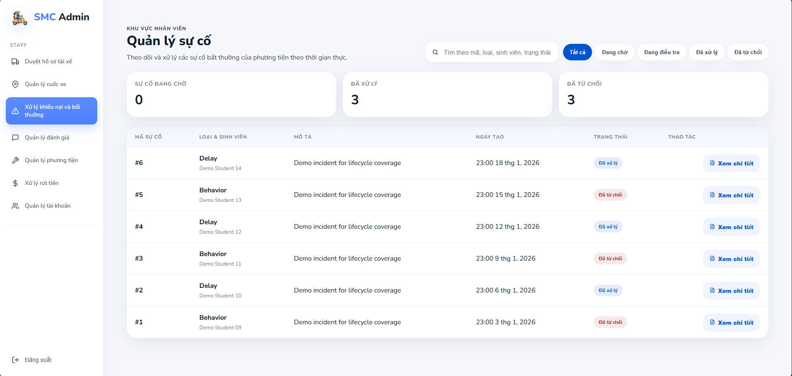

Figure 80: Incident management screen
- Function Details:
  - Data: Complaint ID, Reporter name, Related trip ID, Complaint type, Status (Pending/Processing/Resolved), Submitted date.
  - Validation: Only Staff/Admin can access.
  - Business Rules: BR-25, BR-40, BR-44
  - Normal & Abnormal Cases:
    - Normal: Staff opens complaint list -> reviews items -> filters by status/type -> selects complaint to process.
    - Abnormal: No complaints -> show empty state. Load error -> show retry.

3.10.2 Complaint Details
- Function trigger: Staff clicks 'View Details' on a complaint in the Complaints List.
- Function description: This function displays full complaint information including reporter details, trip info, complaint description, uploaded media evidence, and action history.
- Screen layout:
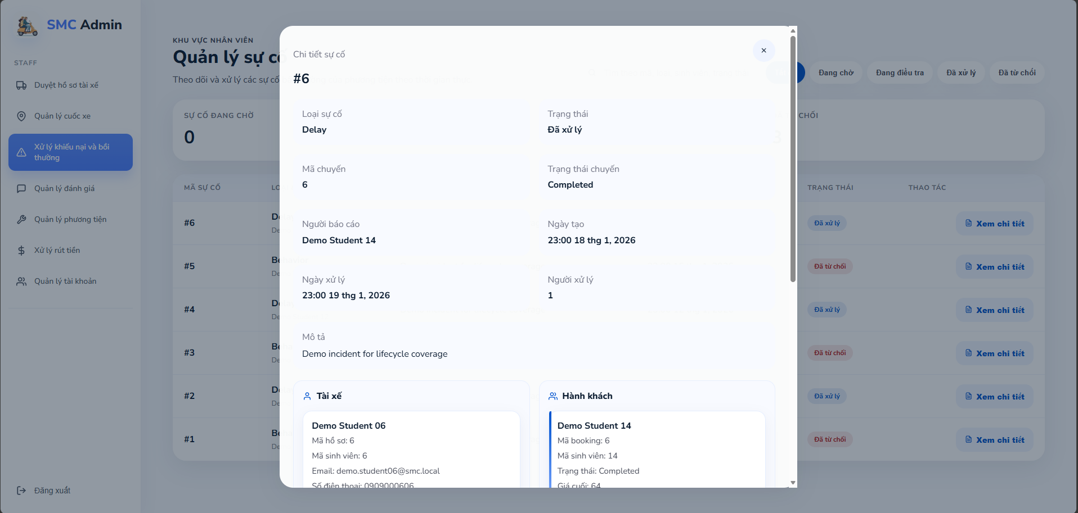

Figure 81: Incident detail screen 1
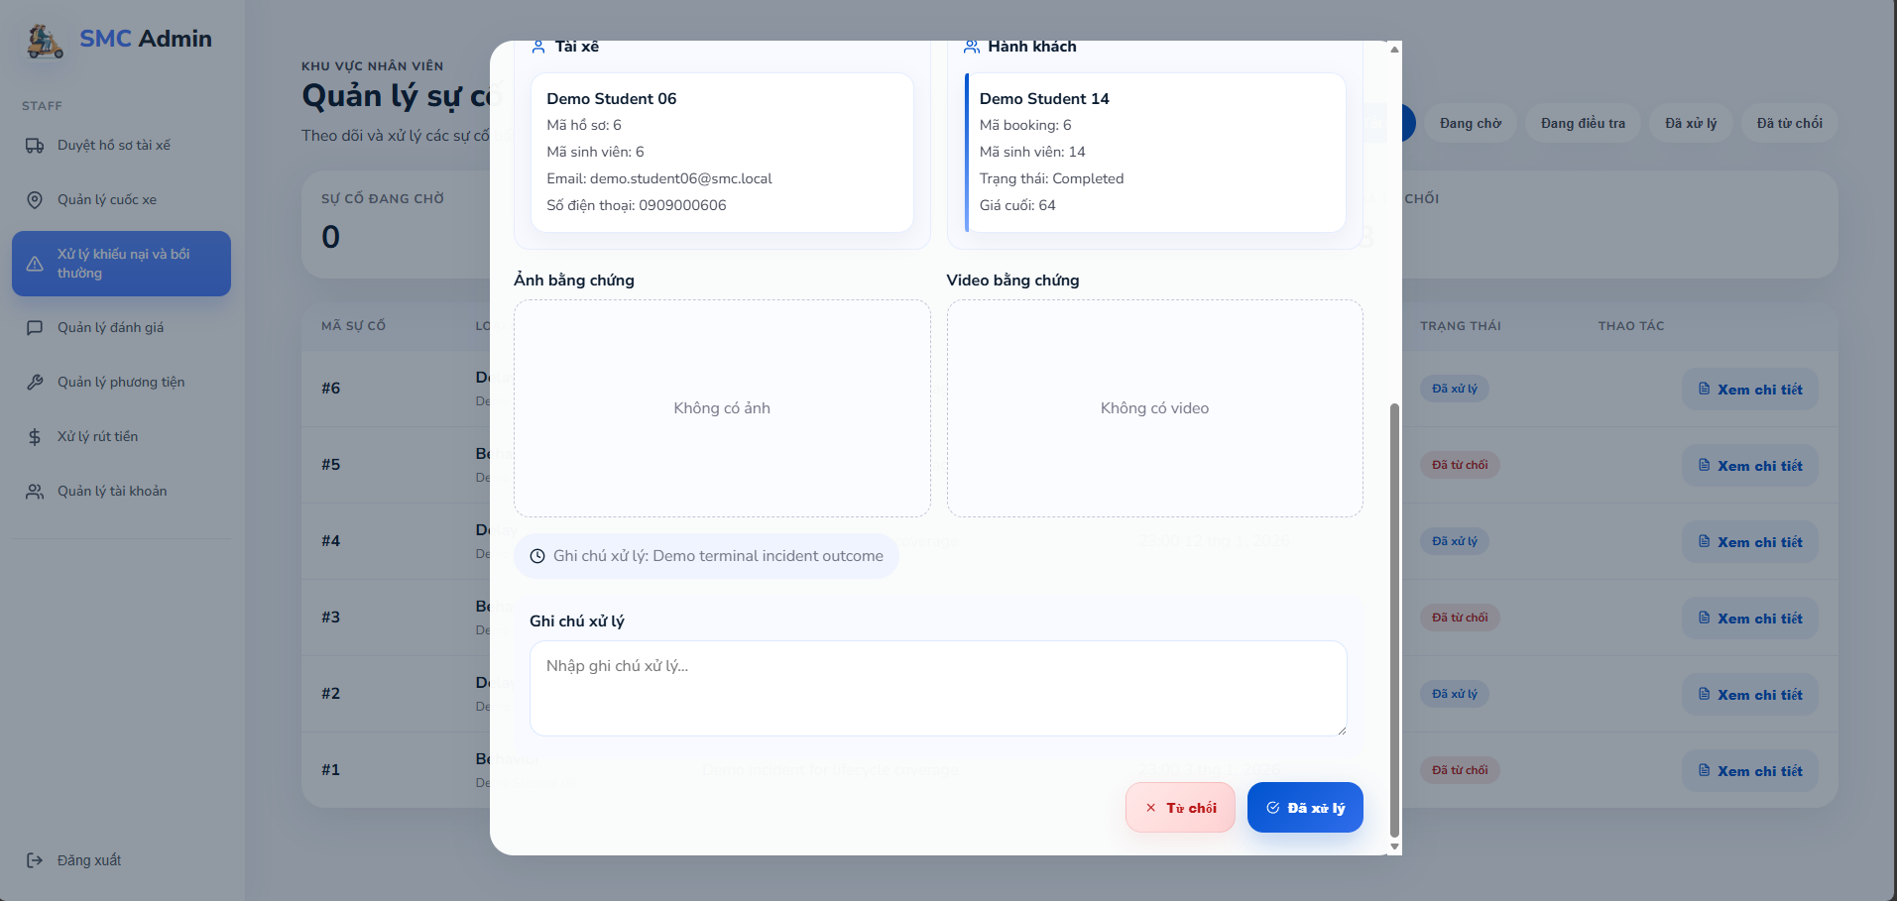

Figure 82: Incident detail screen 2
- Function Details:
  - Data: Reporter information, Trip details, Complaint description, Uploaded media (images/videos), Timeline of events, Action history.
  - Validation: Staff cannot edit complaint content.
  - Business Rules: BR-25, BR-40, BR-44
  - Normal & Abnormal Cases:
    - Normal: Staff opens complaint -> reviews all sections -> prepares resolution action.
    - Abnormal: Media load failure -> show placeholder. Trip data missing -> flag as incomplete.

3.10.3 Resolve Complaint
- Function trigger: Staff clicks 'Resolve' on the complaint detail screen.
- Function description: This function allows Staff to resolve a complaint by selecting a resolution type (Refund, Voucher, Warning, Suspension) and applying it.
- Screen layout:
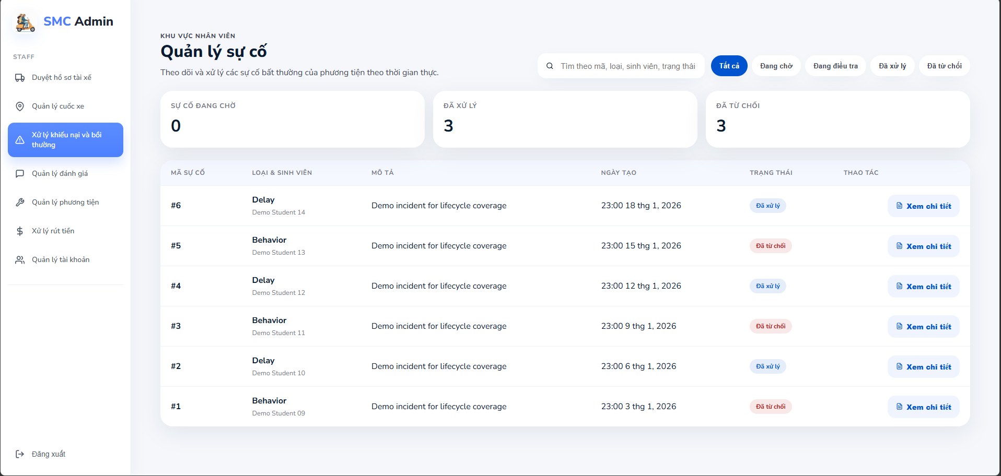

Figure 83: Incident management screen


Figure 84: Incident detail screen with 2 button
- Function Details:
  - Data: Resolution type (Refund/Voucher compensation/Warning/Account suspension), Notes.
  - Validation: Resolution type must be selected before confirming.
  - Business Rules: BR-20, BR-25, BR-36, BR-37, BR-40, BR-44
  - Normal & Abnormal Cases:
    - Normal: Staff selects resolution type -> adds notes -> confirms -> system updates complaint status to Resolved.
    - Abnormal: Invalid resolution -> block action. Wallet service error -> show error.

3.11 Withdrawal Processing

3.11.1 Withdraw Requests List
- Function trigger: Staff navigates to Withdraw Requests.
- Function description: This function allows Staff to view and manage all withdrawal requests submitted by users (Student/Driver) with filter by status, role, and date.
- Screen layout:
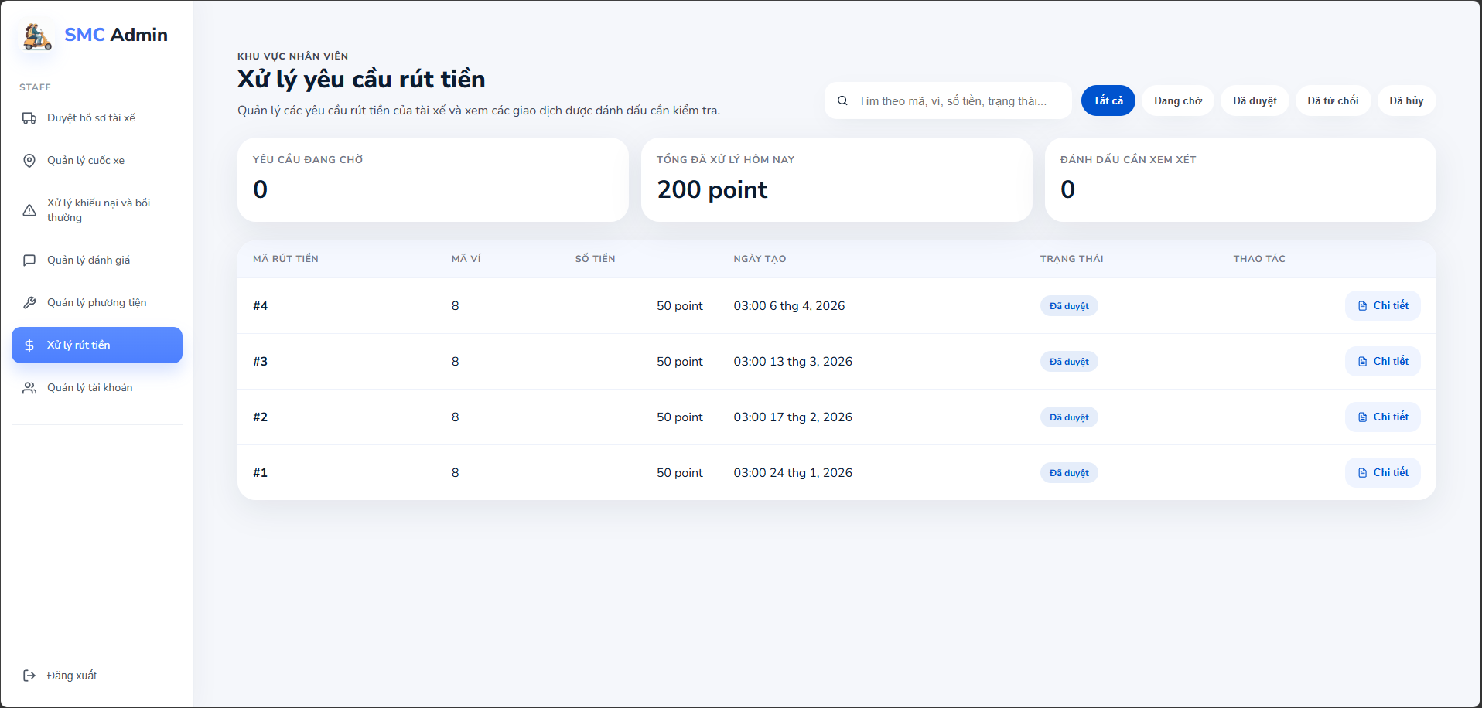

Figure 85: Withdraw request list screen
- Function Details:
  - Data: Request ID, User ID, User Name, Role (Student/Driver), Withdrawal Amount, Bank/Payment Method, Request Date, Status (Pending/Approved/Rejected/Processing).
  - Validation: Only Staff/Admin can access. Withdrawal request must be in Pending status to process.
  - Business Rules: BR-34, BR-35, BR-39, BR-40, BR-44
  - Normal & Abnormal Cases:
    - Normal: Staff opens Withdraw Requests -> reviews pending requests -> selects a request to process.
    - Abnormal: Insufficient balance -> auto-reject. Duplicate request -> block. System error -> retry.

3.11.2 Approve / Reject Withdraw
- Function trigger: Staff clicks 'Approve' or 'Reject' on a withdrawal request.
- Function description: This function allows Staff to approve and process a withdrawal to the user's external account, or reject it with a reason.
- Screen layout:
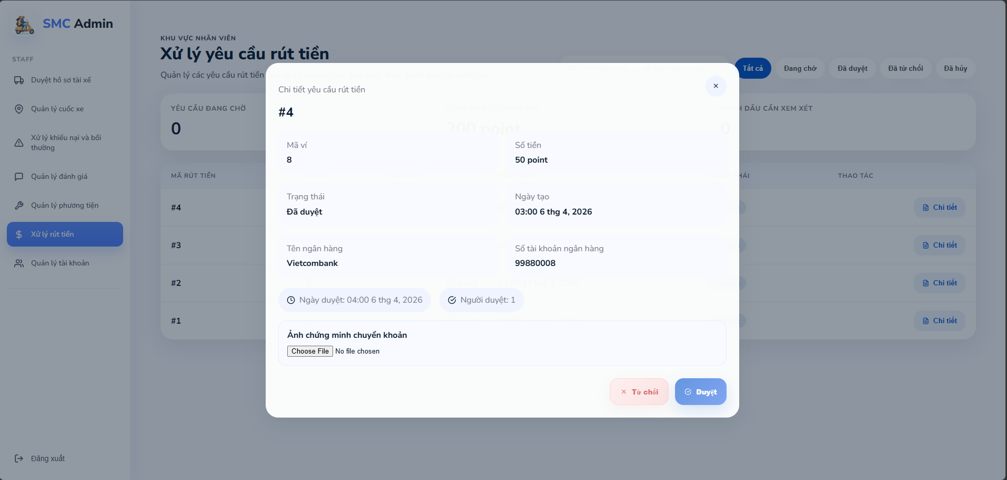

Figure 86: Withdraw request detail screen
- Function Details:
  - Data: User information, Withdrawal amount, Bank/payment details, Transfer proof image (for approval), Rejection reason (for rejection).
  - Validation: Wallet must have sufficient locked balance. Payment information must be valid. Transfer proof image required for approval.
  - Business Rules: BR-34, BR-35, BR-36, BR-39, BR-40, BR-44
  - Normal & Abnormal Cases:
    - Normal: Staff reviews request -> clicks Approve -> uploads transfer proof -> system calls payment service -> status updated to Completed -> user notified.
    - Abnormal: Payment failure -> status set to Failed -> retry or manual handling. Invalid bank info -> reject with reason. Network error -> queue for retry.

4. Non-Functional Requirements

4.1 External Interfaces
Third-party Organization API (University/Student Authority)
- Provide student data (lists, semester class schedules)
- Update student information via a secure API
- Support student verification/authentication for the SMC-Ride system
Map Service (Open Street Map API)
- Routing, distance calculation, ETA
- Real-time location and trip tracking
- Support matching, mobility corridor, and heatmap analytics
Payment Gateway / External Payment
- Support top-up/withdrawal outside the system (if integrated)
- Current scope: withdrawals are handled manually by Staff; the system records requests and processing status only
Notification Service (Push/In-app)
- Send notifications for: matching, trip confirmation/cancellation, withdrawals, vouchers, complaints, Trust Score violations
Realtime Services (Chat/Tracking)
- Student–Driver chat
- Real-time location synchronization while the app is running

4.2 Quality Attributes
Map Service (Open Street Maps API)
- Routing, distance calculation, ETA
- Real-time location and trip tracking
- Support matching, mobility corridor, and heatmap analytics
Payment Gateway / External Payment
- Support top-up/withdrawal outside the system (if integrated)
- Current scope: withdrawals are handled manually by Staff; the system records requests and processing status only
Notification Service (Push/In-app)
- Send notifications for: matching, trip confirmation/cancellation, withdrawals, vouchers, complaints, Trust Score violations
e Services (Chat/Tracking)
- Student–Driver chat
- Real-time location synchronization while the app is running

4.2.1 Usability
The system provides clear user flows for:
- Booking rides (flexible) and creating fixed rides based on weekly schedules (1–4 weeks)
- Real-time driver location and trip tracking
- Student–Driver chat
- Wallet, vouchers, and withdrawal requests
- Post-trip rating and complaint submission with images/videos
Trip status must be displayed clearly and consistently:
- Matching → Confirmed → Ongoing → Completed / Cancelled / Expired
Error messages must include actionable guidance, for example:
- No suitable Driver found → suggest changing time/pickup point/ride type
Key functions (Ride, Schedule, Wallet, Voucher, Complaint) must be quickly accessible from the main screen.

4.2.2 Reliability
Availability
- The system must maintain stable service for core functions: booking/accepting rides, tracking, chat, wallet, vouchers, complaints.
Mean Time Between Failures (MTBF)
- The system must record and monitor failure frequency weekly/monthly to improve stability.
Mean Time To Repair (MTTR)
- When incidents occur, the system must support fast recovery to avoid disrupting critical flows (booking/matching/tracking/wallet).
Accuracy
- Location and route data must be accurate enough for matching, tracking, and heatmap use cases.
- Financial data (wallet/withdrawal/voucher) must be correct and consistent across transactions.
Maximum Bugs or Defect Rate
- The system must minimize defects impacting user experience and business operations; severe issues must be prioritized.
Bugs or Defect Rate (Critical definition)
- “Critical” defects include (at minimum):
- Incorrect wallet balance / incorrect withdrawal status
- A single ride request accepted by multiple Drivers at the same time (violates BR-12)
- Missing audit logs for critical actions (violates BR-44)
- Incorrect trip states causing loss of service or financial impact

4.2.3 Performance
- Response time (average, maximum)
  - Actions such as creating ride requests, publishing rides, confirming rides, and viewing wallet/vouchers must respond quickly and must not freeze the app.
- Throughput
  - The system must handle a high volume of booking/matching/accept operations during peak hours.
- Capacity
  - The system must support many concurrent online Students/Drivers while running real-time tracking and chat simultaneously.
- Resource utilization
  - Optimize real-time location update frequency to reduce battery and mobile data usage.
  - Backend must optimize storage/processing for tracking, audit logs, and complaint media uploads to prevent overload.

4.2.4 Security
- Authentication & Verification
  - The system must authenticate all users before allowing access to protected functions.
  - Student accounts must be verified using Citizen ID + Student Card or Student Email (FPT Mail) (per BR-01).
- Authorization (Role-based Access Control)
  - The system must enforce role separation: Student, Driver, Staff, Admin.
  - Only Staff/Admin can approve Driver accounts and manage complaints/withdrawals (BR-04, BR-40, BR-41).
  - Unapproved Drivers must not be allowed to publish or accept rides (BR-05).
- Data Protection
  - Personal and financial data must be encrypted and protected (BR-45).
  - Uploaded complaint evidence (images/videos) must be stored securely and accessible only to authorized roles (Student/Driver involved + Staff/Admin).
- Location Privacy
  - Real-time location sharing must be limited to ride-related parties (Student–Driver) and Staff/Admin for incident handling.
  - Location sharing must stop automatically when the user logs out or closes the app (BR-30).
- Audit Logging
All critical actions must be logged for traceability and investigation (BR-44), including: login, ride creation/confirmation/cancellation, wallet updates, withdrawal handling, voucher issuance, complaint processing, and role/account changes

4.2.5 Maintainability
- Modular Design
  - The system should be structured into maintainable modules (e.g., Auth, Profile, Schedule, Ride, Matching, Chat, Tracking, Wallet, Voucher, Complaint, Admin/Staff).
- Configuration & Business Rules
  - Configurable parameters (e.g., minimum time gap between rides, response timeout 90 seconds, commission 12%, pricing formula) should be maintained via configuration rather than hard-coded to reduce change risk.
- Monitoring & Supportability
  - The system should provide operational visibility (logs, basic metrics) to support Staff/Admin workflows: complaints, incidents, withdrawals, and ride performance statistics.
- Backward Compatibility
  - API changes should be versioned to avoid breaking existing mobile app releases.
- Documentation
  - The system should maintain updated documentation for APIs, core business rules (BR-01 to BR-48), and operational procedures for Staff/Admin.

5. Requirement Appendix

5.1 Business Rules
ID | Business Rules
BR-01 | Each Student account must be registered and verified using a National ID (CCCD) along with a student card or a university email (FPT Mail)
BR-02 | A Student may register as a Driver using the same account without creating a new account.
BR-03 | A Student registering as a Driver must provide a valid driver’s license and vehicle registration documents..
BR-04 | A Driver account can only be activated after approval by Staff.
BR-05 | An unapproved Driver is not allowed to post trips or accept ride requests.
BR-06 | Weekly schedules (1–4 weeks) are used for fixed/corridor streams; flexible streams can be created directly without a corridor.
BR-07 | Fixed trips can only be created within a timeframe that matches the declared class schedule.
BR-08 | Flexible trips are allowed outside the class schedule but must not overlap with confirmed recurring trips.
BR-09 | The system does not allow a user to have two trips or riderequests too close to each other beyond the configured limit (minimum 10 minutes between trips).
BR-10 | Each ride request can only be accepted by one Driver at a time.
BR-11 | Drivers have the right to decline a ride without providing a reason.
BR-12 | If a ride request is declined, it will automatically be forwarded to another suitable Driver, if available.
BR-13 | Drivers must respond to a suggested ride request within 600 seconds.
BR-14 | Students must respond to a suggested trip within 600 seconds.
BR-15 | When the driver accepts the suggested ride request, the driver's wallet must have sufficient funds to cover 10% of the FinalPricePoint (along with the cancellation penalty rate after the passenger has checked in).
BR-16 | The suggested ride will automatically expire if the Driver does not respond on time
BR-17 | Driver selection is performed automatically by the system based on a matching algorithm. Students cannot manually choose Drivers.
BR-18 | The student's location must be within a 300m radius of the driver's travel route to be eligible for AI matching.
BR-19 | If a driver cancels a booked trip before it has departed, their credit score will not be reduced.
BR-20 | Students affected by driver cancellations will be compensated: refund of charged booking points + a 10% voucher (Usage 1, valid for 30 days).
BR-21 | If a Student does not show up at the pickup location on time, they will be marked as Absent.
BR-22 | An Absent Student will have their Trust Score reduced by 5 and be charged a cancellation fee which is 100% of the trip fee
BR-23 | If a Driver does not arrive at the pickup location on time, students can file a complaint. Staff will review the complaint and penalize the driver.
BR-24 | If a Driver fails to arrive on time, the system automatically cancels the trip and the Student will receive refund points and a compensation voucher.
BR-25 | In case of an accident or serious incident, the system must record the incident and forward it to Staff/Admin for resolution according to procedures.
BR-26 | The system requires both Students and Drivers to share their real-time location immediately upon opening the application.
BR-27 | Real-time location sharing must be maintained throughout the entire time the application is active.
BR-28 | Location data is used for matching, mobility corridor generation, heatmap analysis, and user safety.
BR-29 | Real-time location sharing automatically stops when the user logs out or closes the application.
BR-30 | Drivers and Students with a Trust Score below 80% will be permanently banned (with a 2-day prior notice to withdraw funds).
BR-31 | Users with a Trust Score below 90% will have reduced priority in the matching process.
BR-32 | Each user is allowed to own only one e-wallet within the system.
BR-33 | The e-wallet allows users to view balance, top up funds, and submit withdrawal requests.
BR-34 | Withdrawals are processed manually by Staff outside the system and do not integrate with third-party payment gateways.
BR-35 | The system only records withdrawal requests and their processing status.
BR-36 | If a withdrawal request fails, the amount must be refunded to the user’s wallet and the user must be notified.
BR-37 | Vouchers can be issued by Admin or automatically granted in compensation cases.
BR-38 | Each trip can apply for a maximum of one voucher.
BR-39 | Point conversion: 1 point = 1,000 VND
BR-40 | Staff has the authority to handle complaints, process withdrawals, approve drivers, manage user accounts.
BR-41 | Admin has the authority to manage the system, vouchers, notifications, reports, and user accounts.
BR-42 | Admin can view revenue, trip completion rate.
BR-43 | The system must provide heatmap data of ride demand hotspots for analytical purposes.
BR-44 | All critical system actions must be logged for auditing and traceability.
BR-45 | Personal data and financial data must be encrypted and secured according to safety standards.
BR-46 | The system takes a 12% commission on each trip.
BR-47 | Fare calculation formula:  Trip Price = Base Fare (3,000 VND) + (Distance × Price per km (3,000 VND/km))
BR-48 | The system must not support ride matching, filtering, or exclusion based on sensitive personal attributes such as gender, appearance, body shape, ethnicity, religion, or other discriminatory factors. Matching decisions shall be based only on operational and service-related criteria.
BR-49 | Users who receive a permanent ban notification must withdraw remaining wallet funds within the specified notice period. After the ban becomes effective, the user will no longer be able to log in or submit withdrawal requests through the system and must contact support for further assistance.
BR-50 | Drivers are not allowed to reject more than three consecutive ride requests within a configured time window. Repeated rejections may reduce matching priority or trigger temporary restrictions.
BR-51 | Vehicles must be verified and approved before being used for ride operations within the system.
BR-52 | Only drivers with active status, approved profiles, approved vehicles, and online availability are eligible to receive ride matching requests.
BR-53 | Incident and complaint reports should include supporting evidence such as images, videos, or descriptions whenever available to assist Staff in the resolution process.
BR-54 | A user must not participate in multiple active bookings or trips that overlap in time.
BR-55 | Wallet funds associated with a pending withdrawal request must be temporarily unavailable for other transactions until the withdrawal request is approved or rejected.
BR-56 | Critical ride, payment, incident, and account notifications must be stored in the system to ensure users can review missed notifications.
BR-57 | Drivers participating in fixed trips should follow the registered mobility corridor and planned checkpoints unless an incident or approved route change occurs.
BR-58 | Student identity and enrollment information must be validated against authorized university data sources before account activation.
BR-59 | The system must prevent duplicate ride requests with substantially identical pickup, destination, and departure time created by the same user.
BR-60 | Real-time location information shall only be accessible to authorized participants involved in the related trip or booking.
BR-61 | Bookings that are not confirmed within the configured response period shall automatically expire and release all reserved matching resources.

Table 10: Table of business rule

5.2 Common Requirements
CR-01 Input Validation: All required fields must be validated before submission (e.g., pickup, destination, time, schedule week range).
CR-02 Format Validation: Email/phone/ID formats must be validated where applicable.
CR-03 Business-rule Validation: The system must enforce business rules (e.g., schedule conflicts, minimum time gap between rides, driver approval required, 90s response timeout).
CR-04 Error Handling: The system must show clear user-friendly error messages and suggested next actions.
CR-05 Consistent Status & State: Trip, wallet, voucher, complaint, and driver approval statuses must be consistent across all screens and devices.
CR-06 Audit Logging: All critical actions must be logged for traceability (login, ride actions, wallet changes, voucher issuance, complaint handling, account/role changes).
CR-07 Notifications: The system must send push/in-app notifications for important events (match found, trip confirmed/cancelled, withdrawal status, complaint updates).
CR-08 Security & Access Control: Role-based access control must be applied (Student/Driver/Staff/Admin).
CR-09 Data Protection: Personal, location, and financial data must be protected (encryption in transit and at rest where applicable).
CR-10 Media Upload Constraints: Complaint uploads must enforce file type/size limits and handle upload failures gracefully.
CR-11 Location Permission Handling: If location permission is denied, the system must prompt the user and restrict location-dependent features.
CR-12 Network Resilience: The app must handle lost connectivity (retry, reconnect chat, offline hints).
CR-13 Timezone & Time Format: All displayed times must respect the user’s timezone; server time stored in a consistent standard (e.g., UTC).
CR-14 Configurability: Key parameters (minimum time gap, response timeout, commission rate, pricing rules) must be configurable without code changes.

5.3 Application Messages List
# | Message code | Message Type | Context | Content
1 | MSG01 | In line | No search / no data found | No search results.
2 | MSG02 | In red, under the text box | Required field is empty | The * field is required.
3 | MSG03 | Toast message | Invalid format | Invalid {field} format..
4 | MSG04 | Toast message | Update profile successfully | Profile updated successfully.
5 | MSG05 | Toast message | Save weekly schedule successfully | Schedule saved successfully
6 | MSG06 | In red, under the text box | Schedule week range invalid (1–4) | Week range must be between 1 and 4 weeks..
7 | MSG07 | In red, under the text box | Time conflict with existing fixed ride | This time conflicts with an existing fixed ride.
8 | MSG08 | In red, under the text box | Time gap between rides is too small | Please keep at least {min_gap} minutes between rides
9 | MSG09 | Toast message | Ride request submitted | Ride request submitted. Finding a driver…
10 | MSG010 | In line | No suitable driver found | No suitable driver found. Try changing time or pickup point.
11 | MSG011 | Toast message | Driver accepted the ride | Driver accepted your request. Ride confirmed
12 | MSG012 | Toast message | Driver rejected the request | Driver declined. Finding another driver…
13 | MSG013 | In line | Driver did not respond within timeout | No response from driver. Please try again
14 | MSG014 | Toast message | Trip started | Trip started. Have a safe ride!
15 | MSG015 | Toast message | Trip completed | Trip completed successfully. Please rate your driver.
16 | MSG016 | Toast message | Rating submitted | Thank you! Your rating has been submitted.
17 | MSG017 | Toast message | Complaint submitted | Complaint submitted. Our staff will review it.
18 | MSG018 | In line | Media upload failed | Upload failed. Please try again
19 | MSG019 | In line | Location permission denied | Location permission is required to use this feature.
20 | MSG020 | In line | GPS is off | GPS is turned off. Please enable location services
21 | MSG021 | Toast message | Wallet withdrawal request created | Withdrawal request submitted successfully
22 | MSG022 | Toast message | Withdrawal processed successfully | Withdrawal processed successfully
23 | MSG023 | Toast message | Withdrawal failed and refunded | Withdrawal failed. Amount has been refunded to your wallet.
24 | MSG024 | Toast message | Voucher applied | Voucher applied successfully
25 | MSG025 | In line | Voucher not applicable | This voucher cannot be applied to this trip.
26 | MSG026 | In line | Driver account pending approval | Driver mode is pending approval.
27 | MSG027 | In line | Driver not approved attempting to publish/accept | You must be approved to publish or accept rides.
28 | MSG028 | In line | Trust Score warning | Your Trust Score is low. Your priority may be reduced.
29 | MSG029 | In line | Driver feature banned (Trust Score < 80%) | Driver features are locked due to low Trust Score
30 | MSG030 | In line | Student banned (Trust Score < 80%) | Your account is restricted due to policy violations

Table 11: Application Messages List

