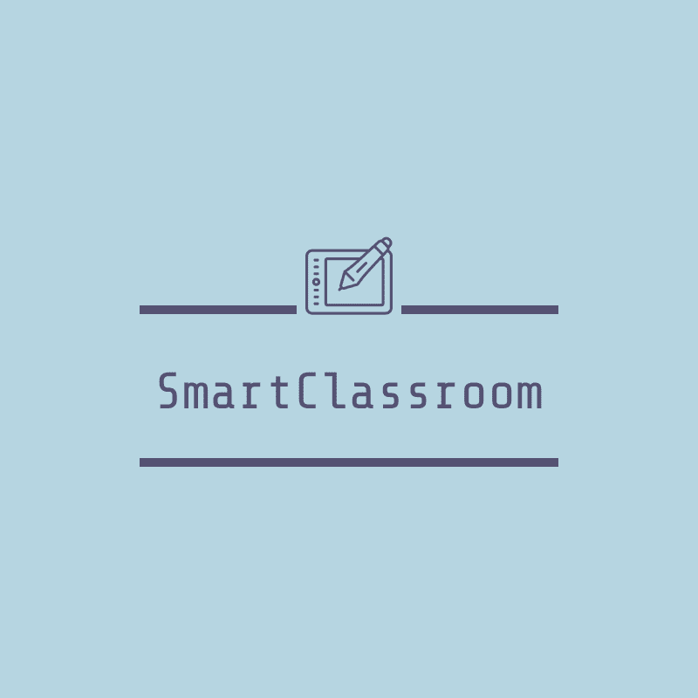

**Submitted By:**

**Group 15 - Ctrl+Alt+Elite**

Apurva N. Saraogi (160101013)   
Daman Tekchandani (160101024)

Samyak Jain (160101059)

Shreyanshi Bharadia (160101067)

**Table of Contents**

**Feature Description -** **3**

**Equipments -** **4**

**Installation -** **4**

**Running the tests -** **5**

**Explanation of Hard Coded and Calibrated Sensor values:** **6**

**Smart Classroom**

# **Feature Description -**

Smart Classroom aims at fostering the use of more interactive alternatives to traditional universities methodologies. In this project, we have incorporated Smart Glove, Proxy Detector, Smart Room and Live Portal.

* **Smart Glove** to allow professor to control all mouse actions remotely. Since, it is noticed that generally a professor is away from his PC and to change mouse pointer he need to go close to his system which is redundant. Thus, this Smart Glove which will enable him to control all mouse actions from anywhere.
* **Proxy Detector** which marks attendance of all the students present in the class and makes sure no proxy is marked. Every seat is recognised with the help of unique RFID numbers. When a student is ready to mark his attendance, first RFID Scanner scans the unique code of seat and then with the help of webcam captures the picture of student. In this manner, all students mark their attendance. To make sure no student leaves the class after marking his attendance, we monitor every seat, if someone is sitting there or not. If a person is not sitting on his respective seat for more than 5 mins, he is marked ABSENT. Later on, with the help of face_recognition API we detect who was sitting on which seat and store the attendance of that day.
* **Smart Room** to make the physical environment of class supporting. To assist professor, we have created two modes: Classroom mode and Projector Mode. Also, we have automated gate opening, light switching and blackboard cleaning.
* **Live Portal** which shows what seats are occupied and by whom. Also, it tells the attentiveness of the students if they are using laptops. For this we are using MQTT to take concentration data implemented by Group 16(Smart Cubicle) . You can also download attendance sheet of any day.

# 

# 

# Equipments -

|  |  |
| --- | --- |
| **Equipment** | **Quantity** |
| Ultrasonic sensors | 4 |
| Servo motors | 3 |
| Accelerometer(GY61) | 1 |
| Flex sensors | 2 |
| Webcam | 1 |
| PIR sensor | 1 |
| RFID scanner(RC522) | 1 |
| Bluetooth Module(HC-05) | 1 |
| Push buttons, Switches, LEDs | - |
| Arduino Board(ATmega2560) | 2 |
| Raspberry Pi | 1 |

# **Installation** **-**

**Installation on your system -**

pip install pyautogui

pip install django

sudo apt-get install mosquito

sudo apt-get install mosquitto-client

**Installation on Raspberry Pi -**

pip install face_recognition

# Running the tests -

**Mouse Module -**

1. Run mouse.ino on arduino ide.
2. Connect the accelerometer and flex sensors to the pins specified in the code.
3. 1st two fingers of the glove are attached to the flex sensor and accelerometer to the middle of the glove.
4. Now run python script mouse.py
5. Tilt the hand in direction in which you want to move mouse pointer.
6. Bend first finger for left mouse click and second finger for right mouse click.

**Proxy Detection Module -**

1. Connect Rfid scanner and webcam to raspberry pi according to the pins specified in proxy_detection.py
2. Run proxy_detection.py.
3. Place Rfid scanner above the rfid chip and point webcam to your face.
4. Press capture button to register your attendance.
5. After all attendances are taken , connect pi to pc through ethernet and press processing button for registering attendances. Attendance is stored as date.txt.
6. After class is over, press over button to reset all the data.

**Smart Room -**

1. Connect Servo Motors, LEDs, PIR sensor, and ultrasonic sensor to arduino as specified in the code.
2. Upload classroom.ino on arduino (ATmega2560)
3. Gate opens automatically whenever a person tries to enter the room. Ultrasonic sensors will help us to detect if a person is standing in front of gate and then with the help of servo motor gate opens.
4. Whenever a person enters inside classroom all the lights classroom will become on. We are detecting presence of a person with the help of PIR sensor.
5. Professor will be provided with a button to toggle between Projector Mode and Blackboard Mode.
6. In Blackboard Mode Windows will be open and all the lights will be on to their full brightness. In Projector Mode Lights near the Projector Screen will get dim and window will get closed.
7. On Just pressing a switch BlackBoard will be cleaned automatically. We are doing this with the help of a servo motor.

**Live Portal -**

1. To run go to folder name plab inside Live Portal directory and type in terminal

python3 manage.py runserver

Visit localhost:8000 in your browser to view live class map.

1. Displays which seats are occupied in class right now by reading the data of Serial Monitor of Arduino.
2. After Attendance Processing is complete, displays the name of students which occupy the respective seats.
3. Using MQTT, data of concentration is taken live from Smart Cubicle group and displayed on the Portal.
4. Attendance of previous days can be downloaded from the portal.

# Explanation of Hard Coded and Calibrated Sensor values:

1. In **mouse.ino,** for deciding whether the person wants to tilt his hand in particular direction we used values of accelerometer in each direction which were most suitable for movement.
2. In **mouse.ino** to decide whether a person wants to use left or right click we repeatedly performed experiments to decide the most suitable threshold value for deciding whether a person actually wants to click or not.
3. In **classroom.ino,** for opening of gates, the threshold value chosen is 16. If there is no obstacle, value of Ultrasonic sensor is greater than 16. Whenever there is any obstacle on any side of the door, the value is lesser than 16.
4. In **classroom.ino**, threshold for detecting a person on chair is 45. If there is no person sitting, the value of Ping Sensor is greater than 45 and otherwise less than 45.
5. In **classroom.ino**, if the person is away from his seat for 1200 cycles, which is approximately 5 minutes, he will be marked absent.
6. In **classroom.ino,** the gate is opened for 2 more cycles after once opened; giving some more time for person to enter after he is detected.