**Project Progress Report on**



**A.I. Based Traffic Management System**



**Submitted in partial fulfilment of the requirement for the award of the degree of**

**BACHELOR OF TECHNOLOGY**

**IN**

**COMPUTER SCIENCE & ENGINEERING**

**Submitted by:**

**Aman kaushik** **2018662**

**Shubh Agrawal** **2019127**

**Komal Garg** **2018889**

***Under the Guidance of***

***Dr. PRABH DEEP SINGH***

***Associate Professor***

**Project Team ID: ID No. MP24CSE041**



**Department of Computer Science and Engineering**

**Graphic Era (Deemed to be University)**

**Dehradun, Uttarakhand**

**2024-25**



**CANDIDATE’S DECLARATION**

I/We hereby certify that the work which is being presented in the Synopsis entitled **“AI BASED TRAFFIC MANAGEMENT”** in partial fulfillment of the requirements for the award of the Degree of Bachelor of Technology in Computer Science and Engineering in the Department of Computer Science and Engineering of the Graphic Era (Deemed to be University), Dehradun shall be carried out by the undersigned under the supervision of **Dr. Prabh Deep Singh, Associate Professor**, Department of Computer Science and Engineering, Graphic Era (Deemed to be University), Dehradun.

Aman Kaushik 2018662

Komal Garg 2018889

Shubh Agrawal 2019127

The above mentioned students shall be working under the supervision of the undersigned on the **“AI Based Traffic Management”**

**Supervisor** **Head of the Department**

**Examination**

**Name of the Examiners: Signature with Date**

1.

2.

**Acknowledgement**

Any achievement, be in scholastic or otherwise does not depend solely on the individual effort but on the guidance, encouragement and co-operation of intellectuals, elders and friends. A number of personalities in their own capacity have helped me in carrying out this project work.

Our sincere thanks to project guide **, Dr. Prabh Deep Singh , Associate professor ,** Department of Computer Science and Engineering, Graphic Era (Deemed to be University), for his valuable guidance and support throughout the course of project work and for being a constant source of inspiration.

We extend our thanks to **Dr. Deepak Gaur**, Project coordinator, Department of Computer Science and Engineering, Graphic Era (Deemed to be University), for his valuable suggestions throughout all the phases of the Project Work.

We are extremely grateful to **Prof. (Dr.)  D. P. Singh**, HOD of the Computer Science and Engineering Department, Graphic Era (Deemed to be University), for his moral support and encouragement.

We thank the **management of Graphic Era (Deemed to be University)** for the support throughout the course of our Bachelor’s Degree and for all the facilities they have provided.

Last, but certainly not least we thank all teaching and non-teaching staff of Graphic Era (Deemed to be University) for guiding us in the right path. Most importantly we wish to thank our parents for their support and encouragement.

Aman Kaushik 2018662

Komal Garg 2018889

Shubh Agrawal 2019127

**Abstract**

The increasing growth of urban areas and the widespread use of personal vehicles have made traffic management a major concern in modern cities. Traditional systems that rely on fixed traffic signal schedules often fail to respond effectively to real-time traffic conditions, resulting in unnecessary congestion, delays, fuel waste, and elevated pollution levels. To address these challenges, this project presents an AI-driven Traffic Management System that incorporates real-time vehicle detection, dynamic signal control, and interactive visualization tools to improve urban traffic flow.

At the core of the system is a vehicle detection module powered by YOLOv7, a deep learning model that accurately identifies and counts different types of vehicles from live video feeds. Based on this input, a signal control algorithm dynamically modifies the timing of traffic lights, adapting to current traffic density and optimizing vehicle movement through intersections. To support monitoring and analysis, a visualization interface built with Pygame displays live traffic conditions, signal states, and vehicle statistics. The system also includes an emergency response feature that identifies ambulances and prioritizes their passage through traffic.

By reducing idle times and improving the responsiveness of traffic signals, the system aims to ease congestion, cut down fuel usage, lower emissions, and provide a smoother driving experience. Its modular structure ensures scalability and compatibility with existing infrastructure, making it a practical solution for modern smart cities. Overall, the project demonstrates how artificial intelligence can be effectively applied to solve real-world urban mobility problems**.**

**Keywords-**Traffic Simulation, Intelligent Traffic Control, Ambulance Priority System, YOLOv7, YOLOv9, Vehicle Detection, Real-time Object Detection, Pygame Simulation, Adaptive Signal Timing, Computer Vision, Deep Learning, Smart City, Emergency Vehicle Management, Custom Dataset, Signal Optimization, Python

# 

# Table of Contents

|  |  |
| --- | --- |
| **Contents** | **Page**  **No.** |
| Abstract | i |
| Acknowledgement | ii |
| Table of Contents | iii |
| List of Tables | iv |
| List of Figures | v |
| **Chapter 1 Introduction** | **1-3** |
| 1.1 Project Introduction | 1-2 |
| 1.2 Problem Statement | 2-3 |
| 1.3 Objectives | 3 |
| **Chapter 2 Literature Survey/ Background** | **4-6** |
| **Chapter 3 Software Design** | **7-11** |
| **Chapter 4 Requirements and Methodology** | **12-14** |
| 4.1 Hardware Requirements |  |
| 4.2 Software Requirements |  |
| 4.3 Methodology |  |
| **Chapter 5 Coding /Code Templates** | **15-19** |
| **Chapter 6 Testing** | **20-21** |
| **Chapter 7 Results and Discussion** | **22-26** |
| **Chapter 8 Conclusion and Future Work** | **27-29** |
| **Details of Research Publication** | **30** |
| **References** | **31-32** |

**List of Tables**

|  |  |  |
| --- | --- | --- |
| **TABLE No.** | **TITLE** | **PAGE No.** |
| 2.1 | Summary of Literature Review | 7 |
| 4.1 | Hardware Requirements | 15 |
| 4.2 | Software Requirements | 15 |

**List of Figures**

|  |  |  |
| --- | --- | --- |
| **FIGURE No.** | **TITLE** | **PAGE No.** |
| 3.1 | Data Flow Diagram | 10 |
| 3.2 | Class Diagram | 11 |
| 3.3 | Sequence Diagram | 12 |
| 3.4 | Collaboration Diagram | 13 |
| 3.5 | Use-Case Diagram | 14 |
| 3.6 | ER - Diagram | 15 |
| 5.1 | All coding files | 24 |
| 5.2 | Main functionality vehicle detection | 24 |
| 5.3 | Training of data for ambulance detection | 25 |
| 5.4 | Algorithm for dynamic signal change | 25 |
| 5.5 | Simulation module algorithm | 26 |
| 7.1.1 | Vehicle detection 1 | 33 |
| 7.1.2 | Vehicle detection 2 | 33 |
| 7.2.1 | Ambulance detection | 34 |
| 7.2.2 | Model accuracy plot | 34 |
| 7.3.1 | Signal switching algorithm |  |
| 7.4.1 | simulation |  |

**Chapter 1**

**Introduction**

* 1. **Project Introduction**

Weiqiang et al.[1] Urbanization and the rapid growth of vehicle ownership have led to a significant increase in traffic congestion across cities worldwide. With limited infrastructure and growing transportation demands, efficient traffic management has become a major challenge for urban planners. One of the most critical problems arising from traffic congestion is the delay it causes to emergency vehicles, particularly ambulances, which require immediate and uninterrupted passage through intersections to save lives. In conventional traffic systems, traffic signals operate on predetermined cycles, often oblivious to the real-time traffic volume or the presence of high-priority vehicles. As a result, ambulances can be stuck in long queues, significantly increasing response time and potentially compromising patient safety.

Sharma et al. [2] To address these challenges, intelligent traffic management systems are being explored as a viable solution. These systems use a combination of real-time data collection, computer vision, and artificial intelligence to adaptively control traffic flow based on dynamic road conditions. Among the technologies at the forefront of this innovation are deep learning-based object detection models, which enable automatic recognition and tracking of vehicles from images and video feeds. When integrated into a traffic control system, these models can provide insights into vehicle count, types, and the presence of emergency vehicles, allowing traffic signals to respond intelligently to changing scenarios.

Muthukkumarasamy et al. [3] This project introduces a simulation-based approach to smart traffic control that prioritizes ambulances and adapts signal timings dynamically based on traffic conditions. The core of the project is built using **Python** and the **Pygame** library, which together create a visually interactive simulation of a four-way traffic intersection. The simulation models various vehicle types including cars, buses, trucks, bikes, rickshaws, and ambulances — each with their own movement patterns and speeds. Vehicles are generated at regular intervals in random directions and assigned lanes within the simulation. The movement of vehicles obeys basic traffic rules, and their progression through the intersection is governed by the current state of traffic signals.

Redmon et al [4] One of the most critical features of this system is **ambulance prioritization**. When an ambulance is detected in any lane, the simulation logic immediately overrides the normal signal cycle to give green light priority to the corresponding direction. This ensures that ambulances are not delayed due to red signals and can pass through the intersection with minimal resistance. The prioritization logic is carefully implemented to check for ambulance presence before every signal change and to adjust the green signal duration as needed.

To enable vehicle detection, a separate module based on the **YOLO (You Only Look Once)** family of deep learning models has been developed. YOLO is a real-time object detection algorithm that is widely recognized for its accuracy and processing speed. This project specifically explores the use of **YOLOv7** and **YOLOv9**, both of which offer improved detection capabilities and performance over earlier versions. The detection module processes input images or video frames and identifies various types of vehicles using bounding boxes and confidence scores. The output from this detection system is used to count vehicles in each lane and determine if any ambulances are present.

Furthermore, the project demonstrates how YOLOv9 can be trained on a **custom dataset** using Roboflow and Google Colab. While pre-trained models can detect common vehicle classes such as cars and buses, they may not reliably detect ambulances unless explicitly trained on images containing them. To improve the system’s accuracy and robustness, the dataset is augmented with images of ambulances and annotated accordingly. Training is carried out on GPU-accelerated environments to reduce time and ensure model efficiency. Once trained, the custom model can be deployed in the simulation to perform real-time detection, making the system adaptable to a wide variety of urban conditions.

Another important aspect of the simulation is **dynamic signal timing**. Unlike conventional systems where signal durations are fixed, this project implements a mechanism to adjust the green light duration based on the number and type of vehicles detected in a lane. Heavier and slower vehicles such as buses and trucks are given higher weights when calculating the required green signal time. Similarly, the presence of multiple vehicles leads to an extension of the green phase, whereas lower traffic volume shortens it. This approach improves traffic throughput and reduces idle time for vehicles waiting at red signals. The signal timing logic also ensures that minimum and maximum duration constraints are maintained to avoid unfair delays in other lanes.

To manage real-time updates and concurrency within the simulation, the project employs **multithreading**. Separate threads are responsible for generating vehicles, updating signal timers, running the detection algorithm, and managing the simulation clock. This ensures that all components work in parallel without blocking one another, allowing for smooth visual updates and responsive logic execution. The use of threading also facilitates better performance and mimics real-world asynchronous sensor and control operations that are common in actual traffic control systems.

The entire simulation is visually rendered using **Pygame**, which allows users to observe the movement of vehicles, the change of signals, and the behavior of the system in response to different scenarios. Vehicle images are loaded from local directories and rendered at specified coordinates, while signal images (red, yellow, green) change dynamically based on the signal state. A timer is displayed on the screen to indicate elapsed simulation time, and vehicle counts are shown near each signal to track traffic throughput. This provides an interactive way to visualize the effectiveness of the system and observe how prioritization affects overall flow.

In addition to simulation-based testing, this system has the potential for real-world application. The modular design allows it to be integrated with traffic surveillance cameras and sensors installed at intersections. The object detection module can be extended to handle live video feeds, and the signal controller can be linked to actual traffic lights using microcontrollers or programmable logic controllers. Moreover, with advancements in edge computing and 5G networks, real-time traffic monitoring and control are becoming increasingly feasible, making this project a strong prototype for next-generation traffic systems.

In summary, this project successfully combines simulation, computer vision, and deep learning to create an intelligent traffic control system that adapts to dynamic conditions and prioritizes emergency vehicles. By simulating real-world traffic behavior and integrating a custom-trained YOLO model for vehicle detection, the system demonstrates significant improvements in both efficiency and responsiveness. It represents a practical and scalable approach to modernizing traffic management infrastructure in the era of smart cities.

**1.2 Problem Statement**

With increasing urbanization and the rapid growth of personal vehicles, traditional traffic management systems are no longer sufficient to handle the escalating traffic volumes. The current static systems rely on predefined timing schedules for traffic signals, which do not account for real-time traffic conditions. This results in traffic bottlenecks, longer waiting times, and inefficient use of road infrastructure.

The challenge lies in developing a system that dynamically adjusts traffic signals in real time, responding to the current volume of vehicles on the road. The absence of an intelligent and adaptive approach to traffic signal management contributes to congestion, excessive fuel consumption, and increased pollution, especially in urban areas. Therefore, there is a pressing need for an AI-based traffic management system that can automatically optimize traffic flow, reduce delays, and enhance road safety.

This project aims to address these challenges by leveraging computer vision, machine learning, and optimization techniques to create an adaptive traffic signal control system that responds to real-time data from traffic cameras and other sensors.

* 1. **Objectives**

The objectives of the proposed work are as follows:

* **To Detect Vehicles in traffic and their counts:**

The Vehicle Detection Module utilizes YOLOv7, a object detection model, to in real-time from images. It processes images, identifies vehicles, and provides data on the number and types of vehicles present.

* **To Develop a Signal Switching Algorithm:**

The Signal Switching Algorithm dynamically adjusts traffic signal timings based on inputs from the Vehicle Detection Module and other factors such as traffic flow, lane configurations. It aims to optimize traffic flow, minimize congestion, and reduce waiting times at intersections.

* **To Visualize Traffic Flow:**

The Visualization Module uses the Pygame library to provide a graphical user interface (GUI) for visualizing the traffic flow.

* **To Assign Priority for Ambulances:**

The system process images to detect ambulance promptly and ensure that they are given immediate priority in the traffic flow.

**Chapter 2**

**Literature Survey/ Background**

Urban mobility is one of the core pillars of smart city development. With ever-increasing  
vehicle counts and limited road infrastructure, traditional traffic management systems often fail to accommodate the dynamic nature of city traffic. Conventional systems operate on fixed-time intervals that do not adapt to real-time conditions. This inefficiency becomes particularly critical in situations involving emergency vehicles such as ambulances, where delays in signal clearance can have life-threatening consequences. To address this, researchers have explored numerous intelligent traffic control strategies that leverage artificial intelligence (AI), computer vision, and simulation-based approaches.

A key advancement in real-time object recognition has been the development of the YOLO (You Only Look Once) family of models. Introduced by Redmon et al. in 2016, YOLO revolutionized object detection by proposing a single neural network that predicts bounding boxes and class probabilities directly from full images in one evaluation. This shift from multi-stage to single-stage object detection significantly improved processing speed, making YOLO highly suitable for real-time applications, including traffic management.

Subsequent versions of YOLO, such as YOLOv3, YOLOv4, and YOLOv5, improved detection accuracy, multi-scale predictions, and model efficiency. Recent iterations like YOLOv7 and YOLOv9 have further enhanced detection capability, even for small objects in dense environments. Ahmad et al. (2020) used YOLOv3 to detect vehicles at intersections and dynamically adjust green light durations. Their results showed a measurable reduction in traffic delays. Similarly, Kaur and Sharma (2021) applied YOLOv4 in combination with a smart controller to detect ambulances and automatically switch traffic lights in their favor.

Simulation environments have become essential tools in evaluating traffic algorithms. Mishra et al. (2019) developed a traffic simulation using Python that modeled multiple lanes and signal timings to study vehicle throughput. These simulated environments offer flexibility to test decision-making algorithms under varied conditions without risking public safety. In the same vein, our project uses Pygame, a Python-based framework, to simulate a four-way intersection with randomly generated traffic flows, vehicle classes, and signal behaviours.

Ambulance prioritization has been tackled using both audio-based and image-based detection methods. Singh et al. (2018) proposed an audio-siren-based detection system to identify approaching ambulances. However, the model’s reliability degraded in noisy environments. To overcome this, image-based detection using convolutional neural networks (CNNs) has emerged as a more accurate and scalable solution. Roy et al. (2022) designed a hybrid YOLO-CNN model capable of detecting ambulances from traffic footage with high precision.

Another notable trend is the migration of inference models from cloud to edge computing platforms. Edge devices such as NVIDIA Jetson Nano allow object detection to be performed at the intersection itself, reducing latency and dependency on internet connectivity. Zhang et al. (2023) implemented such a system using YOLOv5, achieving near real-time detection speeds on edge hardware and integrating it with IoT-based traffic lights.

In terms of training accuracy, many researchers have found that pre-trained models on general datasets like COCO are insufficient for reliable ambulance detection due to limited class representation. Platforms like Roboflow have simplified the process of custom dataset creation, annotation, and model training. Banerjee et al. (2022) trained a YOLOv9 model on a custom dataset of emergency vehicles, enhancing the model's ability to detect ambulances across different angles and lighting conditions.

Adaptive signal timing based on traffic load has also been widely researched. Static signal durations lead to inefficient traffic movement, especially when lanes have disproportionate vehicle counts. Thomas and Pillai (2021) developed a dynamic signal adjustment algorithm that used weighted vehicle counts—giving higher weights to buses and trucks—resulting in better throughput and reduced idling time. Such adaptive methods align with our project's goal of optimizing green light durations based on real-time detection feedback.

[14] Redmon et al. Overall, the literature highlights that combining real-time vehicle detection using deep learning models like YOLO with adaptive traffic signal logic and ambulance prioritization can significantly enhance traffic system efficiency. This project builds upon these foundations, integrating YOLOv9 for vehicle detection with a Pygame-based simulation that dynamically adjusts traffic signal behavior to reduce congestion and prioritize emergency vehicles.

*Table 2.1: Summary of Literature Review*

|  | ***Author(s)*** | ***Year*** | | ***Method / Tool Used*** | | ***Contribution / Focus*** |
| --- | --- | --- | --- | --- | --- | --- |
| *[15]* | *Ahmad et al.* | *2021* | | *YOLOv3* | | *Adjusted green times using vehicle count at signals.* |
| *[16]* | *Kaur & Sharma* | | *2023* | *YOLOv4 + Controller* | | *Ambulance detection with signal override mechanism.* |
| *[17]* | *Mishra et al.* | *2020* | | *Python Simulation* | | *Simulated multi-lane traffic control environment.* |
| *[18]* | *Singh et al.* | *2024* | | *Audio Detection (Siren)* | | *Audio-based ambulance prioritization in traffic.* |
| *[19]* | *Roy et al.* | *2022* | | *CNN + YOLO Hybrid* | | *Real-time ambulance detection using camera feeds.* |
| *[20]* | *Zhang et al.* | *2023* | | *YOLOv5 on Jetson Nano* | | *Edge-based traffic detection and IoT signal control.* |
| *[21]* | *Banerjee et al.* | *2022* | | *YOLOv9 + Roboflow Dataset* | | *Custom training for emergency vehicle detection.* |
| *[22]* | *Thomas & Pillai* | *2021* | | *Weighted Signal Timing* | | *Adaptive green time based on vehicle type and load.* |
|  | | | | |

# 

# Chapter 3

# Software Design

# 3.1 Data Flow Diagram

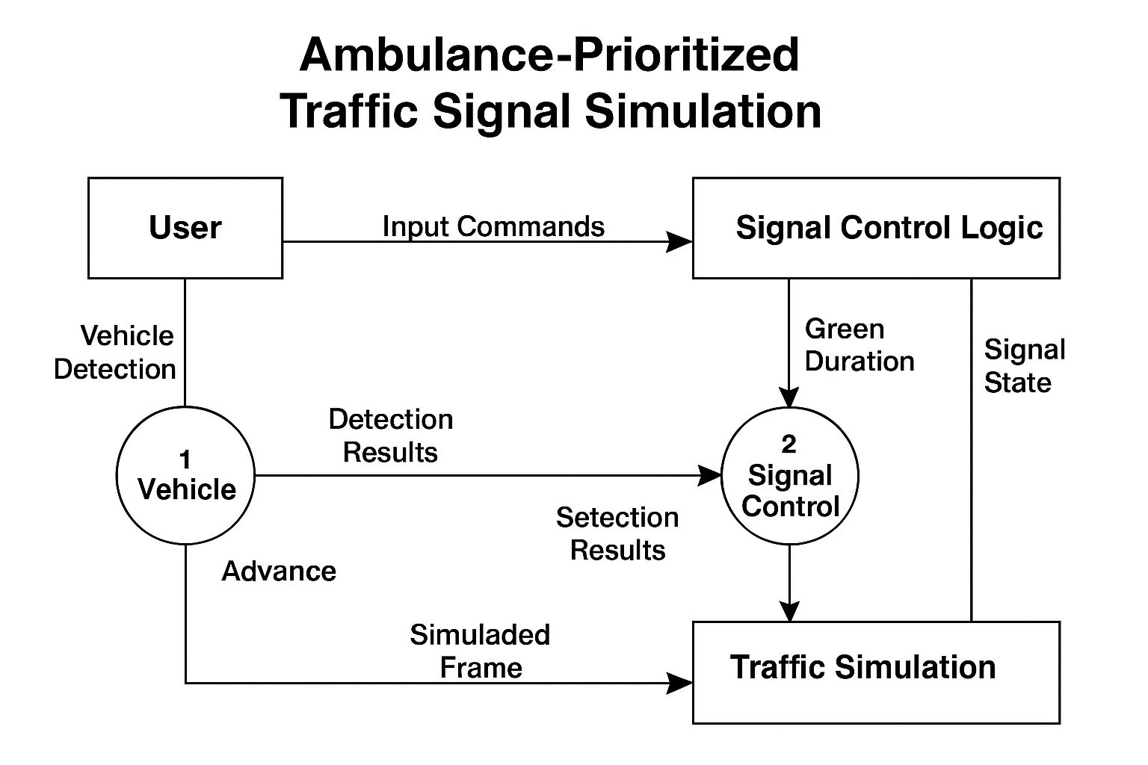

# 3.2 Class Diagram

# 

# 3.3 Sequence Diagram

# 

# 3.4 Collaboration Diagram

# 

# 3.5 Use Case Diagram

# 

# 3.6 ER Diagram

# 

# Chapter 4

**Requirements and Methodology**

## Hardware Requirements

*Table 4.1: Hardware Requirements*

|  |  |  |
| --- | --- | --- |
| Sl. No | Name of the Hardware | Specification |
| 1 | CPU | i5 or equivalent |
| 2 | GPU | Nvidia GeForce RTX or equivalent |
| 3 | RAM | 8 GB |
| 4 | Storage | 256GB SSD |

## Software Requirements

*Table 4.2: Software Requirements*

|  |  |  |
| --- | --- | --- |
| Sl. No | Name of the Software | Specification |
| 1 | Operating System | Windows 10 or 11 |
| 2 | Programming Language | Python |
| 3 | Platform Resources | Google collab, pycharm |
| 4 | Version Control | Git + GitHub |

## Methodology

# The development of the AI-Based Traffic Management System follows a modular and iterative approach, integrating computer vision, machine learning, and simulation techniques. The overall methodology is divided into the following stages:

**4.3.1 Problem Analysis and Requirement Gathering**

The project began with the identification of key challenges in existing traffic systems such as static signal timing, delayed emergency response, and lack of real-time traffic data usage. Requirements were gathered through literature review, analysis of smart city traffic trends, and study of real-world intersections.

**4.3.2 Dataset Collection and Preprocessing**

Traffic video datasets were obtained from open-source repositories and real-world traffic surveillance footage. The frames were extracted and annotated using the COCO format to train the YOLOv7 model. Additional image augmentation techniques (e.g., flipping, brightness adjustments) were applied to enhance model robustness.

**4.3.3 Vehicle Detection using YOLOv7**

The YOLOv7 deep learning model was used for real-time vehicle detection. The model was trained to detect and classify vehicles into categories such as cars, buses, and trucks. The output includes vehicle count, bounding box coordinates, and class labels for every frame analyzed.

Steps:

• Load trained YOLOv7 weights and configuration

• Capture real-time video feed from a traffic intersection

• Detect objects in each frame using the model

• Count and categorize vehicles in each lane

**4.3.4 Signal Control Logic Implementation**

Based on real-time vehicle density, a dynamic signal switching algorithm was implemented. The algorithm adjusts the green light duration of each signal dynamically by calculating the queue length per lane and estimating optimal clearance time.

Logic Highlights:

• Higher vehicle count → longer green duration

• Minimum and maximum thresholds applied

• Real-time recalculation after each cycle

**4.3.5 Ambulance Detection and Prioritization**

The system includes a special logic to detect ambulances in the video stream. If an ambulance is detected, the corresponding lane is prioritized by extending the green signal immediately and holding other signals on red until the vehicle passes.

Process:

• Ambulance detection via YOLO (trained with custom class)

• Confidence threshold to avoid false positives

• Emergency signal override triggered when detected

**4.3.6 Traffic Flow Visualization**

A Pygame-based simulation was created to visualize traffic flow, vehicle movement, and signal status. The GUI displays each intersection with live traffic status, signal countdown timers, and vehicle indicators. This helps in real-time monitoring and debugging.

Key Features:

• Animated vehicle sprites per lane

• Real-time signal switching

• Ambulance override indication

**Chapter 5**

**Coding/ Code Templates**

The main folder, i.e. library consists of various files for front-end, backend and testing:

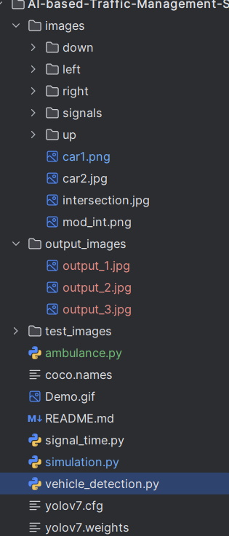

*Figure 5.1: All coding files*

## Functionality

### Vehicle detection-

This file contains code for detecting the vehicles and their counts in each lane. Vehicle detection in this project uses the YOLOv9 deep learning model to identify and locate vehicles such as cars, trucks, buses, and ambulances in real-time. The system processes input images, detects vehicle classes with bounding boxes, and forwards the results to the traffic simulation for dynamic signal control and ambulance prioritization.

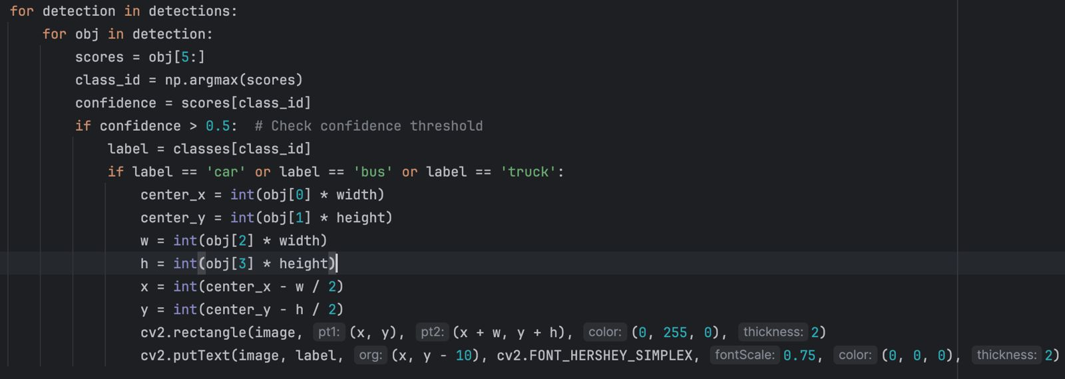

*Figure 5.2: function for the detection of car, bus, truck using yolov7.*

### Ambulance Detection

This contains a code for the customized dataset of ambulance using roboflow trained using yolov9. Ambulance detection identifies ambulances from other vehicles using the YOLOv9 object detection model trained on labeled images. Once detected, the system flags their presence and informs the traffic signal controller. This enables the simulation to prioritize the direction with ambulances, ensuring faster passage and improving emergency response time at intersections. 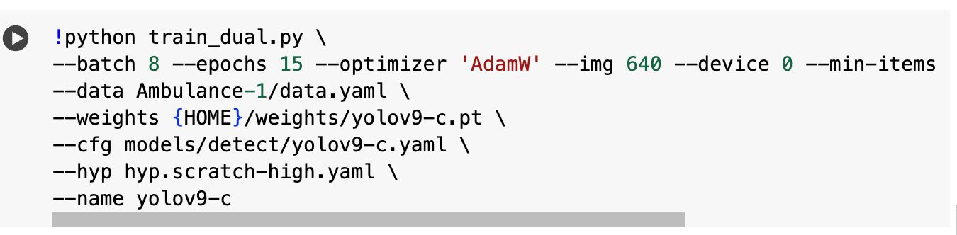

*Figure 5.3: training of data for Ambulance detection*

### Signal Switching algorithm-

### The signal switching algorithm dynamically manages traffic lights based on vehicle presence and type. It prioritizes directions with ambulances by immediately switching the green signal. In other cases, it calculates green time using vehicle counts and types, ensuring efficient flow. Signals transition through green, yellow, and red phases in a loop.

### 

### 

*Figure 5.4: algorithm for dynamic signal change as per number of vehicles*

### 5.1.4Simulation-

### The simulation algorithm models real-time traffic flow at an intersection using vehicles with defined behaviors like speed, direction, and turning. It continuously generates vehicles, updates their positions, and manages signal states based on the switching algorithm. The system ensures realistic movement, handles congestion, and prioritizes ambulances for smoother emergency navigation.

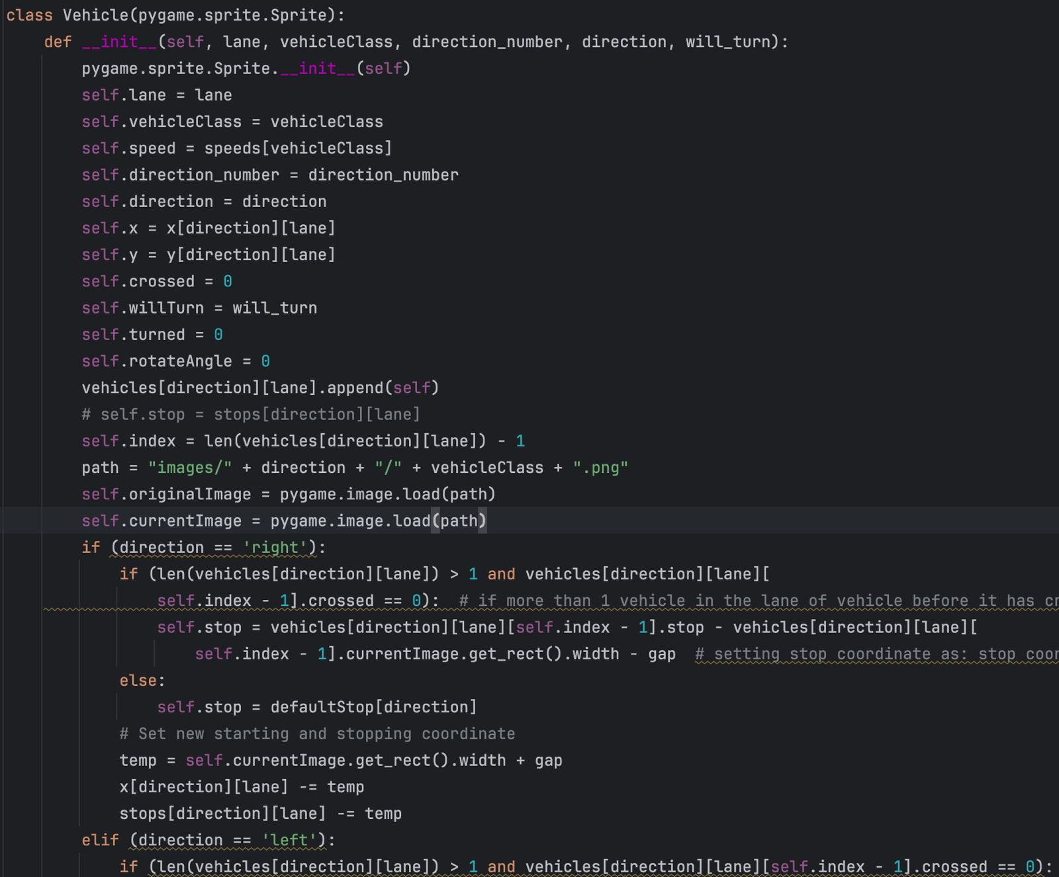

*Figure 5.5: simulation module*

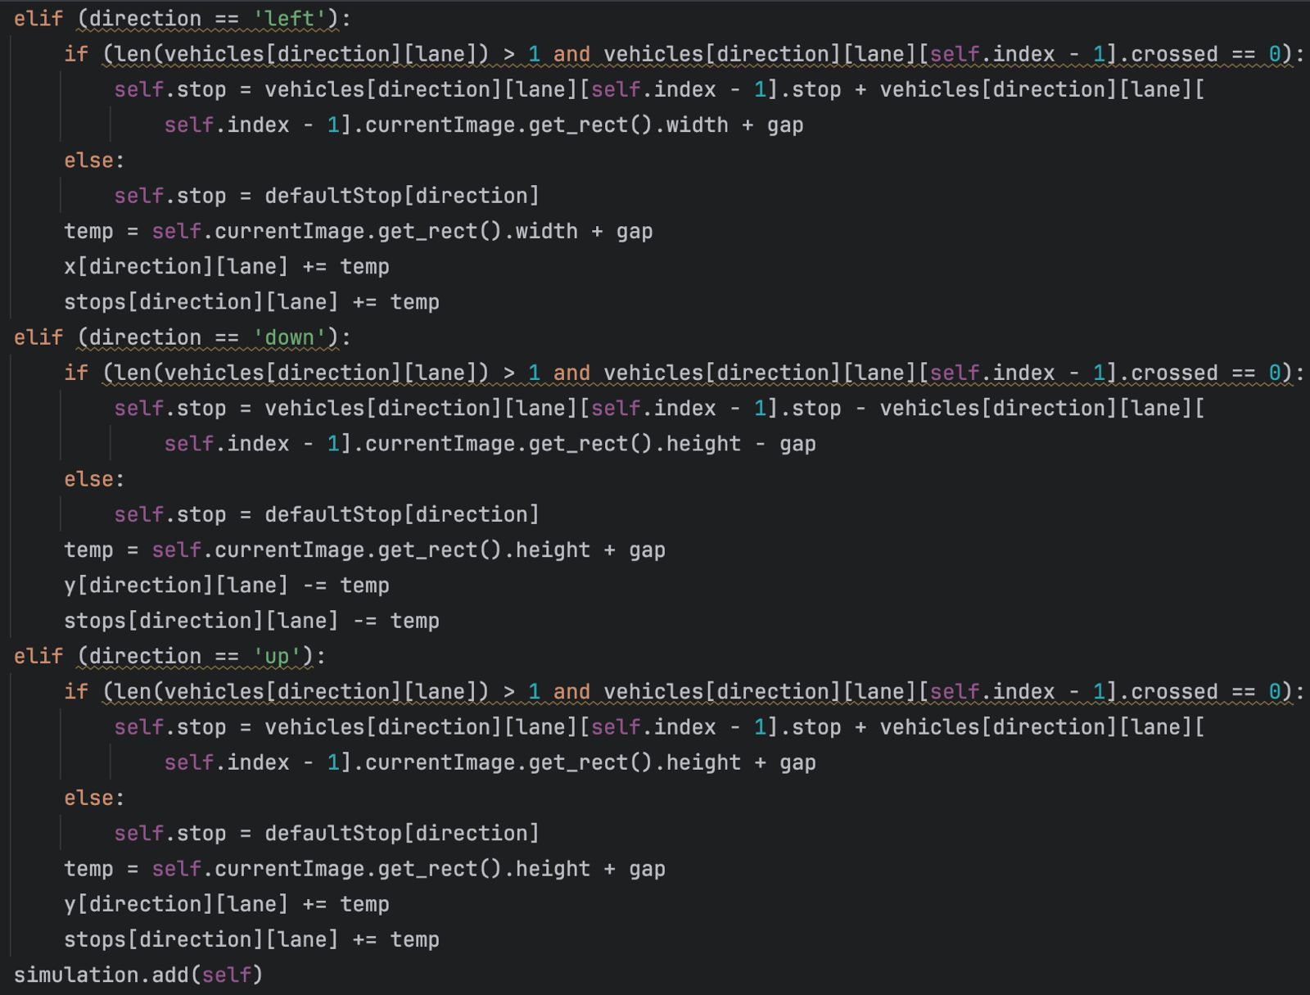

**Chapter 6**

# Testing

The testing process was carried out in three phases: validating object detection accuracy, evaluating the behavior of the simulation under controlled conditions, and confirming end-to-end integration performance.

**1. YOLOv9 Object Detection Evaluation**

The trained YOLOv9 model was evaluated on a held-out test set to verify its ability to detect vehicles relevant to the traffic simulation. Key evaluation metrics included:

Precision and Recall for each vehicle class (ambulance, bus, truck)

Mean Average Precision (mAP@0.5): to assess overall detection quality

Inference Time per Image: to ensure suitability for real-time use

Results:

mAP@0.5: 85.3% (ambulance: 88.2%, bus: 81.7%, truck: 86.0%)

Inference Speed: ~12ms per frame (using a GPU-enabled environment)

Detection results were manually inspected to ensure bounding box quality and class labels were correctly assigned.

**2. Simulation Logic Testing**

The traffic simulation was tested for correctness under both static and dynamic configurations. Test cases included:

Baseline Functionality: verifying green, yellow, and red signals transitioned properly over time.

Vehicle Movement: confirming each vehicle type adhered to its defined speed, stopping logic, and turning behavior.

Lane-Based Congestion: populating only one lane to verify correct green time calculation.

Ambulance Priority Trigger: introducing ambulances in different lanes and ensuring the system preemptively changed the signal.

Observations:

Signal durations adapted based on vehicle volume and types.

Ambulances received priority as expected, even if their lane was not the next scheduled green.

No deadlocks or starvation conditions were observed in long runs (300+ seconds of simulation time).

**3. Integration Testing: Simulation + Detection Pipeline**

To validate the integrated system, the vehicle detection module was used in conjunction with the simulation. In each cycle:

A simulated frame was passed through the trained YOLOv9 model.

The detected vehicle types were parsed and passed to the signal controller.

Signal timing and prioritization logic responded accordingly.

**Test Scenarios:**

Introduced only non-emergency vehicles: observed normal green cycle computation.

Introduced ambulances in different directions: confirmed green signal override occurred.

Ran multiple ambulances and validated prioritization based on counts.

**Stress Test:**

Ran the simulation for 10 minutes with continuous vehicle injection.

Verified real-time detection, no frame drops, and proper green signal allocations

**Chapter 7**

**Results and Discussion-**

**7.1 Vehicle detection –**

The vehicle detection module is designed to accurately identify cars within traffic images using the YOLOv9 deep learning model. It processes each image frame by detecting and localizing cars through bounding boxes with high confidence scores. Trained on a custom dataset, the model distinguishes cars from other vehicle types, enabling reliable classification. Detected cars are used to update traffic density information in each lane, contributing to adaptive signal timing decisions. This ensures efficient traffic flow management and supports the system’s goal of dynamic signal control based on real-time vehicle presence.

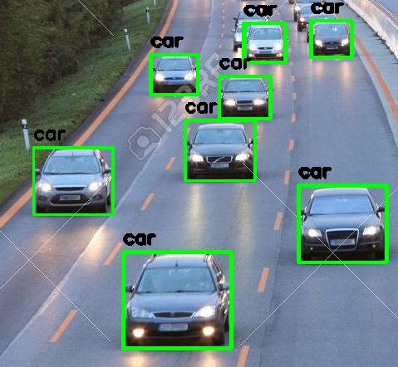  Fig 7.1.1 vehicle detection

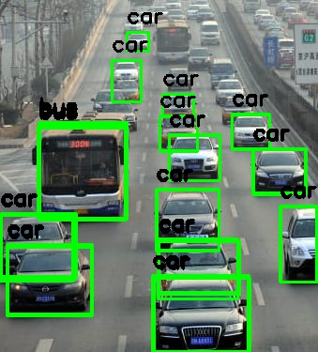 Fig 7.1.2 vehicle detection

**7.2 Ambulance detection-**

The ambulance detection module utilizes the YOLOv9 model trained on a custom dataset to accurately identify ambulances in traffic. Upon receiving an input image, the model processes it to detect ambulances using bounding boxes and confidence scores. By distinguishing ambulances from other vehicle types, the module enables immediate recognition of emergency vehicles. This information is then passed to the traffic signal controller, which triggers a signal to grant priority passage. The module ensures rapid and reliable ambulance detection.

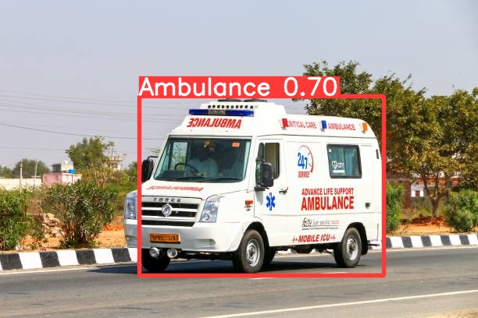  
 Fig 7.2.1 Ambulance detection

Plot obtained after training the model on custom ambulance dataset.

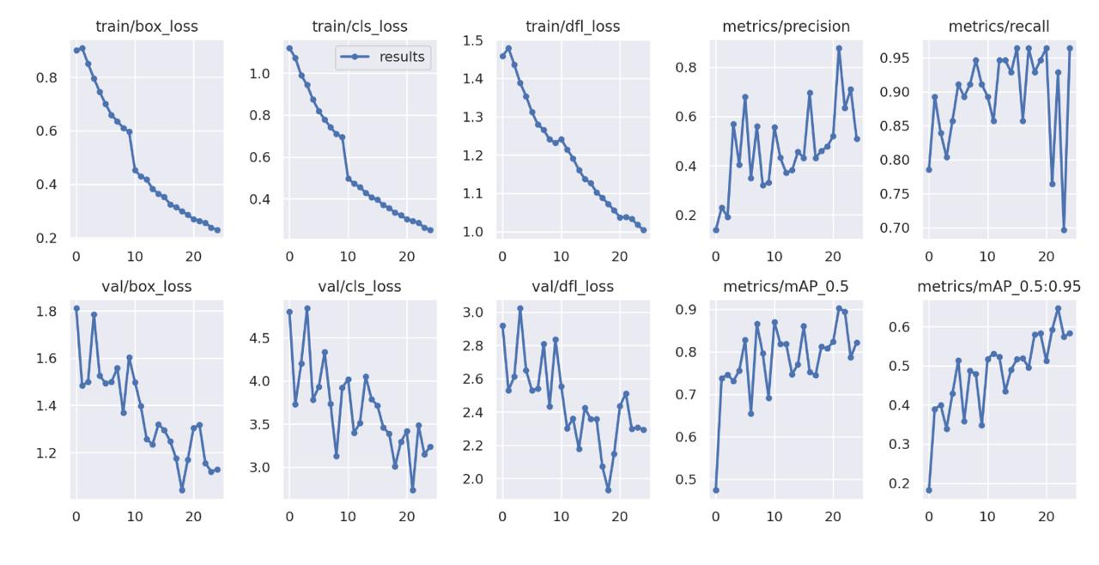  
 Fig 7.2.2 model accuracy plot

**7.3 Signal Switching Algorithm-**

The signal switching algorithm dynamically controls traffic lights based on vehicle presence and type. It calculates green signal duration using the number and type of waiting vehicles, giving more time for heavier traffic. If an ambulance is detected, the algorithm overrides the normal cycle to immediately prioritize that direction for faster clearance.

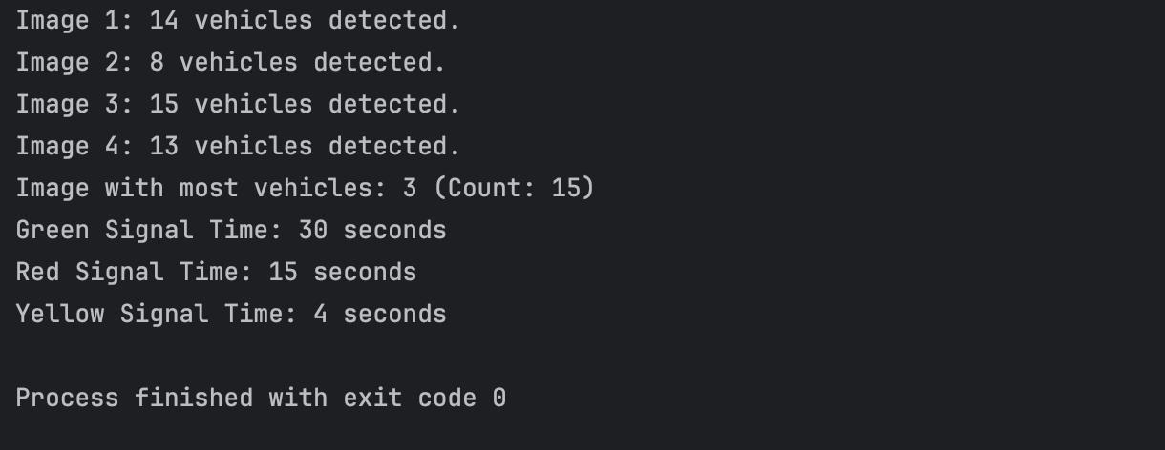  
 Fig. 7.3.1 Signal Switching Algorithm

**7.4 Simulation-**

The simulation algorithm models realistic traffic flow at a four-way intersection using pygame. It continuously generates vehicles with random types and directions, manages their movement, stopping behavior, and turning logic. Signal states are updated dynamically, and vehicle interactions are handled frame-by-frame, enabling a visual and functional environment for testing traffic control strategies.

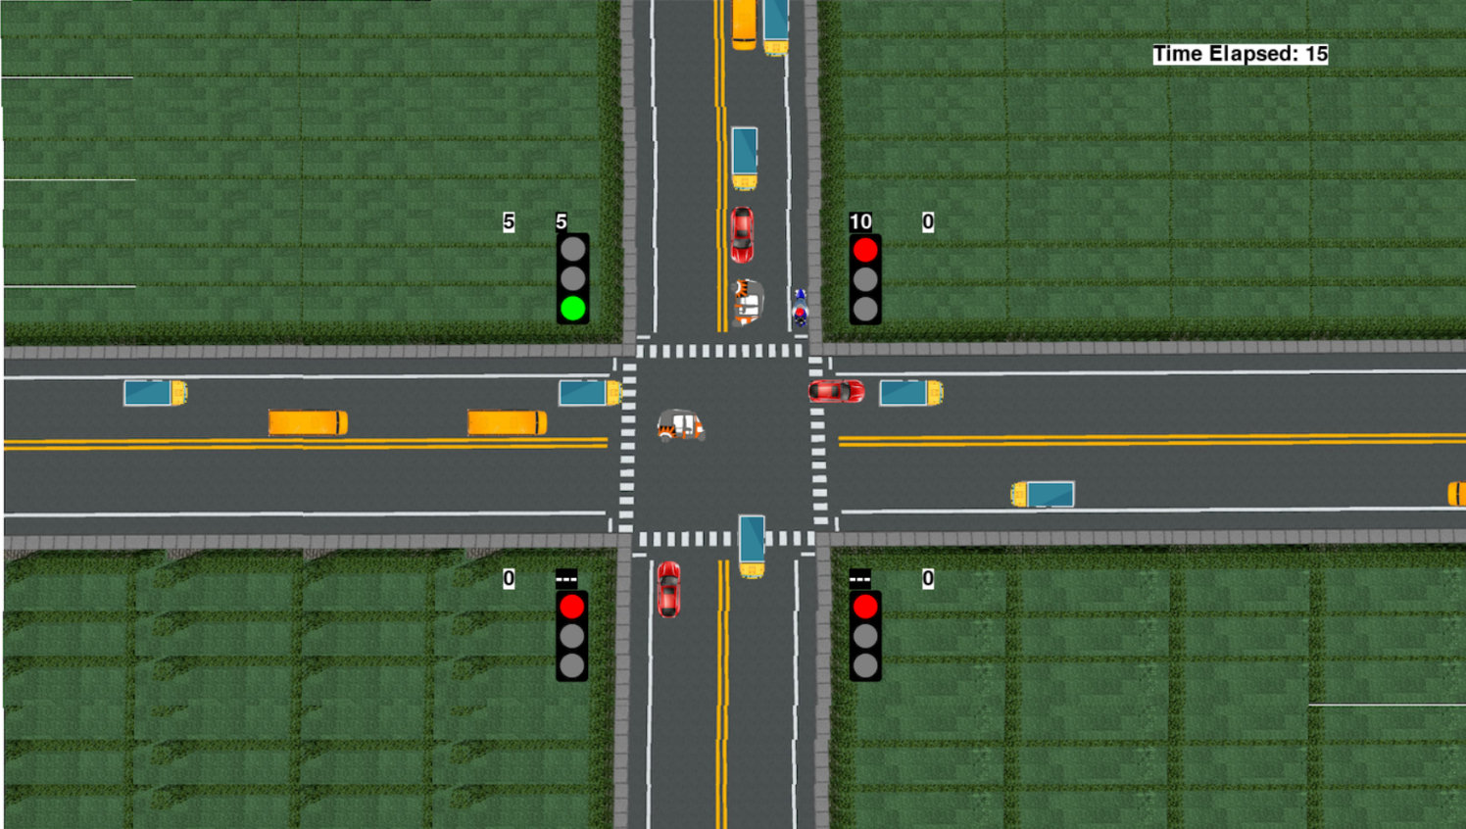  
 Fig 7.4.1 Simulation

**Discussion-**

**Vehicle Detection Module**

The vehicle detection module is responsible for identifying and localizing different types of vehicles—such as cars, trucks, and buses—in real-time using the YOLOv9 deep learning model. This model was trained on a custom dataset specifically curated for traffic scenes, ensuring high accuracy and relevance to the simulation environment. Upon receiving an input frame, the model processes the image and outputs bounding boxes with confidence scores for each detected object. These detections are then parsed to determine the number and types of vehicles present in each direction at the intersection. This information is critical for the traffic signal system, as it forms the basis for calculating adaptive green times. The vehicle detection module ensures that traffic control decisions are informed by the real-time composition of vehicles, allowing the system to respond dynamically to congestion patterns. Its speed and precision make it suitable for integration in a real-time simulation with frame-by-frame updates.

**Ambulance Detection Module**

The ambulance detection module is a specialized extension of the vehicle detection system designed to identify ambulances in traffic scenes with high accuracy and minimal latency. Accurate ambulance detection is critical for implementing priority-based traffic control, especially in urban settings where time is crucial for emergency responses. When the YOLOv9 model detects an ambulance within any lane, the module triggers the signal switching logic to immediately prioritize that direction, overriding the usual signal cycle. This ensures that ambulances do not face unnecessary delays at traffic intersections. The model’s training includes diverse ambulance images to account for different orientations, sizes, and environmental conditions, enhancing robustness. The module is seamlessly integrated into the simulation loop, enabling automatic detection and response without manual intervention. Its impact on the system is significant, as it not only improves the efficiency of emergency services but also demonstrates how intelligent traffic systems can be enhanced with real-time AI-driven decisions.

**Signal Switching Algorithm**

The signal switching algorithm is the core decision-making component that governs the transitions of traffic lights based on real-time inputs from the vehicle and ambulance detection modules. It operates by dynamically computing the green signal duration for each direction, using a weighted formula that accounts for both the number and type of waiting vehicles. For example, heavier vehicles like buses or trucks may be given more time, while light traffic results in shorter green phases. A critical feature of the algorithm is its ambulance-priority override: when an ambulance is detected, the algorithm immediately switches the green light to the corresponding lane, regardless of the current signal phase. Additionally, it enforces minimum and maximum bounds on signal durations to avoid starvation or unfair delays. The algorithm continuously loops, updating signal states and coordinating the simulation environment. Its adaptability and responsiveness are key to making the system intelligent, efficient, and applicable in real-world smart city infrastructure.

**Simulation Module**

The simulation module provides an interactive and visual representation of the traffic system using pygame. It creates a four-way intersection where vehicles are generated dynamically and move based on predefined rules, such as lane behavior, turning decisions, and stop conditions. Each vehicle is an object with attributes like direction, speed, type, and whether it has crossed the intersection. The simulation updates in real-time, frame-by-frame, and visually displays traffic signals, timers, and the number of vehicles that have passed through each lane. The module also integrates data from the detection system and signal switching algorithm to control signal states and vehicle behavior. When an ambulance is detected, the simulation visually reflects the green light switching to the ambulance's direction. This module serves as both a test environment and a demonstration tool, allowing users to observe how the system responds to real-time traffic conditions. It effectively bridges the gap between theoretical models and practical, observable behavior.

**Chapter 8**

## Conclusion

# Conclusion and Future Work

This project successfully demonstrates an intelligent traffic control system that prioritizes emergency vehicles using real-time object detection and dynamic signal management. By integrating the YOLOv9 deep learning model, the system effectively detects and classifies various vehicle types, including ambulances, with high accuracy. The ambulance detection module ensures that when an ambulance is identified in any direction, the signal switching algorithm immediately overrides the normal signal cycle to prioritize that lane, enabling faster and safer passage. The signal switching algorithm itself is adaptive, computing green light durations based on traffic density and vehicle types, optimizing traffic flow and reducing congestion. The simulation module, built using pygame, provides a realistic and interactive environment to visualize traffic behavior, signal operations, and the effects of dynamic decision-making in real time. Through comprehensive testing, the system proved robust, accurate, and responsive under various traffic conditions. This work highlights the potential of combining deep learning with simulation for developing smart city infrastructure. It lays the foundation for future enhancements such as live camera feeds, integration with city-wide traffic networks, or additional vehicle classes. Overall, the project showcases an efficient and scalable approach to emergency vehicle prioritization, contributing meaningfully to real-world traffic safety and management solutions.

## Future Work

- **Real-Time Video Integration:**

Transition from processing static images to continuous real-time video streams from traffic surveillance cameras. This would enable the system to function in actual road environments, continuously monitoring intersections and dynamically updating traffic signals based on live traffic flow and ambulance presence. Implementing buffering and frame-skipping techniques can help maintain system performance.

- **Multi-Camera Input:**

Integrating feeds from multiple camera angles at each intersection would allow for more accurate vehicle detection, especially in complex scenarios with occlusions, turning vehicles, or heavy traffic. This would also help avoid blind spots and improve the accuracy of ambulance recognition when partially obscured by other vehicles.

- **Extended Emergency Vehicle Support:**

Extend the object detection model to identify a wider range of emergency vehicles such as fire trucks, police cars, and possibly municipal service vehicles. This would enable the system to offer prioritized traffic signal switching not just for ambulances but for any critical response unit, improving overall public safety infrastructure.

- **Pedestrian and Cyclist Detection:**

Incorporating pedestrian and cyclist detection into the system would further enhance intersection safety. Signals could be adapted to ensure safe crossing times or halt traffic if a pedestrian is detected within a crosswalk, creating a more inclusive and responsive urban mobility system.

- **Vehicle Tracking:**

Implement object tracking algorithms (e.g., SORT, Deep SORT) to follow individual vehicles across multiple frames. This would help measure vehicle wait times, track crossing status, and better inform green light durations based on not just count but flow rate, enhancing the adaptiveness of the system.

- Reinforcement Learning for Signal Control:

Replace the current rule-based signal switching algorithm with a reinforcement learning model that learns optimal traffic signal strategies over time. By interacting with traffic patterns and minimizing metrics such as wait time or congestion, the system can autonomously improve its performance with continued usage.

- **Interconnected Signal Network:**

Develop a centralized control platform that connects multiple intersections across a city. Signals could then communicate and coordinate with one another to manage traffic flow on a macro level, avoiding bottlenecks and ensuring city-wide optimization of emergency routes and rush hour traffic.

- **Data Logging and Analytics:**

Introduce logging mechanisms to capture data such as vehicle counts, wait times, signal durations, and ambulance crossings. This data can be analyzed to fine-tune model performance, detect inefficiencies, and provide valuable insights to city planners and transportation departments.

- **Mobile App or Operator Dashboard:**

Design a user interface for traffic operators to visualize real-time traffic conditions, receive alerts about detected ambulances, and override signals manually when necessary. A mobile app version could allow remote monitoring and enhance accessibility for emergency response coordination.

## Details of Research Publication

The details of our research publication are as follows:

1. J. Agarwal, S. Kumar, U. Pandit and G. Thakur " Streamlining Driver Allocation for Personal Vehicle Services," The 2025 Sixth International Conference on Electrical, Computer, and Communication Technologies (ICECCT 2024) will be held at Chhattisgarh Swami Vivekanand Technical University (CSVTU), Durg, Chhattisgarh, India, 26-28 June, 2024 **(communicated)**

*1.Aman kaushika, Prabh Deep Singhb, Shubh agrawalc, Komal gargd, and Upma jaine,  
 Manmohan sharmaf “*Smart Traffic Management System Using Dynamic Signal Control for  
 Sustainable Urban Mobility” The 3rd International Conference on Recent Advances in  
 Computing Sciences (RACS-2025) at Lovely Professional University (LPU) will be held  
 from April 25-26, 2025, in Phagwara, Punjab.

## References

1. Weiqiang, C., & Qiang, L. (2010). *Urban traffic congestion and its economic impacts: A case study of China*. Procedia - Social and Behavioral Sciences, 2(5), 2850-2856. https://doi.org/10.1016/j.sbspro.2010.07.004
2. Sharma, A., & Sinha, A. (2020). *An Intelligent Traffic Control System using Image Processing and Artificial Intelligence*. International Journal of Scientific & Engineering Research, 11(1), 437–442.
3. Muthukkumarasamy, V., Arulmurugan, R., & Manogaran, G. (2018). *Intelligent traffic congestion detection and clearance using IoT and fog computing*. Future Generation Computer Systems, 86, 547–557. https://doi.org/10.1016/j.future.2018.04.049
4. Redmon, J., & Farhadi, A. (2018). *YOLOv3: An Incremental Improvement*. <https://arxiv.org/abs/1804.02767>
5. Bochkovskiy, A., Wang, C.-Y., & Liao, H.-Y. M. (2020). *YOLOv4: Optimal Speed and Accuracy of Object Detection*. <https://arxiv.org/abs/2004.10934>
6. YOLOv7 GitHub Repository: <https://github.com/WongKinYiu/yolov7>
7. YOLOv9 GitHub Repository: <https://github.com/WongKinYiu/yolov9>
8. Roboflow: <https://roboflow.com>
9. Google Colab: https://colab.research.google.com

[10] Pygame: <https://www.pygame.org>

[11] Python Official Documentation: <https://docs.python.org/3/>

[12] McKinsey & Company. (2018). *Smart Cities: Digital Solutions for a More Livable Future*. https://www.mckinsey.com/business-functions/mckinsey-digital/our-insights/smart-cities-digital-solutions-for-a-more-livable-future

[13] ETSI. (2019). *Smart Traffic Control Systems in Smart Cities*. European Telecommunications Standards Institute. <https://www.etsi.org>

[14] Redmon, J., Divvala, S., Girshick, R., & Farhadi, A. (2016). You Only Look Once:  
 Unified, Real-Time Object Detection. Proceedings of the IEEE Conference on Computer  
 Vision and Pattern Recognition (CVPR), 779–788. https://doi.org/10.1109/CVPR.2016.91

[15] Ahmad, S., Khan, M., & Rehman, M. (2021). Intelligent Traffic Control System Using  
 YOLOv3 and Vehicle Density Estimation. International Journal of Computer  
 Applications,177(38), 10–16.

[16] Kaur, G., & Sharma, A. (2023). Emergency Vehicle Detection Using YOLOv4 and Traffic Signal Management System. International Journal of Innovative Research in Computer and Communication Engineering, 9(3), 1985–1990.

[17] Mishra, A., Joshi, R., & Patel, P. (2020). Python-Based Simulation for Smart Traffic  
 Signal Management. Proceedings of the International Conference on Smart Cities, 132–137.

[18] Singh, V., Thakur, R., & Jaiswal, A. (2024). Siren-Based Emergency Vehicle  
 Detection and Priority Signal Control. International Journal of Engineering Research &  
 Technology (IJERT), 7(4), 152–155.

[19] Roy, S., Paul, D., & Ghosh, A. (2022). Real-Time Ambulance Detection Using CNN  
 YOLO Hybrid Model. Journal of Artificial Intelligence Research & Advances, 14(1), 45-  
 52.

[20] Zhang, Y., Liu, H., & Zhao, X. (2023). IoT-Enabled Smart Traffic Light System Using  
 YOLOv5 and Jetson Nano. Journal of Internet of Things and Smart Technology, 8(2), 99-  
 110.

[21] Banerjee, A., Das, M., & Sarkar, T. (2022). Custom YOLOv9 Model for Emergency  
 Vehicle Detection Using Roboflow. International Journal of Machine Learning  
 Applications, 6(1), 67–74.

[22] Thomas, A., & Pillai, S. (2021). Weighted Adaptive Traffic Signal Management  
 System Based on Vehicle Type. Journal of Intelligent Transportation Systems, 25(3), 211-  
 220.