**CHAPTER 3`**

**3. METHODOLOGY**

The methodology of this project involves analyzing the structural behaviour of a G+10 residential building under different mass distribution scenarios. The main goal is to evaluate how the placement of water storage tanks impacts the building’s response to seismic, hydrostatic, and wind loads. To carry out this analysis, we used SAAD Pro

**3.1 Planning and Model Development:**

The planning and model development stage involved two primary tasks: drawing the building plan and performing the structural analysis. These tasks were accomplished using **AutoCAD** for drafting the floor plan and **SAAD Pro**  for structural analysis and simulation.

**3.1.1 AutoCAD for Drawing:**

AutoCAD was used to create the floor plans for the G+10 residential building. This helped in accurately representing the building layout, including the arrangement of rooms, columns, beams, and other structural elements.

1. **Plan Creation:** The building layout was drawn following standard architectural practices to ensure consistent dimensions and proper spacing.
2. **Dimensions:** The floor plan covered an area of 30 m × 14 m, with residential units arranged for each floor. Each floor consist of 4 flats of 2Bhk layout.
3. **Exporting for Analysis:** Once finalized, the AutoCAD plan was exported to SAAD Pro for structural analysis.
4. **Building Plan Details:**

* **Type:** G+10 Residential Building
* **Plan Area:** Approx. 30 m × 14 m (420 m²)
* **Total Height:** 36.3 m
* **Typical Storey Height:** 3.3 m

The below is the floor plan of building 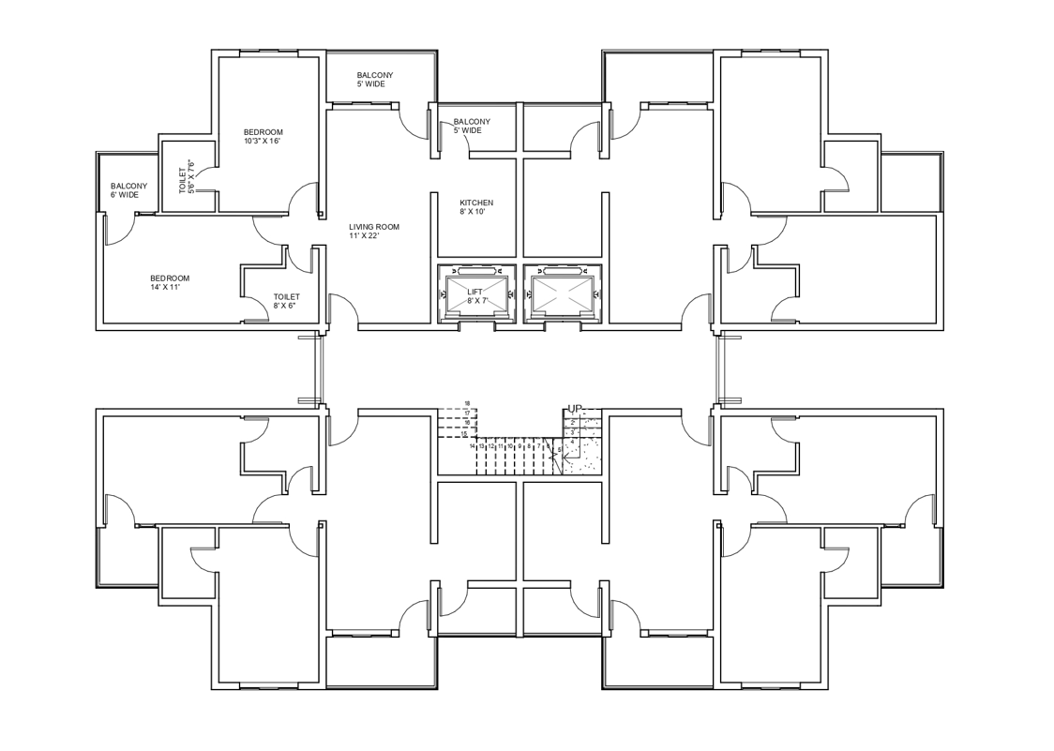

**3.1.2 SAAD Pro (STAAD) for Structural Analysis:**

After drafting the floor plan, the structural analysis was conducted using SAAD Pro (commonly referred to as STAAD). This software was used to simulate the structural behaviour under different loading conditions and to compare the impact of varying mass distribution configurations.

1. **Modeling the Frame:** The RC frame of the G+10 building was modeled based on the AutoCAD drawings. The frame included columns, beams, and slabs accurately positioned as per the plan.
2. **Material Properties:** Concrete and steel properties were defined according to standard specifications, including grade, density, and strength characteristics.
3. **Mass Distribution Configuration:**
   * GRID 1: Two large tanks (100 m³ each) centrally located on the rooftop.
   * GRID 2: One central 100 m³ tank on one side and 20 individual 5 m³ tanks in flats.
   * GRID 3: Distributed model with 40 flats, each having a 5 m³ tank.
4. **Load Assignments:** Different types of loads were applied to the model:
   * Dead Load: Self-weight of structural components.
   * Live Load: Loads from occupants and movable items.
   * Seismic Load: Ground motion effects as per IS 1893 (Part 1) 2002.
   * Wind Load: Lateral forces from wind pressure.
   * Hydrostatic Load: Forces due to water storage in tanks.

**3.2** **Mass Distribution Configuration:**

**3.2.1 GRID 1 – Centralized Roof-Top Water Storage Model**

**Design Description**:

In this model, two large tanks (each 100 m³) are placed on the rooftop of a G+10 residential building. These tanks act as the sole water storage units for the entire structure. The combined capacity is 200 m³, and water is distributed vertically downward to all flats.

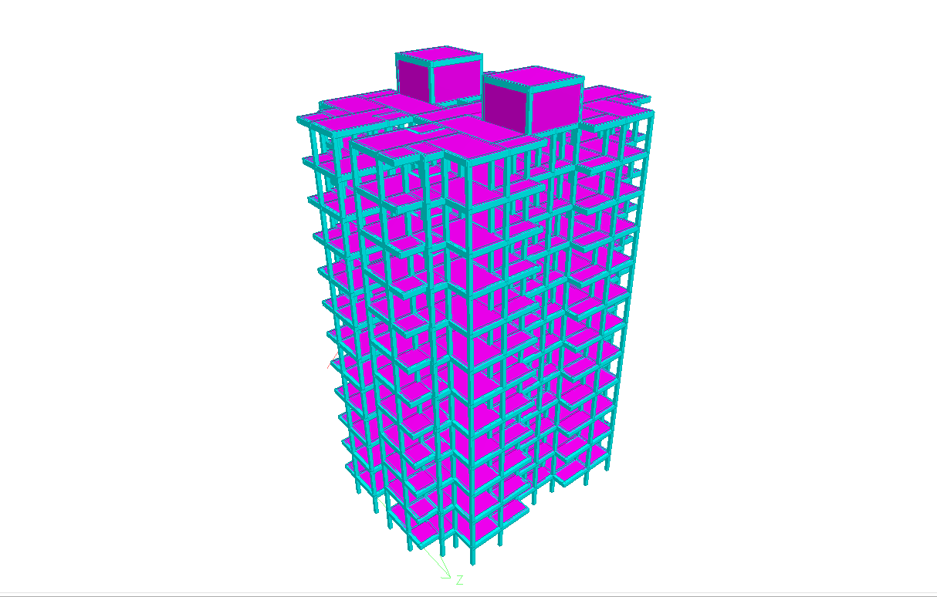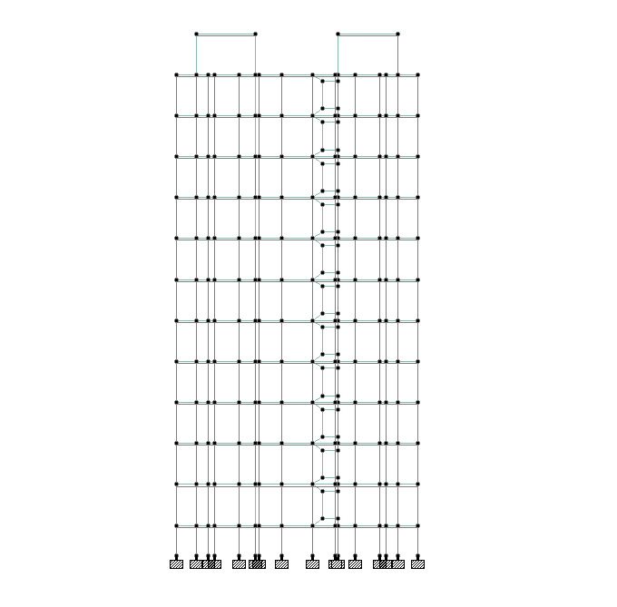

**Model-Based Advantages**:

1. **Structural Simplicity**: Requires only two large tank platforms on the roof, reducing the complexity of civil layout and load distribution designs across other floors.
2. **Optimized Floor Space**: No space on residential floors is occupied by tanks, preserving usable area within flats and common corridors.
3. **Ease of Central Monitoring**: Structural inspection, waterproofing checks, and integrity assessments are limited to the rooftop zone, simplifying model planning and long-term upkeep.

**Model-Based Limitations**:

1. High Roof Load Concentration: 200 m³ of water equals 200,000 kg (200 tons); concentrated rooftop load demands strong reinforcement, especially for seismic or wind load considerations.
2. **Elevated Center of Gravity**: Water weight at the highest point increases the building's center of mass, which can affect lateral load resistance and structural balance during earthquakes or strong winds.
3. **Access & Safety Design**: Requires additional structural provisions like walkways, ladders, or railings for safe access to the tanks for inspection or emergency shutoff.

**3.2.2 GRID 2 – Distribution Model (One Side Central + Flat Tanks)**

**Design Description:** This design splits the water storage system. A central 100 m³ tank is placed on one side of the building, possibly at an intermediate level or on a cantilevered platform. This tank serves 20 flats, which also each have their own 5 m³ individual tank.

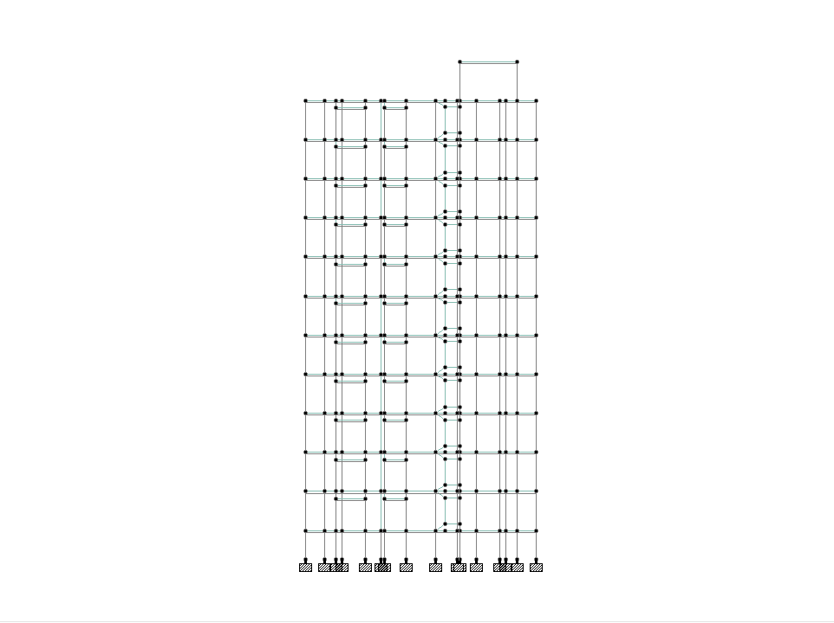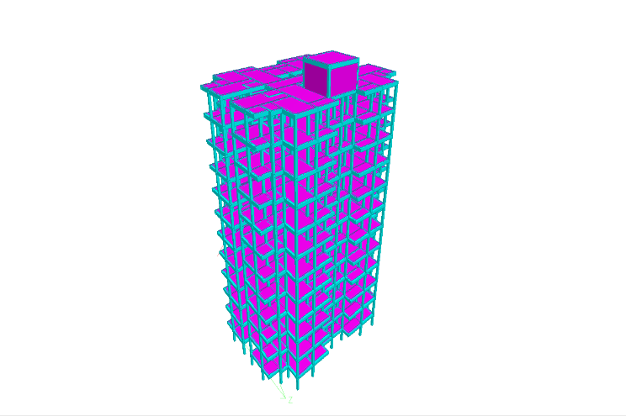

**Model-Based Advantages:**

1. **Balanced Structural Load**: The 100 m³ tank is placed off-center, possibly on an intermediate slab or platform, which lowers the building’s overall center of gravity compared to Grid 1.
2. **Distributed Load Distribution**: The remaining water is stored across multiple flats (20 small tanks), distributing structural loads horizontally across the tower in a more uniform manner.
3. **Modular Expansion Feasibility**: Easier to expand or adapt individual components of the design (e.g., increase capacity or change tank materials) without impacting the whole structure.

**Model-Based Limitations**:

1. **Asymmetric Load Distribution**: The side placement of the large tank introduces lateral imbalance, requiring structural countermeasures (e.g., stiffer frames or braces on the opposite side).
2. **Architectural Intrusion**: Flat-level tanks reduce usable built-up area or may require external duct space or reinforced balconies to support tanks.
3. **Complex Drainage/Routing Design**: Structural slabs and piping need custom routing to manage both central and local tanks without interference with living or structural zones.

**3.2.3 GRID 3 – Fully Distributed Flat-Based Model**

**Design Description:** This model eliminates all centralized storage. Instead, each of the 40 flats is provided with its own 5 m³ tank, totaling 200 m³. These are positioned inside or adjacent to individual flats commonly in utility balconies or dedicated service shafts.

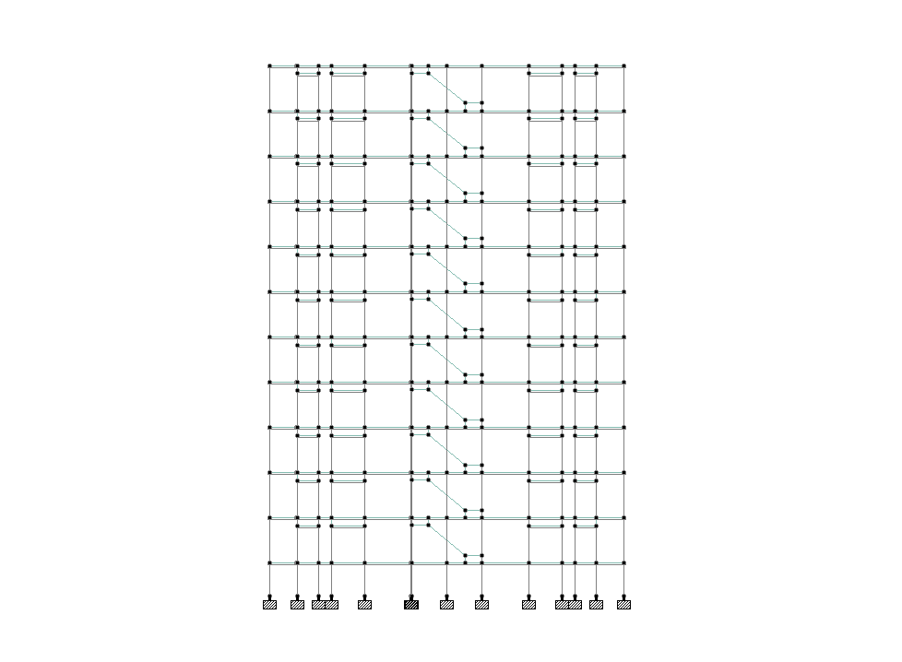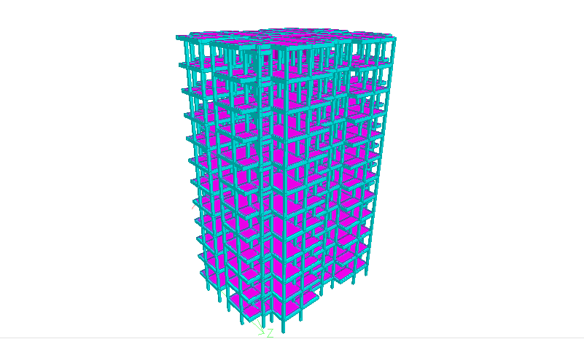

**Model-Based Advantages:**

1. **Even Structural Load Distribution**: With tanks uniformly spread across all floors and units, the vertical and horizontal load paths remain consistent, leading to better load balance.
2. **Lower Roof Load**: The roof bears no water storage load, simplifying top-floor structural design and reducing wind-induced stress factors.
3. **Flexibility in Design Integration**: Tanks can be integrated into flat designs as part of utility areas or vertical ducts, allowing diverse layout approaches for architects.

**Model-Based Limitations:**

1. **Design Fragmentation**: Requires allocation of tank space in every flat, reducing flexibility in interior layouts or resulting in irregular projections/bulkheads.
2. **High Structural Detailing Requirement**: Each floor and flat must be detailed for localized point loads, especially in slab design, waterproofing, and vibration control.
3. **Maintenance Access Design Challenge**: Structural provisions must be made for access and inspection of each tank, which can be difficult to standardize across all units.

**3.3 LOAD ASSIGNMENTS :**

**3.3.1 Dead Load**

Permanent construction material loads compressing the roof, floor, wall, and foundation systems, including claddings, finishes, and fixed equipment, are referred to as dead loads. The total load of all building components that do not change over time, such as steel columns, concrete floors, bricks, roofing material, and so on, is referred to as dead load.

The assignment of dead load in Staad.pro is done automatically by giving the member's property.

In Staad.Pro, we assign dead load in terms of self-weight. We must create a dead load case. In the load case, we have a self-weight option that automatically calculates weights based on material properties such as density, and after the assignment of dead load select all beams and columns to carry it. After the dead load is assigned, the structure looks like this, the skeletal structure turns red, as shown below.

Dead loads are calculated using **IS 875 (Part-1)-1987.**

**3.3.2 Live load**

Live load refers to the temporary or moving weight that a structure supports during its use. These loads vary depending on how the space is used and include things like people, furniture, movable equipment, and stored materials. Activities like maintenance work can also add to live load.  
  
Because these loads are not fixed, they can change location and intensity over time. For example, the number of people in a shopping mall changes throughout the day, or furniture may be rearranged in an office.

**3.3.3 Seismic Load**

The use of earthquakes caused agitation on a structure is termed as seismic loading. It occurs at a structure's contact surfaces, either with the ground or with adjacent structures. It is primarily determined by the anticipated seismic parameters at the site (seismic hazard), geotechnical parameters, and structure parameters.

For our structure we have considered the following loading factors to occur as per IS 1893 (Part 1) 2002

$Earthquake load in X direction=1{KN/m}^{2}$

$Earthquake load in Z direction=1{KN/m}^{2}$

In Staad.Pro the seismic load is applied in two directions, X & Z respectively. A seismic load case must be created for both directions. In the load case we can further input the seismic conditions based on Zone. Our structure lies in Zone IV. Assign the load case to view and it looks like this:

## **3.3.4 Wind Load**

Wind load is the force that wind exerts on a building’s surfaces. When wind blows against a structure, it creates pressure on the side it hits and sometimes suction on the opposite side. This force acts on walls, roofs, and other exposed parts of the building.  
  
The taller or broader a structure is, the more wind load it will experience, especially in open or high-altitude locations. Wind can cause a building to sway or vibrate, which may affect both the structure’s safety and the comfort of the people inside. To counter this, engineers analyze wind conditions and building shape to ensure the structure can withstand wind forces from all directions.

Wind loads can be generated automatically by Staad.Pro. Any custom intensity vs height data can be specified, and the software will calculate wind loading on the structure based on that. Wind loading can also be generated using codes such as **IS 875 (Part 3)-1987**, in which case the software calculates the intensity vs height data and then generates the wind loading on the structure based on that.

Both vertical and horizontal loads are affected by wind load. This is due to wind load creating a negative (suction) pressure on the roof's top, causing roof uplift.

**3.3.5 Hydrostatic Pressure** refers to the pressure exerted by a static fluid (like water) against the walls and base of a container or structural element. In building analysis, this pressure is particularly relevant when dealing with water storage tanks or any fluid-containing structures integrated into the building.

Hydrostatic pressure acts perpendicular to the surface of the tank walls and increases linearly with depth. This means that the pressure at the bottom of the tank is greater than at the top.

In STAAD Pro, hydrostatic pressure is applied as a **distributed load** acting on the tank walls and base. The software allows for the definition of pressure varying with height, which is essential for accurately simulating the effect of water stored at different levels. The pressure is calculated and applied as a triangular or trapezoidal distribution, reflecting the increase in pressure from the top to the bottom of the tank.

**3.4 Load Combinations**

Load combinations refer to the combinations of various loads acting simultaneously on the G+10 building to assess its structural performance under real-world conditions. These combinations include dead loads (DL), live loads (LL), seismic loads (EL), wind loads (WL), and hydrostatic loads (HL).

The purpose of using load combinations is to evaluate how the building responds when different forces act together,

* DL + LL
* DL + LL + W X
* DL + LL + W -X
* DL + LL + W Z
* DL + LL + W -Z
* DL + LL + EQ X
* DL + LL + EQ -X
* DL + LL + EQ Z
* DL + LL + EQ -Z
* DL + W X
* DL + W -X
* DL + W Z
* DL + W -Z
* DL + EQ X
* DL + EQ -X
* DL + EQ Z
* DL + EQ -Z

**3.5 CODES USED**

**IS 1893 (Part 1) 2002** **–** Code earthquake resistant structure

**IS 456:2000–** Code for plain and reinforced concrete

**IS 3370 (Part 1 to Part 4)-** Concrete Structures for Liquid Storage

**IS 875 (Part-1)-1987 –** Code for dead loads

**IS 875 (Part-2)-1987** Code for live loads

**IS 875 (Part-3)-1987-** Code for wind loads