**Mini Project Report on**



**Real-time Human Detection & Counting (People Counting) using Python**



**Submitted in partial fulfillment of the requirement for the award of the degree of**

**BACHELOR OF TECHNOLOGY**

**IN**

**COMPUTER SCIENCE & ENGINEERING**

**Submitted by:**

**Student Name : DAMAN RAKWAL University Roll No. :2018772**

***Under the Mentorship of***

**Mr. KIREET JOSHI**

**Assistant Professor**



**Department of Computer Science and Engineering**

**Graphic Era (Deemed to be University)**

**Dehradun, Uttarakhand**

**January 2023**



**CANDIDATE’S DECLARATION**

I hereby certify that the work which is being presented in the project report entitled **“Real time Human Detection & Counting (People Counting) using Python ”** in partial fulfillment of the requirements for the award of the Degree of Bachelor of Technology in Computer Science and Engineeringof the Graphic Era (Deemed to be University), Dehradun shall be carried out by the under the mentorship of **Mr. Kireet Joshi, Assistant Professor**, Department of Computer Science and Engineering, Graphic Era (Deemed to be University), Dehradun.

Name: Daman Rakwal University Roll no: 2018772

**Table of Contents**

|  |  |  |
| --- | --- | --- |
| **Chapter No.** | **Description** | **Page No.** |
| Chapter 1 | Introduction | **1** |
| Chapter 2 | Literature Survey | **2-3** |
| Chapter 3 | Methodology | **4-6** |
| Chapter 4 | Result and Discussion | **7-9** |
| Chapter 5 | Conclusion and Future Work | **10-11** |
|  | References | **12** |

# Chapter 1

**Introduction**

### 1.1-Introduction:

Real-time crowd counting in videos becomes more and more important for public

area monitoring for the purpose of safety and security. The goal of crowd counting is

to estimate the number of people passing through a given line or a given area. It has

many valuable real-world applications, such as controlling the number of people in

the venues, estimating the people flow in the subway station, counting people entering

and exiting. In this python project, we are going to build a real time human detection

and counting system by using open source computer vision (open cv) library and Histogram of Oriented Gradient (HOG) feature descriptor algorithm which will we used to detect people in a particular frame by calling it’s pretrained model for human detection, providing that pretrained model to the support vector machine for the purpose of detection. Histogram of Oriented Gradient (HOG) is a inbuild feature of open cv library, can be used by just importing open cv library to the code to access it’s features.

# Chapter 2

**Literature Survey**

### 2.1- Navneet Dalal and Bill Triggs:

We study the question of feature sets for robust visual object recognition, adopting linear SVM based human detection as a test case. After reviewing existing edge and gradient based descriptors, we show experimentally that grids of Histograms of Oriented Gradient (HOG) descriptors significantly outperform existing feature sets for human detection. We study the influence of each stage of the computation on performance, concluding that fine-scale gradients, fine orientation binning, relatively coarse spatial binning, and high-quality local contrast normalization in overlapping descriptor blocks are all important for good results. The new approach gives near-perfect separation on the original MIT pedestrian database, so we introduce a more challenging dataset containing over 1800 annotated human images with a large range of pose variations and backgrounds.

### 2.2- Xinjian Zhang and Liqing Zhang:

Real-time crowd counting is of many potential applications, such as surveillance, crowd flow control in subway. In this paper, we propose a fast and novel method for estimating the number of people in crowded surveillance scenes. This method is able to count people in real time and is robust to changes of illumination and background. The combined rectangle features and cascade of boosted classifier are employed to train a multi-scale head-shoulder detector. The detector can detect human in every frame with a high accuracy. Then human tracking is used to track the detected people and remove duplicates in successive frames. Experiments on a real-world video show the proposed method can give an accurate estimation in real time.

### 2.3-Significance of the People Counting Softwares:

People counting software helps businesses keep track of the number of people entering and leaving their premises. Usually, this type of software uses cameras, sensors, and other technology to count the number of people in real-time. Here are some features provided by people counting software:

#### 2.3.1-Facial Recognition:

People counting software can recognize individuals by their facial features and store information about them. This way, businesses can review the data in order to identify trends in customer visits.

#### 2.3.2- Heat Mapping:

Heat maps are visual representations that show which areas get the most foot traffic. This feature allows businesses to determine which areas of their stores get the most attention and allocate staff accordingly.

#### 2.3.3- Queue Management:

People counting software can measure and analyze wait times for customers in queues or lines. This allows businesses to better understand customer service levels and make improvements if needed.

#### 2.3.4- Real-Time Data Collection:

People counting software collects data from multiple sources in real-time so businesses can have a better understanding of how many customers visit their stores at any given time.

#### 2.3.5- Reporting Tools:

People counting software includes reporting tools that generate graphs, charts, and other visuals that allow users to analyze data more easily. These reports are useful for understanding customer behaviors over a period of time as well as identifying opportunities for improvement.

# Chapter 3

**Methodology**

### 3.1- Project Prerequisites:

The project in Python requires you to have basic knowledge of python programming and the OpenCV library. We will be needing following libraries:-

#### 3.1.1-OpenCV: A strong library used for machine learning.

#### 3.1.2-Imutils: To Image Processing.

#### 3.1.3-Numpy: Used for Scientific Computing. Image is stored in a numpy array.

#### 3.1.4-Argparse: Used to give input in command line.

To install the required library, run the following code in your terminal.

pip install opencv-python

pip install imutils

pip install numpy

### 3.2-Open CV:-

OpenCV is the huge open-source library for the computer vision, machine learning, and image processing and now it plays a major role in real-time operation which is very important in today’s systems. By using it, one can process images and videos to identify objects, faces, or even handwriting of a human. When it integrated with various libraries, such as NumPy, python is capable of processing the OpenCV array structure for analysis. To Identify image pattern and its various features we use vector space and perform mathematical operations on these features.

### 3.3-Histogram of Oriented Gradient Descriptor:-

HOG is a feature descriptor used in computer vision and image processing for the purpose of object detection. This is one of the most popular techniques for object detection, to our fortune, OpenCV has already been implemented in an efficient way to combine the HOG Descriptor algorithm with Support Vector Machine or SVM.

### 3.4-Download vs code and add python extension to it.

### 3.5-MAIN POINTS INCLUDE IN PROJECT:-

#### ****3.5.1-Import the libraries.****

#### ****3.5.****2. Create a model which will detect Humans:

We will use HOGDescriptor with SVM already implemented in OpenCV. **cv2.HOGDescriptor_getDefaultPeopleDetector()** calls the pre-trained model for Human detection of OpenCV and then we will feed our support vector machine with it.

#### ****3.5.3-Detect() method:****

**Video:** A video combines a sequence of images to form a moving picture. We call these images as Frame. So in general we will detect the person in the frame. And show it one after another that it looks like a video. That is exactly what our Detect() method will do.  It will take a frame to detect a person in it. Make a box around a person and show the frame and return the frame with person bounded by a green box.

Everything will be done by detectMultiScale(). It returns 2-tuple.

1. List containing Coordinates of bounding Box of person.  
   Coordinates are in form X, Y, W, H.  
   Where x,y are starting coordinates of box and w, h are width and height of box respectively.

#### ****3.5.****4-peopleDetection() method:

There are two ways of getting Video.

1. Web Camera
2. Path of file stored

we can take images also. So our method will check if a path is given then search for the video or image in the given path and operate. Otherwise, it will open the webCam.

#### ****3.5.****5-ByWebCam() method:

**cv2.VideoCapture(0)** passing 0 in this function means we want to record from a webcam. **video.read()** read frame by frame. It returns a check which is True if this was able to read a frame otherwise False. Now, For each Frame, we will call detect() method. Then we write the frame in our output file.

#### ****3.5.****6-ByVideo () method:

This method is very similar to the previous method except we will give a path to the Video. First, we check if the video on the provided path is found or not. *.* The implementation is similar to the previous function except for each frame we will check that it successfully reads the frame or not. At the end when the frame is not read we will end the loop.

#### ****3.5.****7-ByImage() method:

This method is used if a person needs to be detected from an image.

#### ****3.5.****8-arguments() method:

The function arguments() simply parses and returns as a dictionary the arguments passed through your terminal to our script. There will be Three arguments within the Parser:

1. **Image:** The path to the image file inside your system
2. **Video:** The path to the Video file inside your system
3. **Camera:** A variable that if set to ‘true’ will call the ByWebCam() method.

#### ****3.5.9-Main function:****

**In this we initializing hog descriptor. Afterwards we call pretrained model for human detection to feed the support vector machine.**

# Chapter 4

**Result and discussion :**

### 4.1Results:-

#### 4.1.1-For image:-

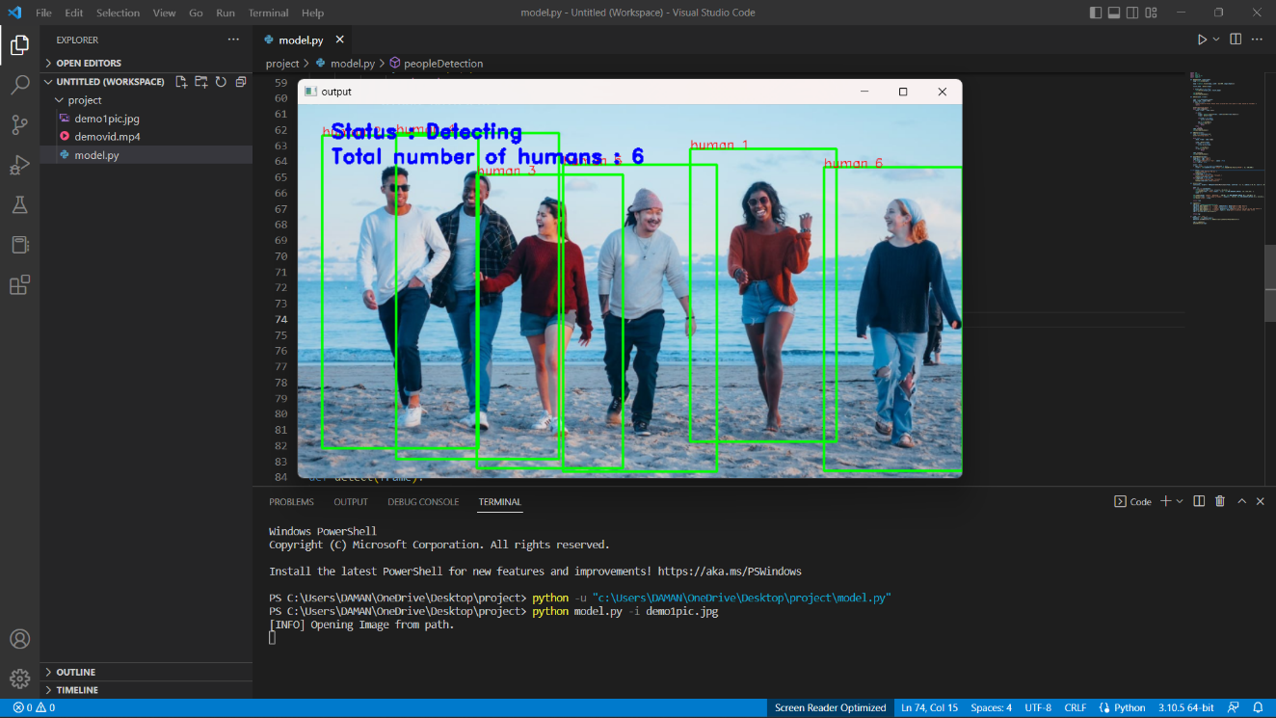

#### 4.1.2-For videos:-

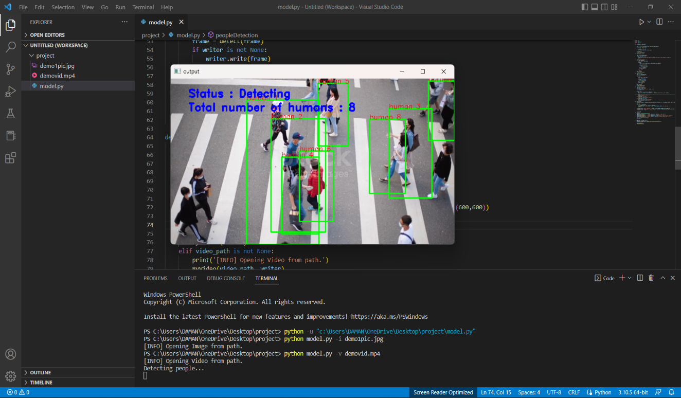

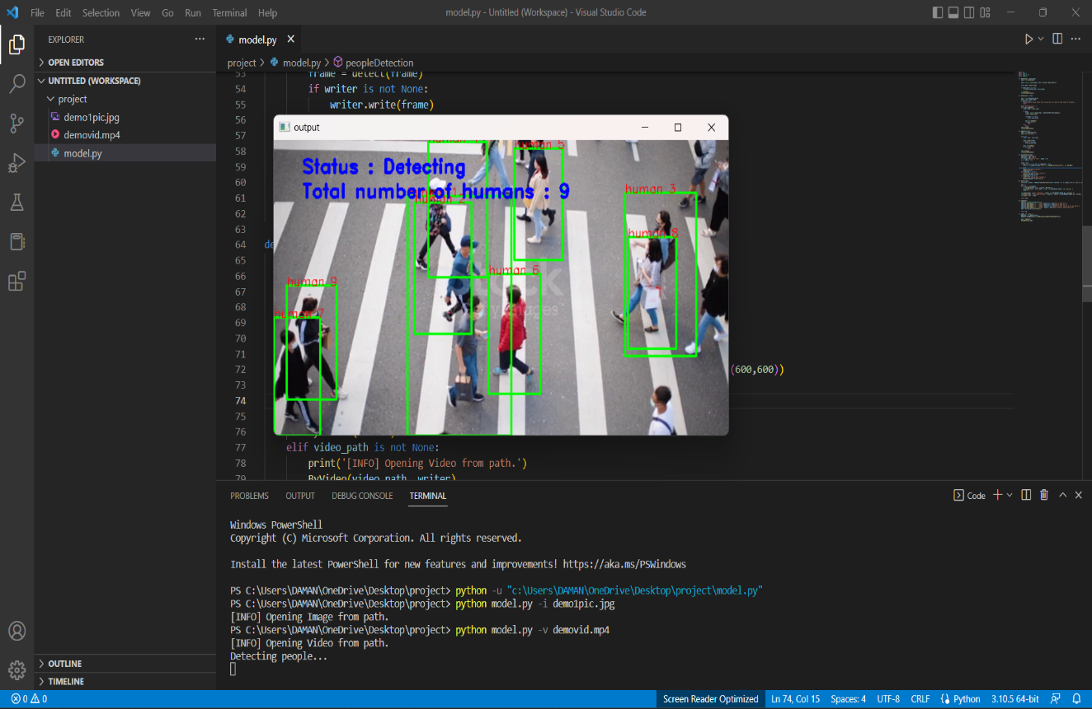

### 4.2-Discussion:

Although the results are not so accurate but it can detect and count people upto some extent. In this project ,we have used open cv library to detect and process the images according to user’s wish . We have also used imutils library for resizing the image according to the required dimensions. HOG algorithm is used to detect the people in the frame. We are calling pretrained model of human detection from open cv and providing it as a source for support vector machine. By this we will able to detect human in the videos, images etc. Although using hog algorithm we cannot get the accurate results by it but it will detect humans upto some extent. Using hog we cannot recognize the person which is to close to the camera. There are some drawbacks in this project but in future I will try to reduce those draw backs so it will work accurately.

# Chapter 5

**Conclusion and Future Work**

We humans are very social animal, so we gather around for many purposes like celebrating a festival, a party, a marriage and various other things. And people detection is important to avoid some mishappening or for security purposes, for surveys, government works etc. Real-time crowd counting in videos becomes more and more important for public area monitoring for the purpose of safety and security. The goal of crowd counting is to estimate the number of people passing through a given line or a given area. It has many valuable real-world applications, such as controlling the number of people in the venues, estimating the people flow in the subway station, counting people entering and exiting. Keeping this all things in our mind we have made a project which will able to detect human in frames.

Although using hog algorithm we cannot get the accurate results by it but it will detect humans

Upto some extent. Using hog we cannot recognize the person which is to close to the camera. There are some drawbacks in this project but in future I will try to reduce those draw backs so it will work accurately.

In future I will try to make this project more efficient by using the other best algorithms for

Human detection as this project is very useful in our daily life.

### 5.1-Future of human detection model and their usage:-

#### **5.1.1**-Automated people counting systems are becoming increasingly popular, as they offer a cost-effective solution for businesses to accurately track the number of visitors in their establishments. Such systems can be used to determine peak periods, calculate footfall patterns and gather more detailed insights into consumer behavior.

#### **5.1.2**-Facial recognition software is also gaining traction in many industries, as it allows businesses to quickly identify customers and verify their identities with a high degree of accuracy. This technology can be used to enhance security measures and personalize the customer experience.

#### **5.1.**3-Big data analytics has become essential for businesses that want to gain insights from the large volumes of customer data they collect on a daily basis. By using sophisticated analytics tools, companies can uncover valuable trends related to purchasing habits, preferences and more.

**References**

[1]Navneet Dalal and Bill Triggs “**Histograms of Oriented Gradients for Human Detection**”INRIA Rhone-Alps, ˆ 655 avenue de l’Europe, Montbonnot 38334, France {Navneet.Dalal,Bill.Triggs}@inrialpes.fr, <http://lear.inrialpes.fr>

[2] Xinjian Zhang and Liqing Zhang “**Real Time Crowd Counting with Human Detection and Human Tracking**” Key Laboratory of Shanghai Education Commission for Intelligent Interaction and Cognitive Engineering, Department of Computer Science and Engineering, Shanghai Jiao Tong University, China {zha,lqzhang}@sjtu.edu.cn

[3]Sourceforge-<https://sourceforge.net/software/people-counting/#:~:text=People%20counting%20software%20can%20be,related%20to%20understanding%20individual%20behavior>