Week 4 Progress

1) I set up two Glue crawlers: zomato_crawler_et and zomato_curated_database. The zomato_crawler_et crawler is responsible for creating the raw Zomato database (zomato_db), whereas the zomato_curated_database crawler is used to generate the curated Zomato database (zomato_db_curated).
zomato_crawler_et:
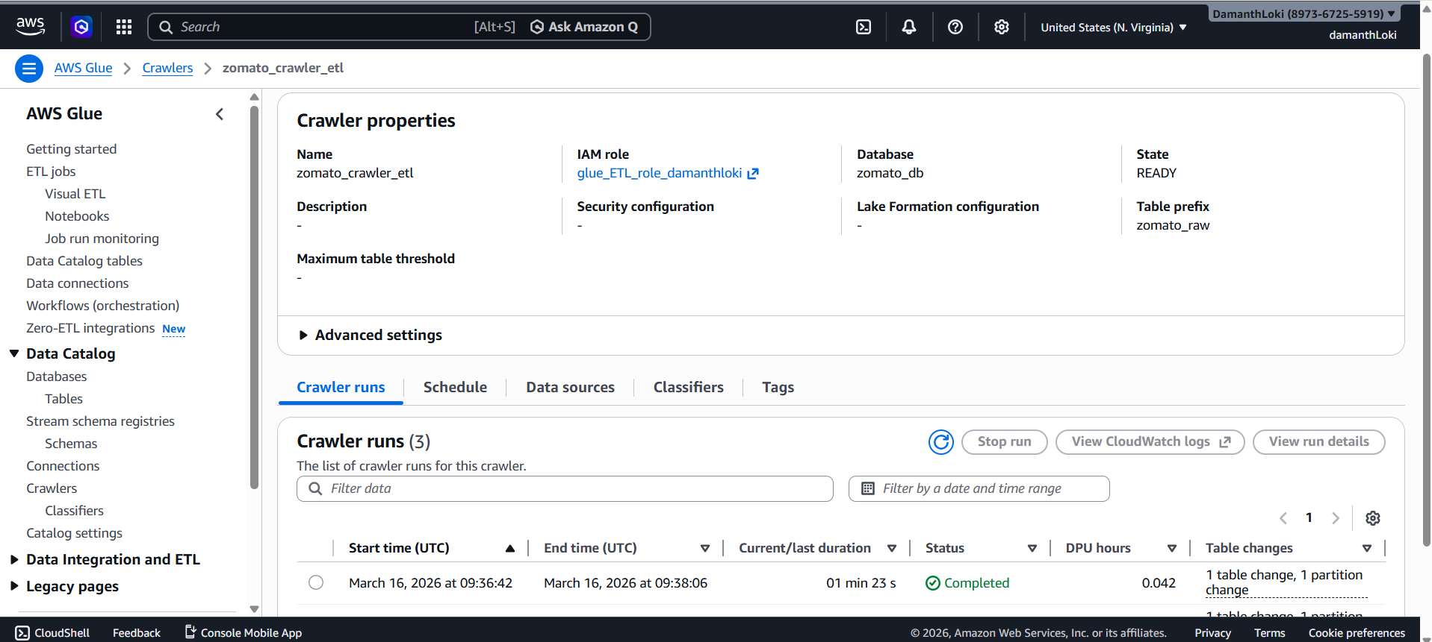
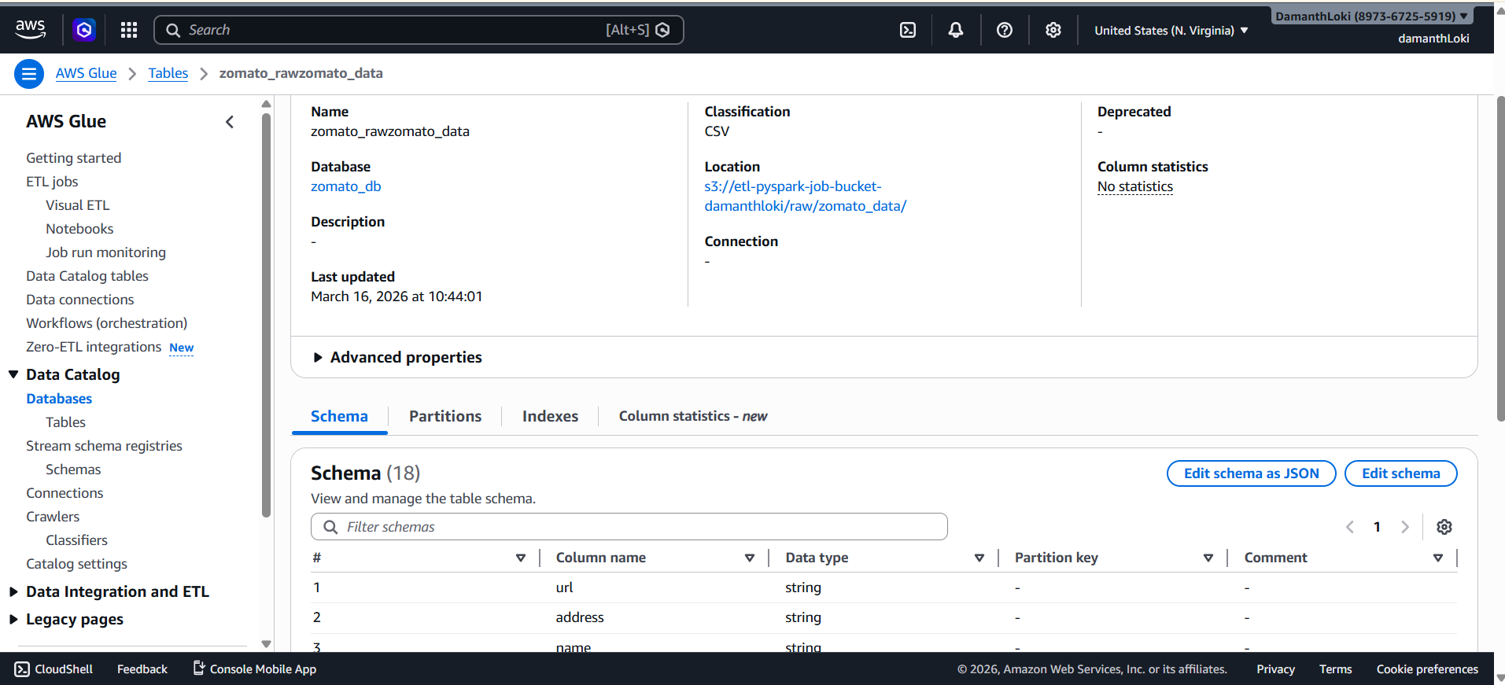
zomato_curated_database:
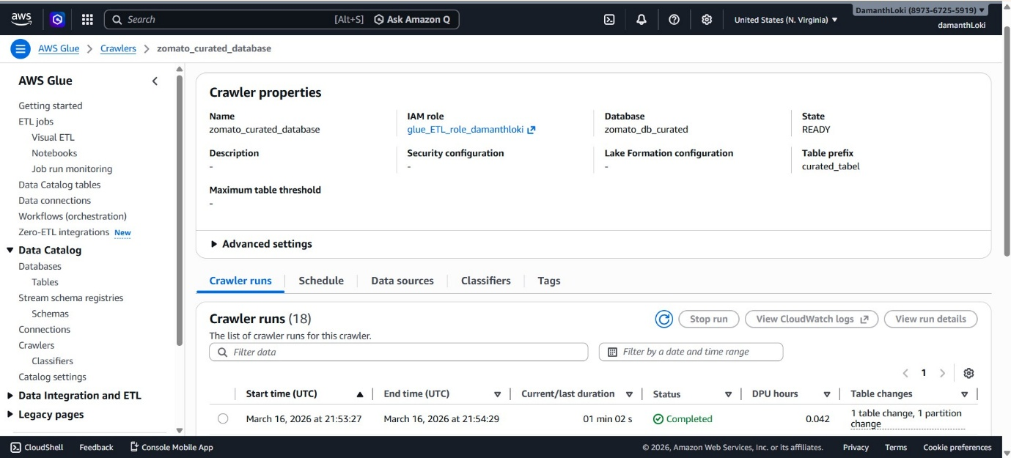
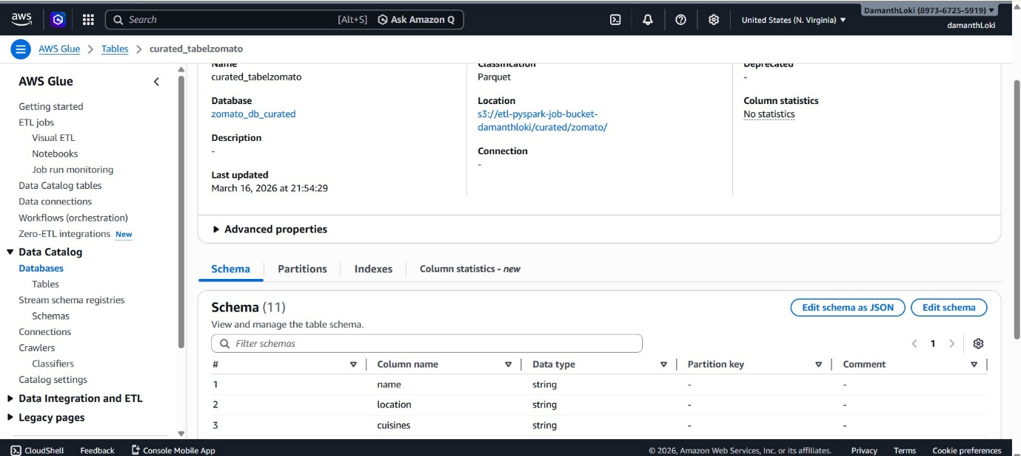

2. I designed and implemented a Glue job to ingest raw data from S3, perform necessary transformations and data cleansing, and write the processed data as partitioned Parquet files to the curated layer. Additionally, I configured job bookmarks for incremental processing and incorporated retry mechanisms to enhance robustness. The Glue job settings are outlined below.
Parameter Value
Job Name etl-job-zomato
IAM Role glue_ETL_role_damanthloki
Glue Version 4.0- Supports Spark 3.3, Scala 2, Python 3
Worker Type G.1X(4vCPU and 16GB RAM)
Number of Worker 2
Language Python
Script location s3://etl-pyspark-job-bucket-damanthloki/scripts/zomato_glue_etl.py
Job bookmark Enabled
IAM role glue_ETL_role has permisions AmazonS3ReadOnlyAccess, AWSGlueServiceRole, CloudWatchLogsFullAccess.
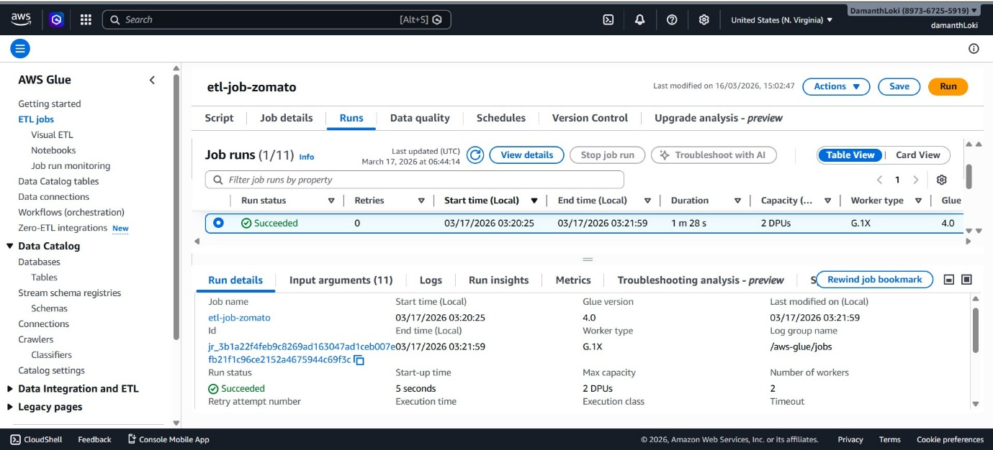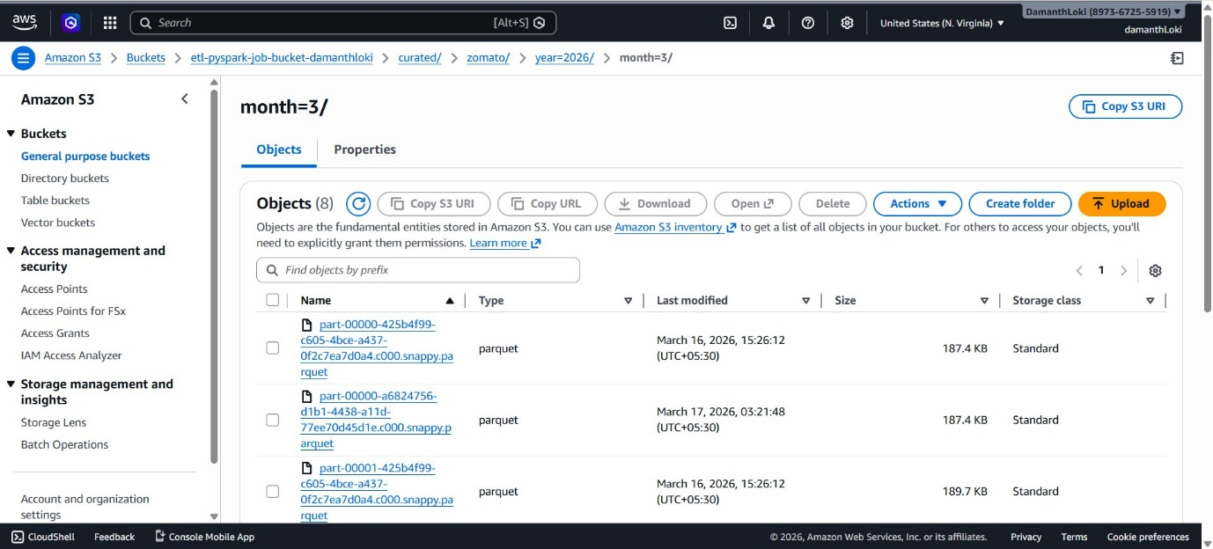
3) I configured Lake Formation permissions to provide Athena with read access to the curated data while restricting access to the raw data, and validated the setup using a limited IAM user.
Data lake data access permissions:
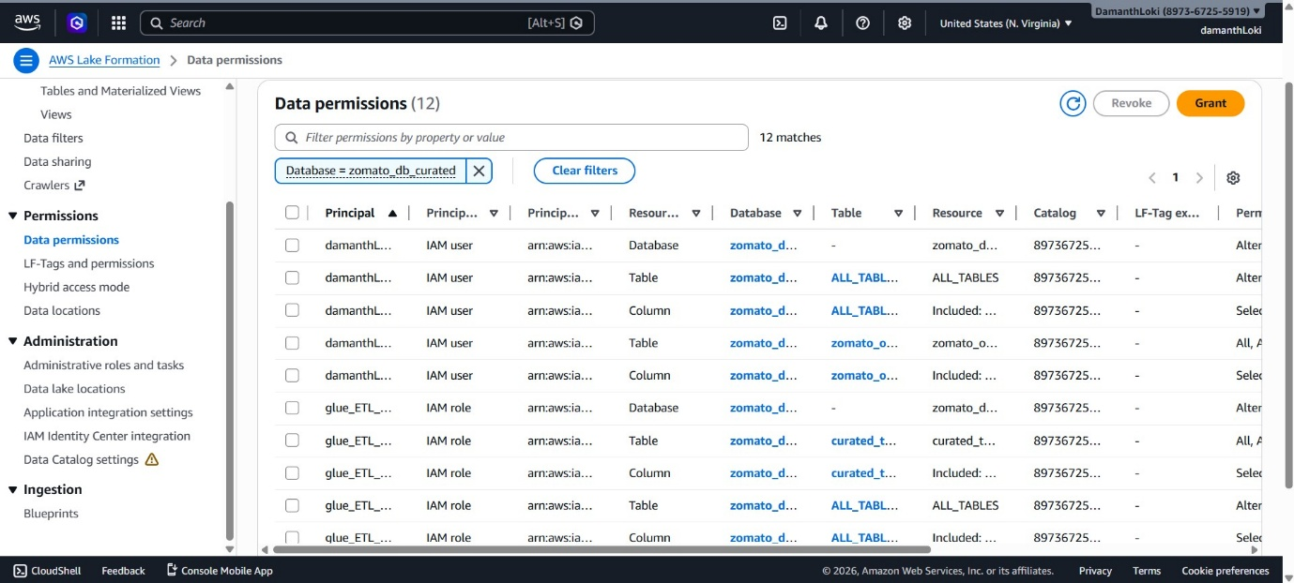
Data lake data location access permissions:
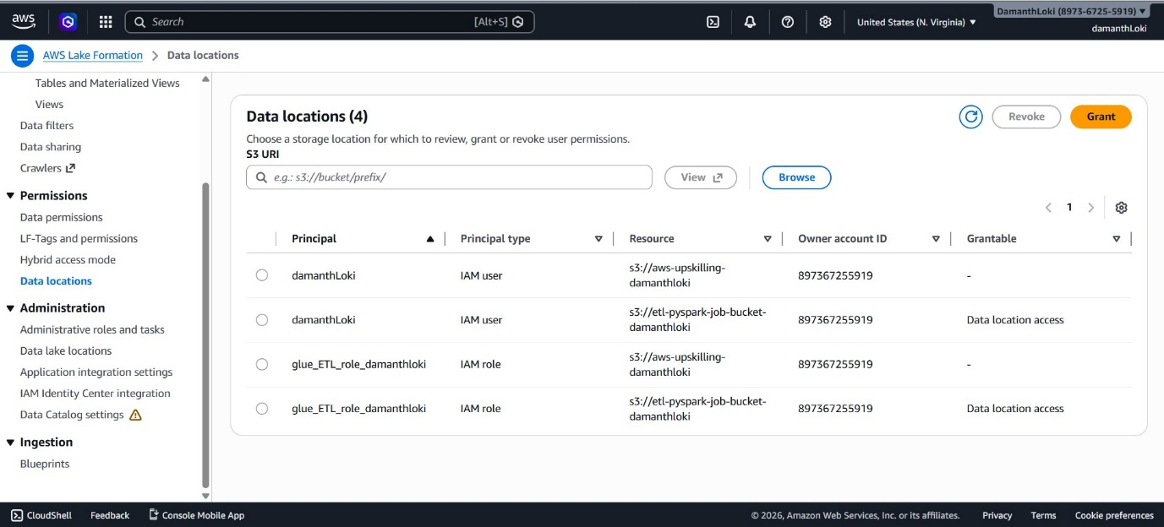
The query on the curated database table executed successfully without any errors:
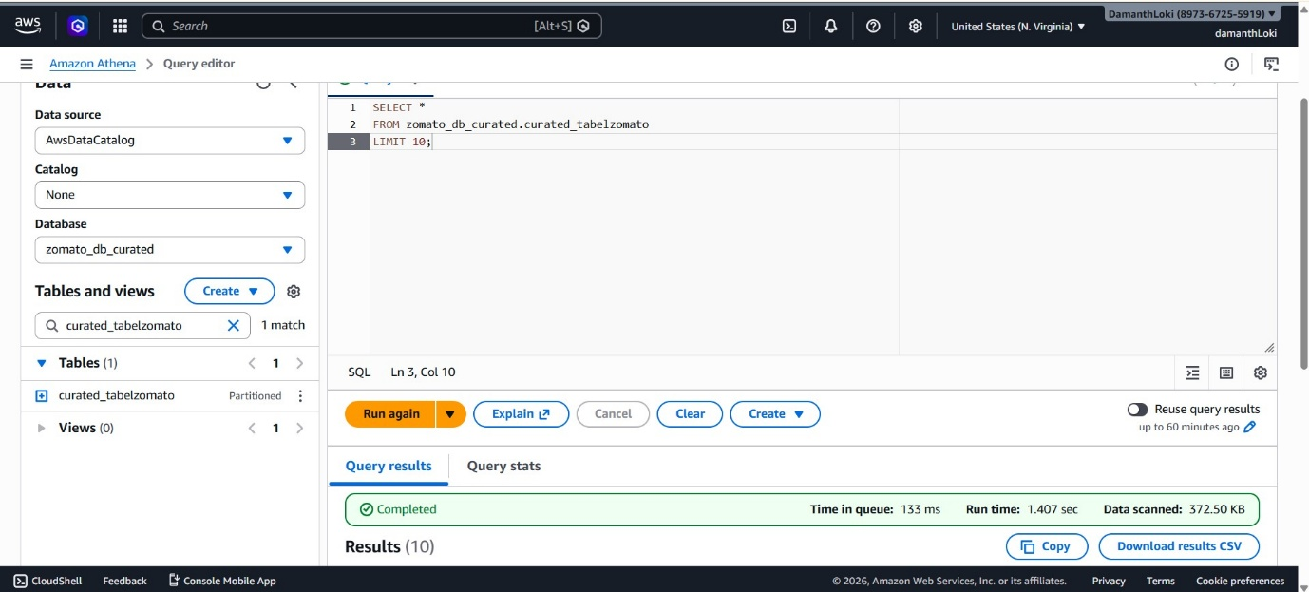The query on the raw database table resulted in an error:
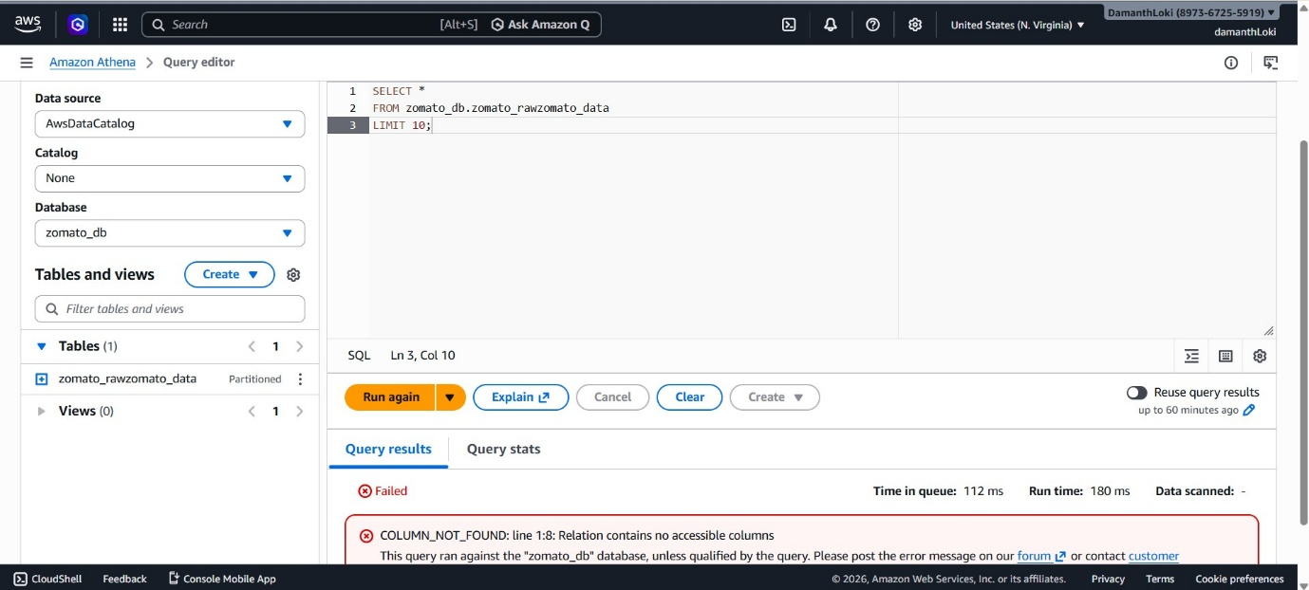

4) I first created a zomato_optimized table using a CTAS query. I then executed a simple SELECT query on both the curated and optimized tables. The results showed a reduction in query execution time from 746 ms to 702 ms.
CTAS query:
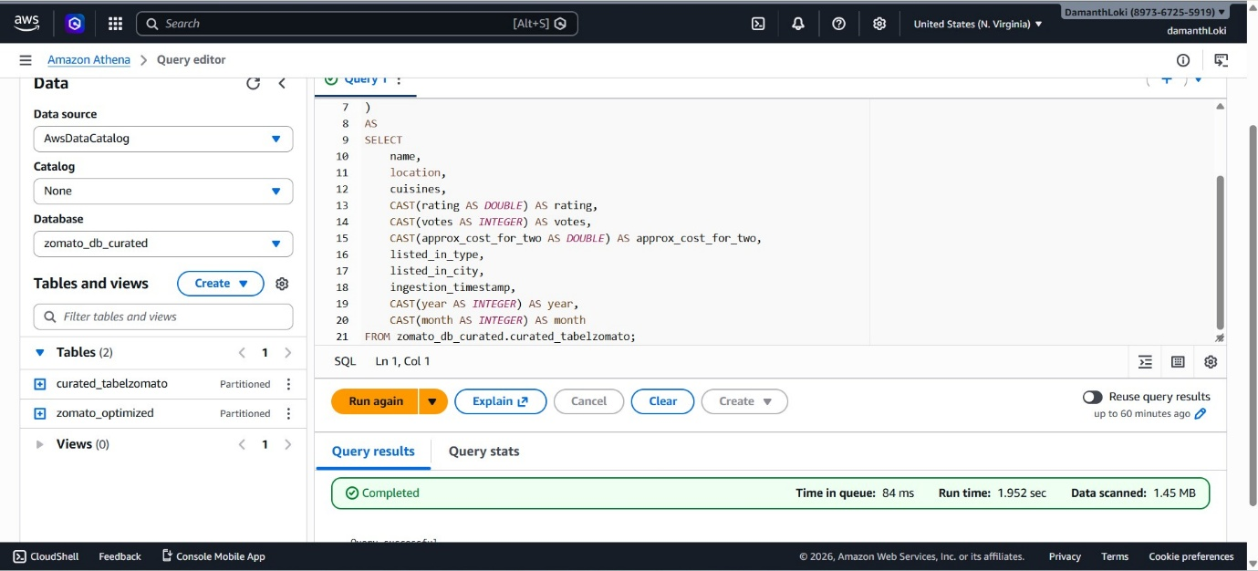
Query executed on the curated table:
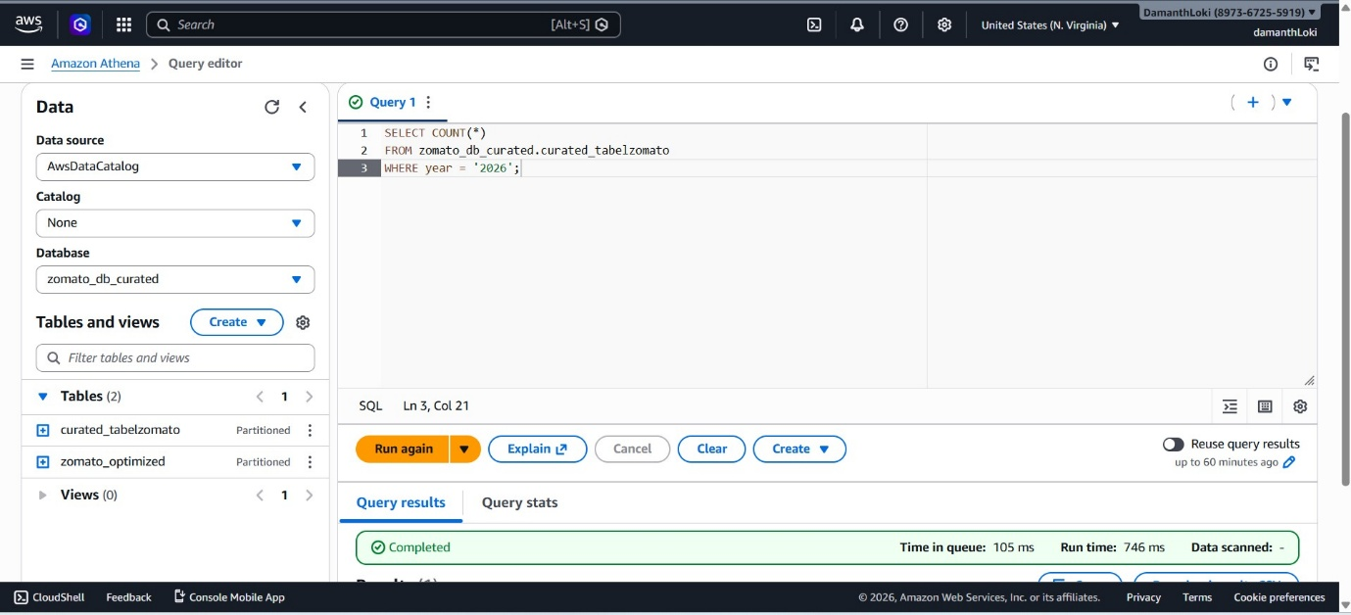
Query executed on the optimized table:
