Week 5 Progress
1) I have designed an automated data pipeline that ingests raw data, transforms it, validates it, and notifies stakeholders.
Workflow:
S3 (raw CSV)
↓
Glue ETL (clean + transform)
↓
S3 (curated Parquet)
↓
Athena (query + validation)
↓
Step Functions (orchestration)
↓
SNS (notifications)
a) Data Ingestion (S3):
I created an S3 bucket and uploaded the Zomato.csv data file into the raw folder.
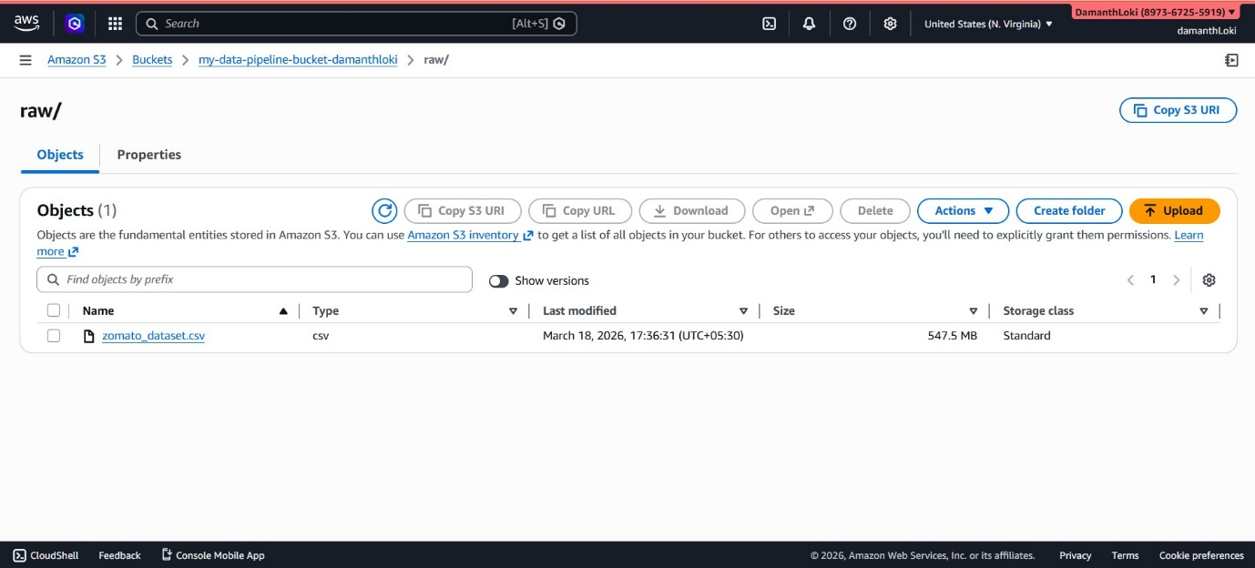
b) Data Transformation using a Glue Job:
The Glue job specifications are:
- Type: Spark
- Glue version: Glue 5.0 (supports Spark 3.5, Scala 2, Python 3)
- Language: Python 3
- Worker Type: G.1X (4 vCPU and 16 GB RAM)
The cleaning and transformations performed are:
- Fixed column names
- Converted 'rate' to numeric
- Cleaned 'approx_cost'
- Converted Yes/No values to boolean
- Removed unnecessary columns ("reviews_list", "menu_item", "phone", "url")
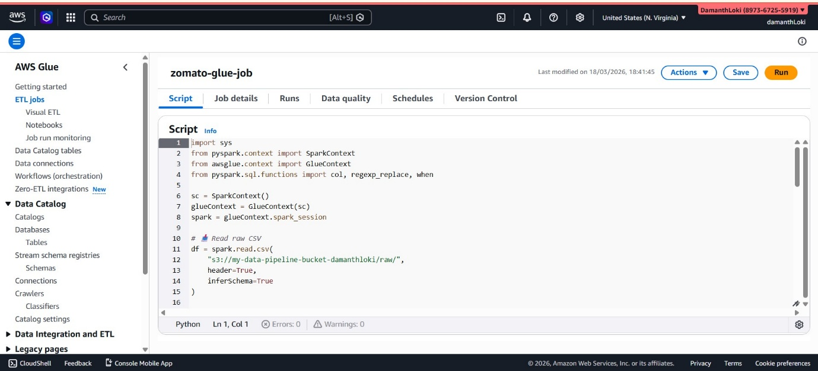
c) Data Cataloging (Glue + Athena):
Created a database “zomato_pipeline_db” and a table “zomato_curated”.
d) Data Validation:
Validated the data using Athena before executing the Step Function.
e) Step Functions:
Created a Step Function “my_pipeline_step_function” that performs the following:
- Starts the Glue job
- Waits for completion (.sync)
- Runs an Athena query
- Based on the result:
• On success → Sends a notification via SNS indicating successful execution
• On failure → Sends a notification via SNS including the error message
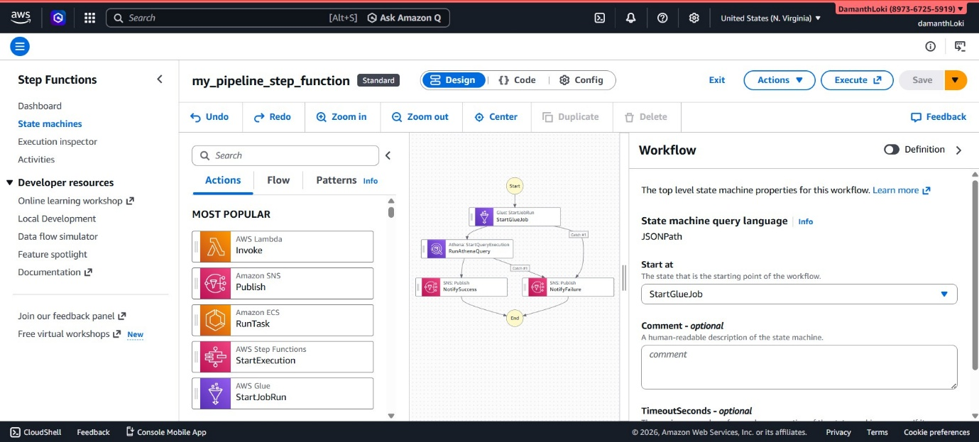
f) SNS:
Created an SNS topic “pipeline-alerts” to send success and failure notifications for the Step Function.
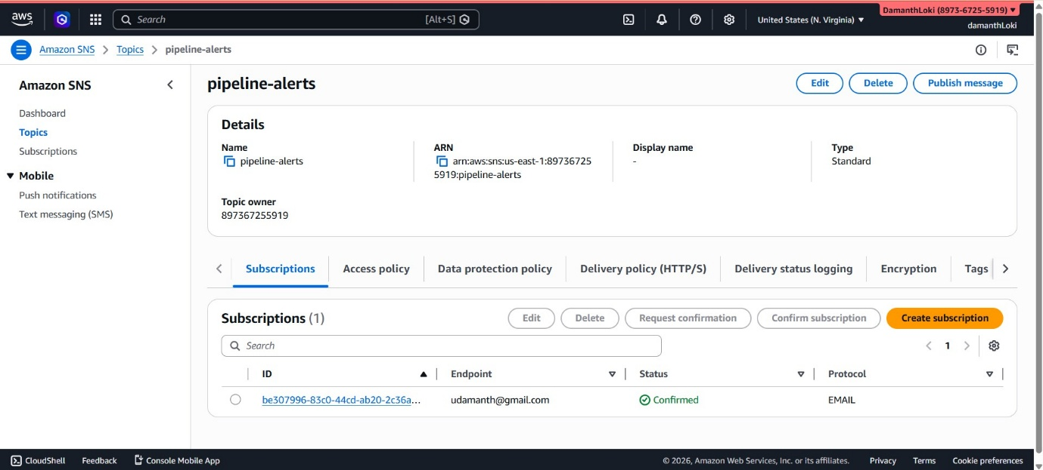
g) IAM Roles Used:
1) “glue_ETL_role_damanthloki” (Glue IAM role) with the following permissions:
- AmazonS3FullAccess
- AWSGlueServiceRole
- CloudWatchLogsFullAccess
- LakeFormationDataAccess
2) “step_function_IAM_role_damathloki” (Step Functions IAM role) with the following permissions:
- AWSLambdaRole
- AWS Glue access
- Amazon Athena access
- Amazon SNS access
h)Below are the screenshots showing the results and success status of the Step Function.
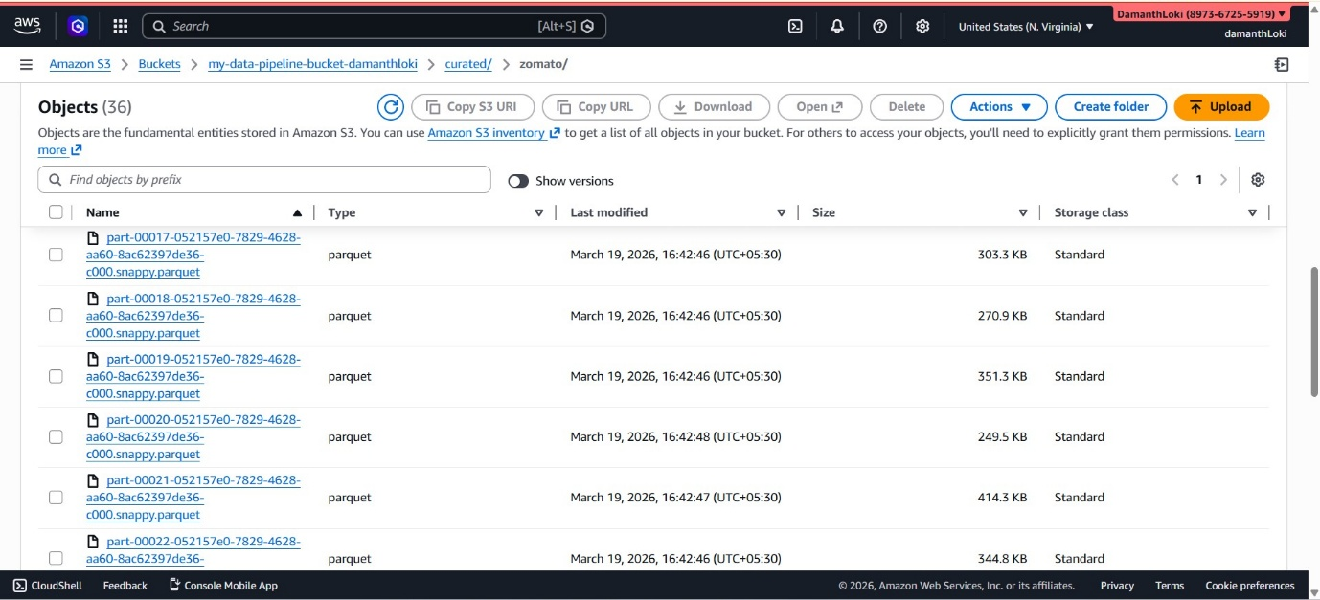
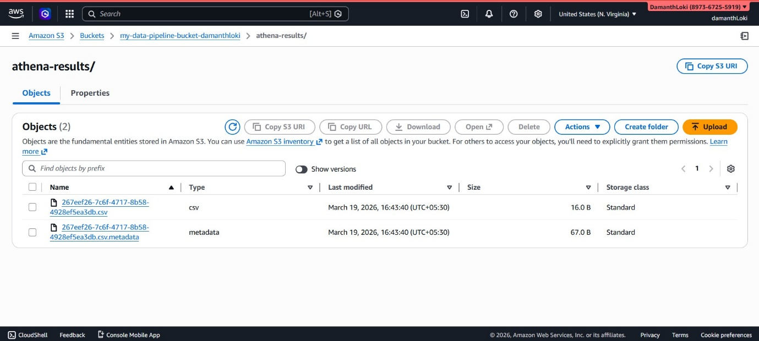
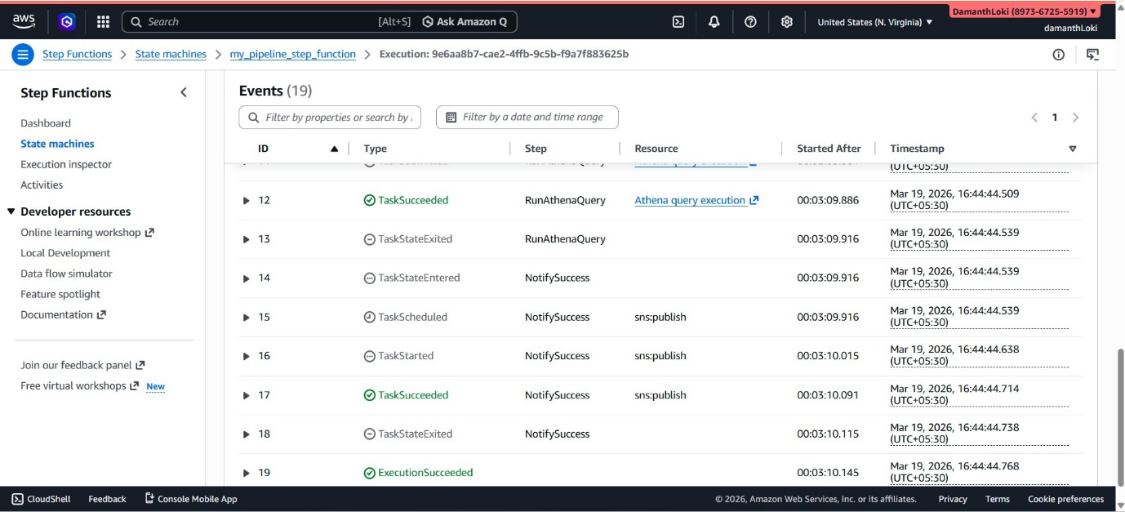
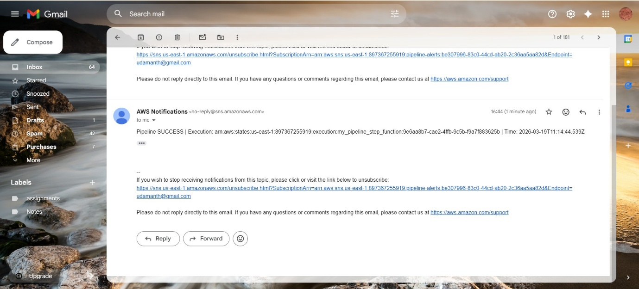
2) API Gateway Ingestion Layer
This week, I implemented a real-time ingestion layer using Amazon API Gateway integrated with AWS Lambda.
- Implemented an Amazon API Gateway REST API for event ingestion
- Created a POST /events endpoint using Lambda Proxy Integration
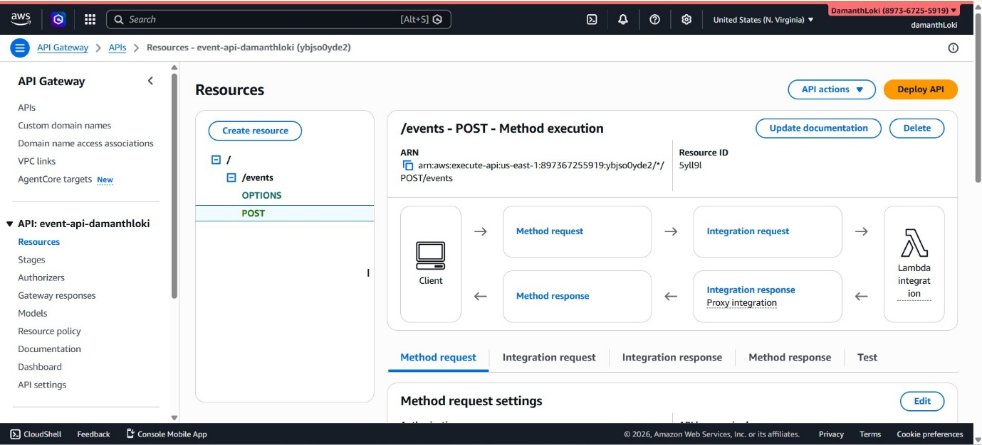
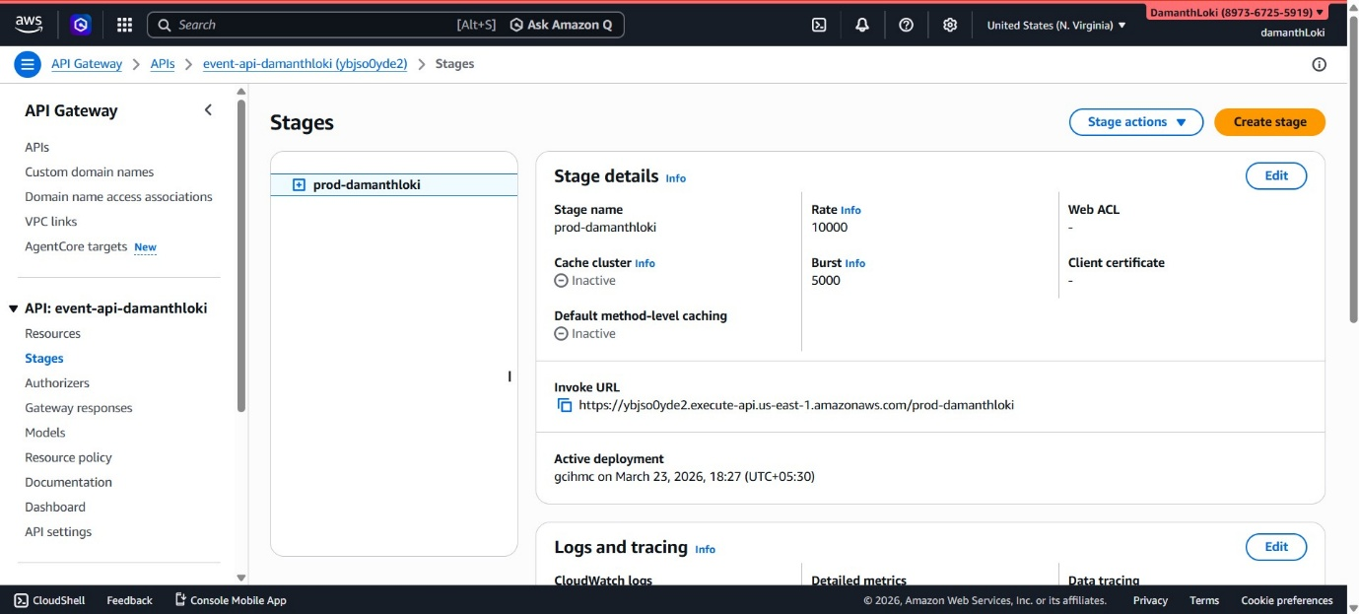
- Enhanced the Lambda function to:
  - Validate incoming requests (e.g., ensure event_type is present)
  - Enrich events with metadata (timestamp, client IP)
  - Store processed records in Amazon S3 under raw/events/
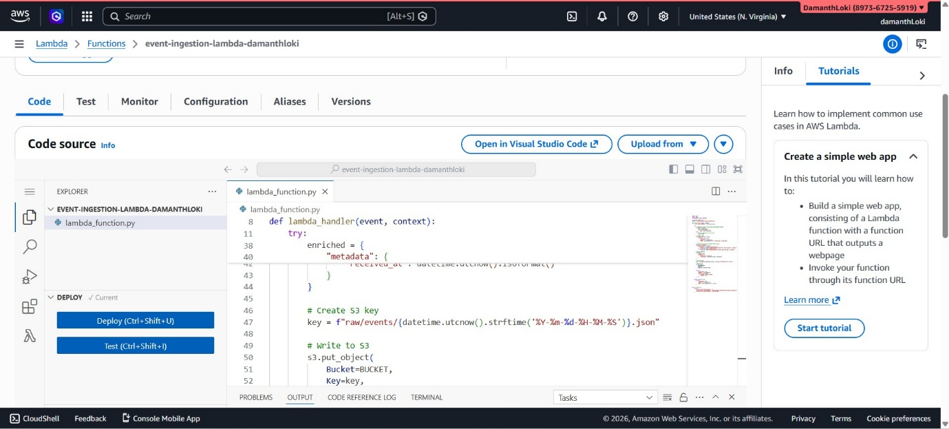
- Enabled CORS for secure cross-origin access
- Configured an API key and usage plan for access control and throttling
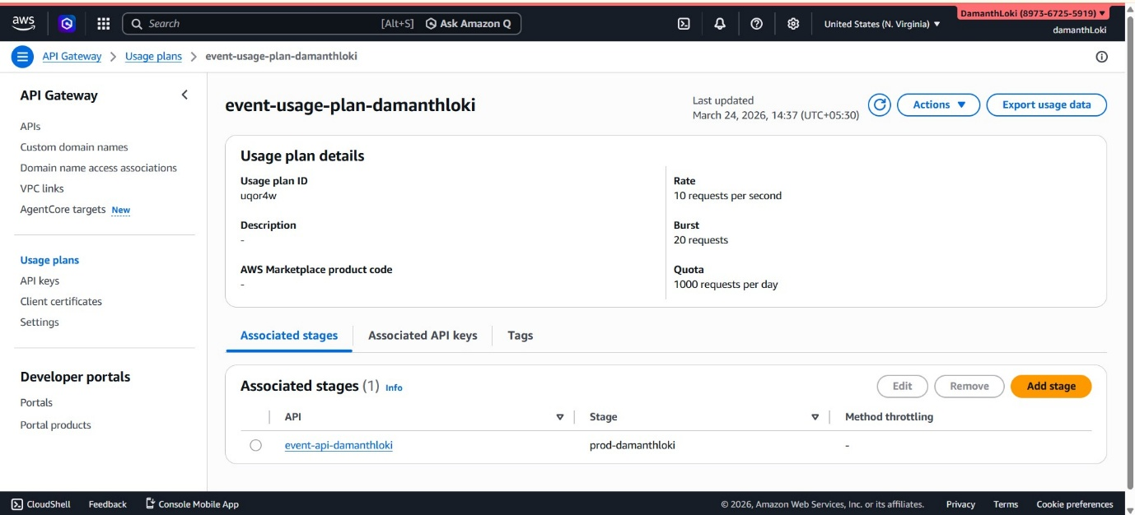
- Enabled CloudWatch logs and metrics for monitoring
- Created CloudWatch alarms for:
  - 5XX error spikes
  - High latency
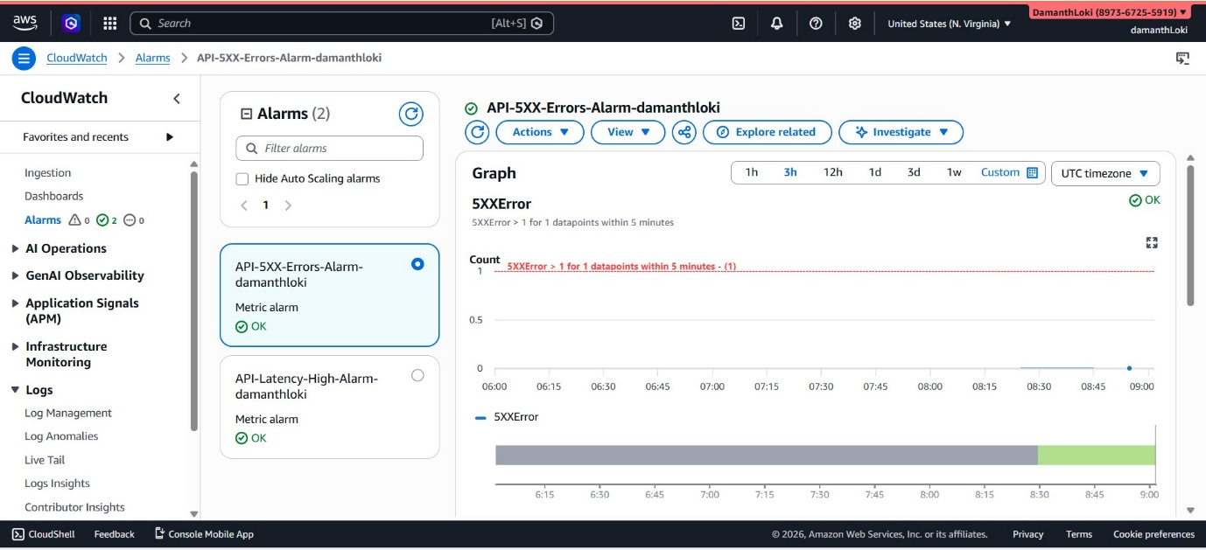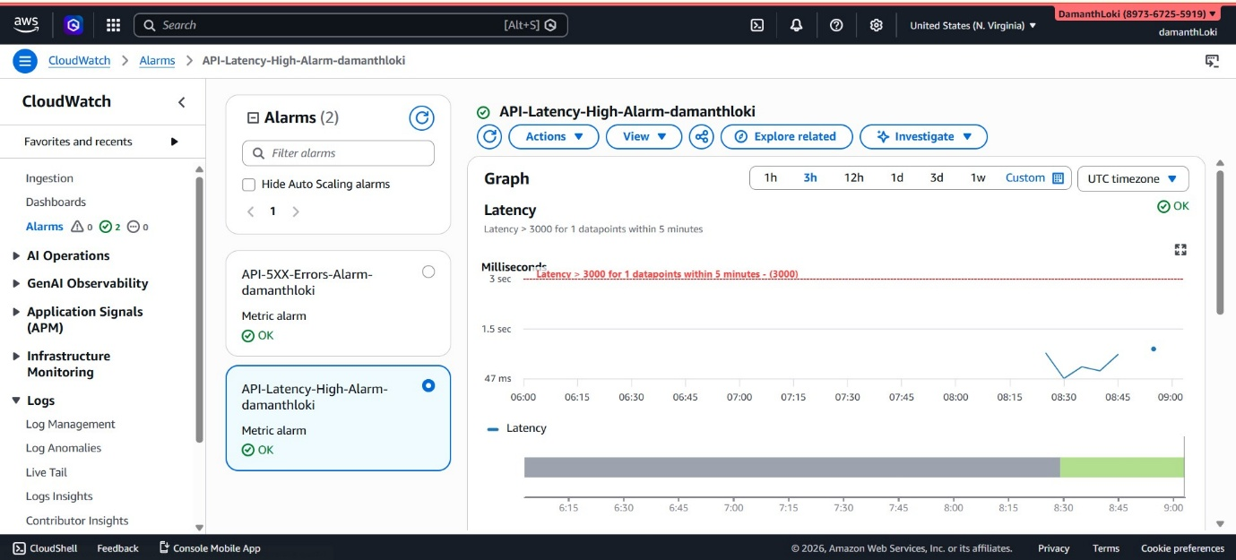
- Performed end-to-end testing using curl, confirming successful ingestion to S3
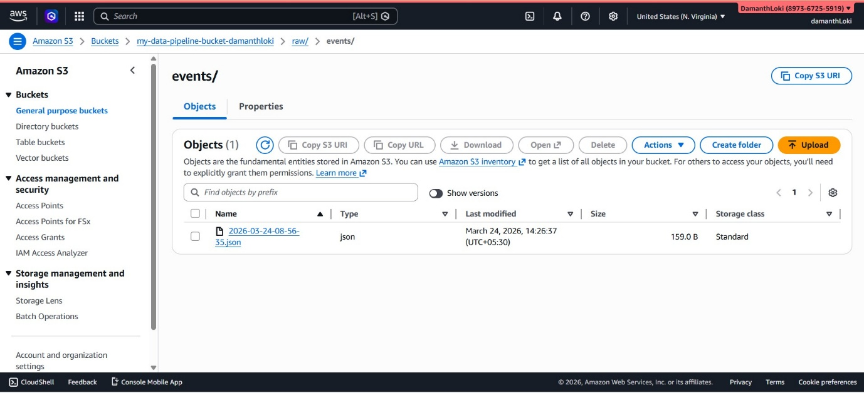
This API now acts as the primary ingestion entry point for the pipeline, integrating with AWS Glue, Athena, Step Functions, and SNS.

