Week 6 Progress
1)Designed and implemented a CI/CD pipeline using GitHub Actions to automate infrastructure deployment on AWS.
- Developed an Infrastructure-as-Code solution using AWS CloudFormation to provision core resources including S3, IAM roles, Glue database, and Step Functions.
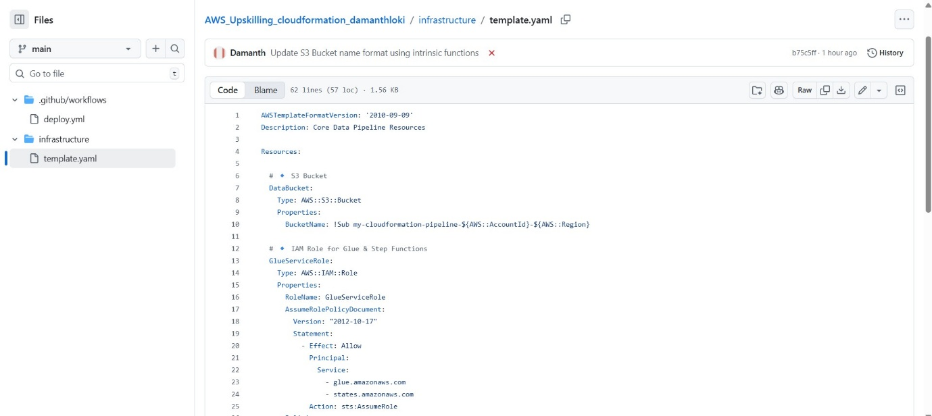
- Automated end-to-end deployment triggered on code commits, reducing manual provisioning effort and ensuring consistent environment setup.
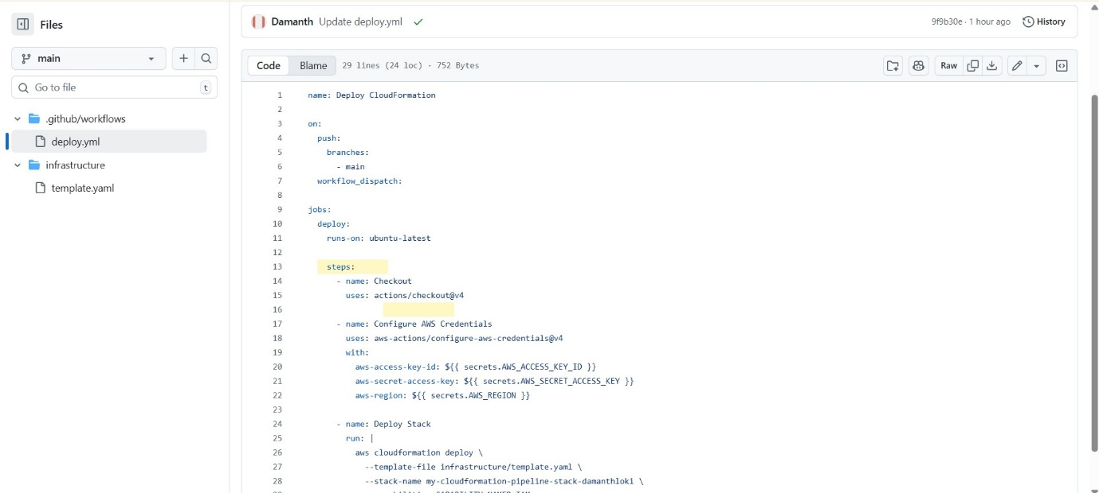
- Integrated secure credential management using GitHub Secrets for AWS authentication and access control.
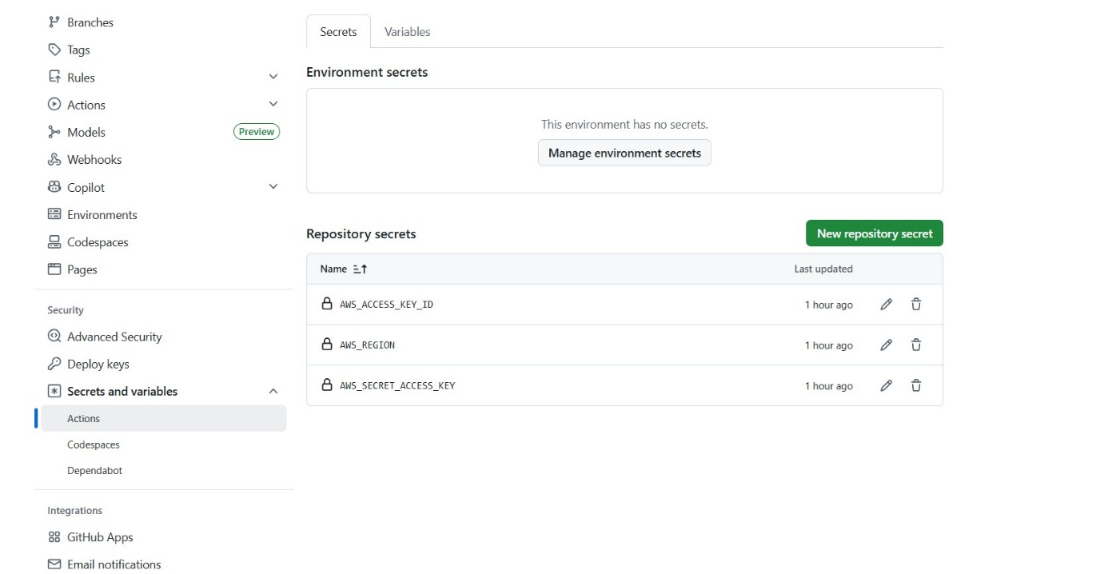
- Implemented dynamic resource naming using CloudFormation intrinsic functions (!Sub, AccountId) to avoid global conflicts and ensure reusability.
- Debugged and resolved deployment failures (S3 naming conflicts, IAM role duplication, region misconfiguration) using CloudFormation Events and pipeline logs.
- Enabled idempotent deployments and version-controlled infrastructure, improving reliability and maintainability of the data pipeline architecture.
- Validated deployments by testing workflows in AWS Step Functions and verifying resources across AWS services.
