Week 7 Progress:

1)I created an S3 bucket named "week7-upskilling-bucket-damanthloki" and developed a Python script to generate synthetic user activity data (user_id, event_type, timestamp, device, country) for recent dates. The script saves the data as partitioned JSON files and uploads them to the S3 bucket with retry logic and logging.
A sample user activity record is as follows:
{
"user_id": "a1b2c3d4e5f6",
"event_type": "purchase",
"timestamp": "2026-03-31T18:42:10Z",
"device": "mobile",
"country": "India"
}
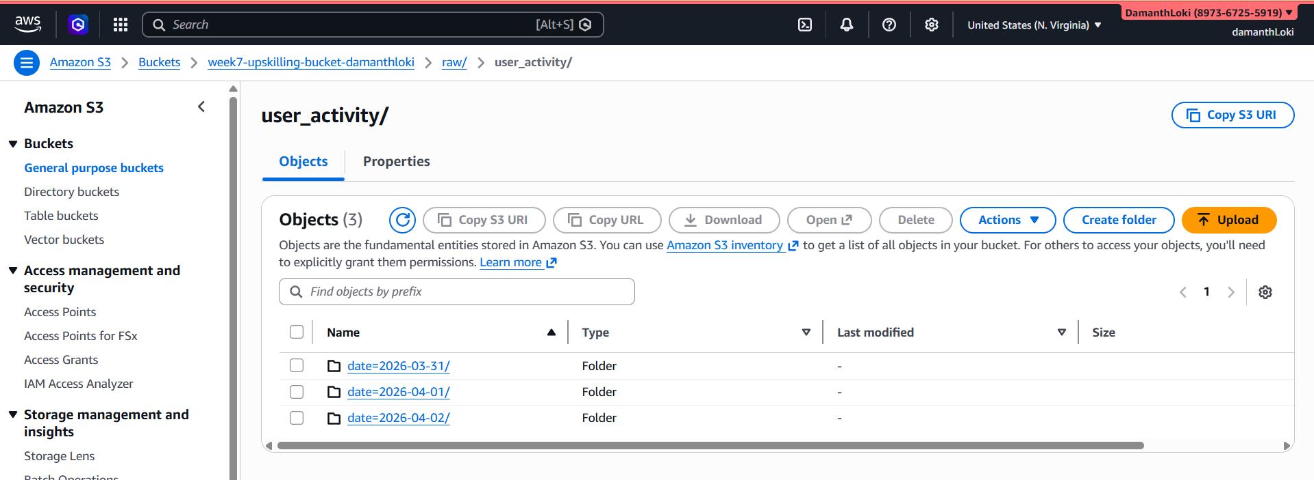
2)Next, I created a Glue Crawler named "user-activity-raw-crawler-damanthloki" to discover the schema of the raw data stored in the S3 bucket. The crawler successfully generated a table named rawuser_activity in the user_activity_db database.
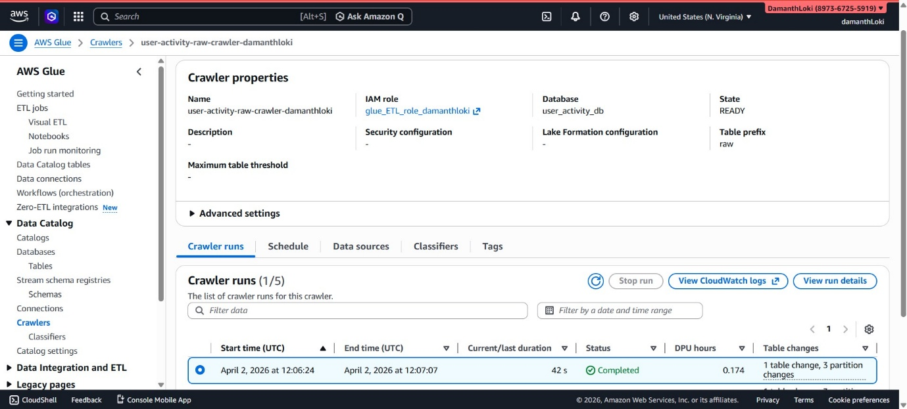
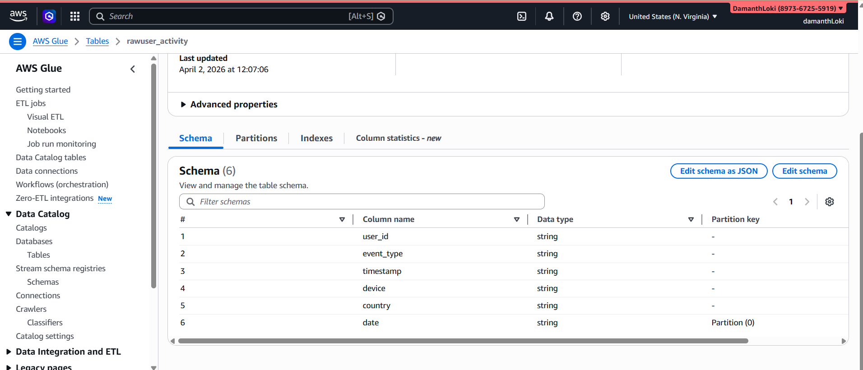
3)After that, I developed a Glue job named "user-activity-transform-job-damanthloki" to perform data transformations, including:
- Parsing timestamps
- Removing duplicate records
- Adding derived columns such as event_date, event_hour, and is_mobile
The transformed data is written to the curated S3 path:
s3://week7-upskilling-bucket-damanthloki/curated/user_activity/
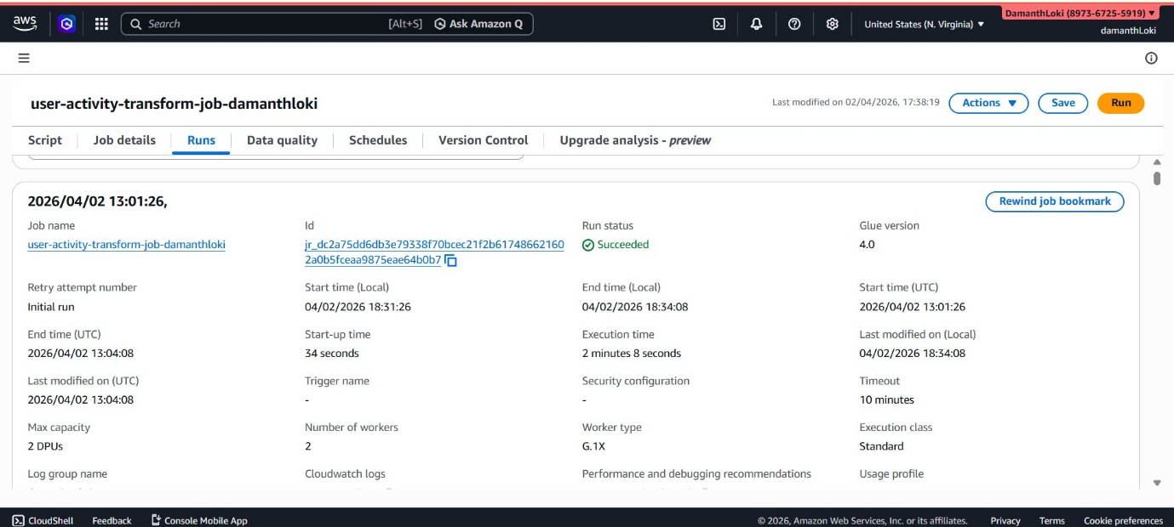
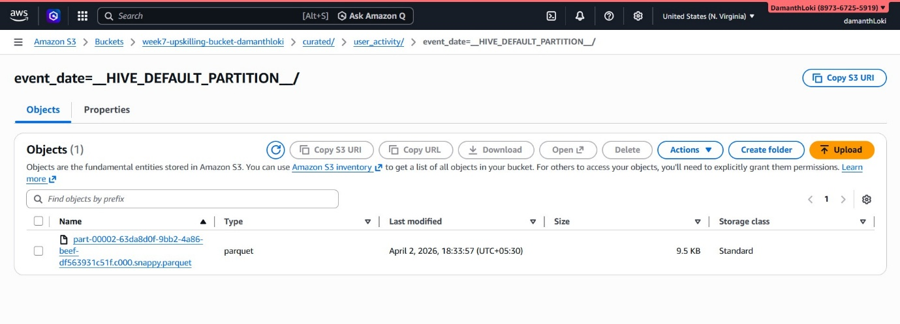
4)I then created a Step Function named "week7-user-activity-step-function" to orchestrate the workflow. This Step Function triggers the Glue job with a date parameter and handles success and failure scenarios using AWS Lambda functions.
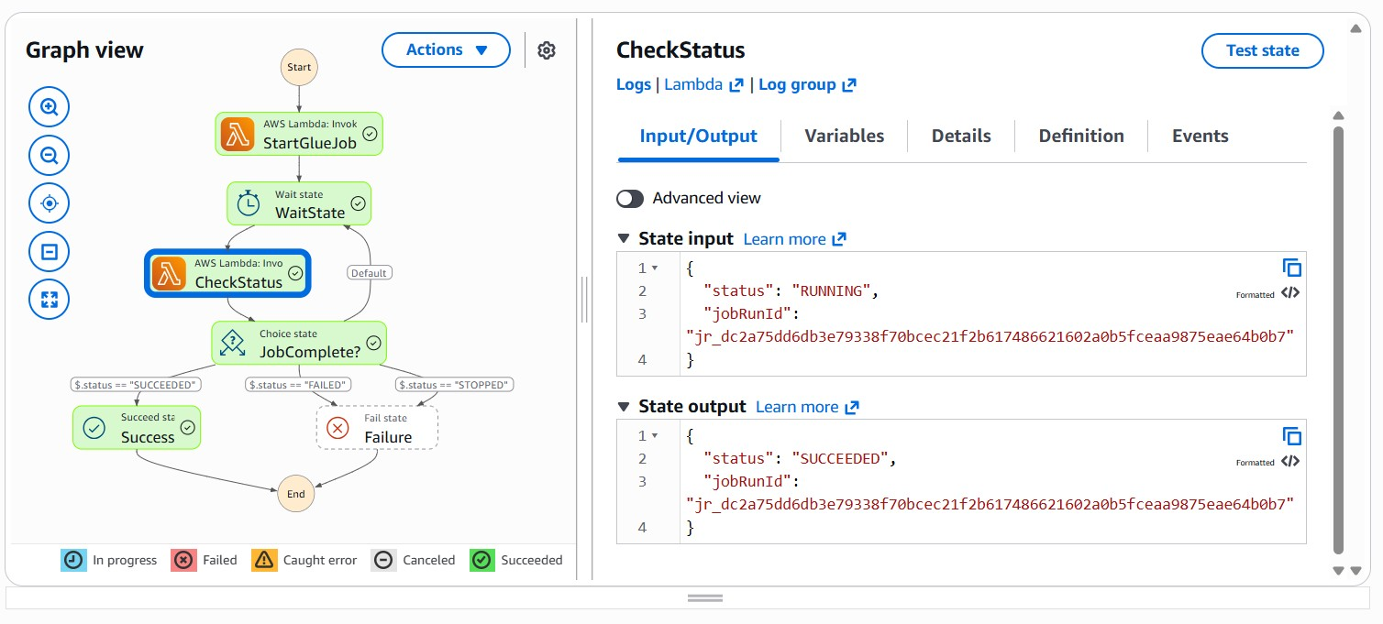
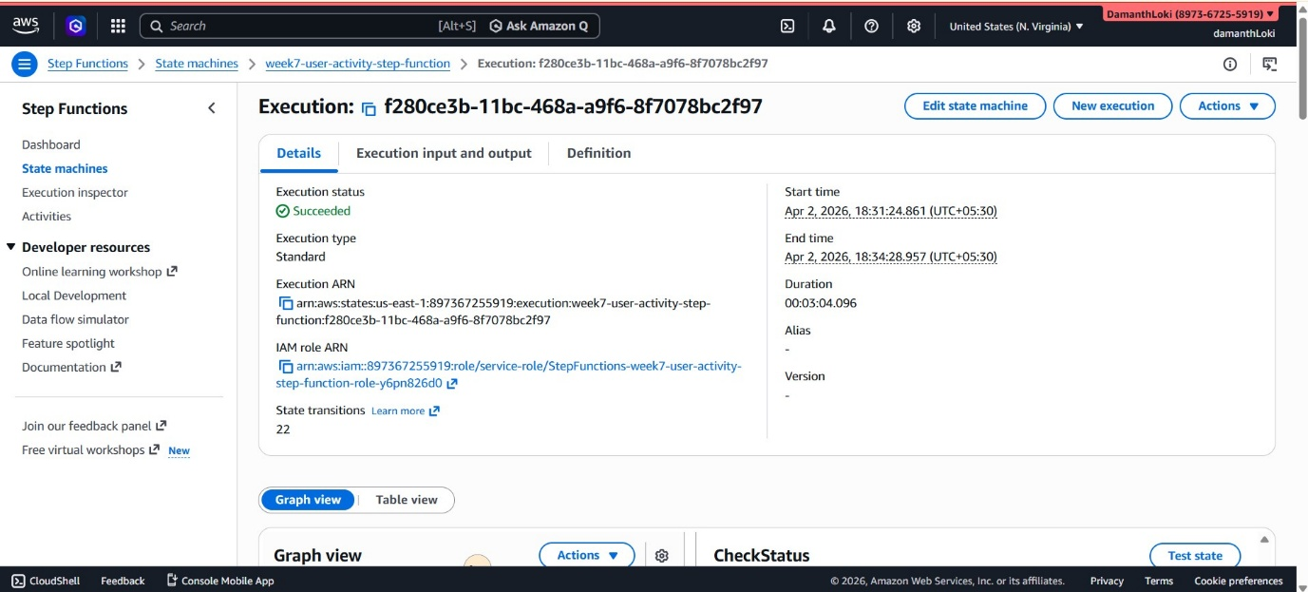
Two Lambda functions were created:
- "start-glue-job-lambda-week7" – to trigger the Glue job
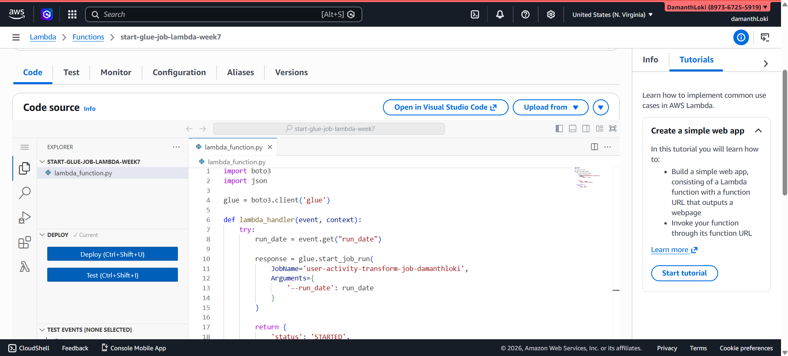
- "check-glue-job-status-lambda-week7" – to monitor the job status
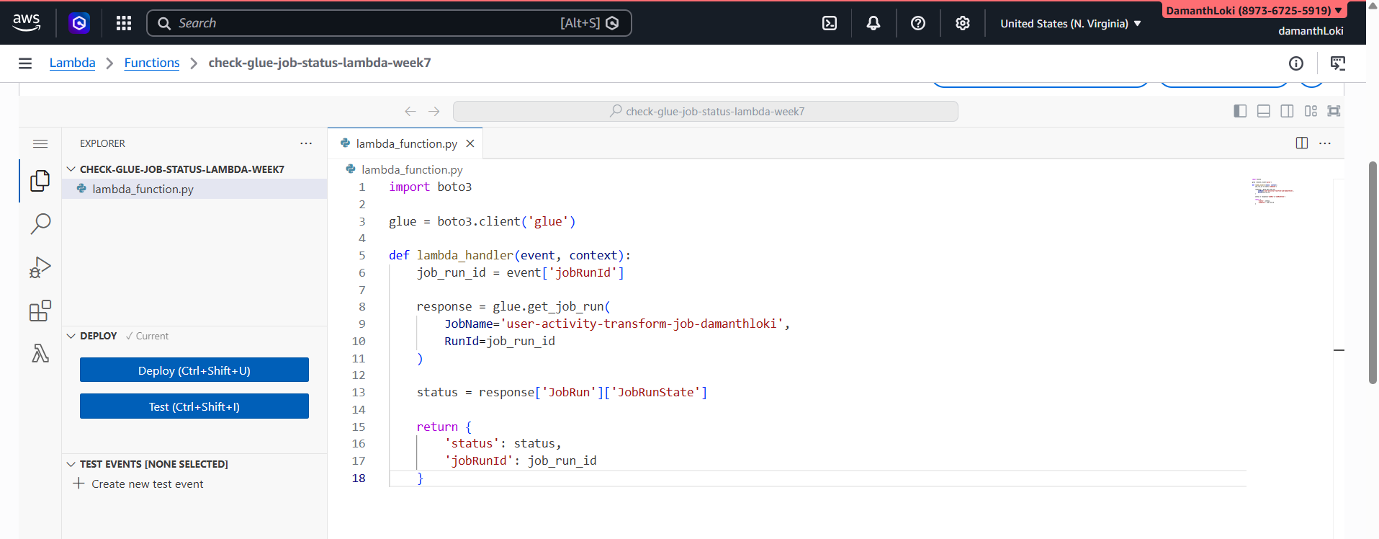
5)Finally, I created a curated table in Athena and executed several SQL queries, including:
- A query to create the curated table curated_user_activity
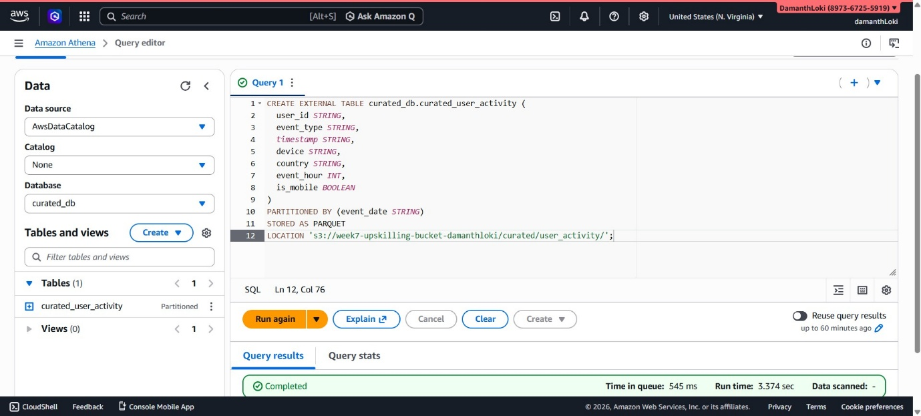
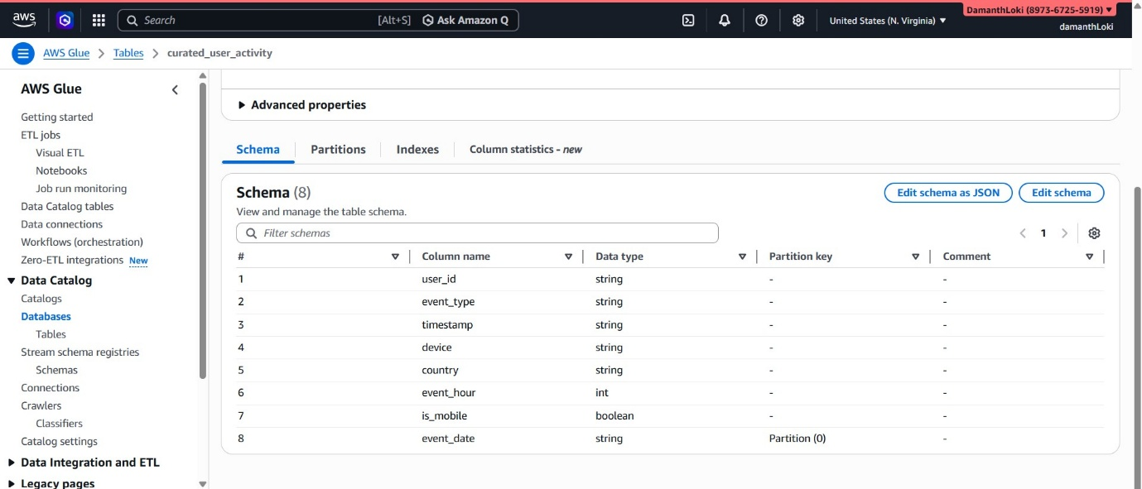
- A query to validate data in curated_user_activity
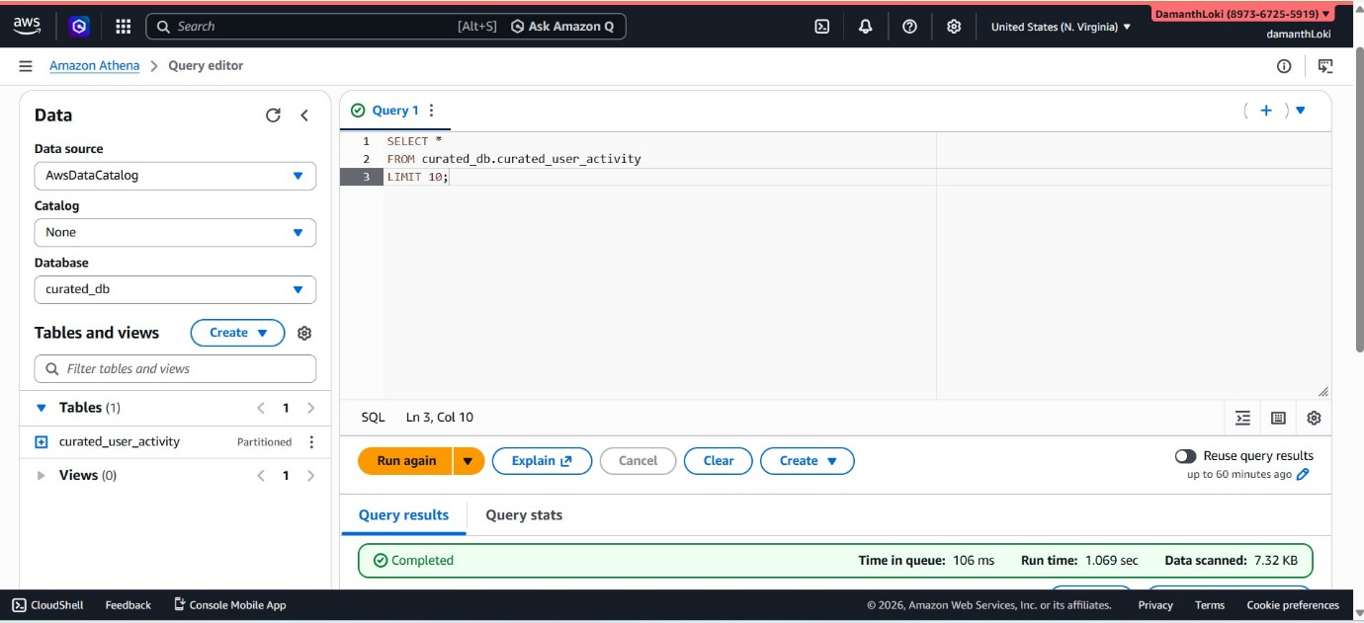
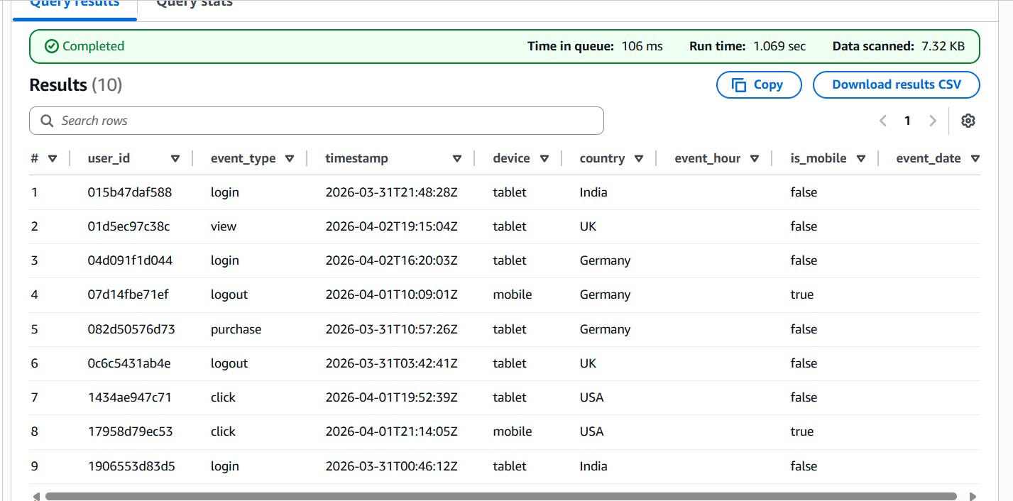
- A query to get device-wise event counts
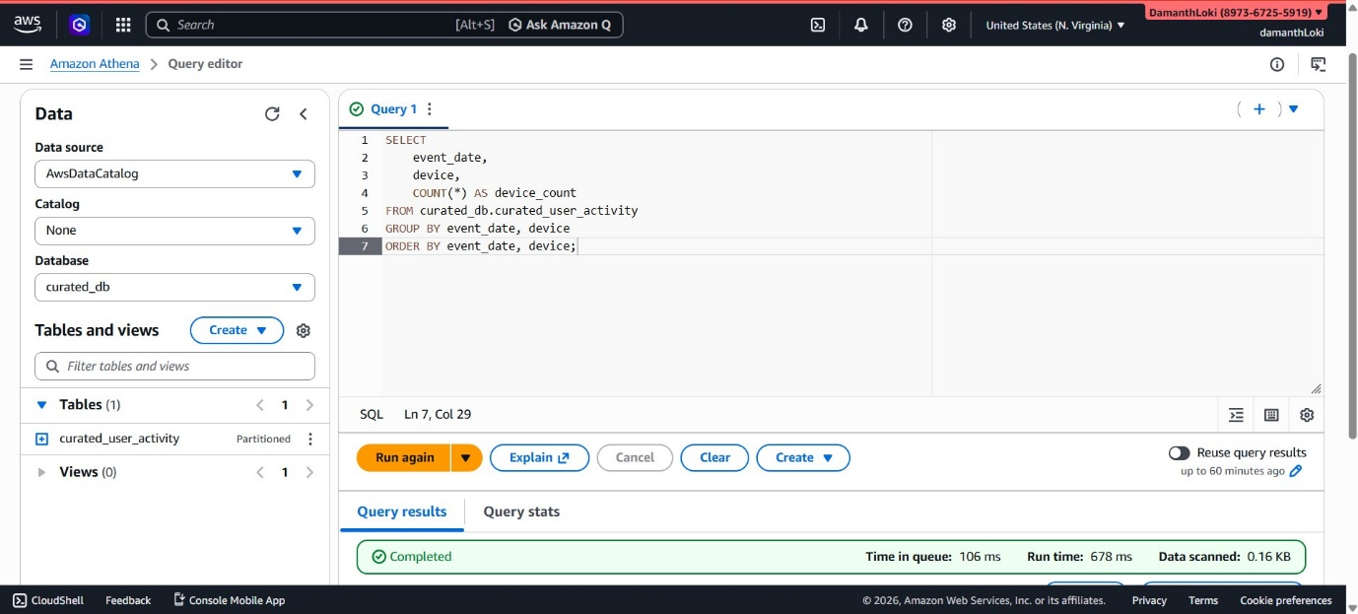
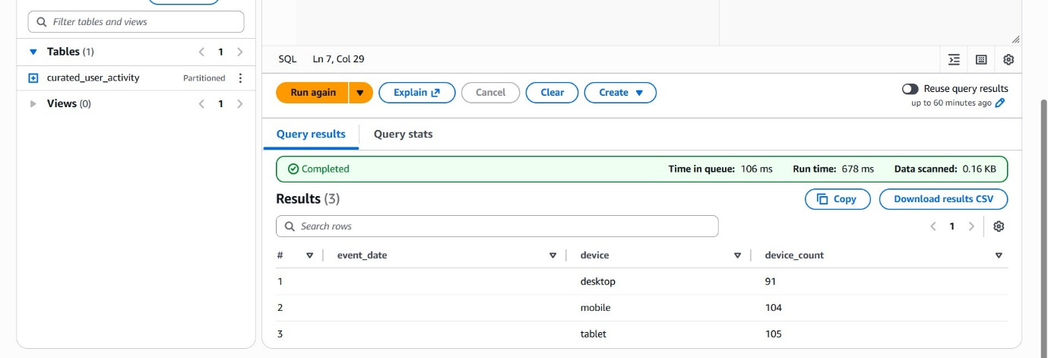
- A query to get daily event counts
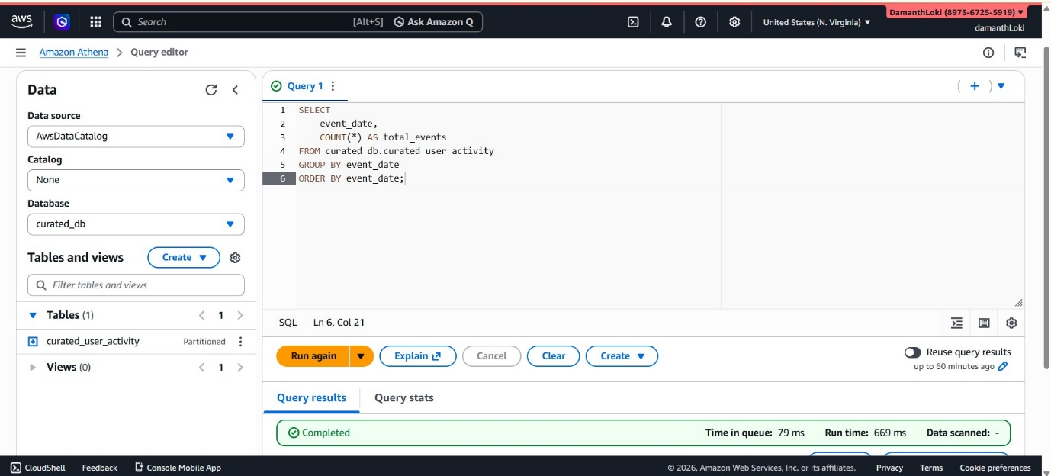
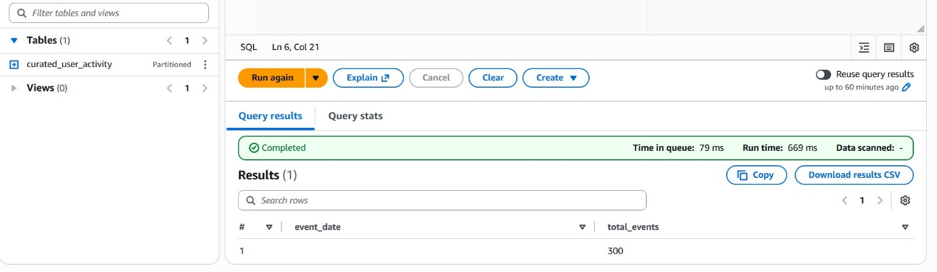
- A query to create a view for daily summary
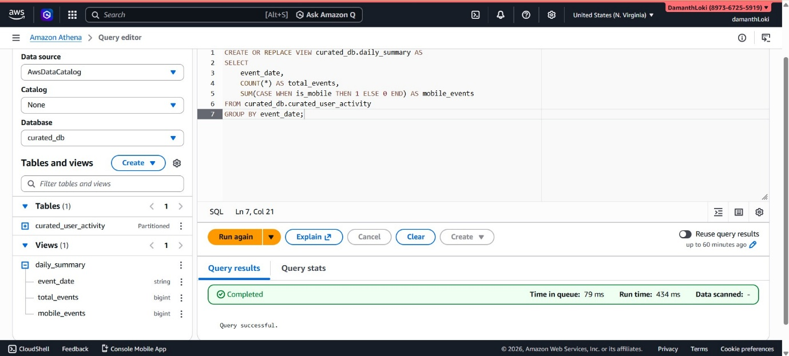
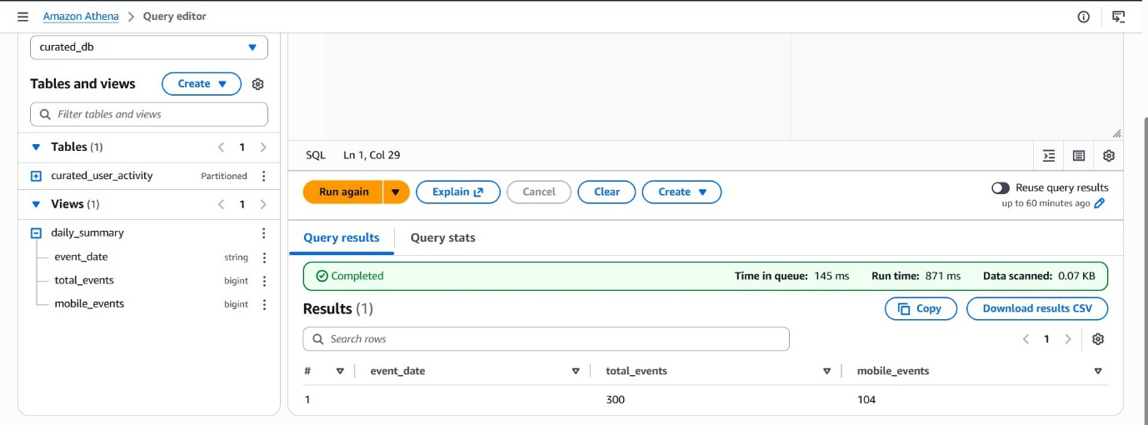
6. A query to get device distribution
