Week 3 Progress

1. Created an S3 bucket with a defined folder structure for raw, staging, and curated layers. Enabled default encryption and implemented a lifecycle policy to transition objects in the raw layer to Standard-IA after 30 days and to Glacier after 90 days.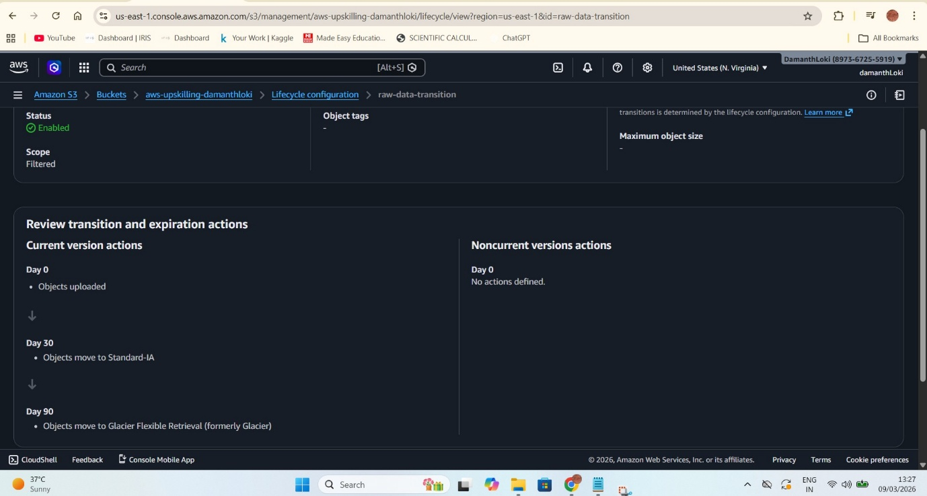
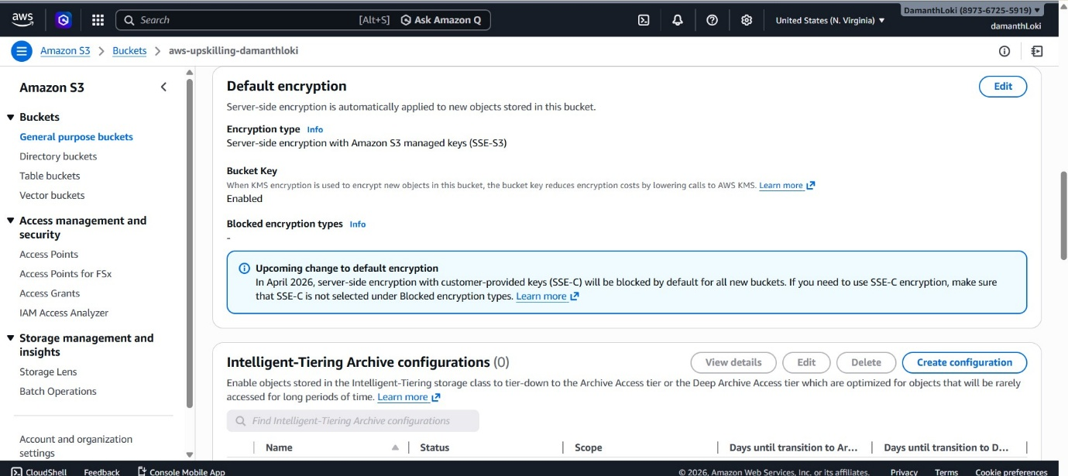

2. Created IAM roles and policies for AWS Glue and AWS Lambda following the principle of least privilege and enabled MFA for the admin user.
a) Created an IAM role for AWS Glue with read/write access to Amazon S3 and logging permissions for Amazon CloudWatch.
b) Created an IAM role for AWS Lambda with read access to Amazon S3 and permissions to write logs to Amazon CloudWatch.
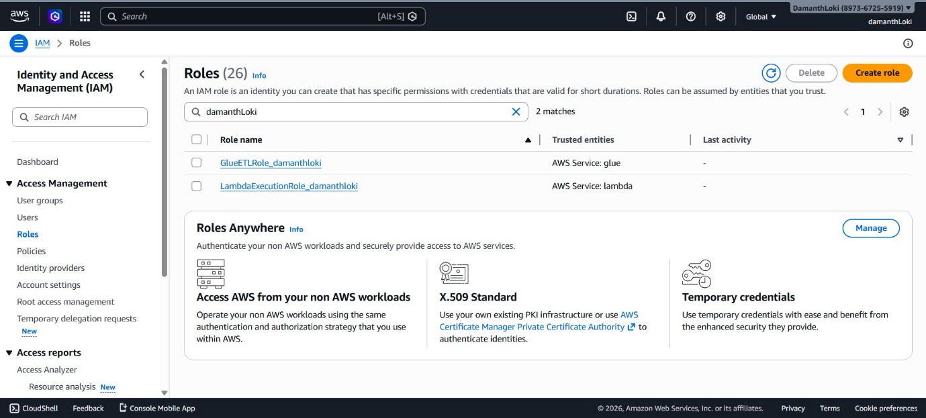

3. Uploaded Week 1 Parquet output files to S3 using the AWS CLI and developed a Python script with boto3 to perform multipart uploads and retrieve object listings from the bucket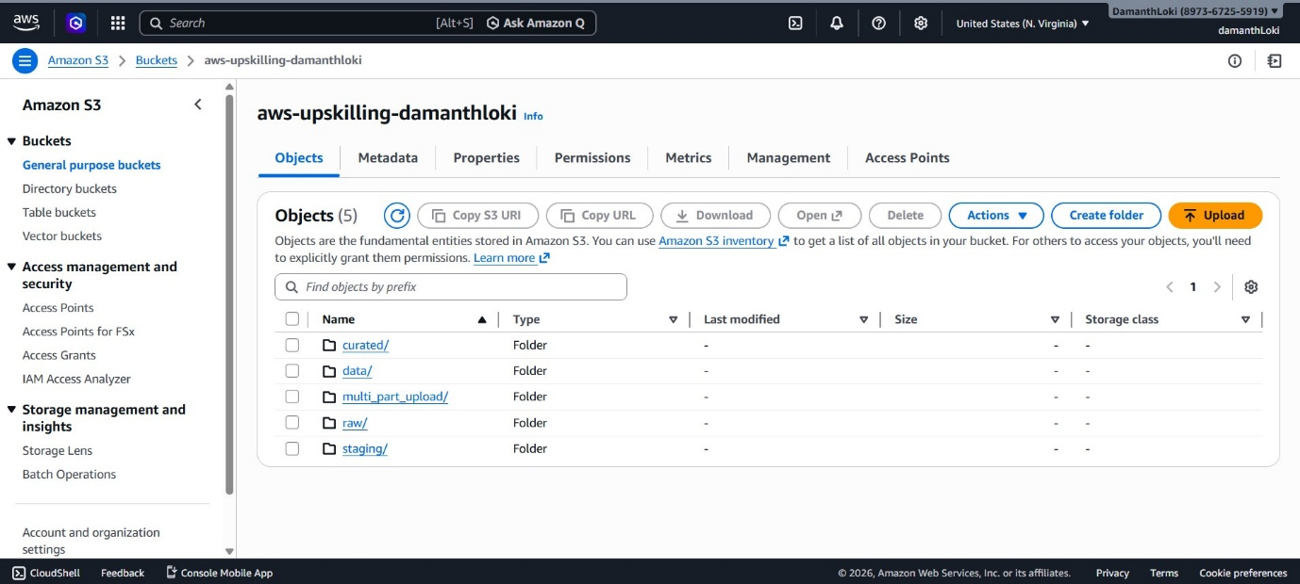
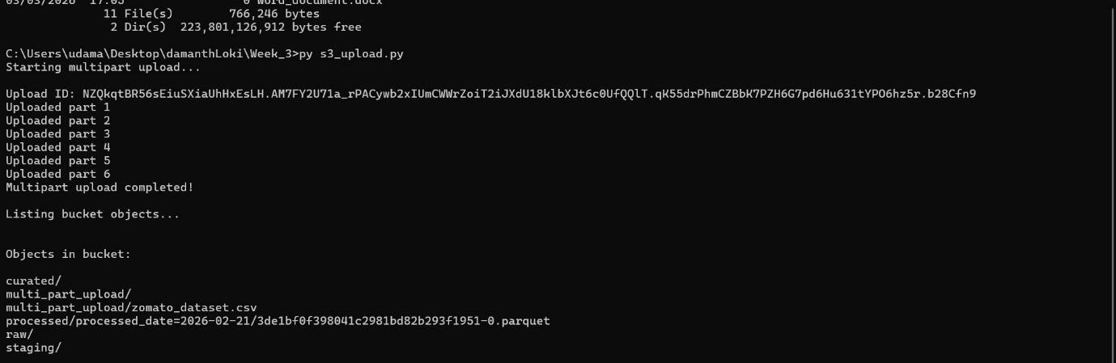

4. Enabled CloudTrail, created a CloudWatch dashboard to monitor S3 metrics (PUT, GET, 4xx, and 5xx), and configured an AWS Budget with an alert threshold for cost monitoring.
