PREPARAÇÃO DE AMBIENTE

INSTALAR KUBUNTU – KDE + UBUNTU

já tem o PYTHON3.10.4 Instalado.

INSTALAR O PIP

Python 3
Step 1: Install Python3-venv

First, as a best-practice, we ensure all packages are up to date:

root@ubuntu:~# apt-get update -y

Next, let's install python3-venv

root@ubuntu:~# apt-get install -y python3-venv

Step 2 - Install pip3
If Python 3 has already been installed on the system, execute the command below to install pip3:
sudo apt-get -y install python3-pip

STEP 3

python3 -m venv tutorial-env

source tutorial-env/bin/activate

$ source ~/envs/tutorial-env/bin/activate
(tutorial-env) $ python
Python 3.5.1 (default, May 6 2016, 10:59:36)
...
>>> import sys
>>> sys.path
['', '/usr/local/lib/python35.zip', ...,
'~/envs/tutorial-env/lib/python3.5/site-packages']
>>>

COLLECTING NOVAS
python3 -m pip install novas

python3 -m pip install requests==2.6.0

python3 -m pip install --upgrade requests

(tutorial-env) root@painel-psa:/home/painel# pip3 show requests
Name: requests
Version: 2.28.1
Summary: Python HTTP for Humans.
Home-page: https://requests.readthedocs.io
Author: Kenneth Reitz
Author-email: me@kennethreitz.org
License: Apache 2.0
Location: /home/painel/tutorial-env/lib/python3.10/site-packages
Requires: certifi, charset-normalizer, idna, urllib3
Required-by:
(tutorial-env) root@painel-psa:/home/painel#

STEP 4 – SELENIUM

pip install selenium

STEP 5 – gTTS

pip3 install Gtts

STEP 6 – RAY

pip3 install ray

STEP 7 – PLAYSOUND

painel@painel-psa:/var/www/html$ pip3 install playsound

STEP 8 – INSTALAR O CHROME

versão debian-64 bits

STEP 9 -

instalar o webdiver do chrome linux.

STEP 10 – NODEJS

sudo apt install nodejs

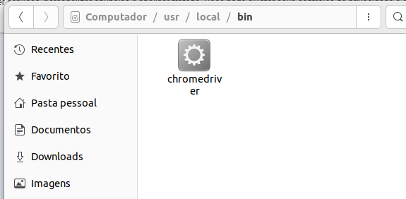

STEP 11 - NPM

sudo apt install npm

STEP 12 – JSON SERVER

painel@painel-psa:~$ npm install -g json-server

added 182 packages, and audited 183 packages in 15s

21 packages are looking for funding
run `npm fund` for details

4 moderate severity vulnerabilities

To address all issues (including breaking changes), run:
npm audit fix --force

Run `npm audit` for details.

STEP 12 – STAR JSON SERVER

DENTRO DA PASTA QUE SE ENCONTRA O ARQUIVO JSON

Start JSON Server
json-server --watch dados_a.json
json-server --host 10.85.191.125 --port 4000 dados_a.json

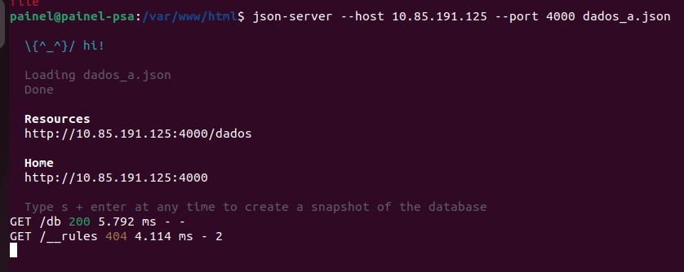

STEP 13 – LOCALIZAÇÃO

