LETTER OF EXPLANATION TEMPLATE

(Date)

Guidance and Counseling Unit
Office of the Student Services
Benguet State University

Dear Sir/Ma’am

This is to explain my absence/tardiness on (date/s of absence/tardiness) due to (state reason/s). Attached herewith are relevant documents (state certificate) and the identification card of my undersigned guardian for your reference.

Very truly yours,
(Signature Over Printed Name)

Noted:
(Signature Over Printed Name of Parent/Legal Guardian)
RELEVANT DOCUMENTS
Prepare at one (1) photocopy of ANY of the following supporting documents (original copy for verification), whichever is applicable:
- Verified Medical Certificate
- Approved Travel Order
- Death Certificate / Obituary / Barangay Certification of Death of Deceased Relative
- Invitation letters or programs with the name of the student indicated
- Marriage Certificate
- Baptismal Certificate
- Wedding Invitation/Baptism indicating the student's name as sponsor.

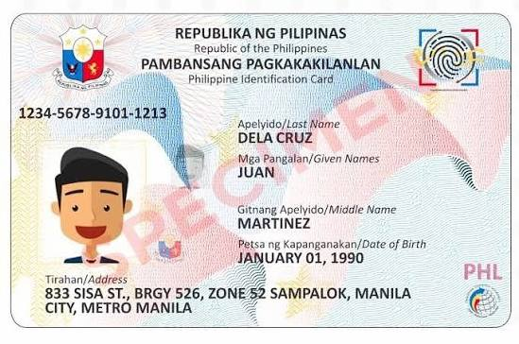
Photocopy of Valid ID of the Parent/Legal Guardian who signed the letter of explanation.


Three (3) specimen signatures of the Parent/Legal Guardian who signed the letter of explanation.

List of Accepted Valid Identification Cards for the Parent/Legal Guardian:
- Driver's License
- Passport
- Professional Regulation Commission (PRC) ID
- National Bureau of Investigation (NBI) Clearance
- SSS Card (digitized)
- Alien Certificate of Registration (ACR) / Immigrant Certificate of Registration
- Police Clearance
- Postal ID
- Voter's ID
- Barangay Certification
- GSIS e-Card
- Philhealth Card
- Senior Citizen Card
- Other ID's issued by the government

