ADAR Pilot Library
Parent Structures and Hypotheses
4 libraries · 19 parent hairpins · 6,793 designs

1. The libraries
Four libraries, pooled and demultiplexed by primer pair. Set 1 and Set 2 are different parent panels. Library 1 takes the longest designs per parent; Library 2 is its complement, deduplicated against it.
Library | Primer | Parents | Designs
Library 1, Set 1 | ART5 | 9 | 1,800
Library 1, Set 2 | ART7 | 10 | 2,000
Library 2, Set 1 | ART10 | 9 | 1,276
Library 2, Set 2 | ART11 | 10 | 1,717
Each design is a parent hairpin with one perturbation applied, trimmed to a given length. The perturbation axes are: base pairs above or below the edit site converted to GC or AU (k = 1–5), the base opposite the edited adenosine swapped (across), and in Library 2, above and below changed together.

2. Parent structures
Edit-site adenosines in red. Only parents that contribute designs are shown.

Set 1 — ART5 and ART10
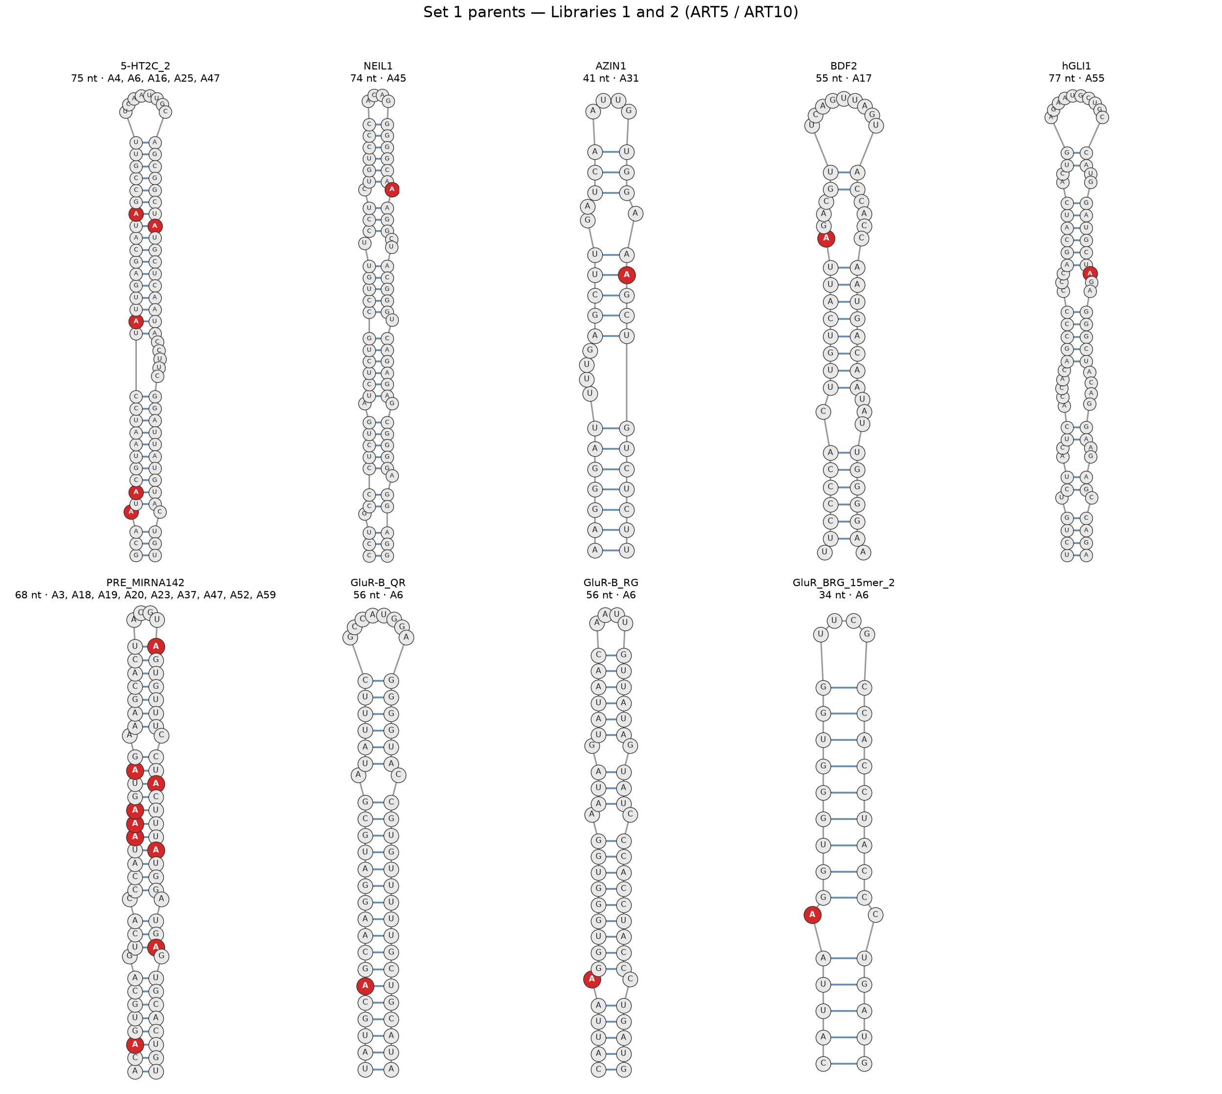
Set 1: nine parent hairpins. Natural mammalian substrates plus truncated GluR-B constructs.

Set 2 — ART7 and ART11
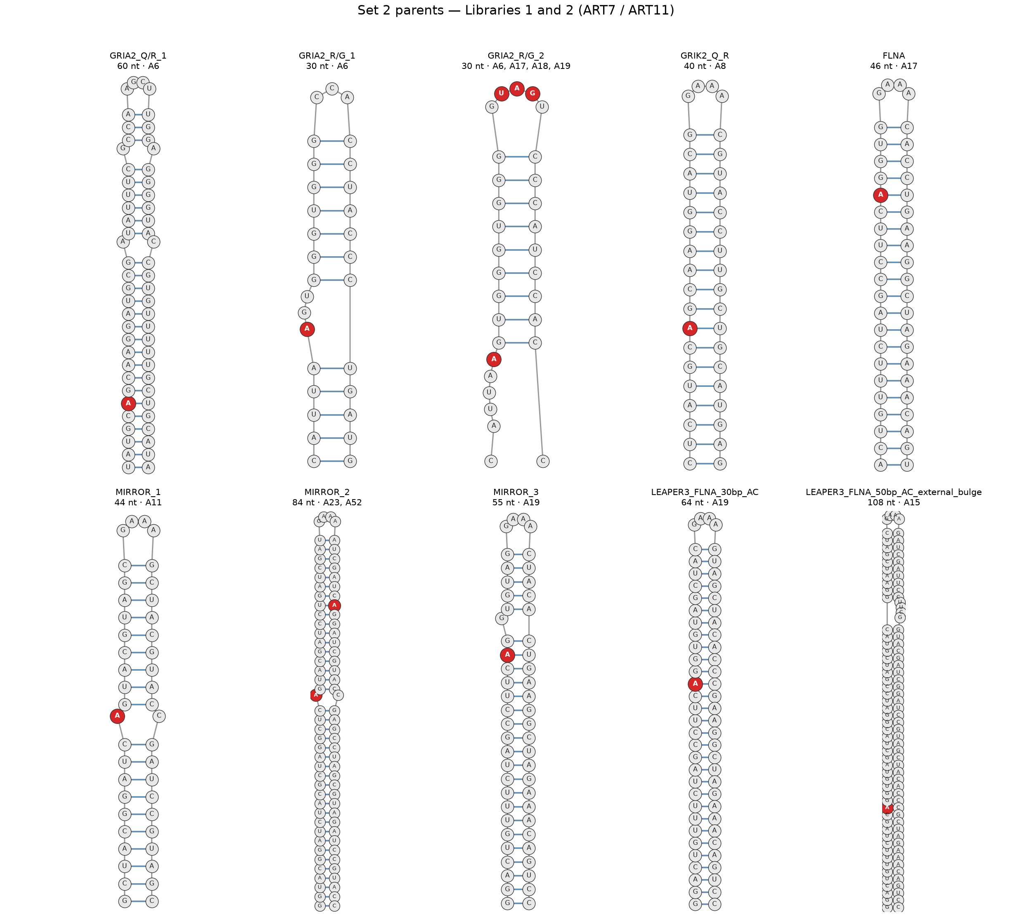
Set 2: ten parent hairpins. Natural substrates (GRIA2, GRIK2, FLNA) plus engineered designs (MIRROR, LEAPER3).

3. Hypothesis per library

Library 1, Set 1 — ART5
HYPOTHESIS
Editing efficiency at a given adenosine is set by local duplex features within about five base pairs of the target, and those features act independently.
Predictions:
- The base opposite the target matters most: across_C (A:C mismatch) beats wild-type, which beats across_G and across_A.
- Local stability is non-monotonic — the duplex must be stable enough to form but loose enough to let the base flip out. All-GC clamps should suppress editing at high k.
- 5′-side changes outweigh 3′-side changes at matched k, reflecting an asymmetric ADAR footprint.

Library 1, Set 2 — ART7
HYPOTHESIS
The rules found in Set 1 are portable: the same perturbation applied to the same edit site in a different structural context produces the same rank order of effects.
Predictions:
- GRIA2_R/G_1 and GRIA2_R/G_2 carry the same biological site in different folds — the response should track the fold, not the site.
- The engineered parents (MIRROR, LEAPER3) should follow the same rules as the natural ones if those rules are physical rather than evolutionary.

Library 2, Set 1 — ART10
HYPOTHESIS
Local determinants are NOT additive. Changing the duplex above and below the edit site at the same time interacts, because the two sides jointly decide whether the target base can flip out of the helix. This is the one thing Library 1 cannot test.
Predictions:
- Combined variants deviate from the additive prediction built from Library 1’s single mutants — specifically a negative interaction when the site is clamped from both sides.
- Duplex length has a threshold rather than a gradient: editing collapses below a minimum length instead of declining smoothly.

Library 2, Set 2 — ART11
HYPOTHESIS
The interaction seen in Library 2 Set 1 is general, not a quirk of one parent panel: the same effect recurs, with the same sign, on the Set 2 parents.
This is the replication arm. It is what lets the conclusion read “local determinants are non-additive” rather than “non-additive in these nine hairpins.”

4. What this pilot settles
The point of the pilot is to find out which axes produce usable signal before committing to a full library. Four things it should resolve:
- Which axes move editing at all. above, below, across and length each get hundreds of designs across many parents.
- Where the length floor really sits. 738 designs fall below 20 nt and should read at the assay floor, which fixes the usable minimum empirically.
- How noisy the assay is. 588 designed sequences appear under more than one barcode, giving a direct technical-variance estimate from 1,773 oligos.
- Which parents are worth scaling. Twelve of nineteen carry combined variants; those are where the interaction test has power.

Two notes for the analysis
- Demultiplex on (primer, barcode), never barcode alone. 154 barcodes recur across libraries; the composite key is unique for all 6,793 oligos.
- Group on sequence, not on mutation label. 518 designs labelled as mutations are identical to their unmutated parent, because the substitution set a base pair that was already there. Grouping by label would score them as real effects of zero.

