ADAR Pilot Library — Set 1
What the Ordered Set Contains, and the Hypothesis Behind It
3,076 oligos · 9 parent hairpins · 2 sub-libraries · ordered and in experiment

1. What this set is
Set 1 is a sequence-variant library built from nine validated ADAR parent hairpin substrates. Each member is one parent, carrying one defined perturbation, trimmed to a defined length. It was ordered as two sub-libraries sharing a single primer pair format, and submitted as 3,076 oligos of 170 nt each.
Sub-library | Primer | Designs | Selection rule
Library 1 | ART5 | 1,800 | The 200 longest designs per parent.
Library 2 | ART10 | 1,276 | Complement of Library 1: deeper trims, then combined above+below variants, deduplicated by exact sequence.
Total |  | 3,076

Oligo format
Each 170 nt oligo is assembled as:
FWD primer (19) + left flank + designed sequence + right flank + barcode (12) + REV primer (19)
Flanks are C/T only with no run longer than 3, so they stay unstructured. Barcodes are 12 nt, GC-balanced, with a minimum Hamming distance of 4 within the library.
IDENTIFIER NOTE
The submitted FASTA names oligos oligo_set1_1_seq_N, in an order that does not match the design files, so the names carry no design information. All 3,076 full-length sequences are unique, so every name maps back by exact sequence match — see submitted_set1_crosswalk.csv. That crosswalk is required to tie reads to parents and mutation classes.

2. Parent structures
The nine parents below are the structural basis of every member. Each is a single hairpin; edit-site adenosines are red. Three further records in the source file were excluded: 5-HT2C_1 and AZIN1_2 fold into two stem domains rather than one hairpin, and GluR_BRG_15mer has its edit site in the unpaired 5′ overhang, outside the stem.
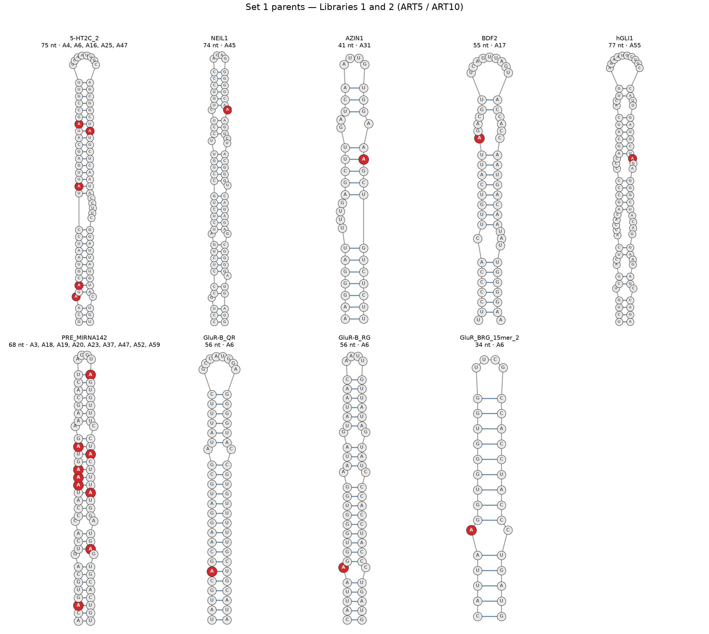
The nine Set 1 parent hairpins. Red = annotated edit site.

3. What each parent contributes
Length and GC ranges below span both sub-libraries. The combined column counts designs carrying simultaneous above+below mutations — the interaction arm.
Parent | Endogenous substrate | Edit site(s) | L1 | L2 | Total | Length | GC % | Comb. | <20 nt
5-HT2C_2 | HTR2C — serotonin receptor 2C | A4, A6, A16, A25, A47 | 200 | 200 | 400 | 20–75 | 12–71 | 0 | 0
NEIL1 | NEIL1 — DNA glycosylase | A45 | 200 | 114 | 314 | 8–74 | 15–72 | 0 | 56
AZIN1 | AZIN1 — antizyme inhibitor 1 | A31 | 200 | 29 | 229 | 6–41 | 8–76 | 0 | 103
BDF2 | — | A17 | 200 | 170 | 370 | 19–53 | 26–73 | 157 | 3
hGLI1 | GLI1 — oncogene | A55 | 200 | 28 | 228 | 18–77 | 41–75 | 0 | 1
PRE_MIRNA142 | pre-miR-142 | A3, A18–20, A23, A37, A47, A52, A59 | 200 | 200 | 400 | 22–68 | 18–68 | 0 | 0
GluR-B_QR | GRIA2 — Q/R site | A6 | 200 | 200 | 400 | 10–56 | 25–75 | 54 | 28
GluR-B_RG | GRIA2 — R/G site | A6 | 200 | 200 | 400 | 8–56 | 6–75 | 67 | 39
GluR_BRG_15mer_2 | GRIA2 — R/G 15mer variant | A6 | 200 | 135 | 335 | 8–34 | 17–85 | 86 | 44
Total |  |  | 1,800 | 1,276 | 3,076 |  |  | 364 | 274

Composition by perturbation class
Class | n | Share
Above (5′ of edit site) | 1,448 | 47.1%
Below (3′, toward loop) | 839 | 27.3%
Combined above+below | 364 | 11.8%
Across (opposing base) | 239 | 7.8%
Unmutated parent | 186 | 6.0%

4. The hypothesis behind the structure
OVERALL HYPOTHESIS
ADAR editing efficiency is jointly determined by three kinetic parameters: k_fold, the thermodynamic stability of the dsRNA hairpin conformation; k_bind, the efficiency with which ADAR engages the duplex; and k_flip, the energetic cost of extruding the target adenosine from the helix for deamination. By systematically varying base-pair identity, stem length, and the identity of the base opposing the edit site — combined with DMS-MaPseq structural probing to validate solution conformation — the contribution of each parameter can be deconvolved across a diverse set of endogenous ADAR substrates.
Each perturbation class in the library is designed to load onto one of those three parameters, so that the measured editing response separates them.
Variant class | What changes | Parameter | Hypothesis
Length trimming | Stem shortened inward from both ends, anchored on the edit site. | k_fold, k_bind | A minimum duplex length is required for stable folding and productive ADAR engagement. Shorter stems reduce k_bind by limiting the dsRNA footprint. DMS-MaPseq confirms which truncations retain the native fold.
Above mutations (1–5 bp, cumulative) | Base pairs 5′ of the edit site set to all-GC or all-AU. | k_bind, k_fold | GC-rich regions above the edit site stabilise the duplex and enhance ADAR binding affinity. AU-rich regions destabilise it, lower the local melting temperature, and reduce editing.
Below mutations (1–5 bp, cumulative) | Base pairs 3′ of the edit site, toward the loop, set to all-GC or all-AU. | k_flip | The base pair closing the edit site on the loop side resists base flipping. GC pairs below raise the barrier to k_flip and suppress editing; AU pairs facilitate flipping and increase it.
Across mutations (C, G, A) | Base paired with the target adenosine changed from U to C, G or A. | k_flip, deamination rate | The opposing base sets the mismatch energy at the edit site directly. A·C mismatches are preferred by ADAR over A·U Watson–Crick pairs (lower k_flip barrier). A·G and A·A test how local instability drives or inhibits deamination independently of global duplex stability.
Combined above+below (5 × 5) | Both flanking regions mutated simultaneously, GC or AU. | k_fold × k_flip interaction | Tests whether above and below effects are independent or cooperative. A stable duplex above with a weak pair below may optimally balance k_bind and k_flip; fully GC or fully AU surroundings reveal the upper and lower bounds of editing efficiency.
DMS-MaPseq validation | No sequence change — chemical probing of all variants. | k_fold (structural) | Confirms the designed mutations produce the intended structural change in solution. Unpaired A/C reactivity validates the assumed dot-bracket topology and reveals misfolding or alternative structures that would confound kinetic interpretation.

5. Coverage of this set
Three properties of the ordered set bear on how far each hypothesis can be tested. None reflects a synthesis error — all 3,076 designs were built and submitted as intended — but each constrains interpretation.

The interaction arm covers four parents, not nine
Library 1 fills its 200-per-parent quota with the longest designs, and Library 2 draws deeper trims before combined variants. Parents with rich length ladders therefore exhaust their quota before reaching the combination grid.
Combined variants present | Combined variants absent
BDF2 (157), GluR_BRG_15mer_2 (86), GluR-B_RG (67), GluR-B_QR (54) | 5-HT2C_2, NEIL1, AZIN1, hGLI1, PRE_MIRNA142
The k_fold × k_flip interaction hypothesis is therefore testable on four parents. The other five contribute to the single-axis hypotheses only.

274 designs fall below the ADAR substrate threshold
The trim ladder has no minimum length, so it peels to 6 nt. 274 designs are under 20 nt, concentrated in AZIN1 (103 of its 229). These should read at the assay floor regardless of mutation class — which makes them a usable empirical floor estimate, but they should be excluded before fitting any length–response curve.

3,076 oligos carry 2,539 distinct sequences
537 oligos duplicate another design’s sequence under a different barcode and a different mutation label. The cause is that a substitution setting a base pair that was already present leaves the sequence unchanged, and a mutation outside the retained trim window is not represented in the child. These duplicates are genuine technical replicates — the same molecule under independent barcodes — and give a direct estimate of assay noise.
ANALYSIS CONSEQUENCE
Group reads on the designed sequence, not on the mutation label. Grouping by label would score a sequence identical to its unmutated parent as a real mutation effect of zero, biasing the additivity test toward the additive conclusion it is meant to test.

