Damian Franco

CS 375 – 001

Homework #10:

1. 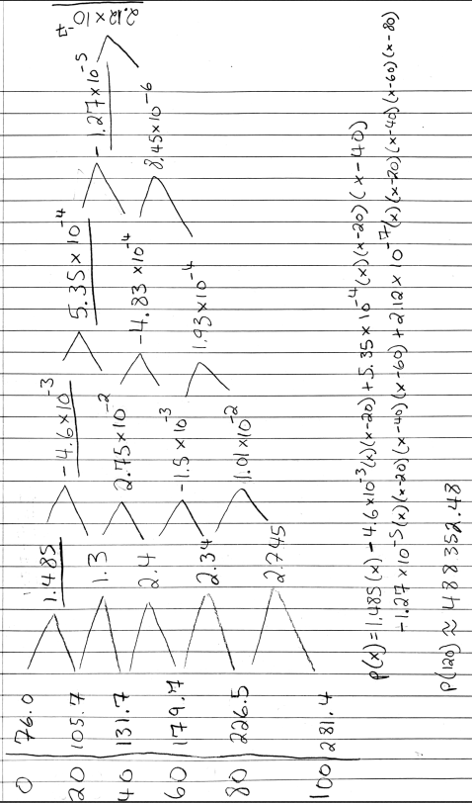For number 1, we were asked to “predict” what the population was in 2020 based off the US census data given to us here in this data set *D* = {(0,76.0), (20,105.7), (40,131.7), (60,179.7), (80,226.5), (100,281.4)}. To “predict” for the population in 2020, then we would have to find the interpolation polynomial and the best line in the least squares sense. Once the polynomial and best line is found then by plugging in for *x* = 120 to solve. To find the interpolation polynomial, I solved it using the Newton approach and found that when estimating to that one, then my numbers were vastly off. I ended with *p(120) = 488352.48*, which is very far off from 331 million. I do not think that the best line from the least square’s approximation will be nearly as bad as that, so I tried it. I found the *p(120) = 6527.018* using my least squares line which is much closer than the polynomial approximation. This shows to me that in some cases, the least squares line may be better than the interpolation polynomial found by any other way. The work for first, the Newton approach to find the interpolant, and second, the least squares approach is found below.

**Newton Approach:**

**Lease Squares Approach:**

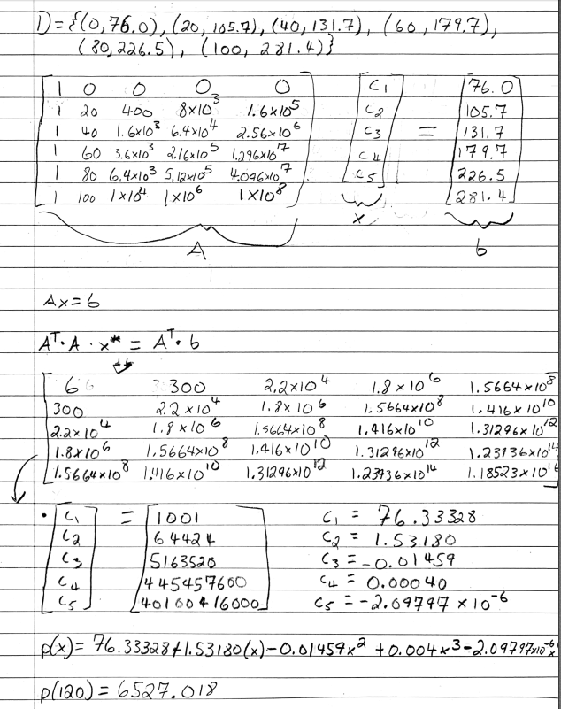

1. For number 2, we were given matrix characteristics and were asked to construct a 10 x 10 Hilbert matrix. Then we had to truncate the matrix down to the *n* columns to find the matrix *A*. The truncated 10 x 6 and 10 x 8 matrices were found for *n = 6 and 8*. Next, I solved for the matrix *b* with the equation given to us, *b = Ac* where *c* is equal to a vector full of 1’s. Now that all those are solved for, the full *Ax = b* equation is known, as well as other aspects needed to solve the problem. I then moved on to part (a) and (b). All work for both parts, including source code, is shown on the next pages.
2. For part (a), we were asked to solve the least squares problem for *n =6 and 8* numerically. I then took my known matrices and vectors to MATLAB and performed the needed steps to solve the lease squares problem for both. It also asked us to get the condition number to see how many correct decimal places can be computed and for the leas squares solution I found the norms to be *6.004e+13* for *n = 6* and *3.904e+18* for *n = 8* which both show that there is large number of errors within both problems when computed normal. The correct decimal places that can be computed for *n* *= 6* is *2* and the correct decimal places for *n = 8* is *1* because they are very high numbers listed as the condition numbers which results in the amount of decimal digits of accuracy that are lost. Overall, the precision using the least squares sense is very low and I expect the QR factorization approach to be much better.
3. For part (b), we had to do the same for part (a), but with the QR factorization of the given problem. I first found my QR factorization through MATLAB’s *qr* function and then I plugged in that to the MATLAB function provided to us on the website, *UTriSol.m*. This allowed me to solve the system using the QR factorization. In this problem, I had to truncate the matrix *A* for both *n = 6* and *n = 8* to solve the problem efficiently. I found that this way is more accurate than the least squares approach because the norms for both solutions showed a smaller precision error than part (a). The condition number for both *n* *=6* and *8* were both equal to *1.602e+13* which is lower than the loss of precision in part (a). The number of correct decimal places that can be computer is *3*.

**Part (a):**

***n = 6:***

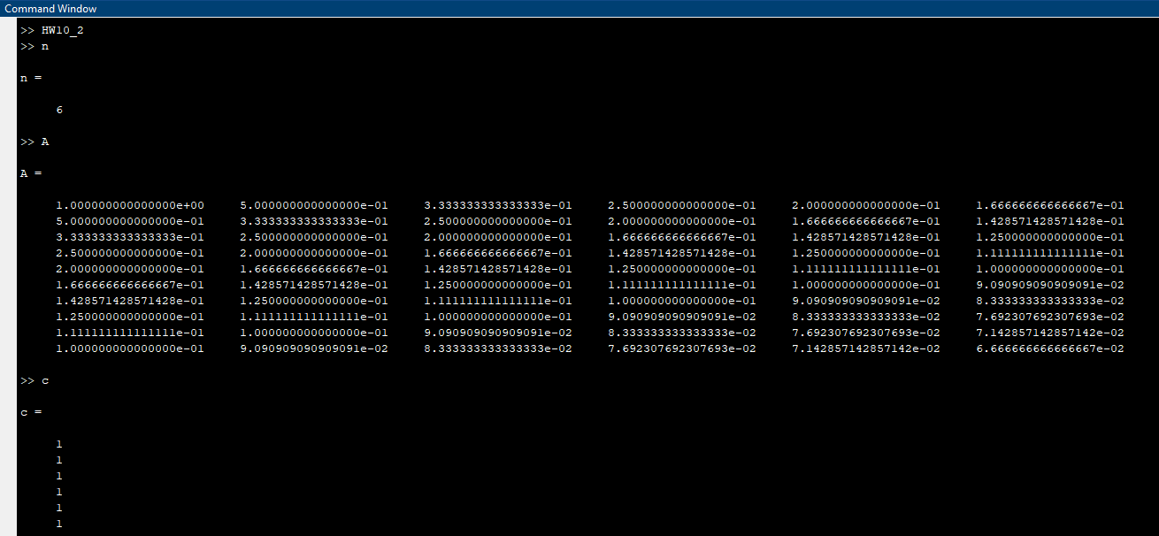

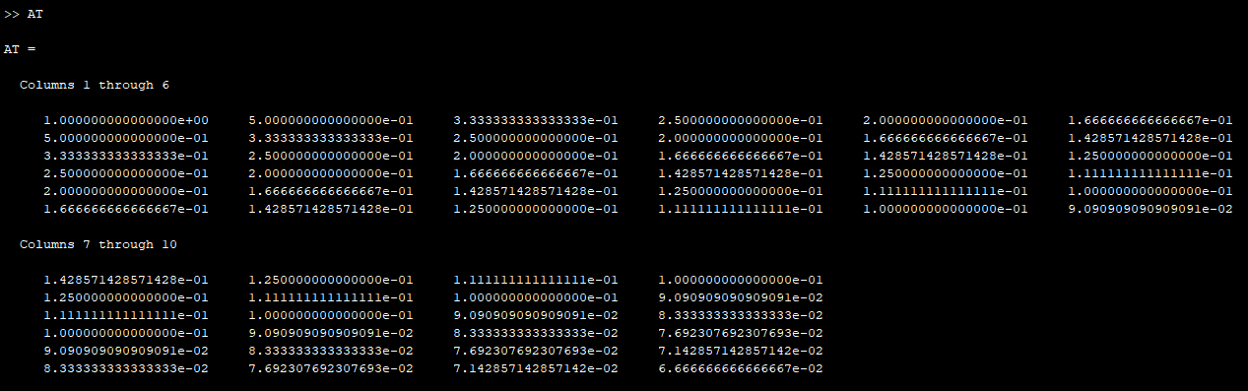

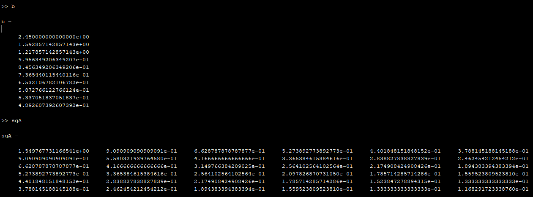

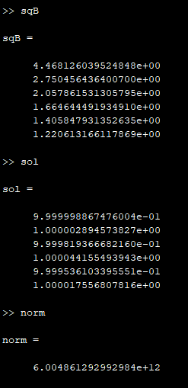

**Part (a):**

***n = 8:***

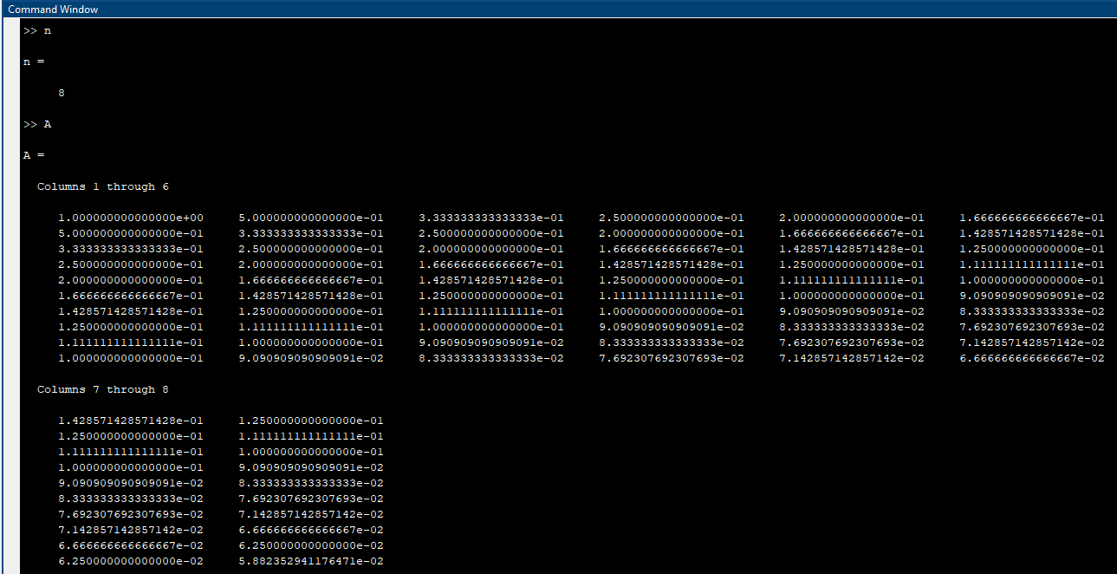

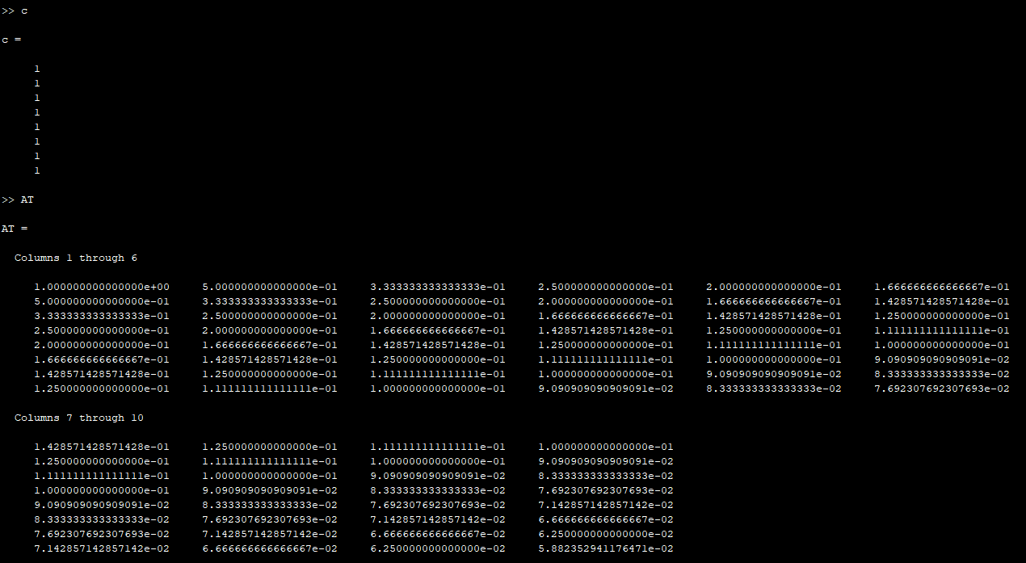

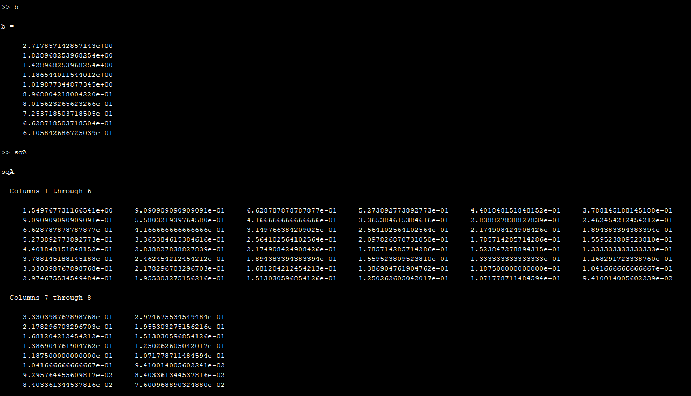

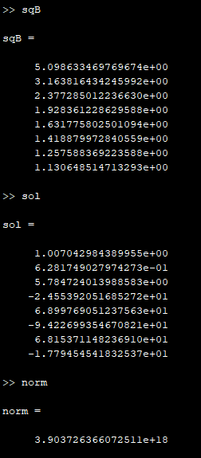

**Part (b):**

***n = 6:***

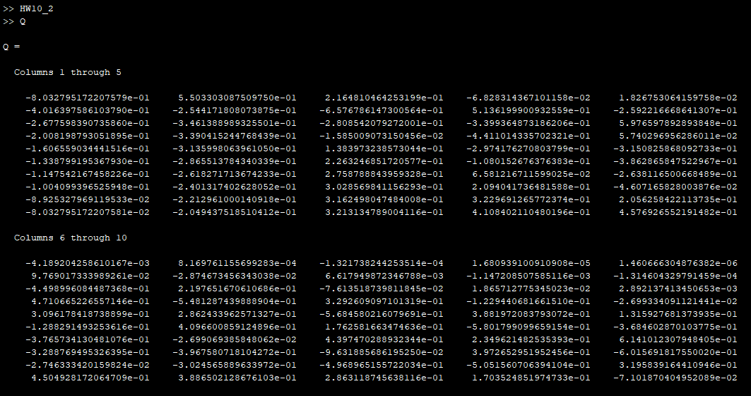

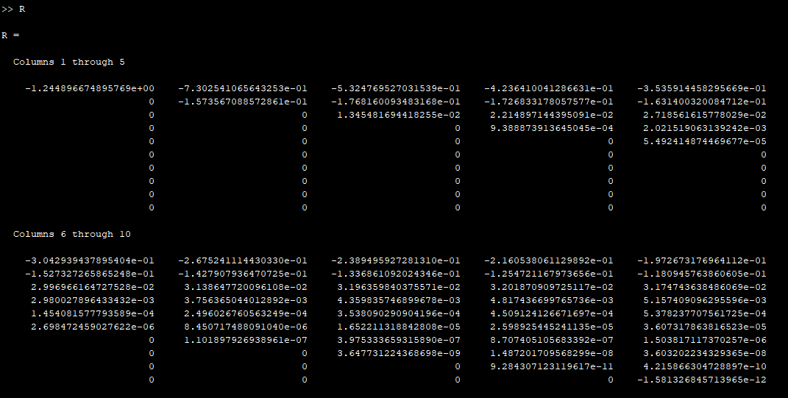

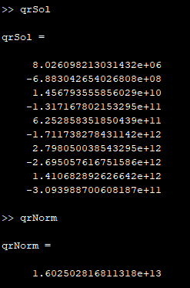

**Part (b):**

***n = 8:***

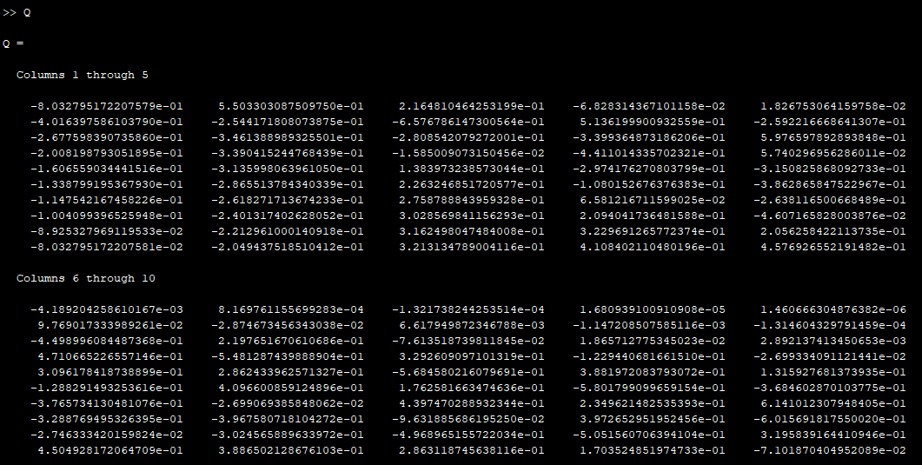

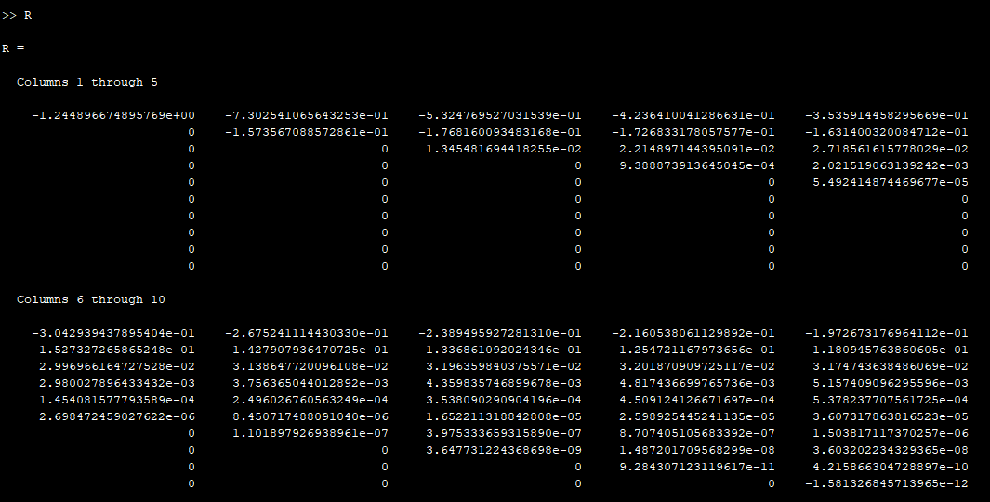

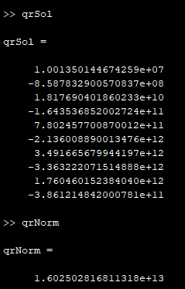

**Source Code:**

***HW11_2.m***

1 % function HW10_2

2 % This function doest the set up and solving for

3 % both part (a) and (b) on HW10, problem 2. This

4 % will solve for least squares and QR factorization.

5 n = 8;

6 H = hilb(10);

7 A = H(:,1:n);

8 c = ones(n, 1);

9 AT = transpose(A);

10 b = A*c;

11

12 % Part A

13 sqA = AT*A;

14 sqB = AT*b;

15 sol = sqA\sqB;

16 norm = cond(sqA);

17

18 % Part B

19 [Q,R] = qr(H);

20 qrSol = UTriSol(R, b);

21 qrNorm = cond(H);

1. For number 3, we were asked to find the *QR* factorization by hand of the given matrix with the Givens rotation approach. The first thing I did, after I jotted down the matrix given to us, was referenced the examples in the linalg5 narrations and notes which provided me with a clear understand on how to approach this problem and use Givens rotation to compute the QR factorization. The first thing I did was count the number in which we need to zero out, and that was three. I knew that if we had to zero out 3 values in our matrix to find *Q*, then there is going to be three orthogonal matrices *G1, G2,* and *G3* that can be multiplied into the matrix *V* to zero out values. These *G* matrices will also be combined to find the *R* in our *QR* factorization. With that, I started to zero out values and found my *G* matrices. After I zeroed out my values and found my *Q* matrix, I multiplied the *G* matrices together and solved for *Q*. I have an actual representation that I found listed first and then I estimated those values to show some much nicer looking *Q* and *R* matrices. That is how I went about solving this problem. All work, including my exact and estimation *QR*, are shown on the next two pages. Overall, my takeaway from this homework is that *QR* Factorization is more accurate than using the normal equations approach.

