Damian Franco

CS 375 – 001

Homework #11:

1. For the first, and only, problem for this week we were given a least squares problem and first asked to use the Gram-Schmidt procedure to find the *QR* factorization in part (a), followed by solution of the least squares problem and the length of the minimum residual in part (b). All work for both parts can be found on the next pages.

1. For part (a), I followed the instructions to find the *QR* factorization in this week’s narration and notes for linalg6. I will quickly run through how I went about solving this before I get into my findings. First, I took the matrix *A* that was given to us and found my *a1* and *a2* vectors. Those will help solve for my *q* vectors and my *r* elements within my *Q* and *R* matrices. I found my first element of my *R* matrix by finding the 2 norm of my *a1*matrix, which turned out to be ***6***. Having my *r11* matrix found allows me to find my first *q* vector by dividing each element by *r11*. Next, I move on to finding my *r12*, *r22*, and my *q2* vector which is all I need to know to solve my *QR* factorization. I found the *r12* with the equation *r12* = *q1Ta2*. Finally, I found the *r22* element and *q2* vector by the equation *r22q2* = *a2* - *r12 q1*. After finding all elements of my *Q* and *R* matrices, I then put them all together to find the thin factorization of the problem. To find the thick *QR* factorization, I performed the cross product of my *q* vectors *q1* x *q2* and appended that to my *Q* matrix to get a new 3x3 dimension matrix. Lastly, I added a row of 0’s to my *R* matrix to find my thick factorization. That is how I found the *QR* factorization by hand. Comparing my answer to MATLAB’s output, it seems like it is almost the same, but I did notice that there are some signs on elements with my matrices *Q* and *R* that are different from my “by hand” solution. This could be because of numerical error on MATLAB’s part, or just an algebraic mistake on my end, but the numbers seem to be consistent. Thick *QR* factorization is unique because *Q* is made an orthogonal matrix which gives us information about the size of the residual.
2. For part (b), this was very straight forward. I found the solution to the least squares problem by first multiplying the *b* vector given to us in the *Ax = b* problem by the transposition of the *Q* matrix. This will give us the *w* matrix that we must use to solve *x1* and *x2* with. Next, I solved the system and found the solution with the vector *xLS*. Lastly, I found the minimum residual by finding the 2 norm of the *w* vector.

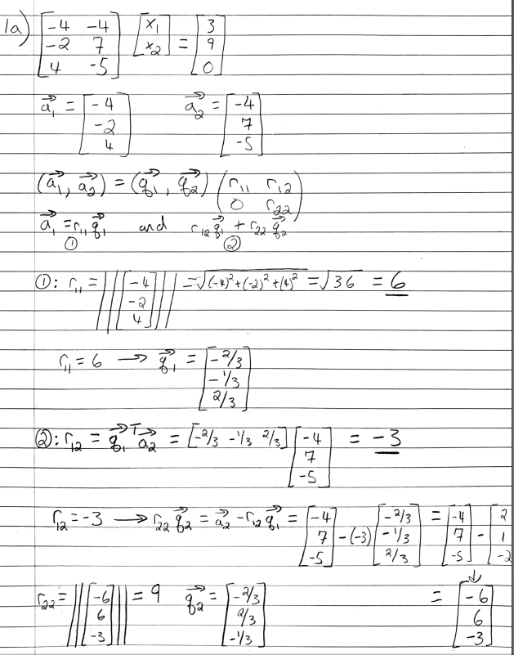

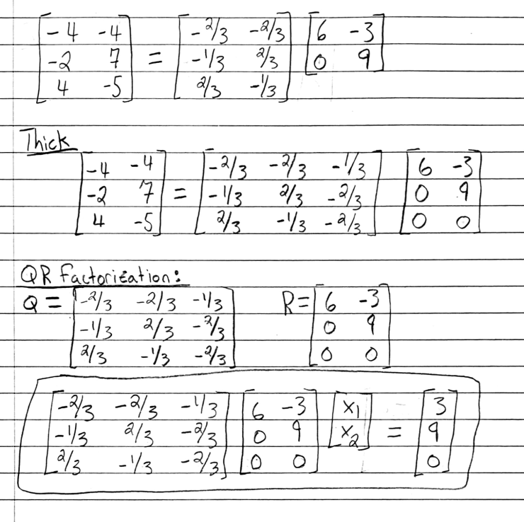

**Source Code:**

***HW11_1.m***

1 % function HW11_1

2 % This function does not the set up and solving for

3 % both part (a) and (b) on HW11, problem 1. This

4 % will solve for least squares and QR factorization

5 % of the given matrix A.

6 format compact

7 A = [-4 -4; -2 7; 4 -5];

8 [Q R] = qr(A);

9 Arep = rats(A);

10 Qrep = rats(Q);

11 Rrep = rats(R);

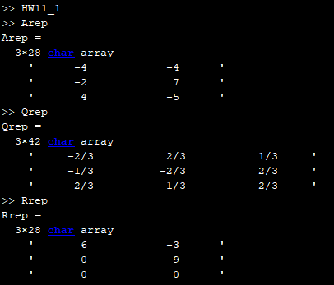**MATLAB Output:**

