Damian Franco

CS 375 – 001

Homework #9:

1. For number 1, we were given a data set and had been asked to (a) construct the dived-difference table associated with the data set and write down the associated degree-3 Newton interpolation polynomial *p4(x)* and (b) use the error formula for polynomial interpolation to estimate the error at *sin(x)* and compare it to the true error.
2. For part (a), the final example in the notes for interp4 was a very similar problem and that helped me out. The pen-and-paper work is shown on the next page. First, I found the divided difference table associated with the data set given. I had to do many simplifications that are not shown on my work, but I ended up finding my three values for the polynomial and plugged them in to the Newton interpolation polynomial equation. Lastly, I finalized my interpolating polynomial and wrote it down and squared it. One quick note about my written work, I have two polynomials boxed and both are equal. The first equation boxed is the non-simplified version and the second boxed equation is the simplified version on the equation.
3. For part (b), we were asked to estimate the error at *x* = 1 and the equation *f(x)* = *sin(x)*. I wrote all of this in MATLAB and used it as a sort of calculator. I ended up finding that the true error is equal to ***3.849684673111753e-04*** and my estimated error was ***5.347641232066746e-04.*** The estimated error is greater than the true error just like the equation tells us. This is also true because the true error should have less of an error than our error finding with the error formula for polynomial interpolation. Overall, the errors are very similar and are both expected when doing numerical computing.

**ALL WORK IS SHOW ON NEXT TWO PAGES…**

**By Hand Work (Part a):**

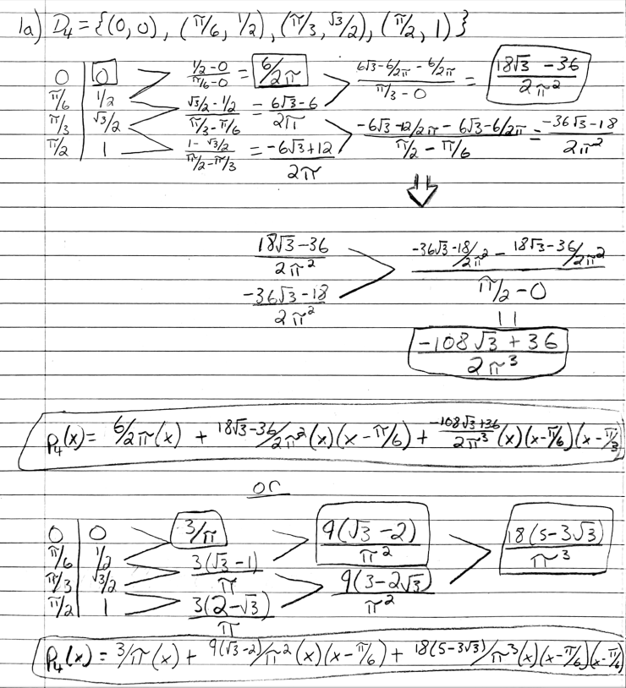

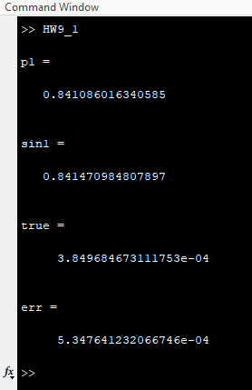**MATLAB Output:**

**Source Code:**

*HW9_1.m*

1 %

2 % function HW9_1

3 % This function will find the true error and the error

4 % from the formula given to us from the notes and

5 % print out the findings.

6 %

7 format long

8 p = @(x) (3/pi)*(x) ...

9 + ((9*(sqrt(3)-2))/pi^2)*(x)*(x-(pi/6)) ...

10 + ((18*(5-3*sqrt(3)))/pi^3)*(x)*(x-(pi/6))*(x-pi/3);

11 p1 = p(1);

12 p1

13 sin1 = sin(1);

14 sin1

15 format long e

16 true = abs(sin(1) - p(1));

17 true

18 err = abs((1-0)*(1-pi/6)*(1-pi/3)*(1-pi/2))/factorial(4);

19 err

1. For number 2, we were asked to use the Chebyshev Theorem to do three different things: (a) show that [0, pi/2] is a fundamental domain for sin*x*, (b) find the degree *d* for which an interpolating polynomial using Chebyshev points will deliver this accuracy on the interval [0, pi/2], and (c) find the accuracy difference from *d* and to *d* with equally spaced points being used instead. All work for all parts are on the next pages.
2. For part (a), I took the addition-of angle formulas that were given to us at the beginning of the problem and found the function for *Tn(x)* which is equal to the following: *sin(npi – x).* After finding that, I then wanted to prove that every input that put in for *n* is equal to ­*-sin(x)* or *sin(x)*, which would prove the [0, pi/2] is a fundamental domain for *sin(x)*. I first plugged in a lot of numbers for *n* and found that this was true and then after I proved some *LEMMA’*s which were very similar to the ones in the notes for this module. The *LEMMA*’s helped prove the bigger picture when it comes to the appropriate and fundamental domain and I found that all *LEMMA’*s passed and proved that the [0, pi/2] is a fundamental domain for *sin(x)*.
3. For part (b), I first read up on the Chebyshev Theorem and found to get a more accurate number of digits then I must try to have a higher degree. The first degree I tried was *d* = 5, which was not close to the amount of accuracy I needed. Next, I tried *d =* 30 and *d =* 40 which were giving me close numbers like *7.12 x 10-4* and *6.36 x 10-5*. Finally, after some trial and error, I found that at the degree *d* = 48, that would give me an accurate account of 6 digits on my estimation. When *d* = 48, the output of the function would be *9.21 x 10-6*, which is exactly where I want it to be. That is how I went about solving that part of this problem.
4. For part (c), I first plotted the value or *|psi(x)|* which is shown below. I know that my outcome for *|psi(x)|* was *9.21 x 10-6* when I had non-equal spaced points. When I find the maximum of *|psi(x)|* with equally spaced points, I noticed that that outcome is much smaller and more accurate than my non-equally spaced points outcome. I ended up retrieving *1.66 x 10-13* from the equally spaced point function which is much more accurate than the non-equally spaced points function which makes sense in my mind. If there is more consistency and less fuzziness from the equally spaced points, then that could be a reason why too.

**ALL WORK IS SHOW ON NEXT TWO PAGES…**

**Part (a) Pen-and-Paper Work:**

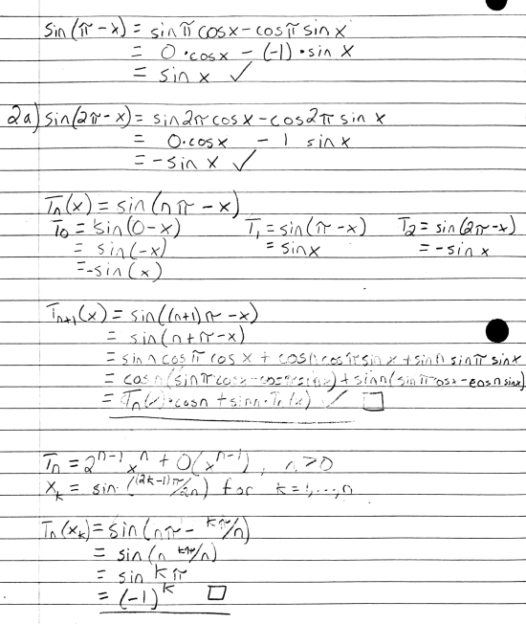

**Part (b) Pen-and-Paper Work:**

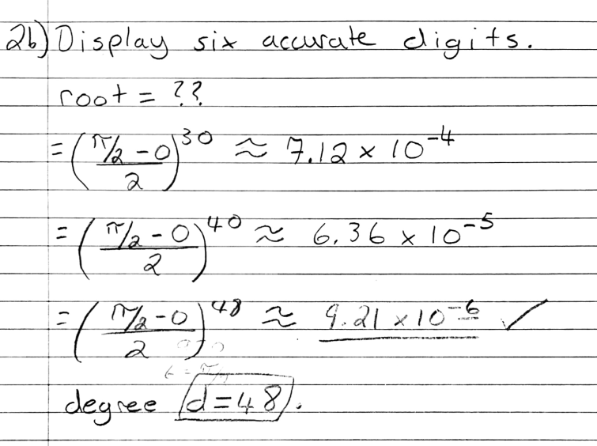

**Part (c) Graph:**

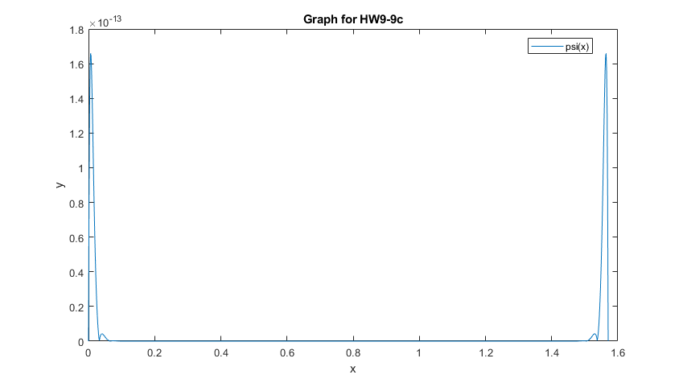

1. Number 3 asks us to find the line which best fits the data set given in the least squares sense. This one was straight forward. I followed the steps given to us in the linalg4 narrations and with some help from online sources on Khan Academy. First, I found the matrix in *A* and matrix *B* that would help solve for this equation. I knew that the had to solve for the matrix *x* (and solve for *m* and *b*). The expression *Ax* = *B* proved to have no solution which is exactly why we had to use lease squares to solve. Next, I solved for *x\** for the equation *ATAx* = ATB*. I found the transpose of matrix *A* and used that to find the variables *m\** and *b*\* which would lead to the solving of the best quadratic fit for the data set. I found that the best equation was ***y = 14/5x + 3/5*** which ***m = 14/5*** and ***b = 3/5***. The pen-and-paper work is shown on the next page.

**ALL WORK IS SHOW ON NEXT PAGE…**

