Final Project – Winter 2021 – COMP256

Due: Fri. Apr.16th, 5 PM.

Contents

Task1: (40%) – Train one of a given ml-agents examples. 1

Task2: (50 %) – Create your own game/environment to train and use 1

Task 3 (10 %) - Playtest another group’s solution of their Task2 (due before Week12 class) 2

Work as a group to do the following:

# Task1: (40%) – Train one of a given ml-agents examples.

Using ML-Agent Unity environment, please select one of the examples and carry out the training:

. Pick an example from the ones given (not the Basic one) and open scene

. Run the training command from the command line

. Start (play) the scene on the Unity Editor when prompted (you need to set the Model to None in all the agents in the scene).

. Allow for the training to finish.

. Get the created model (an .nn file) and drag'n'drop it in the TFModels subfolder of the example you picked.

. Add the model to all the agents in the scene and run the scene again.

. Validate the model (see if the agent is doing what it is supposed to do; compare it with the given model(s) also; it should behave identically)

. Use TensorBoard to create a graphical dashboard of the results saved in summaries.

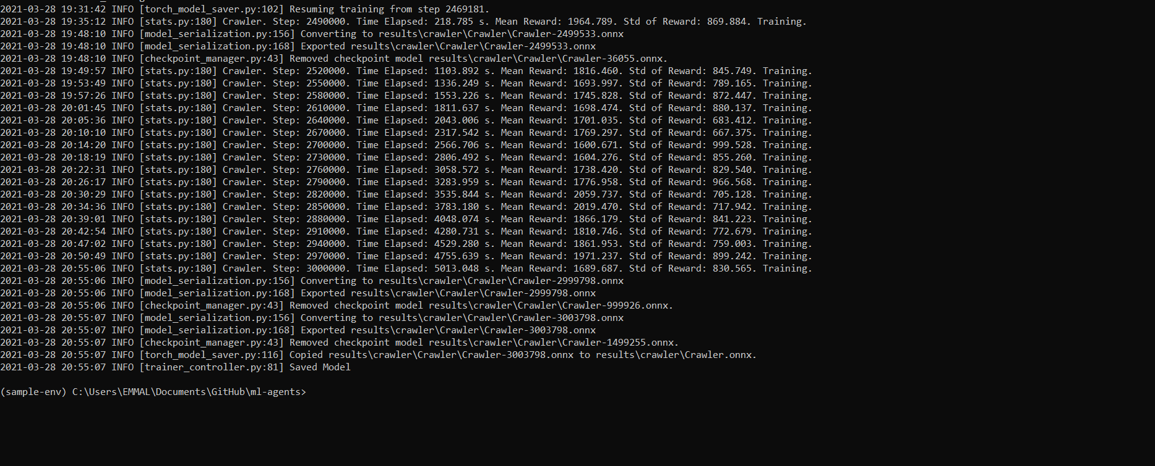

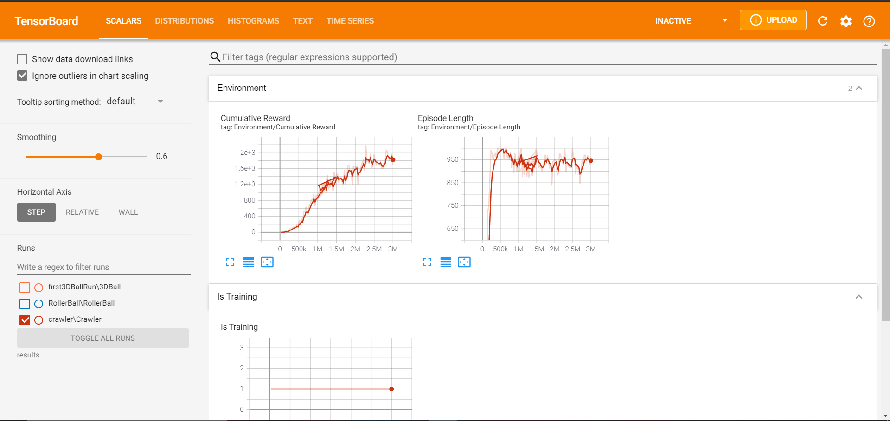

# Task2: (50 %) – Create your own game/environment to train and use

- Using the knowledge acquired through 'Making a New Learning Environment', make a new environment (scene) or reuse a prior VRTK scene with the purpose to add a ml-agents structure (academy, agents, brain), to train and then to use the created model thereby creating “smart” ml-agent(s) to use in your game scene;

. create a simple GDD for your game/environment (5 %)

. set up appropriate reward structure (5%)

. add academy (5 %)

. add agent (5 %)

. train the agent; (take TensorBoard snapshots in a separate word document) (10 %)

. use the .nn file as a model for the brain and exhibit the solution. (10%)

. build an .exe of your environment from Task2 and **upload a rough version of it before week12 class** so the teams can do playtesting. (5 %)

. Incorporate the feedback from playtesting and reflect in GDD what changes you made or why you didn’t make the suggested changes. (5 %)

# Task 3 (10 %) - Playtest another group’s solution of their Task2 build (due before Week12 class)

. Playtest another group’s Task2 and give feedback to the corresponding group. (10%)

**Present your work on last week (week13).**

**. Export your environment completely in a unitypackage (without the ml-agents package).**

**. Zip it in conjunction with the folders .\config\, .\models\ and .\summaries\, and …**

**. … the Word document with the snapshots taken from TensorBoard usage while training, and …**

**. … the simple GDD for your environment, and …**

**. ,,, the final build folder of task 2**

**. Upload the final deliverables in eCentennial by Fri.Apr.16th, 2021**