Incident Response: Nmap Scans in Wazuh (No WAF vs With WAF)
Exercise Overview:
Scenario A - No WAF: cloudflared VM → Sophos Firewall → DVWA.
Scenario B - With WAF: cloudflared VM → Sophos Firewall → WAF → DVWA.
Scan 1 – Ping sweep (host discovery)
In Scenario A, Suricata successfully recorded network traffic involving your Kali Linux machine and DVWA server without a WAF. No confirmed intrusion detection alert is shown in this event.
Figure 1 Scenario 1
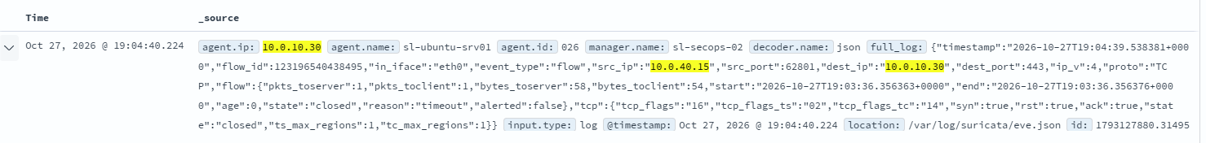
Figure 2 Scenario 2
In Scenario B, Kali-Linux (10.0.40.15) Nmap scanned with 10.0.10.17. It tried to reach TCP port 80, commonly used for HTTP web traffic. The firewall named overwatch (WAF) inspected the traffic. The firewall denied the connection. The event was recorded and made available in Wazuh for analysis below.
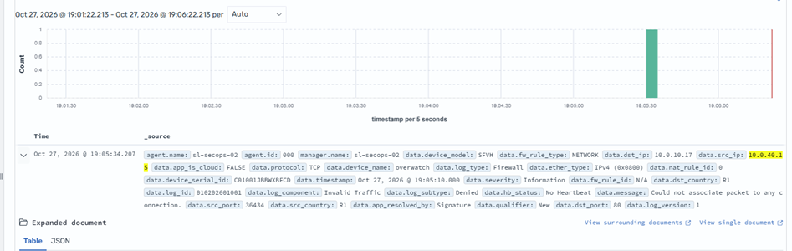

Scan 2 - TCP SYN port scan
In Scenario A, Suricata successfully recorded network traffic between Kali Linux and DVWA. One event involved port 80, which matches the port targeted by your Nmap command. Another event involved port 443, which requires separate correlation. No WAF was involved in this scenario. No explicit Nmap detection alert is visible in these two records.

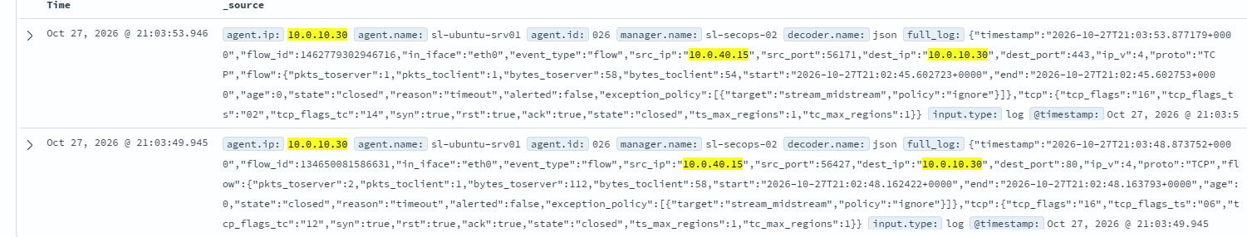

In Scenario B, a TCP SYN port scan was performed from the Kali Linux machine (10.0.40.15) against the WAF endpoint (10.0.10.17). During the investigation, Wazuh recorded a Sophos firewall event involving TCP traffic from the Kali Linux machine to the WAF endpoint on port 80. The firewall classified the traffic as invalid and denied the packet because it could not associate it with an existing connection. This demonstrates that the Sophos firewall can identify and reject unexpected network traffic independently of the SafeLine WAF.

Scan 3 - Service/version + default scripts
In Scenario A, Nmap service/version detection and default script scanning were performed from the Kali Linux machine (10.0.40.15) against the DVWA server (10.0.10.30). During the investigation, Wazuh recorded an Apache web server access log showing an HTTP GET request to /evox/about. The request contained an Nmap Scripting Engine user-agent, indicating that it originated from Nmap-generated activity. The server returned an HTTP 404 response because the requested resource was not found. Wazuh subsequently triggered rule 31101, classified at alert level 5. This demonstrates that Nmap's application-layer probes reached the web server and were recorded by Apache before being analysed by Wazuh.
In Scenario B, an Nmap service/version detection scan was conducted from Kali Linux (10.0.40.15) against the SafeLine WAF endpoint (10.0.10.17). During the investigation, Wazuh recorded a Sophos firewall event showing TCP traffic from the Kali Linux machine to the WAF endpoint on port 80. The firewall classified the packet as invalid traffic and denied it because the packet could not be associated with an existing connection.
Scan 4 - HTTP enumeration (the clearest WAF difference)
In Scenario A, Nmap performed HTTP enumeration against the DVWA server (10.0.10.30). Apache recorded an HTTP HEAD request targeting a Sitecore-related resource, which returned a 404 response. Wazuh detected the event and triggered rule 31101 at level 5.
In Scenario B, an HTTP enumeration scan was conducted against the WAF endpoint (10.0.10.17). Wazuh recorded a Sophos firewall event showing TCP traffic from Kali Linux (10.0.40.15) to port 80. The firewall classified the packet as invalid and denied it because it could not associate it with an existing connection.
Scan 5 - Aggressive scan (everything at once)
In Scenario A, an aggressive Nmap scan was conducted against the DVWA server (10.0.10.30). Wazuh displayed 69 matching events within the selected five-minute period. The expanded Sophos firewall log recorded an ICMP error message originating from the DVWA server and directed towards Kali Linux (10.0.40.15). The firewall allowed the traffic under the VLAN-TO-VLAN rule. Key takeaway: The results demonstrate network-level visibility during the aggressive scanning exercise. However, further analysis of the remaining events is required to confirm Nmap-specific detections and identify any application-layer reconnaissance activity.
In Scenario B, an aggressive Nmap scan was conducted against the WAF endpoint (10.0.10.17). Wazuh recorded a Sophos firewall event involving TCP traffic from Kali Linux (10.0.40.15) to destination port 30302. The firewall classified the packet as invalid and denied it because it could not associate it with an existing connection.

Scan 6 - Vulnerability scan (NSE vuln scripts)
In Scenario A, an Nmap vulnerability scan was performed against the DVWA server (10.0.10.30). Wazuh displayed 2,192 matching events within five minutes, with a significant concentration of activity around 22:41.The expanded Sophos firewall log recorded TCP traffic from Kali Linux (10.0.40.15) to port 80. The firewall classified the packet as invalid traffic and denied it because it could not associate it with an existing connection.
Key takeaway: The results demonstrate substantial network activity during the vulnerability scanning exercise and show that Sophos denied at least one packet. However, additional Suricata alerts and Apache access logs are needed to determine whether specific vulnerability probes reached DVWA or triggered security detections.
In Scenario B, an Nmap vulnerability scan was conducted against the WAF endpoint (10.0.10.17). Wazuh recorded a Sophos firewall event showing TCP traffic originating from Kali Linux (10.0.40.15).
The traffic was processed under firewall rule 9 and the VLAN-TO-VLAN NAT rule, demonstrating network-level monitoring between the two network segments.. Was eventually blocked.

